**Modelling dune evolution under a discharge wave**

Jord J. Warminka*

*a* *University of Twente, Department of Water Engineering and Management, Faculty of Engineering Technology, P.O. Box 217, 7500 AE, Enschede, the Netherlands*

**Keywords —** River Dunes, Time-lag

# Introduction

Accurate forecasts of flood levels are essential for flood management. During floods, bed forms develop on the river bed. Dunes have heights in the order of 10–30% of the water depth and lengths in the order of 10 times their height. River bed forms act as roughness to the flow, thereby significantly influencing the (flood) water levels. It is essential to predict the time evolution of bed forms and assess their influence on the hydraulic roughness.

Field observations have shown that dunes of different lengths and amplitude co-exist (e.g. Wilbers & Ten Brinke, 2003). Carling et al. (2000) distinguished three scales of bed forms, ripples, small dunes (length < 5 m) and large dunes (length > 10 m) in the German river Rhine and show that the latter two strongly interact.

Several successful attempts were made to model bed form evolution and associated roughness using detailed numerical modeling (e.g. Nabi, 2010). However, these models require long computational times and are therefore not applicable for operational flood management. Paarlberg et al. (2010) developed a process-based model for bed form evolution that requires limited computational effort. This model accounts for flow separation and is able to predict bed form development towards equilibrium conditions. However, the interaction with secondary bed forms is currently not included in the model. Therefore, the objective of this research is to explain and model the interaction between primary and secondary bed forms during a discharge wave measured in a flume.

* Corresponding author

*Email address:* [j.j.warmink@utwente.nl](mailto:j.j.warmink@utwente.nl) (Jord Warmink)

**Observations from data**

We compared the flume data from Wijbenga and Van Nes (1986) who imposed two discharge waves in the flume, with the field data from Wilbers and Ten Brinke (2003) of two discharge waves of 1995 and 1998 in the river Rhine and Waal in the Netherlands. This showed that dune height evolution is similar in the flume and in the field, but the decrease of dune length in the flume is not visible in the field measurements, where dune length only seems to grow. To explain the observed decrease in bed form length in the flume and field data, we propose an hypothesis based on super-imposition of secondary bed forms (Fig. 2). The key is that dune length of an individual dune never decreases, but only increases and that secondary bed forms are responsible for the observed decrease in bed form length, because they develop on top, and during decreasing discharge, they become dominant. Because these secondary dunes have a smaller length, the dune length rapidly decreases.

**Time-lag approach**

We applied a time-lag approach for the flume data. Coleman et al. (2005) adopted the commons scaling relationship for sand-wave development from an initially flat bed:

$\frac{P}{P_{e}}={\left(\frac{t}{t_{e}}\right)}^{γ}$ (1)

where P is the average value of dune length or height, Pe is the equilibrium value, t is time, te is the time to achieve Pe, and γ is a growth rate parameter. Coleman et al. (2005) derived a relation for γ, based on flume experiment with a discharge step. They showed that growth rate was different for dune height and length and mainly depended on sediment size. Using this approach for the data from Wijbenga & Van Nes (1986) yielded γH=0.42 and γL = 0.37.

Coleman et al. (2005) used their data to derive the *te* for dunes:

$t_{e}\left[\frac{u_{*}}{D_{50}}\right]=2.05⋅10^{-2}\left[{\left(\frac{D_{50}}{h}\right)}^{-3.5}\right]\left[{\left(\frac{θ}{θ_{cr}}\right)}^{-1.12}\right]$ (2)

They assumed that the times to equilibrium are equal for dune height and dune length, based on flume experiments with a sudden step in discharge that show that after a certain period of time dunes reach their equilibrium. However, observed dune heights during a flood wave from Wijbenga and Van Nes (1986) show that the maximum dune height is reached long before the maximum dune length is reached (Fig. 2). Calibration showed that for dune height, the te values need to adapted with a factor 0.01 to yield realistic dune heights for the Wijbenga and Van Nes (1986) data.

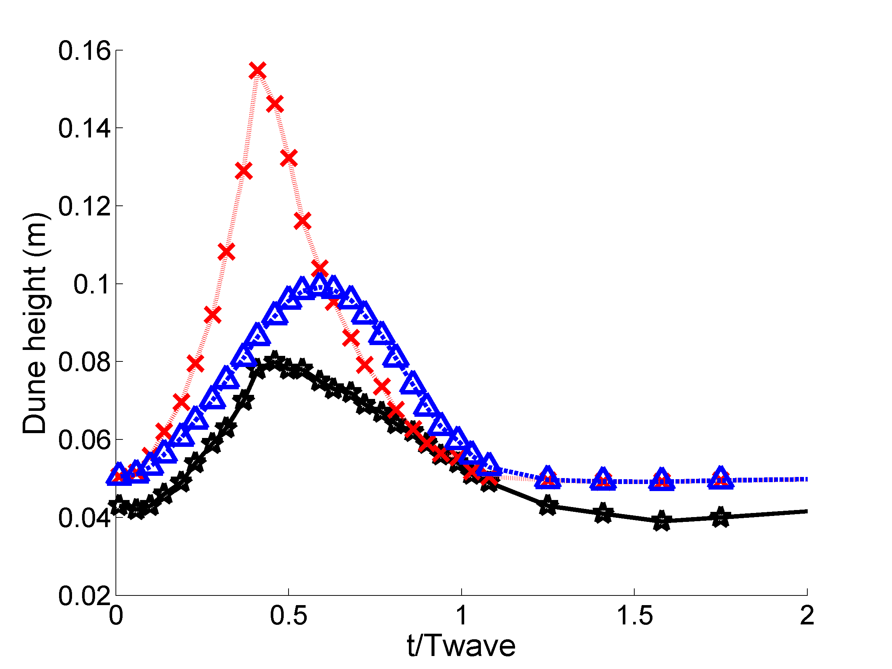

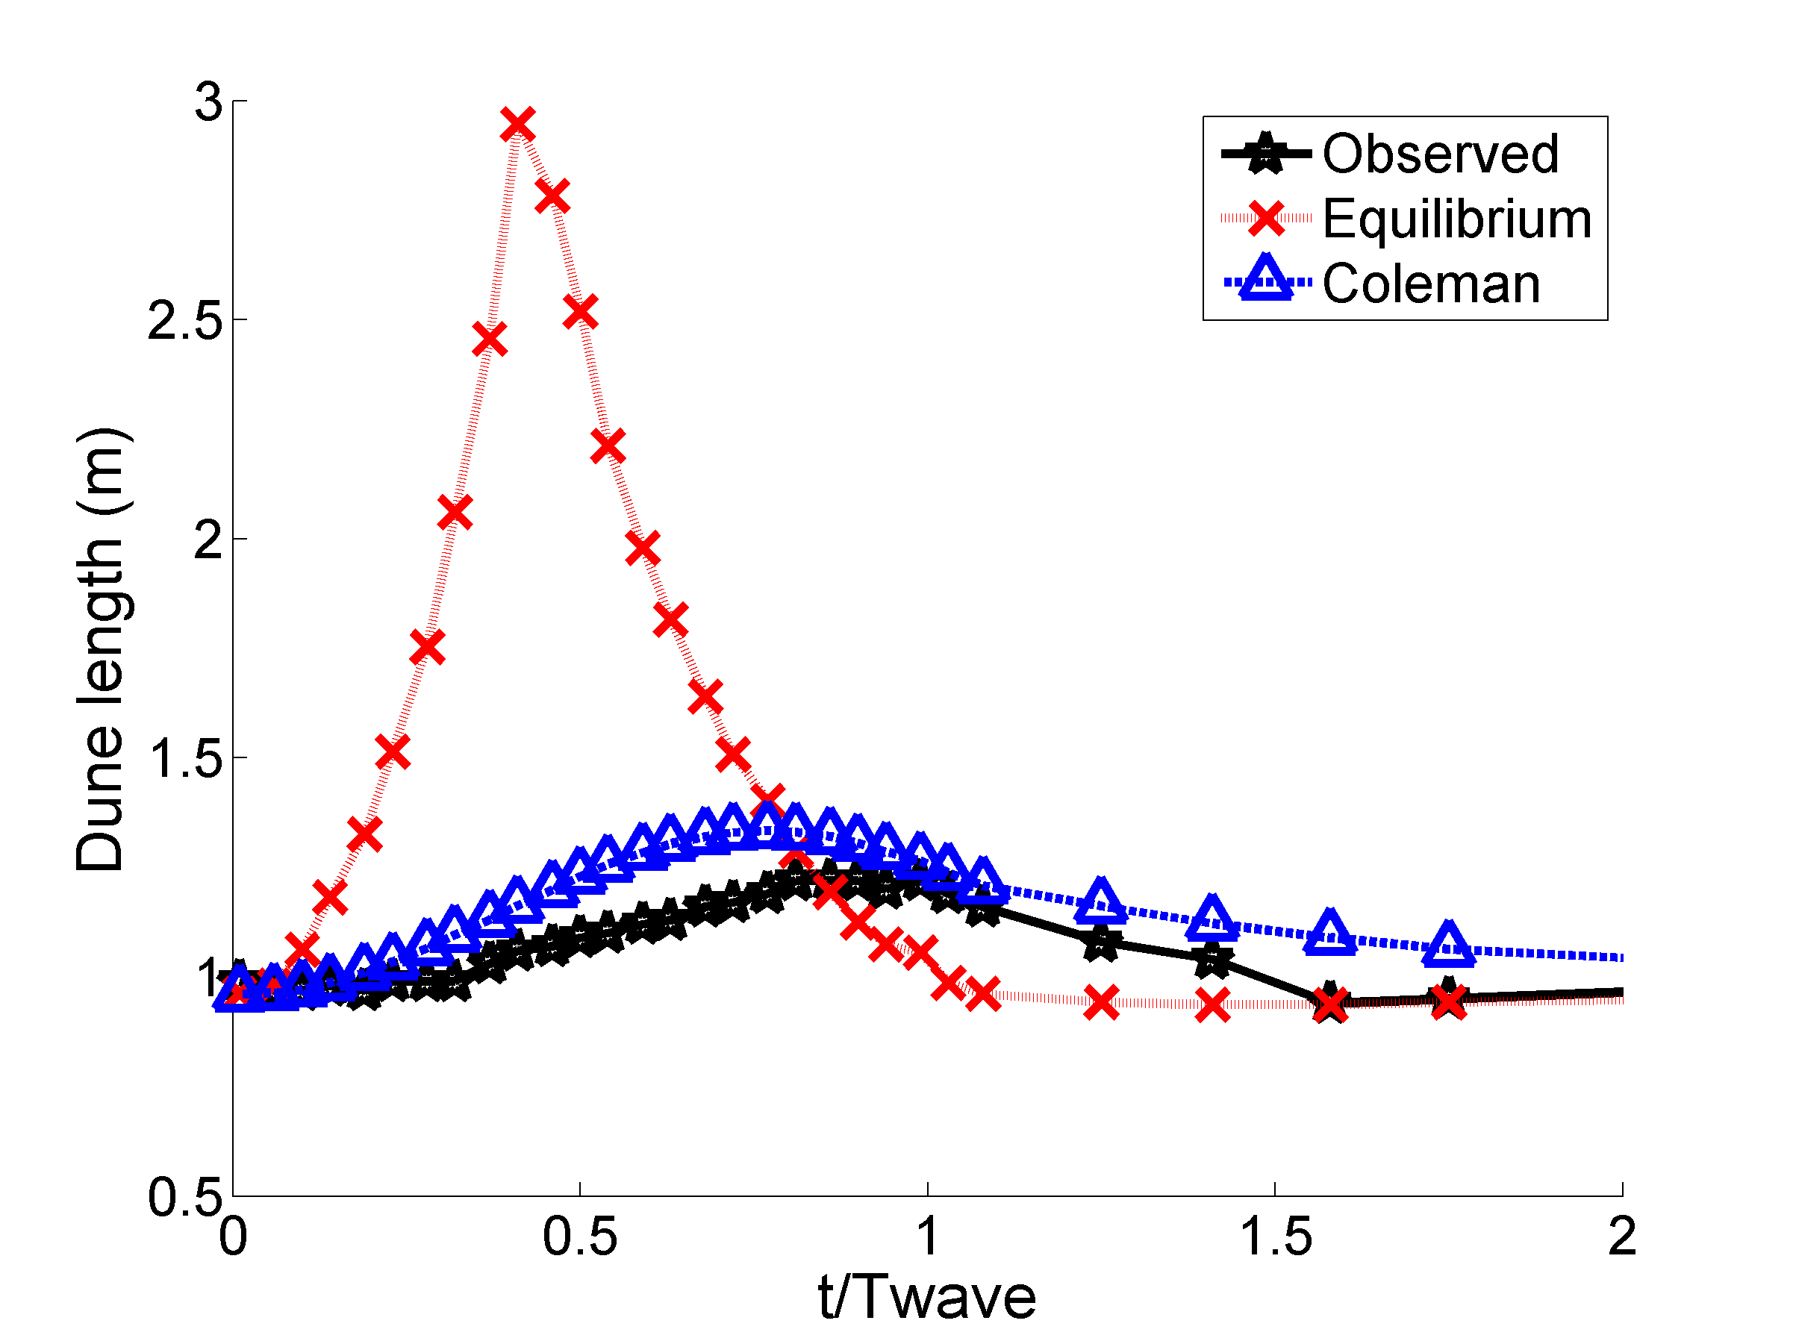

Figure 1. Dune height and dune length prediction using the time-lag approach. The crosses show the Pe predictions

Fig. 1 shows the predicted dune height and length using this time-lag approach. The times to equilibrium, te, ranged between 3 to 320 days. These values seem unrealistic, but resulted in a reasonably good fit to the observed dune dimensions. Calibration of *te* for dune height only was required by multiplying te by 0.01. This is not feasible and limits the practical applicability for flood forecasting. Furthermore, the process of overtaking of the

# References

Carling, P.A., Gölz, E., Orr, H.G., Radecki-Pawlik, A. 2000. The morphodynamics of fluvial sand dunes in the River Rhine near Mainz, Germany. I. Sedimentology and morphology. Sedimentology 47, 227-252.

Coleman, S.E., Zhang, M.H., Clunie, T.M. 2005. Sediment-wave development in subcritical water flow J. Hydr. Eng. 131, 106-111.

Nabi, M. 2010. Computational modelling of three-dimensional bedform evolution. Proc. River Flow 2010, 905-911.

Paarlberg, A.J., Dohmen-Janssen, C.M., Hulscher, S.J.M.H., Termes, P., Schielen, R.M.J. 2010. Modelling the effect of time-dependent river dune evolution on bed roughness and stage. Earth Surface Processes and Landforms 35, 1854-1866.

Wijbenga, A. and Van Nes, A.R. 1986. Flow resistance and bedform dimensions for varying flow conditions; results of flume experiments with flood waves. WL|Delft Hydraulics. Report M1314 part XIII, Delft, the Netherlands.

Wilbers, A.W.E. and Ten Brinke, W.B.M. 2003. The response of subaqueous dunes to floods in sand and gravel bed reaches of the Dutch Rhine. Sedimentology 50, 1013–1034.

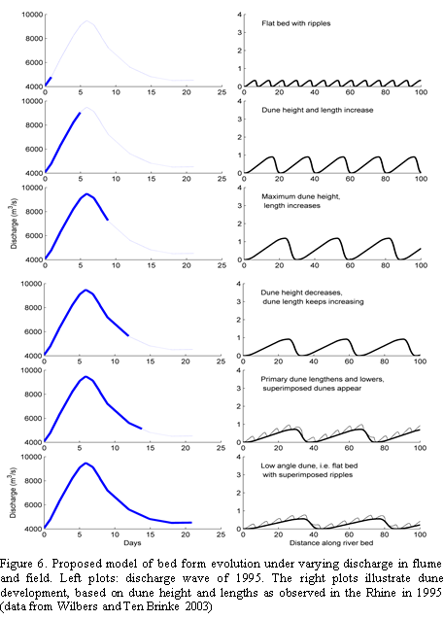

Figure 2. Proposed model of bed form evolution during the receding limb of the flood wave. Left: discharge wave of 1995 in Rhine. Right: illustration of dune development (height and length observed in the Rhine in 1995 from (Wilbers & Ten Brinke 2003).