Title, only first letter capital (Arial bold 16 pt)

*Empty line or special paper notice. Arial italic 10 pt.*

(Authors: full first name preferred. Affiliation letter in superscript. Arial 10 pt, e.g. Albert B. Authora,b*, Collin Authora

*aAffiliation full address (Arial italic 9 pt)*

*bSecond affiliation full address (Arial italic 9 pt)*

*(empty line, Arial 10 pt)*

**Keywords —** Keyword 1, Keyword 2, Keyword 3

(Empty line Arial 10 pt)

# Layout (Headings: Arial bold 11 pt)

Main text: Arial 10 pt, justified. Paper Size A4. Margins: Top: 2.5 cm, Left 2.5 cm, Bottom 2.5 cm, Right 2.5 cm. Header: 1.25 cm, Footer: 1.25 cm. Title, authors and addresses are across the whole page, the main text is in two columns (Width: 7.4 cm, Spacing: 1.2 cm). All text is aligned left. Line spacing: single.

(Between paragraphs empty line Arial 10 pt)

# Structure

The common paragraph structure of a paper is: Introduction (background, motivation of research), Method, Results, Conclusion, (Acknowledgements), References. No abstract is required.

Numbering or bullets:

1. Numbers are aligned left, indent 0.5 cm.
   * Bullets are aligned left, indent 0.5 cm.

## Subparagraph

Subparagraphs with a heading have a heading in Arial bold and italic 10 pt and are separated from the preceding text by an empty line.

Subparagraphs without heading can be separated by either an empty line or by an indent of 0.5 cm, depending on your preference or available space.

When abbreviations are used, make sure they are explained the first time introduced.

# Figures

Refer to figures in the text as: Fig. X, where X is the number of the figure. Each figure has a figure caption below the figure (see example Fig. 1). Make sure that the text and numbers in the figure are legible and of good quality. When fitting a figure in a column makes the figure illegible, you can use the entire width of the page. Figures can be in colour.

# Tables

Refer to tables in the text as: Table X. Each table has a table caption above the table (see example Table 1). The layout (lines/no-lines, font size (≤ 10 pt)) is flexible and to your own preference. However, make sure that the table is legible. The same as with figures, when fitting a table in a column reduces the legibility, you can use the entire width of the page.

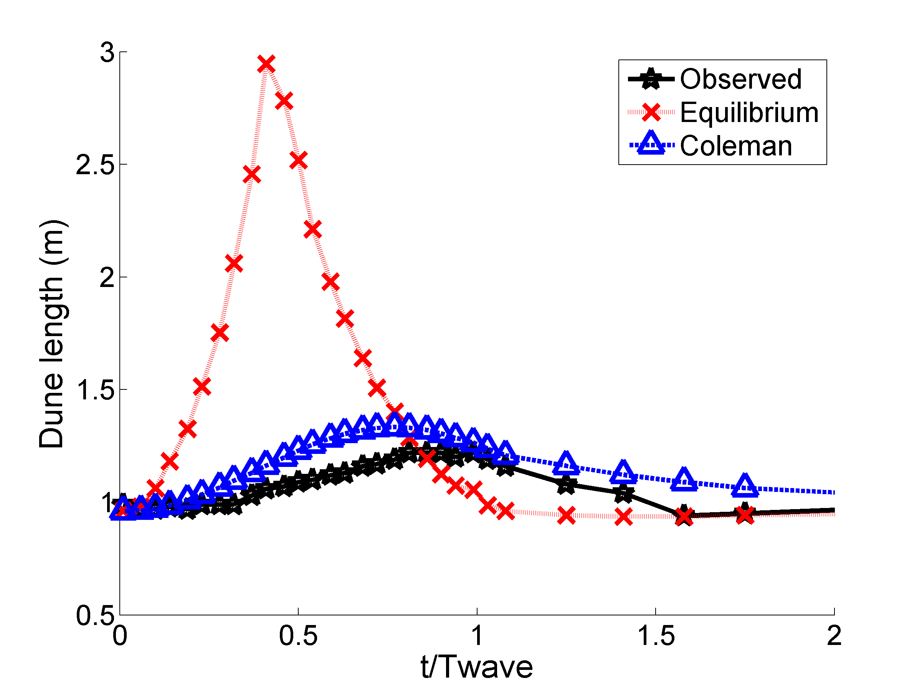

* Corresponding author

*Email address:* [a.b.author@affiliation.com](mailto:a.b.author@affiliation.com) (A.B. Author)

*URL*: [www.affiliation.com/abauthor](http://www.affiliation.com/abauthor) (A.B. Author)

(Arial, 8pt)

!! Do not change location of this box !!

Figure 1. Dune height and dune length prediction using the time-lag approach. (Example of a figure with caption, Arial italic 8 pt.)

Table 1. Maximum discharge (m3/s) and associated water level (cm +NAP) in the Rhine at Lobith in the period 2005-2010 (data from http://live.waterbase.nl/). (Example of table with heading, Arial italic 8 pt.)

|  |  |  |
| --- | --- | --- |
| **Year** | **Discharge**  **(m3/s)** | **Water level** |
| **(cm + NAP)** |
| 2005 | 5542 | 1333 |
| 2006 | 5776 | 1351 |
| 2007 | 6136 | 1377 |
| 2008 | 4473 | 1231 |
| 2009 | 4417 | 1227 |
| 2010 | 5829 | 1354 |

# Equations

For equations use Office Math size 10:

$C_{r}=\sqrt{\frac{1}{\frac{1}{C_{0}^{2}}+\frac{C_{D}D h N}{2gA_{p}}}}$ (1)

Leave an empty line before and after the equation. Number equations as above and refer to equations in the text as Eq. (X) or (Eq. X). Explain all symbols in the equations.

# References in text

Refer to literature in the text as (Author, 2007) or when the author’s name is used in the text: Author (2007). Two authors are referred to as (Author and Bauthor, 2007). When there are more than two authors refer to (Author et al., 2007). Make sure that all references mentioned in the text are listed at the end of the paper under references and vice versa.

# References

References are in Arial 8 pt. Indent second line: 0.25 cm.

Below examples are given for different sources.

*Paper:*

Shiono, K., Knight, D.W. (1991) Turbulent open channel flows with variable depth across the channel. Journal of Fluid Mechanics, 222: 617-646.

*Book:*

Jansen, P.Ph., Van Bendegom, L., Van den Berg, J., De Vries, M., Zanen, A. (1979*)* Principles of river engineering. The non-tidal alluvial river. Delftse Uitgevers Maatschappij. 509 p.

*Report:*

Parmet, B.W.A.H., Van de Langemheen, W., Chbab, E.H., Kwadijk, J.C.J., Diermanse, F.L.M., Klopstra, D. (2001) Analyse van de maatgevende afvoer van de Rijn te Lobith. Institute for Inland Water Management and Waste Water Treatment (RIZA), RIZA report 2002.012. Arnhem, The Netherlands.

*Website:*

McGahey, C. and Samuels, P. G. (2006) Methodology for Conveyance estimation in Two-Stage Straight, Skewed and Meandering Channels, <http://www.river-connveyance.net/documents/AHRXXXCongresspaper.pdf>. Last accessed Jan. 2006.