CI-CD_Pipeline_Assigment

**Task 1:** Set Up a Simple HTML Project

* + Create a simple HTML project and push it to a GitHub repository.

🡺 [git@github.com:kdbhai/CI-CD_Pipeline_Assigment.git](mailto:git@github.com:kdbhai/CI-CD_Pipeline_Assigment.git)

🡺 HTML file created

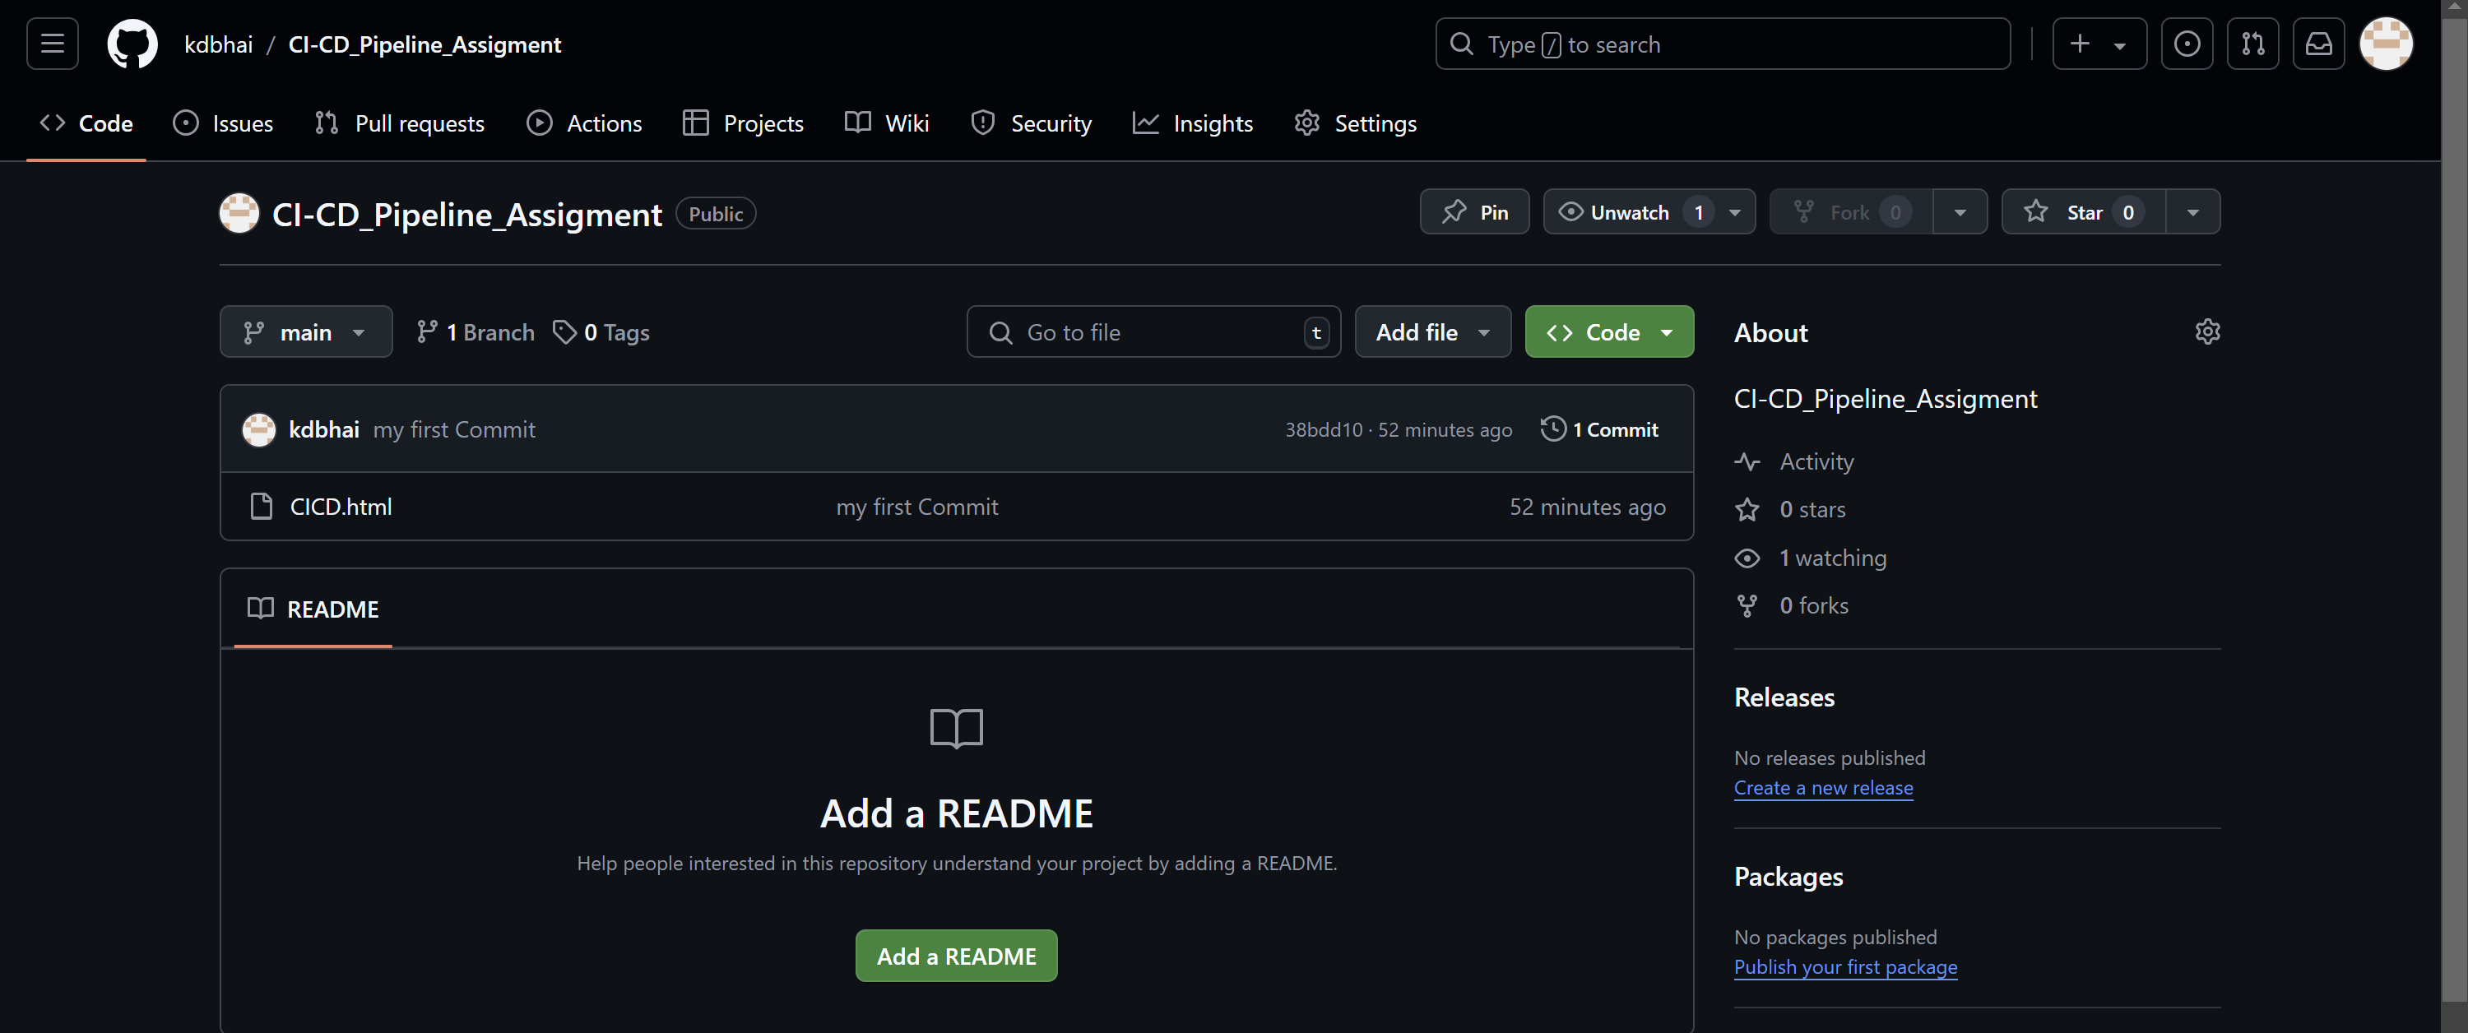

* **Task 2: Set Up an AWS EC2/Local Linux Instance with Nginx**

**🡺**

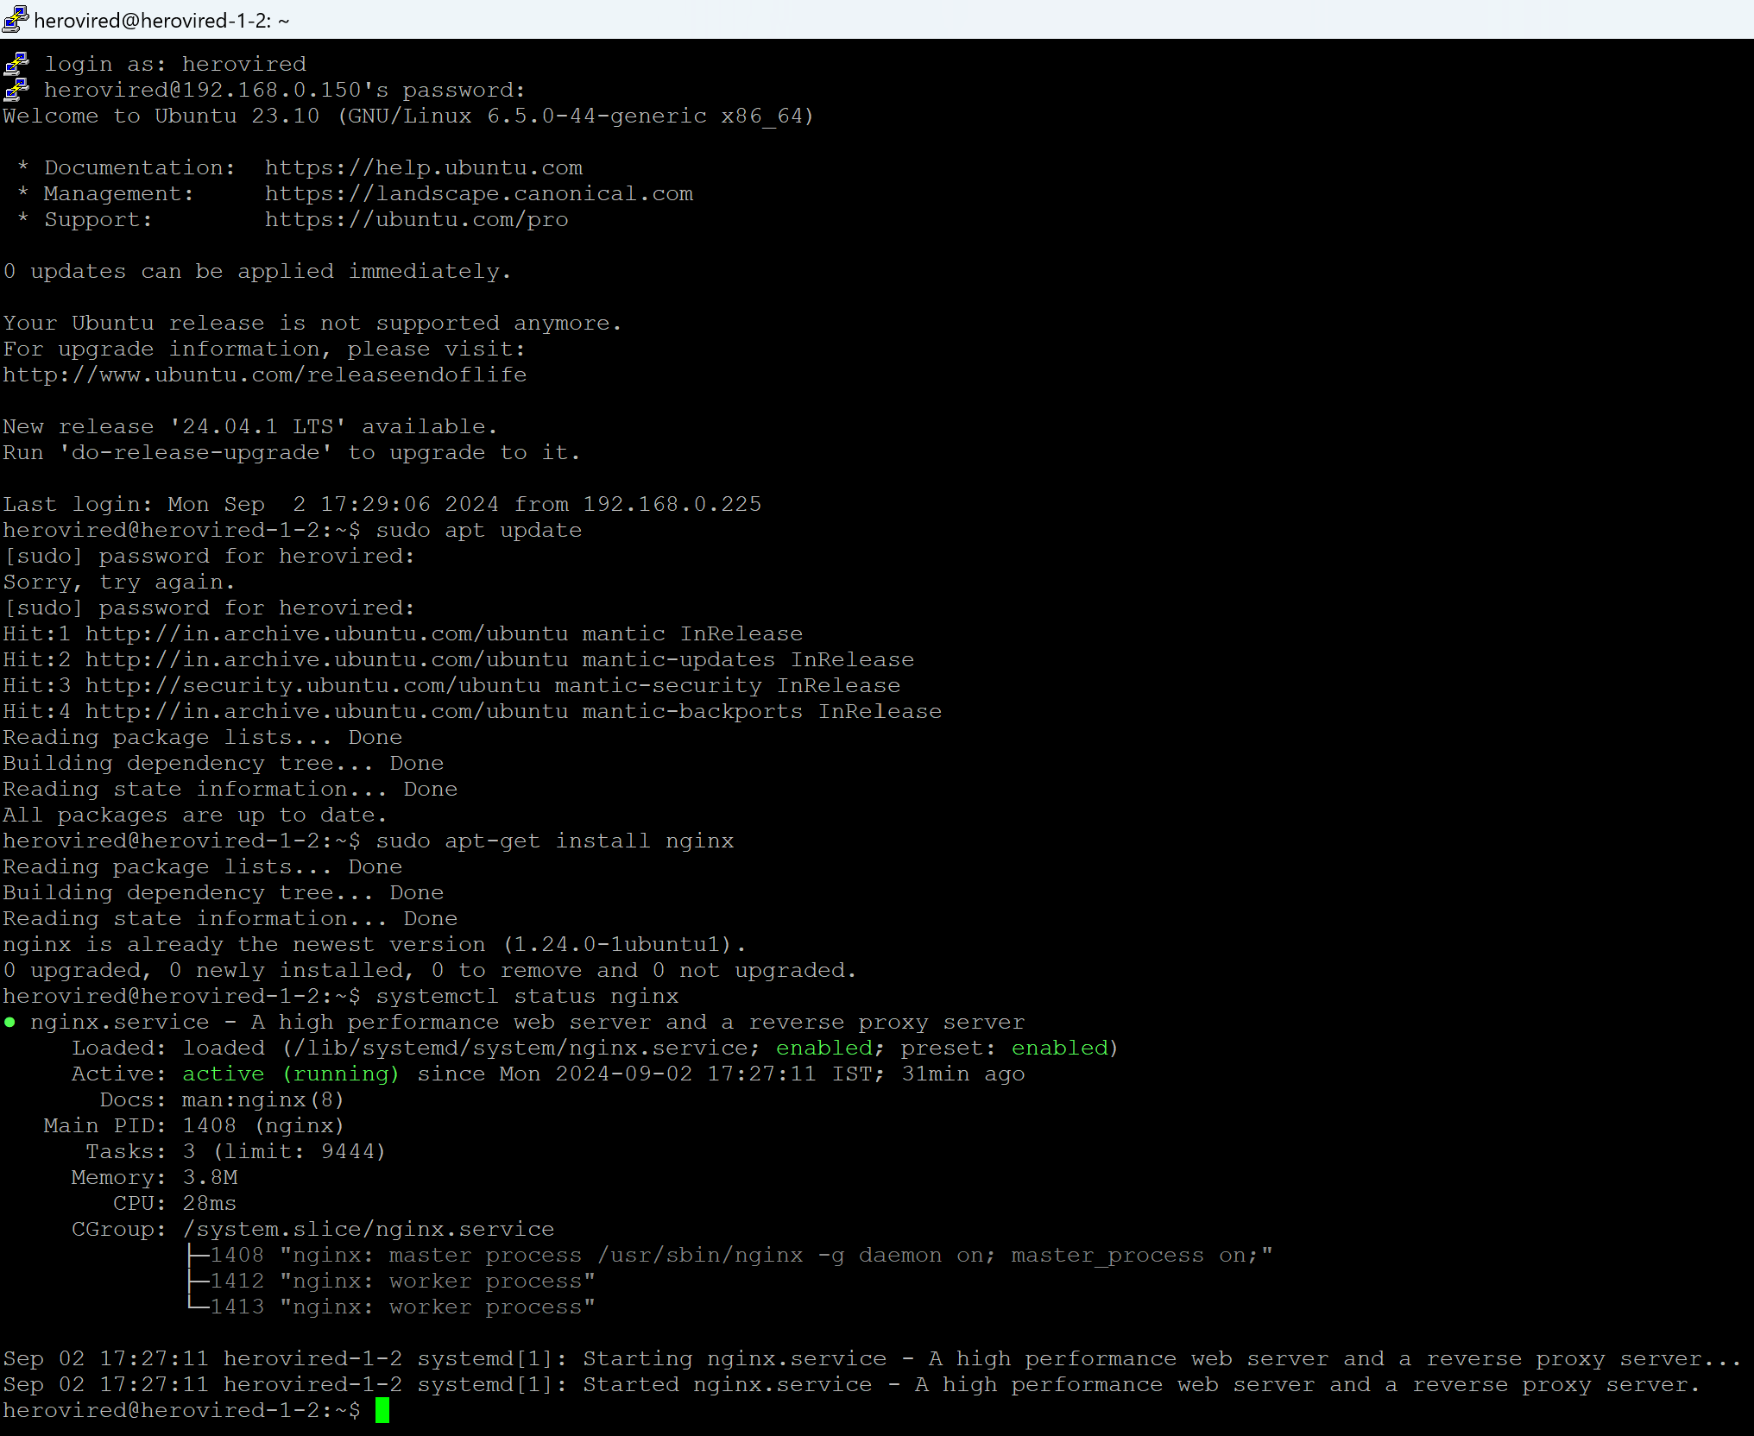

* **Task 3:** Write a Python Script to Check for New Commits
  + - Create a Python script to check for new commits using the GitHub API.

🡺

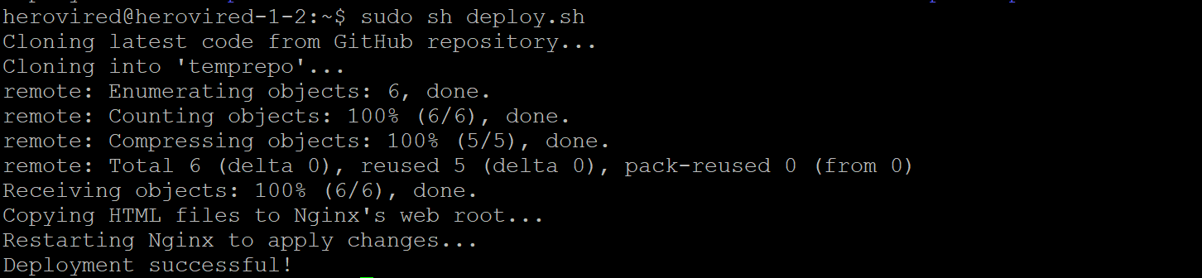

* **Task 4:** Write a Bash Script to Deploy the Code
  + - Create a bash script to clone the latest code and restart Nginx.

🡺

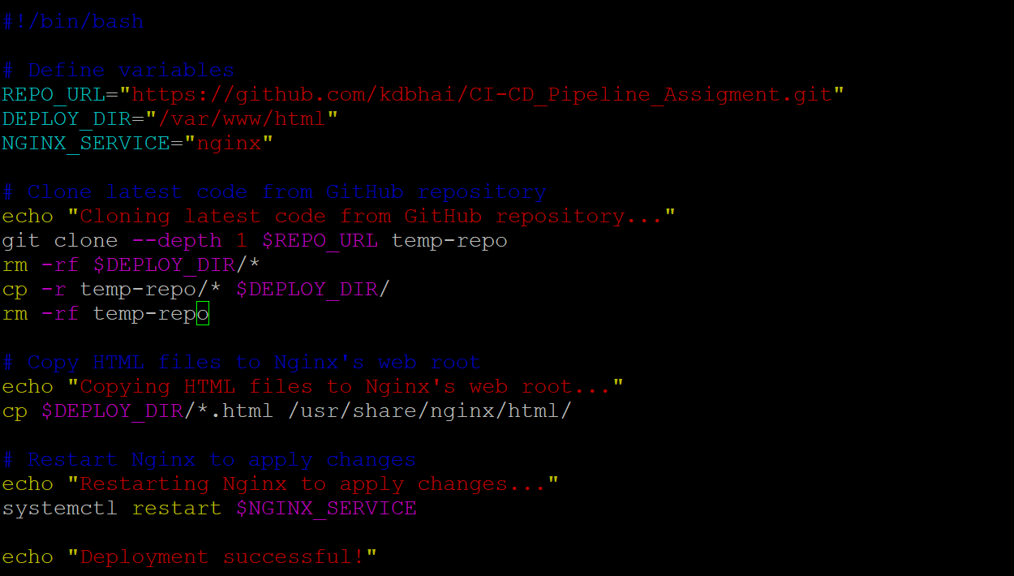

* **Task 5: Set Up a Cron Job to Run the Python Script**
  + - **Create a cron job to run the Python script at regular intervals.**

**🡺**

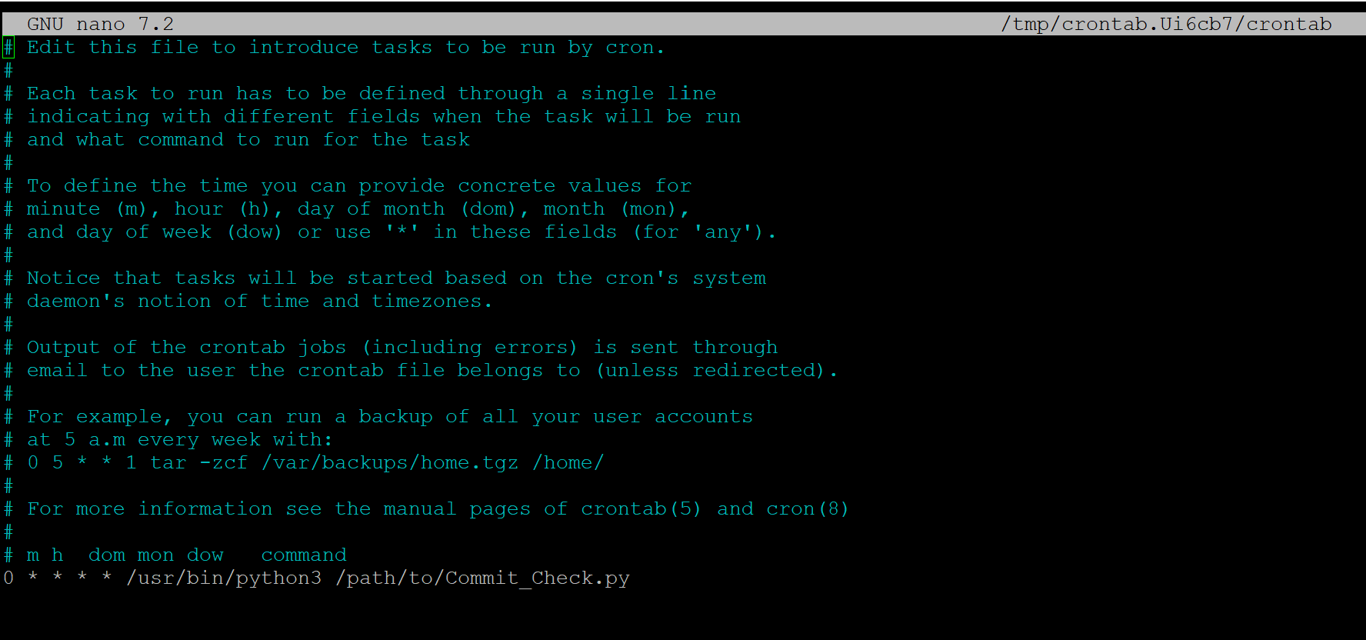

* **Task 6:** Test the Setup
  + - Make a new commit to the GitHub repository and check that the changes are automatically deployed.

🡺before

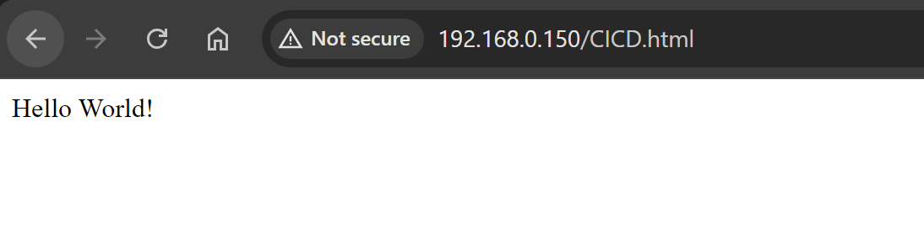

🡺After

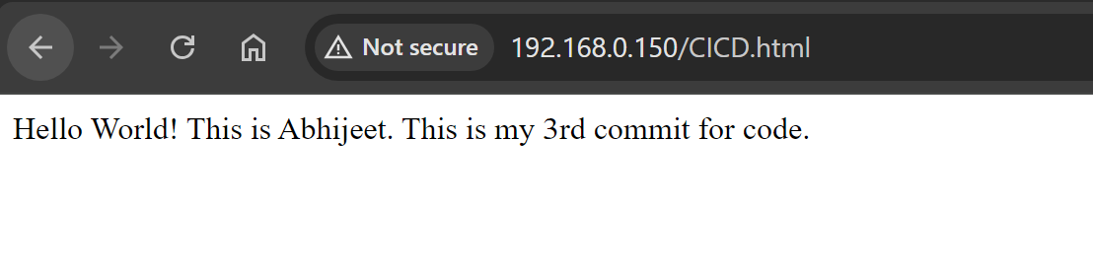

🡺Code output

