暑假班七年级英语上册期末测试
(满分120分 时间100分钟)
第一部分 听力（25分）
Ⅰ.听句子，选择正确图片。每个句子读两遍。(5分)
( )1. A.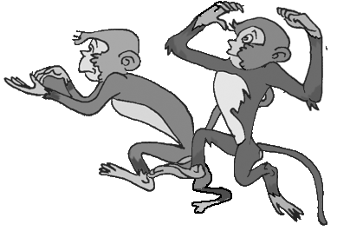 B. C.
( )2. A.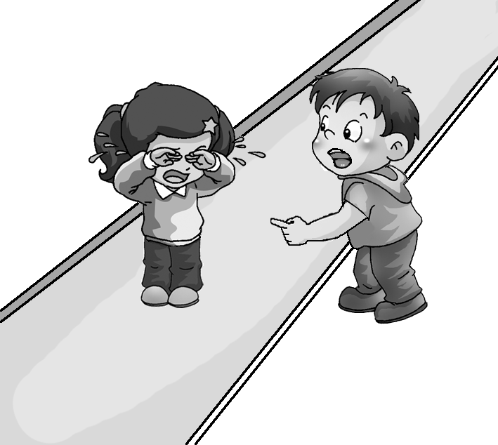 B.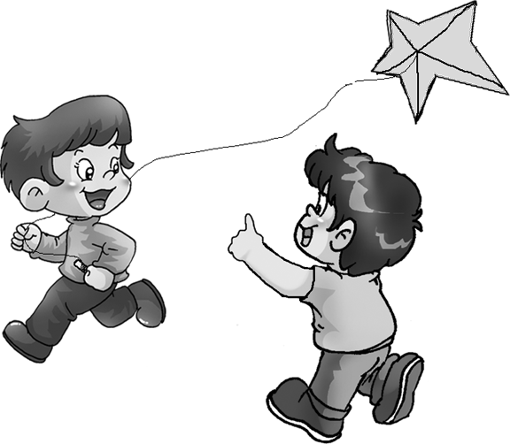 C.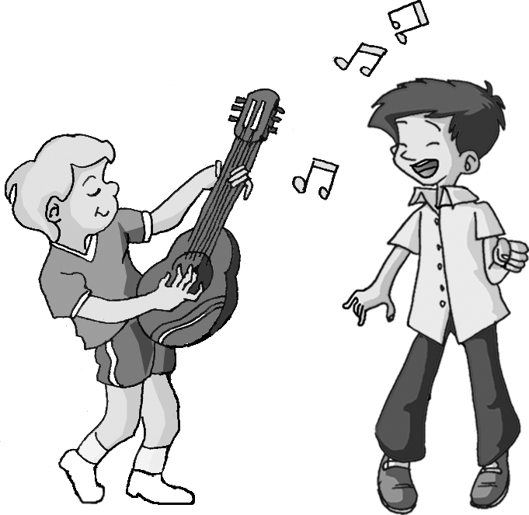
( )3. A. B.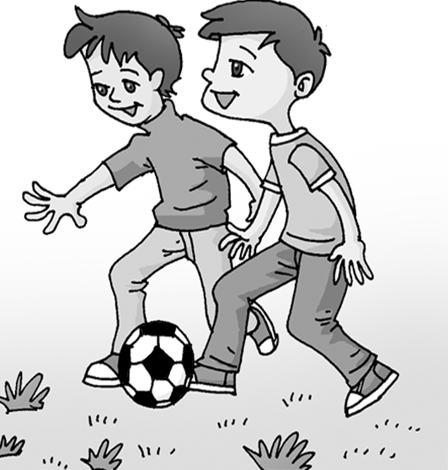 C.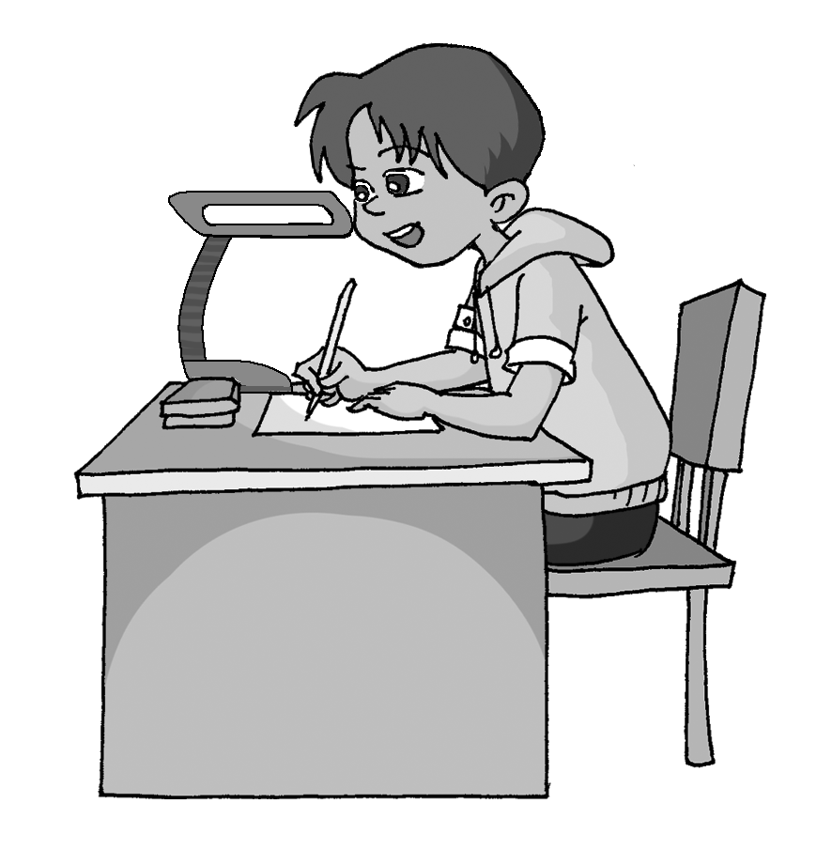
( )4. A.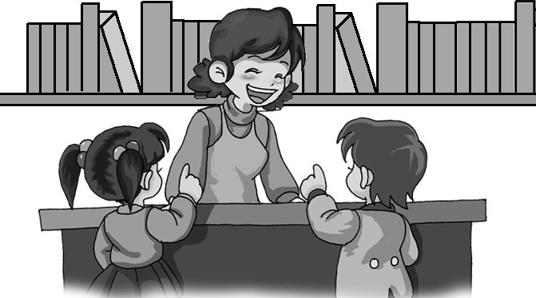 B.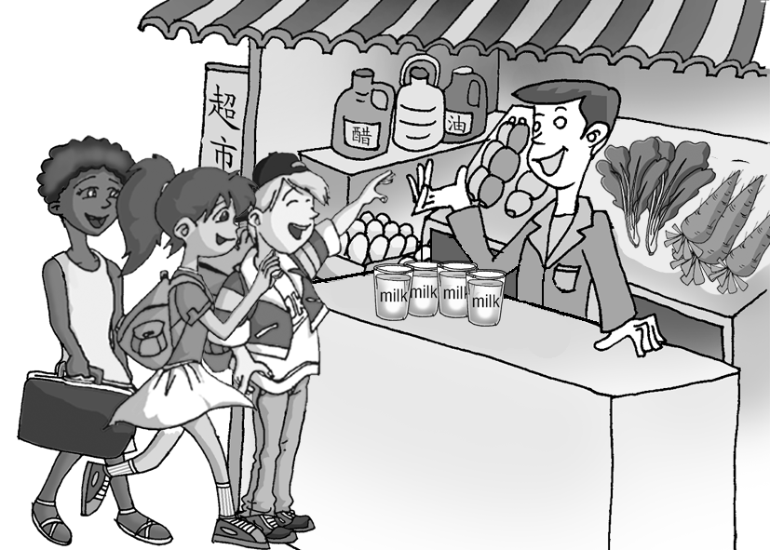 C.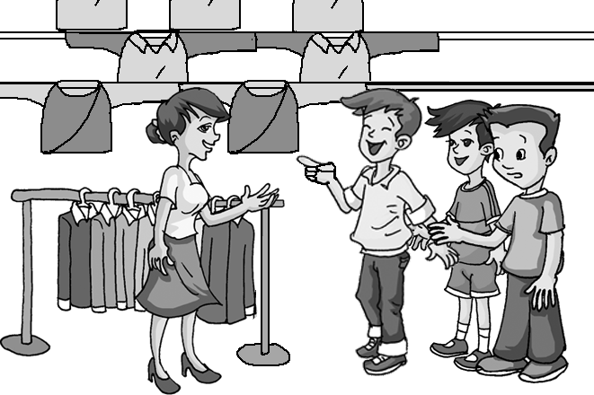
( )5. A. B. C.
Ⅱ.听句子，选择正确答语。每个句子读两遍。(5分)
( )6. A. I’m in Class One. B. I’m in China. C. I’m in Grade Seven.
( )7. A. It’s Tom. B. It’s Mike’s. C. It’s new.
( )8. A. They are very kind. B. Yes, I think so. C. I want to visit China.
( )9. A. Where is the fish?
B. Thank you.
C. I don’t think your fish is very nice.
( )10. A. Good idea.
B. OK, going fishing is my favorite.
C. Yes, I’d like to.
Ⅲ.听对话及问题，选择正确答案。每组对话和问题读两遍。(5分)
( )11. A. New. B. Old. C. Nice.
( )12. A. Apples. B. Bananas. C. Oranges.
( )13. A. Rice and vegetables. B. Fish with vegetables. C. Milk and bread.
( )14. A. In an office. B. She teaches English. C. In a school.
( )15. A. He would like a red jacket.
B. He would like a white jacket.
C. He would like a yellow jacket.
Ⅳ.听短文，选择正确答案。短文读两遍。(5分)
( )16. Jim is ____ years old.
A. 14 B. 13 C. 11
( )17. Jim’s father is ____.
A. a driver B. a teacher C. a farmer
( )18. Jim and Susan are in ____.
A. the same grade B. the same school C. different schools
( )19. Jim is in ____.
A. Grade Seven B. Grade Eight C. Grade Nine
( )20. Jim’s family is from ____.
A. China B. England C. America
Ⅴ.听短文，根据短文内容，完成表格。短文读三遍。(5分)
People | Favorite animals
Nick | 21. ____________
Bob | 22. ____________
Jim | 23. ____________
Linda | 24. ____________
Mr. Green | 25. ____________
第二部分 基础知识运用（65分）
Ⅰ.单项选择。(15分)
( )1. —Hi, Tony. ____ is my friend, Jack.
—Hello, Jack! Nice to meet you.
A. He B. That C. This D. It
( )2. —____ bike is this?
—I think it’s Sally’s.
A. What B. Whose C. Where D. Who
( )3. —What does your brother look like?
—____
A. Yes, he is tall. B. He is 20 years old.
C. No, he isn’t. D. He is tall.
( )4. Miss Wang teaches ____ English. We all like ____.
A. us; her B. we; her C. our; her D. we; she
( )5. —What about something to drink?
—____
A. Not at all. B. That’s right. C. All right. D. You are welcome.
( )6. —Is this ____ schoolbag, Michael?
—No, it isn’t. ____ is here.
A. your; My B. your; Mine C. yours; My D. yours; Mine
( )7. —Boys and girls, welcome to my home and ____.
—Thank you.
A. help yourselves B. help yourself C. helps yourself D. help you
( )8. —How do you spell your name, please?
—____
A. P-E-T-E-R, Peter. B. This is Peter.
C. I’m Peter. D. You can call me Peter.
( )9. —Peter, we are good friends. We can help ____.
—Yes, you’re right.
A. other B. each C. each other D. every other
( )10. —____
—It’s ten to eight.
A. What’s this? B. What’s the time?
C. What do you do? D. How do you like it?
( )11. —____
—She is a nurse.
A. Who is your mother? B. Is your mother a nurse?
C. Where is your mother? D. What does your mother do?
( )12. —____
—Some rice, please.
A. What about something to drink?
B. Would you like to have lunch with me?
C. May I take your order?
D. Can I help your order?
( )13. —What would you like ____?
—A glass of water, please.
A. drink B. have C. to drink D. to eat
( )14. —____ do you go to school in the morning?
—At 7: 30.
A. What B. What time C. How D. Where
( )15. —Let’s go fishing this afternoon.
—____
A. Good idea. B. Yes, I’d love to.
C. I like fish a lot. D. No problem.
Ⅱ.情景交际。(10分)
A. 从Ⅱ栏中找出Ⅰ栏各句的应答语。(5分)
Ⅰ Ⅱ
( )16. Nice to meet you. A. They’re 30 yuan.
( )17. Where does your brother work? B. I want a skirt for my daughter.
( )18. What can I do for you? C. Some milk, please.
( )19. Would you like something to drink? D. Nice to meet you, too.
( )20. How much are the pants? E. He works in a hospital.
B. 从方框中选择适当的句子补全对话，有两项多余。(5分)
A: Good morning, sir. 21
B: I’d like to buy some chicken, please.
A: 22
B: Two kilos, please.
A: OK. Here it is. 23
B: No. And some apples, please.
A: 24
B: Four, please.
A: Here you are.
B: Thank you. 25
A: Let me see. Forty yuan.
B: OK. Here you are.
A: Thank you. Goodbye!
A. How much chicken would you like?
B. May I help you?
C. Is that all?
D. Thank you.
E. How many apples do you need?
F. How much are they?
G. I’ll take it.
21. 22. 23. 24. 25.
Ⅲ.完形填空。(10分)
Kids like to play games(游戏). Do you often play hide-and-seek(捉迷藏) 26 your friends? A lot of kids often play this game and love to play 27 . Hide-and-seek is a very 28
game. Maybe(可能) your father and mother 29 the game. Maybe your grandparents play it,
30 . 31 do we know this? Old stories(故事) tell us 32 hide-and-seek. In old photos, we can 33 the game, too. Boys and girls play 34 old games. Big kids tell small kids about 35 . And so the games live on(继续存在).
( )26. A. and B. for C. with D. to
( )27. A. one B. it C. they D. ones
( )28. A. old B. new C. big D. small
( )29. A. take B. need C. play D. see
( )30. A. one B. too C. to D. two
( )31. A. Why B. How C. What D. Where
( )32. A. about B. to C. with D. for
( )33. A. say B. see C. talk D. like
( )34. A. a lot B. much C. many D. lot of
( )35. A. they B. them C. him D. her
Ⅳ.阅读理解。(30分)
(A)
I’m Zhao Kai. I have a good friend. His name is Ben. 36 He comes to China because(因为) his parents work in China. 37 He speaks English very well, but his Chinese isn’t good. I often help him with Chinese and he helps me with English. 38 He has many friends in our school. Ben often plays with his friends. 39 His favorite food is jiaozi. I often invite(邀请) him to my home for dinner. 40 . Do you want to be Ben’s friend?
阅读短文，从方框中选出合适的句子填入文中，使短文完整、通顺。
A. We help each other.
B. He comes from America.
C. So he is very happy.
D. He likes to eat Chinese food.
E. Now Ben is in my class.
36. ____ 37. ____ 38. ____ 39. ____ 40. ____

(B)
SDTV Station (电视台)
Pudong No.1 Restaurant
Xu Guoqing, Manager(经理)
66 Huangpu Road, Shanghai
Tel: 021-55326788
15823017699

Wang Tao, Office worker
20 Quancheng Road(路), Ji’nan
Tel: 0531-76453210
18853106796
Email: wangtao888@163.com
Renmin Hospital
Xia Zhanhui, Doctor
68 Guangming Road, Shenzhen
Tel: 0755-6357617
Email: xzh6357617@126.com

Shuntong Taxi Company(出租公司)
Liu Yong, Driver
102 Xinhua Stree(街), Tianjin
Tel: 022-38902756
13872205368
Email: tjliuyong@sina.com

根据名片内容，选择正确答案。
( )41. Wang Tao works in ____.
A. SDTV Station B. Pudong No.1 Restaurant
C. Renmin Hospital D. Shuntong Taxi Company
( )42. We can call Xu Guoqing at ____.
A. 0531-76453210 B. 0755- 6357617
C. 13872205368 D. 15823017699
( )43. If your friend is ill (生病的), he can call ____.
A. Wang Tao B. Xu Guoqing C. Xia Zhanhui D. Liu Yong
( )44. You can’t get in touch with (与……联系) ____ by Email.
A. Wang Tao B. Xu Guoqing C. Xia Zhanhui D. Liu Yong
( )45. Liu Yong lives in ____. He is a ____.
A. Ji’nan; worker B. Shanghai; manager
C. Shenzhen; doctor D. Tianjin; driver
(C)
My Family Tree
My name is Bill. I’m from England. I am a worker. My wife(妻子), Ann, is a teacher. We have two kids. A son and a daughter. Jim is our son. Sally is our daughter. They are students. My father’s name is Robby. My mother’s name is Diana. They are old. I have a brother. His name is Robert. He is a worker, too. My wife’s father is Sam. Her mother’s name is Rose. Her sister is Lily. She is a teacher, too.
根据短文内容, 填入适当的单词完成家谱。
Robby
46
47
Rose

48
Bill
Ann
49

Jim
50

46. ____ 47. ____ 48. ____ 49. ____ 50. ____
第三部分 写作 (30分)
Ⅰ.词汇。(10分)
A. 根据句意及首字母提示填词。(5分)
1. —What time do you get up in the morning?
—I get up at a q____ past six.
2. My father is a d____. He works in a hospital.
3. —Who are the old man and the old woman in the photo?
—They are my g____ , my father’s parents.
4. —Does your sister have l____ hair?
—No. Her hair is short.
5. Look at that apple t____. Many apples are on it.
B. 根据句意，从方框中选择合适的单词并用其适当形式填空。(5分)
shop vegetable they read look
6. Mike ____ like his father.
7. —Tom and Bill are my friends. Do you know ____?
—Yes. We are in the same class.
8. Would you like to go ____ with me this afternoon?
9. —Why not ____ English now?
—Good idea.
10. Many children don’t like eating ____.
Ⅱ.根据汉语意思完成下列句子，每空一词。(5分)
11.打扰了, 你的电话号码是多少？
____ ____, what’s your ____ number?
12.你姑姑是什么职业？
____ ____ your aunt ____?
13. 李红喜欢语文，但她一点也不喜欢英语。
Li Hong likes Chinese. But she ____ ____ English ____ ____.
14. —你愿意和我共进午餐吗？
—是的, 我很乐意。
—Would you like ____ ____ lunch ____ me?
—Yes, I’d love to.
15. —你认为这条裤子怎么样？
—太长了。
—____ do you ____ ____ the pants?
—They’re too long.
Ⅲ.书面表达。(15分)
下列表格中是Lily和Jack两个人的资料, 请根据表格提供的信息, 写一篇短文, 介绍两人的情况。要求60-70词。开头已给出，词数不计入其中。
Name | Country | Favorite color/food/animals | Get up | Go to bed  (上床睡觉)
Lily | England | pink, jiaozi, pandas | 6:30 | 9:30
Jack | Canada | blue, hamburgers, lions | 6:40 | 9:50

Lily is an English girl. She likes pink very much.
____________________________________________________________________________________________________________________________________________________________________________________________________________________________________________________________________________________________________________________________________________________________________________________________________________________________________________________________________________________

