暑假班四年级英语期末检测卷

(60分钟　100分)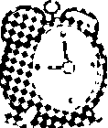姓名:________

　第一部分听力(30分)

一、听录音，选出对应的图片。(10分)

(　　) 1.A. B.　 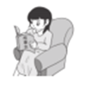 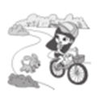 (　　) 2. A.　　B.

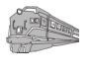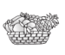

(　　) 3.A. B. (　　) 4. A. B.

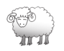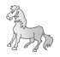

(　　) 5.A.　B.

二、听录音，判断下列图片与录音内容是(√)否(×)相符。(10分)

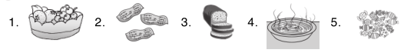

(　　)　　 　 (　　)　　 (　　)　　 (　　)　　 　(　　)

三、听录音，根据问句选择适当的答语。(10分)

(　　) 1.A.Yes, I do. B．Yes, I can.

(　　) 2.A.She is running. B．He is running.

(　　) 3.A.It's ten yuan. B．It's going to fish.

(　　) 4.A.It's on your left. B．It's about sports.

(　　) 5.A.I'm going to swim. B．I'm watching TV.

四、听对话，判断正(T)误(F)。(10分)

(　　)1.Sam can play basketball.

(　　)2.The supermarket is next to the zoo.

(　　)3.Tom is running.

(　　)4.Jim is going to swim.

(　　)5.Amy has peanuts at Christmas.

　　　　　　　　　　　第二部分　笔试(60分)

五、选出每组中不同类的单词。(5分)

(　　) 1.A.soupB．milkC．some

(　　) 2.A.climbB．visitC．now

(　　) 3.A.trainB．planeC．winner

(　　) 4.A.ChinaB．ChineseC．English

(　　) 5.A.noodlesB．dumplingsC．food

六、看图补全单词。(10分)

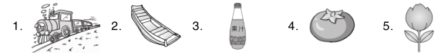

tr__ __n　　　　b__ ____t　　　　j__ __ce　　　to__ __to　　fl__ __er

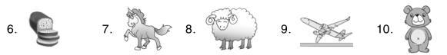

br__ __d　　　h__ __se　　　　sh__ __p　　　pl__ __e　　　　b__ __r

七、判断下列图片与所给短语是(T)否(F)一致。(10分)

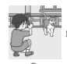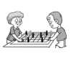

(　　) 1. play chess　(　　) 2.fly a kite

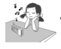

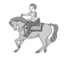(　　) 3.do the high jump(　　) 4. ride a horse





(　　) 5. read a book (　　) 6. play basketball

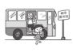

(　　) 7. get on the bus(　　) 8. row a boat

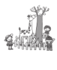

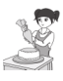(　　)9. at the zoo (　　)10. make dumplings

八、单项选择。(10分)

(　　) 1.—________is your pen?

—It's five *yuan*.

A．HowB．How manyC．How much

(　　) 2.(N)—What are the men doing?

—They________chess.

A．playB．playingC．are playing

(　　) 3.—Happy New Year!

—________！

A．Thank youB．Happy New YearC．Happy birthday

(　　) 4.(N)There________a pig and two monkeys in the picture.

A．amB．isC．are

(　　) 5.—Is he goingto do the high jump?

—No, ________．

A．he isn'tB．he isC．is he

九、读对话，根据其内容选择正确的图片。(5分)

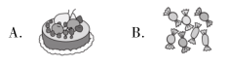(　　) 1.—Do you want some sweets?

—Yes, please.

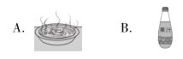

(　　) 2.—Can I have some soup?

—Yes, of course.

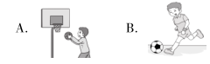(　　) 3.—Can you play basketball?

—Yes, I can.

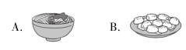(　　) 4.—What are you doing?

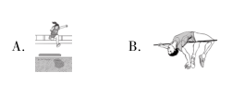—I'm making dumplings.

(　　) 5.—What are you going to do?

—I'm going to do the long jump.

十、用括号里所给单词的正确形式填空。(5分)

1．We're going to________(play)chess.

2．(N)I like________(eat)bread.

3．He can't________(make)noodles.

4．This is________(Amy)book.

5．(N)In this photo, she__________(fly)a kite.

十一、连词成句。(5分)

1．are，go，We，plane，going，by，to(.)

__________________________________________________________________[来源:学科网]

2．on，the，Let's，bus，get (.)

__________________________________________________________________

3．to，her，She，talking，is，friend(.)

__________________________________________________________________

4．you，far，Can，jump(？)

__________________________________________________________________

5．you，Are，to，sports，day，on，run，going(？)

__________________________________________________________________[来源:学科网]

十二、阅读短文，判断正(T)误(F)。(10分)

My favourite festival is the Mid­autumn Festival(中秋节)．We usually(通常)watch the moon(月亮)and eat moon cakes(月饼)．The moon cake is very nice. We have a big dinner that day. I often have a good time at that festival.[来源:学科网]

(　　) 1.My favourite festival is the Spring Festival.

(　　) 2.We usually watch the moon and eat dumplings at the Mid­autumn Festival.

(　　) 3.The moon cake isn't very nice.

(　　) 4.We have a big dinner that day.

(　　) 5.I often have a good time at the Mid­autumn Festival.

附加题：

默写出26个英文字母

|  |
| --- |
|  |
|  |
|  |

|  |
| --- |
|  |
|  |
|  |

|  |
| --- |
|  |
|  |
|  |

二、补全对话。

A:1._________________. B: Yes.I want some apples. I also want some pears and some oranges. A: Anything else（还要别的吗））?

A: 2._________________. B: 3.________________.

|  |
| --- |
| A.No, that’s all. B: Can I help you?  C: Thank you . D: How much are they? E: Here is the money（钱）. |