### CHAPTER 1

### INTRODUCTION

### ABOUT PROJECT

EduLearn.AI is an AI-powered e-learning platform designed to enhance the online education experience by integrating automated lecture transcription and an AI-driven chatbot for real-time student support. The platform enables teachers to create and upload video lectures, while students can access courses, view transcripts, and interact with an AI chatbot for better understanding.

Built using React.js for the frontend and FastAPI for the backend, EduLearn.AI ensures scalability, security, and efficiency in delivering educational content. The Whisper AI model generates accurate real-time lecture transcripts, making learning more accessible, especially for students who prefer text-based study materials or those with hearing impairments. Additionally, the Gemini AI chatbot processes lecture transcripts to answer student queries, enabling interactive learning beyond traditional video-based courses.

The platform incorporates MongoDB for database management, Cloudinary for cloud-based multimedia storage, and Firebase for secure authentication. This structured architecture ensures smooth course management, real-time interaction, and efficient data processing.

### EduLearn.AI aims to bridge the gap between passive video learning and active knowledge acquisition by leveraging AI-driven automation and natural language processing. By integrating real-time transcription, AI-powered assistance, and an intuitive course management system, the platform enhances engagement, accessibility, and efficiency in digital education.

### PROJECT OBJECTIVES

### The primary objective of EduLearn.AI is to create an AI-powered e-learning platform that enhances the learning experience by integrating automated transcription and AI-driven assistance. The key objectives of the project include:

### Facilitate AI-Driven Learning – Provide students with real-time lecture transcripts and AI-powered chatbot support to improve comprehension and accessibility.

### Automate Lecture Transcription – Use Whisper AI to generate accurate real-time text transcripts of video lectures, making content more accessible.

### Enhance Student Interaction – Enable an AI chatbot (Gemini 2.0 Flash) to process transcripts and answer student queries, making learning more interactive.

### Streamline Course Management – Allow teachers to create, upload, and manage courses easily, with structured organization for better user experience.

### Seamless Content Storage & Streaming – Utilize Cloudinary for cloud-based video storage, ensuring fast and reliable content delivery.

### Efficient Backend & Database Management – Implement FastAPI for a high-performance backend and MongoDB for structured data management.

### User-Friendly & Responsive Interface – Develop an intuitive React.js frontend, ensuring smooth navigation across devices.

### Role-Based Access Control – Assign students, teachers, and admins specific roles for a well-managed and secure platform.

### Scalability & Performance Optimization – Build a secure and scalable architecture to handle large volumes of students, teachers, and course materials.

### Data Security & Authentication – Ensure user authentication via Firebase, protecting user data and transactions with encryption techniques.

### FUNCTIONALITY

### EduLearn.AI offers a range of AI-powered functionalities tailored for students, teachers, and administrators, ensuring an efficient and interactive e-learning experience.

### 1.3.1 Student Functionality

### Access AI-Powered Transcripts – View real-time lecture transcriptions generated using Whisper AI.

### AI Chatbot Assistance – Ask questions and get context-aware answers from the Gemini 2.0 Flash chatbot.

### Enroll & Access Courses – Browse available courses, enroll, and access video lectures and materials.

### User Dashboard – Track enrolled courses, view progress, and manage learning resources.

### 1.3.2 Teacher Functionality

### Upload & Manage Courses – Create and organize course content, including videos and documents.

### Monitor Student Engagement – Track student queries and interaction with the AI chatbot.

### Edit & Update Courses – Modify course content, update transcripts, or delete outdated material.

### 1.3.3 Admin Functionality

### User & Role Management – Add, update, or remove students and teachers from the platform.

### Content Moderation – Review transcriptions and chatbot responses for accuracy.

### System Monitoring – Ensure the backend (FastAPI) and database (MongoDB) operate efficiently.

### 1.3.4 Platform-wide Functionalities

### Automated Lecture Transcription – Convert video lectures into text transcripts for accessibility.

### AI Chatbot for Q&A – Provide real-time assistance to students based on lecture transcripts.

### Secure Authentication & Authorization – User login management via Firebase.

### Cloud-Based Storage & Video Streaming – Store and deliver course content efficiently using Cloudinary.

### Scalable & Responsive UI – Ensure smooth navigation across all devices (desktop, tablet, mobile).

### Advanced Search & Filter – Quickly find relevant courses, lectures, and topics.

### INTERFACE

EduLearn.AI features a modern, intuitive, and AI-powered interface to enhance learning, teaching, and administration. Built using React.js, it ensures a dynamic and responsive experience across all devices. The interface is designed to provide personalized interactions based on user roles.

**1.4.1 Student Interface**

* **Home Page:** Showcases featured courses, search functionality, and category filters.

**Course Catalog:** Allows students to explore courses with detailed information (title, instructor, transcript availability, AI chatbot support).

* **Course Details Page:** Displays course overview, AI-generated transcript previews, instructor profiles, and video content.
* **Dashboard:** Tracks enrolled courses, learning progress, and provides access to transcripts.
* **AI-Powered Transcript & Chatbot Interface:**
* Displays automated lecture transcripts generated using Whisper AI.
* Provides an AI chatbot (Gemini 2.0 Flash) for real-time Q&A support based on transcripts.

**1.4.2 Teacher Interface**

* **Course Management Panel:**
* Allows teachers to create, update, and delete courses.
* Manage lecture transcripts and AI chatbot responses.
* **Content Upload Section:** Upload video lectures, PDFs, and other materials using Cloudinary.
* **Student Engagement Tracking:** View transcript usage stats and AI chatbot queries to track learning patterns.
* **Edit Course Details:** Modify descriptions, enhance transcripts, adjust pricing, or restructure course content.

### DESIGN AND IMPLEMENTATION CONSTRAINTS

EduLearn.AI is designed to be a scalable, secure, and AI-powered E-learning platform. However, certain technical and functional constraints influence the design and implementation. These are categorized as follows:

**1.5.1 Hardware Constraints**

* **Server Requirements:** Requires a cloud server with minimum 4GB RAM, Quad-core CPU, and SSD storage for optimal performance.
* **Hosting Infrastructure:** Needs scalable cloud hosting (e.g., AWS, Vercel, Render) to handle dynamic user traffic.
* **Client-Side Requirements:** The platform is web-based, requiring users to have a modern browser (Chrome, Firefox, Edge) and an active internet connection.

**1.5.2 Software Constraints**

* **Technology Stack:** Built using the MERN stack (MongoDB, Express.js, React.js, Node.js), limiting alternative frameworks.
* **Database Management:** Uses MongoDB (NoSQL), which lacks SQL joins, requiring optimized schema design and indexing.
* **Cloud Storage:** Cloudinary is used for video & media storage, subject to Cloudinary’s pricing and storage limits.
* **AI Model Constraints:**
  + Whisper AI for transcript generation requires high computational power for real-time transcription.
  + Gemini 2.0 Flash AI chatbot is dependent on Google’s API rate limits and NLP processing speed..

**1.5.3 Functional Constraints**

* **Course Content Restrictions:**
  + Only teachers can upload courses.
  + Students must enroll to access premium content and AI-driven transcripts.
* **SQL IDE Limitations:**
  + Supports only SELECT queries for security.
  + DROP/TRUNCATE operations are blocked to prevent database corruption.
* **Lecture Transcription Constraints:**
  + Whisper AI transcripts may have minor inaccuracies, requiring manual review.
  + Transcription is limited to supported languages based on the model’s capabilities.

**1.5.4 Performance Constraints**

* **Concurrent Users:** The system must handle multiple users accessing courses & AI chatbots simultaneously, requiring load balancing & caching**.**
* **API Rate Limits:**
  + Razorpay transactions and Cloudinary file uploads are subject to API rate limits.
  + Whisper AI & Gemini AI APIs have NLP processing limitations affecting chatbot response time.
* **Rendering Performance:** React.js ensures smooth performance, but excessive API calls or large datasets may cause UI lag.

**1.5.5 Security Constraints**

* **User Authentication:** Uses JWT (JSON Web Token) for secure authentication & session management.
* **Data Encryption:**
  + Sensitive user data & payment transactions are encrypted using HTTPS & secure hashing algorithms.
  + AI-generated transcripts are stored securely to prevent unauthorized access.
* **Unauthorized Access Prevention:**
  + Admin & teacher panels are restricted via access control policies (RBAC - Role-Based Access Control).
  + AI chatbots & lecture transcripts are protected to ensure verified users only can access course-specific content.

### ASSUMPTIONS AND DEPENDENCIES

### The development and functionality of EduVantage rely on certain assumptions and external dependencies, which influence the platform’s scalability, security, and performance.

### 1.6.1 Assumptions

### Users Have a Stable Internet Connection:

### The platform requires an active internet connection for accessing courses, making transactions, and using the SQL IDE.

### Users Have Basic Technical Knowledge:

### Students and teachers are assumed to have basic web application skills (logging in, navigating the platform, purchasing courses).

### Teachers Upload High-Quality Content:

### Course effectiveness depends on well-structured videos, PDFs, and assignments uploaded by teachers.

### Users Provide Accurate Information:

### It is assumed that students and teachers will enter valid details during registration and payment to avoid transaction failures.

### SQL IDE is Used for Educational Purposes Only:

### Students are expected to use the SQL IDE responsibly and not attempt malicious queries (e.g., SQL injection).

### Admin Will Manage Platform Effectively:

### The admin is responsible for monitoring courses, users, and transactions to maintain platform integrity.

### 1.6.2 Dependencies

### Technology Stack (MERN):

### The platform is built using MongoDB, Express.js, React.js, and Node.js.

### Any major updates or deprecations in these technologies could require modifications in the system.

### Cloud Storage (Cloudinary):

### All course materials (videos, PDFs, documents) are stored on Cloudinary.

### Storage limits, API pricing, and availability could impact content accessibility.

### Hosting Service:

### The platform requires a reliable cloud hosting provider (Vercel, Render, AWS) to ensure uptime and scalability.

### Browser Compatibility:

### EduLearn depends on modern web browsers (Chrome, Firefox, Edge, Safari) for optimal performance.

### Older browsers may not support all features (e.g., modern UI elements, real-time SQL execution).

### Third-Party Libraries & APIs:

### Various NPM packages, authentication modules, and UI frameworks are used.

### Any deprecation, security vulnerabilities, or API updates may require changes in the codebase.

# CHAPTER 2

**SOFTWARE & HARDWARE REQUIREMENTS**

### INTRODUCTION

For the successful development, deployment, and operation of EduLearn.ai, specific software and hardware requirements must be met. The software stack includes essential frameworks, databases, cloud services, and third-party APIs that contribute to the seamless functioning of the platform. Additionally, testing tools are necessary to ensure security, performance, and reliability.

On the hardware side, sufficient computing resources are required for development, hosting, and user accessibility. Developers need a capable system for building and testing the platform, while the hosting server must be robust enough to support concurrent users. End users, including students and educators, require a device with an active internet connection and a modern web browser to access EduLearn.ai efficiently.

This chapter outlines the critical software and hardware components needed to ensure the smooth operation and scalability of EduLearn.ai.

### SOFTWARE REQUIREMENTS

### 2.2.1 Development Tools & Technologies

### Frontend: React.js (JavaScript Library for UI Development)

### Backend: Node.js with Express.js (Server-side Framework)

### Database: MongoDB (NoSQL Database for storing user, course, and transaction data)

### Operating System: Windows 10/11, macOS, or Linux

### Internet Connection: Stable broadband connection for real-time testing & cloud integration

**2.1.2 Testing Tools**

* **Postman:** API testing and debugging
* **Jest & Mocha:** Unit testing for JavaScript (Backend & Frontend)

**2.1.3 Deployment & Hosting Services**

* **Web Hosting:** Vercel / Render / Heroku
* **Database Hosting:** MongoDB Atlas (Cloud database service)
* **Domain Management:** Namecheap / GoDaddy
* **Version Control:** Git & GitHub for source code management

### HARDWARE REQUIREMENTS

### 2.3.1 Developer System Requirements

* **Processor:** Intel i3 or AMD Ryzen 5 (or higher)
* **Storage:** Minimum 250GB SSD (Recommended: 512GB SSD)
* **Operating** **System:** Windows 10/11, macOS, or Linux
* **Internet Connection:** Stable broadband connection for real-time testing
* **RAM:** Minimum 8GB RAM (Recommended: 16GB)

### 2.3.2 Server Requirements (Hosting)

### Processor: Quad-core or higher

### RAM: Minimum 8GB RAM (Recommended: 16GB for handling multiple concurrent users)

### Storage: Minimum 100GB SSD (Expandable based on media storage needs)

### Bandwidth: High-speed internet with unlimited data transfer

### 2.3.3 End-User Requirements

### Device: Desktop, Laptop, Tablet, or Smartphone

### Processor: Dual-core or higher (for smooth course playback)

### RAM: Minimum 4GB RAM (Recommended: 8GB)

### Browser: Latest versions of Chrome, Firefox, Edge, Safari

### Internet Speed: Minimum 5 Mbps (Recommended: 10 Mbps or higher for smooth video streaming)

**CHAPTER 3**

# PROBLEM DESCRIPTION

### OVERVIEW

With the rise of digital education, traditional learning methods have become increasingly inadequate. Many students face challenges such as limited access to quality resources, a lack of personalized learning experiences, and inefficient course delivery systems. Similarly, educators struggle with complex course management tools and restricted outreach to a global audience.

Existing e-learning platforms often have high subscription costs, complicated user interfaces, or limited customization options, making it difficult for educators to create and monetize their content effectively.

**EduLearn.ai** is designed to solve these challenges by offering a user-friendly, AI-powered, and scalable e-learning platform. It enhances student engagement through interactive course delivery while enabling educators to create, manage, and sell their courses seamlessly. By integrating AI-driven lecture transcription, an intelligent chatbot for instant assistance, and a built-in SQL IDE, EduLearn.ai ensures a more personalized and efficient learning experience.

### PROBLEMS IN THE EXISTING SYSTEM

### Limited Accessibility & Flexibility

### Many students face challenges in accessing high-quality educational content due to financial constraints and geographical barriers.

### Traditional learning methods require physical attendance, reducing flexibility for remote learners.

### Lack of Hands-on Learning Opportunities

### Many e-learning platforms focus solely on theoretical content, offering limited interactive tools for practical learning.

### Students studying databases often lack a built-in SQL IDE, making it difficult to practice and execute queries in real time.

### Storage & Scalability Issues

### Large volumes of video lectures, documents, and other resources require efficient cloud storage for smooth access.

### Many existing platforms struggle with scalability, leading to slow performance as user traffic grows.

### Security & Role Management Concerns

### Some platforms do not have proper role-based access, leading to security risks.

* Administrators need better tools for managing courses, user access, and financial transactions securely.

### PROJECT IMPACT AND SIGNIFICANCE

### EduLearn.ai effectively addresses the challenges in existing e-learning platforms by providing a scalable, AI-powered, and feature-rich online education system with the following key solutions:

### AI-Powered Learning & Engagement: Personalized learning experiences powered by AI, ensuring adaptive content delivery and improved student engagement.

### Remote Learning Accessibility: Students can access courses anytime, anywhere, overcoming geographical and financial barriers.

### Effortless Course Management: Teachers can seamlessly upload, structure, and update courses using an intuitive and user-friendly dashboard.

### Secure Payment Gateway: Integrated Razorpay ensures safe, seamless, and hassle-free transactions for course enrollments.

### Interactive SQL IDE: A built-in SQL IDE allows students to practice and execute database queries in real-time, enhancing practical learning.

### Scalable Cloud Storage: Cloudinary ensures efficient, secure, and scalable storage for course materials, including videos, documents, and assignments.

### Role-Based Access Control: Dedicated functionalities for admins, teachers, and students ensure organized platform management, security, and controlled access.

### CONCLUSION

The traditional education system faces several challenges, such as limited accessibility, inefficient course management, high costs, and a lack of hands-on learning opportunities. Many existing e-learning platforms fail to offer a cost-effective, user-friendly, and AI-driven learning environment for both students and educators.

EduLearn.ai effectively addresses these issues by providing a scalable, AI-powered e-learning platform that allows teachers to create and manage courses effortlessly, students to access high-quality content anytime, and admins to oversee platform operations efficiently. Cloudinary for scalable content storage, and an interactive SQL IDE for practical learning, EduLearn.ai ensures a comprehensive and engaging educational experience.

Moreover, the platform is built with a focus on security, flexibility, and ease of use, ensuring seamless access across multiple devices. By leveraging modern web technologies, AI-driven personalization, and cloud-based solutions, EduLearn.ai is well-positioned to transform digital education—making learning more accessible, engaging, and effective for students worldwide.

# CHAPTER 4

# LITERATURE SURVEY

* 1. **LITERATURE SURVEY**

The evolution of e-learning platforms has significantly reshaped modern education, offering flexible, accessible, and AI-powered learning opportunities. This section explores existing research, technologies, and methodologies in e-learning systems, identifying their strengths and limitations to highlight how EduLearn.ai enhances them.

* 1. **Evolution of E-learning Systems**

The concept of e-learning has advanced from simple web-based tutorials to AI-driven, cloud-integrated, and highly interactive platforms. Initially, Learning Management Systems (LMS) such as Moodle, Blackboard, and Canvas provided structured course management features, but they were often complex to implement and required institutional support [1].

The emergence of MOOCs (Massive Open Online Courses) like Coursera, Udemy, and edX revolutionized digital education, enabling access to high-quality courses worldwide [2]. However, these platforms frequently impose high commission fees on instructors, limiting their profitability. EduLearn.ai addresses these challenges by offering a cost-effective, AI-enhanced, and educator-friendly platform that simplifies course creation, delivery, and student engagement.

* 1. **Role of Technology in E-learning**

Modern E-learning systems leverage several cutting-edge technologies to enhance learning experiences:

* 1. **MERN Stack for Web-Based E-learning**
     1. The MERN Stack (MongoDB, Express.js, React.js, and Node.js) enables scalable, interactive, and real-time web applications [3].
     2. EduLearn.ai leverages MERN to ensure seamless frontend-backend communication for a smooth learning experience.
  2. **AI-Powered Learning & Personalization**
     1. Platforms like Khan Academy and Duolingo use AI to personalize learning paths based on user performance.
     2. EduLearn.ai integrates AI-driven analytics and recommendation systems to tailor courses and content to students' needs.
  3. **Cloud-Based Storage & Scalability**
     1. E-learning platforms use Google Drive, AWS S3, and Cloudinary for scalable content storage [4].
     2. EduLearn.ai integrates Cloudinary for secure and efficient course material storage and seamless media delivery.
  4. **Secure Payment Gateway Integration**
     1. Online learning platforms use PayPal, Stripe, and Razorpay for secure transactions [5].
     2. EduLearn.ai integrates Razorpay for fast and seamless course payments.
  5. **Interactive IDE for Hands-on Learning**
     1. Many e-learning platforms lack built-in coding environments for practical application [6].
     2. EduLearn.ai features an AI-assisted SQL IDE, allowing students to write and execute queries in real-time, enhancing hands-on learning.
  6. **Challenges in E-learning**

1. **Student Engagement & Retention**

* Studies indicate that only 10-15% of students complete online courses due to a lack of motivation and engagement [7].
* Solution: EduLearn.ai enhances engagement through interactive learning experiences, including:
  + AI-driven personalized learning paths
  + Real-time SQL practice
  + Gamified course progress tracking
  + User-friendly and engaging UI

1. **Security & Payment Fraud Prevention**

* Online learning platforms are vulnerable to unauthorized access, data breaches, and payment fraud [8].
* Solution: EduLearn.ai ensures robust security with:
  + JWT authentication for secure user sessions
  + End-to-end HTTPS encryption
  + Razorpay’s secure API for fraud prevention

1. **Scalability & Performance Optimization**

* Platforms must support thousands of concurrent users without performance issues [9].
* Solution: EduLearn.ai implements:
  + MongoDB indexing for optimized database queries
  + Server-side caching for faster content delivery
  + Efficient API calls and load balancing for enhanced scalability.
  1. **Future of E-learning Platforms**

The future of online education will be shaped by:

* AI-powered adaptive learning paths for personalized education [10].
* VR/AR-based interactive education for immersive experiences [11].
* Blockchain-based certification systems to ensure secure and verifiable credentials [12].
  1. **Conclusion**

Despite advancements, many e-learning platforms struggle with engagement, security, scalability, and cost-effectiveness. EduLearn.ai addresses these challenges by integrating secure payment processing, AI-driven learning, scalable cloud storage, and an interactive SQL IDE to provide a comprehensive and future-ready e-learning experience. By leveraging cutting-edge technologies, EduLearn.ai ensures a cost-effective, engaging, and accessible digital learning environment for students, educators, and administrators.

# CHAPTER 5

**SOFTWARE REQUIREMENT SPECIFICATION**

**5.1 FUNCTIONAL REQUIREMENTS**

* + 1. **User Roles and Functionalities**

1. **Admin**

* Manage users
* Perform CRUD operations on courses.
* Create and manage course categories.
* View and manage payment transactions.

1. **Teacher**

* Register/Login using email authentication.
* Create, edit, and delete courses.
* Upload course content
* Set course pricing and manage enrolled students.
* View earnings and transaction history.

1. **Student**

* Register/Login using email authentication.
* Browse available courses and filter by category.
* Access enrolled courses and study materials.
  + 1. **Course Management**
* Teachers can create, update, and delete courses.
* Admin has the authority to manage all course listings.
* Courses include multiple content types.
* Course progress tracking for students.
  + 1. **Authentication** 
       - JWT-based authentication for secure logins.
       - Role-based access control for users.
       - Encryption for sensitive user data (e.g., passwords).
    2. **Chatbot** 
       - A personalized chatbot to assist students with course-related queries.
       - Provides real-time answers using LLM (Large Language Model) integration.
       - Helps in navigating the platform and accessing study resources efficiently.
    3. **Transcript Generator**
       - Converts audio/video lectures into readable text transcripts.
       - Uses speech-to-text APIs to enhance accessibility for all students.
       - Allows downloading or viewing transcripts alongside course videos.
    4. **Ai Quiz Generator**
       - Automatically generates quizzes from uploaded course content.Role-based access control for users.
       - Utilizes NLP to extract key concepts and frame questions.
       - Helps teachers save time and students to test their understanding effectively.
  1. **NON-FUNCTIONAL REQUIREMENTS**
     1. **Performance Requirements**
* The system should handle at least 500 concurrent users without lag.
* Course videos should load within 2 seconds on a standard broadband connection.
  + 1. **Security Requirements**
* All user data must be encrypted using (bcrypt for passwords).
* HTTPS enforced for secure communication between client and server.
  + 1. **Usability Requirements**
* The platform should have a user-friendly interface for easy navigation.
* Responsive design to work on desktops, tablets, and smartphones.
  + 1. **Scalability Requirements**
* The backend should support horizontal scaling using load balancers.
* Cloudinary storage should scale dynamically based on content uploads.
* The database (MongoDB) should handle millions of records efficiently.
  + 1. **Availability & Reliability**
* 99.9% uptime guarantee with cloud-based deployment.
* Automatic failover mechanisms to prevent downtime.
  + 1. **Maintainability & Extensibility**
* Modular codebase following MVC architecture.
* Microservices-ready design for future scalability.
* Easily extendable to add new features like AI-powered course recommendations.
  + 1. **Compliance Requirements**
* Follows GDPR for data protection and privacy.
* Payment system complies with PCI-DSS security standards.
* Content policies align with DMCA copyright regulations.

**CHAPTER 6**

**SOFTWARE DESIGN**

* 1. **USE CASE DIAGRAM**

The Use Case Diagram represents user interactions with the system.

**Actors in the System:**

1. **Admin**

* Manage Users
* System Maintenance

1. **Educator**

* Upload Lectures
* Manage Students

1. **Student**

* Register/Login
* Enroll in Course
* Generate Transcript
* Interact with AI Chatbot

**Use Case Diagram for EduLearn:**

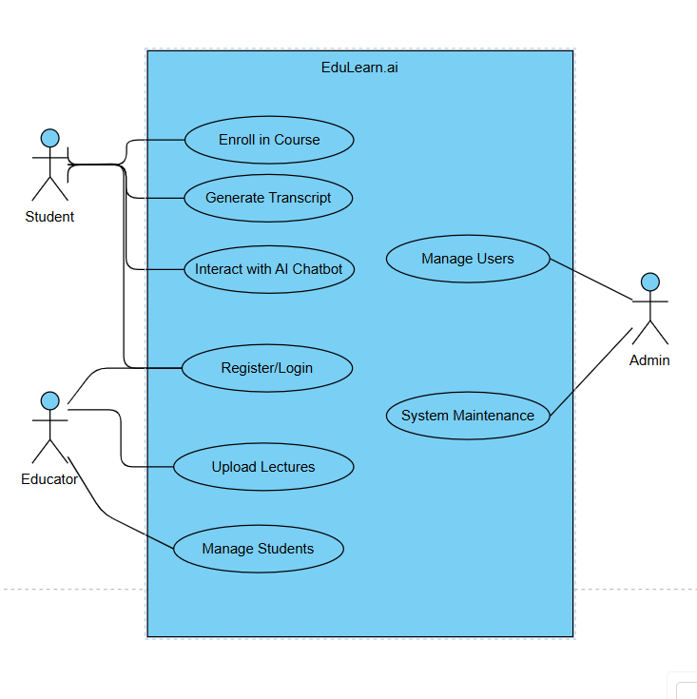

**Figure 6.1.1: Use Case Diagram**

* 1. **ER DIAGRAM**

Since MongoDB is a NoSQL database, it follows a document-oriented model, where data is stored in collections instead of relational tables.

**Key Collections in the System:**

* **Users** – Stores Admin, Teacher, and Student details.
* **Profiles** – Stores additional user details.
* **Courses** – Contains course details, sections, and subsections.
* **Categories** – Stores course categories.
* **Course Progress** – Tracks student progress in enrolled courses.
* **Rating and Reviews** – Stores student feedback for courses.
* **Sections and Subsections** – Manages course content structure.

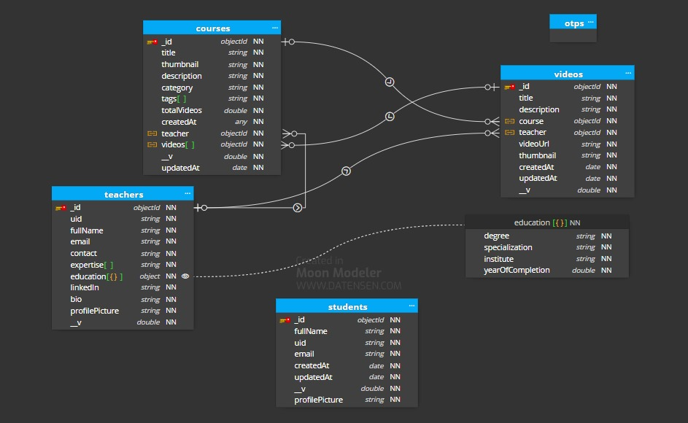

**Figure 6.2.1: ER Diagram**

* 1. **DATA FLOW DIAGRAM**

The Data Flow Diagram (DFD) represents the flow of information within the EduVantage system. It visually depicts how data moves between users, processes, and storage components. The DFD is structured into two levels:

* **Level 0:** High-level overview of the system.
* **Level 1:** Detailed flow of data between different entities.

1. **Level 0 DFD**

The Level 0 DFD shows the EduVantage system as a single entity interacting with Users (Admin, Teachers, Students).

**Entities in Level 0 DFD:**

* **Admin:** Manages courses, users, and categories.
* **Teacher:** Creates and manages courses.
* 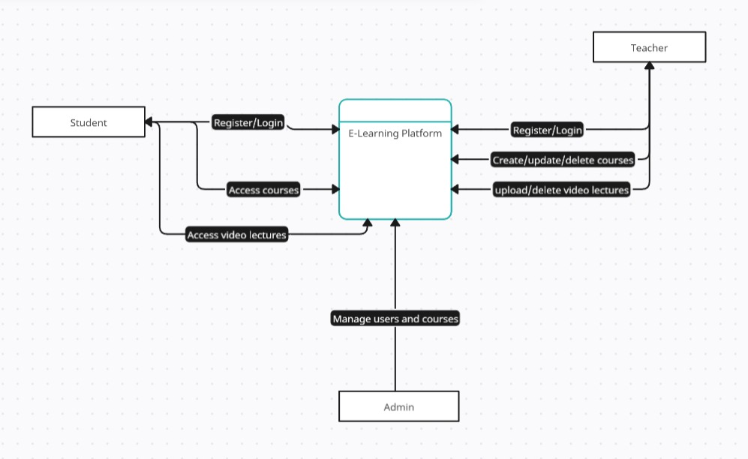**Student:** Purchases and accesses courses.

**Figure 6.3.1: Level 0 Data Flow Diagram**

1. **Level 1 DFD**

The Level 1 DFD breaks down the system into multiple processes, showing how data is transferred between different components.

**Processes in Level 1 DFD:**

• Users register/login and authenticate.  
• User data is stored in the database.  
• Teachers manage courses and upload videos.  
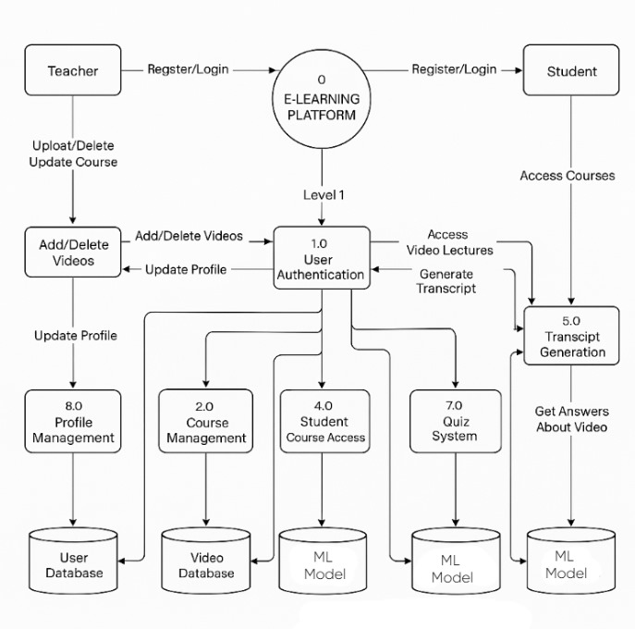• Course videos are stored in Cloudinary.  
• Students access courses and generate transcripts.  
• ML model powers quiz and transcript generation. Students browse and purchase courses.

**Figure 6.3.2: Level 1 Data Flow Diagram**

* 1. **CONCLUSION**

The Software Design for EduLearn.ai follows a document-based structure using MongoDB, ensuring scalability, flexibility, and efficiency. Each collection represents a key entity, with relationships managed using references (ObjectIds) or embedded documents. This design approach ensures fast querying, minimal redundancy, and high performance.

# CHAPTER 7

# OUTPUT SCREENS

* + 1. **OUTPUT SCREENS**

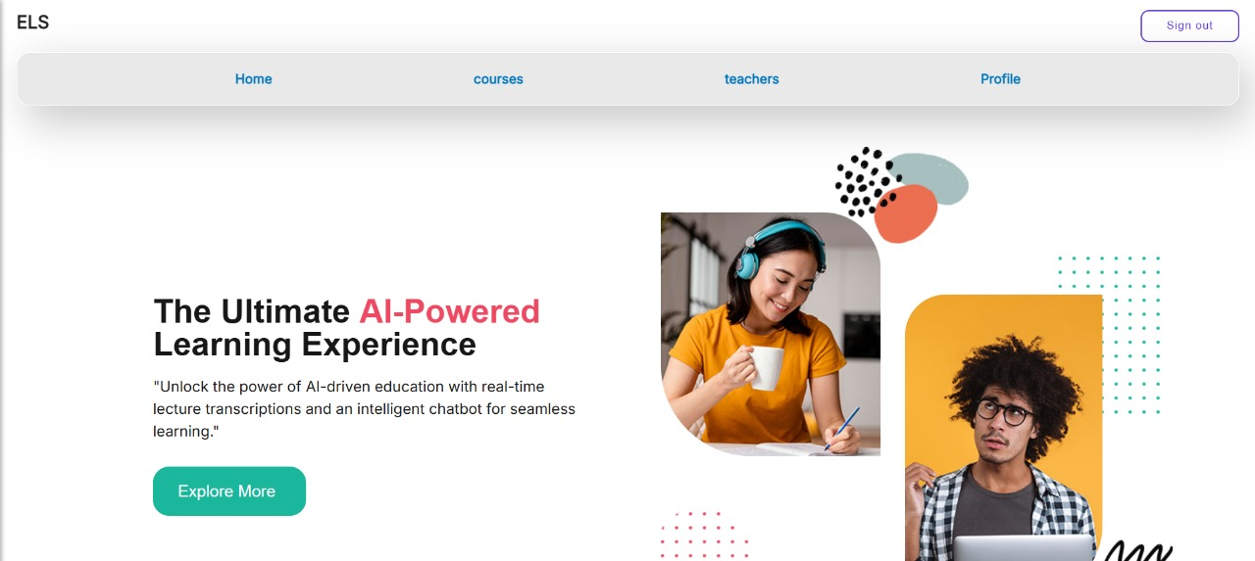

**Figure 7.1.1 Home Page**



**Figure 7.1.2 About Us Page**



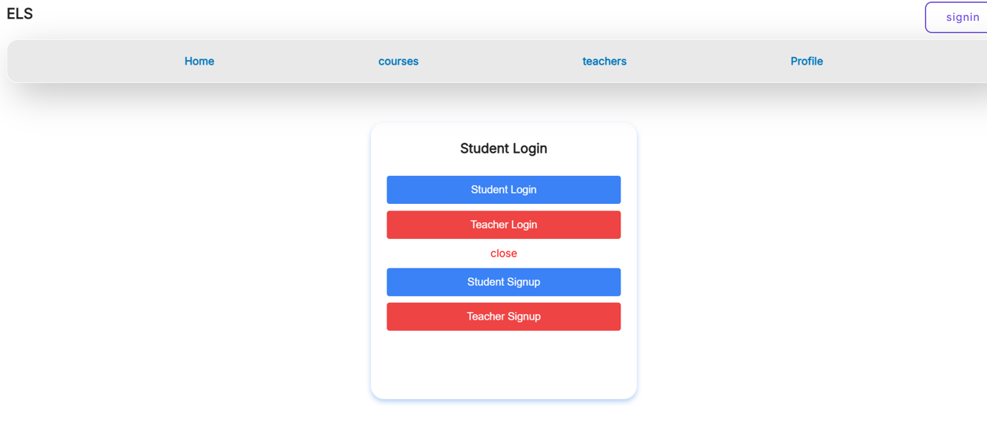

**Figure 7.1.4 Login / Sign up**

**Figure 7.1.3 Contact Us Page**

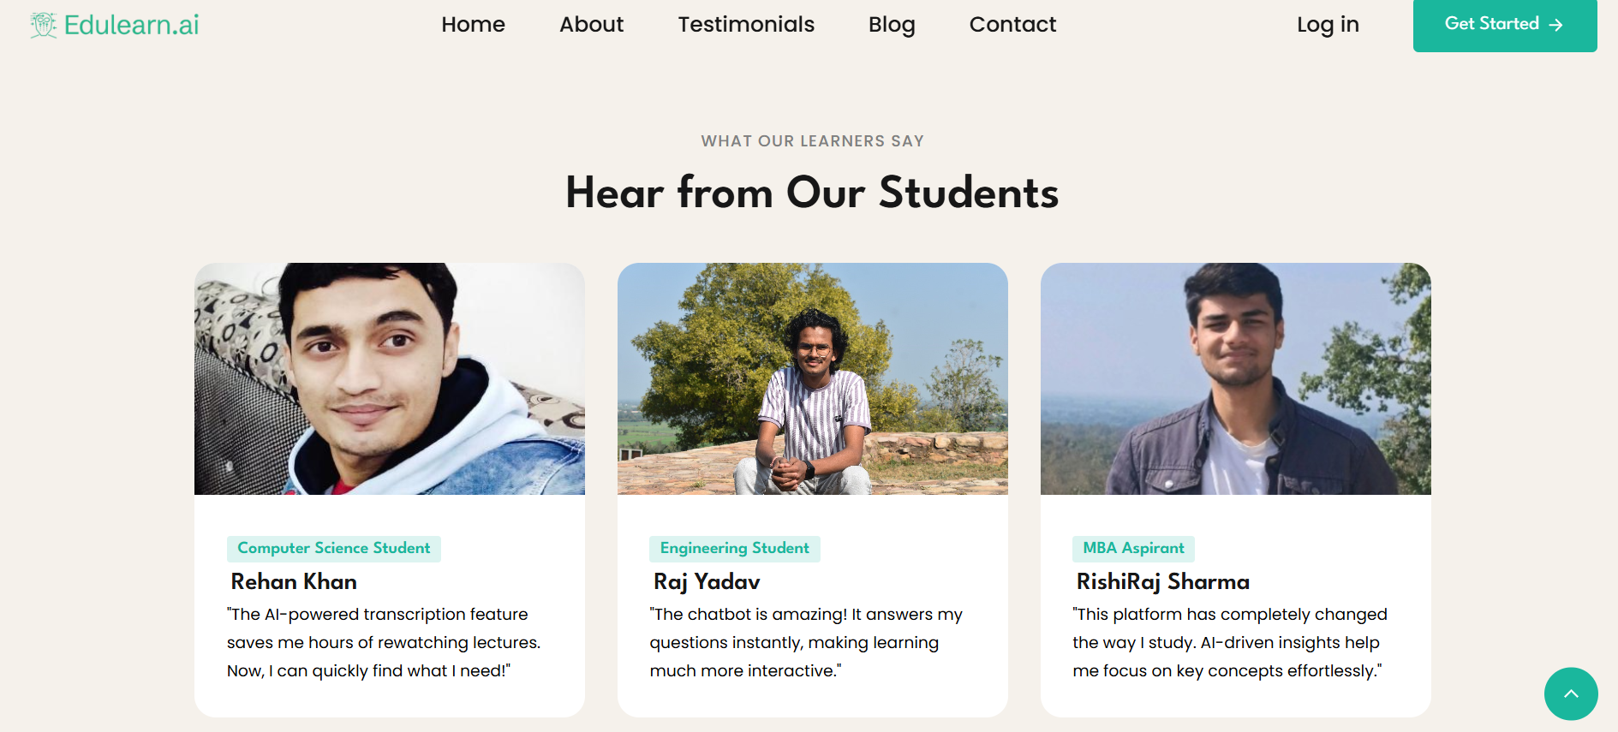

**Figure 7.1.5 Testimonials**

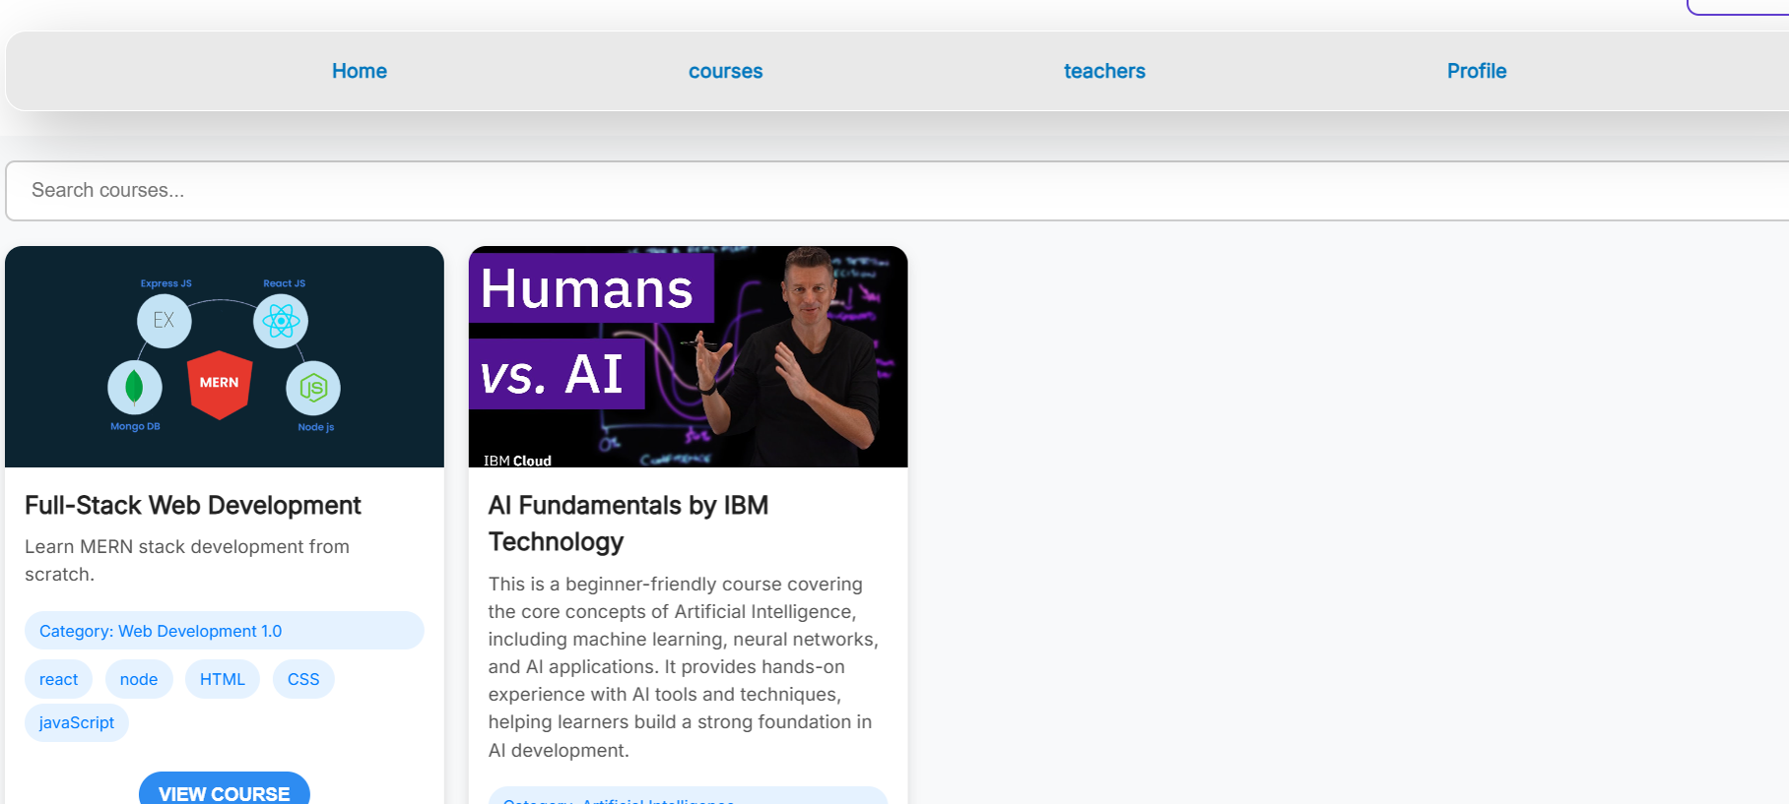

**Figure 7.1.6 Courses**



**Figure 7.1.7 Teacher Profile**

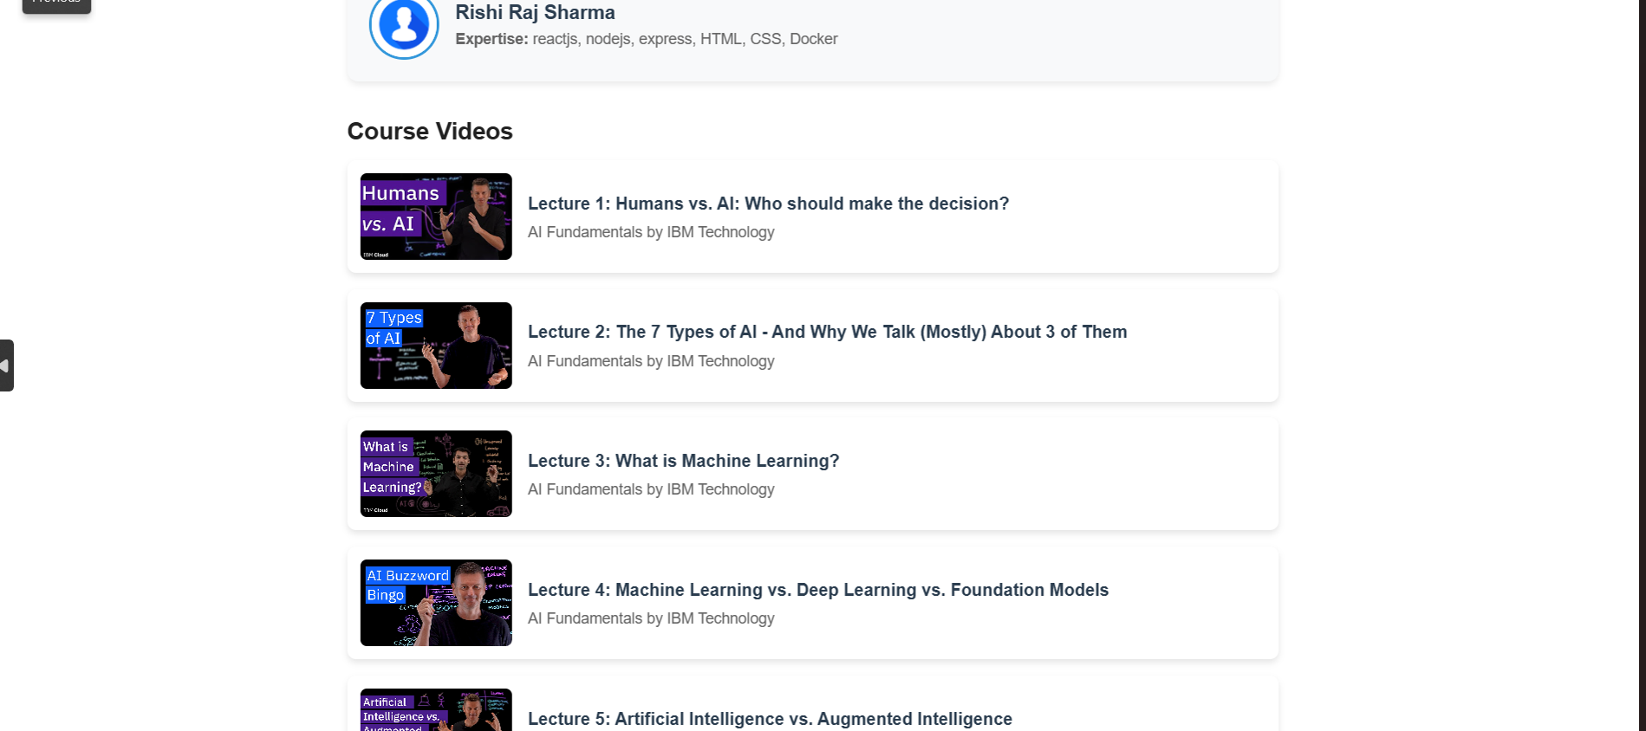

**Figure 7.1.8 Course Page**

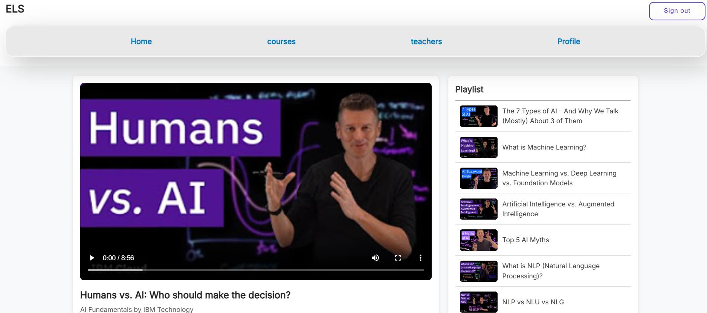

**Figure 7.1.9 Video Page**

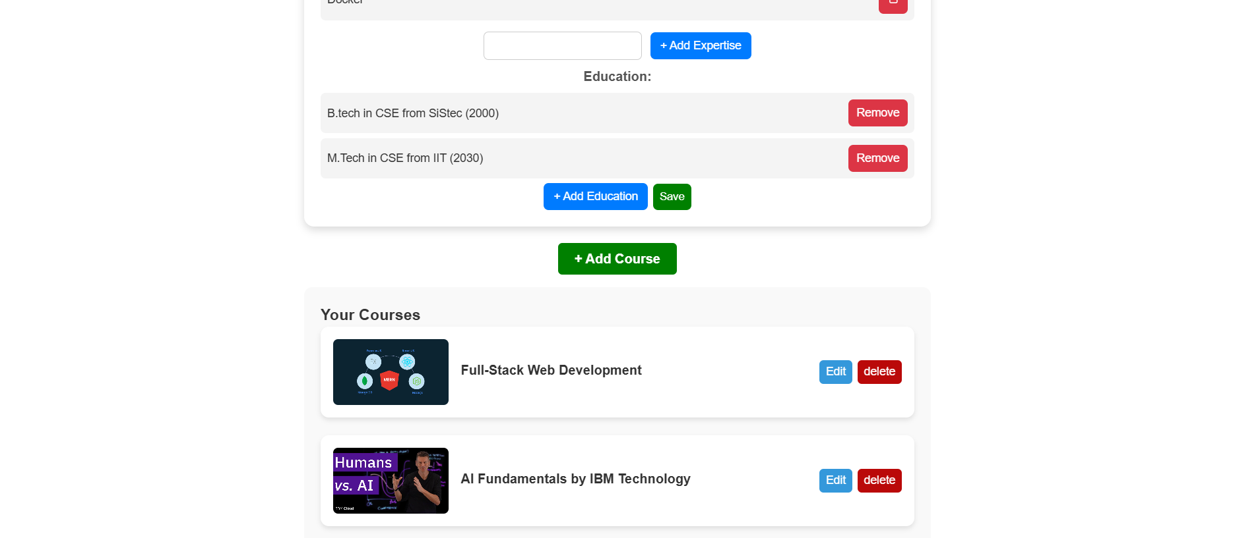

**Figure 7.1.10 Teacher Profile Edit**

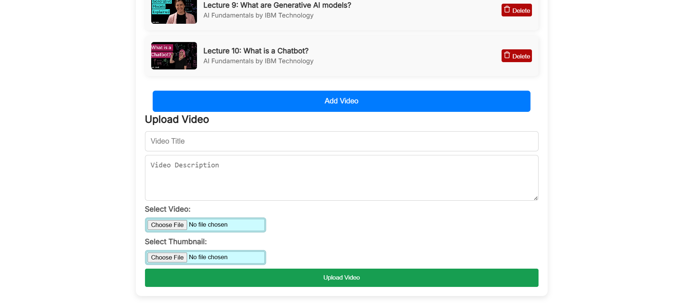

**Figure 7.1.11 Course Edit Page**

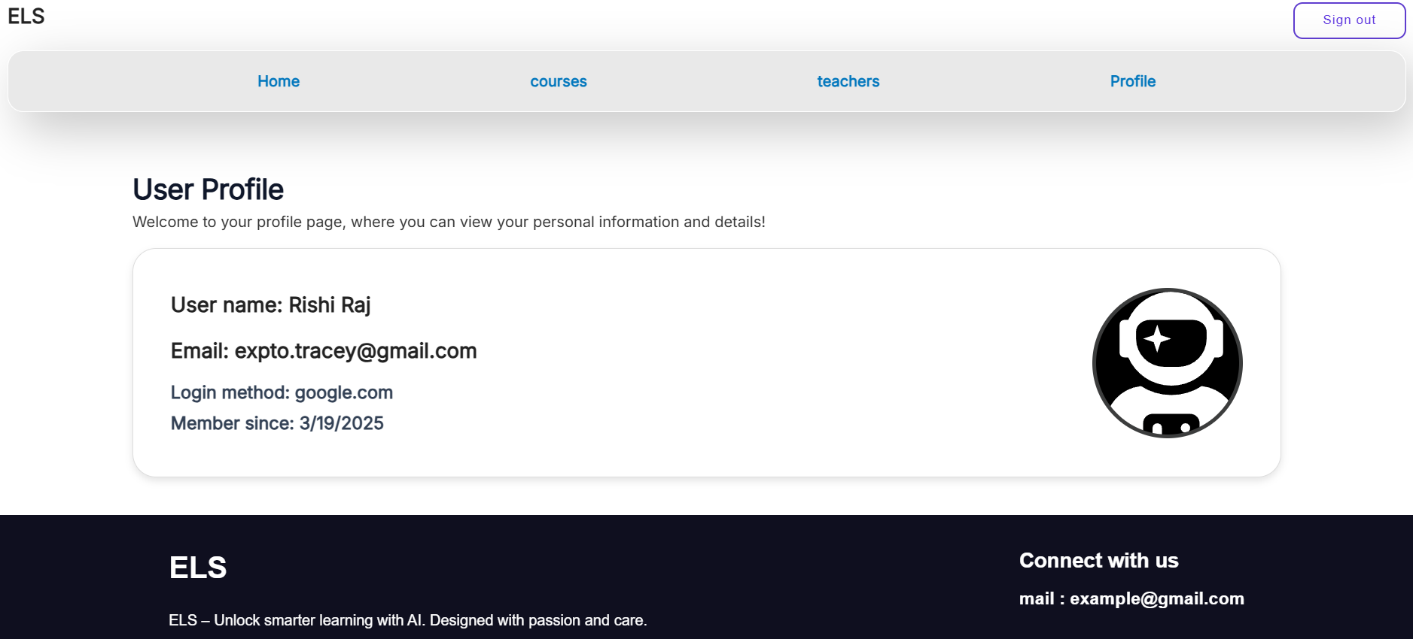

**Figure 7.1.12 Student Profile Page**

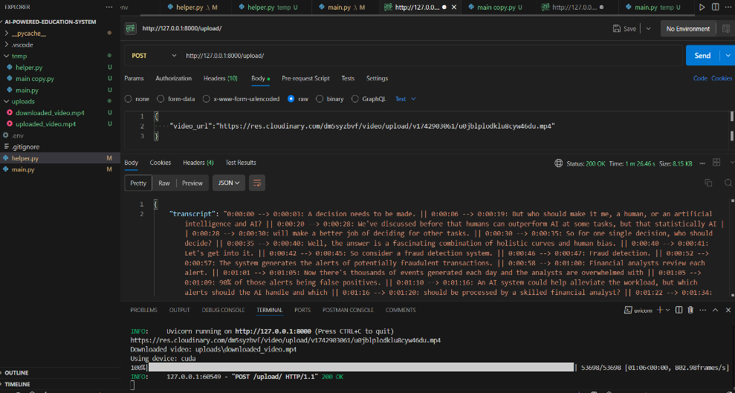

**Figure 7.1.13 Transcript Page**

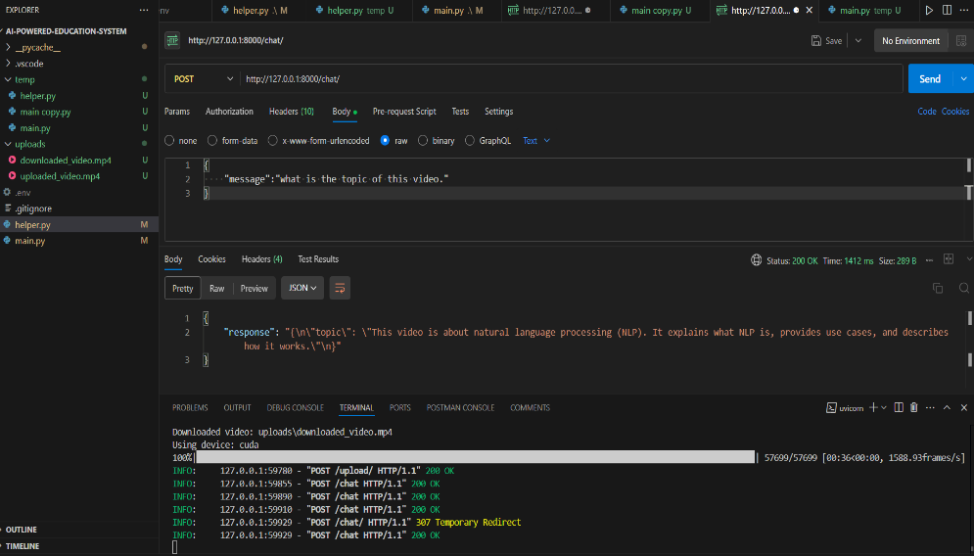

**Figure 7.1.14 Response Page**

# CHAPTER 8

# DEPLOYMENT

# OVERVIEW

Deployment is the final phase of software development, where the EduLearn.ai e-learning platform is made accessible to users over the internet. To ensure seamless operation, the project is deployed using cloud-based services that provide scalability, reliability, and efficient resource management. The frontend of the platform is hosted on Vercel, which is optimized for fast and automated deployment of React applications.

The backend is deployed on Render, a platform that supports Node.js applications and offers automatic scaling, making it suitable for hosting APIs. The database is managed using MongoDB Atlas, a cloud-based NoSQL database that ensures high availability and secure storage of application data. Additionally, Cloudinary is used for media storage, allowing efficient management of course materials such as videos and images. For secure payment processing, Razorpay is integrated into the system to handle transactions seamlessly.

This chapter details the deployment process, environment setup, domain configuration, and continuous deployment strategy to ensure a smooth and professional production environment.

# DEPLOYMENT ARCHITECTURE

# The EduLearn.ai platform follows a cloud-based deployment architecture to ensure scalability, reliability, and efficient performance. The frontend is developed using ReactJS and CSS and is hosted on Vercel, allowing for fast, automated deployments with minimal downtime. The backend, built with Node.js and Express.js, is deployed on vercel, ensuring a stable and scalable API service. The database is managed using MongoDB Atlas, a cloud-based NoSQL database that offers high availability and secure data storage. For handling media files such as course videos and images, Cloudinary is integrated, providing optimized and scalable cloud storage. This deployment setup ensures that EduLearn.ai remains responsive, secure, and capable of handling a growing number of users efficiently.

# DEPLOYMENT OF FRONTEND

# Vercel is a cloud platform optimized for frontend applications. It offers automatic deployments and global CDN distribution for fast performance.

# Steps to Deploy React Frontend on Vercel

# Push the project to GitHub/GitLab/Bitbucket.

# Import the repository into Vercel Dashboard.

# Configure Environment Variables (API URLs, Razorpay Keys, Cloudinary Keys).

# Click Deploy.

# Once deployed, Vercel provides a public URL for the frontend application.

# DEPLOYMENT OF BACKEND

# Vercel is a cloud platform that supports Node.js applications with automatic deployments and free hosting for small projects.

# Steps to Deploy Node.js Backend on Vercel

# Push the Backend Code to GitHub.

# Log in to Vercel.com, Click "Add New Project" and import the GitHub repository.

# Vercel auto-detects Node.js – you can configure the project settings if needed. Set up Environment Variables (MongoDB URI, Cloudinary API keys) under Project Settings > Environment.

# Click Deploy and wait for the build process to complete. Once deployed, Vercel provides a public URL for your backend API.

# DATABASE SETUP

# MongoDB Atlas is a cloud-based database for secure and scalable data storage.

# Steps to Set Up MongoDB Atlas

# Create an Account on MongoDB Atlas

# Create a New Cluster and Choose a Free Tier

# Connect to the Database

# Copy the MongoDB Connection String and update it in Render's environment variables

# DOMAIN CONFIGURATION

# For a professional setup, a custom domain can be linked to the Vercel frontend.

# Steps to Connect a Custom Domain

# Purchase a Domain (from Namecheap, GoDaddy, etc.).

# Add the Domain in Vercel Dashboard.

# Set CNAME record to Vercel’s provided URL.

# Now, the frontend is accessible via the custom domain.

# CONTINUOUS DEPLOYMENT

# Both Vercel and Render support auto-deployments on every push to the GitHub repository.

# Steps to Enable Continuous Deployment

# Ensure GitHub repository is linked to Vercel (frontend) and vercel (backend).

# Every time code is pushed to GitHub, the changes are automatically deployed.

# Monitor deployments via the Vercel dashboards.

# CONCLUSION

# The EduLearn.ai platform has been successfully deployed using a robust and scalable cloud-based architecture. The frontend is hosted on Vercel, ensuring fast and efficient deployment, while the backend, built with Node.js and Express.js, is deployed on vercel, providing a reliable API infrastructure. MongoDB Atlas is utilized for database management, offering secure and high-availability data storage. Additionally, Cloudinary is integrated for seamless media storage, optimizing content delivery. With automated deployment processes and global accessibility, EduLearn.ai is fully optimized for production, ensuring a smooth and scalable e-learning experience for students and educators.