Simulating the Ramsey-Cass-Koopmans Model using MATLAB and Simulink

By Sonia Bridge and Ken Deeley, MathWorks

Many economic and financial models involve systems of differential equations with no explicit analytical solution. Solving these systems numerically is a key challenge for economists and other financial professionals.

The fundamental Ramsey-Cass-Koopmans (RCK) model aims to explain long-term economic growth in terms of capital accumulation and consumption growth [1-3]. The core RCK model is two-dimensional, comprising two coupled ordinary differential equations (ODEs) for per-capita wealth (*k*) and per-capita consumption (*c*). The phase portrait of the model is shown in figure 1. We choose to discuss the RCK model because it is common in university courses and textbooks, and demonstrates key concepts without being excessively complex.

This article presents a complete workflow showing how both MATLAB and Simulink can be used to create, simulate and visualize the RCK model. Simulink is a block diagram environment used for modeling time-varying systems with feedback. Such systems are typical in control engineering applications, which have for many years influenced economic modeling [6]. Although Simulink provides an intuitive visual representation of models, it is not a tool typically used by financial analysts. However, for financial models containing ordinary differential equations, Simulink can be utilized as an appropriate modeling and presentation environment.

Given the familiarity of financial professionals with MATLAB, together with the applicability of Simulink in this example, we have chosen to implement the RCK model in both (interconnected) environments.

The code and models used in this article are available for download.

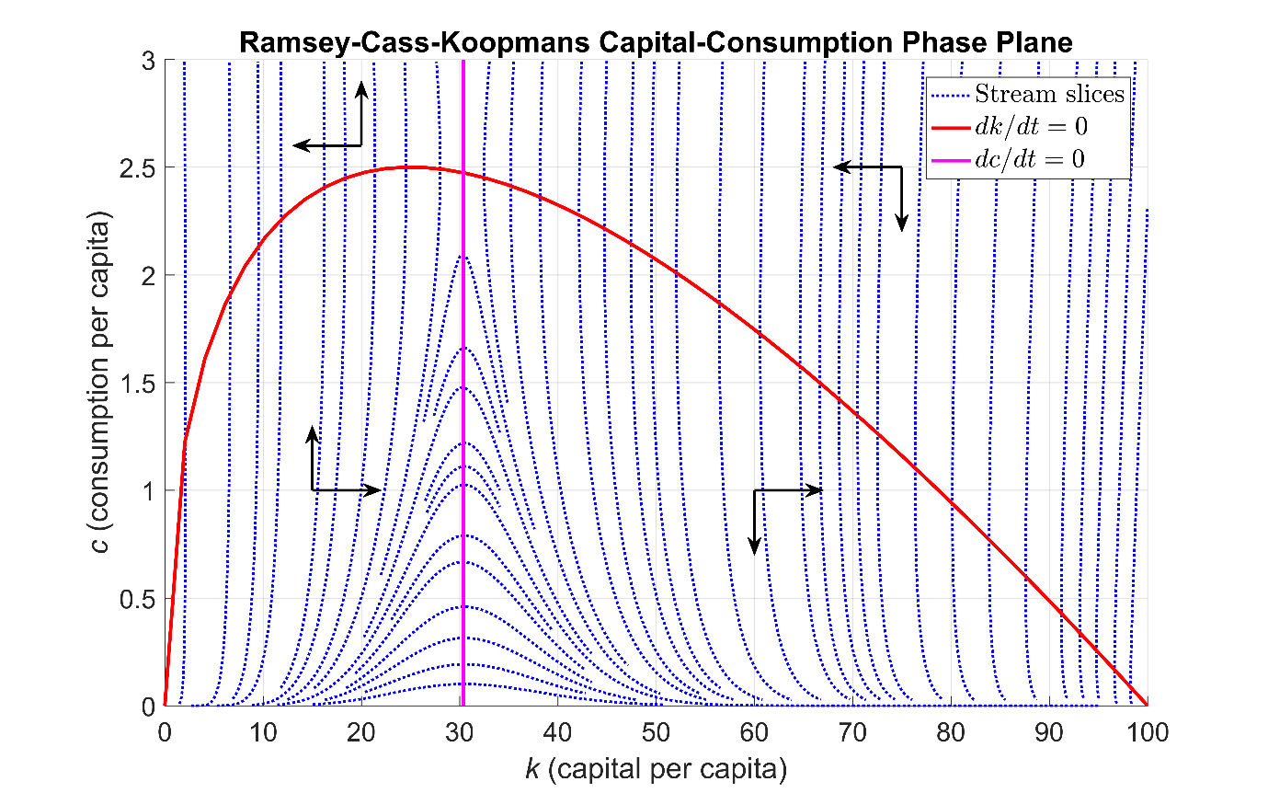

Figure 1: Phase portrait of the Ramsey-Cass-Koopmans system of ordinary differential equations

**The Ramsey-Cass-Koopmans Model**

The core RCK model equations for per-capita wealth (*k*) and per-capita consumption (*c*) are as follows.

$$\frac{dk}{dt}=f\left(k\right)-c-\left(ϕ+ξ+δ\right)k, \frac{dc}{dt}=c\left(\frac{f^{'}\left(k\right)-θ-ξ-δ}{ρ}-ϕ\right)$$

Since *k* and *c* appear in both equations, the two ODEs are coupled. The terms in these equations are as follows.

* $f\left(k\right)=k^{α}$ is a production function measuring the relative economic output in terms of *k* and a capital elasticity parameter $α$ (the responsiveness of the output production to changes in the input capital);
* $ϕ$ is the growth rate of labor productivity (e.g., due to technological innovation or efficiency improvements);
* $ξ$ is the growth rate of labor supply (e.g., due to migration or population increase);
* $δ$ is the depreciation rate of capital (e.g., due to inflation);
* $f^{'}\left(k\right)=αk^{α-1}$ is the derivative of the production function $f(k)$;
* $θ$ is an elasticity parameter indicating the tendency of consumers to smooth out their consumption over time;
* $ρ$ is the rate at which consumers discount their future consumption (e.g., by indicating a preference for immediate consumption or attempting to preserve their long-term average consumption.)

**Creating the RCK Model using MATLAB**

We can solve many systems of ODEs directly using the MATLAB function ode45, provided they are expressed in the standard form on the time interval $[t_{0}, t_{f}]$ and subject to the initial condition $Y\left(0\right)=Y_{0}.$ We note that $Y$ and $G\left(t, Y\right)$ are vector-valued if there are multiple unknown functions of time.

We begin by defining the necessary model parameters in a structure variable params, and write a vector-valued function RCK_Equations representing the right-hand side of the standard differential equation $\frac{dY}{dt}=G\left(t, Y\right).$ This function returns a 2-element vector, containing the values of $\frac{dk}{dt}$ and $\frac{dc}{dt}$ at each time step. We also write two auxiliary functions RCK_f and RCK_df returning the values of the production function $f(k)$ and its derivative $f'(k)$ respectively. Encapsulating these functions in separate files makes it easy to investigate the effect of different production functions on the numeric results.

function dY_dt = RCK_Equations(t, Y, params)

%RCK_EQUATIONS Function defining the right-hand sides of the two %coupled ordinary differential equations defining the Ramsey-Cass-%Koopmans model.

% Extract k and c.

k = Y(1);

c = Y(2);

% Write down the equations for dk/dt and dc/dt.

dY_dt(1, 1) = RCK_f(k, params) - c - ...

(params.phi + params.xi + params.delta) * k; % dk/dt

dY_dt(2, 1) = ( ( RCK_df(k, params) - params.theta - params.xi - ...

params.delta ) / params.rho - params.phi ) * c; % dc/dt

end % RCK_Equations

The next step is to create a function handle (@) containing the input function for ode45 by parametrizing RCK_Equations with the predefined parameters structure params. This function is required to be a function of time (t) and state (Y) only.

RCK_Fun = @(t, Y) RCK_Equations(t, Y, params);

We ensure that both per-capita wealth and consumption remain nonnegative over time using odeset.

opts = odeset('NonNegative', [1, 2]);

Taking the initial conditions to be $k_{0}=25$ and $c_{0}=2$ and allowing time to run from 0 to 1.5 units, we can now solve the system using ode45. The outputs of ode45 are time and state. As we create a time vector t directly, we only request the second output from ode45.

Y0 = [25; 2];

t = linspace(0, 1.5, 5000);

[~, Y] = ode45(RCK_Fun, t, Y0, opts);

k_out = Y(:, 1); % Output per-capita wealth

c_out = Y(:, 2); % Output per-capita consumption

The MATLAB visualization function comet allows us to create an animated trajectory of the solution path. The final frame of this animation, superimposed on the phase plane, is shown in figure 2. The red line is a small portion of the curve $\frac{dk}{dt}=0$ as shown in figure 1.

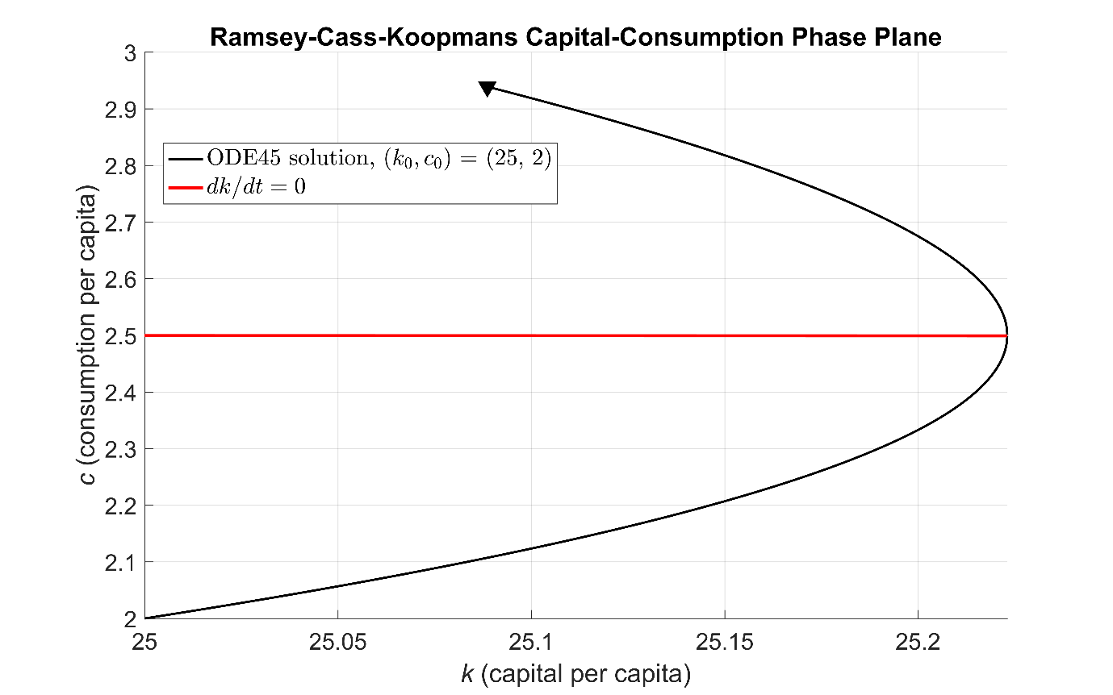

Figure 2: Solution trajectory starting from the point $\left(k_{0},c_{0}\right)=(25, 2)$ obtained by solving the coupled system of equations directly using ode45.

**Steady States and Solving the System using Time Elimination**

We can find the steady state(s) of the system by solving the equations $\frac{dk}{dt}=\frac{dc}{dt}=0$. Solving $\frac{dk}{dt}=0$ yields the curve $c^{*}\left(k\right)=f\left(k\right)-\left(ϕ+ξ+δ\right)k.$ This is the red curve in figure 1. Solving $\frac{dc}{dt}=0$ yields a single value for $k,$ namely

$$\hat{k}={\left(\frac{α}{ρϕ+θ+ξ+δ}\right)}^{1/(1-α)}.$$

This value defines the vertical line $k= \hat{k}$ in figure 1. We can use the meshgrid function to create lattices K and C of capital/consumption points. After computing the differentials dK and dC as defined by the RCK equations, we can use the streamslice visualization function to render the streamlines in the $(k, c)$ plane.

streamslice(K, C, dK, dC)

Overlaying the curves $c^{*}$ and $k= \hat{k}$ creates the phase portrait shown in figure 1.

As mentioned in [2], there is no analytical solution for the model’s transition to its steady state. However, we can use the time elimination technique [2] to obtain the following:

Integrating with respect to gives a solution trajectory for $c$ as a function of $k$. To avoid problems evaluating $\frac{dc}{dk}$ when its numerator or denominator are zero, we split up the $k$-domain into two parts: one to the left of $\hat{k}$ and one to the right [2]. Applying the same technique (using ode45) as described in the previous section gives the solution trajectory as shown in figure 3.

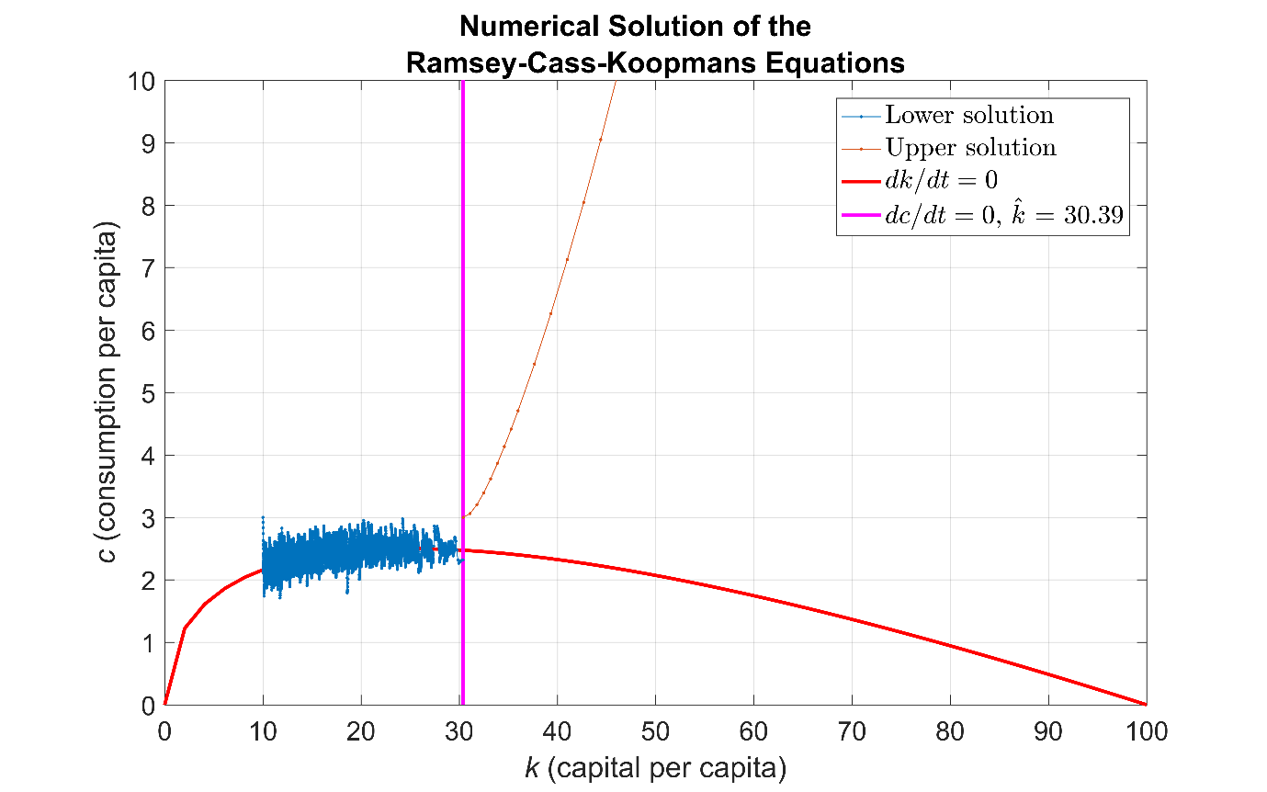

Figure 3: Upper and lower solution paths for a consumption strategy obtained using the time-elimination method.

We observe that the upper solution path is smooth, whereas the lower solution path suffers from numerical instabilities in the vicinity of $\frac{dk}{dt}=0$, a characteristic of certain stiff systems [4]. In this case, instead of using ode45, we can use a solver designed to handle stiff systems, such as ode15s. To improve the reliability of the solution trajectory, we compute the Jacobian of the system and pass it to the solver via odeset. The resulting smooth path is shown in figure 4. Note that for larger or more complex systems, we could use Symbolic ToolboxTM to compute analytic Jacobians without manual calculation.

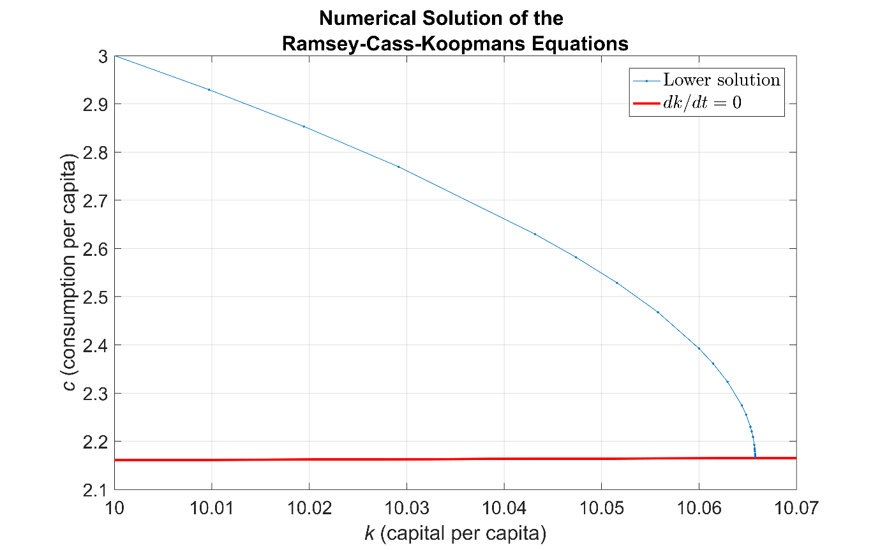

Figure 4: Lower solution path obtained using the stiff solver ode15s.

**Creating the RCK Model using Simulink**

Simulink provides a set of predefined libraries of blocks that you can combine to create a complete visual representation of your system of ODEs. Simulink is also a simulation engine providing fixed and variable time step ODE solvers.

Data is represented in Simulink in two ways. *Signals* are the lines connecting blocks and represent time-varying data, e.g., the derivative . *Parameters* are system values stored inside blocks, e.g., the initial condition .

When modeling ODEs, we begin with the Integrator block from the Continuous library. This block integrates its input signal (the derivative). Since the system has first-order derivatives for *k* and *c*, we begin with two integrator blocks. The initial conditions and are assigned as parameters inside the integrator blocks. Note that red lines indicate signals not yet connected to other blocks.

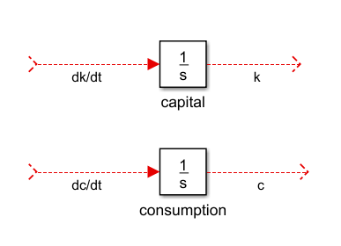

To implement the right-hand sides of the RCK equations, we utilize the following commonly-used blocks.

|  |  |  |
| --- | --- | --- |
| **Block** | **Symbol** | **Purpose** |
| Constant |  | Reference model parameters (e.g., params.phi). |
| Product |  | Multiply signals. |
| Sum |  | Add or subtract signals. |
| Gain |  | Multiply or divide a signal by a constant. |
| Math Function |  | Mathematical operations (e.g., powers and logarithms). |
| Outport |  | Pass results to the MATLAB workspace (e.g., and ). |

As our model increases in size and complexity, we can simplify it by grouping blocks into *subsystems* using the Subsystem block.

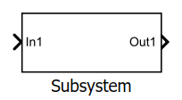

We encapsulate the production function in a subsystem as follows.

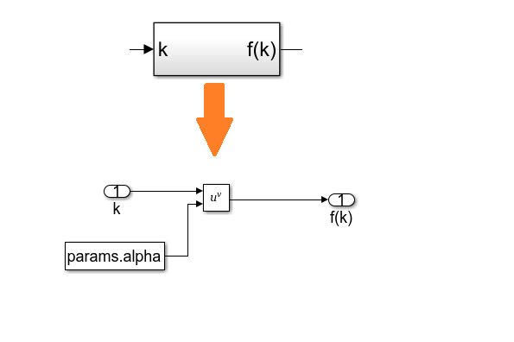

We approximate the derivative using the Derivative block.

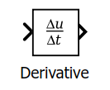

Note that the Derivative block should not be used as the starting point when modeling ODEs, as it has no initial condition parameter.

The complete RCK model is shown below.

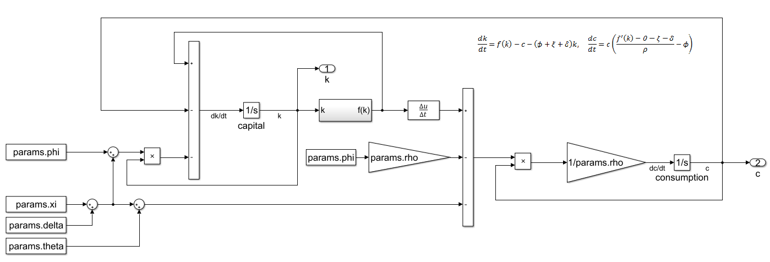

After constructing the model, we specify the simulation stop time as 500 time units and press the green **Run** button to simulate the model.



Figure 5 shows the resulting trajectory starting from the point

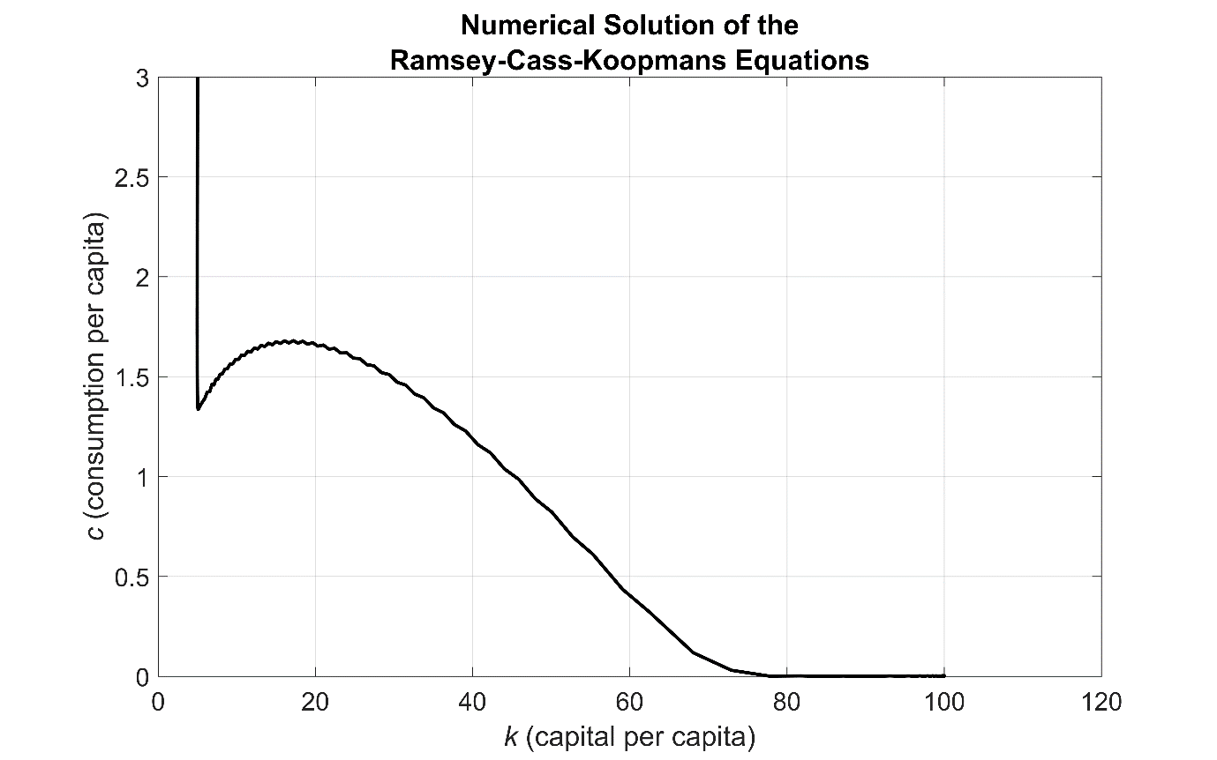

Figure 5: Solution trajectory starting from the point .

**Running Simulations Efficiently in Parallel**

As part of the model analysis, we may want to investigate the dependency of the model on its parameters by running simulations using different sets of parameter values. Each of these simulations can be run independently of the others, which is ideal for a parallel implementation using the parfor construct from Parallel Computing ToolboxTM. Starting with the MATLAB-based model implementation, we create lattices of grid points K0 and C0 representing the different initial conditions we would like to investigate. Within each iteration of the parfor-loop, we select a different initial condition Y0 and store the outputs k_out and c_out using cell arrays.

RCK_Fun = @(t, Y) RCK_Equations(t, Y, params);

opts = odeset('NonNegative', [1, 2]);

t = linspace(0, 1.5, 1000);

parfor k = 1:numel(K0)

% Initial values for per-capita wealth and consumption.

Y0 = [K0(k); C0(k)];

% Solve the coupled system.

[~, Y] = ode45(RCK_Fun, t, Y0, opts);

k_out{k} = Y(:, 1); % Output per-capita wealth

c_out{k} = Y(:, 2); % Output per-capita consumption

end % parfor

Using 100-by-100 lattices of initial conditions means that we perform 10,000 parallel simulations of the model. This produces the solution trajectories shown in figure 6.

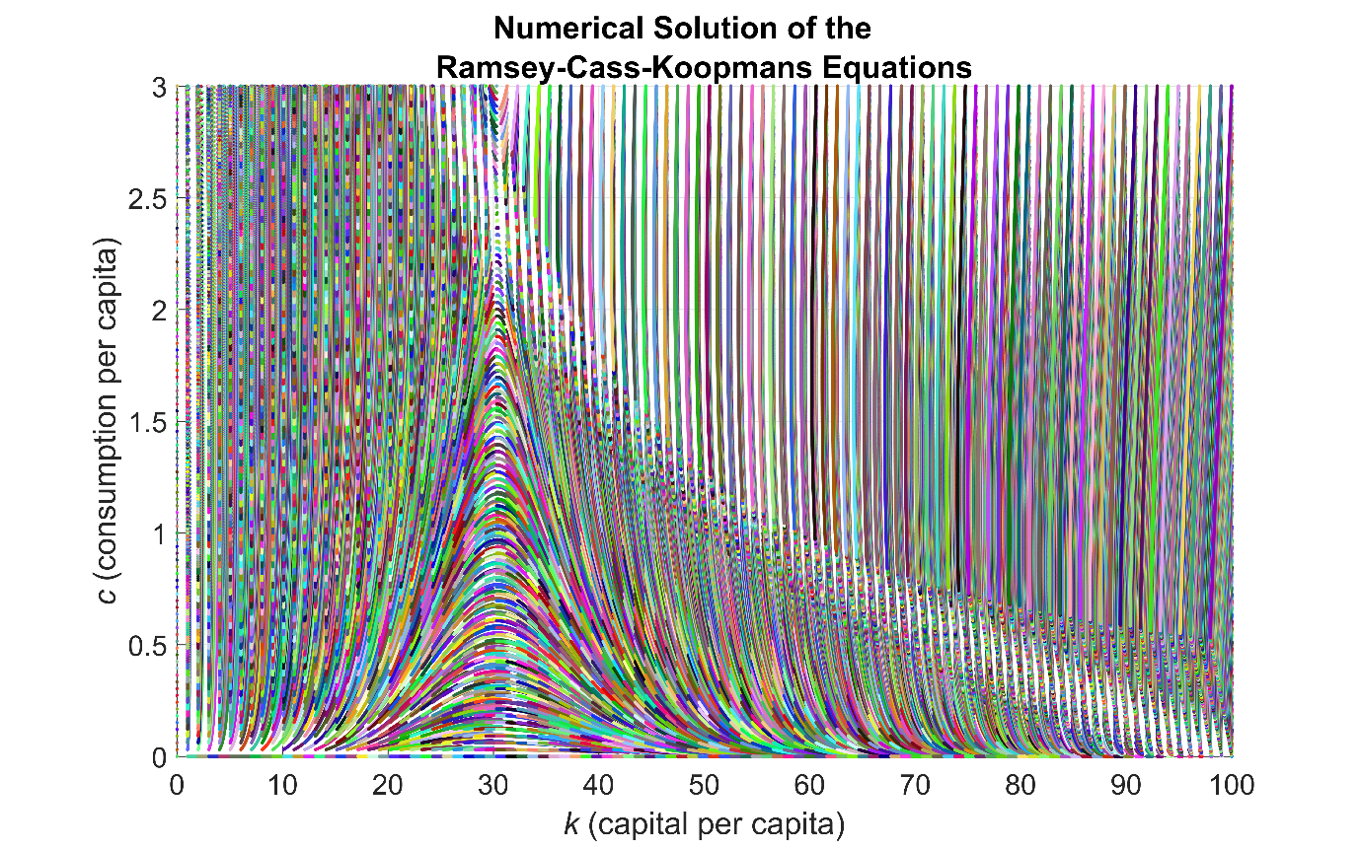

Figure 6: Solution paths of the RCK model starting from different initial conditions.

We use the guideline steps below to simulate the Simulink RCK model in parallel [5].

* Load the model on each worker using load_system and the spmd construct.
* Define arrays K0 and C0 of initial conditions over which we want to simulate the model.
* Write a function to simulate the model programmatically using the sim command. Note that to set parameters programmatically in the model using set_param, we need to convert numerical values to text. The try/catch construct safeguards against any unexpected convergence issues for isolated sets of initial conditions.
* Within each iteration of the parfor loop, call the function with a different set of initial conditions.

%% Load the model once per worker.

spmd

load_system('RCK_Model');

end % spmd

%% Perform the simulations in parallel.

parfor k = 1:numel(K0)

simout(k) = runSim(K0(k), C0(k));

end % parfor

function simout = runSim(k0, c0)

% RUNSIM Function simulating the model for different initial values

% for per-capita wealth and consumption using the stiff system solver

% ode15s and a stop time of 45 time units.

% Format the initial values for per-capita wealth and consumption as text.

k0 = num2str(k0);

c0 = num2str(c0);

set_param('RCK_Model/capital', 'InitialCondition', k0)

set_param('RCK_Model/consumption', 'InitialCondition', c0)

% Run the simulation.

try

simout = sim('RCK_Model', 'Solver', 'ode15s', 'StopTime', '45');

catch

% If a simulation run fails to converge, assign an empty output.

simout = Simulink.SimulationOutput;

end % try

end % runSim

The solution trajectories for 10,000 parallel simulations of the model are shown in figure 7.

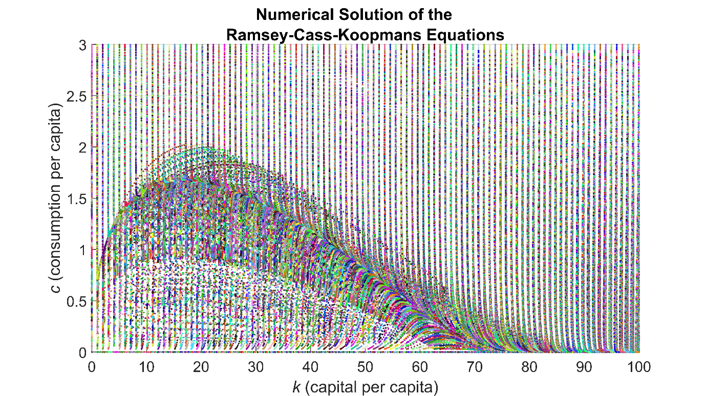

Figure 7: Solution paths of the RCK model starting from different initial conditions.

**Summary**

In this article we have demonstrated that the RCK model, a system of coupled ODEs, can be simulated using MATLAB and Simulink. Working through the various modeling challenges, we have seen benefits in both approaches.

Using the MATLAB approach, we transformed the equations to the standard form as required by ode45 and made use of function handles. On the other hand, using the Integrator block in Simulink, we implemented the differential equations “as is”.

Using the Simulink approach, derivatives such as and the Jacobian matrix are computed automatically, via the Derivative block and the solver Jacobian configuration setting of ode15s respectively. Using the MATLAB approach, we could evaluate such derivatives automatically using Symbolic Math Toolbox.

We have seen two important features of Simulink that simplify the modeling of a large or complex system of ODEs. First, subsystems help us to organize our model by grouping functionally-related blocks, e.g., the subsystem defining the production function The Simulink model window also provides an intuitive visual layout of the model.

Parallelizing the MATLAB and Simulink modeling approaches is similar. In both cases we use the parfor construct, and in the Simulink framework we make use of the sim command to simulate the model programmatically.

**Products Used**

MATLAB

Simulink

Parallel Computing Toolbox

**References**

1. C. Groth, Lecture notes in macroeconomics, 2011

(<http://www.econ.ku.dk/okocg/MAT-OEK/Mak%C3%98k2/Mak%C3%98k2-2011/Lectures%20and%20lecture%20notes/Ch10-2011-1.pdf>)

1. Christopher D. Carroll, The Ramsey/Cass-Koopmans (RCK) Model, November 2011 (<http://www.econ2.jhu.edu/people/ccarroll/public/lecturenotes/Growth/RamseyCassKoopmans.pdf>)
2. Pierre-Olivier Gourinchas, The Ramsey-Cass-Koopmans Model, 2014 (<http://eml.berkeley.edu/~webfac/gourinchas/e202a_f14/Notes_Ramsey_Cass_Koopmans_pog.pdf>)
3. Cleve Moler, Stiff Differential Equations (<http://www.mathworks.com/company/newsletters/articles/stiff-differential-equations.html>)
4. Guy Rouleau, Tips for simulating models in parallel (<http://blogs.mathworks.com/simulink/2016/05/05/tips-for-simulating-models-in-parallel/>)
5. David Kendrick, Applications of Control Theory to Macroeconomics (1976)

(<http://www.nber.org/chapters/c10438.pdf>)