AI Usage Documentation
Alchemia Labs Technical Assessment — Keylor Delgado

1. How Claude was used across this project
Claude (Anthropic, claude.ai web interface) was used as a pairing and tutoring partner throughout this assessment, not as an autonomous code generator. The working pattern was consistent: Claude proposed an approach or a piece of code, explained the reasoning and, when requested, walked through it line by line before it was run; I ran every command and script myself, and shared the actual terminal/BigQuery output back for Claude to interpret. Nothing was accepted without being run and checked against real output.
Claude was used for:
- Explaining GCP/BigQuery concepts I hadn't used before (sandbox mode, service accounts, IAM roles, INFORMATION_SCHEMA, ARRAY_AGG, dataset vs. table vs. project scoping).
- Drafting the Python extraction/load scripts (extract_crm.py, extract_catalogue.py, load_to_bigquery.py) and the ranking SQL, then explaining each function and line on request.
- Diagnosing errors from real tracebacks and BigQuery error messages (see Section 2).
- Structuring the project (folder layout, .gitignore, README, this document) and helping prioritize the 5 required deliverables against a 2-day deadline.
- General “what does X mean” explanations — e.g. the difference between a dataset and a CRM, what Parquet is, what a snapshot vs. a delta export is — asked because I wanted to understand the reasoning, not just get code that worked.

2. Where Claude was wrong, and how it was caught and corrected
The table below lists concrete instances where Claude's first suggestion was incorrect or incomplete. In every case, the mistake was caught either by running the code/query and getting a real error, or by inspecting actual output and noticing it didn't match expectations — not by inspection of the suggestion alone.
Where it happened | What Claude got wrong | How it was caught & fixed
Environment setup, day 1 | Gave PowerShell syntax (backtick line continuation, $VARIABLE) while the terminal was actually cmd.exe. | Caught from the prompt format in the screenshot (no "PS" prefix). Switched to PowerShell for consistency and re-issued the commands with correct syntax.
IAM setup | Assumed dataset-level IAM bindings (bq add-iam-policy-binding on the analytics dataset) would work on a sandbox project. | BigQuery returned "This feature requires allowlisting." Recognized this as a sandbox limitation and switched to project-level bindings (gcloud projects add-iam-policy-binding) instead, noting the trade-off (broader access) in the assumptions page.
Parquet cleaning script | Assumed select_dtypes(include="object") reliably identifies text columns, same as it did for the CRM CSVs. | Script crashed: AttributeError: Can only use .str accessor with string values, not date. Parquet preserves real date types even under pandas' generic "object" label. Fixed by checking the actual value type per column (isinstance(value, str)) instead of trusting the declared dtype.
Ranking query, first version | Grouped by store_number, store_name, city, county together. Didn't anticipate that store_name changes over time for the same store_number. | User noticed store_number 2512 and 3814 appeared twice with slightly different names and split totals. Traced it to store name changes over time; fixed by grouping on store_number alone and using ARRAY_AGG(... ORDER BY date DESC LIMIT 1) to pick the most recent display name.
Category filtering | Suggested WHERE LOWER(category_name) LIKE '%gin%' without checking results for false positives. | User ran it and shared the output: it matched "PUERTO RICO & VIRGIN ISLANDS RUM" (via "vir-GIN"). Replaced the wildcard match with an explicit IN (...) list of the 6 confirmed gin categories.
CRM ↔ public dataset join | Wrote the exclusion subquery assuming store_number had the same type in both tables. | BigQuery error: "Cannot execute IN subquery with uncomparable types STRING and FLOAT64." Diagnosed that pandas had inferred store_number as FLOAT64 from the CRM CSV during load, while the public dataset stores it as STRING. Fixed with an explicit CAST(store_number AS STRING); flagged the pandas type-inference issue as a root cause to fix properly in the assumptions page.
Verifying the exclusion filter | Wrote a verification query that recomputed the top-25 ranking from scratch, without re-applying the exclusion filter, then compared it against the CRM — an apples-to-oranges comparison. | The query returned 53,848 "overlaps," which looked alarming. On inspection, the verification query itself was flawed (it never reapplied the NOT IN filter), not the original ranking query. Rewrote the check to test the actual 25 store_numbers already produced by the validated query, using UNNEST(...) against a fixed list, which correctly returned 0.
.gitignore not taking effect | Instructed the user to create .gitignore via VS Code's file picker without confirming it saved before running git add. | git status showed __pycache__/*.pyc staged despite the .gitignore rules. cat .gitignore then showed the file didn't exist at all. Recreated it via a PowerShell here-string (more reliable than a manual save), then re-staged everything from a clean git rm -r --cached .

3. Representative prompts used
The prompts below are illustrative of the overall approach, not an exhaustive log. The full conversation (available on request) contains the complete exchange, including every command run and every piece of real output shared back to Claude.
1. Initial environment setup
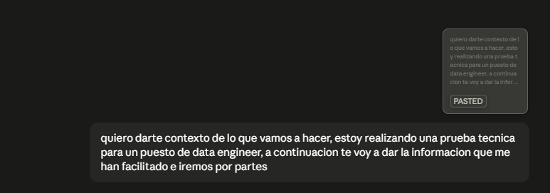
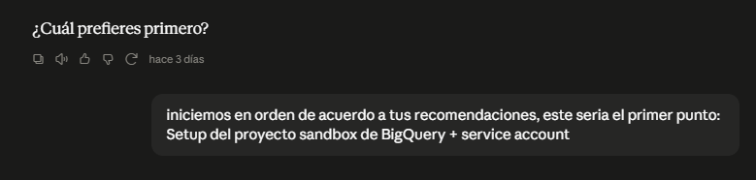

2. Requesting step-by-step, no skipped explanations
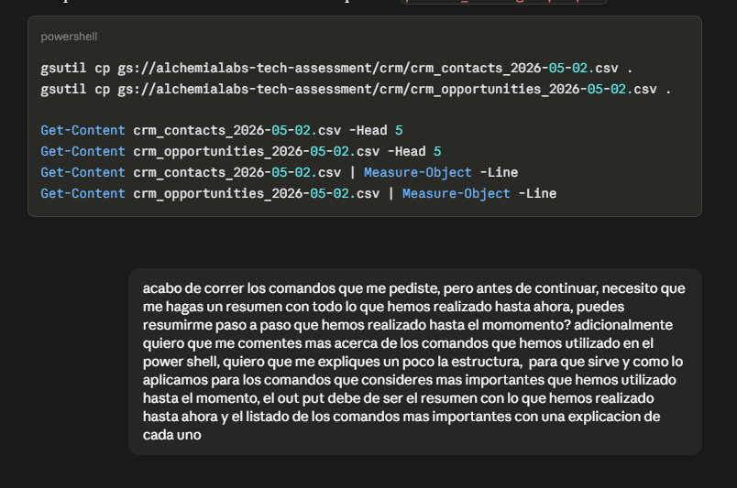
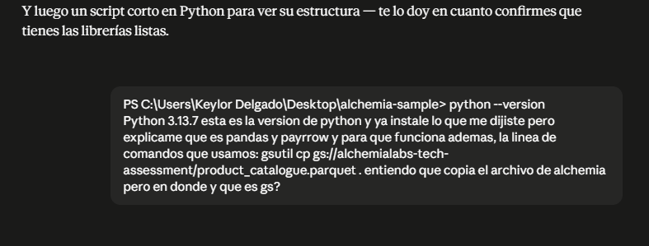
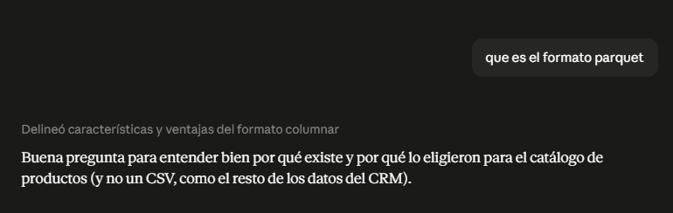
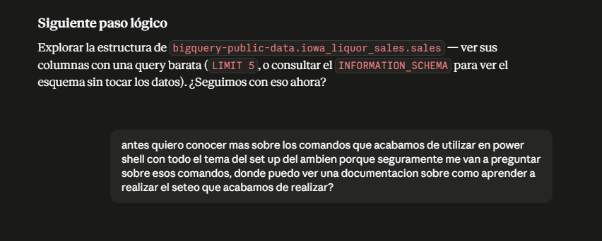
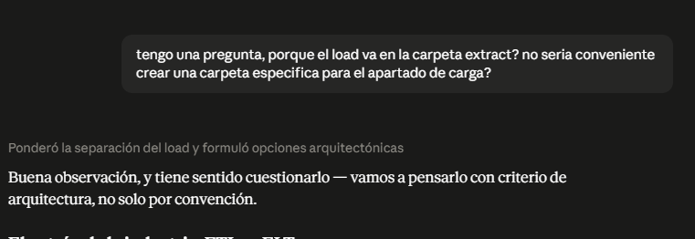
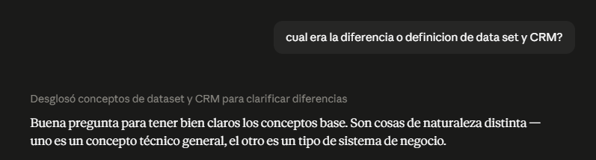
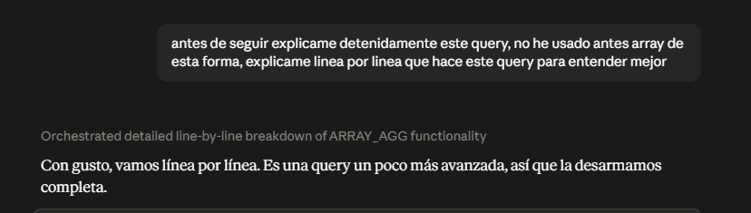
3. Pushing back / requesting verification
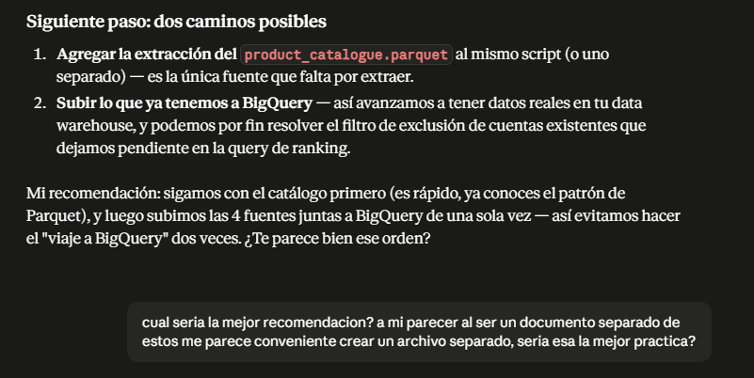
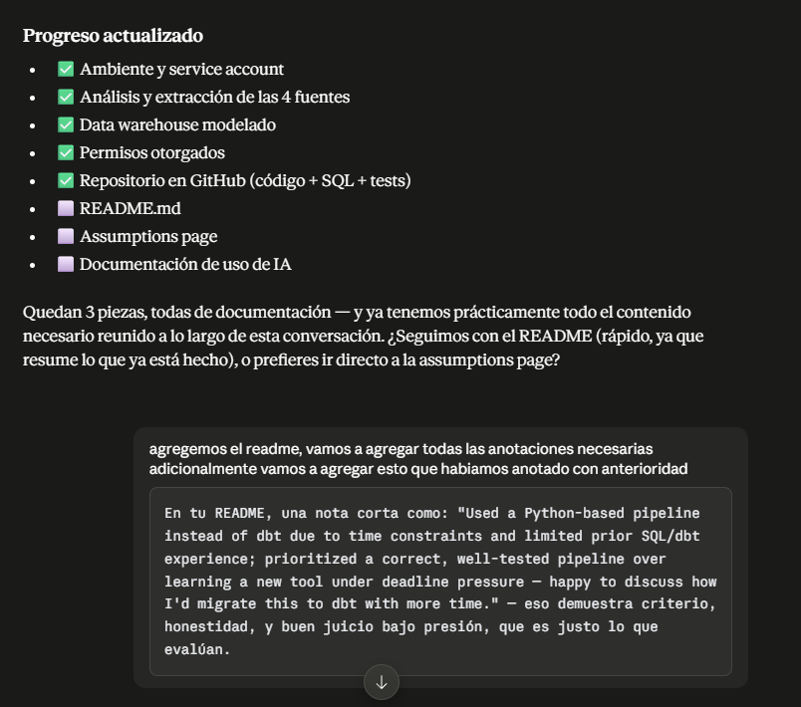
4. Time-boxed planning
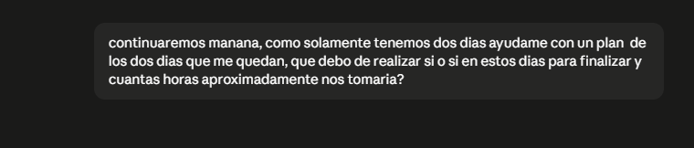
5. Explicit tool decision under time pressure
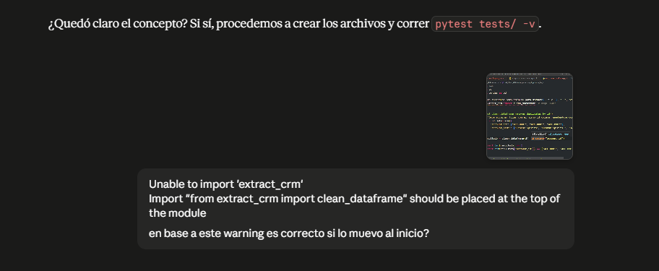
[answered: never used dbt, basic SQL] → asked Claude to decide dbt vs. plain Python given that context
Rather than defaulting to the brief's recommended tool, this was an explicit request for a recommendation based on actual skill level and time remaining — resulting in the documented decision to use Python instead of dbt (see README).

4. What this process demonstrates
- Every suggested command or script was actually run, and real output (including errors) was fed back — the pipeline in the repo reflects what was verified to work, not just what Claude proposed.
- Several of the more important fixes in this project (the store_name grouping bug, the LIKE '%gin%' false positive, the store_number type mismatch, the flawed verification query) were caught because raw output was inspected and questioned, not accepted at face value.
- Time-boxing decisions (e.g. Python over dbt) were made deliberately, based on an honest assessment of prior experience, and are documented as such in README.md and ASSUMPTIONS.md rather than presented as if they were the ideal approach.

