10402542

Erasmus Exchange Program

Professor Andreas Prokop

**Seizure-like behaviours in *Drosophila* induced by microtubule aberration**

Uma imagem com inseto, animal

Descrição gerada com confiança muito alta

**Abstract**

Axons are the long cellular processes of neurons that act like electrical cables sending electrical messages to target neurons or cells. Axon development, structure, function and maintenance depend on the microtubule (MT) cytoskeleton, organised into parallel bundles by MT-regulatory proteins. Motor proteins, such as kinesins and dyneins are involved in the transport of cargo along these MT bundles. My study was based on previous findings that the triple-heterozygous *Eb104524/+msps1/+tauko/+* mutation affecting three very different MT-regulators and causing MT bundle aberrations in neurons of the fruit fly *Drosophila*, also induce epilepsy-like conditions. This opens up novel pathways to understand potential new causes underlying this common neurological disease affecting millions of people worldwide. The initial hypothesis for my project was that MT aberration might impair the transport of typical channel proteins linked to epilepsy, based on previous reports that mice lacking the motor protein KIF5A show reduced GABAA receptor transport and display epilepsy (Nakajima et al., 2012, Neuron 76, 945ff.). Inducing seizure with electroshocks and measuring recovery time as a readout for the severity of the condition, I could demonstrate that *Eb104524/+msps1/+tauko/+* mutant larvae suffer from a seizure-like condition. The condition was significantly improved when applying commercial anti-epileptic drugs (AEDs), indicating typical epilepsy mechanisms to be involved. Furthermore, my experiments suggest MTs to be causative: the *Eb104524/+msps1/+tauko/+* mutant phenotype was improved by the MT-stabilising drug Epothilone B, and I could show that other conditions affecting MT regulation (tau-/-, Efa6-/-, pan-neuronal knock-down of Eb1) likewise cause seizure-like phenotypes. Knock-down of Eb1 in different neuron classes pinpointed motorneurons as the essential cells responsible for seizure induction. Furthermore, I found that loss of kinesin-1 (Khc) and -3 (Unc-104) and of the GABAA receptor (Rdl) all cause seizure-like conditions, consistent with my original hypothesis. However, further experiments failed to deliver ultimate proof: Firstly, only the *Rdl* mutation in heterozygosis showed a genetic interaction with *msps1/+tauko/+*, but not the two kinesin mutations. Secondly, Rdl localisation in dendrites of motorneurons seemed unaffected in *Eb104524/+msps1/+tauko/+*. In conclusion, my work builds a strong case for MTs aberrations as a potential cause for epilepsy, but the underlying mechanisms remain open.

1. **Introduction**

Epilepsy is the sudden and repeated appearance of seizures including convulsive movements and even loss of consciousness (Cobb, 1932). Seizures are either generalised, from both hemisphere of the brain or partial, beginning in one or more parts of one hemisphere of the brain (Loscher, 2002). According to the World health organisation, epilepsy is a non-communicable disease, which represents one of the most common neurological disorders affecting approximately 50 million people worldwide. Epilepsy affects 4-10% of the general population, and 7-15‰ in low- and middle-income countries. It has therefore important economic and social impact, and patients suffer from stigma and discrimination. If diagnosed in time and the appropriate medication is implemented, more than 70% of patients can live without seizures, and this owed to decades of research into epilepsy.

Three subtypes of epilepsy exist, which are complex epilepsy, symptomatic epilepsy and idiopathic epilepsy. Complex epilepsy affects 10% of patients and has both genetic and environmental causes. Symptomatic epilepsy affect 30% of patients and is due to structural brain abnormalities caused by a brain tumour, stroke, infections or developmental aberrations (Bonello et al., 2015; Heron et al., 2007; Kwan and Brodie, 2000). Idiopathic generalised epilepsy (IGE) affects 60% of patients (Kwan and Brodie, 2000) and is difficult to understand because its genetic causes cover a wide spectrum and may even touch multiple genes at the same time (Charlier et al., 1998). IGE mostly affects genes encoding or regulating neuronal voltage-gated and ligand-gated ion channel subunits which are therefore referred to as channelopathies (Heron et al., 2007).

Potential causes of idiopathic epilepsy include mutations in the KCNQ1, KCNQ2 and KCNQ3 genes, which are members of the KQT-like family encoding a voltage-gated potassium channel; impaired potassium currents can lead to an overload of neuronal excitability resulting in a seizure-like phenotype (Heron et al., 2007). For example, a number of missense mutations in these channels are autosomal-dominant causing Benign Familial neonatal convulsions (BFNC) (Charlier et al., 1998); mutations in KCNQ2 are linked to Benign Familial Neonate Seizures (BFNS) with seizure-phenotypes in neonates and in 15% of adults. Anti-Epileptic drugs targeting KV7/KCNQ/M potassium channels are Retigabine and ICA-105665 (Rogawski and Bazil, 2008)

Also sodium channels are important for action potential propagation; accordingly, also mutations of genes encoding voltage-gated sodium channels subunits, such as the *SCN1A* and *SCN2A* alpha or *SCN1B* beta-subunits, are linked to epilepsy(Heron et al., 2007). These are gain-of-function mutations causing an increase in Na+ currents hence neuronal excitability, for example in epileptic encephalopathies (linked to *SCN1A*) or Benign familial neonatal-infantile seizures (BFNIS; linked to *SCN2A*) (Heron et al., 2007). Therefore, anti-epileptic drugs targeting voltage-gated Na+ channels, cause their fast or slow inactivation, correlating with a fast versus slow onset of recovery from seizure; typical drugs are Phenytoin and Valproate, which target the intracellular mouth between domain III and IV of the sodium channel α-subunit (Castro et al., 2005; Rogawski and Loscher, 2004a).

A further gene linked to IGE, is the cholinergic receptor alpha2 subunit (CHRNA2); the heterozygous *I279N* missense mutation results in an increased sensibility of the excitatory synaptic receptor gated by the transmitter acetylcholine. This mutation causes autosomal dominant front lobe epilepsy accompanied also by sleep disorder, fatigue, anxiety and cognitive dysfunctions. People affected have nocturnal seizures and unorganised movements while sleeping (Aridon et al., 2006). Further mutations affect the transmembrane domain of other acetylcholine receptors subunits CHRA4 and CHRNB2, likewise leading to epilepsy (Heron et al., 2007).

IGE-linked mutations can also affect genes encoding GABAA receptor subunits, such as *GABRG2* and *GABRA1*(Heron et al., 2007). GABAA receptors inhibit synaptic excitation, which explains why their loss causes over-excitation leading to seizure. Many anti-epileptic drugs target this receptor class, such as Phenobarbital, which acts by enhancing GABA-R current by acting as a positive allosteric modulator increasing the probability that the channel is opened (Rogawski and Loscher, 2004b), Vigabatrin and Tiagabine inhibit GABA transaminase (a GABA-degrading enzyme) (Greenfield, 2013), or Valproate which increases GABA synthesis and reduces turnover(Perucca, 2002).

Further mutations were identified as potential causes for complex epilepsies and affect genes, such as *CACNA1H* (a Cav3.2 T-type calcium channel)*, GABRD* (a GABAA receptor delta subunit), or *KCND2* (α-subunit of the Kv4.2 voltage-gated potassium channel). For example, the GABAA receptor δ subunit mediates tonic inhibition which is an important mechanism to control epilepsy(Heron et al., 2007).

Genetic causes for epilepsy may not affect the channel proteins directly, but also the genes involved in their processing. For example, channel proteins have to be incorporated into the axonal membrane or at synapses, and this requires axonal transport to bring them to their final locations. Accordingly, the molecular motor protein KIF5A was shown to be essential for GABAA receptor transport, and KIF5A deletion in a mouse model causes epilepsy (K. Nakajima et al., 2012)**.**

In this context, it is of interest that axonal transport is dependent on axonal microtubules (MTs); my host group discovered that fruit flies lacking one copy each of the three MT-regulating genes Eb1, tau and Msps/XMap215 (see more detail below), caused seizures in flies. The aim of my project was therefore to validate whether these seizures represent an epilepsy-like condition, whether MT regulation is the essential cause, and to investigate potential mechanisms mediating between MT regulation and seizure, starting with GABA-R transport as a potential candidate.

*Drosophila melanogaster* has been used as model organism for genetic and biomedical research for over a hundred years, and it is the by far best understood animal we have; the fact that 10 researchers were awarded the Nobel prize in Medicine and Physiology for their work with *Drosophila* illustrates its relevance (Prokop, 2018). *Drosophila* is a cost effective and efficient model organism which can be bred in great numbers in a short time, easily kept and handled with little space requirement (A. Prokop et al., 2013). Furthermore, the breadth of existing knowledge, genetic, molecular, cell biological and experimental strategies available in vivo and in cell culture are vast and promote efficient research (Ejsmont and Hassan, 2014; Hahn et al., 2016). Importantly, research in *Drosophila* has potential implications for human disease, based on the fact that 75% of genes implicated in human diseases are conserved in *Drosophila*’s genome (Reiter et al., 2001).

Capitalising on this fact, *Drosophila* is being used to understand genes linked to human diseases (Wangler et al., 2017), and it has been instrumental in understanding principles of nervous system development, function and disease (Bellen et al., 2010; Mudher and Newman, 2007; Andreas Prokop et al., 2013). For example, *Drosophila* is being used as a model for epilepsy; the same classes of sodium, potassium and GABA receptor channels that are linked to human epilepsy (see above) are also involved in *Drosophila*, to a degree that human anti-epileptic drugs have ameliorating effects in fly (Kroll et al., 2015; Leal and Neckameyer, 2002; Parker et al., 2011). For example, the *parabss1* gain-of-function mutant allele of the para sodium channel which causes hyper-excitability , can be ameliorated but bot treated due to it severity with the anti-epileptic drugs gabapentin, potassium bromide, although phenytoin may be an exception showing a considerable change on mutants phenotype (Parker et al., 2011; Reynolds et al., 2004; Song and Tanouye, 2008). Interestingly, other studies in *Drosophila* have already reported potential links from MT regulators to seizure-like conditions (Duncan et al., 2013; Holth et al., 2013), providing further motivation for my project.

Along these lines, the Prokop’s laboratory used the fruit fly to understand the cytoskeletal machinery of neurons during axonal growth and maintenance (Andreas Prokop et al., 2013; Sánchez-Soriano et al., 2007). Neurons are composed of long axons, which are the longest cellular process of animals acting like electric cables that wire our nervous systems and bodies(Andreas Prokop et al., 2013). Axon growth and maintenance depends on the MT cytoskeleton (Hahn et al., 2019; Andreas Prokop et al., 2013; Voelzmann et al., 2016). Axonal MTs are organised into parallel bundles and their integrity is important for axonal growth, function and maintenance. They form the structural backbones of axons and the highways for the transport of proteins, vesicles, mRNA and organelles. This transport is performed by specialised proteins: kinesins for anterograde and dynein/dynactin for retrograde transport (Andreas Prokop et al., 2013). The proper organisation of MT bundles depends on the action of MT-binding and -regulating proteins; for example, Eb1 binds to the polymerising plus ends of MTs to regulate their behaviour, Msps/XMAP215 is a MT polymerase, and tau binds to the MT lattice and has multiple functions including MT stabilisation (Hahn et al., 2019);(Voelzmann et al., 2016). Recent work has shown that these three genes cooperate to regulate MT polymerisation and organisation; if one copy of each gene is taken out in the same animal (*Eb1+/- tau+/- msps+/-* triple-heterozygotes), neurons display a severe aberration of axonal MT bundles consisting in disorganised, intertwined MTs. In addition, these animals show epileptic phenotypes in form of seizure-like behaviours. This occurs in aged adults and can be observed using a well-established electroshock assay (Marley and Baines, 2011) (see Methods) in triple-heterozygous larvae (Petzold, 2018).

The current hypothesis for why this triple-heterozygous condition causes vulnerability to seizure is based on axonal transport, analogous to the above mentioned work in mouse (Kazuo Nakajima et al., 2012): MT disorganisation might lead to the disruption of anterograde transport of voltage-gated channels (e.g. Para or Shaker) in axons or GABAA receptors (Rdl) in dendrites. Motor proteins known to transport anterogradely in axon and/or dendrites are kinesin-1 (Kinesin heavy chain/Khc) and kinesin-3 (especially Unc-104).

Work previous to my study had already shown that a quantifiable seizure-like phenotype can be observed in the triple-heterozygous animals (*Eb104524/+ msps1/+ tauko/+*) at larval stages. Building on this methodology, I could confirm the seizure-like phenotype and could demonstrate that it can be rescued with anti-epileptic drugs. Experiments applying a MT-stabilising drug, using further MT regulators and neuron specific knock-down of Eb1, strongly suggest that seizure induction is mediated by MT aberration primarily in motorneurons. Finally, I provide data showing that loss of kinesin-1 or -3 motor proteins likewise cause seizure-like conditions but through a mechanism that we can currently not link to MTs, whereas loss of GABA-receptors links to MTs in the context of the seizure phenotype.

1. **Methods and Materials**
   1. Fly stocks

Flies were maintained on standard cornmeal medium at 25°C. Different fly strains were used in this study: **Oregon-R** (Blooming Stock Centre) controls, **para*bss1*** (Richard Baines; gain-of-function mutant allele; (Howlett et al., 2013; Parker et al., 2011)), ***eb104524/+***(Blooming Stock Centre; hypomorphic allele; (Elliott et al., 2005)), ***msps1/+*** (gift from H. Ohkura; null allele of the XMAP215 homologue); ***tauko/+*** (gift from L. Partdridge; amorphic allele deleting exons 2 to 6; (Burnouf et al., 2016)), ***Khc8/+*** (Blooming Stock Centre, stock #1607) is an amorphic allele, resulting from several point mutations, such as Nucleotide change C 16269635T leading to an aa change R210term. This mutation leads to a lack of molecular function of the gene product. It is also called a “Loss-of-function mutation”. *Imac is* a gene encoding a Kinesin 3, also known as unc-104. ***Imac170*** (Pack-Chung et al.,2007) is an allele, resulting from the non-sense mutation (G16763061A nucleotide change) leading to premature stop codon (FlyBase Organisation, 2019). ***Rdl1/+*** (Blooming Stock Centre, stock #1687), is a chromosomal aberration induced by gamma ray, more specifically an inversion of chromosome 3 (Stilwell and Ffrench-Constant, 1998). ***Efa6GX6w*** is a genomically engineered null allele (Blooming Stock Centre, stock # 60587), ***UAS-Rdl-HA*** (Kueppers et al., 2003), ***UAS-eb1-RNAi*** (Blooming Stock Centre), ***elav-GAL4*** (pan-neuronal driver on chromosome 3; (Luo et al., 1994)), ***Ok6-Gal4***(motorneuron-specific driver on chromosome 2L; (Sanyal, 2009)), and ***ChaT:Bac-Gal4*** (specific for cholinergic neurons; chromosome 3R; (Salvaterra and Kitamoto, 2001); **CTG** (*Cyo*, *twist*-GAL4 UAS-2xEGFP) and **TTG** (*TM3*, *twist*-GAL4 UAS-2xEGFP) balancer chromosomes (Halfon et al., 2002)

* 1. Induction of seizure-like phenotype in L3 larvae by electroshocking

The first step of this experiment consists in the establishment of different settings by using a voltmeter measuring the voltage emitted by the power source. Larvae were kept in 25°C. To avoid bias, they were left for 25 minutes at room temperature. Afterwards, larvae from each genotype were washed in water to eliminate food-residues using a brush. Larvae were placed in a dry petri dish and the excess of water was removed with absorbent paper. Larvae were only taken when they showed movements which could then be compared to movements after the electroshock induction. Larvae were electroshocked for 2 seconds using the probe which is linked to a power source. Seizure-like phenotype was described as a full paralysis of larvae body. This epileptic-like phenotype ended when larvae return to have a full peristaltic wave along their body resulting from contraction (Marley and Baines, 2011). In total, 25 control and 25 mutant larvae were analysed per genotype.

* 1. Drug feeding and seizure-like behaviour test in L3 *Drosophila* larvae

Phenytoin and Valproate (1.2 mM, Sigma) were added to standard cornmeal medium, which as melted previously. Epothilone B (10μM) was applied in a normal vial on the top of cornmeal medium. Eggs were lay down and larvae fed on each drug. After L3 larvae formation, approximately 30 larvae were collected for each AEDs and induced to electroshock stimulations at 3V during 2 seconds. In response to electroshock L3 larvae undergo a series of contractions and paralysis (Marley and Baines, 2011). Recovery time was measured.

* 1. Dissection and staining of L3 larvae brains

About 20 L3 larvae per genotype were dissected with two forceps in PBS (phosphate buffered saline); media and brains were kept on ice. CNSs were fixed with 4% PFA(paraformaldehyde) for 30 minutes under rotation. Afterwards, the brains were washed 4 times with PBT(PBS supplemented with 0.3% Triton X-100) and incubated with primary antibodies in PBT for 2 hours at room temperature or overnight at 4°C: anti-HA (rat, 1:500, Sigma) and anti-Fas2 (mouse, 1:10, Sigma). Brains were then washed four times with PBT and incubated with secondary antibodies for 2 hours at room temperature or overnight at 4 °C: anti-mouse-Cy3 (donkey; 1:200, Sigma), anti-rat-Alexa488 (donkey; 1:200, Sigma). Secondary antibodies were co-incubated with Atto647-conjugated phalloidin (1:500, Sigma). Finally, larvae CNS were washed four times with PBT and embedded using ProLong Gold..

* 1. Microscopy and image analysis

Larvae selection was made using the microscope Leica Microsystems MZ10F, GFP Plus fluorophore. A stereomicroscope Leica MZ75 microscope was used for brains dissection. All the observation were done in 10X and 40X magnification and images captured with the BleuFOX3 of the Olympus BX51 and Leica DL6000 Microscope with Hamamatsu digital camera C10600ORAC-R2 with specific filter sets for Alexa488, Cy3 and Phalloidin.

Image analyses was carried out with Fiji ImageJ software. Signal intensity could be calculated by placing of all images in the same position and with squares (having the same size) placed in two parts of the ventral nerve cord, one in the neuropil and the other in the cortex containing cell bodies. The ratio of measured intensities was calculated with Excel (Microsoft Office 365).

Statistical analyses were carried out with GraphPad Prism version 7 software. Power analysis was done to ensure that a sufficient number of larvae was used to obtain significant results (25 to 50 larvae per genotype per experimental condition). Sample size is indicated in each diagram. The results are calculated as mean ± standard error of the mean (SEM). Significance between groups or genotypes was assessed using non-parametric tests: two-way ANOVA, Mann-Whitney test, and Kruskal-Wallis test with 95% confidence intervals. Asterisks correspond to the level of significance of the results. P value < 0.05 is considered significant. **** = p value < 0.0001, *** = p value < 0.001, ** = p value < 0.01, * = p value < 0.05 and ns = not significant.

1. **Results**
   1. Electroshock experiment: Calibration curve

To test my hypothesis that microtubule aberrations cause seizure-like behaviours in *Drosophila*, I used electroshock assays where seizures are induced in larvae with custom-made probe and the recovery time (TRec) until larvae showed normal movements again was determined. Long recovery periods indicate seizure-like conditions as a fly model of epilepsy (Marley and Baines, 2011). To optimize the electroshock assay, the probe had to be calibrated. This is necessary, because custom-made probes differ in shape which impacts on shock application, and there will be differences between experimentators in how the probe is applied. The aim of calibration is to determine a voltage at which strong seizure-like conditions are induced in seizure models, but recovery periods are kept as short as possible to keep time investment in experiments as low as possible. For the calibration, I used *parabss1* mutant larvae as a well-established fly model for epilepsy (Marley and Baines, 2011) and Oregon-R wild-type larvae as my standard control, to work out the most time-effective procedure that would clearly separate between both conditions. Electroshocks were done in 25 larvae per genotype at 0V, 2V, 3V, 4V, 6V, 8V for 2 seconds. This time was set-up by previous experiments done in my host laboratory and in Baines’ Laboratory and was maintained constant during the entire set of experiments. The appropriate voltage, which is established when a significant difference is present between TRec of control and mutant larvae, was determined statistically using the Sidak's multiple comparisons test.

Electroshocking with 3V was lowest voltage where the recovery time of para*bss1* larvae was significantly enhanced relative to that of Oregon-R larvae, with a mean difference of **134s** and a 95% Confidence Interval (CI) of [90.7 ; 177.3] (Fig.1 for details). 3V is the lowest voltage at which the difference between *parabss1* and Oregon-R is statistically stable. At higher voltages, difference TRec between the control and para*bss1* mutant larvae does not improve but the overall recovery times become longer, extending the experimental time unnecessarily. I therefore chose 3V as my standard, which lies well in between other reported values of 4V (Petzold, 2018) and 2.5V (Baines, 2017)

Uma imagem com texto

Descrição gerada com confiança alta**Fig.1:** Recovery time as a function of different voltages. 25 wild-type and 25 para*bss1* (bss) were electro-shocked at 0, 2, 3, 4, 6, 8V and the recovery time measured in seconds. Differences in recovery time at each voltage was statistically assessed using Sidak's multiple comparisons test (P values < 0.0001). At 3V, TRec-wt: 36.87s ± 16.84 SD, TRec-*parabss1*: 168.1s ± 62.33 SD; PSid< 0.0001. Note that the mean of the TRec for para*bss1* mutant at 3V (which is about 168.1 s) is inferior to those at 4, 6, and 8V (218.9 s; 249.2 s and 254.8 s respectively).

* 1. Triple heterozygous show seizure-like phenotype which can be rescued by anti-epileptic drugs

As explained in the introduction, my first aim was to test whether *Eb104524/+ msps1/+ tauko/+* triple-heterozygous larvae display true seizure-like phenotypes. In agreement with previous reports (Petzold, 2018), I found a stark increase in recovery time from wild-type controls to *Eb104524/+ msps1/+ tauko/+* , with a mean difference of about **90.43**s (Fig.2)

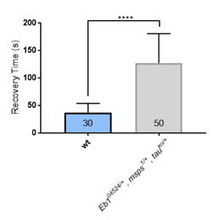**Fig. 2.** *Eb104524/+msps1/+tauko/+* triple heterozygous larvae display extended recovery time from electroshock. 30 wild-type and 50 *Eb104524/+msps1/+tauko/+* triple heterozygous larvae were electro-shocked at 3V revealing a mean difference in recovery time of **90.43**s (TRec-*wt*: 36.86 ± 16.84SD, TRec-*triple*: 127.3 ± 53.25SD; P<0.0001). Each bars shows the mean TRec, error bars indicate SD, **** p<0.0001

To test whether these seizure-like phenotypes are caused by typical epilepsy-linked mechanisms, I tested whether the anti-epileptic drugs (AEDs) Phenytoin and Valproate have an ameliorating effect. Phenytoin causes the inactivation of voltage-dependent Na+ channels (Rogawski and Loscher, 2004a). Valproate is an anti-epileptic drug and a mood stabiliser up-regulating GABAergic transmission and down-regulating voltage-dependent Na+ channels (Castro et al., 2005; Perucca, 2002). Importantly, both drugs were shown previously to suppress seizure-like phenotypes in genetic *Drosophila* epilepsy models .

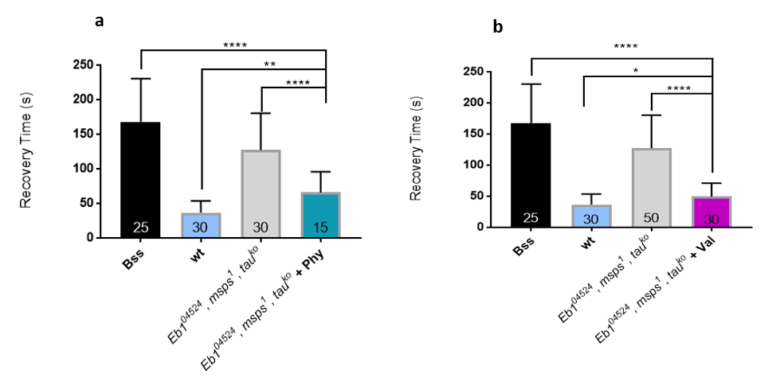When I applied Phenytoin and Valproate in the food at previously published concentration throughout larval life (see Methods for details), I found a significant decrease in TRec of *Eb104524/+msps1/+tauko/+* larvae with both drugs (Fig3.a,b). Mutant larvae fed with the AEDs are not completely cured relative to wild-type, but they are significantly reduced by ~ **51.7**% for phenytoin and ~**38.9**% for valproate (Fig3.b), as has similarly been reported for picrotoxin-treated larvae, which have seizure-like phenotype induced by this proconvulsant drug (Stilwell et al., 2006). This result provides a strong indication that prolonged seizures in *Eb104524/+msps1/+tauko/+* larvae reflect an epilepsy-like condition based on a novel mechanism that might be relevant to human health, too.

**Fig. 3: Antiepileptic drugs rescue seizure-like behaviour in triple heterozygous *Eb104524/+ msps1/+ tauko/+* larvae.** Both experiments use *parabss1* and Oregon-R larvae as controls. Reduced TRec of triple-heterozygous fed in phenytoin (a) and valproate (b) (n=15, n=30 respectively) compare to triple-heterozygous L3 larvae fed in standard cornmeal media (n=50). Each bars shows the mean TRec, error bars indicate SD, **** p<0.0001, ** p<0.01, * p<0.05. (TRec-*triple-cornmeal-media*: 127.3s ± 53.25SD, TRec-*triple-Phy*: 65.8s ± 30SD; PMW < 0.0001; Fig3.a) and (TRec-*triple-cornmeal-media*: 127.3s ± 53.25SD, TRec-*triple-Val*: 49.47s ± 21.68SD; PMW < 0.0001;TRec-*wt*: 36.86 ± 16.84, TRec-*triple-Phy*: 65.8s ± 30SD; PMW **= 0.0013**; Fig3.a) **and** (TRec-*wt*: 36.86 ± 16.84s, TRec-*triple-Val*: 49.47s ± 21.68SD; PMW **= 0.0388**)

* 1. Seizure-like behaviour are caused by aberrant MT networks.

Eb1, Tau and Msps are all MT-regulating proteins that are important for the maintenance of MT bundles (personal communication I.Hahn), suggesting that seizure-like phenotypes are caused by aberrant MT networks. To test this hypothesis, I fed low doses of the MT-stabilising drug Epothilone B (Nabors et al., 2016; Voelzmann et al., 2016)to ***Eb104524/+ msps1/+ tauko/+*** larvae throughout larval life (see Methods). In these experiments I observed a significant amelioration of the seizure-like phenotype by **44**% (Fig.4). However, the tested larvae have a TRec slightly enhanced compare to Oregon-R (wild-type) suggesting that the seizure-like phenotype is not completely rescued (Fig.4). These results support the hypothesis that seizure-like phenotype in *Drosophila* are due to MTs destabilisation and/or disorganisation.

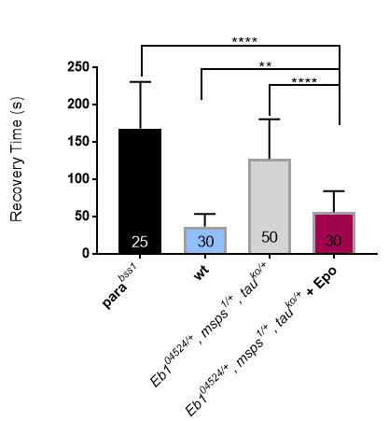

**Figure 4**: **Seizure-like phenotype of *Eb104524/+ msps 1/+ tauko/+* larvae rescued by Epothilone B.** *parabss1* and Oregon-R larvae were used as controls. (TRec-*triple-cornmeal-media*: 127.3s ± 53.25SD, TRec-*triple-EpoB*: **56.13**s ± 28.06SD; PMW < **0.0001**) and (TRec-*bss*: **168.1s** ± 62.33SED, TRec-*triple-EpoB*: : **56.13**s ± 28.06SD; PMW < **0.0001**) and (TRec-*wt*: 36.86 ± 16.84, TRec-*triple-EpoB*: **56.13**s ± 28.06SD; PMW = **0.0011**). Each bars shows the mean TRec, error bars indicate SD, **** p<0.0001, ** p<0.01.

Other MT regulator are the protein Tau and EFA6. Tau as a well-known MT regulator that contributes to MT assembly and stabilisation (Iqbal et al., 2005), its deletion is not lethal in *Drosophila* *(Burnouf et al., 2016)*. However, Tau gene is involved in several neurological diseases, also called tauopathies, such as Alzheimer Disease and is essential for the normal brain function of mammalian species. I found a significant increase in TRec of *tauko/tauko* compare to the wild-type, which is about ~**44**% (Fig.5)

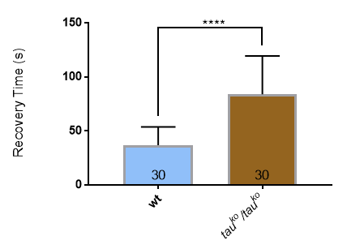

**Fig.5**: **Seizure-like phenotype is find in** ***tauko/tauko* larvae**. (TRec-*wt*: 36.86 ± 16.84, TRec-*tauko/tauko*: **83.77**s ± 35.58SD; PMW< **0.0001**). Each bars shows the mean TRec, error bars indicate SD, **** p<0.0001

I also tested if the epileptic-like phenotype can be caused by mutations affecting MT organisation via different mechanisms. EFA6 is a Guanine Nucleotide Exchange Factor (GEF) from the Arf family of GTPases. EFA6 is a membrane-associated protein that regulates MTs by eliminating polymerising MTs that reach the cortex, thereby regulating axonal growth, branching an bundle maintenance (Qu et al., 2018). I could observe that *Efa6-/-* mutants show a significant increase of seizure-like behaviour by ~**314**% (Fig.6). Surprisingly, the seizure-like phenotype in *efa6* mutants is quite severe: There is no significant difference between the Trec of *parabss1* and *efa6* mutant larvae. Moreover, mutants show an increase TRec compared to the triple-heterozygous *Eb104524/+ msps 1/+ tauko/+* by **20**%. Overall, my results suggest that mutations affecting other MTs regulators also cause a seizure-like phenotype.

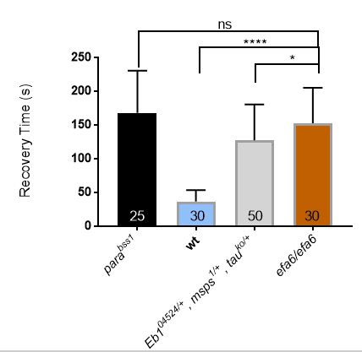

**Fig.6: Seizure-like behaviour in efa6- mutants.** After electroshock of 30 mutant larvae, recovery time was measured. efa6-/efa6- mutants have an enhanced TRec compare to those of Oregon-R larvae, double-heterozygous and triple-heterozygous larvae and a no significant difference of TRec when compared to *parabss1*. (TRec-*wt*: 36.86 ± 16.84, TRec- *efa6-/efa6*-: 152.6s ± 52.42SD; PMW < **0.0001**); (TRec-*parabss1*:, TRec- efa6-/efa6-: 152.6s ± 52.42SD; PMW = **0.5100**); (TRec- *efa6-/efa6*-: 152.6s ± 52.42SD, TRec- doubles-: 88.93 ± 37.78 SD; PMW < **0.0001**) and (TRec- *efa6-/efa6*-: 152.6s ± 52.42SD, TRec-*triples*-:127.3s ± 53.25SD; PMW < **0.05**). Each bars shows the mean TRec, error bars indicate SD, **** p<0.0001, * p<0.05, ns = no significant.

* 1. The cytoskeleton of motorneurons is implicated in seizure-like phenotype.

*Eb104524/+ msps1/+ tauko/+* triple-heterozygous larvae display true seizure-like phenotypes. However, mutations affecting these larvae are present in all the cells of the body. One of the aims of this study was to determine which subset of neurons are implicated in seizure-like phenotype in *Drosophila* larvae. For this, RNAi technique was applied in three different subsets of neurons to knocking-down *Eb1* using the UAS/Gal4 system, in which the Gal4 transcription factor is expressed specifically in one tissue and allow the transcription of a gene under the UAS control (Duffy, 2002).

Knocking down *Eb1* in **all neurons** of the L3 larvae CNS using an *elav* promoter led to a severe increase in recovery time by by **217**% in *elav-GAL4 UAS-Eb1-RNAi* compared to Oregon-R larvae (Fig.7a). We could expect to have a stronger phenotype in triple-heterozygous because they have three genes mutated which are important for MTs organisation. However, no significant difference was find between TRec of triple heterozygous and *elav-GAL4 UAS-Eb1-RNAi* larvae**.** This results suggests that *Eb1* are present in lower levels in *elav-GAL4 UAS-Eb1-RNAi* larvae compare to levels in the triple heterozygous. Thus, the RNAi used here is very efficient as previously tested in Prokop’s laboratory (Petzold, 2018) . For a more accurate result, MT disorganisation would have to be compared between triple-heterozygous and *Eb1-RNAi*, but I can speculate that MT disorganisation might be stronger in *elav-GAL4 UAS-Eb1-RNAi* larvae.

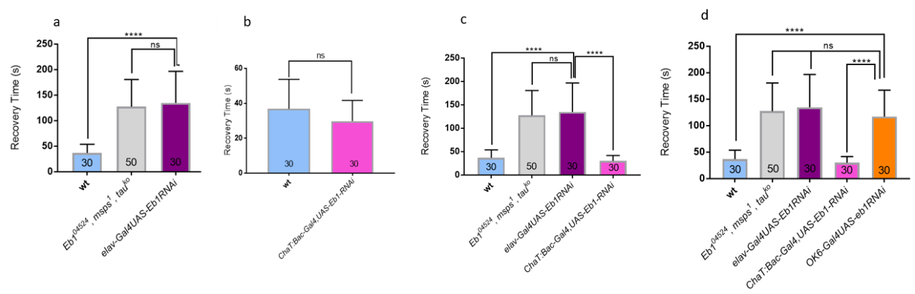

**Fig.7: Testing seizure-like phenotype in L3 larvae when Eb1-RNAi is applied in all the neurons of the CNS** (Fig.7a), **in cholinergic neurons** (Fig.7b) **and in motorneurons** (Fig.7c), (n=30) compare to Oregon-R and triple-heterozygous larvae (n=30 and n=50 respectively). When Eb1-RNAi is applied in all neurons (TRec-*wt*: 36.86 ± 16.84SD, TRec-*elav-GAL4UAS-Eb1RNAi* : 134.7s ± 61.8SD; Pvalue < **0.0001**) and (TRec-*triples*-:127.3s ± 53.25SD; TRec-*elav-GAL4UAS-Eb1RNAi* : 134.7s ± 61.8 SD; Pvalue = **0.5748**). For *Eb1-RNAi* in cholinergic neurons (TRec-*wt*: 36.86 ± 16.84SD, TRec-*ChaT:Bac-GAL4UAS-Eb1RNAi*: 29.83 ± 11.8SD; P value=**0.1064**) and (TRec-*elav-GAL4UAS-Eb1RNAi* :117 s ± 49.87SD, TRec-*ChaT:Bac-GAL4UAS-Eb1RNAi:* 29.83 ± 11.8 ; P value<0.0001). For Eb1-RNAi in motorneurons (TRec-*wt*: 36.86 ± 16.84SD, TRec-*OK6 -GAL4UAS-Eb1RNAi* :117 s ± 49.87SD; Pvalue < **0.0001**); (TRec-*triples*-:127.3s ± 53.25SD; TRec-OK6*-GAL4UAS-Eb1RNAi* : 117 s ± 49.87SD; Pvalue =**0.5416**). p value = **0.3298**) and(TRec-*elav-GAL4UAS-Eb1RNAi* :117 s ± 49.87SD, TRec-*OK6-GAL4UAS-Eb1RNAi:* 117 s ± 49.87SD ; P value =**0.3298**).Each bars shows the mean TRec, error bars indicate SD, **** p<0.0001, ns = no significant.

In order, to determine if a specific subset of neurons is inducing the seizure-like phenotype I tested knockdown of *Eb1* in cholinergic neurons and in motorneurons (Fig.7b, c).

I used *ChaT:Bac-Gal4,* which is specific to cholinergic neurons (Salvaterra and Kitamoto, 2001) to reduce EB1 levels in cholinergic neurons and found no significant increase in recovery time (TRec-*wt*: 36.86 ± 16.84SD, TRec-*ChaT:Bac-GAL4UAS-Eb1RNAi*: 29.83 ± 11.8SD; P value=0.1064). I could conclude that knocking-down of *Eb1* affects a subset of neurons different than cholinergic neurons.

In contrast,*Eb1* is knock-down specifically in motorneurons (via OK6-Gal4) led to an increase in TRec by 217% compare to Oregon-R. There is no significant difference between the TRec of *OK6-GAL4 UAS-Eb1-RNAi* and *elav-GAL4 UAS-Eb1-RNAi* larvae (Fig.7d), in which *Eb1* is mutated in every cells of the body. These results suggest that seizure-like phenotype in *elav-GAL4 UAS-Eb1-RNAi* larvae could be due to mutations affecting motorneuronal cells specifically. I could conclude that knocking-down in motorneurons is a major cause of seizure-like phenotype in *Drosophila* larvae.

* 1. There is no genetic interaction between loss of motor proteins and double-heterozygous mutants *msps 1/+ tauko/+* .

Kinesins are motor proteins involved in the anterograde transport of several cargoes, such as proteins, lipids, mRNA and others slong microtubules (Roy et al., 2005)(Fig.8). Mutations affecting kinesins and other transport proteins are the causes of developmental and neurodegenerative brain disorders (Prokop, 2013). **An accumulation of organelles** can be seen in larval axons in Khc8/8 (Gunawardena and Goldstein, 2001) and can be **lethal** (I.Hahn, personal communication). *Imac* is essential for the transport of synaptic vesicles precursors. Indeed, experimental evidence show that imac170 mutants have impaired synaptic boutons formation (Pack-Chung et al., 2007).

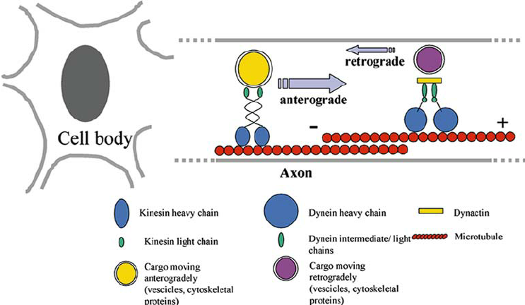**Fig.8** **Anterograde and retrograde axonal transport by motors kinesins and dyneins, respectively.** *“Anterograde and retrograde axonal transport by motors kinesins and dyneins, respectively. Kinesins and dyneins move on microtubules and transport Golgi-derived vesicles, cytosolic protein complexes, cytoskeletal polymers, and other cargos like ribosomes and messenger RNAs”* Taken from Roy, Zhang et al. 2005

This study is based on the main hypothesis that MT-regulators, affect organisation of MT bundles which leads to aberration in motor protein-dependent vesicle transport (K. Nakajima et al., 2012). My aim is to test this hypothesis by determining if whether or not *msps* and *Tau* mutants genetically interact with two types of kinesins, Khc8 and imac170, which can be implicated in the transport of GABA-R. Genetic interaction is defined as when mutations in two genes produce a phenotype that is higher than the phenotype produced by each mutation individually (Mani et al., 2008). Previous work in Prokop Lab did not found genetic interaction between genes implicated in MTs organisation (*Eb104524/+ ,msps 1/+ ,tauko/+*) and the two studied kinesins when mutated (Petzold, 2018). This experiments were done with triple-heterozygous mutants, which are already very severe and perhaps seizure-like behaviour cannot be enhanced. I tested seizure-like phenotype in *msps 1/+ tauko/+,* *Khc8* and *imac170* as controls. Each genotype had an enhanced TRec compare to control larvae by **141**%, **157**%, and **240**% respectively(Fig.9). Moreover, *Khc8/+*and *msps 1/+ tauko/+,* have similar TRec contrary to *Imac170* which have an increased TRec (Fig.10a,b). Indeed, *imac170/+* has a seizure-like phenotype as severe as the triple-heterozygous phenotype (Fig.10b).

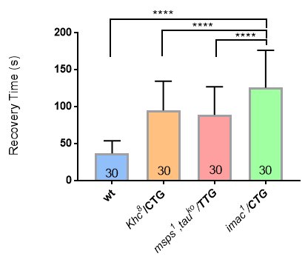

**Fig. 9: Seizure-like phenotype in *msps1/+, tauko/+*; *Khc8/+* and *imac170/+* larvae.** (TRec-*wt*: 36.86 ± 16.84SD, TRec-*msps1/+, tauko/+* : 88.93s ± 37.78SD; P MW< **0.0001**), (TRec-*wt*: 36.86 ± 16.84SD, TRec-*Khc8/+*: 94.8s ± 39.41SD; PMW< **0.0001**) and (TRec-*wt*: 36.86 ± 16.84SD, TRec-*imac170/+*: 125.5s ± 50.5SD; PMW < **0.0001**). Each bars shows the mean TRec, error bars indicate SD, **** p<0.0001, * p<0.05, ns = no significant.

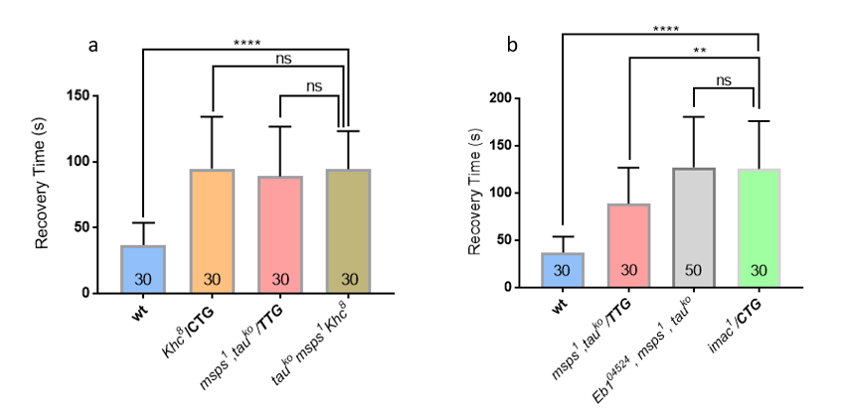

**Fig.10 Testing genetic interactions between genes encoding MT-regulators and genes encoding kinesins.** *Khc8*, *imac170* and *msps1/+*, tauko/+ are the control genotypes showing seizure-like phenotypes (Fig.9). (TRec- *Khc8/+*: 94.8s ± 39.41SD, TRec-*msps1/+, tauko/+* : 88.93s ± 37.78SD; P MW = **0.52**), (TRec-*imac170/+*:125.5s ± 50.5SD, TRec-*msps1/+, tauko/+* : 88.93s ± 37.78SD; P MW = **0.0029**), (TRec-*imac170/+*:125.5s ± 50.5SD, TRec- TRec-*triples*-:127.3s ± 53.25SD; P MW = **0.9390**). **No Genetic interactions** **between *khc8/+/CTG*and *msps-, tauko/TTG (a)***: (TRec- *msps1/+, tauko/+* *Khc8/+*: 94.27s ± 28.99SD, TRec-*wt*: 36.86 ± 16.84SD; P MW <0.0001), (TRec- *msps1/+, tauko/+* *Khc8/+*: 94.27s ± 28.99SD, TRec- *Khc8/+*: 94.8s ± 39.41SD; PMW **=0.8001**), (TRec- *msps1/+, tauko/+* *Khc8/+*: 94.27s ± 28.99SD, TRec- *imac170/+*:125.5s ± 50.5SD; PMW **= 0.4041**). **No genetic interaction between** ***imac170 /CTG* and *msps-, tauko/TTG (b):*** (TRec- *msps1/+, tauko/+ imac170*: 131.4s ± 61.49SD, TRec-*wt*: 36.86 ± 16.84SD; P MW <0.0001), (TRec- *msps1/+, tauko/+ imac170*: 131.4s ± 61.49SD, TRec-*imac170/+*:125.5s ± 50.5SD;PMW= **0.8573**), TRec- *msps1/+, tauko/+ imac170*: 131.4s ± 61.49SD, TRec-*msps1/+, tauko/+* : 88.93s ± 37.78SD; P MW = **0.0031**). Each bars shows the mean TRec, error bars indicate SD, **** p<0.0001, ** p<0.01, ns = no significant.

Even though I found a significant increase in TRec of ***msps1,tauko* and *Khc8/+*** larvae compared to Oregon-R, there is no significant increase in TRec of ***msps1,tauko*, *Khc8/+*** triple heterozygous mutants and the two controls genotypes ***msps1,tauko*** and ***Khc8/+*** (Fig.10a). These results suggest that larvae resulting from the cross have a seizure-like phenotype, but there is no genetic interaction between ***msps1,tauko*** and ***Khc8/+***.

Similary, even though*imac170; msps1,tauko* show a seizure-like phenotype (Fig10b) there was no significant difference was found between TRec of *imac170* and *imac170; msps1,tauko* larvae(Fig.10b). Thus, there is no genetic interaction between both genotypes.

As no genetic interaction was found between both MT regulators and transport motors, we chose an alternative experiment to test this. I wanted to test if overexpression of the molecular motor imac could improve potential transport-dependent seizures in *taudef* mutants. I could previously show that ***tauko/ko*** larvae have a seizure-like phenotype and tried to show the same for ***taudef/def***. However, I found that ***taudef/taudef***larvae are lethal and I could therefore not test this hypothesis. According to some researches in FlyBase data base, Taudef (MR22) uncovers apart from ***tau*** eleven other genes that are eliminated and lethality could be due to loss of one of these genes. Three of them can show lethality in homozygosity: ***Pins***gene is important for *Drosophila* cell cycle, proliferation, cell organisation, development and other mechanisms. Homozygous mutations can be lethal just before the end of pupal stage. ***Rps10a***gene encoding a cytoplasmic small ribosomal protein and show lethality if homozygous mutations. ***WDB19***, is recessive lethal and is a protein phosphatase activator and determines the adult lifespan (FlyBase, 2019).

* 1. Genetic interaction between proteins implicated in MTs organisation and the GABAA receptor.

As explained previously, my aim is to test whether the GABAA-R localisation is impaired in presence of mutations affecting genes important for MT organisation.

***Rdl*** *(Resistant to Dieldrin)* gene belongs to the group of **GABA-gated Chloride channel subunits and are widely expressed in** *Drosophila*CNS (Mcgonigle and Lummis, 2009). Is a gene coding to a specific protein called GABAA receptor. Rdl is crucial in the mediation of synaptic inhibition and regulates cellular excitability. In the case of insects, GABA is the principal neurotransmitter and when binding to Rdl, it leads to the opening of a specific pore allowing the passage of chloride anions leading to hyperpolarization and decrease excitability (Galanopoulou, 2008) This experiment suggests that when mutated, the Rdl protein expression decreases and neuronal transmission cannot be controlled and reduced anymore, leading to seizure-like behaviour when electroshock stimulations.

I found that Rdl1/+ mutants display a seizure-like phenotype; their TRec is enhanced by ~**63.4**% compare to wild-type larvae. Additionally, ***msps/+-, tauko/+*** larvae has a more severe seizure-like phenotype compare to Rdl1/+ mutants by ~**28.7**% (Fig.11).

Uma imagem com objeto, relógio

Descrição gerada com confiança muito alta

**Fig.11** Seizure-like phenotype is seen in Rdl1/+ mutants. Rdl1/+ mutants phenotype is enhanced compare to Oregon-R but inferior to ***msps-/+, tauko/+***: (TRec- Rdl1/+: 60.23s ± 19.16SD, TRec- TRec-*wt*: 36.86 ± 16.84SD; PMW <**0.0001**), (TRec- Rdl1/+: 60.23s ± 19.16SD, TRec-*msps1/+, tauko/+* : 88.93s ± 37.78SD; P MW = **0.52**). Each bars shows the mean TRec, error bars indicate SD, **** p<0.0001, ** p<0.01.

**Genetic interaction is found between *Rdl1/+* and the double mutants *msps1/+tauko/+***

When combined, *Rdl1/+; msps1/+,tauko/+* larvae have a significantly enhanced TRec by~111% compare to *Rdl1/+* mutants (Fig12.) and by ~43% compare to the double-heterozygous. I could conclude that there is a genetic interaction between both genotypes. Overall, my result suggest that this genetic interaction could potentially be a new model using *Drosophila* to understand possible causes of epilepsy.

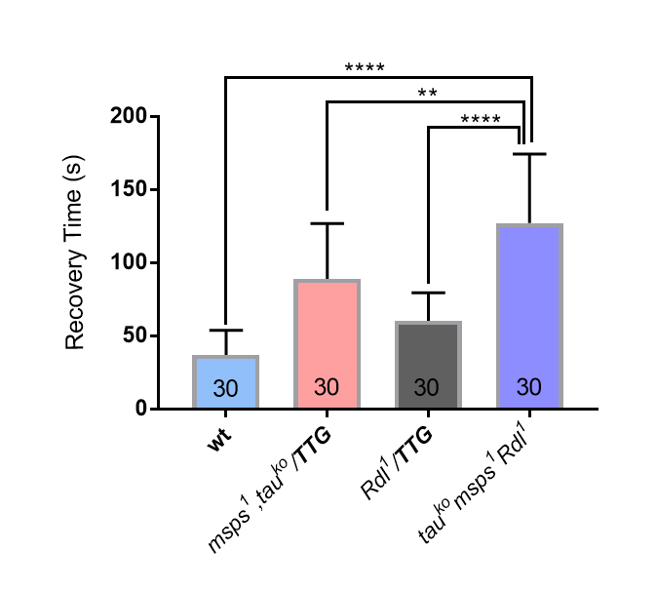

**Fig.12: *Rdl1/+* and *msps1/+*,*tauko/+* genotypes interact causing severe seizure-like phenotype.** (TRec- *Rdl1/+; msps1/+,tauko/+*: 127.1s ± 47.16SD, TRec- Rdl1/+: 60.23s ± 19.16SD; PMW <**0.0001**)**,** TRec- *Rdl1/+; msps1/+,tauko/+*: 127.1s ± 47.16SD, TRec-*msps1/+, tauko/+* : 88.93s ± 37.78SD; PMW **=0.0022**)

* 1. Immunohistochemistry: RDL is located in neuropils and in cell bodies of OK6Gal4>Rdl-HA and motorneurons.

Because no genetic interactions were found with the studied kinesins the exact transport mechanism of Rdl is not yet determine, for this reason an immunohistochemistry assay was realised in order to determine the location of Rdl in control larvae and in triple-heterozygous. If location of this receptor varies between both types of larvae, it could suggest that there is actually an impairment in the transport of Rdl.

Insect neurones represent a big advantage in neuroscience studies because they are easily detectable and can be recognised individually. Synaptic area is also well defined and neurites are precisely located by mapping the neuronal projections into the neuropil using staining, such as Fasciclin II (Landgraf et al., 2003). Fasciclin II is a cell membrane glycoprotein of *Drosophila* corresponding to NCAM in vertebrates, which has an important role in CNS formation: neuronal differentiation, axonal growth, and synaptic formation (Kristiansen and Hortsch, 2010). Fasciclin II is recognised by α-Fasciclin II antibodies, which remain stable and constant over time. These specific antibodies are used to understand where neuropils are situated, which are defined as the synaptic areas (Landgraf et al., 2003). Thanks to Fasciclin II staining, it was discovered that the neuropil is fragmented into several regions, which develop during the embryonic stage and are remain until the larval stages(Landgraf et al., 2003).

I determined the localisation of Rdl receptors in motorneurons by expressing *UAS-Rdl-HA* using Ok6-Gal4. The HA tag allows me to detect Rdl protein localisation using a α-HA antibody. HA is a surface glycoprotein from the Human influenza hemagglutinin virus A and is used as a epitope tag to facilitated protein purification and detection without interfering with proteins bioactivity and distribution (Schembri et al., 2007). I co-stained Fasciclin II, Fas II and the HA staining and I could conclude that in control and triple-heterozygous brains Rdl is located in the synaptic area of the ventral nerve cord, in which motorneurons form synapsis with CNS neurons and transmit action potential to the muscles of the entire body (Fig.13 a,c). Rdl is also localised in the cells bodies of motorneurons (Fig.13, a). These results are in agreement with previous works realised in Prokop’s Laboratory. Enell et *al*. also found that Rdl receptors are present in majority in synaptic neuropils and play an important role for rapid GABA inhibitory transmission (Enell et al., 2007). If transport of Rdl is impaired I would have expected a HA staining with higher intensity in cell bodies in *Eb104524/+ msps 1/+ tauko/+* *;* OK6Gal4>Rdl-HA larvae compared to controls. However, I could not notice any obvious difference in the staining of both genotypes and the sample number was very small to calculate significative ratios between the intensity transmitted in the neuropil and in cell bodies. In order to determine whether there is a difference between the brains of both genotypes this experiments should be repeated in future experiments with a more accurate method of quantification potentially by including the expression of a membrane marker.

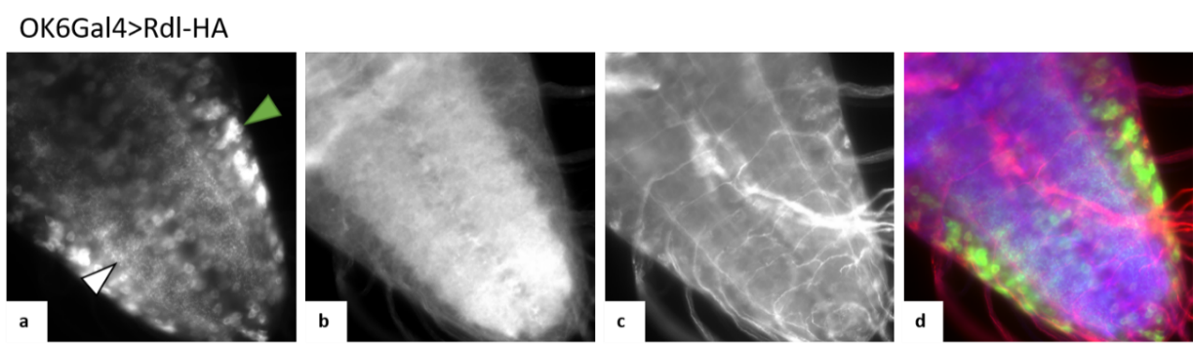Uma imagem com animal, invertebrado, verme

Descrição gerada com confiança muito alta

**Fig.13: Rdl localisation in both cell bodies and neuropil in *OK6-GAL4 UAS-Rdl-HA*** **and *Eb104524/+ msps 1/+ tauko/+* *;* OK6Gal4>Rdl-HA larvae.** The ventral nerve cord is illustrated for both genotypes (magnification X40). **A.** Rdl localisation in the ventral nerve cord determined by α-HA staining. Rdl localised in the dendritic area or neuropil (white arrow), and in cell bodies (green arrow) **B.** Actin as stained for phalloidin. **C.** Neuropil region stained for α-Fas II. **D.** Composite.

1. Discussion

The aim of this study was to determine whether MT regulators, such as the proteins Eb1, Msps, ans tau, induce epilepsy-like phenotypes in *Drosophila* and explore the potential mechanism behind this.

* 1. Main Achievements

I could assess a true epileptic-like behaviour caused by the triple-heterozygote *Eb1-msps-tau* constellation when using the AEDs, Phenytoin and Valproate, in triple heterozygous larvae. A number of experiment show that this epileptic-like condition is mediated by MTs: First, mutations affecting Efa6, a factor eliminating MTs at the cortex and causing MT disorganisation when absent (Qu et al., 2018), also cause a seizure-like phenotype. Second, MTs stabilisation with Epothilone B reduces seizure-like phenotype, which emphasise that MT aberration is the potential cause of seizure-behaviour in *Drosophila.* Also previous studies state that seizure-like phenotypes can be due to MT-regulators defects, such as mutations affecting MT-associated proteins MAP1A and MAP2 (Ballough et al., 1995; Duncan et al., 2013; Gardiner and Marc, 2009; Holth et al., 2013; Hurd et al., 1996; K. Nakajima et al., 2012; Zemlyak et al., 2009). My experiments with neuron-specific knock-down of Eb1 show that the seizure-like phenotype originates in motorneurons, which have pronounced dendrites localising Rdl channels proteins (Sánchez-Soriano et al., 2005). Accordingly, loss of *Rdl* causes a seizure like phenotype, which can be enhanced when in conjugation with the double heterozygous genotype msps1/+, tauko/+, i.e. revealing genetic interaction as a potential indication that these genes are functionally interlinked. However, no genetic interactions were found between genes encoding kinesins (*Khc8* and *imac170*) when combined with *msps1/+ tauko/+*, which fails to support (but does not exclude) our working hypothesis that MT aberration affects Rdl transport as the underlying mechanism for seizure-like behaviours. Furthermore, using immunohistochemistry, I could determine Rdl location in the CNSs of control and triple-heterozygous L3 larvae. Rdl is located in the synaptic area (neuropil), but also in the cell bodies of motorneurons; unfortunately, there is no obvious difference in protein location between both genotypes, although more accurate methods of protein quantification should be applied to make a solid statement. In conclusion, there is a strong case for roles of MTs and MT regulators in the development of epilepsy-like conditions, but the mechanisms stay inconclusive at the moment.

**Uma imagem com texto, mapa

Descrição gerada com confiança muito alta**

**Fig.14: Summary - Project main hypothesis.** Axon structural backbone is the hallmark of neurons and is maintained by numerous proteins, such as *Eb1*, *Msps* and *tau*. Mutations affecting these genes cause MT disorganisation leading to axonal swelling, which disrupt the anterograde movement of motor proteins such as kinesins (*Khc8* or *imac170*). Consequently, the transport of Rdl receptors is reduced to the dendritic area displaying a seizure-like phenotype in *Drosophila* larvae third instar larvae. Adapted from (Prokop, 2016).

* 1. Technical challenges of the electroshock assay

The sample size is an important factor to be taken into consideration and can be determined with statistical methods, such as a Power Test. However, no statistical test was done to determine the number of larvae from each genotype. The sample size of my experiments were based on previous studies done by Giachello and Baines, which also performed electroshock experiments with a sample size between 25 and 50 larvae. The actual probe employed during my experiments was not used for approximately one year. Thus, values could deviate from the previous experiments (Petzold, 2018). The probe contains two wires and the distance between those is variable and could influence the measures. The probe is very delicate and even slight deformation can have an influence on the results. Current propagation can be influenced also if the tissue is wet; for this reason the larval tissue should be dried before the electrical procedure and only third Instar larvae of consistent size should be collected. The **TRec** corresponds to the moment when the larvae re-start to have a continuous peristaltic movement from its posterior to the anterior part of the body (Marley and Baines, 2011). However, it is sometimes difficult to determine this moment because some larvae can have just half of their body paralysed, or some contractions can appear during paralysis in a continuous and un-controlled manner. Thus, the electroshocking procedure is a very subjective and variable experiment. Other external factors can influence the results, such as the room, water, and microscope temperature. Indeed, larvae react badly to cold temperatures and can have a decreased locomotion when in presence of cold temperatures. Indeed, larvae react badly to cold temperatures and can have a decrease locomotion when in presence of cold temperatures. Larvae having locomotion deficiencies and not specific seizure-like phenotypes can present a prolonged TRec. For this reason, this assay has to be done with larvae having a well-defined genotype inducing seizure-like behaviour (Carlo Giachello personal statement). Furthermore, the procedure can be very time consuming. The TRec has to be measured for each larva and is generally difficult to be assessed. Moreover, as stated by Marley and Baines: “experimental validity of using *Drosophila* for human epilepsy research is incomplete” because the exact molecular mechanism behind seizure-like models is not well defined (Marley and Baines, 2011). For this reason, the fruit fly as a model cannot yet overcome this challenge.

* 1. To get a more accurate electroshock assay

Electroshock assays were implemented by other research groups using different model organisms, such as worms and mice (Risley et al., 2016; Swinyard et al., 1952) and are also important in testing AED effectiveness (Brown et al., 1953). Genetic tools can be used to create a more accurate and robust electroshock as described is previous works (Petzold, 2018). Previous experiments that were confirmed in this work were based in *Eb1* knock-downin three sets of neurones. The same experiment can be repeated by knocking-down others studied genes, *Msps* and *tau* using specific RNAi technique and see whether or not seizure-like phenotype is induced. Other genes important for MT regulation can also be tested on their ability of inducing seizure-like phenotype in *Drosophila* when mutated. High precision genome editing can be applied, such as CRISPR-CAS9 (Komor et al., 2017), and the FLP/FRT (Golic and Lindquist, 1989) technologies which target specific sites of the genome (Sigrist, 2009).

Alzheimer disease (AD) and epilepsy are closely linked diseases, patients with AD have an increase likelihood to develop epilepsy (Pandis and Scarmeas, 2012). This can be due to physiological mechanisms shared by both diseases. Indeed, Tau is an important protein implicated in MT stabilisation and tauko/ko mutants display a seizure-like phenotype. Mutations affecting Tau lead to diseases called tauopathies, such as AD (Miranda and Brucki, 2014). I can hypothesise that MT destabilisation is a potential cause of epileptic-like phenotypes and AD.

1. **Conclusion and future directions:**

Human epilepsy is complex to both diagnose and treat because it can results from multiple unknown causes (Marley and Baines, 2011). *Drosophila* as an animal model because it is cheap to handle, stock and manipulate compare to mammals. Among the 75% of fly genes causing disease in humans when mutated (Von Bergen et al., 2005) are genes displaying seizures (Jin et al., 2005). A potential cause of seizure-like phenotype in *Drosophila* can be due to mutations affecting genes crucial for MTs bundling and organisation, resulting in an impaired transport of kinesins along MTs resulting in aberrant GABA-R localisation in the larval CNS. By extrapolation, idiopathic epilepsy in humans could also be caused by several mutations affecting MTs regulators proteins affecting RDL-transport proteins. This work provides initial information for future studies, which focus mostly on the potential mechanisms causing seizure-like behaviour in *Drosophila* L3 larvae.

First, *Efa6-/-* mutant, *tau-RNAi*, *msps-RNAi* and *Eb1-RNAi* larvae could be tested with the MT-stabilising drug Epothilone B to see if there is an improvement of seizure-like phenotype. If so, this would provide a more general statement that MTs play a role in seizure-like behaviour. In contrast, *Rdl-RNAi* larvae could be tested as controls, since we would not expect a MT-stabilising drug to show any effect on this condition.

Mutations on genes encoding tubulin can have an effects on MTs polymerization and/or stability, but they can also have an influence on the interaction of MTBP – Microtubules Binding Proteins and transport proteins, such as kinesins (Niwa et al., 2013). Indeed, one of the aim of this project is to determine if there are mutations in other genes than *Eb1, msps, tau* and *kinesin 1*, that can cause seizure-like phenotypes. Niwa et al. found mutations affecting tubulin genes, TUBB3E410K and TUBB3D417H resulting in reduced ability of different types of kinesins to move along axons and transport cargoes. It could be interesting to find analogues of tubulin genes in drosophila producing the same phenotype when mutated.

Second, genetic interaction can be tested with other kinesins such as KIF21B, which is MT-associated motor highly expressed in the CNS. Experimental data suggests that KIF21B participates in the delivery of GABAA-R transport vesicles into dendrites (Labonte et al., 2014). Thus, GABAA-R should be quantified by immunohistochemistry in KIF21B-KO mutant larvae CNS, more specifically in dendritic area. KIF21B Genetic interaction can also be tested between KIF21B and *Eb1*, *msps*, *tau* genes.

For a more accurate analysis of GABA system in the context of epilepsy, we can test Phenytoin and Valproate capacity of rescuing the seizure-like phenotype of *Rdl1* mutants. Because my initial hypothesis is about GABA-R transport to synaptic sites in dendrites, future research can be done to study specifically GABAergic systems. Phenobarbital, for example, blocks GABAA receptors (Rogawski and Loscher, 2004a) and act by enhancing GABA-R current. Vigabatrin and Tiagabine are GABA-mimetic drugs and inhibit GABA transaminase, an enzyme specialised in the degradation of GABA (Greenfield, 2013). Moreover, BZs increases the GABA inhibitory capacity in post-synaptic clef (Greenfield, 2013). Benzodiazepine is a commonly used anti-seizure drug acting in GABA-R (Rogawski and Loscher, 2004a). GAT1(GABA transporter) inhibitors or GABA reuptake inhibitors, such as Tiagabine, can be tested and their capacity to reduce TRec assessed. If there is a significant improvement of seizure-like phenotype in *Drosophila* larvae it can represent a very important step in the understanding of potential causes of epilepsy.

Moreover, seizure-like phenotype of *Efa6-/-* mutants can be due to the interaction between the mutated protein EFA6 with MTs but it can also be caused by the interaction that this protein has with a K+ channel called TWIK-1, which is found in humans and two similar genes in *Drosophila* (Decressac et al., 2004; Döring et al., 2006). EFA6 interacts with TWIK-1 only if this last one is in interaction with ARF6 and this interaction is important for the K+ channel recycling. It was shown that mutations affection TREK-1 mice make them be more susceptible to ischemia and epilepsy (Heurteaux et al., 2004). It might therefore be that mutations affecting Efa6 have an impact on K+ channel leading to seizure-like phenotypes in *Drosophila.*

To conclude, epilepsy is a very common neurological disorder but difficult to treat and diagnose because of the number of causes, genetic or environmental, that can be the origin of the disease (Marley and Baines, 2011). The molecular mechanisms of this disease are still insufficiently known. However, based on an electroshock assay, I could confirm that seizure-like phenotype in *Drosophila* third instar larvae are due to mutations affecting MT-regulators, which can be rescued by anti-epileptic or MT-stabiliser drugs. The affected genes are therefore potential candidates linked to seizures also in humans. The molecular mechanism involving Kinesins and Rdl remains to be elucidate. It is very difficult to have exact conclusion in studies about epilepsy because molecular mechanism all more closely linked than expected. Experimental evidence shows that one of the subunits of GABA-R encoded by *Rdl* is regulated by WAKE, which the circadian oscillator important to Rdl localisation in the plasma membrane (Macdonald and Rogers, 2017). MacDonald and Rogers also determined that Rdl is implicated in a cascade with other elements: Rdl inhibits *Kcc* (a transmembrane transporter) which can supress *paralytic (para)* the gene mutated in the studied *parabss1* larvae, which encodes a voltage-gated sodium channels. Thus, I could hypothesise that mutations in genes important for MT regulation and bundling, such as *Eb1*, *Msps*, and *tau* can have an effect on Rdl location leading to a disruption of this cascade, which is a potential cause of seizure-like phenotype in *Drosophila*. This study provides a framework to carry out future experiments in order to develop our understanding of the molecular mechanisms at the basis of seizure phenotypes. Extending information about the potential cellular, molecular and genetic causes is crucial for the development of therapies for the prevention and the cure of epilepsy (Loscher, 2002). New AEDs are being developed meeting safety and effectiveness criteria and tested in their capacity to reduce epileptogenesis (Hernandez, 1997). In the future this study can have experiments dedicated in the use of other AEDs to test their efficacy in reducing seizure-like phenotype and their safety.

Acknowledgements

I would like to express my deep gratitude to Professor Andreas Prokop, who allowed me to realise this project and for his patient guidance, encouragement and useful critiques of this research work. I would also like to thanks Dr. Ines Hans for her guidance from the beginning to the end of this project, her patient and assistance in keeping my progress on schedule. My grateful thanks are also for the members of the Prokop laboratory, who have been super welcoming, for their advice and enthusiasm. Moreover, I would like to extend my thanks to the Manchester fly facilities members, particularly Sanjai Patel for his patient, motivation, and support on working with Drosophila. Finally, I would like to thanks Dr. Carlo Giachello for his advice and additional information concerning the electroshock procedure, Natalia Sanchez Soriano, for her suggestions and for the Epothilone B drug; The Blooming Stock, Richard Baines, H. Ohkura, and L. Partdridge for fly stocks.

**References**

Aridon, P., Marini, C., Di Resta, C., Brilli, E., De Fusco, M., Politi, F., Parrini, E., Manfredi, I., Pisano, T., Pruna, D., Curia, G., Cianchetti, C., Pasqualetti, M., Becchetti, A., Guerrini, R. & Casari, G. (2006). 'Increased sensitivity of the neuronal nicotinic receptor alpha 2 subunit causes familial epilepsy with nocturnal wandering and ictal fear', *Am J Hum Genet,* 79(2), pp. 342-50.

Baines, R. A., Giachello, C.N.G. and Lin W-H. (2017). 'Drosophila', in Asla Pitkänen, P. B., DVM, PhD, Aristea S Galanopoulou, Solomon L. Moshé (ed.) *Models of Seizures and Epilepsy.* Second Edition ed: Elsevierpp. 345-355.

Ballough, G. P. H., Martin, L. J., Cann, F. J., Graham, J. S., Smith, C. D., Kling, C. E., Forster, J. S., Phann, S. & Filbert, M. G. (1995). 'Microtubule-Associated Protein 2(Map-2) - a Sensitive Marker of Seizure-Related Brain-Damage', *Journal of Neuroscience Methods,* 61(1-2), pp. 23-32.

Bellen, H. J., Tong, C. & Tsuda, H. (2010). '100 years of *Drosophila* research and its impact on vertebrate neuroscience: a history lesson for the future', *Nat Rev Neurosci,* 11(7), pp. 514-522.

Bonello, M., Michael, B. D. & Solomon, T. (2015). 'Infective Causes of Epilepsy', *Semin Neurol,* 35(3), pp. 235-44.

Brown, W. C., Schiffman, D. O., Swinyard, E. A. & Goodman, L. S. (1953). 'Comparative Assay of Antiepileptic Drugs by Psychomotor Seizure Test and Minimal Electroshock Threshold Test', *Journal of Pharmacology and Experimental Therapeutics,* 107(3), pp. 273-283.

Burnouf, S., Gronke, S., Augustin, H., Dols, J., Gorsky, M. K., Werner, J., Kerr, F., Alic, N., Martinez, P. & Partridge, L. (2016). 'Deletion of endogenous Tau proteins is not detrimental in Drosophila', *Scientific Reports,* 6.

Castro, L. M., Gallant, M. & Niles, L. P. (2005). 'Novel targets for valproic acid: up-regulation of melatonin receptors and neurotrophic factors in C6 glioma cells', *J Neurochem,* 95(5), pp. 1227-36.

Charlier, C., Singh, N. A., Ryan, S. G., Lewis, T. B., Reus, B. E., Leach, R. J. & Leppert, M. (1998). 'A pore mutation in a novel KQT-like potassium channel gene in an idiopathic epilepsy family', *Nat Genet,* 18(1), pp. 53-5.

Cobb, S. (1932). 'CAUSES OF EPILEPSY', *Archives of Neurology & Psychiatry,* 27(5), pp. 1245-1263.

Decressac, S., Franco, M., Bendahhou, S., Warth, R., Knauer, S., Barhanin, J., Lazdunski, M. & Lesage, F. (2004). 'ARF6-dependent interaction of the TWIK1 K+ channel with EFA6, a GDP/GTP exchange factor for ARF6', *EMBO Rep,* 5(12), pp. 1171-5.

Döring, F., Scholz, H., Kühnlein, R. P., Karschin, A. & Wischmeyer, E. (2006). 'Novel *Drosophila* two-pore domain K+ channels: rescue of channel function by heteromeric assembly', *Europ J Neurosci,* 24(8), pp. 2264-74.

Duffy, J. B. (2002). 'GAL4 system in *Drosophila*: a fly geneticist's Swiss army knife', *Genesis,* 34(1-2), pp. 1-15.

Duncan, J. E., Lytle, N. K., Zuniga, A. & Goldstein, L. S. (2013). 'The microtubule regulatory protein Stathmin is required to maintain the integrity of axonal microtubules in *Drosophila*', *PLoS One,* 8(6), p. e68324.

Ejsmont, R. & Hassan, B. (2014). 'The little fly that could: wizardry and artistry of *Drosophila* genomics', *Genes,* 5(2), pp. 385-414.

Elliott, S. L., Cullen, C. F., Wrobel, N., Kernan, M. J. & Ohkura, H. (2005). 'EB1 is essential during Drosophila development and plays a crucial role in the integrity of chordotonal mechanosensory organs', *Molecular Biology of the Cell,* 16(2), pp. 891-901.

Enell, L., Hamasaka, Y., Kolodziejczyk, A. & Nassel, D. R. (2007). 'gamma-Aminobutyric acid (GABA) signaling components in Drosophila: immunocytochemical localization of GABA(B) receptors in relation to the GABA(A) receptor subunit RDL and a vesicular GABA transporter', *J Comp Neurol,* 505(1), pp. 18-31.

Galanopoulou, A. S. (2008). 'GABA(A) receptors in normal development and seizures: friends or foes?', *Curr Neuropharmacol,* 6(1), pp. 1-20.

Gardiner, J. & Marc, J. (2009). 'Disruption of normal cytoskeletal dynamics may play a key role in the pathogenesis of epilepsy', *Neuroscientist*.

Golic, K. G. & Lindquist, S. (1989). 'The Flp Recombinase of Yeast Catalyzes Site-Specific Recombination in the Drosophila Genome', *Cell,* 59(3), pp. 499-509.

Greenfield, L. J. (2013). 'Molecular mechanisms of antiseizure drug activity at GABA(A) receptors', *Seizure-European Journal of Epilepsy,* 22(8), pp. 589-600.

Gunawardena, S. & Goldstein, L. S. (2001). 'Disruption of axonal transport and neuronal viability by amyloid precursor protein mutations in Drosophila', *Neuron,* 32(3), pp. 389-401.

Hahn, I., Ronshaugen, M., Sánchez-Soriano, N. & Prokop, A. (2016). 'Functional and genetic analysis of spectraplakins in *Drosophila*', *Methods Enzymol,* 569, pp. 373-405.

Hahn, I., Voelzmann, A., Liew, Y.-T., Costa-Gomes, B. & Prokop, A. (2019). 'The model of local axon homeostasis - explaining the role and regulation of microtubule bundles in axon maintenance and pathology ', *bioRxiv*, p. 10.1101/577320

Halfon, M. S., Gisselbrecht, S., Lu, J., Estrada, B., Keshishian, H. & Michelson, A. M. (2002). 'New fluorescent protein reporters for use with the Drosophila Gal4 expression system and for vital detection of balancer chromosomes', *Genesis,* 34(1-2), pp. 135-8.

Hernandez, T. D. (1997). 'Preventing post-traumatic epilepsy after brain injury: weighing the costs and benefits of anticonvulsant prophylaxis', *Trends Pharmacol Sci,* 18(2), pp. 59-62.

Heron, S. E., Scheffer, I. E., Berkovic, S. F., Dibbens, L. M. & Mulley, J. C. (2007). 'Channelopathies in idiopathic epilepsy', *Neurotherapeutics,* 4(2), pp. 295-304.

Heurteaux, C., Guy, N., Laigle, C., Blondeau, N., Duprat, F., Mazzuca, M., Lang-Lazdunski, L., Widmann, C., Zanzouri, M., Romey, G. & Lazdunski, M. (2004). 'TREK-1, a K+ channel involved in neuroprotection and general anesthesia', *EMBO J,* 23(13), pp. 2684-95.

Holth, J. K., Bomben, V. C., Reed, J. G., Inoue, T., Younkin, L., Younkin, S. G., Pautler, R. G., Botas, J. & Noebels, J. L. (2013). 'Tau loss attenuates neuronal network hyperexcitability in mouse and *Drosophila* genetic models of epilepsy', *J Neurosci,* 33(4), pp. 1651-9.

Howlett, I. C., Rusan, Z. M., Parker, L. & Tanouye, M. A. (2013). 'Drosophila as a Model for Intractable Epilepsy: Gilgamesh Suppresses Seizures in para(bss1) Heterozygote Flies', *G3-Genes Genomes Genetics,* 3(8), pp. 1399-1407.

Hurd, D. D., Stern, M. & Saxton, W. M. (1996). 'Mutation of the axonal transport motor kinesin enhances *paralytic* and suppresses *Shaker* in *Drosophila*', *Genetics,* 142(1), pp. 195-204.

Iqbal, K., Alonso, A. D. C., Chen, S., Chohan, M. O., El-Akkad, E., Gong, C. X., Khatoon, S., Li, B., Liu, F., Rahman, A., Tanimukai, H. & Grundke-Iqbal, I. (2005). 'Tau pathology in Alzheimer disease and other tauopathies', *Biochimica Et Biophysica Acta-Molecular Basis of Disease,* 1739(2-3), pp. 198-210.

Jin, X., Sun, X. & Song, Q. (2005). 'Woc gene mutation causes 20E-dependent alpha-tubulin detyrosination in *Drosophila melanogaster*', *Arch Insect Biochem Physiol,* 60(3), pp. 116-29.

Komor, A. C., Badran, A. H. & Liu, D. R. (2017). 'CRISPR-Based Technologies for the Manipulation of Eukaryotic Genomes (vol 168, pg 20, 2017)', *Cell,* 169(3), pp. 559-559.

Kristiansen, L. V. & Hortsch, M. (2010). 'Fasciclin II: the NCAM ortholog in Drosophila melanogaster', *Adv Exp Med Biol,* 663, pp. 387-401.

Kroll, J. R., Saras, A. & Tanouye, M. A. (2015). '*Drosophila* sodium channel mutations: Contributions to seizure-susceptibility', *Exp Neurol,* 274(Pt A), pp. 80-7.

Kwan, P. & Brodie, M. J. (2000). 'Early identification of refractory epilepsy.', *New England Journal of Medicine,* 342(5), pp. 314-319.

Labonte, D., Thies, E. & Kneussel, M. (2014). 'The kinesin KIF21B participates in the cell surface delivery of gamma2 subunit-containing GABAA receptors', *Eur J Cell Biol,* 93(8-9), pp. 338-46.

Landgraf, M., Sanchez-Soriano, N., Technau, G. M., Urban, J. & Prokop, A. (2003). 'Charting the Drosophila neuropile: a strategy for the standardised characterisation of genetically amenable neurites', *Dev Biol,* 260(1), pp. 207-25.

Leal, S. M. & Neckameyer, W. S. (2002). 'Pharmacological evidence for GABAergic regulation of specific behaviors in *Drosophila melanogaster*', *J. Neurobiol.,* 50(3), pp. 245-261.

Loscher, W. (2002). 'Current status and future directions in the pharmacotherapy of epilepsy', *Trends Pharmacol Sci,* 23(3), pp. 113-8.

Luo, L., Liao, Y. J., Jan, L. Y. & Jan, Y. N. (1994). 'Distinct morphogenetic functions of similar small GTPases: Drosophila Drac1 is involved in axonal outgrowth and myoblast fusion', *Genes Dev,* 8(15), pp. 1787-802.

MacDonald, S. & Rogers, R. P. (2017). 'Rdl Expression Impacts Circadian Rhythm and Locomotion in Drosophila melanogaster', *Faseb Journal,* 31.

Mani, R., Onge, R. P. S., Hartman, J. L., Giaever, G. & Roth, F. P. (2008). 'Defining genetic interaction', *Proceedings of the National Academy of Sciences of the United States of America,* 105(9), pp. 3461-3466.

Marley, R. & Baines, R. A. (2011). 'Increased persistent Na+ current contributes to seizure in the slamdance bang-sensitive Drosophila mutant', *J Neurophysiol,* 106(1), pp. 18-29.

McGonigle, I. & Lummis, S. C. (2009). 'RDL receptors', *Biochem Soc Trans,* 37(Pt 6), pp. 1404-6.

Miranda, D. d. C. & Brucki, S. M. D. (2014). 'Epilepsy in patients with Alzheimer's disease: A systematic review', *Dementia & Neuropsychologia,* 8(1), pp. 66-71.

Mudher, A. & Newman, T. A. (eds.) (2007). *Drosophila: a toolbox for the study of neurodegenerative disease,* New York: Taylor & Francis.

Nabors, L. B., Surboeck, B. & Grisold, W. (2016). 'Complications from pharmacotherapy', *Handb Clin Neurol,* 134, pp. 235-50.

Nakajima, K., Yin, X., Takei, Y., Seog, D.-H., Homma, N. & Hirokawa, N. (2012). 'Molecular motor KIF5A is essential for GABAA receptor transport, and KIF5A deletion causes epilepsy', *Neuron,* 76(5), pp. 945-961.

Nakajima, K., Yin, X. L., Takei, Y., Seog, D. H., Homma, N. & Hirokawa, N. (2012). 'Molecular Motor KIF5A Is Essential for GABA(A) Receptor Transport, and KIF5A Deletion Causes Epilepsy', *Neuron,* 76(5), pp. 945-961.

Niwa, S., Takahashi, H. & Hirokawa, N. (2013). 'beta-Tubulin mutations that cause severe neuropathies disrupt axonal transport', *Embo Journal,* 32(10), pp. 1352-1364.

Pack-Chung, E., Kurshan, P. T., Dickman, D. K. & Schwarz, T. L. (2007). 'A Drosophila kinesin required for synaptic bouton formation and synaptic vesicle transport', *Nat Neurosci,* 10(8), pp. 980-9.

Pandis, D. & Scarmeas, N. (2012). 'Seizures in Alzheimer disease: clinical and epidemiological data', *Epilepsy currents,* 12(5), pp. 184-187.

Parker, L., Padilla, M., Du, Y. Z., Dong, K. & Tanouye, M. A. (2011). 'Drosophila as a Model for Epilepsy: bss Is a Gain-of-Function Mutation in the Para Sodium Channel Gene That Leads to Seizures', *Genetics,* 187(2), pp. 523-U221.

Perucca, E. (2002). 'Pharmacological and therapeutic properties of valproate: a summary after 35 years of clinical experience', *CNS Drugs,* 16(10), pp. 695-714.

Petzold, T. (2018). *Does axonal microtubule unbundling induce seizure-like behaviour in Drosophila and what is the mechanism for this?* Final year undergraduate project, The University of Manchester, Manchester

Prokop, A. (2013). 'The intricate relationship between microtubules and their associated motor proteins during axon growth and maintenance', *Neural Dev,* 8, p. 17.

Prokop, A. (2016). 'Fruit flies in biological research', *Biological Sciences Review,* 28(4), pp. 10-14.

Prokop, A. (2018). 'Why funding fruit fly research is important for the biomedical sciences', *Open Access Govern,* 20, pp. 198-201.

Prokop, A., Beaven, R., Qu, Y. & Sanchez-Soriano, N. (2013). 'Using fly genetics to dissect the cytoskeletal machinery of neurons during axonal growth and maintenance', *Journal of Cell Science,* 126(11), pp. 2331-2341.

Prokop, A., Beaven, R., Qu, Y. & Sánchez-Soriano, N. (2013). 'Using fly genetics to dissect the cytoskeletal machinery of neurons during axonal growth and maintenance', *J. Cell Sci.,* 126(11), pp. 2331-41.

Qu, Y., Hahn, I., Lees, M., Parkin, J., Voelzmann, A., Dorey, K., Rathbone, A., Friel, C., Allan, V., Ramos, O. P., Sanchez-Soriano, N. & Prokop, A. (2018). 'Efa6 regulates axon growth, branching and maintenance by eliminating off-track microtubules at the cortex', *bioRxiv*, p. 385658.

Reiter, L. T., Potocki, L., Chien, S., Gribskov, M. & Bier, E. (2001). 'A systematic analysis of human disease-associated gene sequences in *Drosophila melanogaster*', *Genome Res,* 11(6), pp. 1114-25.

Reynolds, E. R., Stauffer, E. A., Feeney, L., Rojahn, E., Jacobs, B. & McKeever, C. (2004). 'Treatment with the antiepileptic drugs phenytoin and gabapentin ameliorates seizure and paralysis of Drosophila bang-sensitive mutants', *J Neurobiol,* 58(4), pp. 503-13.

Risley, M. G., Kelly, S. P., Jia, K. L., Grill, B. & Dawson-Scully, K. (2016). 'Modulating Behavior in C. elegans Using Electroshock and Antiepileptic Drugs', *Plos One,* 11(9).

Rogawski, M. A. & Bazil, C. W. (2008). 'New molecular targets for Antiepileptic drugs: alpha 2 delta, SV2A, and K(v)7/KCNQ/M potassium channels', *Current Neurology and Neuroscience Reports,* 8(4), pp. 345-352.

Rogawski, M. A. & Loscher, W. (2004a). 'The neurobiology of antiepileptic drugs', *Nature Reviews Neuroscience,* 5(7), pp. 553-564.

Rogawski, M. A. & Loscher, W. (2004b). 'The neurobiology of antiepileptic drugs for the treatment of nonepileptic conditions', *Nature Medicine,* 10(7), pp. 685-692.

Roy, S., Zhang, B., Lee, V. M. & Trojanowski, J. Q. (2005). 'Axonal transport defects: a common theme in neurodegenerative diseases', *Acta Neuropathol,* 109(1), pp. 5-13.

Salvaterra, P. M. & Kitamoto, T. (2001). 'Drosophila cholinergic neurons and processes visualized with Gal4/UAS-GFP', *Brain Res Gene Expr Patterns,* 1(1), pp. 73-82.

Sánchez-Soriano, N., Löhr, R., Bottenberg, W., Haessler, U., Kerassoviti, A., Knust, E., Fiala, A. & Prokop, A. (2005). 'Are dendrites in *Drosophila* homologous to vertebrate dendrites?', *Dev. Biol.,* 288(1), pp. 126-138.

Sánchez-Soriano, N., Tear, G., Whitington, P. & Prokop, A. (2007). '*Drosophila* as a genetic and cellular model for studies on axonal growth', *Neural Develop,* 2, p. 9.

Sanyal, S. (2009). 'Genomic mapping and expression patterns of C380, OK6 and D42 enhancer trap lines in the larval nervous system of Drosophila', *Gene Expression Patterns,* 9(5), pp. 371-380.

Schembri, L., Dalibart, R., Tomasello, F., Legembre, P., Ichas, F. & De Giorgi, F. (2007). 'The HA tag is cleaved and loses immunoreactivity during apoptosis', *Nature Methods,* 4(2), pp. 107-108.

Sigrist, S. J. (2009). 'The Yin and Yang of synaptic active zone assembly', *Sci Signal,* 2(70), p. pe32.

Song, J. & Tanouye, M. A. (2008). 'From bench to drug: Human seizure modeling using Drosophila', *Progress in Neurobiology,* 84(2), pp. 182-191.

Stilwell, G. E. & ffrench-Constant, R. H. (1998). 'Transcriptional analysis of the Drosophila GABA receptor gene Resistance to dieldrin', *Journal of Neurobiology,* 36(4), pp. 468-484.

Stilwell, G. E., Saraswati, S., Littleton, J. T. & Chouinard, S. W. (2006). 'Development of a Drosophila seizure model for in vivo high-throughput drug screening', *Eur J Neurosci,* 24(8), pp. 2211-22.

Swinyard, E. A., Brown, W. C. & Goodman, L. S. (1952). 'Comparative Assays of Antiepileptic Drugs in Mice and Rats', *Journal of Pharmacology and Experimental Therapeutics,* 106(3), pp. 319-330.

Voelzmann, A., Okenve-Ramos, P., Qu, Y., Chojnowska-Monga, M., Del Cano-Espinel, M., Prokop, A. & Sanchez-Soriano, N. (2016). 'Tau and spectraplakins promote synapse formation and maintenance through Jun kinase and neuronal trafficking', *Elife,* 5.

von Bergen, M., Barghorn, S., Biernat, J., Mandelkow, E. M. & Mandelkow, E. (2005). 'Tau aggregation is driven by a transition from random coil to beta sheet structure', *Biochim Biophys Acta,* 1739(2-3), pp. 158-66.

Wangler, M. F., Yamamoto, S., Chao, H.-T., Posey, J. E., Westerfield, M., Postlethwait, J., Hieter, P., Boycott, K. M., Campeau, P. M. & Bellen, H. J. (2017). 'Model Organisms Facilitate Rare Disease Diagnosis and Therapeutic Research', *Genetics,* 207(1), pp. 9-27.

Zemlyak, I., Manley, N., Vulih-Shultzman, I., Cutler, A. B., Graber, K., Sapolsky, R. M. & Gozes, I. (2009). 'The microtubule interacting drug candidate NAP protects against kainic acid toxicity in a rat model of epilepsy', *Journal of Neurochemistry,* 111(5), pp. 1252-1263.

Web sites

* FlyBase (2019) , Allele: Dmel\unc-104170 . Available at : <http://flybase.org/reports/FBal0241893>, [accessed on 8th Febrary 2019].
* FlyBase (2019), Allele: Dmel\Eb104524. Available at: <http://flybase.org/reports/FBal0008064> , [accessed on 10th April 2019].
* FlyBase (2019), Allele: Dmel\tauMR22. Available at : <http://flybase.org/reports/FBal0151385>, [accessed on 27th March 2019].
* Life Science Archive (2015), Fly method is epilepsy’s ray of light. Available at: <https://lsmanchesterblog.wordpress.com/2015/11/05/fly-method-is-epilepsys-ray-of-light/> , [accessed on 30th March 2019]
* Prokop, A. (2015). Why fly? Blog post in „droso4schools“. Available at: [droso4schools.wordpress.com/why-fly](http://droso4schools.wordpress.com/why-fly) [accessed on 15th April 2019].
* Santa Cruz Biotechnology (2019), Epothilone B (CAS 152044-54-7). Available at : <https://www.scbt.com/scbt/product/epothilone-b-152044-54-7> , [accessed on 5th April 2019].
* WHO (2019), Epilepsy. Available at: <https://www.who.int/news-room/fact-sheets/detail/epilepsy> , [accessed on 12th February 2019].