Guided Research: Supporting Formulas in Collaborative Spreadsheets
Korhan Deniz AKIN
Contents
Guided Research: Supporting Formulas in Collaborative Spreadsheets 1
1 General Information 2
2 Representing Spreadsheet Data in Yjs 2
2.1 YColumns & YRows (SpreadSheet.tsx) 2
2.2 YMap (Cell.tsx) 4
2.3 YColKeep & YRowKeep (SpreadSheet.tsx) 5
3 Formula Support 7
3.1 Information 7
3.2 Implementation Details 7
3.2.1 Formula Parser 7
3.2.2 Spreadsheet Store 8
3.2.3 SpreadSheet Component 9
3.2.4 Cell Component 10
11
3.3 Formula Recalculation 12
3.4 Circular Reference Handling 13
3.5 Benchmarking 14
4 CSV Support 14
5 References 14

General Information
In this research, we aimed to build a collaborative spreadsheet that supports formula parsing like Microsoft Excel. React.js and TypeScript have been used to build the application. Typescript is chosen instead of Javascript because it provides strict typing. It was a good opportunity for me to learn them.
Synchronization across multiple clients is achieved by Yjs, which is a JavaScript framework that uses Conflict-free Replicated Data Types (CRDTs) with an abstraction of shared data [1]. Zustand is used for global React state management. Real-time updates are transmitted to the connected peers using a WebSocket layer which is implemented by y-websocket.

Representing Spreadsheet Data in Yjs
Representing spreadsheet in a collaborative environment was quite straightforward. Yjs framework was very useful because it abstracts all the network broadcasting messages, CRDT implementations, merging updates with CRDTs, and even WebSocket connections. Therefore, none of these aspects are needed to be reimplemented. However, using this framework with React’s state management was the hardest part because Yjs only solves synchronization between other clients not how the client’s screen is updated and how does the data is displayed. I can say that getting used to this took some time. I will be trying to explain how I handled that in relevant sections.
My implementation uses 2 arrays and a map. These arrays store cell IDs and are crucial to display them on the table with respect to the order. The map is used to store the content of the cells. This means there is no global grid, which might cause bottlenecks during adding/removing columns/rows so, instead of storing the entire table as a matrix, the sheet is stored into separate structures.

YColumns & YRows (SpreadSheet.tsx)
These are CRDT-based arrays that are responsible for ordering cells in the spreadsheet. Using a map structure is not enough to ensure ordering, because maps are unordered.
They appear in the SpreadSheet.tsx component. In this component, YColumns and YRows are used to transfer cell IDs to the Spreadsheet’s React State when this component is mounted. Figure 2.1 and Figure 2.2 demonstrate them. Later, ‘columns’ and ‘rows’ states are used in the table to display the content. They show how the spreadsheet synchronizes the Yjs shared column data with the local React state. Because Yjs data structures live outside of the React state, changes in Yjs do not trigger a re-render in the user interface (as I mentioned before). An observer function inside ‘useEffect’ bridges this gap. When a user adds or removes a column, the observer function receives an event:
- Insertions: When new column IDs are inserted, their target index is found using ‘findYArrayElement’ function. The new column is inserted into the local ‘columns’ array.
- Deletions: Deleted column IDs are collected from into a data structure. Then the local React state is then updated by filtering out these deleted columns.

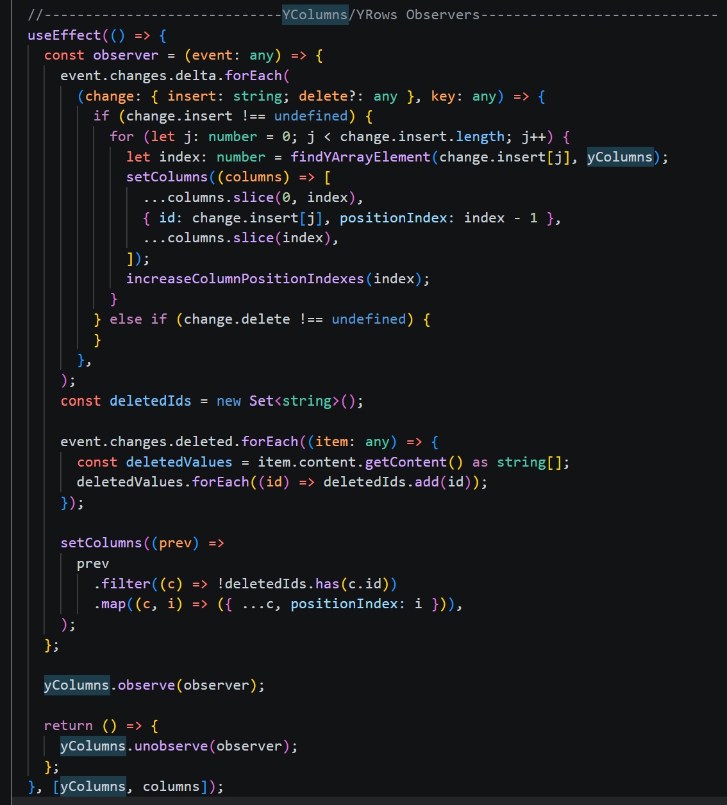
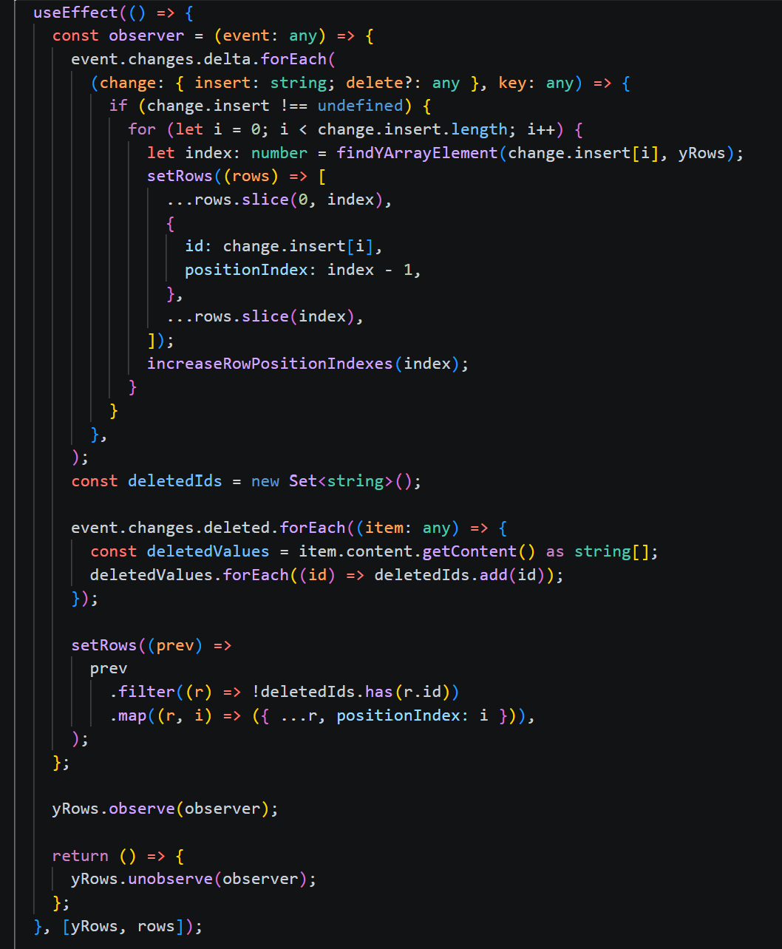
Figure 2.1 YColumn observer in SpreadSheet.tsx
Figure 2.2 YRow observer in SpreadSheet.tsx

YMap (Cell.tsx)
To keep values of each cell, YMap structure was used. It’s a CRDT-based key-value (Yjs provided abstraction for CRDTs as mentioned) pair where ids are defined as $let cellId: string = `\$\{col.id\},\$\{row.id\}`;$ and contents are just texts. To use the YMap effectively in my implementation, for every Cell on the spreadsheet, an observer is defined. This observer is responsible for keeping track of the remote updates of the Cell’s own content. This comes with a performance cost, but the benefits are not negligible. This was the most convenient approach that I could come up with and I couldn’t find any other approach rather than using a global grid.
First, with this approach, storing Cell components in a global grid was not needed. If there was a global grid, adding or removing rows/columns would be costly because of shifting all the remaining elements.
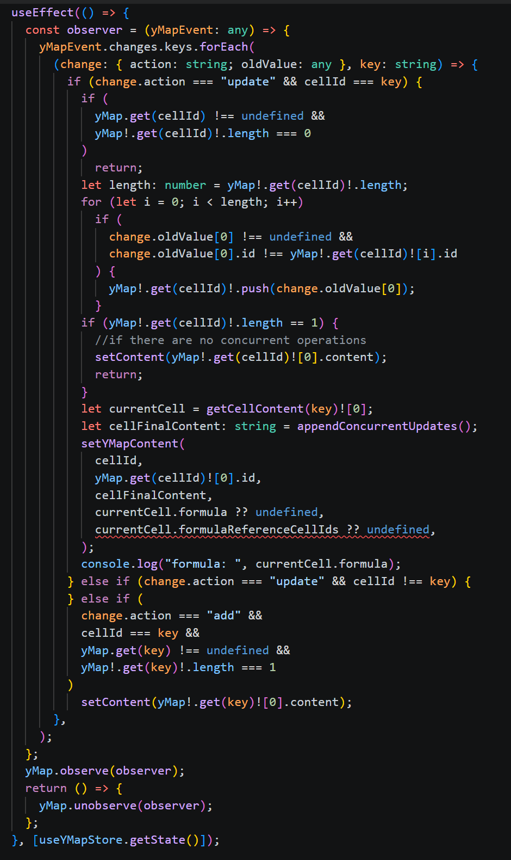
Figure 2.3 illustrates the YMap observer. This observer also has an implementation for Update-Wins CRDT. The idea behind it is to store updates that are concurrent to each other (e.g., offline clients performing updates) and merge them by concatenation. That’s the reason why YMap entries have arrays as their values. Later $appendConcurrentUpdates()$is called to do string concatenation (merging concurrent updates).
Figure 2.3

YColKeep & YRowKeep (SpreadSheet.tsx)
With the standard Yjs, data was lost when a user modified a cell and, at the same time, another user deleted the corresponding column or row. SpreadSheet addresses such data loss by using “keep” arrays for columns and rows [2]. When there is a “positive update” on a cell:
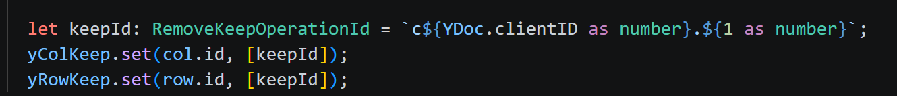
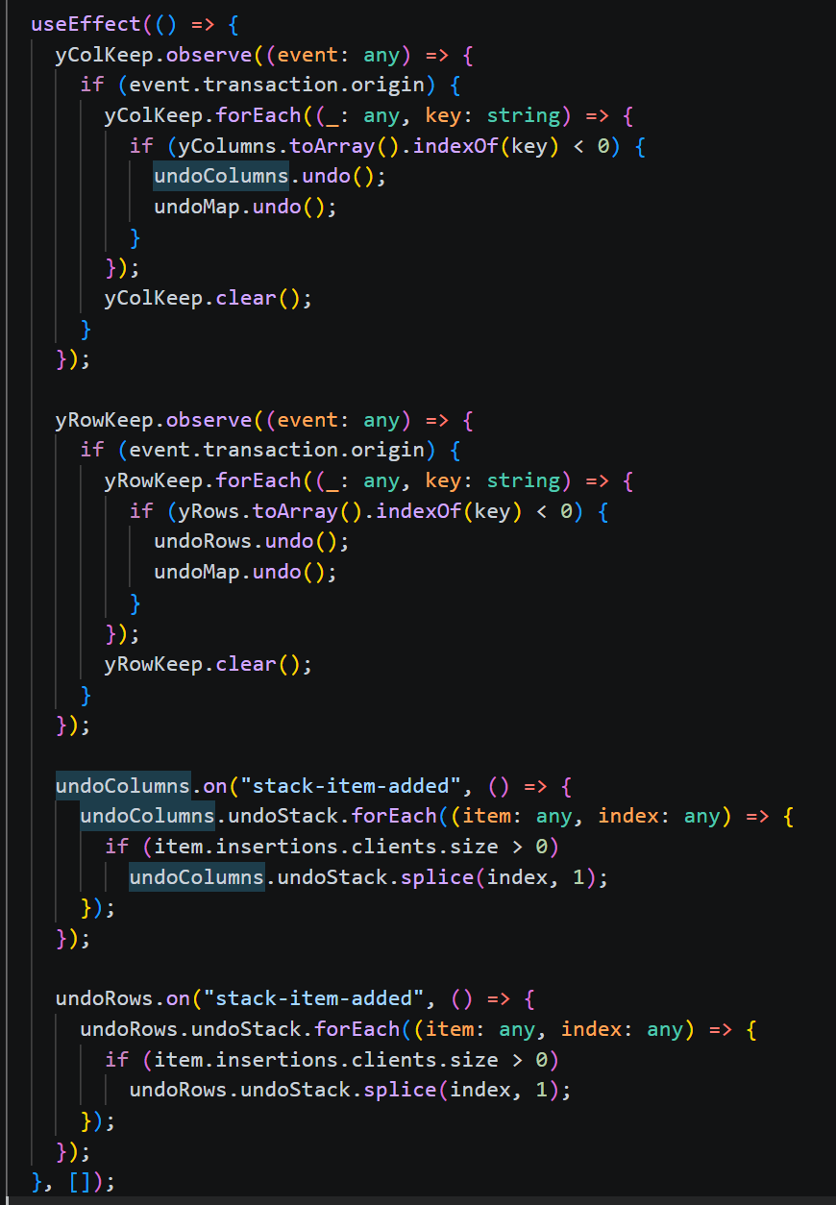
“keep id” in Figure 2.4 is stored in those arrays. Clients monitor the changes of arrays with observers, and if they are non-empty, “undo” operations are performed equal to the number of elements in the array structures.Figure 2.5 demonstrates the observer implementation for YRowKeep and YColKeep arrays.
Figure 2.4 Keep ID
Figure 2.5 YColKeep & YRowKeep implementation with UndoColumns and UndoRows in SpreadSheet.tsx

Formula Support

Information
We thought support of formulas in a collaborative environment would be interesting for several reasons:
- The implementation itself.
- Secondly, retrieving spreadsheet data for formula calculation. What is the feasible way of doing this without ruining the spreadsheet if there are offline users too?
- Thirdly, formula recalculation for every update and its probable bottlenecks. For example, let’s say a result is computed for a formula using 1000 cells and a user updates one cell value by incrementing it by one. In this scenario, should the formula be calculated from the very beginning, or is it possible to support this functionality more efficiently? While the current implementation does so by recalculating the formula, hard coding improvements by addressing supported formulas is possible.
- What happens when a new row or column is added in between formula reference cells? (To be impelemented)
- Lastly, addressing probable issues such as circular referencing during calculation and recalculation.

Implementation Details
In this section, I will explain the relevant parts of functions/components for formula calculation.

Formula Parser
First, the `fast-formula-parser` [3] library has been used for formula functionality. The main implementation for this library is in ‘formula.ts’. In this file, there are 2 functions: ‘parser()’, which comes from the library itself, and ‘parserDriver()’ which calls the parser() with ‘spreadsheetData’ obtained in the Spreadsheet component.
This parserDriver() function returns the formula result and returns the IDs of the cells that have been marked (or registered) while computing the formula result. Figure 3.1
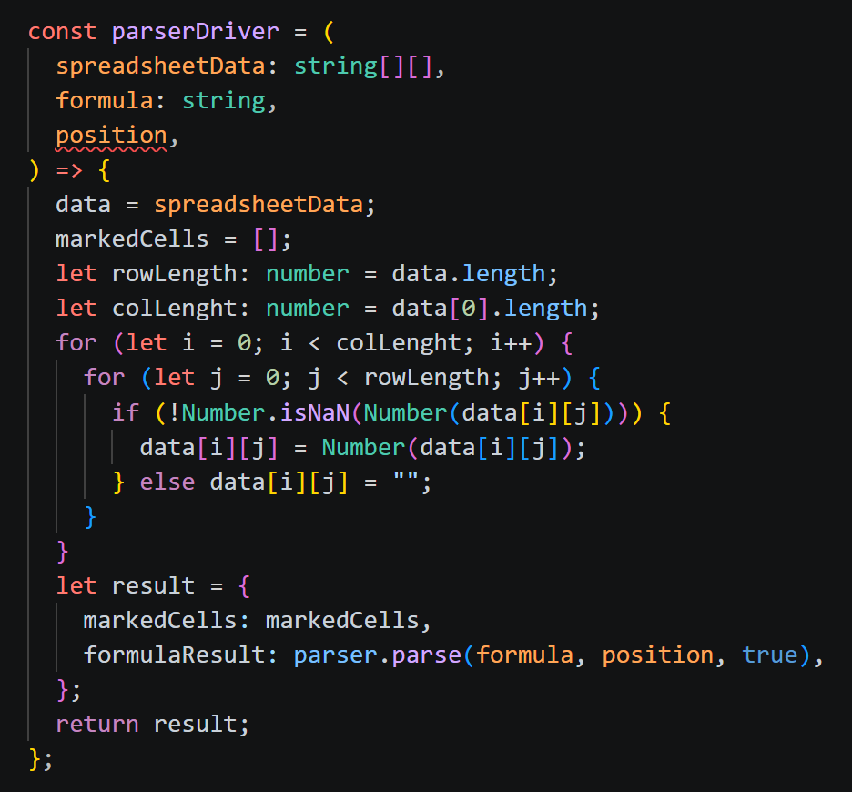
demonstrates this function.
Figure 3.1 parserDriver() function which calls parser() function which is from the fast-formula-parser library.

Spreadsheet Store
To retrieve the store globally, Zustand, which is a small, fast, and scalable state management solution [4], has been used. It is like Redux but was easier to implement.
Normally, the direction for the data transfer is from the parent to the child. However, it would not have been feasible to transfer all spreadsheet data from the Spreadsheet component to every Cell. The second solution requires $spreadsheet data*num of total cells$. With Zustand, there is a single spreadsheet used for formula calculations.
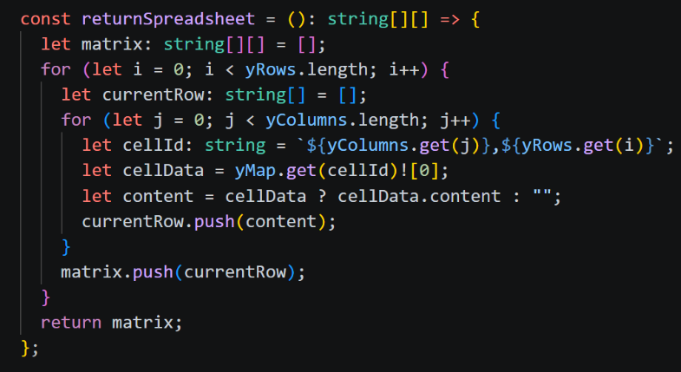
‘spreadSheetData’ is the name of the object that contains all values in each cell and is a matrix of strings obtained from ‘SpreadSheetStore.ts’: ‘returnSpreadSheet()’. As mentioned in section 3.1 this function returns all spreadsheet data (optimization might be possible).
Figure 3.2 returnSpreadSheet() in SpreadSheetStore.ts

SpreadSheet Component
The SpreadSheet component provides a table by implementing the PrimeReact library's DataTable structure with the Yjs framework. While the table's rows and columns are tracked via Yjs arrays ($yRows$, $yColumns$), observers ensure that all additions and deletions are reflected in the local React state. When a new row or column is created, the corresponding cells are automatically created in the shared map, and deletion operations trigger both map cleanup and undo mechanisms. This component also consists of other components, which are headers ($ColumnHeader$), cells ($Cell$), and buttons.

handleFormula()

Cell Component

handleFocusOut()
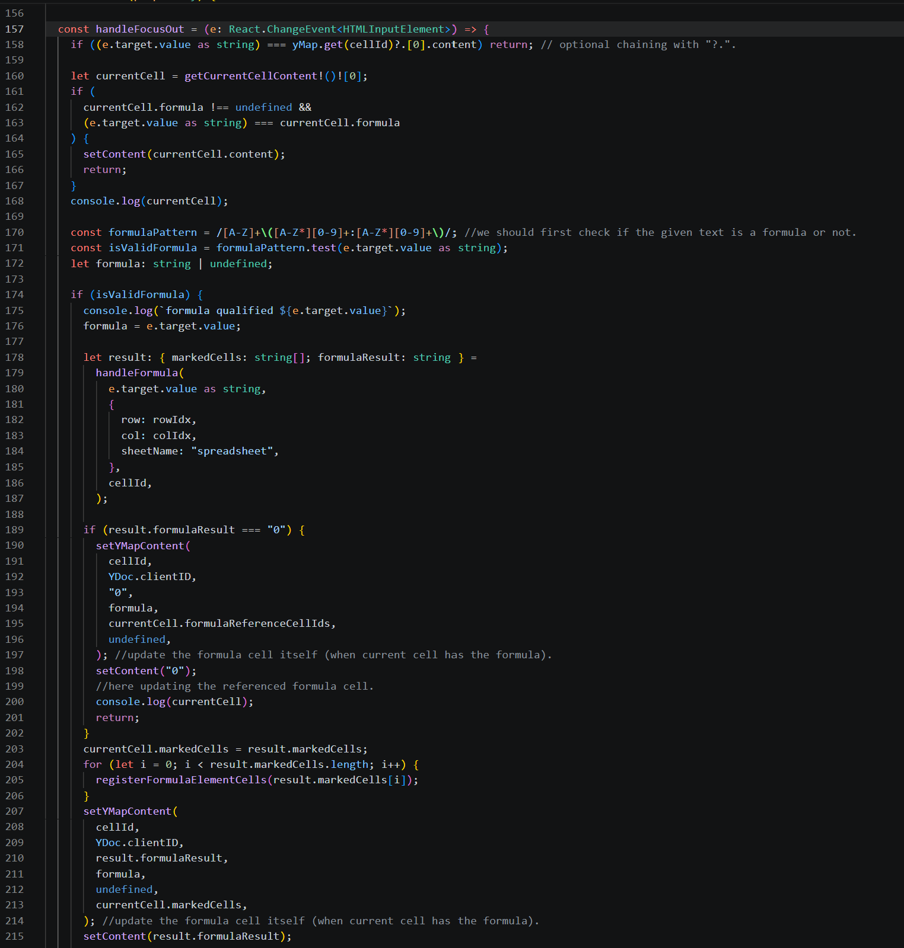
Figure 3.3 handleFocusOut() 1
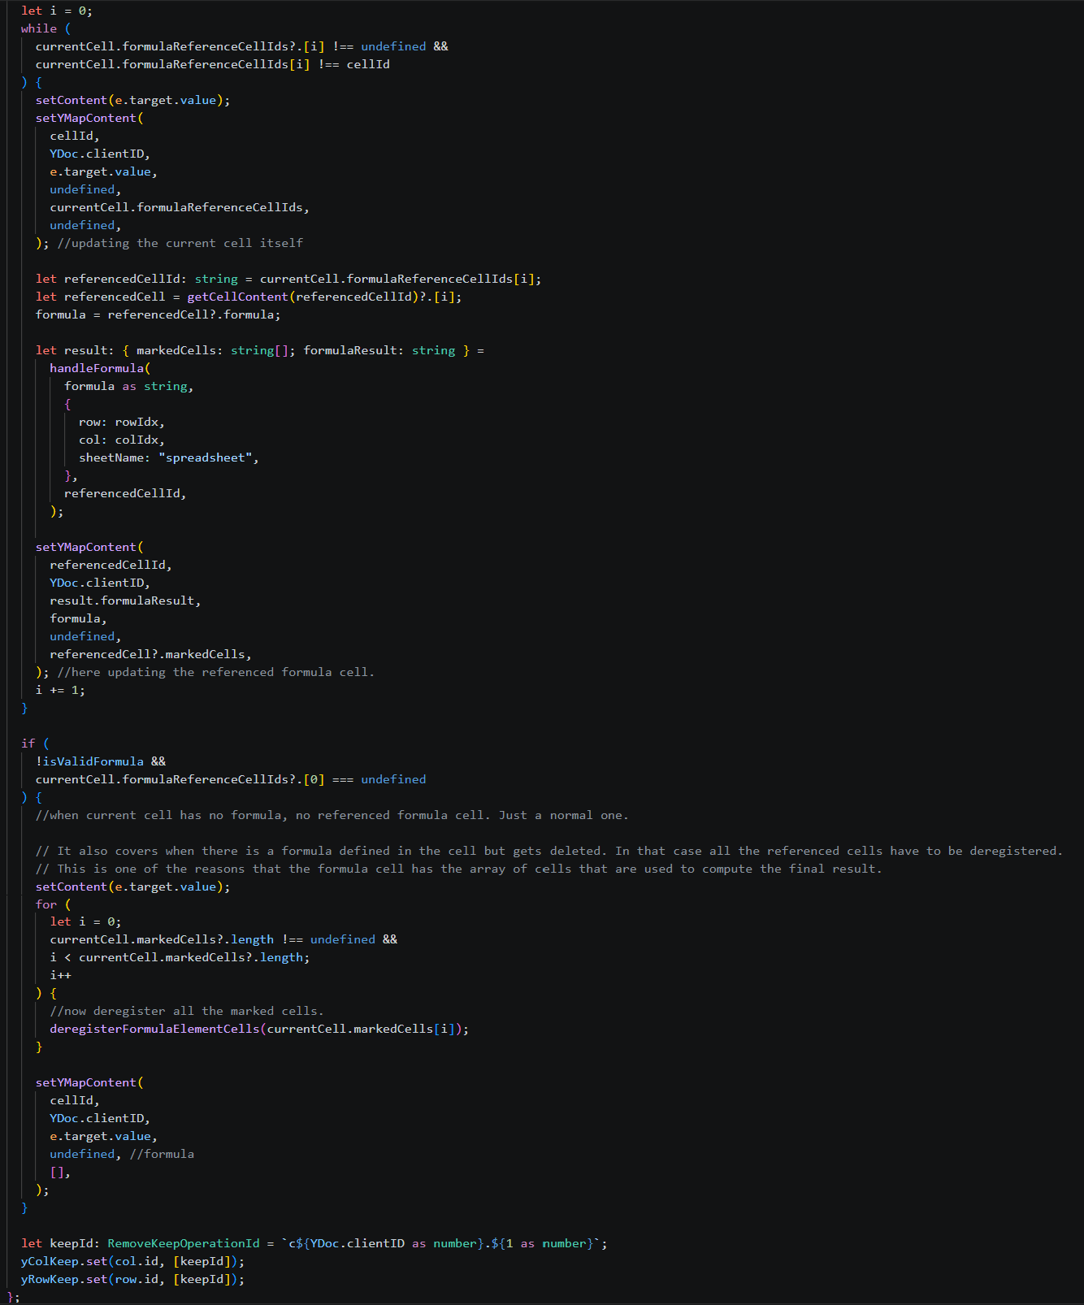
Figure 3.4 handleFocusOut() 2

Formula Recalculation
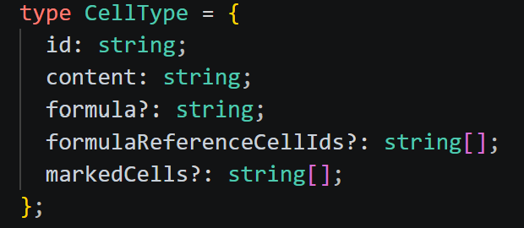
Formula cells register candidate cells in the ‘markedCells[]’ array when the formula is defined to compute the result. Similarly, candidate cells store IDs of the formula cells in the ‘formulaReferenceCells[]’ array. This is an array because there might be multiple formula cells registering the same cell. These 2 arrays are kept in every Cell component and are defined in ‘CellType’. As in Figure 3.5 arrays are optional, denoted with “?”, so it is not a problem if they are undefined.
Figure 3.5 Cell type definition
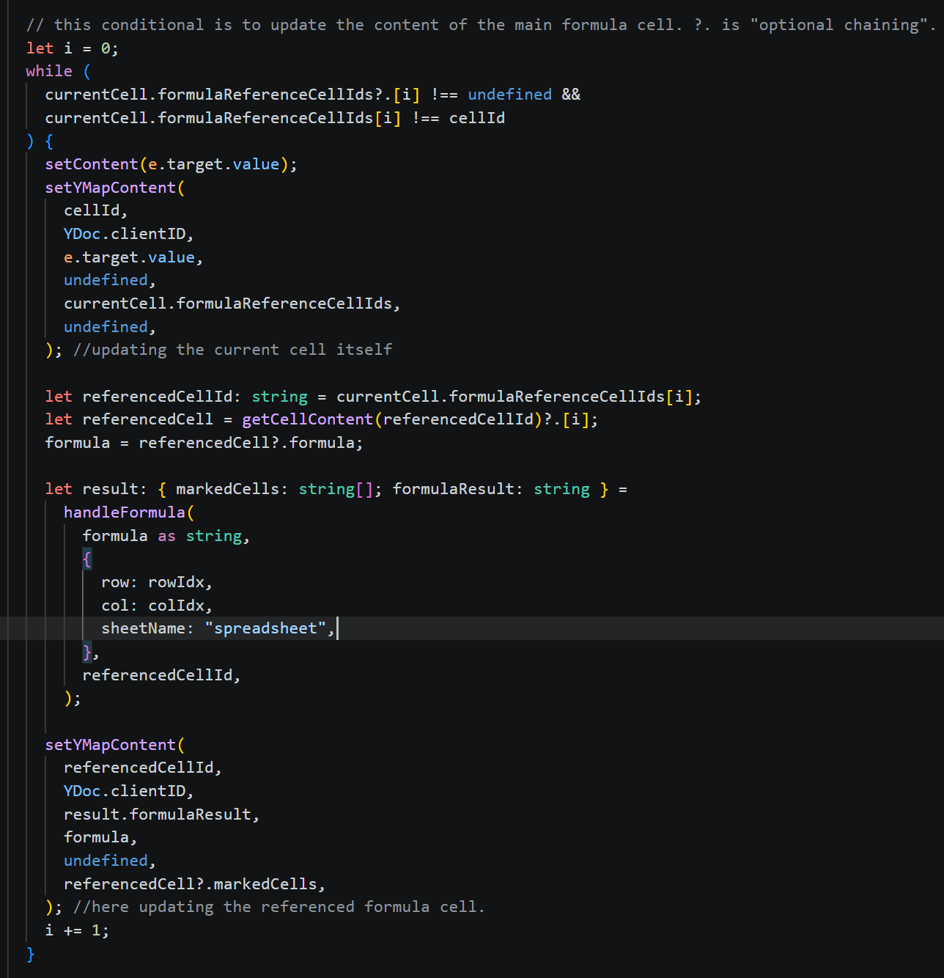
After these operations, the ‘handleFocusOut()’ function in the Cell component is responsible for the formula recalculation as shown in Figure 3.6.
Figure 3.6 The conditional which is responsible from the formula recalculation inside `handleFocusOut()`function.

Circular Reference Handling
A circular reference occurs when a formula refers directly or indirectly back to its own cell value, creating an endless calculation loop. For example, if cell A1 contains the formula =A1+B1, then A1 references itself [5]. Actually, it is not an issue when defining the formula (the cell is not yet related to the corresponding formula). However, when there are updates to cells marked by formulas, a circular reference becomes apparent. Meaningly, when there is formula recalculation (as explained in section 0).
My implementation does not produce an endless loop because formula recalculation does not use observers. Rather, it is being done via the `handleFocusOut()` function in Cell components. Therefore, a formula is calculated via `handleFocusOut()` calls. Even though there are no calculation infinite loops, when a user wants to increase a cell value by one (if the cell is marked and the formula is SUM), as in a circular reference case, formula cells register themselves, the existing result from the previous step, so it does not increase by one rather $formula's previous result + 1$. This produces a result that the user does not intend.
To solve this, Microsoft Excel’s approach is used. When it detects a circular reference, the formula value is set to 0. In my implementation, I have a very basic approach that can be seen in Figure 3.7. This approach might be improved in terms of time complexity via Depth-First Search.
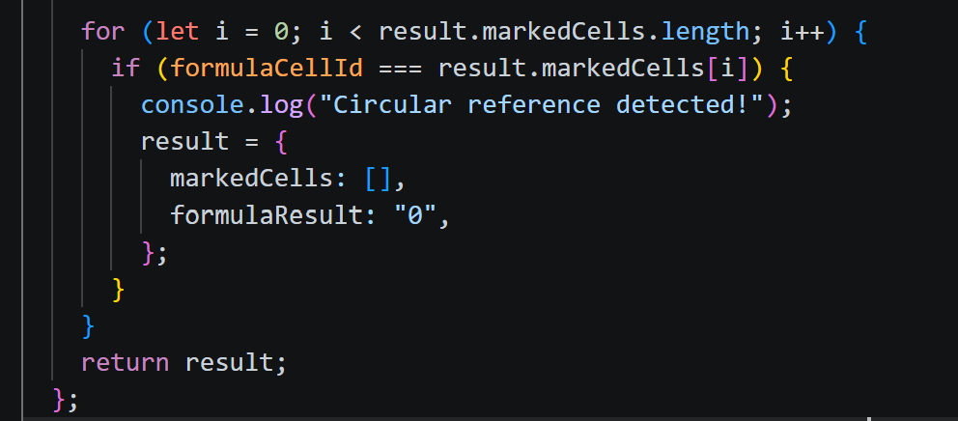
Figure 3.7 Very basic circular reference detection.

Benchmarking

CSV Support

References

[1] | K. Jahns, "Yjs: Shared data types for building collaborative software," GitHub, [Online]. Available: https://github.com/yjs/yjs. [Accessed 23 08 2026].
[2] | P. B. a. A. B. E. Yanakieva, "A Study of Semantics for CRDT-based Collaborative Spreadsheets," in Proceedings of the 10th Workshop on Principles and Practice of Consistency for Distributed Data, Rome, Italy, 2023.
[3] | L. Lyu, " fast-formula-parser," 2020. [Online]. Available: https://www.npmjs.com/package/fast-formula-parser. [Accessed 24 July 2026].
[4] | Poimandres, "Introduction - Zustand," Zustand Documentation., [Online]. Available: https://zustand.docs.pmnd.rs/learn/getting-started/introduction. [Accessed 25 07 2026].
[5] | Macabacus, "Circular Reference in Excel: How to Find and Fix Errors.," Macabacus, [Online]. Available: https://macabacus.com/blog/conquering-circular-references-in-excel. [Accessed 23 July 2026].

