Guided Research: Supporting Formulas in Collaborative Spreadsheets
Korhan Deniz AKIN

Contents
Guided Research: Supporting Formulas in Collaborative Spreadsheets 1
1 General Information 2
2 Representing Spreadsheet Data in Yjs 2
3 Update Wins CRDTs 2
4 Formula Support 2
4.1 Information 2
4.2 Implementation Details 3
4.2.1 Formula Parser 3
4.2.2 Spreadsheet Store 3
4.2.3 SpreadSheet Component 4
4.2.4 Cell Component 4
4.3 Formula Recalculation 4
4.4 Circular Reference Handling 5
4.5 Benchmarking 6
5 CSV Support 6
6 References 6

General Information

Representing Spreadsheet Data in Yjs

Update Wins CRDTs

Formula Support
(Current commit hash: 6686f59abce4cc9bce5412a10547ac37466a29c3 in the branch named: feature/formula_support)

Information
We thought support of formulas in a collaborative environment would be interesting for several reasons:
- One of them was the implementation itself.
- Secondly, retrieving spreadsheet data for formula calculation. What is the feasible way of doing this without ruining the spreadsheet if there are offline users too? (Still an open question for me)
- Thirdly, formula recalculation for every update and its probable bottlenecks. For example, let’s say a result is computed for a formula using 1000 cells and a user updates one cell value by incrementing it by one. In this scenario, should the formula be calculated from the very beginning, or is it possible to support this functionality more efficiently? While the current implementation does so by recalculating the formula, hard coding improvements by addressing supported formulas is possible.
- Lastly, addressing probable issues such as circular referencing during calculation and recalculation.

Implementation Details
In this section, I will explain the related parts of functions/components for formula calculation.

Formula Parser
First of all, the `fast-formula-parser` [1] library has been used for the formula functionality. The main implementation for this library is in `formula.ts`. In this file, there are 2 functions: `parser()`, which comes from the library itself, and `parserDriver()` which calls the `parser()` with `spreadsheetData` obtained in the Spreadsheet component.
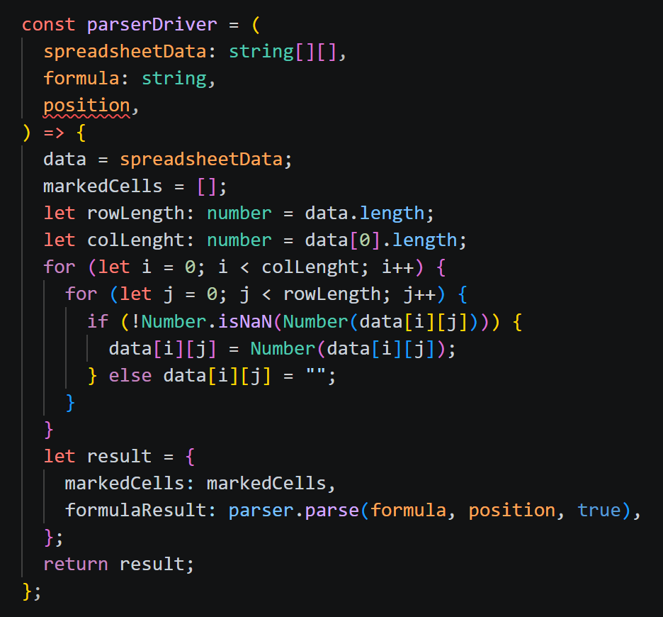
This `parserDriver()` function returns the formula result and returns the IDs of the cells that have been marked (or registered) while computing the formula result. Figure 4.1
Figure 4.1 parserDriver() function which calls parser() function which is from the fast-formula-parser library.
demonstrates this function.

Spreadsheet Store
To retrieve the store globally, Zustand, which is a small, fast, and scalable state management solution [2], has been used. It is similar to Redux but was easier to implement.
Normally, the direction for the data transfer is from the parent to the child. However, it would not have been feasible to transfer all spreadsheet data from the Spreadsheet component to every Cell. The latter solution requires $spreadsheet data*num of total cells$. With Zustand, there is a single spreadsheet data to be used for formula calculation.
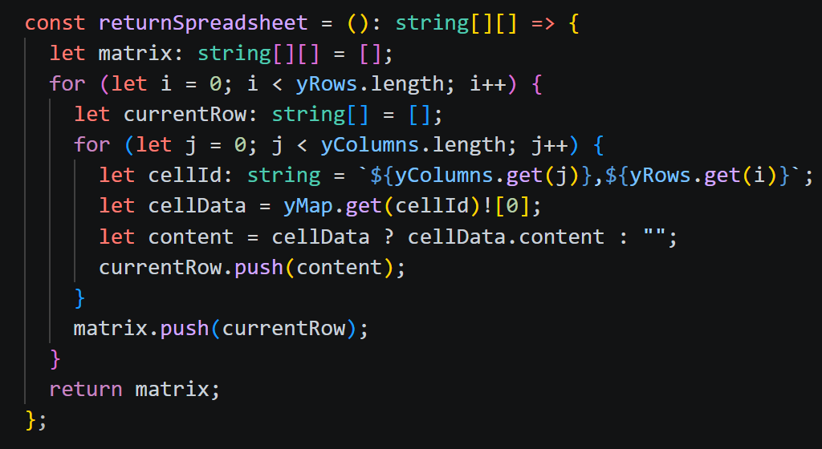
`spreadSheetData` is the name of the object that contains all values in each cell and is a matrix of strings obtained from `SpreadSheetStore.ts`: `returnSpreadSheet()`. As mentioned in section 4.1 this function returns all spreadsheet data (optimization might be possible).
Figure 4.2 returnSpreadSheet() in SpreadSheetStore.ts

SpreadSheet Component

handleFormula()

Cell Component

handleFocusOut()

Formula Recalculation
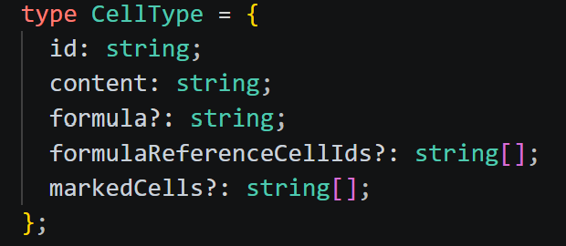
Formula cells register candidate cells in the `markedCells[]` array when the formula is defined to compute the result. Similarly, candidate cells store IDs of the formula cells in the `formulaReferenceCells[]` array. This is an array because there might be multiple formula cells registering the same cell. These 2 arrays are kept in every Cell component and are defined in `CellType`. As in Figure 4.3 arrays are optional, denoted with “?”, so it is not a problem if they are undefined.
Figure 4.3 Cell type definition
After these operations, the `handleFocusOut()` function in the Cell component is responsible for the formula recalculation as shown in Figure 4.4.
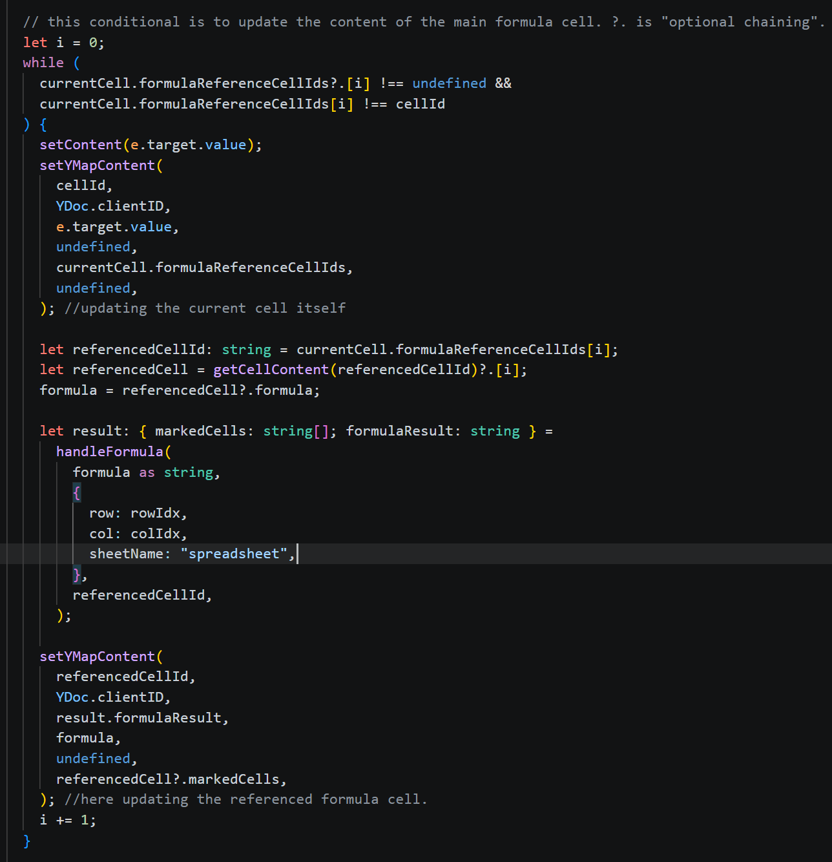
Figure 4.4 The conditional which is responsible from the formula recalculation inside `handleFocusOut()`function.

Circular Reference Handling
A circular reference occurs when a formula refers directly or indirectly back to its own cell value, creating an endless calculation loop. For example, if cell A1 contains the formula =A1+B1, then A1 references itself [3]. Actually, it is not an issue when defining the formula (the cell is not yet related to the corresponding formula). However, when there are updates to cells marked by formulas, a circular reference becomes apparent. Meaningly, when there is formula recalculation (as explained in section 4.3).
My implementation does not produce an endless loop because formula recalculation does not use observers. Rather, it is being done via the `handleFocusOut()` function in Cell components. Therefore, a formula is calculated via `handleFocusOut()` calls. Even though there are no calculation infinite loops, when a user wants to increase a cell value by one (if the cell is marked and the formula is SUM), as in a circular reference case, formula cells register themselves, the existing result from the previous step, so it does not increase by one rather $formula's previous result + 1$. This produces a result that the user does not intend.
To solve this, Microsoft Excel’s approach is used. When it detects a circular reference, the formula value is set to 0. In my implementation, I have a very basic approach that can be seen in Figure 4.5. This approach might be improved in terms of time complexity via Depth-First Search.
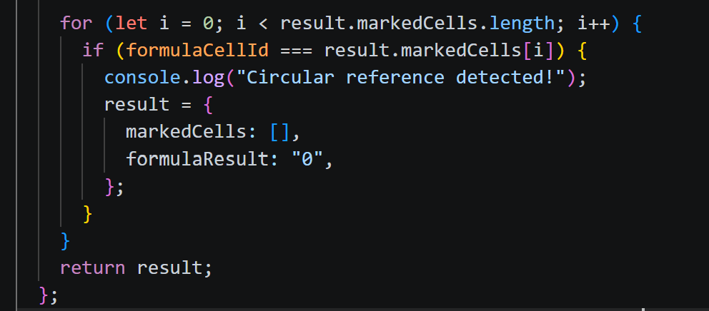

Figure 4.5 Very basic circular reference detection.

Benchmarking

CSV Support

References

[1] | L. Lyu, " fast-formula-parser," 2020. [Online]. Available: https://www.npmjs.com/package/fast-formula-parser. [Accessed 24 July 2026].
[2] | Poimandres, "Introduction - Zustand," Zustand Documentation., [Online]. Available: https://zustand.docs.pmnd.rs/learn/getting-started/introduction. [Accessed 25 07 2026].
[3] | Macabacus, "Circular Reference in Excel: How to Find and Fix Errors.," Macabacus, [Online]. Available: https://macabacus.com/blog/conquering-circular-references-in-excel. [Accessed 23 July 2026].

