Does Socioeconomic Status Predict ACT Scores in the United States? An Analysis of Key Socioeconomic Indicators and Their Relationship with ACT Scores
Kyle DeRosia, PhD, CSCS

ABSTRACT
INTRODUCTION: Insurance status, a proxy for socioeconomic status, has been shown to influence academic achievement scores in students up to eighth grade in Arkansas. However, it is unknown if other socioeconomic status indicators are associated with educational outcomes across the US at higher educational levels. Therefore, the purpose of this project was to determine which specific socioeconomic variables predicted ACT scores. METHODS: Publicly available data from EdGap.org and the National Center for Education Statistics were used to determine if socioeconomic status predicted average ACT scores. Data from each source was joined and incorrect data was corrected before analysis. To determine which socioeconomic variables best predicted ACT scores, multiple linear regression analysis was used. Different multiple linear regression models were compared using their respective R² values and extra sum-of-squares F tests to determine the final model. RESULTS: The percentage of students eligible for free or reduced-price lunches was the single best predictor of ACT scores, but the addition of percentage of adults with a college degree improved the predictive power of the model. ACT scores tend to be higher in schools where fewer students are eligible for discounted lunches and where more adults have college degrees. CONCLUSION: Students in families with higher socioeconomic status tend to score better on the ACT than their lower socioeconomic status counterparts, though not all indicators of socioeconomic status were significant predictors of ACT scores.
INTRODUCTION
Previous literature has identified links between socioeconomic variables and educational outcomes (Burhan et al., 2017; ElHassan et al., 2018). However, these studies investigated younger populations and included either global data (Burhan et al., 2017) or data from only Arkansas (ElHassan et al., 2018). Additionally, these studies used either insurance status or GDP per capita as proxy measure of socioeconomic status. These variables may not be the best indicators of socioeconomic status. Insurance status may be related to socioeconomic status, but it is not a direct measure of it. Furthermore, GDP per capita does not represent the individual families’ socioeconomic status. Therefore, the purpose of this project was to determine if unemployment rate, the percentage of adults with a college degree, the percentage of children in a married couple family, the median household income, and the percentage of students eligible for free or reduced-priced lunches predicted ACT scores in the United States. It was hypothesized that students in families with lower socioeconomic status would have lower average ACT scores than those from families with higher socioeconomic status.
METHODS
Publicly available data was used to gather information about specific indicators of socioeconomic status and school information, including ACT scores. Data from each source was joined and assessed to determine if there were missing values or incorrect data entries. Data entries were considered incorrect if they were out of range for the specific variable of interest. For example, ACT scores range from one to 36, so negative values or values greater than 36 were considered out of range. Values considered out of range were set to Nan before being imputed using an iterative impute. To determine which socioeconomic variables best predicted ACT scores, multiple linear regression analysis was used. The correlation coefficient for the each predictor variable with ACT scores were computed first to determine which variables would be best suited for the model. Then, multiple linear regression models were compared using R² values and extra sum-of-squares F tests to determine the final model. The significant level for the extra sum-of-squares F test was set to α=0.05. Normality of the residuals was confirmed using residual plots. All data cleaning and analysis was performed using custom-written Python 3 software.
RESULTS
The percentage of adults with college degrees and the percentage of students eligible for discounted school lunches had the strongest correlations with ACT scores (Figures 1 and 2). The final model to predict ACT scores from socioeconomic factors took the form of $ACT score= β_{0}+β_{1}\left(percent college\right)+ β_{2}\left(percent lunch\right)$. Model summary information can be found in Table 1. Both the percentage of adults with college degrees and the percentage of students eligible for free or discounted school lunches were significant predictors of ACT scores, explaining 62.6% of the variance in average ACT scores.
Table 1: Summary information from the multiple linear regression model
 | Coefficient | Standard Error | t-value | p-value
Intercept | 22.40 | 0.09 | 237.72 | <0.01
Percent College | 1.90 | 0.12 | 15.41 | <0.01
Percent Lunch | -7.78 | 0.09 | -89.68 | <0.01

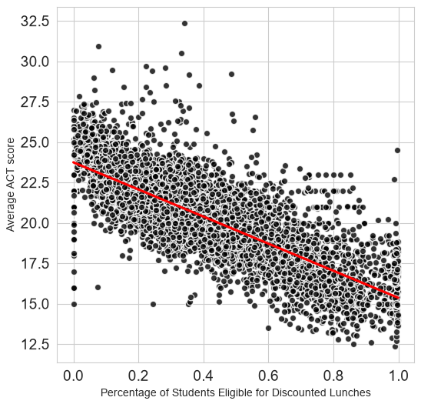
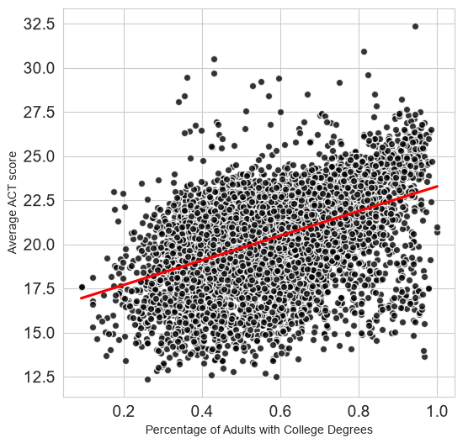
Figure 2: The relationship between the percentage of students eligible for discounted school lunches and average ACT scores.
Figure 1: The relationship between the percentage of adults with college degrees and average ACT scores.

DISCUSSION
The final model that was selected contained only two predictor variables: The percentage of adults with college degrees and the percentage of students eligible for discounted lunches. This model explained 62.6% of the variance in average ACT scores. This model was compared to another model with three predictor variables [$ACT score= β_{0}+ β_{1}\left(unemployment rate\right)+ β_{2}\left(percent college\right)+ β_{3}\left(percent lunch\right)$]. This more complex model that included unemployment rate explained 62.8% of the variance. Since the model performance was similar to the simpler, two variable model it was decided to move forward with the two-predictor model. The final model indicated that for every one percent increase in the percentage of adults with college degrees the predicted average ACT score increases by 1.9 points. This results aligns with the findings from Burhan and colleagues who found that the number of years of education a child’s parents had was associated with their cognitive ability (Burhan et al., 2017). However, this analysis does not explain why this relationship exists. It could be that the parent’s education is an indirect predictor of ACT scores through some other relationship between the parent’s education and another socioeconomic factor. For example, parents with more education may earn higher paying jobs, allowing them to enroll their students in higher rated schools. The percentage of students eligible for discounted lunches was the most influential factor on average ACT scores, with a one percent increase in the percentage of students eligible leading to an average decrease in ACT scores by 7.78 points. Eligibility for discounted or free school lunches is an indicator of poverty, so it could be that there are fewer educational opportunities or resources available to these students. For example, families that are struggling financially are likely not spending additional funds on private tutoring, online learning resources, textbooks, etc. However, additional data is needed to identify the cause of this observed relationship.
CONCLUSION
Socioeconomic status appears to be a powerful predictor of educational outcomes, namely ACT scores. Specifically, when a larger proportion of students are eligible for free or discounted lunches at a school it can be expected that the schools average ACT scores will be lower than those from schools where fewer students are eligible. Further research is needed to determine the specific cause of this relationship.
REFERENCES
Burhan, N. A. S., Yunus, M. Md., Tovar, M. E. L., & Burhan, N. M. G. (2017). Why are cognitive abilities of children so different across countries? The link between major socioeconomic factors and PISA test scores. Personality and Individual Differences, 105, 95–106. https://doi.org/10.1016/j.paid.2016.09.043
ElHassan, N. O., Bai, S., Gibson, N., Holland, G., Robbins, J. M., & Kaiser, J. R. (2018). The impact of prematurity and maternal socioeconomic status and education level on achievement-test scores up to 8th grade. PLOS ONE, 13(5), e0198083. https://doi.org/10.1371/journal.pone.0198083

