Seattle Weather Project Report

The purpose of this project is to determine if there is more precipitation in Seattle, WA or Grand Rapids, MI. Data used in this project was publicly available from the NOAA. The data was first checked to ensure that the dates contained in the data sets for each city were the same. Then, missing values were checked and, if present, filled with the average rainfall for the days that were missing. The analysis was primarily descriptive, using summary statistics and data visualizations to determine which city had more precipitation.

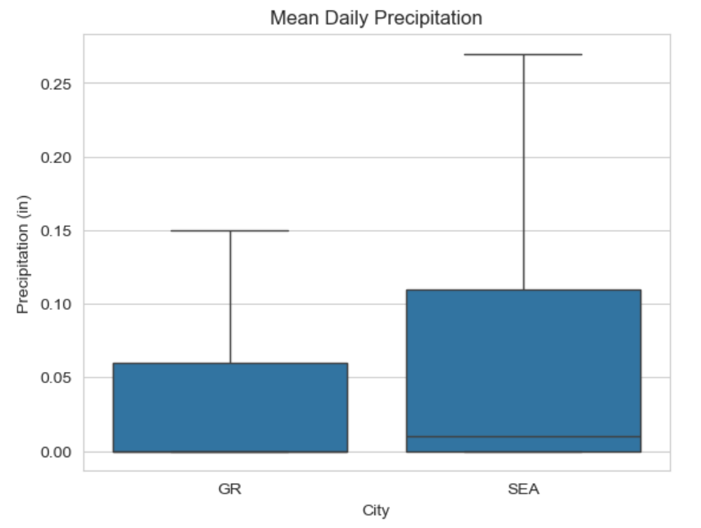
It was determined that Seattle has more annual precipitation than Grand Rapids. First, the following boxplot shows that Seattle has higher ranges of values for precipitation and that the median precipitation is greater than Grand rapids.

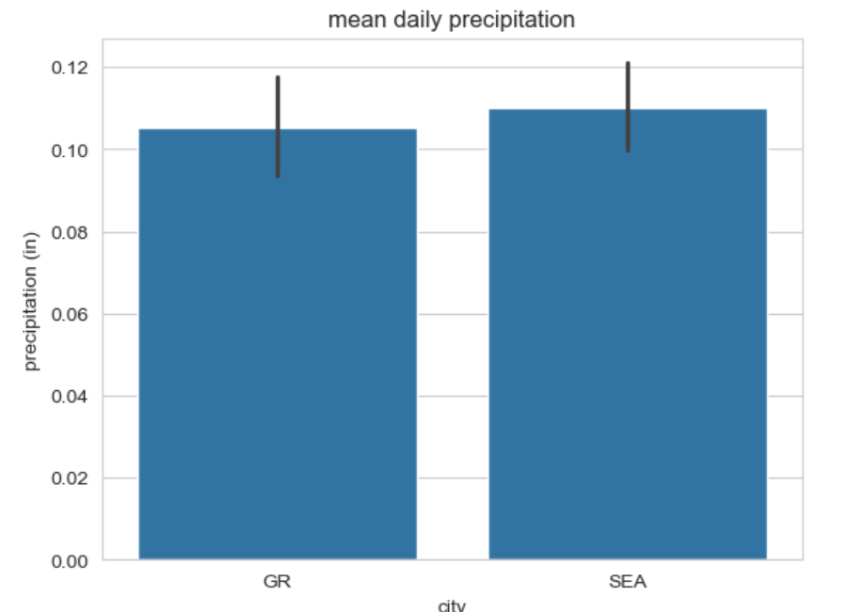
Additionally, when comparing mean precipitation between cities, we also see that Seattle has a slightly larger value.
Based on both visualizations, it can be concluded that Seattle receives more precipitation than Grand Rapids.

