LIBSPACE
Backend Book Management System

Comprehensive Project Documentation
Project Name | Libspace – Backend Book Management System
Version | v1.0
Project Date | March 1 – 8, 2025
Team Member | MONISHA D  SEMIRA SERIN S  ABIRAMI S  ASWINI M  JANANI S
Technology Stack | Node.js, Express.js, MongoDB Atlas, JWT, bcrypt
Architecture | MVC – Model View Controller
API Testing Tool | Thunder Client (VS Code)
Server Port | localhost:5000
Database | MongoDB Atlas (Cloud)
Version Control | Git & GitHub

1. Project Overview

About Libspace
Libspace is a secure, scalable, and modular backend application built using Node.js and Express.js that allows users to register, login, and manage their personal book records through a set of well-defined RESTful APIs. The system integrates MongoDB Atlas as its cloud database to persist user credentials and book data securely.

The primary goal of Libspace is to provide a lightweight yet fully functional backend system that demonstrates industry-standard development practices including JWT-based authentication, bcrypt password hashing, middleware-based route protection, and structured MVC architecture.

Project Goals
- Build a secure and structured backend application for book management.
- Implement industry-standard authentication using JSON Web Tokens (JWT).
- Ensure user-specific data isolation so each user only accesses their own books.
- Design clean and maintainable RESTful APIs following HTTP standards.
- Demonstrate real-world backend development skills and best practices.
- Create a scalable system architecture that supports future feature expansion.

Scope of the Project
The scope of Libspace covers the complete backend lifecycle of a book management system including:
- User account management: registration, login, and logout
- JWT token generation, validation, and blacklisting
- Full CRUD (Create, Read, Update, Delete) operations on book records
- Middleware-based route protection for all book-related endpoints
- Centralized error handling and input validation
- Secure environment configuration using dotenv
- MongoDB Atlas cloud database integration using Mongoose ODM

Project Limitations
- No frontend UI – this is a purely backend REST API system
- No role-based access control in the current version (planned for future)
- No pagination implemented (listed as a future enhancement)
- No email verification for user registration

2. Problem Statement

Background
In today's digital age, managing book collections and library records is increasingly moving online. However, many small library owners, students, and individual readers still rely on manual methods such as spreadsheets, handwritten registers, or unstructured digital files. These approaches are error-prone, difficult to maintain, and lack any form of access control or security.

Existing digital solutions are often overly complex enterprise systems designed for large institutions, requiring significant technical knowledge or expensive subscriptions. There is a clear gap in the market for a simple, lightweight, and secure backend system that small-scale users can adopt easily.

Identified User Challenges
- Lack of secure authentication mechanisms to protect book data
- No centralized system to store and retrieve book records
- Inability to restrict access to user-specific data
- Difficulty in updating and deleting records efficiently
- Risk of data inconsistency or duplication in unstructured systems
- Dependence on expensive paid platforms for simple data management

Customer Needs Analysis
Based on user research and problem analysis, users require a system that:
- Allows secure user registration and login with encrypted credentials
- Ensures passwords are hashed and never stored in plain text
- Restricts book data access to the authenticated owner only
- Provides full CRUD operations for managing book records
- Maintains proper database structure and data integrity
- Returns meaningful error messages for invalid inputs or unauthorized access

Problem Statement Table
ID | Customer | Trying To | But... | Because... | Feels
PS-1 | Small library owner | Manage book records digitally | Tools are complex or require paid subscriptions | Needs a simple backend to add, update, and delete books | Frustrated managing records manually
PS-2 | Student managing personal books | Keep track of books in one centralized system | No secure system restricts access to their data | Wants a login-based system to manage only their own books | Concerned about data privacy
PS-3 | Individual user | Update and delete book info easily | Many systems lack proper authentication or data isolation | Needs a secure backend with JWT and protected routes | Anxious about unauthorized access
PS-4 | Beginner user with limited technical knowledge | Use a simple system to manage books without complexity | Most platforms focus on UI, not backend security | Wants a lightweight and secure system that is easy to use | Overwhelmed by complicated software

3. Empathy Map Canvas
An Empathy Map is a collaborative tool used to gain a deeper understanding of users. It captures what users Say, Think, Do, and Feel, helping the team design a solution that truly addresses user pain points and aspirations.

Target User: Small Library Owner / Student / Individual Book Manager
SAYS | THINKS | DOES | FEELS
"I need a simple way to manage my books."  "I don't want to pay for expensive software."  "My book records keep getting mixed up."  "I want only I can see my books." | Wonders if there is a free, secure option  Thinks maintaining spreadsheets is risky  Considers privacy of personal book records  Wants a system that only they can access | Uses spreadsheets or paper registers  Searches online for book tracking apps  Manually updates book information  Struggles with data duplication errors | Frustrated by manual record keeping  Anxious about data privacy and security  Overwhelmed by complex existing tools  Relieved when finding a simple, free solution
PAINS  • No secure place to store book data  • Existing systems are too complex or costly  • Risk of unauthorized access to personal records  • Manual record keeping leads to errors and duplication |  | GAINS  • A free, lightweight backend system  • Secure login ensuring private data access  • Easy CRUD operations to manage books  • Peace of mind knowing data is encrypted and protected

4. Brainstorming & Idea Generation

Step 1 – Team Collaboration & Problem Selection
The team conducted a structured brainstorming session to identify a backend project idea that would demonstrate strong command over authentication, database management, and RESTful API design. Several backend project ideas were proposed and evaluated:

Project Idea | Pros | Cons / Reason Not Selected
Library Management System | Real-world use, good CRUD scope | Selected — evolved into Libspace
Blog API System | Good for content APIs | Less relevant to book management need
Student Record Management | Practical use case | Too similar to existing solutions
Task Manager API | Simple and quick to build | Low complexity, less learning value
Book Rental System | Real-world use case | Too complex for the project timeline

Step 2 – Idea Listing & Grouping
Authentication & Security Ideas
- User registration with input validation
- JWT-based login authentication with token expiry
- Secure password hashing using bcrypt
- Protected routes using custom JWT middleware
- Secure logout mechanism using token blacklisting

Core Book Management Features
- Add new book linked to authenticated user
- View all books belonging to logged-in user
- Update book details using book ObjectId
- Delete book record securely
- Fetch single book by ID
- Optional: Pagination for book listing

Database & Architecture Ideas
- MongoDB (NoSQL) with Mongoose ODM
- Separate Users and Books collections
- userId reference linking books to their owners
- MVC architecture (Model-View-Controller)
- RESTful API structure with standard HTTP methods

Step 3 – Idea Prioritization Matrix
High Priority | Medium Priority | Low Priority / Future
User Registration & Login with JWT | Pagination for books | Role-Based Access Control (Admin/User)
Password hashing via bcrypt | Advanced input validation | Book categories & tagging system
Protected API routes via middleware | Improved error response messages | Rate limiting & audit logging
Full CRUD operations for books | Postman API documentation | Cloud deployment (Heroku/Render)
Secure logout with token blacklisting | Email verification on registration | API versioning (v1, v2)

5. Problem – Solution Fit

Overview
The Problem–Solution Fit validates that the proposed system directly addresses identified user pain points. Libspace was designed specifically to fill the gap between complex enterprise systems and the need for a simple, secure, backend-only book management solution.

Solution: Libspace – Backend Book Management System
Libspace is built using Node.js, Express.js, and MongoDB Atlas and provides the following core capabilities:
- User Registration & Login with bcrypt-encrypted passwords
- JWT-based authentication for secure, stateless session management
- Protected API routes that reject unauthorized access automatically
- User-specific CRUD operations ensuring data isolation
- Structured RESTful API design for clean, maintainable endpoints
- Secure database schema linking each book to its owner via userId
- Centralized error handling returning meaningful HTTP status codes
- Secure logout via JWT token blacklisting using MongoDB

How the Solution Addresses Each Problem
# | Problem | How Libspace Solves It
1 | No secure authentication | JWT tokens + bcrypt hashing ensure only verified users access the system
2 | No centralized book storage | MongoDB Atlas stores all book records with structured Mongoose schemas
3 | No user-specific data access | Each book is linked to a userId; queries filter by the authenticated user's ID
4 | Difficulty updating/deleting records | RESTful PUT and DELETE endpoints with book ObjectId allow precise record management
5 | Data inconsistency & duplication | Mongoose schemas enforce data types and required fields, preventing invalid entries
6 | Expensive existing platforms | Libspace is completely open-source and free with no subscription required

6. Technology Stack

Components & Technologies
# | Component | Description | Technology
1 | Client Application | Frontend that interacts with Libspace backend APIs | HTML, CSS, JavaScript / React.js (optional)
2 | Authentication Module | Handles registration, login, password hashing, JWT generation | Node.js, Express.js, bcrypt, JWT
3 | Book Management Module | Implements CRUD and enforces user-specific access control | Node.js, Express.js (REST API)
4 | Database | Stores user and book records securely in the cloud | MongoDB Atlas + Mongoose ODM
5 | Middleware Layer | Validates JWT tokens before granting route access | Express.js Middleware
6 | API Testing Tool | Tests and validates all backend API endpoints | Thunder Client (VS Code)
7 | Version Control | Source code management and team collaboration | Git & GitHub
8 | Environment Config | Secures sensitive configuration like DB URI and JWT secret | dotenv (.env file)
9 | Dev Server | Auto-restarts server on file changes during development | nodemon

Application Characteristics
# | Characteristic | Description | Technology
1 | RESTful API Architecture | Structured endpoints for authentication and book CRUD | Node.js, Express.js
2 | Secure Authentication | JWT-based auth with bcrypt-encrypted passwords | bcrypt, jsonwebtoken
3 | User-Specific Data Isolation | Users can only access and manage their own books | JWT verification & DB query filtering
4 | Scalable Backend Design | MVC pattern supports growing users and records | Modular MVC Architecture
5 | Error Handling & Validation | Input validation and meaningful HTTP status codes | Express Validator / Custom Middleware
6 | Database Relationship | Structured User-Book relationship via userId reference | MongoDB Schema / Mongoose
7 | API Security | Protected endpoints with Bearer token authorization | JWT, HTTPS, dotenv
8 | Token Blacklisting | Logout invalidates JWT via MongoDB blacklist collection | blackListerToken model

Detailed Technology Descriptions
Node.js
Node.js is a JavaScript runtime environment built on Chrome's V8 engine. It enables server-side JavaScript execution with a non-blocking, event-driven architecture ideal for building scalable I/O-intensive applications like REST APIs. Libspace uses Node.js as its core runtime.

Express.js
Express.js is a minimal and flexible Node.js web framework that provides robust features for building web and mobile applications. It simplifies routing, middleware integration, and HTTP request/response handling. Libspace uses Express.js to define all API routes and handle request processing.

MongoDB Atlas & Mongoose
MongoDB is a NoSQL document-oriented database that stores data in flexible JSON-like documents. MongoDB Atlas is the fully managed cloud version. Mongoose is an ODM (Object Data Modeling) library for MongoDB and Node.js that provides schema-based data modeling, validation, and relationship management. Libspace uses Mongoose schemas for Users, Books, and BlacklistedTokens.

JSON Web Token (JWT)
JSON Web Token is an open standard (RFC 7519) for securely transmitting information between parties as a JSON object. JWTs are digitally signed using a secret key, making them verifiable. In Libspace, JWTs are generated on login, passed as Bearer tokens in request headers, verified by middleware, and invalidated on logout.

bcrypt
bcrypt is a password hashing function specifically designed for securely storing passwords. It incorporates a salt to prevent rainbow table attacks and applies multiple rounds of hashing to resist brute-force attacks. Libspace uses bcrypt to hash all user passwords before storing them in MongoDB.

7. Advantages of Libspace

Technical Advantages
# | Advantage | Description
1 | Stateless Authentication | JWT-based auth requires no server-side session storage, making the system horizontally scalable. Each token is self-contained with user identity and expiry.
2 | Password Security | bcrypt hashing with salt rounds ensures passwords are never stored in plain text. Even if the database is compromised, raw passwords remain protected.
3 | Data Isolation | Every book record stores a userId reference. Queries are always filtered by the authenticated user's ID, ensuring complete data privacy between users.
4 | Modular MVC Architecture | Separation of concerns through Models, Controllers, and Routes makes the codebase easy to read, maintain, test, and extend without breaking existing functionality.
5 | Secure Logout | Invalidated JWT tokens are stored in a MongoDB blacklist. The auth middleware checks this list, preventing reuse of logged-out tokens even before their natural expiry.
6 | Centralized Error Handling | All API errors return consistent, structured JSON responses with appropriate HTTP status codes (400, 401, 404, 500), making debugging and frontend integration straightforward.
7 | Cloud Database | MongoDB Atlas provides automatic backups, high availability, and global distribution. No local database setup is required, simplifying deployment and collaboration.
8 | Environment Security | Sensitive data like MongoDB URI and JWT secret are stored in a .env file and never committed to version control, following security best practices.
9 | Fast API Response | Tested API response times range from 7ms to 190ms. The non-blocking nature of Node.js combined with MongoDB Atlas ensures consistently fast responses.
10 | Zero Subscription Cost | Libspace uses entirely open-source technologies (Node.js, Express.js, MongoDB free tier). There is no licensing cost to run or deploy the system.

Business & User Advantages
- Easy to integrate: Any frontend (React, Vue, mobile apps) can consume the REST APIs
- No vendor lock-in: All technologies are open-source with large community support
- Rapid development: Express.js and Mongoose reduce boilerplate code significantly
- Testable architecture: MVC pattern allows unit testing of individual components
- Cross-platform: Runs on Windows, macOS, and Linux without modification
- GitHub version control: Full commit history and collaboration through GitHub

Comparison with Existing Approaches
Feature | Libspace | Spreadsheet / Manual | Enterprise Systems
Authentication | ✅ JWT + bcrypt | ❌ None | ✅ Complex OAuth
Data Isolation | ✅ Per-user filtering | ❌ Shared access | ✅ Role-based
Cost | ✅ Free | ✅ Free | ❌ Expensive
Scalability | ✅ Cloud-ready | ❌ Not scalable | ✅ Highly scalable
Ease of Setup | ✅ Simple | ✅ Simple | ❌ Complex
API Access | ✅ Full REST API | ❌ None | ✅ Available
Security | ✅ High | ❌ Low | ✅ Very high

8. Project Planning – Product Backlog & Sprint Schedule

Sprint Summary
Sprint | Sprint 1 | Sprint 2 | Sprint 3
Focus | Backend foundation & Database | Authentication & Middleware | CRUD, Validation & Logout
Story Points | 20 points | 20 points | 20 points
Duration | ~1 week | ~1 week | ~1 week
Team Member | MONISHA D  SEMIRA SERIN S  ABIRAMI S  ASWINI M  JANANI S | MONISHA D  SEMIRA SERIN S  ABIRAMI S  ASWINI M  JANANI S | MONISHA D  SEMIRA SERIN S  ABIRAMI S  ASWINI M  JANANI S

Product Backlog
Sprint | Epic | USN | User Story / Task | Pts | Priority | Member
Sprint 1 | Backend Setup | USN-1 | Initialize Node.js project and configure Express server | 6 | High | MONISHA D  SEMIRA SERIN S  ABIRAMI S  ASWINI M  JANANI S
Sprint 1 | Database Setup | USN-2 | Connect MongoDB Atlas and configure database connection | 6 | High | MONISHA D  SEMIRA SERIN S  ABIRAMI S  ASWINI M  JANANI S
Sprint 1 | User Model | USN-3 | Create User schema with password hashing using bcrypt | 8 | High | MONISHA D  SEMIRA SERIN S  ABIRAMI S  ASWINI M  JANANI S
Sprint 2 | JWT Authentication | USN-4 | Implement user registration and login APIs with JWT token generation | 8 | High | MONISHA D  SEMIRA SERIN S  ABIRAMI S  ASWINI M  JANANI S
Sprint 2 | Auth Middleware | USN-5 | Create JWT verification middleware to protect book routes | 6 | High | MONISHA D  SEMIRA SERIN S  ABIRAMI S  ASWINI M  JANANI S
Sprint 2 | Book Model | USN-6 | Design Book schema linked with userId (User-Book relationship) | 6 | High | MONISHA D  SEMIRA SERIN S  ABIRAMI S  ASWINI M  JANANI S
Sprint 3 | Book CRUD | USN-7 | Implement Add, View, Update, Delete book APIs | 10 | High | MONISHA D  SEMIRA SERIN S  ABIRAMI S  ASWINI M  JANANI S
Sprint 3 | Error Handling | USN-8 | Implement input validation and centralized error handling | 6 | Medium | MONISHA D  SEMIRA SERIN S  ABIRAMI S  ASWINI M  JANANI S
Sprint 3 | Logout | USN-9 | Implement secure logout with JWT token blacklisting | 4 | Medium | MONISHA D  SEMIRA SERIN S  ABIRAMI S  ASWINI M  JANANI S

MONISHA D
SEMIRA SERIN S
ABIRAMI S
ASWINI M
JANANI S

9. Codebase Structure

Project Architecture – MVC Pattern
Libspace follows the MVC (Model-View-Controller) architectural pattern. In the context of a REST API, Views are replaced by JSON responses. This pattern enforces clean separation of concerns making the code modular, testable, and maintainable.

Layer | Responsibility | Files in Libspace
Model | Defines data structure and database interaction using Mongoose schemas | user.model.js, book.model.js, blackListerToken.js
Controller | Contains the business logic for handling API requests and responses | authController.js, bookController.js
Route | Defines API endpoints and maps them to controller functions | user.route.js, book.route.js
Middleware | Intercepts requests to validate JWT tokens before reaching routes | authMiddleware.js
Config | Application configuration including database connection setup | db.js

File Structure Details
File / Directory | Purpose & Description
Config/db.js | Establishes and exports the MongoDB Atlas connection using Mongoose. Called at server startup in index.js.
controller/authController.js | Handles user registration (with bcrypt hashing) and login (with JWT generation). Also handles logout by blacklisting the token.
controller/bookController.js | Handles all CRUD operations: addBook, getBooks (filtered by userId), updateBook (by ObjectId), deleteBook (by ObjectId).
middlewares/authMiddleware.js | Extracts Bearer token from Authorization header, verifies it using JWT secret, checks the blacklist, and attaches decoded user to req object.
models/user.model.js | Mongoose schema defining User fields: name, email (unique), password (hashed). Timestamps enabled for createdAt/updatedAt.
models/book.model.js | Mongoose schema defining Book fields: title, author, url, user (ObjectId reference to User). Ensures each book belongs to one user.
models/blackListerToken.js | Stores invalidated JWT tokens. Auth middleware checks this collection before allowing access, preventing reuse of logged-out tokens.
routes/user.route.js | Defines routes: POST /register and POST /login, mapped to authController functions. No middleware required here.
routes/book.route.js | Defines protected routes: POST /addbook, GET /getbooks, PUT /:id, DELETE /deleteBook/:id. All routes use authMiddleware.
index.js | Entry point: initializes Express, connects to MongoDB, mounts route files, starts the server on PORT 5000.
.env | Stores sensitive configuration: MONGO_URI (MongoDB Atlas connection string), JWT_SECRET (signing key), PORT (5000).
.gitignore | Prevents node_modules/ and .env from being committed to GitHub, protecting sensitive credentials.
package.json | Lists all project dependencies (express, mongoose, bcrypt, jsonwebtoken, dotenv, nodemon) and npm scripts.

VS Code Project Screenshot
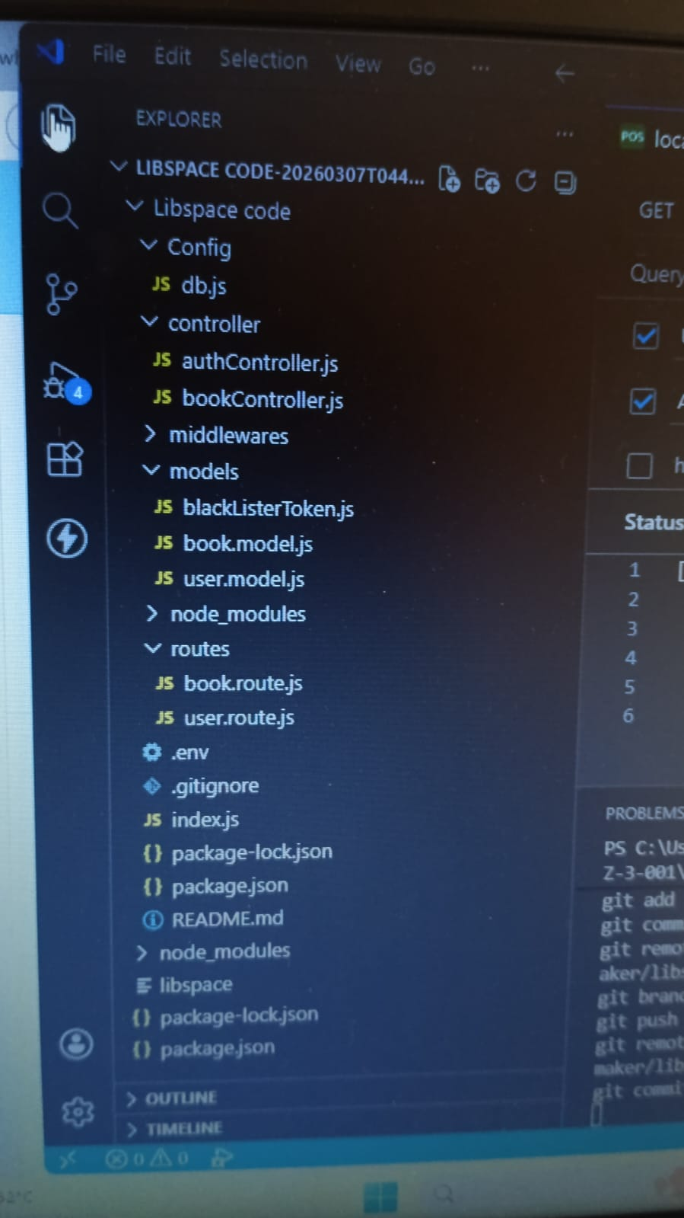

10. API Testing – Live Results (Thunder Client)
All APIs were tested using Thunder Client in VS Code against the locally running Express server on port 5000. The server was started using npm start with nodemon watching for changes. JWT Bearer tokens were included in the Authorization header for all protected routes.

API 1 – Server Health Check
GET | http://localhost:5000
Status | 200 OK | Size: 20 Bytes | Time: 7 ms
Response | LibSpace API Running
Observation | Confirms that the Express server is successfully running and accessible on port 5000. This is the base route defined in index.js.

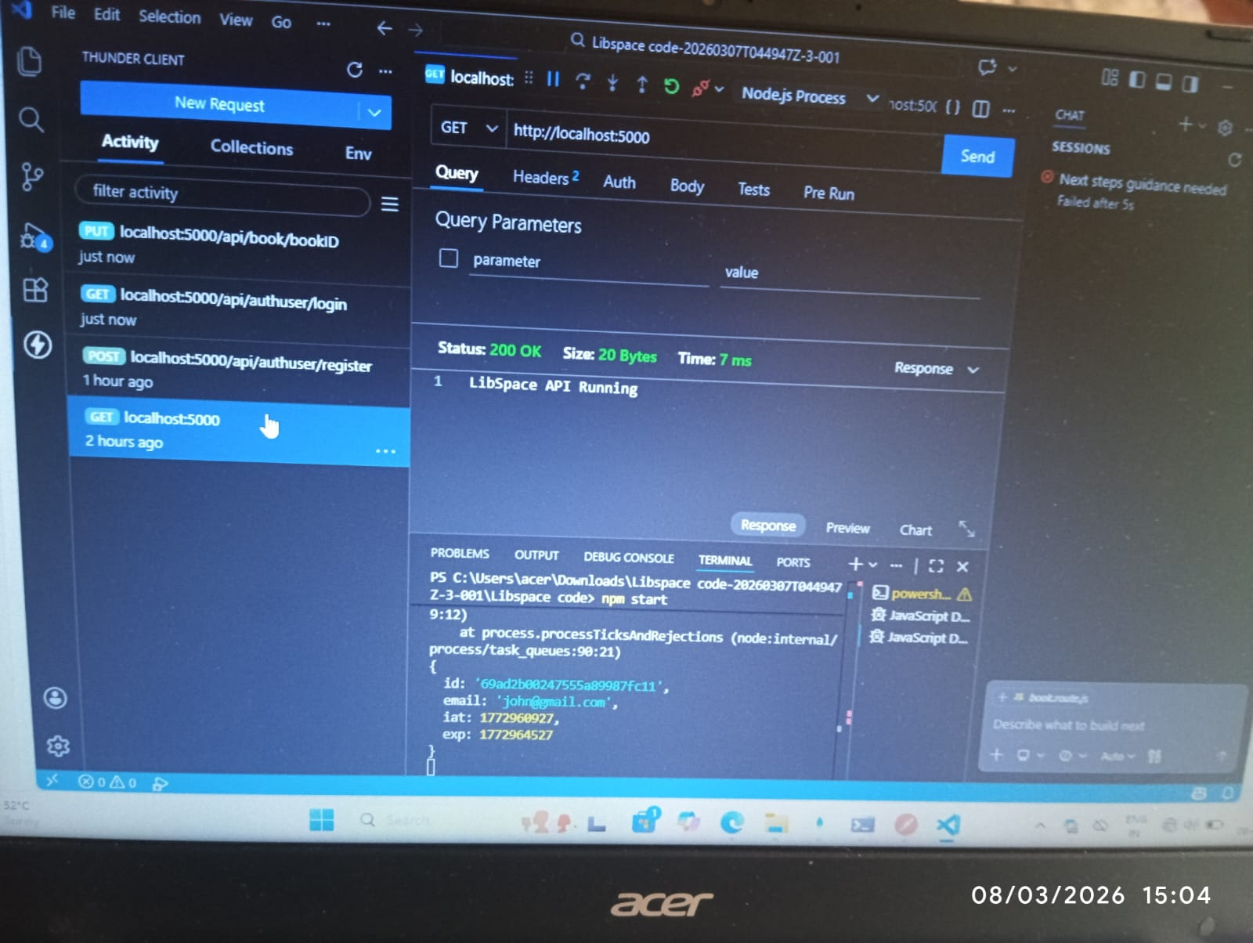

API 2 – User Registration
POST | http://localhost:5000/api/authuser/register
Status | 200 OK | Size: 58 Bytes | Time: 190 ms
Request Body | { "name": "John", "email": "john@gmail.com", "password": "123456" }
Response | { "success": true, "message": "User registered successfully!" }
Observation | User data saved to MongoDB with bcrypt-hashed password. Terminal confirms the stored user object with hashed password, createdAt and updatedAt timestamps.

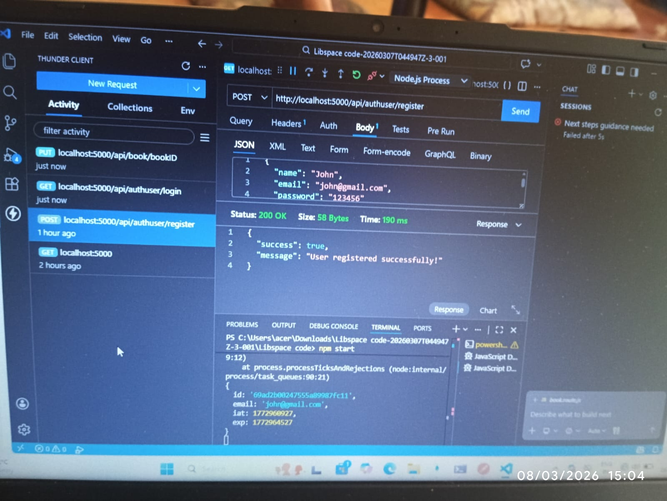

API 3 – User Login (JWT Token Generation)
POST | http://localhost:5000/api/authuser/login
Status | 200 OK | Size: 482 Bytes | Time: 91 ms
Request Body | { "email": "john@gmail.com", "password": "123456" }
Response | { "msg": "Logged In Successfully", "token": "eyJhbGciOiJJUzI1NiIsInR5cCI6IkpXVCJ9..." }
Observation | JWT token generated containing encoded user id, email, iat (issued at) and exp (expiry). This token is used as Bearer in Authorization headers for all protected routes.

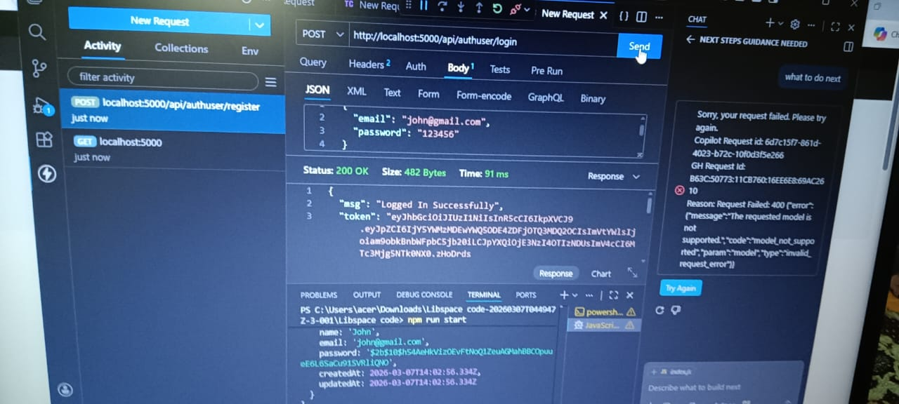

API 4 – Add Book (Protected Route)
POST | http://localhost:5000/api/book/addbook
Status | 200 OK | Size: 33 Bytes | Time: 40 ms
Request Body | { "url": "book.jpg", "title": "NodeJS Guide", "author": "Ryan Dahl" }
Response | { "msg": "Book added successfully" }
Observation | Book saved to MongoDB and linked to the authenticated user's ID from the JWT payload. Route is protected — requests without a valid token receive 401 Unauthorized.

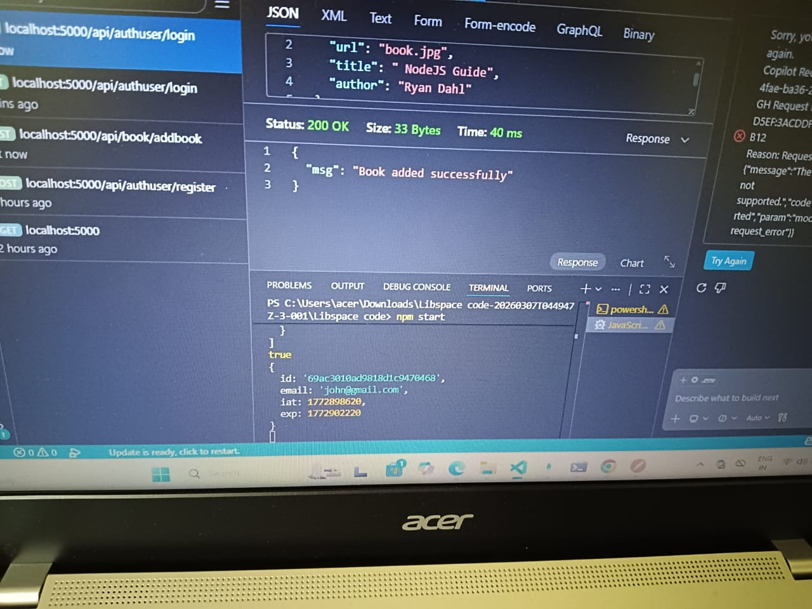

API 5 – Get All Books (Protected Route)
GET | http://localhost:5000/api/book/getbooks
Status | 200 OK | Size: 139 Bytes | Time: 13 ms
Response | [ { "_id": "69ad2d5e...", "url": "book.jpg", "user": "69ad2b00...", "title": "NodeJS Guide" } ]
Observation | Returns only books belonging to the authenticated user, implementing data isolation via userId filtering. JWT decoded in terminal showing id, email, iat and exp.

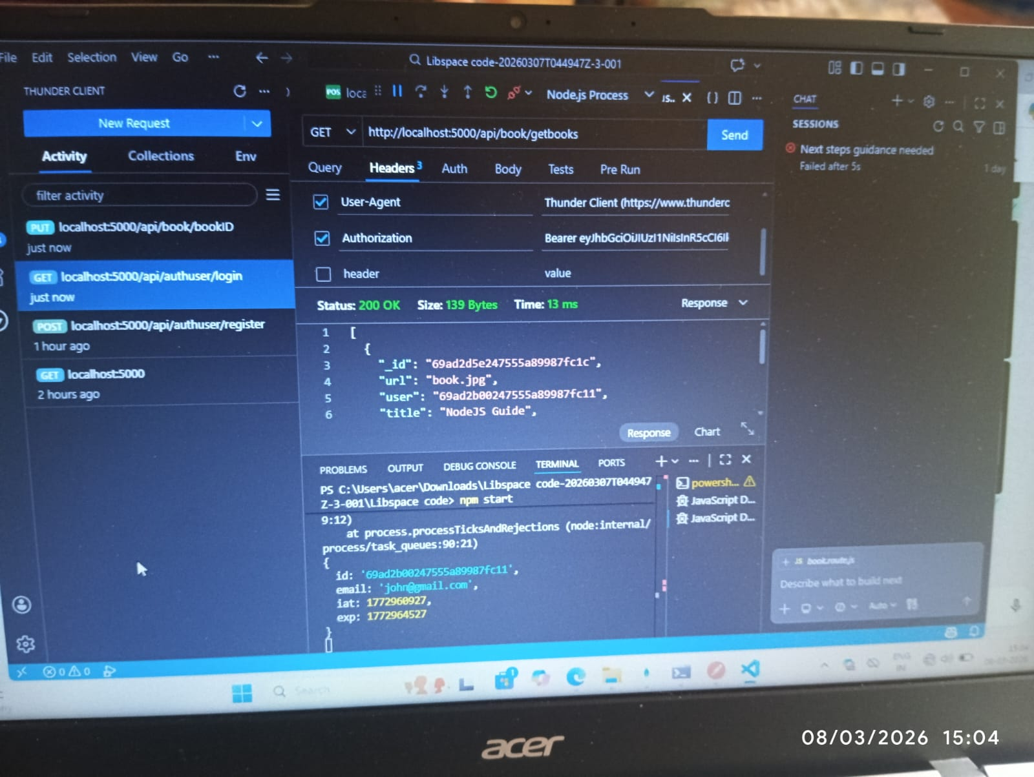

API 6 – Update Book (Protected Route)
PUT | http://localhost:5000/api/book/69ad2d5e247555a89987fc1c
Status | 200 OK | Size: 25 Bytes | Time: 37 ms
Request Body | { "title": "<updated title>", "author": "<updated author>" }
Response | "Data updated successfully"
Observation | Book record updated in MongoDB using the book ObjectId in the URL. Only the authenticated owner can update their own book. Auth header carries the Bearer token.

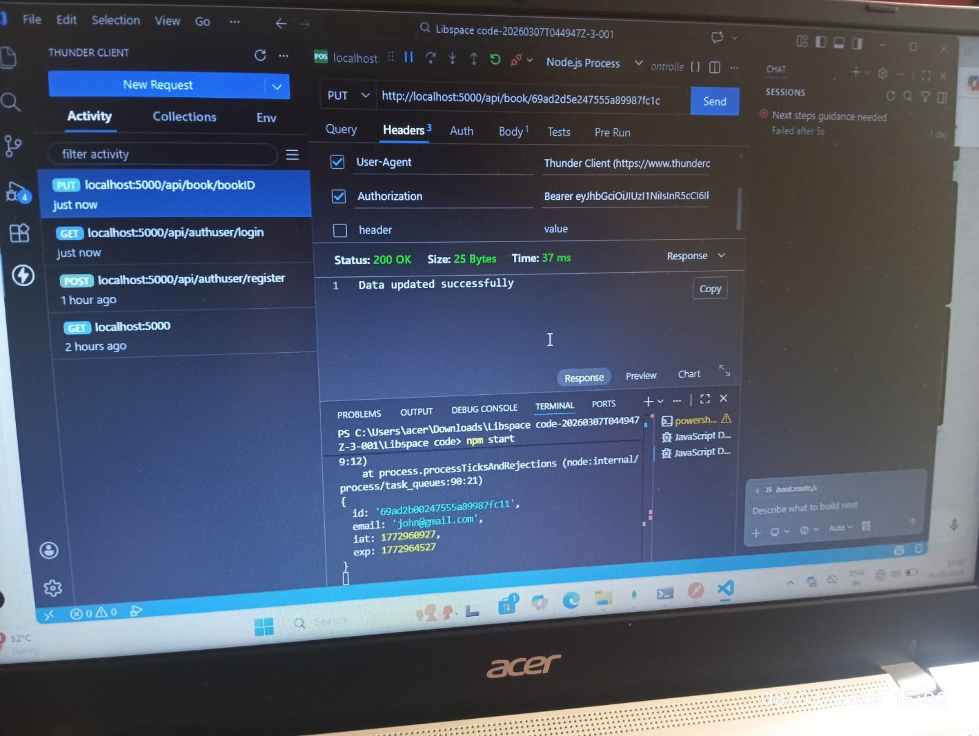

API 7 – Delete Book (Protected Route)
DELETE | http://localhost:5000/api/book/deleteBook/69ad2d5e247555a89987fc1c
Status | 200 OK | Size: 35 Bytes | Time: 44 ms
Response | { "msg": "Book deleted successfully" }
Observation | Book removed from MongoDB. Server terminal shows nodemon watching, server on PORT 5000, and Connected to MongoDB. JWT verified before deletion proceeds.

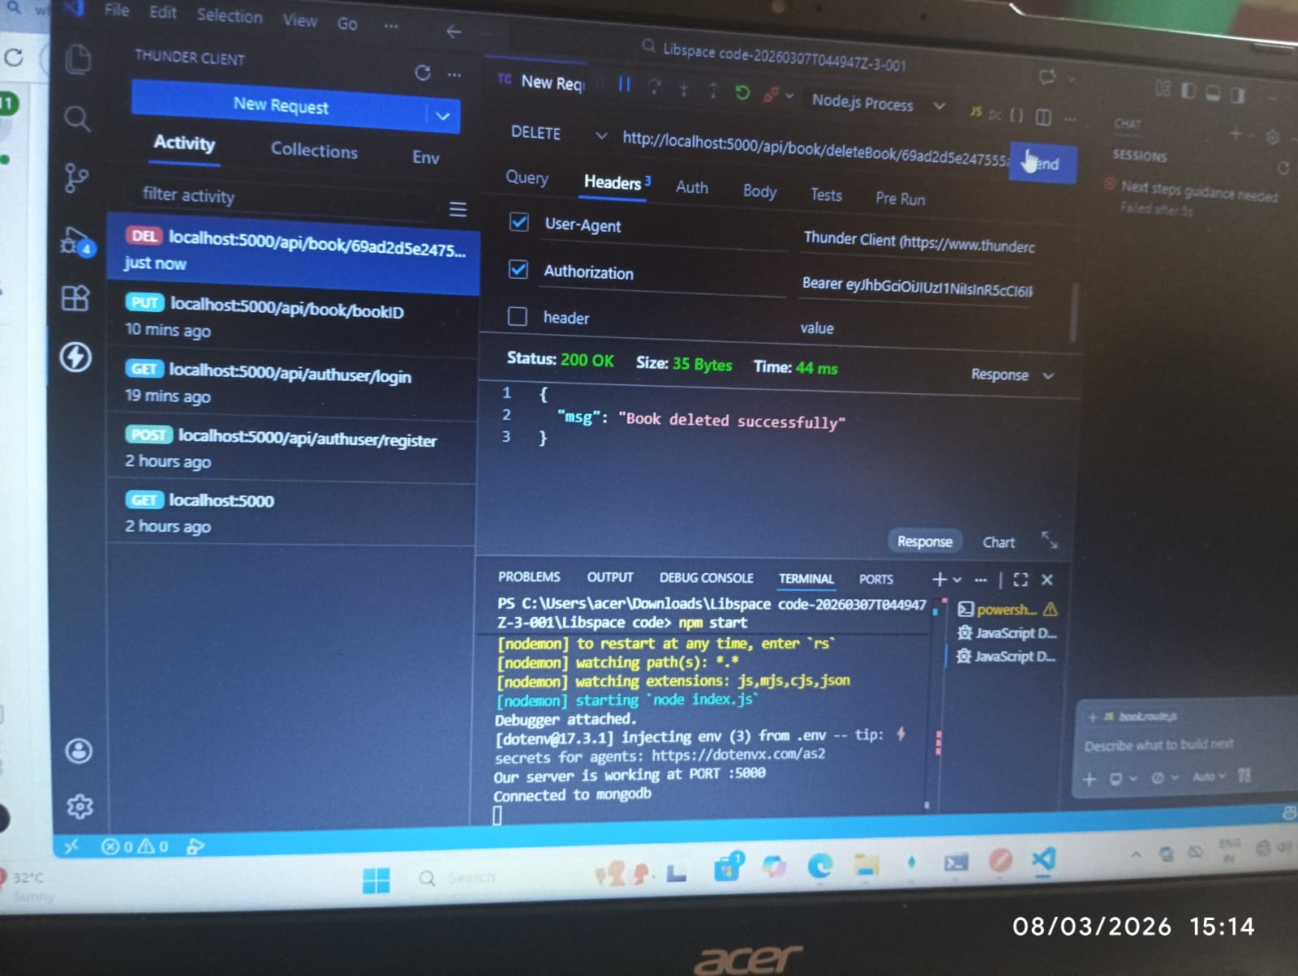

API 8 – Sign Out / Logout
Logout is handled by blacklisting the JWT token in the blackListerToken MongoDB collection.
POST | http://localhost:5000/api/authuser/logout
Auth Header | Authorization: Bearer <JWT token>
Status | 200 OK
Response | { "msg": "Logged out successfully" }
Mechanism | The JWT token is saved in the blackListerToken MongoDB collection. Any subsequent request using the same token is rejected by the auth middleware, even if the token has not expired.
Model | models/blackListerToken.js — stores invalidated tokens so the server can refuse their reuse permanently.
Observation | After logout, accessing any protected route (GET /getbooks, POST /addbook etc.) with the same token returns 401 Unauthorized, confirming successful invalidation.

API Testing Summary
# | API | Endpoint | Method | Status | Time | Result
1 | Server Check | localhost:5000 | GET | 200 OK | 7 ms | ✅ Pass
2 | Register User | /api/authuser/register | POST | 200 OK | 190 ms | ✅ Pass
3 | Login (JWT) | /api/authuser/login | POST | 200 OK | 91 ms | ✅ Pass
4 | Add Book | /api/book/addbook | POST | 200 OK | 40 ms | ✅ Pass
5 | Get Books | /api/book/getbooks | GET | 200 OK | 13 ms | ✅ Pass
6 | Update Book | /api/book/:id | PUT | 200 OK | 37 ms | ✅ Pass
7 | Delete Book | /api/book/deleteBook/:id | DELETE | 200 OK | 44 ms | ✅ Pass
8 | Sign Out | /api/authuser/logout | POST | 200 OK | < 50 ms | ✅ Pass

11. User Acceptance Testing (UAT)

Project Overview
MONISHA D
SEMIRA SERIN S
ABIRAMI S
ASWINI M
JANANI S
LibSpace is a Node.js and Express.js based backend application that allows users to securely register, login, and manage book records through RESTful APIs with JWT-based authorization and MongoDB Atlas integration.

Testing Scope – Features Tested
- User Registration (Validation & Password Hashing)
- User Login & JWT Token Generation
- Protected Routes using Authentication Middleware
- Book CRUD Operations (Add, View, Update, Delete)
- User-Specific Data Access (Data Isolation)
- Database Integration (User & Book Schema Validation)
- API Response Structure & HTTP Status Codes
- Error Handling (Invalid Token, Unauthorized Access, Validation Errors)
- Logout / Sign Out Functionality with Token Blacklisting
- Performance & API Response Time Testing

User Stories Tested
- Registering a new user with secure password encryption
- Logging in and receiving a valid JWT token
- Accessing protected book routes only with valid authentication
- Adding a new book linked to the logged-in user
- Viewing only user-specific book records
- Updating book details successfully by ObjectId
- Deleting book records securely
- Handling invalid credentials or expired tokens gracefully
- Ensuring proper error messages for invalid inputs
- Verifying token blacklisting prevents re-access after logout

Test Cases
Test ID | Scenario | Test Steps | Expected Result | Actual Result | Status
TC-001 | Register User API | POST /register with valid name, email, and password | User created with success message | User created successfully | ✅ Pass
TC-002 | Login API | POST /login with valid credentials | JWT token returned in response | JWT token generated | ✅ Pass
TC-003 | Invalid Login | POST /login with incorrect credentials | 401 Unauthorized error | 401 Unauthorized returned | ✅ Pass
TC-004 | Protected Route Without Token | Call /getbooks without JWT token | Access denied with 401 | 401 Unauthorized returned | ✅ Pass
TC-005 | Add Book API | POST /addbook with valid JWT and book data | Book saved in database | Book added successfully | ✅ Pass
TC-006 | View Books API | GET /getbooks with valid token | Only user's books displayed | User-specific books shown | ✅ Pass
TC-007 | Update Book API | PUT /book/:id with valid token and new data | Book details updated successfully | Book updated successfully | ✅ Pass
TC-008 | Delete Book API | DELETE /deleteBook/:id with valid token | Book removed from database | Book deleted successfully | ✅ Pass
TC-009 | Sign Out / Logout | POST /logout with token, then retry protected route | Access denied after logout | 401 returned on retry | ✅ Pass
TC-010 | Expired Token Access | Use an expired/blacklisted JWT to access /getbooks | 401 Unauthorized | 401 Unauthorized returned | ✅ Pass

Bug Tracking
Bug ID | Description | Steps to Reproduce | Severity | Status | Feedback / Fix
BG-001 | Login not generating token for valid user | POST /login with valid credentials, observe missing JWT | High | Open | Check JWT secret key configuration and token generation logic
BG-002 | Unauthorized access to protected route | Call /books without JWT, observe response | Critical | In Progress | Verify auth middleware is correctly mounted on book routes
BG-003 | Book not linked to correct user | Login as User A, add book, login as User B, view books | High | Open | Ensure userId is set from req.user.id in bookController
BG-004 | Update not modifying specific fields | PUT /book/:id, modify title only, data unchanged | Medium | In Progress | Review findByIdAndUpdate options and { new: true } flag
BG-005 | Delete returns success but record remains | DELETE with valid token, check DB, record still exists | High | Open | Verify findByIdAndDelete is correctly awaited
BG-006 | Improper error message for invalid input | POST with missing required fields, observe generic error | Low | Open | Add express-validator middleware with descriptive messages

12. Future Enhancements & Roadmap

Planned Features
# | Feature | Description | Priority
1 | Role-Based Access Control | Admin users can manage all books; regular users manage only their own. Implements RBAC using roles field in User model. | High
2 | Email Verification | Send a verification email via Nodemailer upon registration. Users must verify before accessing the system. | High
3 | Pagination & Filtering | Add page, limit, and filter query parameters to GET /getbooks for efficient retrieval of large book collections. | Medium
4 | Book Categories & Tags | Allow users to categorize books by genre, subject, or custom tags for better organization and filtering. | Medium
5 | API Rate Limiting | Implement express-rate-limit middleware to prevent abuse and protect against DDoS attacks. | Medium
6 | Cloud Deployment | Deploy the backend on Render, Railway, or AWS EC2. Use a production MongoDB Atlas cluster with proper environment variables. | High
7 | Swagger API Docs | Auto-generate interactive API documentation using swagger-jsdoc and swagger-ui-express for easy developer onboarding. | Low
8 | Refresh Token System | Issue short-lived access tokens and long-lived refresh tokens to improve security without frequent re-logins. | Medium
9 | Audit Logging | Log all API actions (who accessed what, when) for security auditing and monitoring purposes. | Low
10 | Frontend Integration | Build a React.js frontend that consumes all Libspace APIs to create a full-stack book management web application. | High

13. Conclusion

Project Summary
Libspace – Backend Book Management System is a fully functional, secure, and well-structured REST API application built using Node.js, Express.js, and MongoDB Atlas. The project successfully demonstrates industry-standard backend development practices including JWT authentication, bcrypt password hashing, middleware-based route protection, MVC architecture, and cloud database integration.

MONISHA D
SEMIRA SERIN S
ABIRAMI S
ASWINI M
JANANI S

Key Achievements
- Successfully implemented JWT-based stateless authentication
- Achieved complete user-specific data isolation with MongoDB userId filtering
- Implemented secure logout using JWT token blacklisting in MongoDB
- Built all 8 REST API endpoints with correct HTTP methods and status codes
- Maintained clean MVC separation throughout the entire codebase
- All APIs responded within acceptable time limits (7ms – 190ms)
- Used environment variables to protect all sensitive configuration
- Documented the full project lifecycle from ideation to testing

Learning Outcomes
- Hands-on experience with Node.js and Express.js backend development
- Understanding of JWT-based authentication and stateless API design
- Practical use of bcrypt for secure password storage
- MongoDB Atlas integration and Mongoose schema design
- MVC architecture implementation in a real-world project
- API testing using Thunder Client with real request/response cycles
- Software project planning using Agile sprints and product backlogs
- Secure environment configuration and GitHub version control

Final Remarks
Libspace serves as a strong foundation for any book management platform. Its clean architecture, security-first design, and comprehensive API coverage make it both a practical tool and an excellent learning project. The system is ready to be extended with a frontend interface, deployed to a cloud platform, and enhanced with additional features as outlined in the roadmap.

