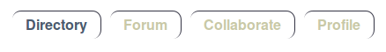

On the Directory tab, you will find a search form, in which you can search for people and organizations from your own workgroup(s) or in your entire network.

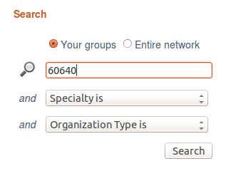

Just like Google, just put in any term here that you are interested in, such as a first name or a zip code.

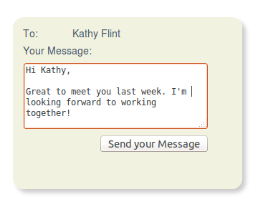
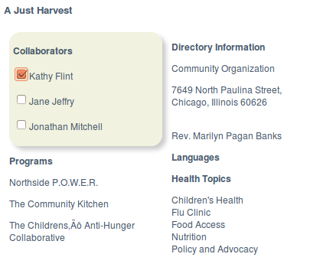
Also notice the message box. By selecting one or more collaborators, the To field of the message box will populate and you can send a brief message to any of the collaborators in your network. Your contact information (and theirs) will remain private.


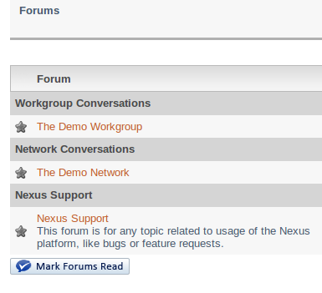
On the Forum tab you will find several important features.

1) Discussion Forums. Here you can post new topics or take part in an ongoing conversation. Make sure to subscribe to topics that you wish to follow closely so that you receive email updates when new content is posted.

2) Calendar. The Calendar sub-tab will reveal you networks calendar, to which you have permission to post events that will be visible to your network. You will receive a daily digest of new events that are posted to the calendar.

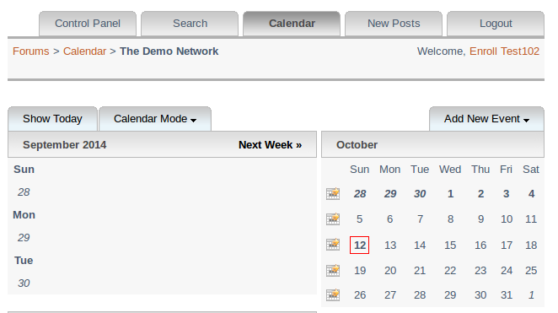
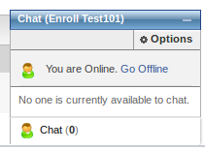
3) Private Chat. At the lower right corner of the page you will find a chat tool which enables you to have a real-time conversation with anyone in your network who is logged in at the same time as you.
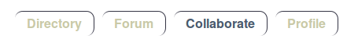

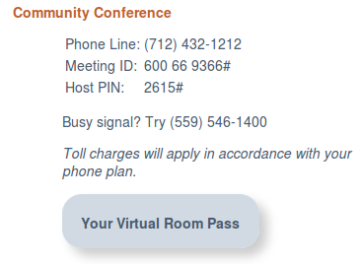
On the Collaborate tab you will find your networks community web conference room. When you activate Your Virtual Room Pass, a new tab will open in your browser and you will enter your network's virtual conference room, packed with features like web cam, file presentation, collaboration on the whiteboard, disktop sharing, chatting, various presentation modes, and session recording. See the tutorial videos available in the conference room for much more information.

On this tab you will also find a community telephone bridge line for times when a quick conversation is what you need. Also, this line may be useful if any web conference participants have trouble establishing audio connection in the web conference (which is possible depending on different client capabilities.)

Both of these resources are available on a first-come first serve basis within your network. A scheduling module will be added to the system soon.
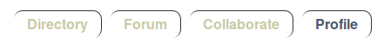

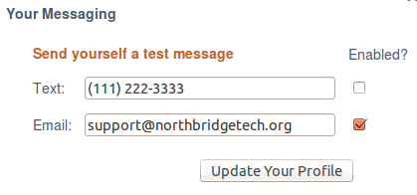
On the Profile tab, you can see your own profile within Nexus. Several items are editable.

Please notice your messaging options in the lower left corner. This is where you can determine where you want messages from your network colleagues to be routed, and you can enable or disable any endpoint at any time.

Note: When you do not have any message endpoints enabled, your message checkbox will be disabled on the Directory tab.

Coming soon: Public portions of your profile will be viewable from the Directory tab so that you can publish your contact information if you wish along with your other interests.

