Why Northbridge?
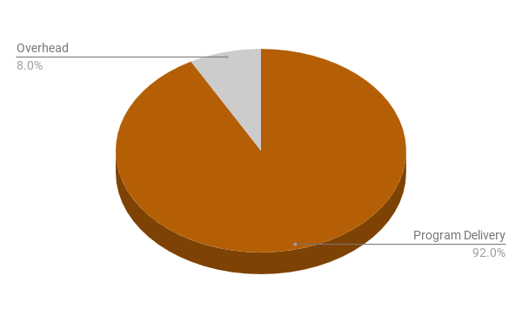Expenditures: Overhead vs. Delivery
Northbridge is a technology nonprofit. And, like a good piece of technology, we take one slice of the problem and solve it. With excellence.

Say more...
Activists fighting for the safety and security of minority communities are chronically challenged with access to technology. So, we figure out how to help, build it in an open source, agile fashion, and give it to them. We do what we do so they can get about creating social progress.
Check out our flagship SaaS product Nexus Web Meet!

What can I do?
Northbridge is a special, close-knit community that reflects the world we are trying to build.
Busy career, but want to give us a boost? Every $60 you give allows an activist group to use our flagship web conferencing platform for a full year. $500 supports a server for 10 weeks. Low administrative costs make your gift high impact and you'll become part of a wonderful community of people determined to make a difference in these challenging times.
Have time on your hands and would like to volunteer? See our web site for how you can apply to get involved on a great team.
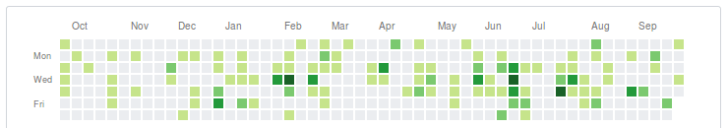Volunteer Activity: Open source code commits: Prior year rolling

Our mission
Won't you join us?
We create software solutions for charitable organizations who do social justice and community building work so that their collective impact is increased.

