
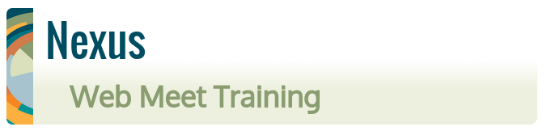

Check your internet browser compatibility
Join the training presentation

Step 3 - Send a chat message to the class
Enter “Hello” in the text box,
then click “Send”
(lower right)




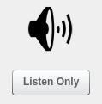
Step 4 – Join conference audio
Select the headphones icon
(upper left)
Check your browser compatibility
Join the training presentation
Send a chat message
Join conference audio
Welcome!

Today's Agenda
Part 1: Introduction

Part 2: Watch a demonstration

Part 3: Practice your media connections

Part 4: Explore additional features of Nexus

Check your browser compatibility
Join the training presentation
Send a chat message
Join conference audio

Step 5 – Watch the demonstration
A new tile will appear in
the room showing the
presenters desktop

Check your browser compatibility Watch the demonstration
Join the training presentation
Send a chat message
Join conference audio

Step 6 – Open up your media options
Log out of the conference room,
then follow the prompts to
return to this room

Check your browser compatibility Watch the demonstration
Join the training presentation Open your media options
Send a chat message
Join conference audio
Step 7 – Join conference microphone
Select the headphones icon,
and this time select the
microphone option
(upper left)

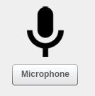

Step 8 – Join conference video (optional)
Select the camera icon.
(This will share your camera.)
(upper left)
Check your browser compatibility Watch the demonstration
Join the training presentation Open your media options
Send a chat message Join conference microphone
Join conference audio Join conference video

Step 9 – Play with other conference room features
Private chat messages
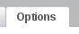

Display language

Layout options
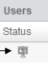
Tile resizing
Change presenter mode
Draw tools
Check your browser compatibility Watch the demonstration
Join the training presentation Open your media options
Send a chat message Join conference microphone
Join conference audio Join conference video

Nice Job! What's next?

Account activation after two trainees.

Q&A

General information webinar sessions.

