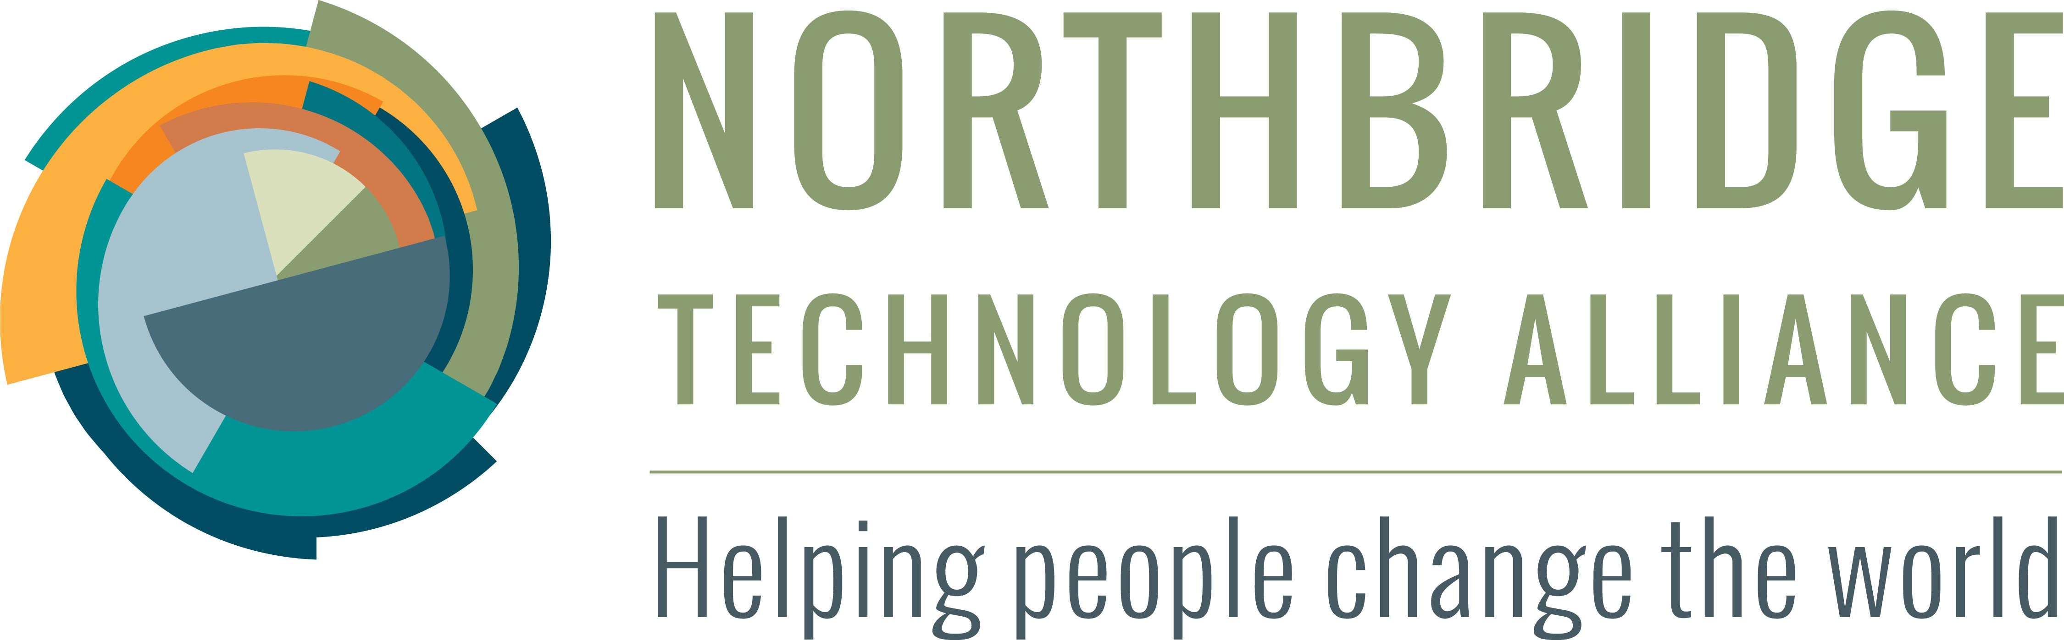






Information Webinar


To Join Conference Audio
Select the headphones icon in the upper left corner

To Communicate with the Moderator and all Attendees
Type your message in the Chat room in the right portion of your screen

We create software solutions for charitable organizations who are engaged in social justice and community-building efforts so that their collective impact is increased.

To Join Conference Audio
Select the headphones icon in the upper left corner

To Communicate with the Moderator and all Attendees
Type your message in the Chat room in the right portion of your screen

Founded in 2012 by Kathy Flint.

After 20 years in the corporate IT sector, Kathy decided to pursue her lifelong interest in social justice activism by organizing the efforts of skilled IT professionals.

To Join Conference Audio
Select the headphones icon in the upper left corner

To Communicate with the Moderator and all Attendees
Type your message in the Chat room in the right portion of your screen

Northbridge is a mission-driven IRS 501(c)(3) tax exempt nonprofit based in the Chicago area.

Northbridge is grant-supported and volunteer-sustained.

Volunteer Application Micro-Grant

To Join Conference Audio
Select the headphones icon in the upper left corner

To Communicate with the Moderator and all Attendees
Type your message in the Chat room in the right portion of your screen

Nexus is our collaboration framework that has been in pilot with major Midwest collaborative networks since 2014.

This year Northbridge is funded to provide 15 web meeting rooms to qualifying partners using our new collaboration platform Nexus. Apply Now

To Join Conference Audio
Select the headphones icon in the upper left corner

To Communicate with the Moderator and all Attendees
Type your message in the Chat room in the right portion of your screen

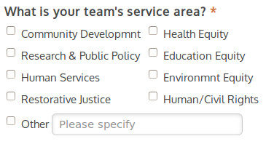
If you fit our partner profile, consider applying for partnership.
Apply Now

Also, please help spread the word by following us on our social media outlets.

To Join Conference Audio
Select the headphones icon in the upper left corner

To Communicate with the Moderator and all Attendees
Type your message in the Chat room in the right portion of your screen

Q&A
Northbridge Technology Alliance
kathy.flint@northbridgetech.org

To Join Conference Audio
Select the headphones icon in the upper left corner

To Communicate with the Moderator and all Attendees
Type your message in the Chat room in the right portion of your screen

