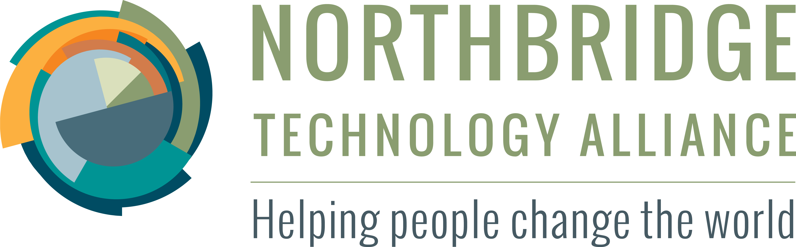
Global Web
Conference
Center

The Northbridge Technology Alliance Global Web Conference Center provides reliable and sophisticated group collaboration using internet-connected laptops, tablets and cell phones. Much like a brick-and-morter conference center, our Global Web Conference Center provides users with a reserved, private, and secure meeting location inside a space flexible enough to accommodate many types of meetings.
feature
feature
feature
feature
feature

Benefits of Web Conferencing
Though the value of face-to-face meetings remains unchallenged, many nonprofits are beginning to realize that the benefits of digital collaboration are also significant.

- Reduced travel expense
- Increased capacity to work with far away people
- Eliminate communication gaps by preserving meeting records in a consistent place
- x
- x
- x
- x

If your nonprofit organization is not fluent with web conferencing tools and services then you may be missing out on an opportunity to extend your impact and reduct your costs.

Why Northbridge for Your Web Conference Needs?
Features: Because we are largely volunteer-supported, Northbridge is able to provide to our nonprofit partners a compelling collection of features that is unrivaled by traditional profit-driven web conference services. And since we are a US 501(c)(3), ...
Training: Corporations of all types and sizes report that there is a learning curve associated with incorporating web conferencing practices into their communication strategies. Because we recognize that in order for the potential benefits of web conferencing to be fully realized, it is essential for organizations to become fluent and confident in their use. Since it is our mission to increase the effectiveness of our partners, we include training in our standard service bundle.
Northbridge Technology Alliance creates software solutions for charitable organizations who are engaged in social justice and community-building efforts so that their collective impact is increased.
We envision a world where technological innovation creates sustainable and forward-thinking solutions that address the hardest social problems facing humanity.
NorthBridge Guiding Principles
- The organizations we serve are the experts about their needs.
- Technology is a means to, not a measure of, progress.
- Effective solutions are tangible and sustainable.
contact@northbridgetech.org
http://northbridgetech.org
866.848.9224

Funding: Finally, our Global Web Converence Center is largely micro-grant supported, allowing our partners options for successful funding even when budget constraints might typically eliminate web conferencing as an option.
Who Is Eligible?
Only people doing social justice work.
See grant for details.
How Do I Sign Up?
Apply online.

