Optima User Guide

V1.0.0

**Table of contents**

Figure list 2

Overview 3

What is Optima: 3

What does it offer: 3

Getting started 3

Home page overview: 3

Jobs: 5

Differences between agents: 5

Create a first job: 5

Device management 7

Device categorization: 7

Device creation: 7

Notifications & triggers: 9

Create triggers: 9

Create notifications: 9

Workflow: 11

Workflow nodes: 11

Create a workflow: 12

User management: 13

Create a user: 13

Create user group: 13

Create role: 14

Reporting: 15

Job & Task report 15

Centralized logging system (ELK system): 15

Compliance Reports :…………………………………………………………………………...16

Create a compliance report.……………………………………………………………..16

Visualisate a compliance report…………………………………………………………16

# **Figure List**

Figure1: login page……………………………………………………………………………………………………………………………3

Figure2: home page………………………………………………………………………………………………………………………….4

Figure3: job List page………………………………………………………………………………………………………………………..5

Figure4: job list…………………………………………………………………………………………………………………………………6

Figure5: device categorization………………………………………………………………………………………………………….7

Figure6: form to create a device……………………………………………………………………………………………………….8

Figure7: form to create triggers………………………………………………………………………………………………………..9

Figure8: form to create notifications……………………………………………………………………………………………….10

Figure9: workflow page……………………………………………………………………………………………………………………11

Figure10: evaluation node……………………………………………………………………………………………………………….11

Figure11: form to create a user……………………………………………………………………………………………………….12

Figure12: building workflow……………………………………………………………………………………………………………13

Figure13: form to create a user group……………………………………………………………………………………………..14

Figure14: form to create a role………………………………………………………………………………………………………..14

Figure15: job report…………………………………………………………………………………………………………………………15

Figure16: task report……………………………………………………………………………………………………………………….15

Figure17: view logs by kibana………………………………………………………………………………………………………….16

# **Overview**

## **What is Optima:**

Optima is a network automation tool used to orchestrate actions simultaneously on a large number of network elements. Optima reduces costs and time needed to modify and update network elements and adds reporting and reliability to the audit or change processes.

## **What does it offer:**

* Service Provisioning rapidly at scale.
* Eliminate user error to manual processes/controls.
* Reduce errors through repeatable job chunks.
* Manage vulnerabilities to allow business to move forward.
* Time to market cut in half.
* Best practice & compliance via network programmability.

# **Getting started**

To access to Optima, use the port 8000 on its host.

The first step is the authentication. You must enter the login and the password. The default login is admin and password is admin.

**Note:** Please change the default password to make

When you are finished click Login.

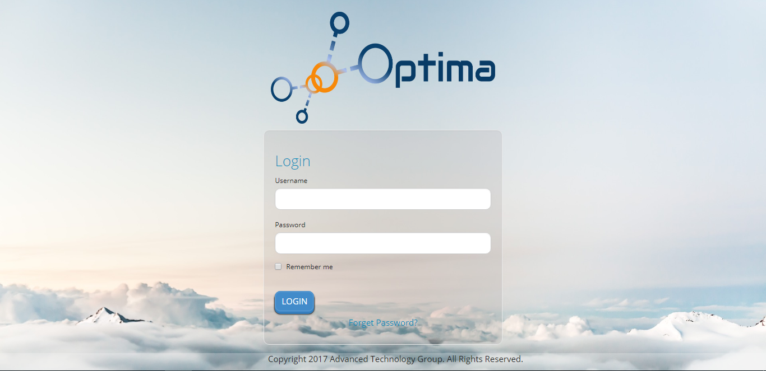

Figure1: login page

## **Home page overview:**

After logging in on the application, the user is redirected to the home page showing the main features of Optima.

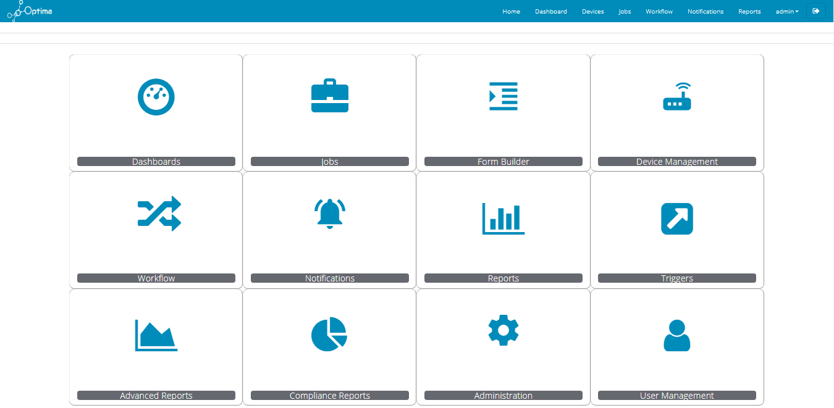

Figure2: Home page

**Dashboards**: this page gives an overview of Optima’s actions and follows in real-time the changes that are made in status of each job and task. Also, details about agents, jobs and devices are displayed.

**Jobs**: In this page we can see the list of jobs by displaying the agent type (configuration parser, configuration sender, differ precheck, differ postcheck, image loader), description, insertion time, scheduled, scheduled date, and the status.

**Form-builder:**  this page displays the different forms for each agent type. This is where update jobs are initiated.

**Device management:** Management of device inventory. Inventory is used for statistics and easier job/workflow updates

**Workflow:** Workflow listing and creation using a drag & drop interface

**Notifications:** Notification management using triggers and targeting different destination types

**Reports:** Real-time job and task status and result visualization

**Triggers:** Rule-based filters for events and status changes on Optima

**User management:** RBAC-based user management with fine-grained permission model.

To access any functionality, click on its icon.

## **Jobs:**

To see the job list click on jobs in home page.

The job list shows all the job previously created. You can edit each of these jobs by clicking on edit icon.

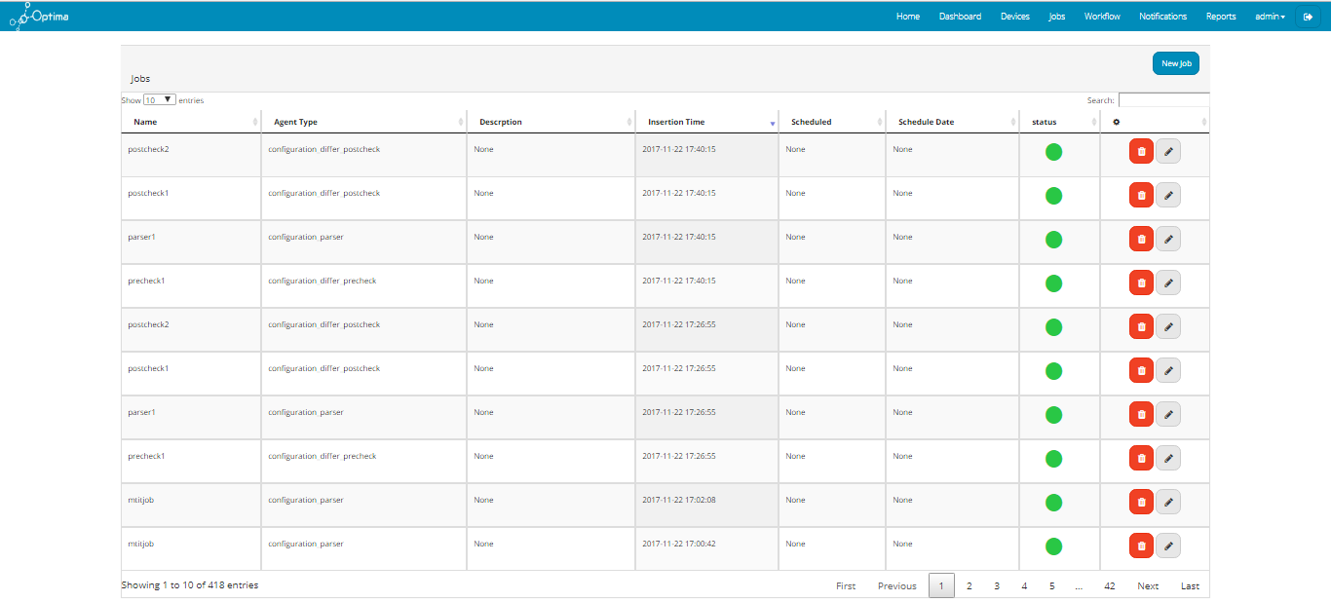

Figure3: job list page

### **Agent types**

We have five types of agents:

**Configuration Parser**: it sends configurations to devices and waits the result of commands. The result is then parsed to look for specific keys.

**Configuration Sender**: sends configuration and simply saves the received output.

**Differ precheck**: Sends a set of commands and saves the result as well as the used commands for later usage

**Differ postcheck**: Each postcheck job is based on a precheck. It uses previously saved commands and compares the current state with the ancient to show the differences.

**Image loader**: Used to load and update OS images on remote devices. It takes care of the whole process of sending the image, making sure its transfer was completed successfully as well as triggering the image installation.

**Create a first job:**

To create a new job click on the button New job. This page has different tabs. Each of these tabs contains a form to create a job of a specific type.

Enter these information to create a job

The table below, shows the fields of forms, that they are common between agents, to create a job.

|  |  |  |  |
| --- | --- | --- | --- |
| name | type | description | example |
| Job name | text | Name of the job | Find SNMP version |
| description | text | Description of the job | Security compliance test |
| credentials | Radio button | *note1 | Use device credentials |
| hosts | Radio button | *note2 | Load a host file |
| scheduling | Radio button | *note3 | Job not scheduled |

*note1: you can use device credentials or enter a login and password

*note2: you can choose the list of the router by uploading a file that contains this list or choosing it from database.

*note3: the job can be scheduled or not. If the job was scheduled, it will be executed after validation the form and if it is not scheduled, the job will be executed until the chosen date.

The tables below, show Parameters’ field of each agent type.

Configuration Parser & Differ Precheck:

|  |  |  |  |
| --- | --- | --- | --- |
| name | type | description | example |
| Strict matching | option | Select yes or no | yes |
| keys | text | Enter a key | ssh |
| Remote command | text | Enter a command | show ip ssh |

Differ Postcheck:

Parameters: show list of job which the agent type is Differ precheck.

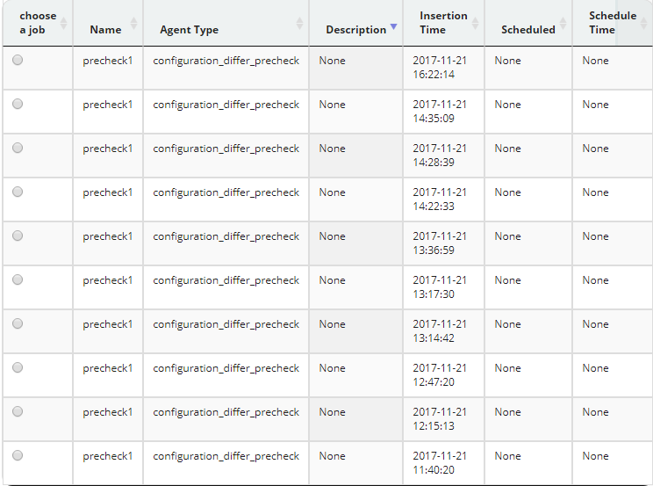

Figure4: job list

Image loader:

|  |  |  |  |
| --- | --- | --- | --- |
| name | type | description | example |
| Storage device | text |  | flash |
| FTP Server name | text | Enter the server name | ftp-server.local |
| FTP port | text | Enter the server port | 23 |
| FTP user | text | Enter the user | optima |
| FTP password | text | Enter the password | optima |
| Image loader | text | Name of the image | Cisco |

In the bottom of the page, you check a checkbox to validate the job before submitting it.

When you are finished click Submit.

## **Device management**

To access to device list click on device management in Home page.

### **Device categorization:**

Devices are organized in the tree view by:

Device Classes

Groups

Locations

To add a new device Classes or groups or locations click on add icon.

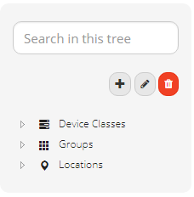

Figure5: device categorization

### **Device creation:**

Before creating a device, specifying the category (device Classes, groups, locations) is required.

To create new device you choose the category. Then a device list appears. Click on the button New Device.

For example if you choose Device Classes category, the form that you should complete includes name, IP address, category (production, preproduction, test, maintenance), location, group, SNMP Community, SNMP Version, login, and password.

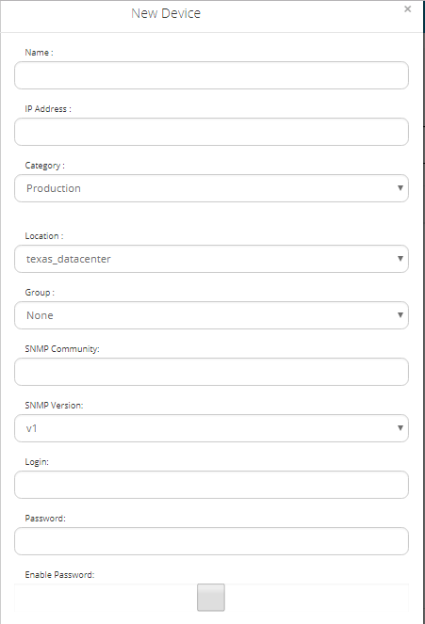

Figure6: form to create a device

## **Notifications & triggers:**

The role to create notifications is to send email in order to notify users about status of jobs and devices.

### **Create triggers:**

To create triggers click on Triggers in home page. The triggers list appears then click on button New trigger.

While creating a trigger, select rules that define it. These rules can be one or more conditions.

To create a trigger you define:

|  |  |  |  |
| --- | --- | --- | --- |
| name | type | description | example |
| name | text | Name of the trigger | Failed jobs |
| enable | checkbox | Enable the trigger | True |
| rule | table | *note1 | *note2 |

*note1: first select the type (device or job), attribute (for each type you choose one of its attribute), operation (equal or not equal), and value.

*note2: type: job

attribute: status

operation: equal

value: FAILED

The trigger can use all or any of its rules.

To add a new rule, click on the add icon.

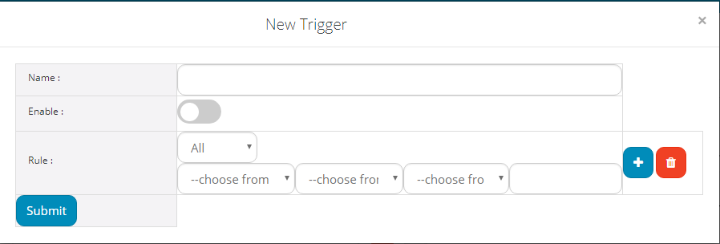

Figure7: form to create triggers

### **Create notifications:**

After creating a trigger, you can create a notification.

To create a notification, click on the button New notification and then you specify:

|  |  |  |  |
| --- | --- | --- | --- |
| name | type | description | example |
| name | text | Name of the notification | Failed jobs |
| Trigger | action | Name of the trigger | Failed jobs |
| subscriber | action | subscribers | admin |
| action | action | *note1 | email |
| message | Text area | Enter the message | *note2 |
| enable | checkbox | Enable the notification | true |

*note1: the way that a user will be notified (email or sms).

*note2: the message that will be sent to a user.

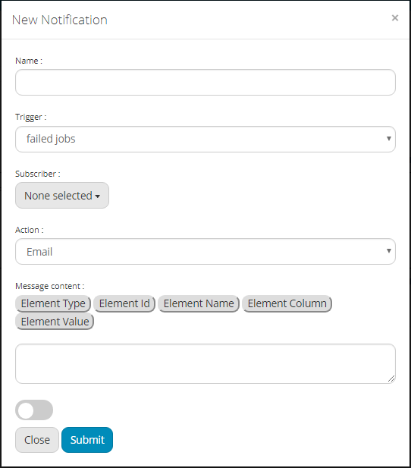

Figure8: form to create notifications

## **Workflow:**

### **Workflow nodes:**

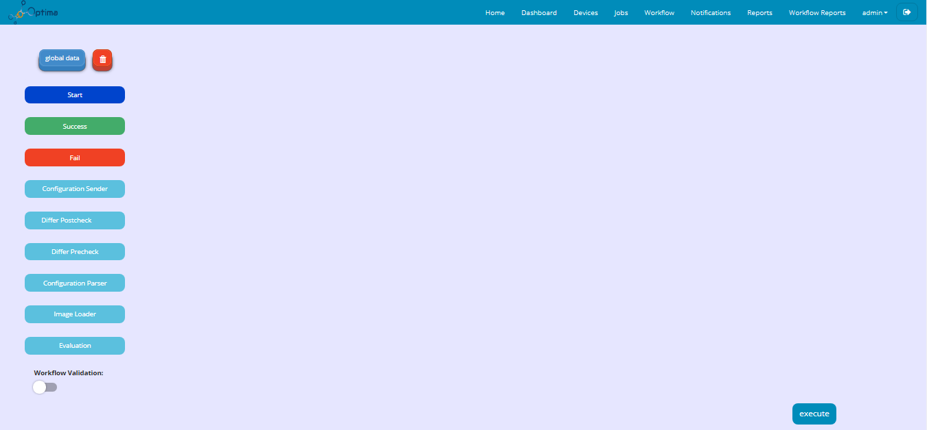

Figure9: workflow page

In the left of the page, you see the nodes. Each node represents an action that the workflow can

execute.

This workflow contains two types of nodes:

Agent node: it is the agent type which is responsible to execute a job

Evaluation node: this node should be placed before the configuration parser’s agent.

This node takes the key that it was defined in the configuration parser and execute this action if the key was found.

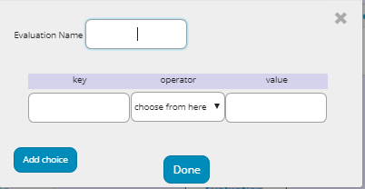

Figure10: evaluation node

|  |  |  |  |
| --- | --- | --- | --- |
| name | type | description | example |
| Evaluation name | text | Name of evaluation | check ssh version 2 |
| key | text | key | up |
| operator | option | operator | contains |
| value | text | Enter a value | FastEthernet0/0 |

You can add these nodes to the workflow by dragging them onto the canvas.

Every node has a form which you enter information about it.

The workflow should start with the start node and finish with the success or fail node.

### **Create a workflow:**

To access to the workflow click on Workflow in home Page. A workflow list appears.

To create a new workflow click on the button new workflow.

To enter information about the new workflow click on the button global data.

To build a workflow, drag nodes onto the canvas. Link nodes together. These links define the path that the workflow can take at run time.

On the bottom of the page, click on the button to validate your workflow before submitting it.

When you are finished click Execute.

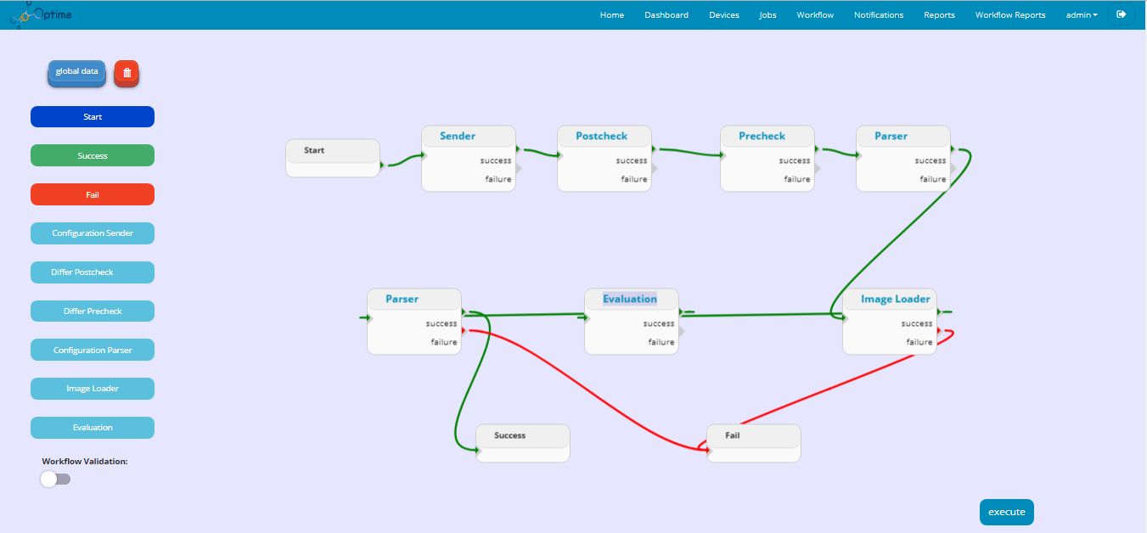

Figure11: building a workflow

## **User management:**

The administrator can assign permissions to each user in the system.

### **Create a user:**

To create a user account you click on button New User and then you specify:

|  |  |  |  |
| --- | --- | --- | --- |
| name | type | description | example |
| name | text | The name of user | admin |
| password | password | The password of user | admin |
| Phone number | text | The phone number of user | 0609874658 |
| email | email | Email of user | admin@gmail.com |
| group | option | *note1 | Admin_user |

*note1: select a role to assign it to a user

Click Send. The user appears in user list.

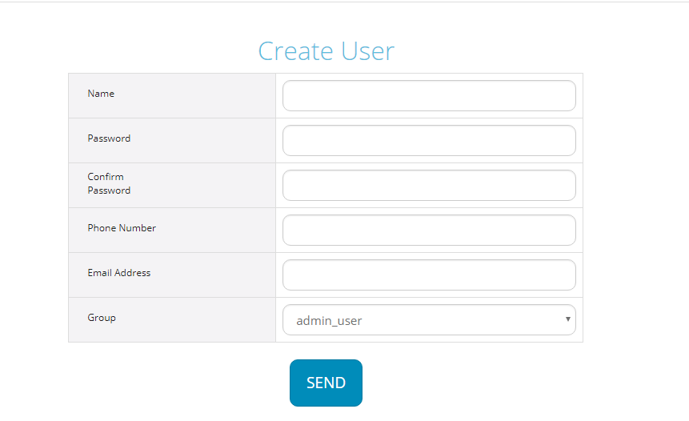

Figure12: form to create user

### **Create user group:**

The administrator can add a new user group. Enter a name and select a role

Click Send. The user group appears in user group list.

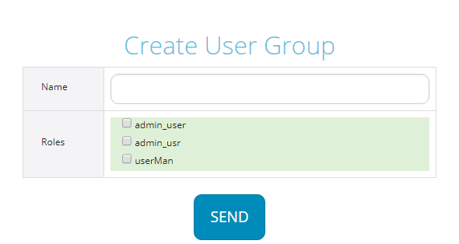

Figure13: from to create a user group

### **Create role:**

The administrator can add a new role. Enter a name and select one or more permissions. You can give permission to users for each feature

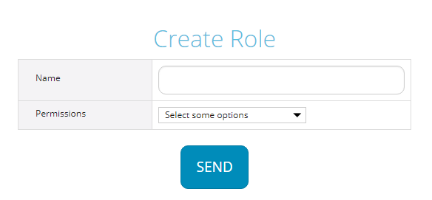

Figure14: form to create a role

## 

## **Reporting:**

### **Job & Task report**

To see job report, on the home page click reports. From this page you can see the list of jobs and their status.

You can see the details of logs with kibana by clicking on the button view logs.

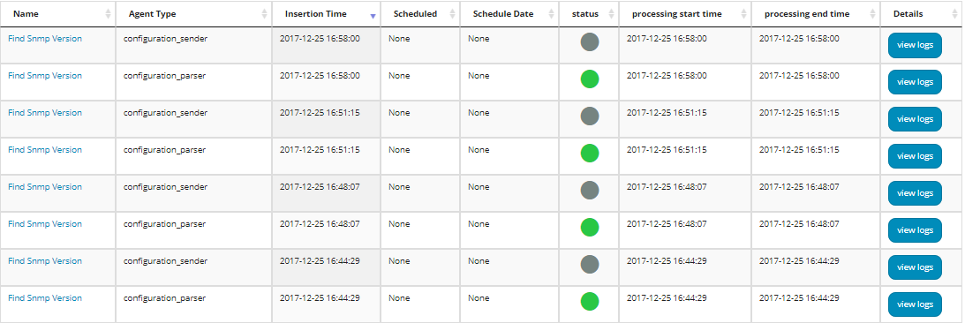

Figure15: job report

You can view task report by clicking on the name of the job.

To see the logs click on button view logs.

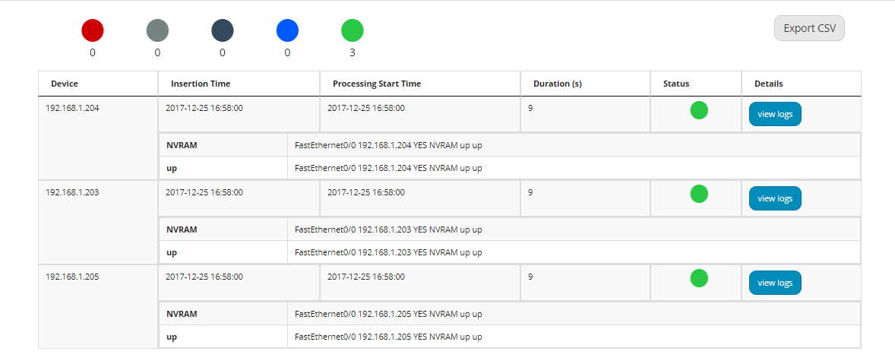

Figure16: task report

### **Centralized logging system (ELK system):**

Centralized logging system allows you to search through all of your logs. It can be useful to manage information for reporting.

ELK system offers a set of application (Elasticsearch,logstash,Kibana) , each serving a distinct purpose.

This page you can see the details of logs.

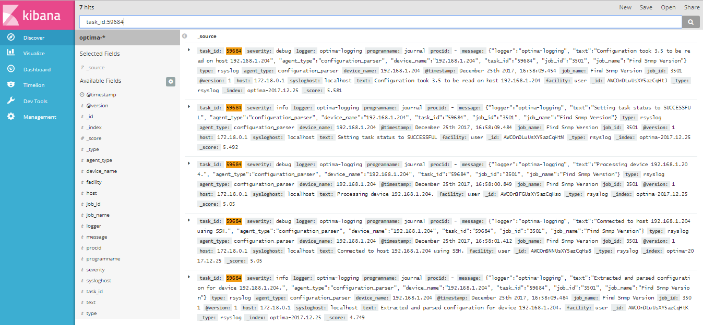

Figure17: view logs by kibana

## **Compliance Report:**

### **Create a compliance report**

To to create a new compliance report, on the home page click compliance reports. In the page bellow you can click on New Compliance Report button and it will redirect uou to the creation page.

Here some details about how to creat a new compliance report .

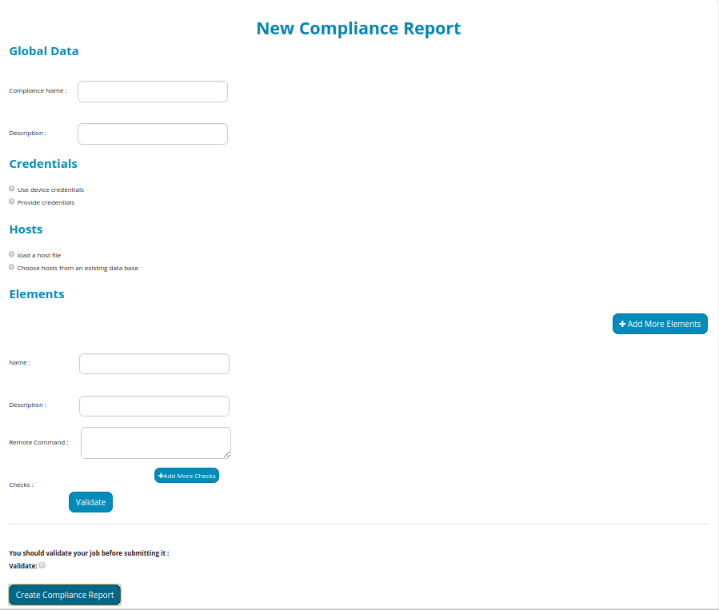

Figure15: job report

You can view task report by clicking on the name of the job.

To see the logs click on button view logs.



Figure16: task report

### **Centralized logging system (ELK system):**

Centralized logging system allows you to search through all of your logs. It can be useful to manage information for reporting.

ELK system offers a set of application (Elasticsearch,logstash,Kibana) , each serving a distinct purpose.

|  |  |  |  |
| --- | --- | --- | --- |
| name | type | description | example |
| Compliance name | text | Name of the compliance report | Compliance test |
| Description | text | Description of the compliance report | Testing a compliance report |
| credentials | Radio button | *note1 | Use device credentials |
| hosts | Radio button | *note2 | Load a host file |

*note1: you can use device credentials or enter a login and password

*note2: you can choose the list of the router by uploading a file that contains this list or choosing it from database.

So in every compliance report created you can add many elements, for example:

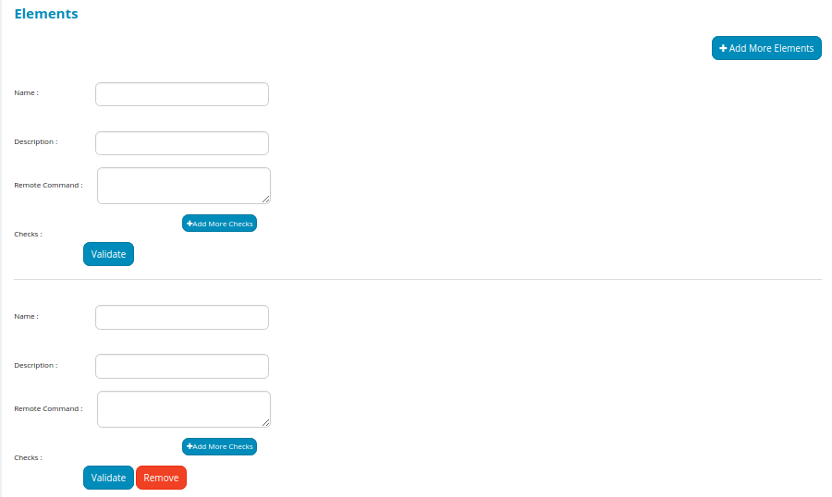

|  |  |  |  |
| --- | --- | --- | --- |
| name | type | description | example |
| Compliance name | text | Name of the element | First element |
| Description | text | Description of the element | The first element of the created compliance report |
| Remote command | text | Enter a command | show ip ssh |

in every compliance report, you can add one, or many checks, those are the main informations you need to fell in the checks table :

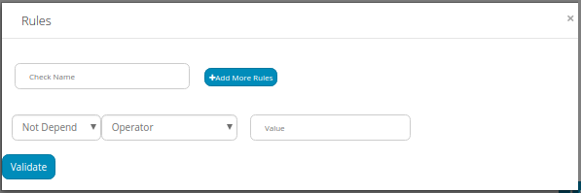

|  |  |  |  |
| --- | --- | --- | --- |
| name | type | description | example |
| Check name | text | Name of the check | check1 |
| type | option | Type of the check | Depend or not depend |
| operator | option | operator | contains |
| value | text | Enter a value | FastEthernet0/0 |

On the bottom of the page click the button valide then create compliance report to create your report.

### **Visualisate a compliance report**

When you click on compliance reports in the home page, it will redirect you to a page where is locate a list of all the created compliance reports templates, so when you click on the execute button, this will execute the compliance report and give you a result.

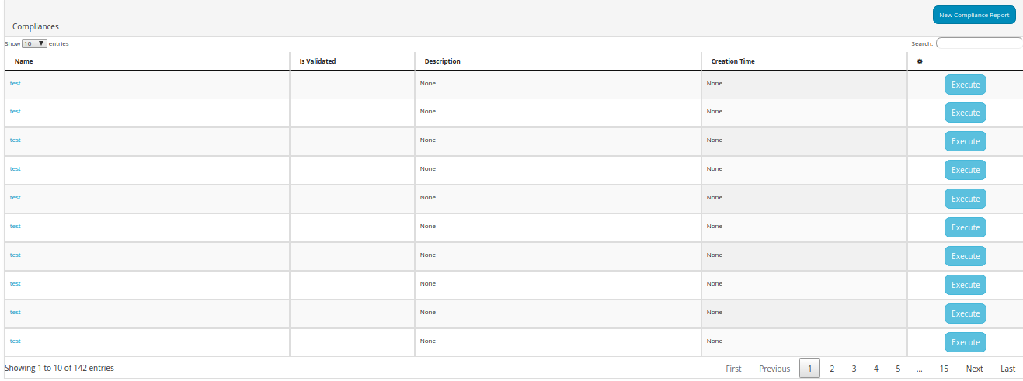

Then, you can click on the name of the executed compliance report to show its results:

and you can click on the date of the execution you want to show its result as bellow:

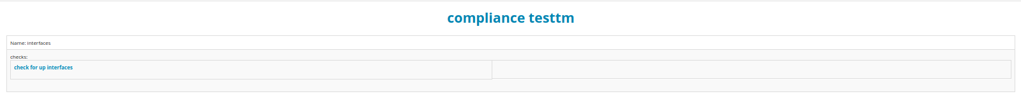in this compliance report was only one check so the results of this check are shown as bellow :

