**High Definition eQTL Tables and Figures**

**Figure Legends**

**Figure 1** The distribution of eQTLs for each transcript abundance phenotype in *C. elegans*, located at the genomic positions of the transcripts. Those eQTLs on the diagonal are cis-eQTLs, whereas those off the diagonal are trans-eQTLs. Adapted from Rockman et al. (2010).

**Figure 2** Circos plot illustrating the pattern of how a particular gene transcript is regulated by eQTLs on different chromosomes in *C. elegans*.



**Figure 1**

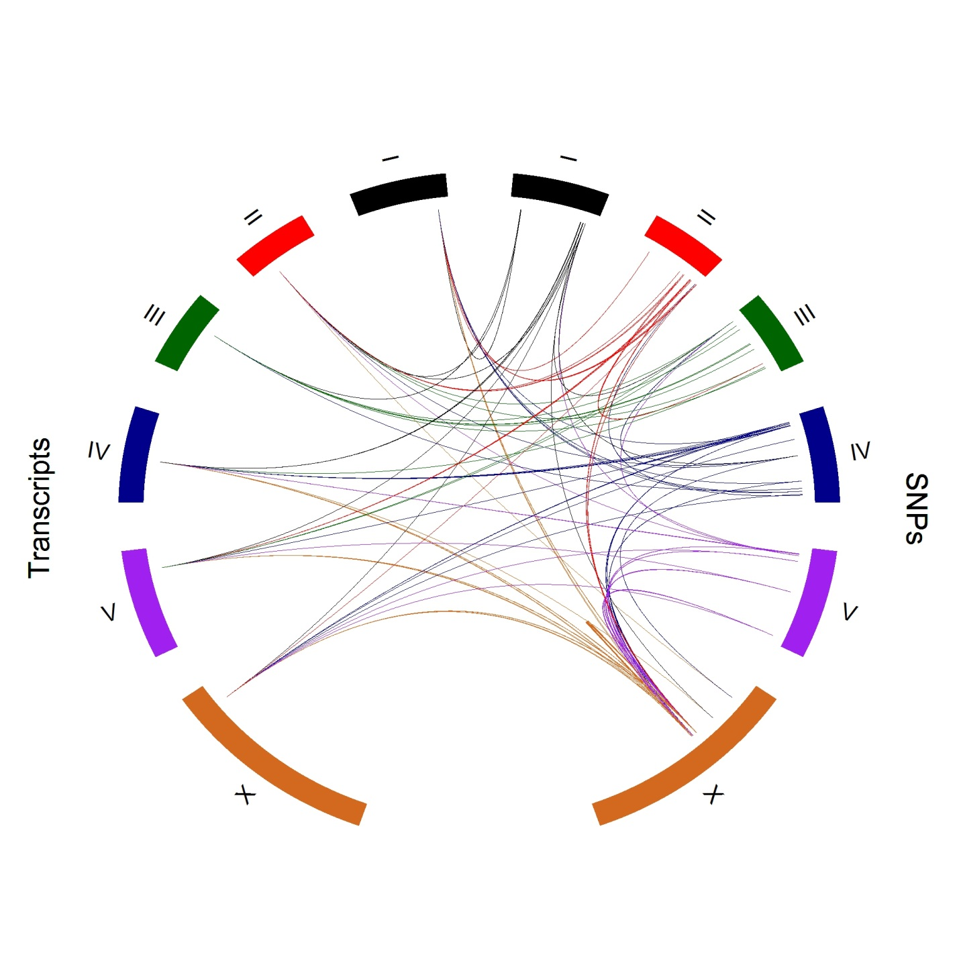

**Figure 2**

Table 1 Results of simulation 1 with $σ=1$ for the random error with independent predictors.

|  |  |  |  |  |  |  |  |  |  |  |  |  |
| --- | --- | --- | --- | --- | --- | --- | --- | --- | --- | --- | --- | --- |
| $$σ=1$$ | **Main Effects** | | | | **Interactions Effects** | | | | **Model** | | | |
| **Method** | **Cov** | **Cor0** | **Inc0** | **Exact** | **Cov** | **Cor0** | **Inc0** | **Exact** | **Size** | **MSE** | $$Adj-R^{2}$$ | **Time** |
| **Single Marker** | 0 | 1 | 0.25 | 0 | NA | NA | NA | NA | 3 | 23.63 | 0.216 | 0.824 |
| **FS** | 0.85 | 0.953 | 0.0625 | 0.85 | NA | NA | NA | NA | 27 | 10.23 | 0.660 | 3.47 |
| **FS2** | 1 | 0.996 | 0 | 1 | 0.95 | 0.981 | 0 | 0 | 27 | 0.302 | 0.989 | 72.31 |
| **iFORM** | 0.9 | 0.999 | 0.05 | 0.9 | 0.9 | 1 | 0 | 0.9 | 7.55 | 2.93 | 0.894 | 4.08 |
| **Oracle** | 1 | 1 | 0 | 1 | 1 | 1 | 0 | 1 | 8 | 1.023 | 0.965 | NA |

Outcomes include the convergence Probability (Cov) $\sum_{m=1}^{M}{I\left(T⊂\hat{T}\right)/M}$, percentage of correct zeros identified (Cor0) $\sum_{m=1}^{M}{\sum_{j=1}^{p}{I(\hat{β_{j}}=0, β_{j}=0)/[M(p-p_{0})]}}$, percentage of incorrect zeros identified (Inc0) , the exact selection probability (Exact) , average model size, Mean Square Error for the model (MSE), the adjusted R-square of the model, and the computational time in seconds.

Table 2 Results of simulation 2 with $σ=2$ for the random error with independent predictors.

|  |  |  |  |  |  |  |  |  |  |  |  |  |
| --- | --- | --- | --- | --- | --- | --- | --- | --- | --- | --- | --- | --- |
| $$σ=2$$ | **Main Effects** | | | | **Interactions Effects** | | | | **Model** | | | |
| **Method** | **Cov** | **Cor0** | **Inc0** | **Exact** | **Cov** | **Cor0** | **Inc0** | **Exact** | **Size** | **MSE** | $$Adj-R^{2}$$ | **Time** |
| **Single Marker** | 0.02 | 0.999 | 0.529 | 0.029 | NA | NA | NA | NA | 1.97 | 27.02 | 0.178 | 0.69 |
| **FS** | 0.8 | 0.953 | 0.05 | 0.8 | NA | NA | NA | NA | 27 | 11.49 | 0.651 | 3.22 |
| **FS2** | 1 | 0.996 | 0 | 1 | 0.98 | 0.98 | 0 | 0 | 27 | 1.17 | 0.964 | 68.2 |
| **iFORM** | 0.97 | 0.998 | 0.007 | 0.97 | 0.95 | 1 | 0 | 0.93 | 8.7 | 4.41 | 0.865 | 3.84 |
| **Oracle** | 1 | 1 | 0 | 1 | 1 | 1 | 0 | 1 | 8 | 3.92 | 0.880 | NA |

Outcomes include the convergence Probability (Cov) $\sum_{m=1}^{M}{I\left(T⊂\hat{T}\right)/M}$, percentage of correct zeros identified (Cor0) $\sum_{m=1}^{M}{\sum_{j=1}^{p}{I(\hat{β_{j}}=0, β_{j}=0)/[M(p-p_{0})]}}$, percentage of incorrect zeros identified (Inc0) , the exact selection probability (Exact) , average model size, Mean Square Error for the model (MSE), the adjusted R-square of the model, and the computational time in seconds.

Table 3 Results of simulation 3 with $σ=3$ for the random error with independent predictors.

|  |  |  |  |  |  |  |  |  |  |  |  |  |
| --- | --- | --- | --- | --- | --- | --- | --- | --- | --- | --- | --- | --- |
| $$σ=3$$ | **Main Effects** | | | | **Interactions Effects** | | | | **Model** | | | |
| **Method** | **Cov** | **Cor0** | **Inc0** | **Exact** | **Cov** | **Cor0** | **Inc0** | **Exact** | **Size** | **MSE** | $$Adj-R^{2}$$ | **Time** |
| **Single Marker** | 0 | 0.999 | 0.612 | 0 | NA | NA | NA | NA | 1.65 | 33.90 | 0.138 | 0.69 |
| **FS** | 0.82 | 0.953 | 0.043 | 0.827 | NA | NA | NA | NA | 27 | 14.44 | 0.633 | 3.22 |
| **FS2** | 1 | 0.997 | 0 | 1 | 0.98 | 0.97 | 0 | 0 | 27 | 2.69 | 0.931 | 68.2 |
| **iFORM** | 0.89 | 0.995 | 0.060 | 0.896 | 0.96 | 1 | 0 | 0.94 | 7.93 | 11.10 | 0.713 | 3.83 |
| **Oracle** | 1 | 1 | 0 | 1 | 1 | 1 | 0 | 1 | 8 | 8.98 | 0.771 | NA |

Outcomes include the convergence Probability (Cov) $\sum_{m=1}^{M}{I\left(T⊂\hat{T}\right)/M}$, percentage of correct zeros identified (Cor0) $\sum_{m=1}^{M}{\sum_{j=1}^{p}{I(\hat{β_{j}}=0, β_{j}=0)/[M(p-p_{0})]}}$, percentage of incorrect zeros identified (Inc0) , the exact selection probability (Exact) , average model size, Mean Square Error for the model (MSE), the adjusted R-square of the model, and the computational time in seconds.

Table 4 Estimated main and epistatic effects of eQTLs by iFORM on gene transcript A_12_P103290 on chromosome I , in a comparison with the result by traditional single marker analysis.

|  |  |  |  |  |  |  |  |  |
| --- | --- | --- | --- | --- | --- | --- | --- | --- |
|  | **iFORM** | | | | | **Single Marker Analysis** | | |
| **eQTL** | **Effect** | | **SE** | ***p*-value** | **Herit-ability(%)** | **Effect** | **SE** | ***p*-**  **value** |
| X1_2068168 (cis-eQTL) | | -0.197 | 0.035 | 0.000 | 0.060 | -0.210 | 0.074 | 0.005 |
| X2_13516256 | | -0.069 | 0.039 | 0.080 | 0.007 | -0.138 | 0.075 | 0.068 |
| X2_13813025 | | -0.023 | 0.052 | 0.665 | 0.001 | -0.095 | 0.074 | 0.201 |
| X2_13694563 | | 0.074 | 0.062 | 0.238 | 0.008 | -0.089 | 0.075 | 0.242 |
| X2_2482896 | | 0.064 | 0.027 | 0.017 | 0.006 | -0.057 | 0.076 | 0.453 |
| X_15500580 | | 0.073 | 0.064 | 0.253 | 0.008 | 0.010 | 0.076 | 0.899 |
| X_14636404 | | -1.768 | 0.092 | 0.000 | 4.794 | 0.024 | 0.076 | 0.751 |
| X4_16403215 | | 0.028 | 0.040 | 0.489 | 0.001 | 0.087 | 0.075 | 0.252 |
| X4_15568674 | | -1.972 | 0.134 | 0.000 | 5.964 | 0.094 | 0.075 | 0.213 |
| X4_1873297 | | 0.044 | 0.026 | 0.086 | 0.003 | 0.095 | 0.071 | 0.185 |
| X4_15632637 | | 1.960 | 0.143 | 0.000 | 5.892 | 0.104 | 0.075 | 0.169 |
| X4_13532205 | | 0.064 | 0.028 | 0.024 | 0.006 | 0.111 | 0.075 | 0.143 |
| X_15820520 | | -0.014 | 0.055 | 0.796 | 0.000 | 0.146 | 0.075 | 0.054 |
| X_14542103 | | 1.786 | 0.087 | 0.000 | 4.892 | 0.162 | 0.075 | 0.031 |
| X2_13516256.X4_15632637 | | -3.799 | 0.268 | 0.000 | 5.534 | NA | NA | NA |
| X2_13516256.X4_15568674 | | 3.753 | 0.276 | 0.000 | 5.401 | NA | NA | NA |
| X_15820520.X_14636404 | | -3.771 | 0.172 | 0.000 | 5.453 | NA | NA | NA |
| X_15820520.X_14542103 | | 3.691 | 0.172 | 0.000 | 5.224 | NA | NA | NA |
| X_14636404.X4_1873297 | | -3.534 | 0.163 | 0.000 | 4.789 | NA | NA | NA |
| X_14636404.X4_13532205 | | -3.567 | 0.166 | 0.000 | 4.879 | NA | NA | NA |
| X_14542103.X4_1873297 | | 3.629 | 0.164 | 0.000 | 5.050 | NA | NA | NA |
| X_14542103.X4_13532205 | | 3.469 | 0.167 | 0.000 | 4.614 | NA | NA | NA |