Connections



Figure . Circuit Model



Figure . Load Model at each Transformer

This example illustrates some of the modeling issues with serving a mixed 3-phase and 1-phase load from different transformer connections.

Load *Master.DSS* and execute the script.

Inspecting the Power report, do you notice anything unusual with the load powers reported?

Why is the phase 1 power in the 3-phase load at B5 zero? Is the total load correct?

Can the B5 transformer serve the 1-phase load (Is there any current in phase 1 on the LV side)?

Why is the load at B4 unbalanced? Can the transformer serve the 1-phase load properly?

Disable the 3-phase load at B4 and solve again. What is the power in the 1-phase load?

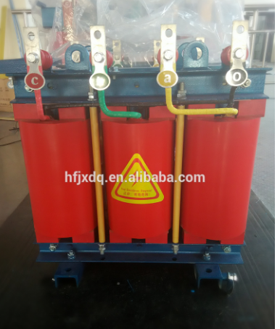The transformer at B4 is similar to the one shown in the photo and it can successfully serve the 1-phase load. How does this photo suggest we should modify the model for the transformer at B4?