Hot-Phase-Cold-Phase Example

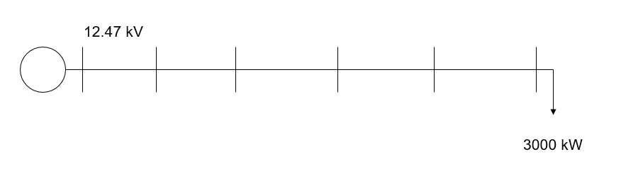

Figure 1. Circuit Model

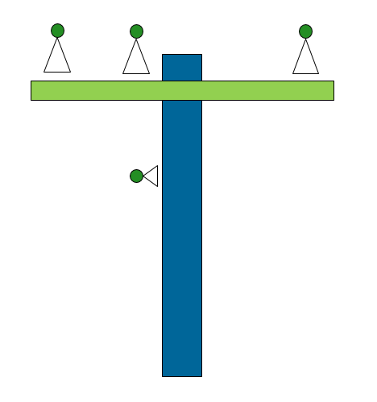

Figure 2. Line Construction

Few power distribution lines are transposed. Many are constructed similarly to Figure 2 with the three phase conductors spaced along an 8 ft horizontal crossarm and a neutral wire about 4 ft below on the pole. This example illustrates a phenomenon you will encounter when performing unbalanced power flow analysis. In industrial load situations ‑ such as a rectangular three-phase submerged arc furnace ‑ the impact is clearly visible. One of the outside electrodes is consumed faster than the other two while the one on the opposite side is consumed slowest. The faster one is called the “hot phase” and the one on the opposite side of the furnace is called the “cold phase”. The same thing happens with a power line with horizontal spacing. Distribution lines with 1-phase voltage regulators feeding loads such as large induction machines or 3-phase DER can show more operations on the outside two phases than on the middle one.

As we shall see, this phenomenon cannot be observed when using the conventional practice of specifying the line impedance by Z1 and Z0.

Open the DSS script file *Hot_n_Cold.DSS.* This script defines a 12.47-kV line consisting of 5 1-mile sections supplying a 3-phase, 3000-kW constant impedance load (model=2). There are some optional script codes inside block comments in the script. You can select and run the entire script for the base case. Then you can go back and selectively run the scripts inside the block comments to see how other line models behave. The line in the base script is defined using **LineGeometry.336_HORIZ**. Note that the neutral is reduced out (by Kron reduction) so we do not have to specify its node connection.

Select and Execute the entire script.

What are the powers in Load.BIGLOAD? In the voltage profile plot, phases ABC are black, red, and blue, respectively. Which one is the “hot” phase? The “cold” phase? What is the % difference in power between the hot and cold phases? In the currents? In the voltages?

Return to the script and selectively execute lines so that the 5 line segments are defined using the definitions in the block comment section titled

**/**** Take Default symmetrical component definition**

This will define the lines using the OpenDSS default LINE model, which uses a symmetrical component definition in terms of Z1 and Z0 (positive- and zero-sequence impedances). Execute the remainder of the script to define the loads and perform the solution.

What are the differences between the phases now.

**Extra Credit (at your leisure)**

There is another line description using the **mtx601** line code from the IEEE 13-bus test feeder. This is a different unbalanced line configuration. Execute the case with this line. What phase is the “hot” phase now?

There is a script at the bottom for applying a 3-phase fault to B5:

**/**** 3-phase fault**

**New fault.F1 Bus1=B5.1.2.3 Phases=3**

**solve mode=direct**

**Vis current Line.Line5**

**\*\*\*\*/**

Feel free to experiment with this to see how the different line models affect the results.