Monte Carlo Fault Study Example

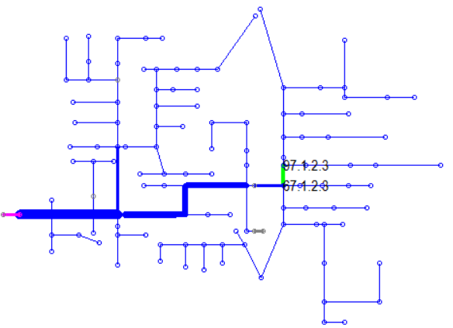

Figure 1. Circuit Model – 123-Bus Test Feeder

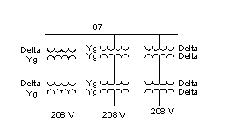

Figure 2. Loads at Bus 67

In this example, we will exercise the Monte Carlo Fault study mode. The IEEE 123-bus test feeder is used as an example. A 1-phase line-to-ground fault is defined at every node (see *FaultAtEveryNode.DSS*). This solution mode will activate one of these faults at a time and solve.

The objective is to determine what the 208-V loads will see for the various service transformer connections. There are Monitor objects on the terminals of the transformers to capture the results for each solution.

Open *Run_MonteCarloFault.dss* and prepare to execute. Change the path name as necessary to run on your computer. Note that there are several blocks of optional code in the block comments. Execute these selectively.

Execute from the CD command down through the Buscoords command. Execute the plot circuit command just to confirm the solution appears to be good.

Execute the “Redirect FaultAtEveryNode.DSS” to define the faults. Then run the rest of the script.

Execute the Show commands for each monitor. Copy-and-past the contents of the monitor into Excel. Select the voltage columns and make a scatter plot. For the Delta-Yg connection, what is the lowest voltage seen at the utilization level? Were you surprised that the voltage did not go to zero except for the Y-Y transformers?

At your leisure, you can run some of the alternate scripts. For example, change the transformer connections and repeat. Or, move the Monitors and see what the voltage sag characteristic is at other locations.