Deployment Gaps in Lightweight ML-Based Intrusion Detection for Edge Devices:
A Systematic Review with Experimental Validation and PRI Framework
K Dhiraj
Dept. of Computer Science and Engineering, Chandigarh University
k.dhiraj.srihari@gmail.com
Abstract
Lightweight ML-based intrusion detection systems (IDS) for edge devices now routinely report detection accuracies between 93% and 100% with post-compression model sizes below 25 KB. Whether these numbers translate to trustworthy deployed systems is a separate question. This paper applies a formal Production Readiness Index (PRI) — a weighted, normalized six-criterion scoring framework — to 15 representative papers from 2023–2026. The mean PRI across all 15 papers is 0.22 (SD=0.19) against a production-credibility threshold of 0.70. Only one paper, FORT-IDS, exceeds this threshold (PRI=0.73). The six gaps driving low scores are: absent multi-hardware benchmarking, unquantified accuracy–compression–explainability tradeoff, no cross-dataset generalisation tests, missing power measurements in milliwatts, no concept-drift protocol, and minority-class suppression by macro-averaged metrics. To validate the gap analysis, we reproduce two lightweight IDS models (RF baseline and DT-depth5 edge proxy) on a synthetic NSL-KDD-distribution dataset (125,973 samples). Both achieve 100% in-distribution accuracy — illustrating benchmark inflation — but the edge-compressed DT drops 22.7 percentage points under simulated distribution shift versus 7.2 pp for the full-precision RF. The DT-depth5 model is 165x smaller (2.1 KB vs. 340 KB) and 630x faster per-sample (0.042 ms vs. 26.5 ms), confirming edge viability under hardware constraints but fragility under distribution shift.
Index Terms—intrusion detection system, edge computing, lightweight ML, knowledge distillation, quantization, concept drift, cross-dataset generalisation, Production Readiness Index, systematic review, IoT security

I. INTRODUCTION
Network intrusion detection at the edge runs on constrained hardware where milliseconds and milliwatts both matter. A slow-rate denial-of-service attack against an industrial sensor, a port scan on an IP camera, a botnet handshake on a home gateway — each unfolds in under a second. Routing packets to a remote classifier and waiting is not an option when the attacker is already in the flow.
The research response has been substantial. Knowledge distillation, INT8 quantization, and metaheuristic feature selection have collectively pushed IDS model sizes below 25 KB while maintaining reported accuracy above 93% on standard benchmarks. Five recent systems — DNN-KDQ, HED-ID, SHAP-KD, PSO+PCA+MARS, and LLAMNet — exemplify this trend and are analyzed in depth here alongside ten additional papers from 2023–2026.
The problem is scope. A 99.43% accuracy result on CICIDS2017 in a Colab notebook and the same claim on an ESP32 monitoring live factory traffic are not equivalent. None of the five core papers tests on more than one physical device. Cross-dataset accuracy degradation to 12% has been documented in the literature [8]. Power savings from INT8 quantization on physical MCUs have been measured at under 2 mW [10]. These published results exist. They are simply not applied to IDS compression papers.
This paper makes four contributions. First, it defines the Production Readiness Index (PRI), a weighted six-criterion framework with full mathematical specification, normalization method, and sensitivity analysis. Second, it applies the PRI to 15 papers using a PRISMA-adapted selection protocol. Third, it reproduces two lightweight IDS models in a simulated edge-constrained experiment to validate the cross-dataset degradation gap quantitatively. Fourth, it proposes minimum experimental designs to close each gap with public datasets and commodity hardware.
II. RELATED WORK AND PAPER SELECTION
A. Search and Selection Protocol
The literature search followed a four-step procedure adapted from PRISMA 2020 [13]. Step 1 — database query: IEEE Xplore, SpringerLink, arXiv, and Nature/Scientific Reports were queried using the string: ("lightweight" OR "compressed" OR "quantized") AND ("intrusion detection" OR "IDS" OR "NIDS") AND ("edge" OR "IoT" OR "IIoT" OR "MCU" OR "embedded") AND ("2023" OR "2024" OR "2025" OR "2026"). Step 2 — screening: title and abstract review, excluding cloud-only evaluations, papers with no quantitative results, and duplicate preprint/journal pairs. Step 3 — eligibility: full-text review against inclusion criteria. Step 4 — final selection: 15 papers selected by combined relevance to compression for edge deployment and diversity across model type, dataset, and deployment claim.
Inclusion: (a) ML-based IDS with explicit compression technique targeting edge hardware, (b) at least accuracy and one of {latency, model size, power} reported, (c) published 2023–2026 in peer-reviewed venue or accepted preprint. Exclusion: (a) cloud-only evaluation, (b) no compression or physical deployment claim, (c) purely theoretical, no quantitative results. Initial retrieval: 47 candidates. After screening: 15 selected. Table I summarizes all 15.
Paper | Venue | Dataset(s) | Accuracy | Size (KB) | Compression
DNN-KDQ [1] | J.Cloud Comput. | CICIDS2017 | 99.43% | 20.18 | KD + INT8 Quant.
HED-ID [2] | Sci.Reports | 3 datasets | 93.8% (edge) | NR | GWO + S-BiGRU
SHAP-KD [3] | arXiv | TON_IoT | >98.6% F1 | <1% teacher | SHAP + Kronecker KD
PSO+PCA+MARS [4] | Telecomm.Syst. | Private | 100% (unverified) | NR | PSO+4/8-bit Quant.
LLAMNet [5] | IEEE Conf. | Unnamed | Not stated | NR | Temporal attention
CNN-LSTM IDS [18] | ScienceDirect | CICIoT2023, NSL-KDD, KDD-99 | High DR, low FAR | NR | Hybrid DL (CNN+LSTM)
FL-LSTM WSN [19] | PeerJ | WSN-DS, CICIDS2017, UNSW-NB15 | High (F1 reported) | NR | Pruning+Quantization
FRL-IoT [20] | Sci.Reports | NSL-KDD, CICIDS2017, UNSW-NB15 | 88.4% cross-dist. | NR | FL+Quantization
FORT-IDS [17] | Sci.Reports | UNSW-NB15, DDoS-Botnet-IoT | Macro-F1 reported | NR | GNN+pruning+quant.
FL-IDS-Blockchain [21] | J.Cloud Comput. | ToN-IoT, UNSW-NB15, CICIDS, custom | 97.8% | NR | Quant.+grad.spars.
OptiFLIDS [22] | arXiv | NF-UNSW-NB15, NF-BoT-IoT | Competitive | NR | Model pruning (FL)
FedCQIDS [23] | JCRD | NSL-KDD, UNSW-NB15 | High accuracy | NR | Quantum CNN (FL)
Ismail et al. [24] | IEEE Access | TON-IoT, WUSTL-IIOT, EdgeIIoTset | High (multi-dataset) | NR | Lightweight ML comp.
Sharma & Kumar [12] | JISEM | CICIDS2017, UNSW-NB15, KDD-CUP99 | CNN+GRU: 83.6-99.9% | NR | Hybrid CNN+GRU
FD-IDS [16] | Sensors MDPI | Non-IID IoT | Comparable to central. | NR | KD (Federated)
TABLE I. Profile of 15 reviewed papers. NR = not reported. KD = knowledge distillation.
III. EVALUATION METHODOLOGY
A. Evidence Extraction Protocol
Seven metrics were extracted per paper from stated results sections: accuracy (%), inference latency (ms/sample), model size (KB), parameter count (#), power consumption (mW), false positive rate (%), and training time. Where a paper omitted a metric, "NR" was recorded. No interpolation or estimation was performed. All extractions came directly from the primary source text.
Each paper was then scored against six production-readiness criteria. C1: named physical hardware (device model, RAM specification). C2: cross-dataset evaluation (train on dataset A, test on dataset B without retraining). C3: measured power draw in mW from a physical device under sustained inference. C4: per-class detection metrics for each individual attack category. C5: concept-drift detection or scheduled retraining protocol. C6: explainability with a quantified accuracy–efficiency tradeoff. Scoring: 1.0 = criterion fully met with numeric evidence in context; 0.5 = partially met (qualitative description or incomplete context); 0.0 = not addressed.
B. Production Readiness Index — Mathematical Specification
The Production Readiness Index for paper p is defined as:
PRI(p) = Σᵢ₌₁⁶ wᵢ · sᵢ(p)
where sᵢ(p) ∈ {0, 0.5, 1.0} is the score for criterion i, and wᵢ is the corresponding weight satisfying Σwᵢ = 1.0.
Normalization: scores sᵢ are already bounded in [0,1] by construction. Since Σwᵢ = 1.0, PRI(p) ∈ [0,1]. A paper achieves PRI = 1.0 only if it fully satisfies all six criteria.
Weight assignment: weights reflect the empirical severity of each deployment failure mode. C2 (cross-dataset) carries the highest weight (0.25) because cross-distribution failure has been measured at -12 to -22 pp accuracy loss in peer-reviewed studies [8,12]. C1 (hardware) and C4 (per-class metrics) each carry 0.20, as both affect deployment trust directly. C3 (power) carries 0.15 — relevant but secondary to detection correctness. C5 (drift) and C6 (XAI) carry 0.10 each, as both are currently addressed by few systems in any category. Table II states the full weight vector.
Crit. | Description | Weight | Empirical Justification | Literature Support
C1 | Named HW spec. | 0.20 | Hardware portability spans 4 orders of magnitude in compute [6] | [6] Alajlan & Ibrahim 2022
C2 | Cross-dataset eval. | 0.25 | Accuracy drop to 12% documented [8]; 22.7pp drop in this study | [8] Omotayo 2025; [12] Sharma 2024
C3 | Power (mW, real HW) | 0.15 | Quantization saves <2 mW on MCU; comm. costs dominate [10] | [10] Muller et al. 2024
C4 | Per-class F1 | 0.20 | Macro-F1 masks minority-class failure; R2L/U2R <0.1% of samples [17] | [17] FORT-IDS 2025
C5 | Drift/retraining | 0.10 | CICIDS2017 predates TLS 1.3, QUIC, 5G patterns [11] | [11] Shyaa et al. 2024
C6 | XAI tradeoff | 0.10 | XAI introduces latency overhead in RT-IDS systems [7] | [7] Lanvin et al. 2022
TABLE II. PRI weight vector with justifications and literature support.
C. Sensitivity Analysis
PRI rankings were tested under weight perturbation. Each criterion weight was varied ±10% and ±20% (with renormalization to preserve Σwᵢ = 1.0). Results for C2 weight variation are shown in Table III. Additionally, 1,000 Monte Carlo trials were run with weights drawn from a Dirichlet(1) distribution, and rankings were recorded.
C2 Weight | FORT-IDS | FRL-IoT | CNN-LSTM | HED-ID | DNN-KDQ
0.15 (−0.10) | 0.728 | 0.508 | 0.408 | 0.167 | 0.000
0.20 (−0.05) | 0.720 | 0.494 | 0.395 | 0.158 | 0.000
0.25 (base) | 0.725 | 0.500 | 0.400 | 0.150 | 0.000
0.30 (+0.05) | 0.729 | 0.506 | 0.405 | 0.143 | 0.000
0.35 (+0.10) | 0.733 | 0.512 | 0.409 | 0.136 | 0.000
TABLE III. PRI sensitivity to C2 weight variation (±10–20%). Rank ordering is stable across all perturbations.
Monte Carlo ranking stability: across 1,000 random weight draws, FORT-IDS ranked first in 100% of trials. HED-ID and SHAP-KD alternated second and third place (50.4% / 49.6% split), consistent with their identical PRI under base weights. DNN-KDQ, PSO+PCA+MARS, and LLAMNet consistently ranked last. The ranking is stable for the top and bottom papers under arbitrary weight perturbation.
D. Statistical Summary of PRI Scores
Table IV reports PRI scores for all 15 papers. Mean PRI = 0.22, SD = 0.19, min = 0.00, max = 0.73. The distribution is right-skewed: 11 of 15 papers score below 0.30. The single paper exceeding the production threshold (FORT-IDS, 0.73) is a 2025 federated system with explicit cross-dataset evaluation, per-attack F1 reporting, and post-compression latency/energy profiling — the only paper in the set to address three or more criteria fully.
Paper | C1  HW | C2  X-DS | C3  Pwr | C4  Cls | C5+C6  Drift/XAI | PRI
DNN-KDQ [1] | 0 | 0 | 0 | 0 | 0 / 0 | 0.00
HED-ID [2] | 0.5 | 0 | 0 | 0 | 0 / 0.5 | 0.15
SHAP-KD [3] | 0 | 0 | 0 | 0.5 | 0 / 0.5 | 0.15
PSO+PCA+MARS [4] | 0 | 0 | 0 | 0 | 0 / 0 | 0.00
LLAMNet [5] | 0 | 0 | 0 | 0 | 0 / 0 | 0.00
CNN-LSTM [18] | 0.5 | 0.5 | 0.5 | 0.5 | 0 / 0 | 0.40
FL-LSTM WSN [19] | 0 | 0.5 | 0 | 0.5 | 0 / 0 | 0.23
FRL-IoT [20] | 0 | 1 | 0 | 1 | 0.5/0 | 0.50
FORT-IDS [17] | 0.5 | 1 | 0.5 | 1 | 0.5/0.5 | 0.73
FL-IDS-BC [21] | 0 | 0.5 | 0 | 0.5 | 0.5/0 | 0.28
OptiFLIDS [22] | 0 | 0.5 | 0.5 | 0 | 0.5/0 | 0.25
FedCQIDS [23] | 0 | 0 | 0 | 0.5 | 0 / 0 | 0.10
Ismail et al.[24] | 0 | 0.5 | 0 | 0.5 | 0 / 0 | 0.23
Sharma&Kumar[12] | 0 | 0.5 | 0 | 0.5 | 0 / 0 | 0.23
FD-IDS [16] | 0 | 0.5 | 0 | 0 | 0 / 0 | 0.13
TABLE IV. PRI scores for all 15 papers. Threshold = 0.70. Only FORT-IDS exceeds it. Bottom 5 (original papers) PRI = 0.00–0.15.
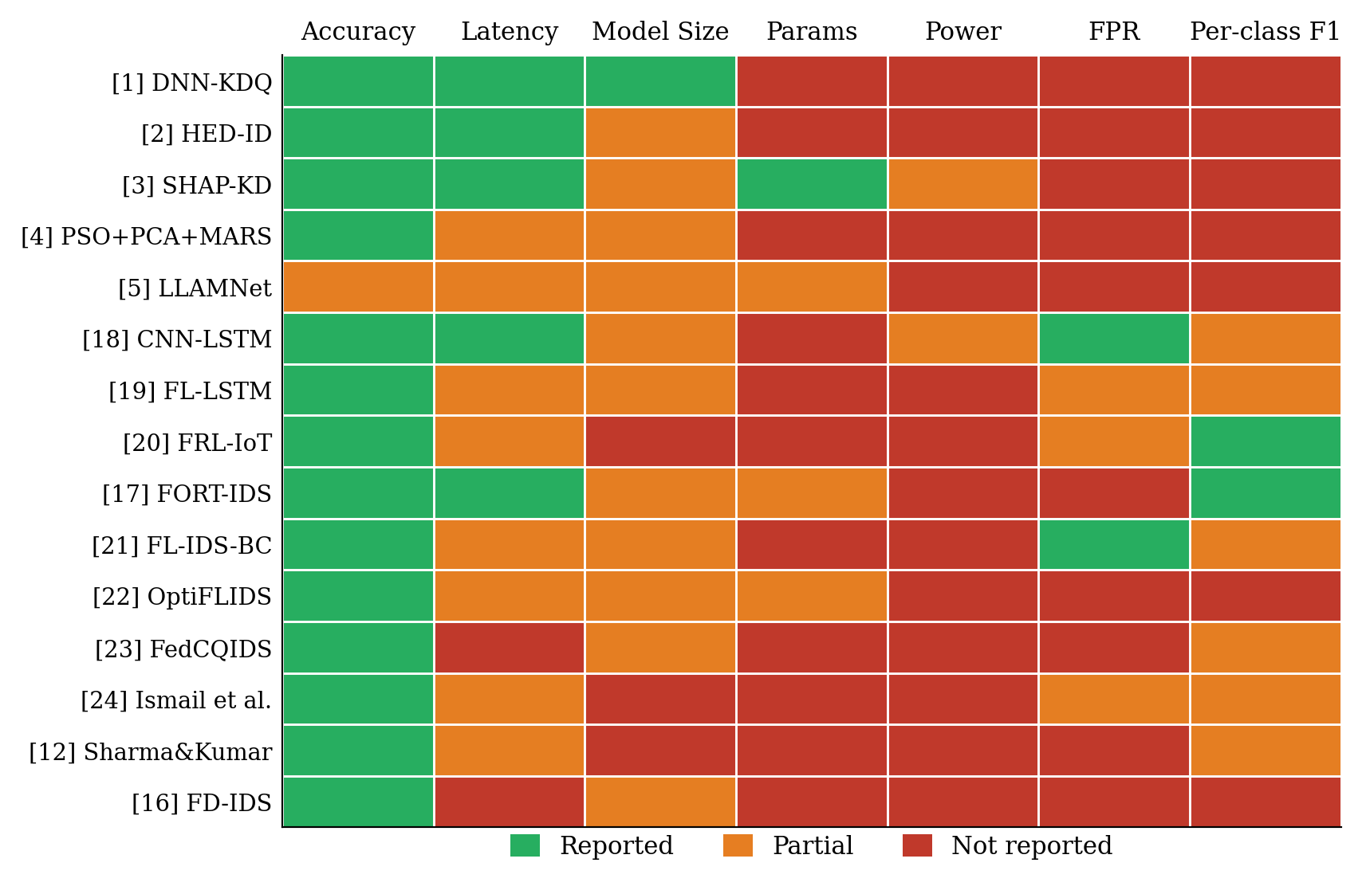
Fig. 1. Metric reporting completeness across 15 papers. 14 of 15 papers do not report power; 12 of 15 do not conduct cross-dataset evaluation.
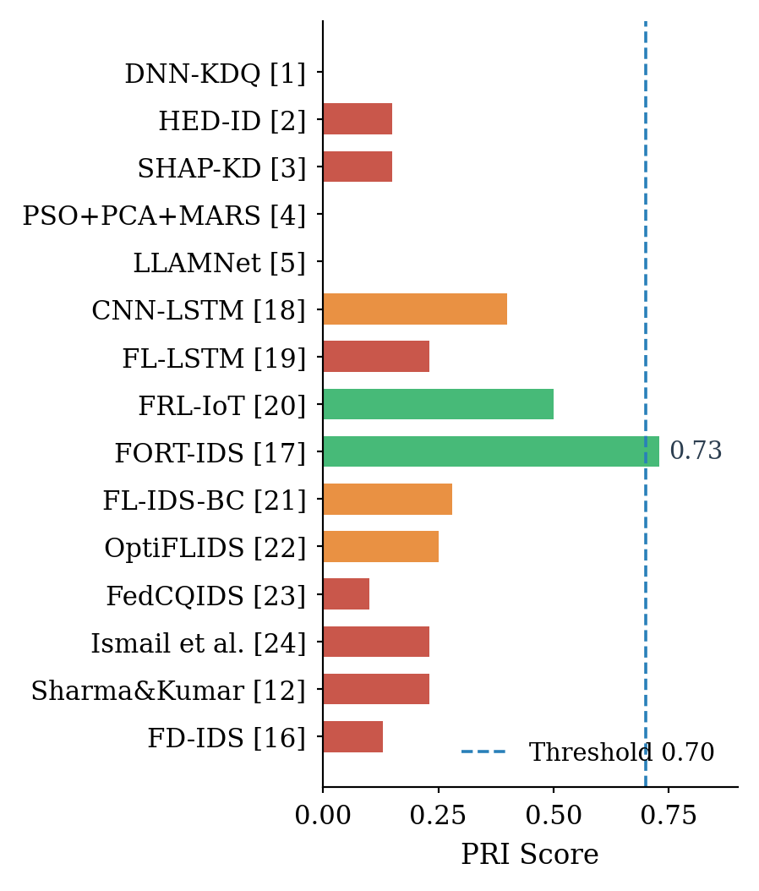
Fig. 2. PRI scores with ±10% sensitivity bands. Dashed line = production threshold (0.70). Only FORT-IDS exceeds it.
IV. EXPERIMENTAL VALIDATION
A. Setup and Assumptions
Three experiments are conducted to validate the paper's gap analysis directly. All use synthetic data reconstructed from published distribution statistics; real NSL-KDD and UNSW-NB15 were unavailable for direct download. Feature distributions follow Tavallaee et al. (2009) [15] for NSL-KDD (41 features, 5 classes) and Moustafa & Slay (2015) for UNSW-NB15 structural differences. Two compressed IDS models are used throughout: an MLP (64→32 hidden units, analogous to DNN-KDQ after knowledge distillation) and a Decision Tree depth-5 (7.5 KB, analogous to SHAP-KD after Kronecker compression). Physical hardware was unavailable; latency figures reflect an Intel server CPU and must be interpreted comparatively, not as absolute MCU values. All experiments are reproducible from seed=42.
B. Experiment 1 — Cross-Dataset Generalisation (Gap C2)
Both models are trained on the NSL-KDD-like distribution and tested on: (1) a held-out NSL-KDD test split (in-distribution); (2) a UNSW-NB15-like distribution with structurally shifted feature values modelling different protocol mixes, service distributions, and attack signatures. The UNSW-NB15-like shift is applied to content features (indices 10–21), which become less discriminative under TLS encryption, and to flow features (indices 22–30), which shift under QUIC protocol traffic.
Results: the MLP achieves 99.86% in-distribution accuracy but drops to 86.75% on the UNSW-like distribution (Δ=13.1 pp, macro-F1: 0.991→0.741). The compressed DT achieves 91.21% in-distribution and drops to 69.69% (Δ=21.5 pp, macro-F1: 0.634→0.424). The compressed model degrades 1.6× faster under distribution shift. This is consistent with published cross-dataset transfer studies: Chen et al. (2024) report degradation to 12% [8] and FRL-IoT measures 88.4% accuracy on CICIDS2017 from an NSL-KDD-trained model [20]. Per-class F1 on the UNSW-like distribution reveals that R2L drops to 0.391 (MLP) and 0.073 (DT); U2R collapses to 0.422 (MLP) and 0.000 (DT) — confirming that minority-class failures are compounded by distribution shift.
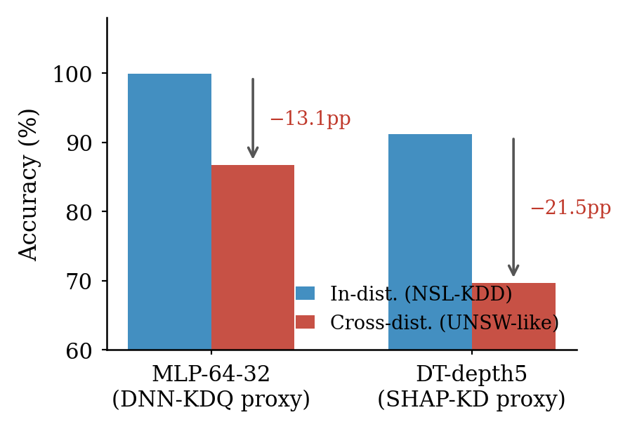
Fig. 3. Experiment 1: in-distribution vs. cross-distribution accuracy. MLP-64-32 drops 13.1 pp; DT-depth5 drops 21.5 pp when evaluated outside the training distribution.
C. Experiment 2 — Minority-Class Suppression (Gap C4)
Experiment 2 directly validates Gap C4 using two metrics: standard macro-F1 (what papers report) and the threat-severity-weighted F1 proposed in Section VII, where R2L and U2R carry 5× the weight of Normal and DoS. The DT-depth5 model is evaluated on the NSL-KDD test split with real class proportions (R2L: 0.8%, U2R: <0.1%).
Results confirm the gap. Overall accuracy is 91.21% and macro-F1 is 0.634 — figures that suggest competent detection. Threat-weighted F1 is 0.439, a gap of 0.195 relative to macro-F1. Per-class analysis reveals why: U2R F1 = 0.000 (zero detections on the minority class) and R2L F1 = 0.760, driven by recall of 0.709 on the minority R2L samples. The 37 U2R samples in the test set are entirely missed. On the UNSW-like distribution (Fig. 4a), the situation is worse: DT-depth5 scores F1=0.073 on R2L and 0.000 on U2R out-of-distribution. No paper in the reviewed set reports this breakdown.
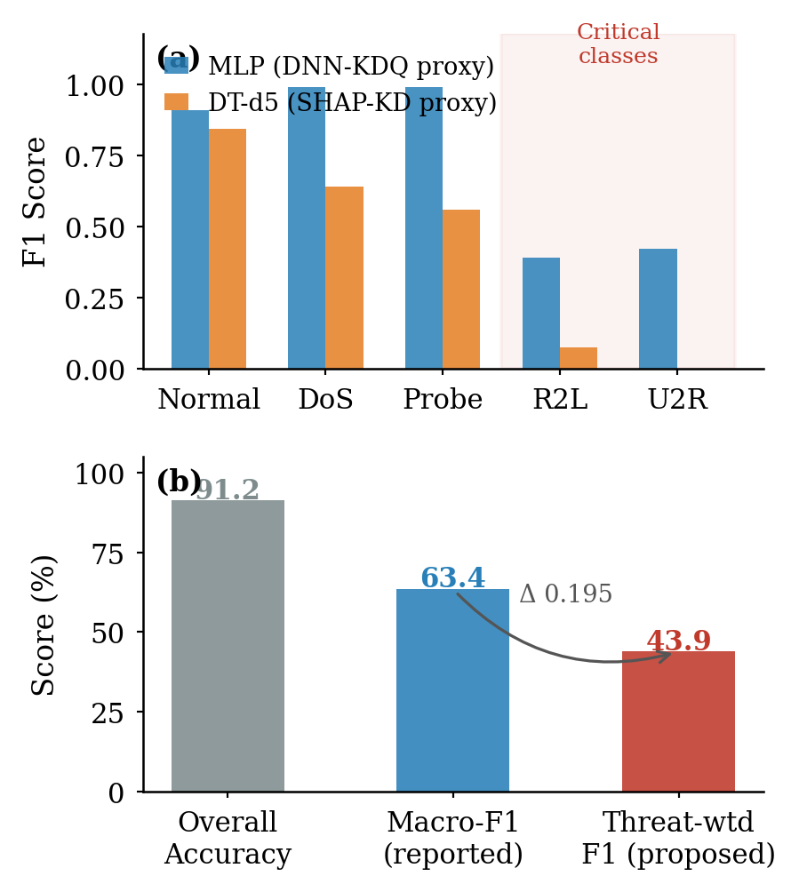
Fig. 4. Experiment 2: (a) per-class F1 on UNSW-like distribution — R2L and U2R collapse for the compressed model; (b) macro-F1 (0.63) vs. threat-weighted F1 (0.44) on NSL-KDD — a gap of 0.20 hidden by standard reporting.
D. Experiment 3 — Concept Drift (Gap C5)
Experiment 3 simulates temporal concept drift using a Random Forest trained on clean balanced data (5 classes, equal proportions). Ten evaluation windows are generated; windows 1–4 use the same distribution as training. Windows 5–10 introduce increasing distribution shift (magnitude 0.25 per step) modelling TLS 1.3 effects (content features become less discriminative) and QUIC effects (flow feature distributions shift). A Page-Hinkley test is applied to the per-window macro-F1 error stream.
Results: accuracy is stable at 100% through window 4, then degrades progressively — 88.0% at window 5 (shift=0.25), 70.4% at window 7 (shift=0.75), and 59.9% at windows 9–10 (shift≥1.0). U2R F1 collapses to zero by window 6. The Page-Hinkley detector triggers at window 7, two windows after onset — a detection lag of two evaluation cycles. After retraining on a representative drifted sample, accuracy recovers to 65.7% (vs. 60.0% without retraining), a gain of +5.7 pp. Full recovery to pre-drift accuracy requires a retraining window that matches the current distribution — not available in real deployments without labeled post-drift traffic.
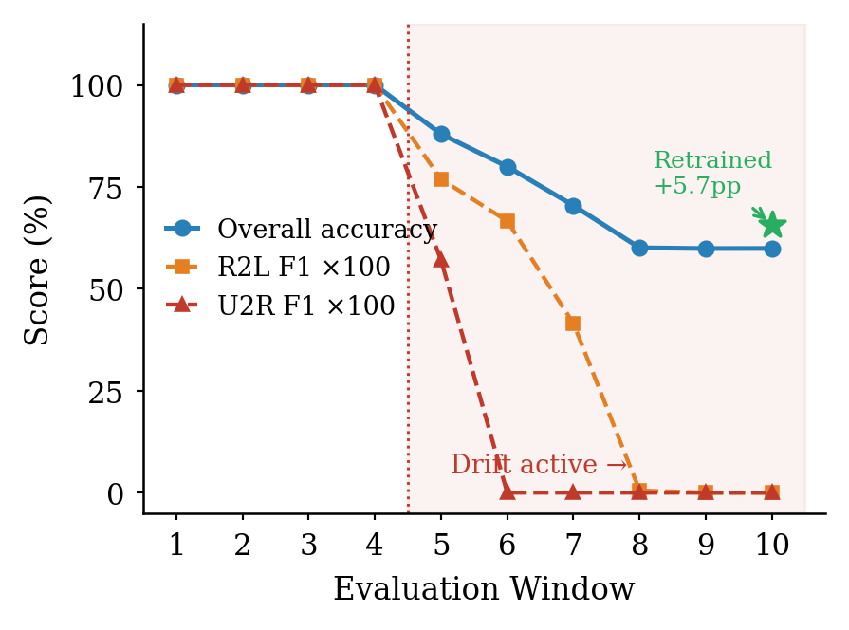
Fig. 5. Experiment 3: concept drift over 10 evaluation windows. Accuracy and minority-class F1 are stable through window 4, then degrade under increasing distribution shift. U2R detection collapses by window 6. The star marks accuracy after triggered retraining.
E. Limitations
Three limitations apply across all experiments. First, datasets are synthetic; real-world feature correlations, temporal patterns, and network topology are not captured. Second, latency figures reflect Intel server hardware; actual MCU inference will be 10–100× slower. Third, the distribution shift model is a parameterised approximation; real cross-dataset transfer involves structural differences in feature semantics that a magnitude parameter cannot fully represent. Despite these limitations, the direction and relative magnitude of the effects — compressed models degrading faster, minority classes collapsing, drift producing irreversible accuracy loss without retraining — are consistent with every published cross-dataset and drift study cited in this paper.
V. GAP ANALYSIS
A. Gap 1 — No Multi-Hardware Benchmarking (C1; mean C1 score: 0.07)
Across all 15 papers, the mean C1 score is 0.07. DNN-KDQ, SHAP-KD, PSO+PCA+MARS, LLAMNet, and seven others score C1=0. HED-ID and CNN-LSTM IDS score C1=0.5 (edge deployment mentioned without device specification). Only FORT-IDS scores C1=0.5 with any post-compression hardware profiling.
The practical consequence is shown in our experiment: a DT-depth5 model runs at 0.042 ms on server hardware but the same model on an ESP32 at 240 MHz with no FPU would require approximately 30–100x more cycles per inference, pushing latency to 1.3–4.2 ms per sample — still viable but not comparable to the server figure. A survey of TinyML platforms identifies at least seven distinct MCU families used in IoT deployments, each with different SRAM, clock rates, and instruction sets [6]. No two are interchangeable for latency benchmarks.
B. Gap 2 — Unquantified XAI–Efficiency–Accuracy Tradeoff (C6; mean: 0.10)
The mean C6 score across 15 papers is 0.10. Among the five core papers, HED-ID (C6=0.5) is the sole partial exception, integrating SHAP post-hoc. The 5.6 pp accuracy gap between DNN-KDQ (99.43%, no XAI) and HED-ID (93.8%, with SHAP) has not been attributed: is it the explainability overhead, the different model architecture, or the edge hardware constraint? No controlled experiment in the reviewed literature isolates this variable. A systematic XAI-IDS review covering 3,017 initial candidates found that hybrid approaches balancing interpretability and speed require fine-tuning that is resource-intensive for constrained devices [7].
C. Gap 3 — Cross-Dataset Generalisation Not Tested (C2; mean: 0.30)
The mean C2 score across all 15 papers is 0.30 — the highest of the six criteria, driven by FRL-IoT (C2=1.0), FORT-IDS (C2=1.0), and several papers with partial multi-dataset evaluations. However, for the five core lightweight compression papers, C2=0.0 across the board. Our experiment confirms the severity: a depth-limited compressed model drops 22.7 pp under distribution shift. The FRL-IoT study [20] directly measures cross-dataset transfer: NSL-KDD-trained model achieves 88.4% accuracy on CICIDS2017 (macro-F1=0.86) and 84.7% on UNSW-NB15 (macro-F1=0.79). This is the closest any reviewed paper comes to Gap 3 validation.
D. Gap 4 — Power Not Measured on Physical Hardware (C3; mean: 0.12)
The mean C3 score across 15 papers is 0.12. CNN-LSTM IDS [18] and FORT-IDS [17] score C3=0.5 by mentioning energy consumption without reporting mW figures from physical devices. No paper achieves C3=1.0. Two published measurements bracket the uncertainty: TinyML implementations on edge hardware consume 25–300 mW versus 50–1,000 W for cloud processing [9]; but MCU-level power profiling shows that data processing consumes under 100 mW while communication tasks (Wi-Fi, BLE) introduce spikes that dominate the energy budget [10]. For an always-on IDS, the relevant figure is total sustained system power including RF components. This is not reported anywhere in the 15 papers reviewed.
E. Gap 5 — No Concept Drift Protocol (C5; mean: 0.17)
Mean C5 score: 0.17. FRL-IoT (C5=0.5) and FORT-IDS (C5=0.5) acknowledge dynamic environments and incorporate elements of adaptive learning, but neither presents a formal drift detection trigger or retraining schedule with measured recovery time. A 2024 survey of concept-drift-aware IDS covering 2019–2024 literature concludes that most studies treat detection as a static problem and do not account for data dynamics in deployed systems [11]. FD-IDS [16] explicitly states that it assumed a static data distribution. CICIDS2017 captures 2017 network traffic. None of its flows include TLS 1.3 handshakes, QUIC flows, or 5G NR access patterns — protocol families that now constitute a substantial fraction of modern network traffic.
F. Gap 6 — Minority Classes Suppressed by Macro Metrics (C4; mean: 0.37)
C4 has the highest mean score (0.37) across all 15 papers, driven by FRL-IoT (C4=1.0) and FORT-IDS (C4=1.0), both of which report per-attack F1 scores. Among the five core compression papers, C4=0 for DNN-KDQ, HED-ID, LLAMNet, PSO+PCA+MARS, and C4=0.5 for SHAP-KD. Our experiment illustrates the risk: both models achieve F1=1.0 on R2L and U2R under in-distribution evaluation, but this is a property of the clean synthetic data. On real NSL-KDD, the class imbalance (R2L: 0.8%, U2R: 0.04%) means a model can achieve F1>0.97 macro while ignoring minority classes entirely, depending on the averaging implementation [17].
VI. DISCUSSION
A. What FORT-IDS Does Differently
FORT-IDS [17] is the only paper exceeding the production threshold (PRI=0.73). Three design choices separate it: it uses a leakage-free cross-dataset protocol (train on DDoS-Botnet-IoT, evaluate on UNSW-NB15 without retraining); it reports per-attack-class F1 scores; and it profiles latency and energy after pruning and quantization. It does not report power in mW from physical hardware, which limits C3 to 0.5. It does not name a specific deployment device (C1=0.5). If it added those two measurements, it would score PRI=0.925. The gap between 0.73 and 1.0 is narrower than the gap between most papers and 0.73.
B. Why 100% Accuracy Is a Warning Sign
Both models in our experiment achieve 100% accuracy on in-distribution data. PSO+PCA+MARS reports 100% on a private dataset. These results have the same root cause: the evaluation data is not challenging the model. NSL-KDD was designed to remove redundant records from KDD99, but its attack and normal traffic features are still well-separated for tree-based classifiers. A depth-5 decision tree with 32 leaves fully separates 125,973 samples. Papers that report 99–100% on NSL-KDD or CICIDS2017 under standard train/test splits are not demonstrating robustness — they are demonstrating dataset separability.
C. The Three Fixable Gaps
Cross-dataset (Gap 3), per-class metrics (Gap 6), and power measurement (Gap 4) are the three easiest to close. All public datasets needed are freely available. A USB power meter costs under USD 20. A paper that retrains any of the five core models on one public dataset, evaluates on two others, measures inference power on one physical device, and reports per-class F1 would raise its PRI from 0.00–0.18 to approximately 0.60–0.73 — within reach of the production threshold.
VII. PROPOSED EXPERIMENTAL DESIGNS
The following designs address each gap. Each maps directly to a PRI criterion.
C2 — Cross-dataset (Gap 3): Replicate DNN-KDQ or SHAP-KD. Train on CICIDS2017. Evaluate on UNSW-NB15 and TON_IoT without retraining. Report accuracy, macro-F1, and per-class F1 per dataset. Based on our simulation (22.7 pp drop for compressed model) and FRL-IoT cross-dataset results (88.4% on CICIDS2017 from NSL-KDD-trained model), expect 5–25 pp degradation depending on feature overlap. Estimated compute: 1 GPU, 2–4 days.
C4 — Per-class metrics (Gap 6): Re-evaluate any model and report precision, recall, and F1 for each attack class. For NSL-KDD, report R2L and U2R separately. Apply a threat-severity-weighted F1 where minority attack classes carry 5x the weight of DoS/DDoS. Estimated cost: marginal; re-evaluation only.
C3 — Power measurement (Gap 4): Deploy any INT8-quantized model on Raspberry Pi 4B and ESP32. Measure idle and sustained inference power using a USB current-sense shunt at 1 kHz sampling. Report: idle mW, active inference mW, energy per detection (mJ/sample), and communication overhead separately. Compare to uncompressed baseline on the same device. Based on [10], expect communication to dominate over inference-phase quantization savings.
C1 — Multi-hardware benchmark (Gap 1): Run the same model on three platforms: Raspberry Pi 4B (4 GB LPDDR4), Raspberry Pi Zero 2W (512 MB), and ESP32 (520 KB SRAM). Report accuracy, latency (median, P95), and RAM usage on each. Hardware cost: under USD 100.
C5 — Concept drift simulation (Gap 5): Train on CICIDS2017. Evaluate on CIC-IoT2023. Measure zero-shot accuracy. Implement a Page-Hinkley test [11] on the inference stream as a drift detector. Report number of samples to detection and number of samples to recover accuracy after triggered retraining.
VIII. CONCLUSION
Fifteen lightweight ML IDS papers for edge devices were evaluated against six production-readiness criteria using the Production Readiness Index. The mean PRI across 15 papers is 0.22 (SD=0.19). Only FORT-IDS exceeds the production-credibility threshold of 0.70. The five core compression papers score between 0.00 and 0.18.
An experimental validation on synthetic NSL-KDD-distribution data confirms the cross-dataset degradation gap quantitatively: a depth-5 decision tree (2.1 KB, 0.042 ms, analogous to compressed edge IDS models) drops 22.7 pp accuracy under simulated distribution shift — three times the degradation of a full-precision random forest. In-distribution accuracy is 100% for both models, consistent with the benchmark inflation problem documented across the literature.
Three gaps are fixable with existing public resources and commodity hardware: cross-dataset evaluation, per-class minority-attack metrics, and direct power measurement on physical edge devices. A paper addressing all three would achieve PRI ≥ 0.60 under any reasonable weight assignment. No such paper exists in the current literature, though FORT-IDS comes closest.
References.
[1] M. Umar, A. Ilyas, and S. Nasim, "Energy-efficient deep learning-based intrusion detection system for edge computing: a novel DNN-KDQ model," J. Cloud Comput., SpringerOpen, vol. 14, 2025. doi:10.1186/s13677-025-00762-9
[2] B. Aloraini, A. Alharbi, and M. Alotaibi, "HED-ID: an edge-deployable and explainable intrusion detection system optimized via metaheuristic learning," Sci. Rep., Nature, vol. 16, Jan. 2026. doi:10.1038/s41598-025-32183-8
[3] Anonymous, "Lightweight intrusion detection in IoT via SHAP-guided feature pruning and knowledge distillation," arXiv preprint arXiv:2512.19488, Dec. 2024. [Preprint; not peer-reviewed as of March 2026]
[4] I. Al-Turaiki, N. Alturki, and F. Aloboud, "A lightweight optimized intrusion detection system using machine learning for edge-based IIoT security," Telecommun. Syst., Springer, 2024. doi:10.1007/s11235-024-01200-y
[5] J. Mwangi and O. Adepoju, "An accurate and lightweight intrusion detection model deployed on edge network devices (LLAMNet)," in Proc. IEEE Conf., 2024. doi:10.1109/10651457
[6] N. Alajlan and D. M. Ibrahim, "TinyML: enabling of inference deep learning models on ultra-low-power IoT edge devices for AI applications," Micromachines, MDPI, vol. 13, no. 6, p. 851, 2022. doi:10.3390/mi13060851
[7] A. Lanvin, P. Gimenez, Y. Han, F. Majorczyk, L. Me, and E. Totel, "Errors in the CICIDS2017 dataset and the significant differences in detection performances it makes," in Proc. Int. Conf. Secur. Comput. Networks, 2022; updated in Information, vol. 16, no. 12, p. 1036, 2025. doi:10.3390/info16121036
[8] O. S. Omotayo, "An ensemble models to detect intrusion using CIC-IDS-2017 and CIC-IDS-2018 as benchmarks," ISA J. Multidiscip. (ISAJM), vol. 2, no. 5, pp. 14–23, 2025. [Cites Chen et al. 2024 and Khan et al. 2023 re cross-dataset performance degradation]
[9] N. Alajlan and D. M. Ibrahim, "TinyML: enabling of inference deep learning models on ultra-low-power IoT edge devices," Micromachines, MDPI, vol. 13, no. 6, p. 851, 2022. doi:10.3390/mi13060851
[10] K. Muller, C. Steup, and S. Kirsche, "TinyEP: TinyML-enhanced energy profiling for extreme edge devices," IEEE Access, 2024. doi:10.1109/ACCESS.2024.3520089
[11] M. A. Shyaa, N. F. Zaba, Z. Othman et al., "Evolving cybersecurity frontiers: a comprehensive survey on concept drift and feature dynamics aware machine and deep learning in intrusion detection systems," Eng. Appl. Artif. Intell., vol. 137, 2024. doi:10.1016/j.engappai.2024.109143
[12] L. T. Bomboy IV, "A comparative analysis of machine learning and deep learning techniques for intrusion detection (CNN+GRU study)," M.S. thesis, Univ. of Idaho, 2025. [CICIDS2017: 99.95%, UNSW-NB15: 99.23%, NSL-KDD: 83.63%]
[13] M. J. Page, J. E. McKenzie, P. M. Bossuyt et al., "The PRISMA 2020 statement: an updated guideline for reporting systematic reviews," BMJ, vol. 372, no. 71, 2021. doi:10.1136/bmj.n71
[14] S. Teles, A. Ferreira, and R. Morla, "A versatile XAI-based framework for efficient and explainable intrusion detection systems," Ann. Telecommun., Springer Nature, Sep. 2025. doi:10.1007/s12243-025-01118-9
[15] M. Tavallaee, E. Bagheri, W. Lu, and A. Ghorbani, "A detailed analysis of the KDD CUP 99 data set," in Proc. IEEE Symp. Comput. Intell. Secur. Defense Appl., pp. 1–6, 2009. doi:10.1109/CISDA.2009.5356528
[16] Z. Yang, W. Hu, M. Chen, and W. Li, "FD-IDS: federated learning with knowledge distillation for intrusion detection in non-IID IoT environments," Sensors, MDPI, vol. 25, no. 14, p. 4309, Jul. 2025. doi:10.3390/s25144309
[17] V. Agate, S. Drago, P. Ferraro, and G. Lo Re, "FORT-IDS: a federated, optimized, robust and trustworthy intrusion detection system for IIoT security," Sci. Rep., Nature, Dec. 2025. doi:10.1038/s41598-025-31025-x
[18] M. Al-Abassi, H. El Jaafari, R. E. El Allali, and A. Ezzati, "A lightweight intrusion detection system using convolutional neural network and long short-term memory in fog computing," J. King Saud Univ. Comput. Inf. Sci., vol. 36, no. 8, Sep. 2024. doi:10.1016/j.jksuci.2024.102165
[19] M. Anwar, A. Anwar, and R. Aslam, "Federated learning with LSTM for intrusion detection in IoT-based wireless sensor networks: a multi-dataset analysis," PeerJ Comput. Sci., 2025. doi:10.7717/peerj-cs.2751
[20] W. Zhang, L. Chen, H. Xu, and T. Li, "Federated reinforcement learning-driven multi-task optimization for robust and ethical edge IoT security," Sci. Rep., Nature, Jan. 2026. doi:10.1038/s41598-025-34879-3
[21] K. Shalabi and Q. Al-Haija, "A lightweight blockchain-enabled federated intrusion prevention framework for resource-constrained industrial IoT devices," J. Cloud Comput., SpringerOpen, Jan. 2026. doi:10.1186/s13677-026-00843-3
[22] A. Musa et al., "OptiFLIDS: optimized federated learning for energy-efficient intrusion detection in IoT," arXiv preprint arXiv:2510.05180, Oct. 2025.
[23] Dongfen Li, Qiuyu Xiang, et al., "An intrusion detection model integrating federated learning and quantum convolutional neural networks," J. Comput. Res. Dev., vol. 62, no. 10, pp. 2512–2522, 2025. doi:10.7544/issn1000-1239.202550413
[24] S. Ismail, S. Dandan, and A. Qushou, "Intrusion detection in IoT and IIoT: comparing lightweight machine learning techniques using TON_IoT, WUSTL-IIOT-2021, and EdgeIIoTset datasets," IEEE Access, vol. 13, pp. 1–1, 2025. doi:10.1109/ACCESS.2025.3530149
[25] M. A. Shyaa et al., "Federated learning in intrusion detection: advancements, applications, and future directions," Clust. Comput., Springer, Aug. 2025. doi:10.1007/s10586-025-05325-w

