Screenshot of UCSC table

Key fields: table = knownCanonical, track = GENCODE v29, region = genome, assembly = hg38

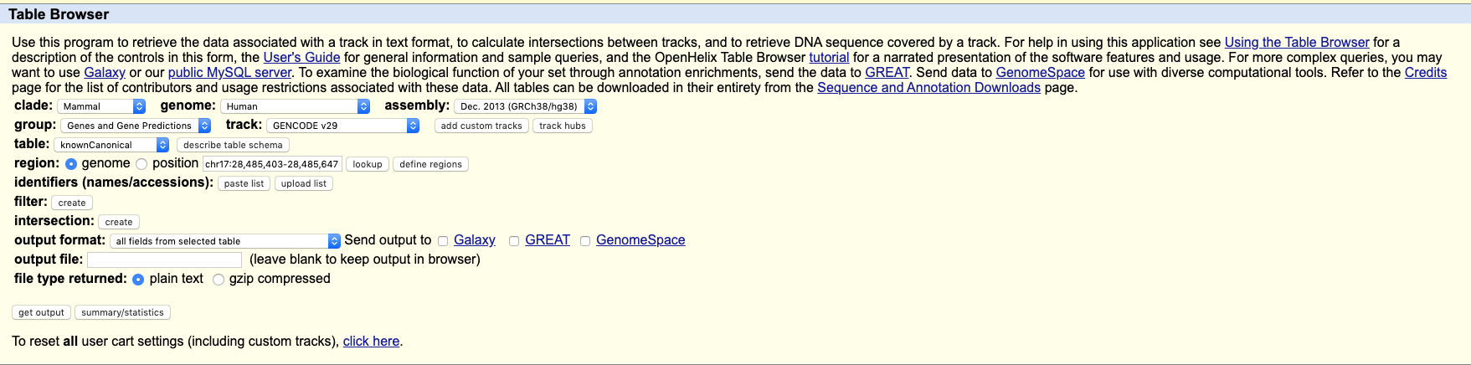

Downloaded this to refs/knownCanonicalTss-hg38-GENCODEv29-DL-4Oct2019.tsv