1. Dataset description and data preprocessing

The study was carried out over a total of 41 individuals, all of them are female and obese. The scale of weights is from 102kg up to 169.6kg. The dataset comprises, for every patient, the expression levels of 45 genes.

Specialists did a priori classification of patients by means of observing laboratory samples. Generally speaking, the patients are categorized in Healthy and Steatosis groups, dubbed as HG and SG, respectively. On the other hand, inside the Steatosis group, the individuals are divided into three disjoint groups of steatosis, steatosis-type I, steatosis-type II, and steatosis-type III; dubbed as ST1, ST2 and ST3, respectively. Figure X shows the distribution of patient per group.

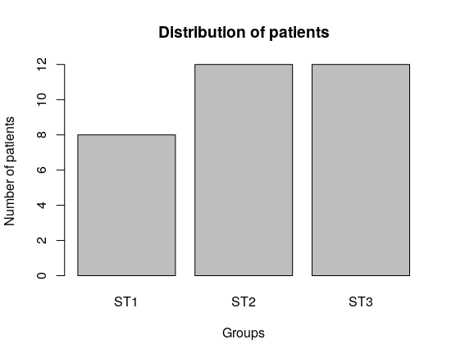
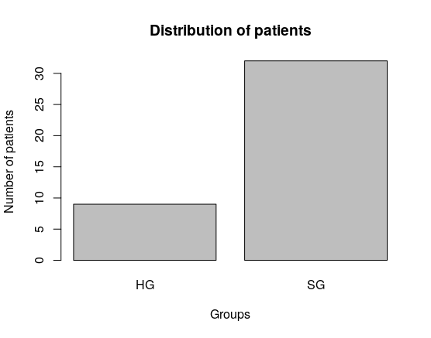

If it is possible, describe more features of the dataset

1.1 Data preprocessing

Before conducting the computational study, the dataset was preprocessed as follows [1]:

1- The dataset was analyzed in order to detect outliers. The outliers detected were removed. To detect outliers, the experts analyzed expression levels which are very different with respect to the distribution of data.

2- All genes with more than 60% of missing values were removed. On the other hand, the genes with very low expression levels (in scale of E-289) were removed. This process leaded to reduce the dataset from 45 to 43 genes, the genes CELF4 and nSR100 were discarded.

3- All missing values were replaced by the medians of the gene expressions belonging to a group of patients.

4- The expressions levels were scaled to [0,1] range, in order to handle all information in the same scale, thus avoiding that the analysis will be biased by genes with high expressions levels. To normalize the data, the Min-Max method was used.

//Describe the cluster analysis, showing how is not possible to obtain good clusters of individuals. There is not a correspondence of the results of clustering process and the a priori classifications of individuals.

//Describe the other cluster analysis, where the 3 groups of individuals were extracted (according to expression levels). Poner los análisis de cluster para los tres escenarios (1,2 y 3), de tal manera que eso de paso a explicar por qué se usaron métodos de selección de características y clasificación.

1- Comparison of two populations of individuals, the control group (healthy individuals, dubbed as HI) and the steatosis group (dubbed as SI).

2- Tree populations of individuals were compared, the group of individuals which have steatosis type 1 (dubbed as ST1), the set of individuals with steatosis type 2 (dubbed as ST2), and the individuals with steatosis type 3 (dubbed as ST3).

3- The comparison between the three population of individuals determined by expert criteria (see Section -to set-), dubbed as G1, G2 and G3, respectively

.

The above results showed that through clustering techniques very few conclusions can be drawn. It is very difficult to conclude which genes distinguish between individuals in HG and SG groups, even less between the three groups of steatosis (ST1, ST2 and ST3).

In this work, we considered important to use the a priori classifications of patients; this information is not taken into account by clustering methods. We hypothesized that by using the a priori classifications (established groups), a better estimation of the most relevant genes could be carried out.

2. Estimating the relevance of genes

In this work, several well-known feature weighting algorithms [2] were used to compute the relevance of genes. Considering each gene as a feature/attribute that describe a patient, we intended to obtain a ranking of genes, the genes are ordering from higher relevance to lower relevance. The relevance of a gene is a weight that represents the ability of it to distinguish pattern classes [3,4].

To avoid biases in the process of estimating the relevance of genes, five well-known feature estimation methods were used, Correlation-Feature-Selection (CFS) [5], Correlation-Attribute-Evaluation (CAE) [1], Gain-Ratio (GR) [1], Information-Gain (IG) [6], and Relief-F (RF) [7]. All these feature estimation algorithms are supervised learning methods, i.e. they use the information regarding to a priori classifications for estimating the relevance of features. On the other hand, these methods do not depend of the effectiveness of a classifier, so that the biases of the learning algorithms do not influence the feature selection process. These methods are know as filter methods, they evaluate the usefulness of a feature (or a set of features) through measures of distance, dependency, information or correlation on data [3,4]. A detailed explanation of these methods can be consulted in the specialized literature.

Feature weighting methods were assessed with leave one-out cross validation for a better estimation of the relevance of genes. In case of RF method, it was executed with 5, 10 and 15 number of nearest neighbors.

All these methods can return rankings of features (genes). Consequently, we computed the final ranking of genes as follows:

Let us say R_{m} is the ranking of genes computed by the feature weighting method m, and $m \in {CFS, CAE, GR, IG, RF}$. $R_m(g)$ represents the rank value of the gene $g$ in ranking $R_m$, and $G$ is the set of all genes analyzed in the study. The final ranking of genes $R_f$ is equal to:

\begin{equation}
R_f= rank(R_ave)
\end{equation}
, where rank(R_ave) represents a function that ranks the genes according to their average rank values, and $R_ave$ is equal to:
\begin{equation}
R_ave= \underset{\forAll g \in G}{\sum \underset{m \in {CFS,CAE,GR,IG,RF}}{\frac{\sum R_m (g)}{5}}}
\end{equation}
Figure X shows a flow chart illustrating the process followed in this work to compute the final ranking of genes. This procedure was implemented by using the popular data mining software WEKA [8].

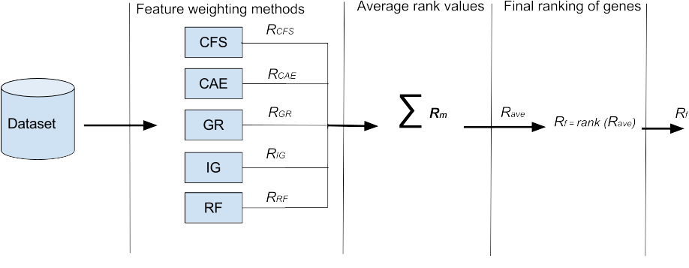

2.1 Results of estimating the relevance of genes

Tables X, XI, XII and XIII show the rankings of genes for each one of the four scenarios analyzed in this work. In tables, the genes are ordered from higher to lower relevance; the smaller the rank value, the higher the relevance.

Table X. Ranking of genes in study HG vs. SG
Gene name | Rank value
U6  U6ATAC  SRM160  U4ATAC  PTB  SAM68TV1  SF3BTV2  SC35  ESRP2  RBM22  RAVER1  TIA1  PSF  U2  U2AF1  U1  U2AF2  PRP8  U11  FB11  SND1  U4  RBM3  TRA2B  ESRP1  MAGOH  U5  CUGBP  NOVA1  RBM45  RBM17  U12  SRSF10  SKIP  SRSF1  TRA2A  SRSF4  SF3BTV1  SRSF9  SRSF3  SRSF6  CA150  SRSF5 | 0.043  0.060  0.086  0.138  0.257  0.328  0.340  0.357  0.368  0.428  0.443  0.486  0.511  0.514  0.521  0.528  0.543  0.557  0.568  0.571  0.614  0.628  0.643  0.671  0.686  0.686  0.686  0.760  0.714  0.711  0.700  0.700  0.711  0.757  0.771  0.814  0.843  0.857  0.914  0.928  0.943  0.943  0.943

Table XI. Ranking of genes in study ST1 vs. ST2 vs. ST3.
Gene name | Rank value
RBM22  SRSF1  RBM45  ESRP1  SF3BTV1  U6ATAC  ESRP2  NOVA1  SRSF6  U11  SF3BTV2  U2  U2AF1  U6  PSF  SRSF4  RBM3  TRA2A  RAVER1  CA150  U4ATAC  SND1  U2AF2  MAGOH  SC35  SKIP  SAM68TV1  SRSF3  U1  SRSF10  TRA2B  SRSF9  PTB  PRP8  TIA1  RBM17  CUGBP  SRSF5  FB11  U5  U12  SRM160  U4 | 0.022  0.196  0.264  0.303  0.319  0.374  0.380  0.483  0.494  0.527  0.538  0.538  0.538  0.560  0.582  0.582  0.593  0.593  0.604  0.611  0.626  0.626  0.637  0.637  0.637  0.637  0.648  0.648  0.648  0.659  0.670  0.692  0.714  0.714  0.714  0.736  0.747  0.747  0.769  0.802  0.813  0.868  0.879

Table XII. Ranking of genes in study G1 vs. G2 vs. G3.
Gene name | Rank value
TRA2A  RAVER1  RBM45  SND1  U11  SF3BTV2  SRSF4  U6ATAC  TRA2B  ESRP2  CA150  SRSF6  U2AF2  PRP8  CUGBP  U5  FB11  SRSF1  RBM22  ESRP1  NOVA1  U4  MAGOH  SRSF5  SAM68TV1  U1  U2  SF3BTV1  SRSF3  SC35  SKIP  U12  U4ATAC  SRSF10  U2AF1  U6  RBM3  TIA1  PSF  PTB  RBM17  SRSF9  SRM160 | 0.102  0.126  0.137  0.160  0.184  0.202  0.262  0.263  0.264  0.325  0.366  0.391  0.413  0.418  0.431  0.436  0.446  0.460  0.499  0.538  0.602  0.608  0.636  0.644  0.650  0.673  0.674  0.684  0.685  0.710  0.714  0.756  0.758  0.781  0.798  0.799  0.839  0.852  0.896  0.896  0.897  0.907  0.920

Table XIII. Ranking of genes in study Improvement vs. Not Improvement
Gene name | Rank value
NOVA1  SF3BTV1  RBM17  RBM22  ESRP1  SF3BTV2  SRSF1  RAVER1  SRM160  CUGBP  U6ATAC  U11  RBM3  CA150  U1  SRSF5  SRSF4  U2  TRA2A  MAGOH  SRSF9  U2AF1  FB11  SKIP  SC35  U2AF2  PRP8  SAM68TV1  U4  SRSF3  U6  PSF  PTB  TRA2B  RBM45  ESRP2  SND1  TIA1  U12  U5  U4ATAC  SRSF10  SRSF6 | 0.223  0.324  0.325  0.339  0.355  0.363  0.412  0.424  0.442  0.448  0.463  0.465  0.465  0.507  0.532  0.549  0.550  0.556  0.563  0.566  0.569  0.573  0.584  0.589  0.600  0.604  0.628  0.632  0.632  0.647  0.656  0.660  0.661  0.674  0.677  0.691  0.709  0.712  0.717  0.722  0.735  0.830  0.895

Table X shows that the U6, U6ATAC, SRM160 and U4ATAC … (poner otros, analizar con Manuel y Mercedes) are in average the most relevant genes that can distinguish between patterns in HG and SG groups. This result corresponds to results shown in Figures (apoyarse en los gráficos de barras de Mércedes con las diferencias significativas) … where we can see that exists a significant difference between the variance of expression levels on these genes in HG and SG groups.

Concluir algo muy similar a lo de arriba, pero para los otro tres escenarios estudiados (tratando de siempre poner las gráficas de diferencias significativas que tiene Mercedes)

This preliminary study, regarding to the relevance of genes, allowed us to extract very significant information/knowledge that may lead to better analysis about which actually are the genes with more influence in steatosis disease.

The use of data mining techniques, in specific the use of supervised feature weighting methods, can lead to a superior estimation of the relevance of genes. The process followed to determine final rankings of genes has as main advantages [3,4]: (i) the consideration of a priori classifications (expert knowledge), (ii) detection of redundant information, and (iii) detection of interacting features (genes).

On the other hand, the process followed has advantages over traditional approaches, such as Principal Component Analysis (PCA) [9]. Traditional approaches for non-supervised dimensionality reduction commonly tend to not exploit expert knowledge [1].

3. Determining the best subset of genes in predicting steatosis disease

Up to now, a ranking of genes was computed for each scenario analyzed in this work. However, we aimed to determine the best subset of genes that can predict when a patient belongs or not to the different groups defined in each scenario.

The direct analysis of a ranking of genes (see Tables X, XI, XII and XIII) is not an easy task, since it is complex to compute a threshold to decide the point (gen) for which all the subsequent genes in the ranking could be considered as irrelevant.

In this work, to determine the best subset of genes by means of rankings of genes computed before, the method proposed in [4,10] was extended. It provides a heuristic for searching over feature rankings.

We proposed a computational method that allows us to determine the best subset of genes without evaluating all possible combinations of genes, which is $2^n -1$ (exponential size), where $n$ is the number of genes in the dataset. It requires to evaluate at most $\frac{n(n-1)}{2}$ combination of genes.

Given a final ranking of genes $R_f$, let us say $R_{f}^{g}$ represents the sub-ranking of genes, where $g$ is the top gene of ranking $R_{f}^{g}$; i.e. the sub-ranking of genes is formed by $g$ and all subsequent genes in $R_f$.

Figure X shows a flowchart with the steps that are performed for each sub-ranking $R_{f}^{g} | \forall g \in R_f$. Finally, the best subset of genes is the one that lead the classifier to have a better performance in predicting whether a patient belongs or not to a group.

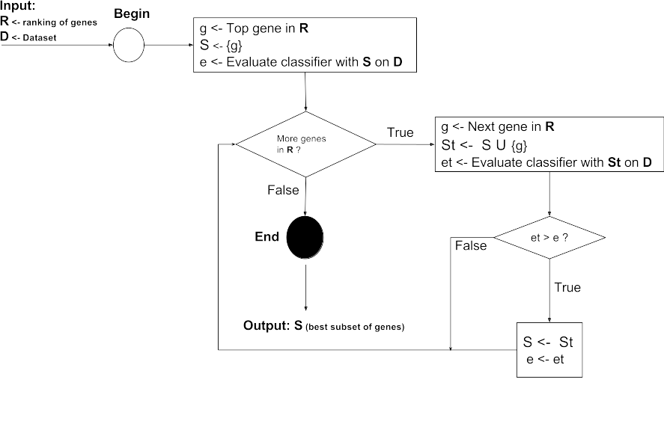

3.1 Results of determining the best subset of genes

Note that, in the method proposed in previous section, we need to use a classifier in order to determine the relevance of subsets of genes. In this work, we used the popular Random Forest algorithm [11] as classifier.

Random Forest is a supervised machine learning method that constructs a forest of random trees. It has as relevant characteristic that the process of constructing the ensemble of trees may conduct to an intrinsic variable selection. Therefore, we not only favor the gene selection process by means of the processes described in Sections 2 and 3, but also the internal mechanism of Random Forest influence the subset selection.

Figure X also shows that we determined when a subset of genes is better than another one using the results of evaluating the classifiers. In this work, we have used the average AUC as a accuracy measure of the effectiveness.

In all experiments, a leave one-out cross validation for a better validation of classifiers was used. On the other hand, three different seeds for random number generation were employed in executing Random Forest.

3.1.1 Relevant genes to differentiate the HG and SG groups

Executions | Genes |  |  |  |  |  |  |  |  |  |  | Average AUC
Executions | CUGBP | PTB | RBM22 | RBM3 | RBM45 | SRM160 | SRSF1 | U1 | U4 | U6 | U6ATAC
1 |  | 1 |  |  | 1 | 1 |  |  | 1 |  | 1 | 0.960
2 |  | 1 | 1 |  |  | 1 | 1 | 1 |  | 1 | 1 | 0.948
3 | 1 | 1 | 1 | 1 |  | 1 |  |  |  | 1 | 1 | 0.953

These conclusions are supported by : (poner gráficas que generó Mercedes entre sanos y enfermos para estos genes, donde se evidencien que existen diferencias)

3.1.2 Relevant genes to differentiate the ST1, ST2 and ST3 groups

Executions | Genes |  |  |  |  |  |  |  |  |  |  | Average AUC
Executions | ESRP1 | ESRP2 | PSF | RBM22 | SRSF6 | U1 | U11 | U2 | U2AF1 | U5 | U6ATAC
1 | 1 | 1 |  | 1 | 1 | 1 |  | 1 |  | 1 | 1 | 0.844
2 | 1 | 1 |  | 1 | 1 |  | 1 | 1 |  |  |  | 0.835
3 |  |  | 1 | 1 |  |  |  | 1 | 1 |  |  | 0.846

3.1.3 Relevant genes to differentiate the G1, G2 and G3 groups

Executions | Genes |  |  |  |  |  |  | Average AUC
Executions | RAVER1 | RBM45 | SND1 | SRSF4 | TRA2A | TRA2B | U6ATAC
1 | 1 |  | 1 | 1 | 1 | 1 | 1 | 1.0
2 | 1 | 1 | 1 | 1 | 1 | 1 | 1 | 1.0
3 | 1 | 1 | 1 | 1 | 1 | 1 | 1 | 1.0

3.1.4 Relevant genes to differentiate the Improvement and Not-Improvement groups

Executions | Genes |  |  |  |  |  |  |  |  |  | Average AUC
Executions | ESRP2 | NOVA1 | RAVER1 | RBM22 | SC35 | SF3BTV1 | SRSF9 | U2 | U2AF1 | U6ATAC
1 |  | 1 |  | 1 | 1 |  |  | 1 |  | 1 | 1.0
2 |  | 1 |  | 1 |  |  | 1 |  |  |  | 1.0
3 | 1 | 1 | 1 |  |  | 1 | 1 | 1 | 1 | 1 | 0.989

References

[1] S. García, J. Luengo and F. Herrera. Data preprocessing in Data Mining. Springer, vol. 72, 2015.

[2] D. Wettschereck, D.W. Aha and T. Mohri, A review and empirical evaluation of feature weighting methods for a class of lazy learning algorithms. Artificial Intelligence Review, vol. 11, 273–314, 1997.

[3] O. Reyes, C. Morell and S. Ventura. Evolutionary feature weighting to improve the performance of multi-label lazy algorithms. Integrated Computer-Aided Engineering vol. 21, pp. 339–354, 2014.

[4] O. Reyes, C. Morell and S. Ventura. Scalable extensions of the ReliefF algorithm for weighting and selecting features on the multi-label learning context. Neurocomputing, vol. 161, pp. 168–182, 2015.

[5] M. A. Hall. Correlation-based Feature Subset Selection for Machine Learning, PhD. Thesis, The University of Waikato, New Zeland. 1998

[6] Quinlan, J.R.: C4.5: Programs for Machine Learning. Morgan Kaufmann Publishers, 1993.

[7] M. Robnik-Sikonja and I. Kononenko. Theoretical and empirical analysis of ReliefF and RreliefF. Machine Learning, vol. 53 (1–2), pp. 23-69, 2003.

[8] M. Hall, E. Frank, G. Holmes, B. Pfahringer, P. Reutemann, and Ian H. Witten. The WEKA Data Mining Software: An Update. SIGKDD Explorations, vol. 11, issue 1, 2009.

[9] G. Dunteman. Principal Components Analysis. SAGE Publications, Newbury Park , 1989.

[10] R. Ruiz, J.C. Riquelme, J.S. Aguilar-Ruiz, Heuristic search over a ranking for feature selection, in: Proceedings of IWANN 2005, Lectures Notes in Computer Science, Springer-Verlag, Berlin, Heidelberg, vol. 3512, pp. 742–749, 2005.

[11] Leo Breiman. Random Forest. Machine Learning. Vol 45 (1), pp. 5-32, 2001.

