Training Day10 Report:

26 June 2024

Keys Takeways:

**1. Downloading Apache Jena Fuseki**

* **Visit Official Website**: Go to the Apache Jena website at [jena.apache.org](https://jena.apache.org/).
* **Navigate to Downloads**: Find the download section for Fuseki.
* **Select Version**: Choose the desired version of Fuseki. The latest stable release is recommended.
* **Download Archive**: Download the zip or tar.gz archive suitable for your operating system.
* **Extract Files**: Extract the downloaded archive to a preferred directory on your system.

**2. Java Version Requirements**

* **Java Compatibility**: Ensure that you have Java installed on your system. Apache Jena Fuseki requires Java 8 or later.
* **Check Java Version**: Open a terminal or command prompt and run the command java -version to verify your Java version.
* **Install/Update Java**: If needed, download and install the latest Java Development Kit (JDK) from the [Oracle website](https://www.oracle.com/java/technologies/javase-downloads.html) or use an open-source alternative like OpenJDK.

**3. Uploading Data Over Apache Jena Fuseki**

* **Start Fuseki Server**: Navigate to the directory where Fuseki is extracted and run the server using the command ./fuseki-server (Linux/Mac) or fuseki-server.bat (Windows).
* **Access Fuseki UI**: Open a web browser and go to http://localhost:3030 to access the Fuseki user interface.
* **Create a Dataset**:
  + Click on "Datasets".
  + Click on "Add new dataset".
  + Enter a name and select the dataset type (e.g., in-memory or TDB).
* **Upload RDF Data**:
  + Select the newly created dataset.
  + Go to the "Upload" tab.
  + Choose the RDF data file (e.g., .ttl, .rdf) from your local machine.
  + Click "Upload" to load the data into the dataset.

**4. Writing and Executing a Query**

* **SPARQL Query Execution**:
  + Select the dataset you want to query from the Fuseki interface.
  + Go to the "Query" tab.

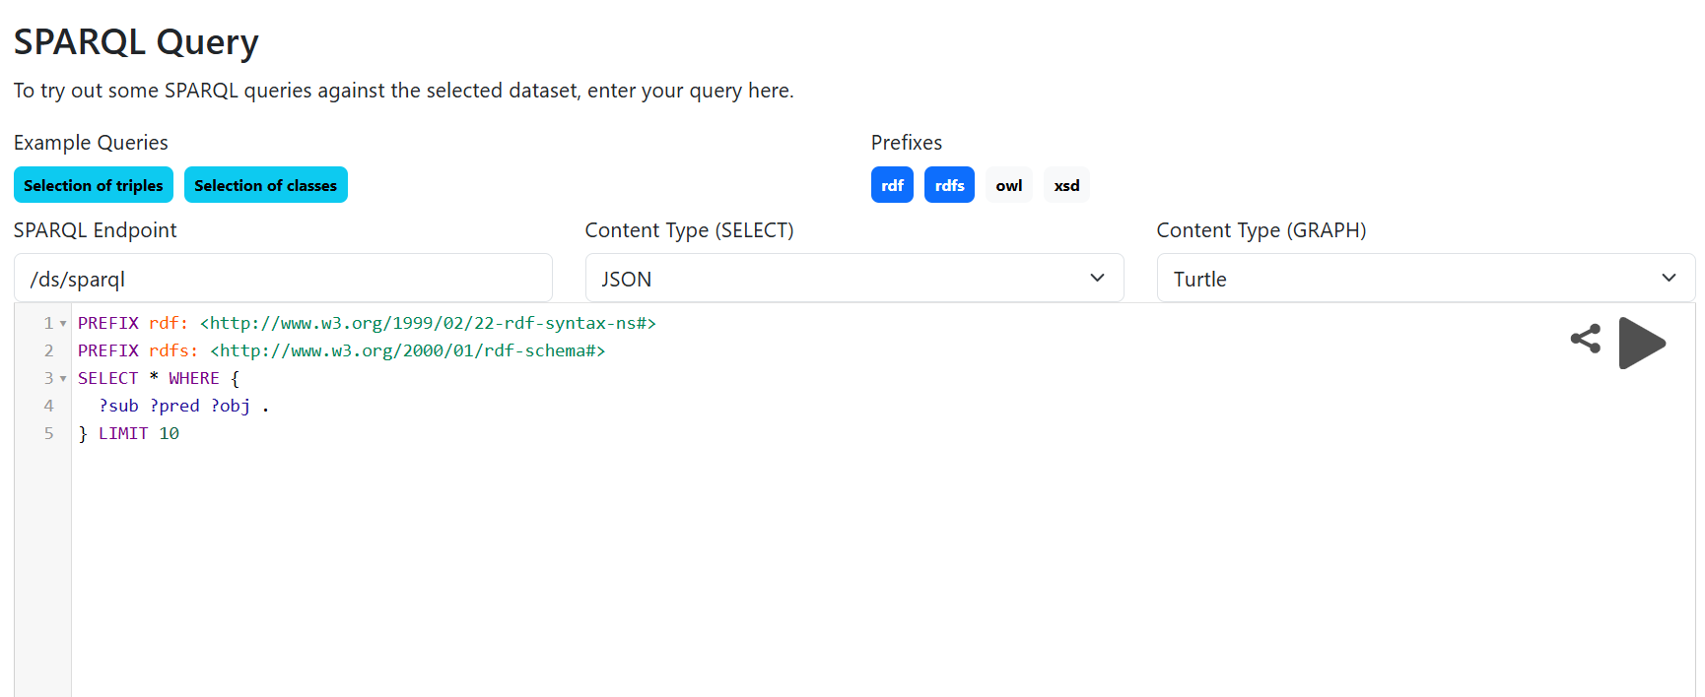

* **Writing a Query**:
  + Use SPARQL, a query language for RDF data. Example query:

sparql

Copy code

PREFIX foaf: <http://xmlns.com/foaf/0.1/>

SELECT ?name WHERE {

?person a foaf:Person .

?person foaf:name ?name .

}

* + This query selects the names of all persons in the dataset.
* **Running the Query**:
  + Enter the SPARQL query into the query text area.
  + Click "Run Query" to execute.
  + View results in the results pane, which displays the query output in tabular form.

