Training Day7 Report:

20 June 2024

Key Takeways:

**JIRA**

* **Project Management Tool**: Developed by Atlassian for software development teams.
* **Agile Support**: Facilitates Scrum and Kanban methodologies.
* **Task Management**: Create, update, and manage tasks, issues, and projects.
* **Custom Workflows**: Tailor workflows to fit specific team processes.
* **Reporting and Analytics**: Provides detailed reports on team performance and project status.
* **Integration**: Connects with tools like Confluence, Bitbucket, GitHub, and more.
* **Enhanced Collaboration**: Improves team communication and collaboration.
* **Increased Transparency**: Offers visibility into project progress and bottlenecks.
* **Improved Productivity**: Streamlines task management and prioritization.
* **Scalability**: Suitable for teams of all sizes.

**W3 Validation**

* **Markup Validation**: Checks the validity of HTML/XHTML documents.
* **CSS Validation**: Validates Cascading Style Sheets.
* **Error Reporting**: Provides detailed error messages and suggestions.
* **Compatibility**: Supports various web document types and versions.
* **Improved Accessibility**: Ensures web content is accessible to a wider audience.
* **Better SEO**: Valid code can improve search engine rankings.
* **Cross-browser Compatibility**: Reduces rendering issues across browsers.
* **Professionalism**: Reflects commitment to quality and best practices.

**Wave Extension**

* **Accessibility Tool**: Developed by WebAIM to evaluate web content accessibility.
* **Visual Indicators**: Uses icons to highlight accessibility issues directly on the web page.
* **Error Categorization**: Classifies issues into errors, alerts, features, structural elements, and ARIA.
* **Detailed Reports**: Generates comprehensive reports for in-depth analysis.
* **Enhanced Usability**: Helps create user-friendly web content.
* **Compliance**: Assists in meeting WCAG (Web Content Accessibility Guidelines) standards.
* **Immediate Feedback**: Provides real-time insights during development.
* **Educational Tool**: Helps developers understand and address accessibility issues.

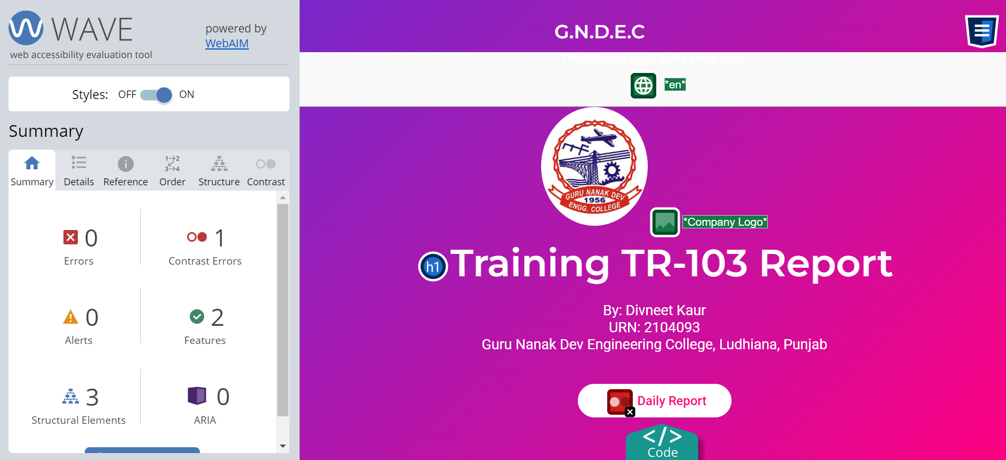

**Lighthouse Extension**

* **Quality Audit Tool**: Open-source tool for improving web page quality.
* **Performance Metrics**: Measures page load speed, interactivity, and overall performance.
* **Accessibility Audits**: Checks for common accessibility issues.
* **Best Practices**: Evaluates adherence to modern web development practices.
* **SEO Analysis**: Assesses basic search engine optimization practices.
* **PWA Checks**: Evaluates Progressive Web App features and compliance.
* **Holistic Improvement**: Provides comprehensive audits to improve web pages.
* **Actionable Insights**: Delivers detailed enhancement suggestions.
* **Continuous Monitoring**: Integrates into development workflows for ongoing quality assurance.
* **Broad Scope**: Covers multiple aspects of web quality, from performance to SEO.

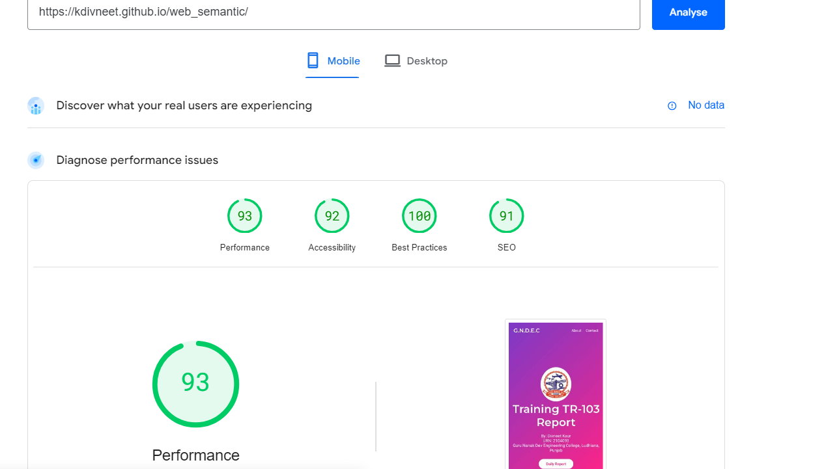

**What Font Extension**

* **Font Identification**: Displays font name, size, weight, and style on web pages.
* **Detailed Font Info**: Provides additional font details like family, line height, and color.
* **Easy to Use**: Simple activation and hover to get font details.
* **Browser Compatibility**: Works with Chrome and Firefox.
* **Design Inspiration**: Helps discover new fonts and understand typography choices.
* **Consistency**: Assists in maintaining consistent typography across websites.
* **Efficiency**: Quickly provides font information without inspecting code.
* **Educational**: Useful for learning about different fonts and their properties.