CO1 – Assessment Tool 2 : Concept Mapping
CSA1205-COMPUTER ARCHITECTURE
NAME: DIVYA SHREE.K
REG NO:192521376

Question 1: CPU, Memory, I/O Devices and Bus Structures
Construct a detailed concept map showing the relationship between CPU (ALU, Control Unit, Registers), memory (cache, RAM), and I/O devices. Extend the map to include single-bus, multi-bus, and hierarchical bus structures, and clearly illustrate how data and control signals flow among these components during execution. Indicate possible points of delay or bottlenecks and how different bus structures help in improving performance.
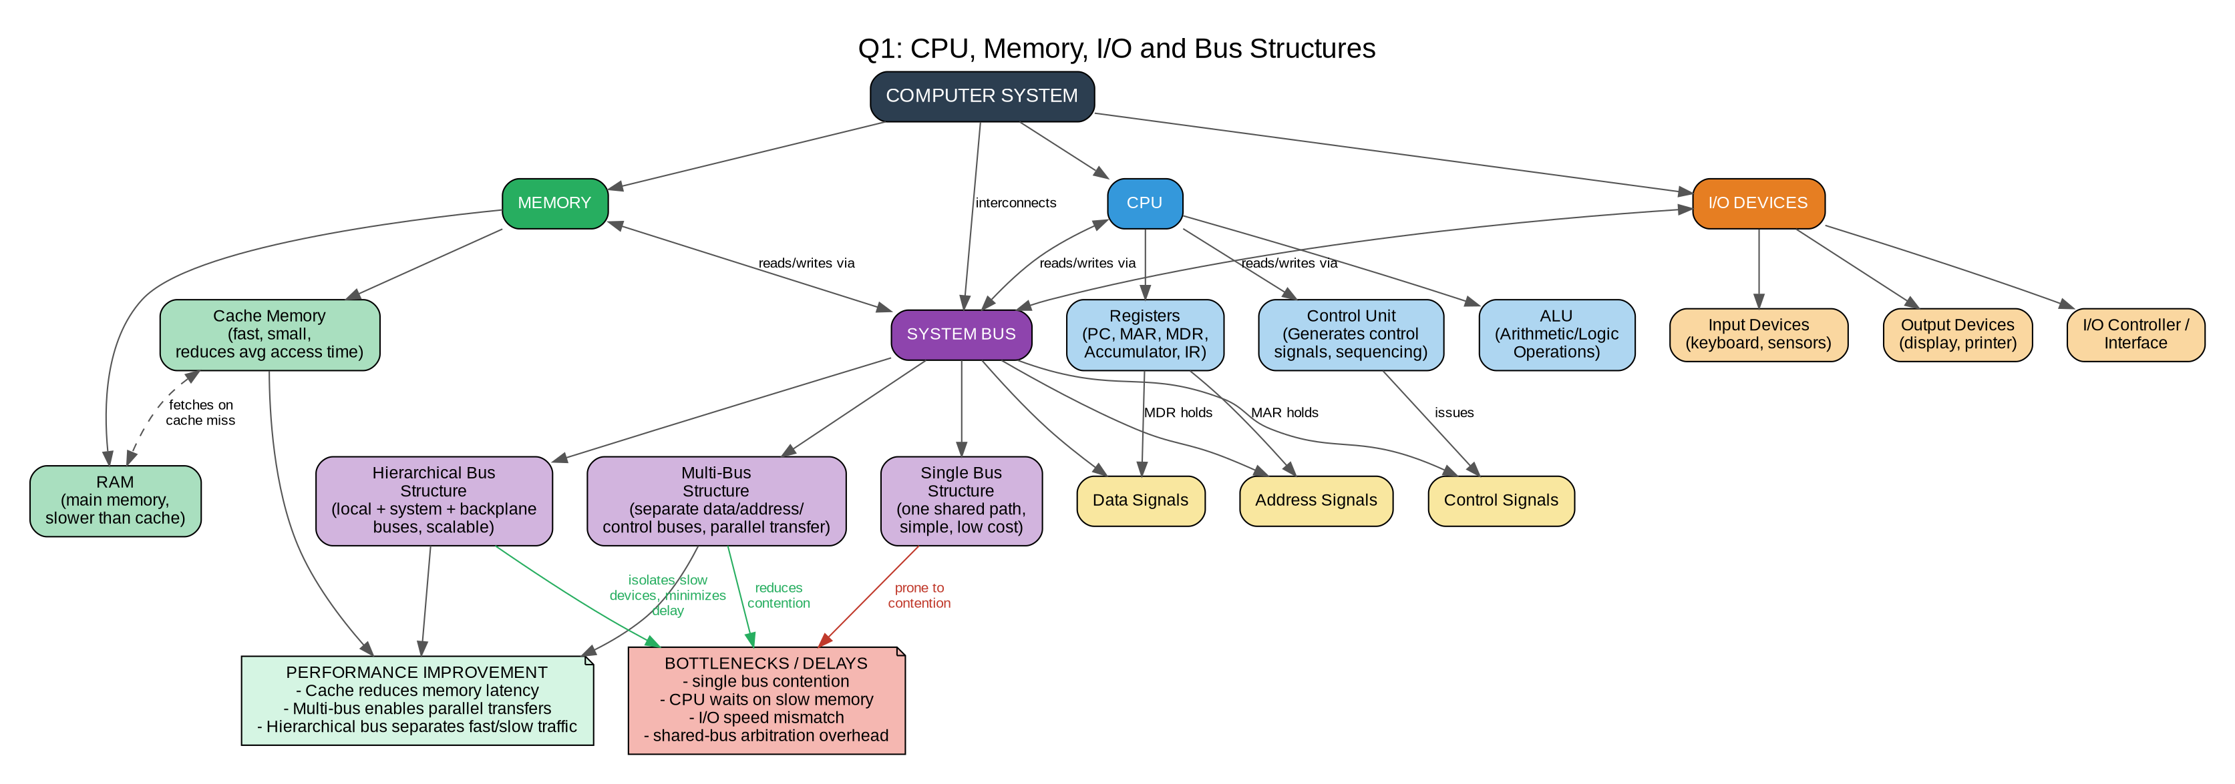

Explanation :
- The CPU's ALU performs computations, the Control Unit generates timing/control signals, and Registers (PC, MAR, MDR, IR) temporarily hold data/addresses during execution.
- Cache sits between CPU and RAM to reduce average memory access time; RAM holds the bulk of active data/programs.
- I/O devices communicate with the CPU through controllers/interfaces rather than directly.
- In a single-bus structure, only one data transfer can happen at a time, causing contention when CPU, memory, and I/O compete for the bus.
- Multi-bus structures use separate address, data, and control buses, allowing parallel transfers and reducing delay.
- Hierarchical bus structures isolate slow devices (I/O) from fast ones (CPU-memory), improving overall throughput.
- Bottlenecks mainly arise from bus arbitration, slow memory response, and mismatched I/O speeds; wider/faster buses and caching help mitigate these.

Question 2: Instruction Execution Cycle and CPU Performance
Develop a comprehensive concept map linking the instruction execution cycle (fetch, decode, execute) with CPU performance parameters such as CPI, clock cycles, and execution time. Show how each stage contributes to overall execution time, and include connections to factors like memory access, instruction complexity, and pipeline stalls. Also, represent how benchmarking is used to evaluate performance.
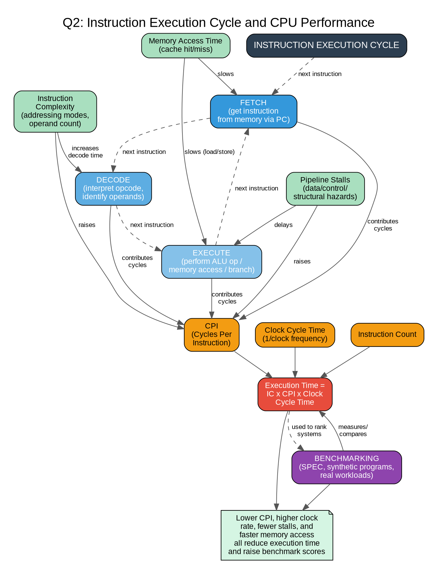
Figure 2: Concept map for Question 2

Instruction Execution Cycle & CPU Performance

Execution Time = Instruction Count × CPI × Clock Cycle Time — the core formula linking the cycle to performance.

Memory access delays and pipeline stalls increase CPI, directly slowing execution.

Benchmarking measures real execution time across standard workloads to compare CPUs fairly.

Question 3: 8085 vs 8086 Architecture Comparison
Create a concept map comparing 8085 and 8086 architectures, including their instruction sets, register organization, addressing modes, and memory segmentation (in 8086). Clearly show how these architectural features influence program execution, multitasking capability, and efficiency in real-time applications.

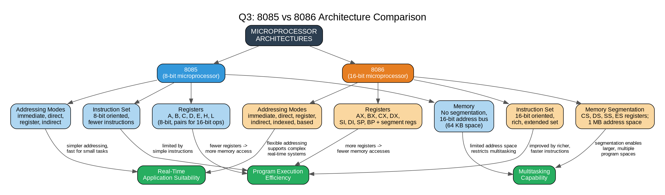
Figure 3: Concept map for Question 3

8085 vs 8086 Architecture

8085 is an 8-bit processor with a simpler instruction set and no memory segmentation, limiting addressable memory to 64 KB.

8086 is a 16-bit processor with a richer instruction set, more registers, and segmented memory (CS, DS, SS, ES), extending address space to 1 MB.

More registers in 8086 reduce the need for frequent memory access, improving execution speed.

Segmentation in 8086 allows multiple programs/data areas to coexist, enabling better multitasking support compared to 8085.

8086's flexible addressing modes (indexed, based) suit complex real-time applications better than 8085's simpler modes.

8085 remains efficient for small, simple, real-time control tasks due to its lower overhead.

Question 4: Addressing Modes and Instruction Types
Draw a detailed concept map that connects various addressing modes (immediate, direct, register, indirect, indexed) with instruction types (data transfer, arithmetic, control instructions). Illustrate how each addressing mode affects memory access time, instruction size, and execution speed, and show real-world scenarios where specific addressing modes are preferred.
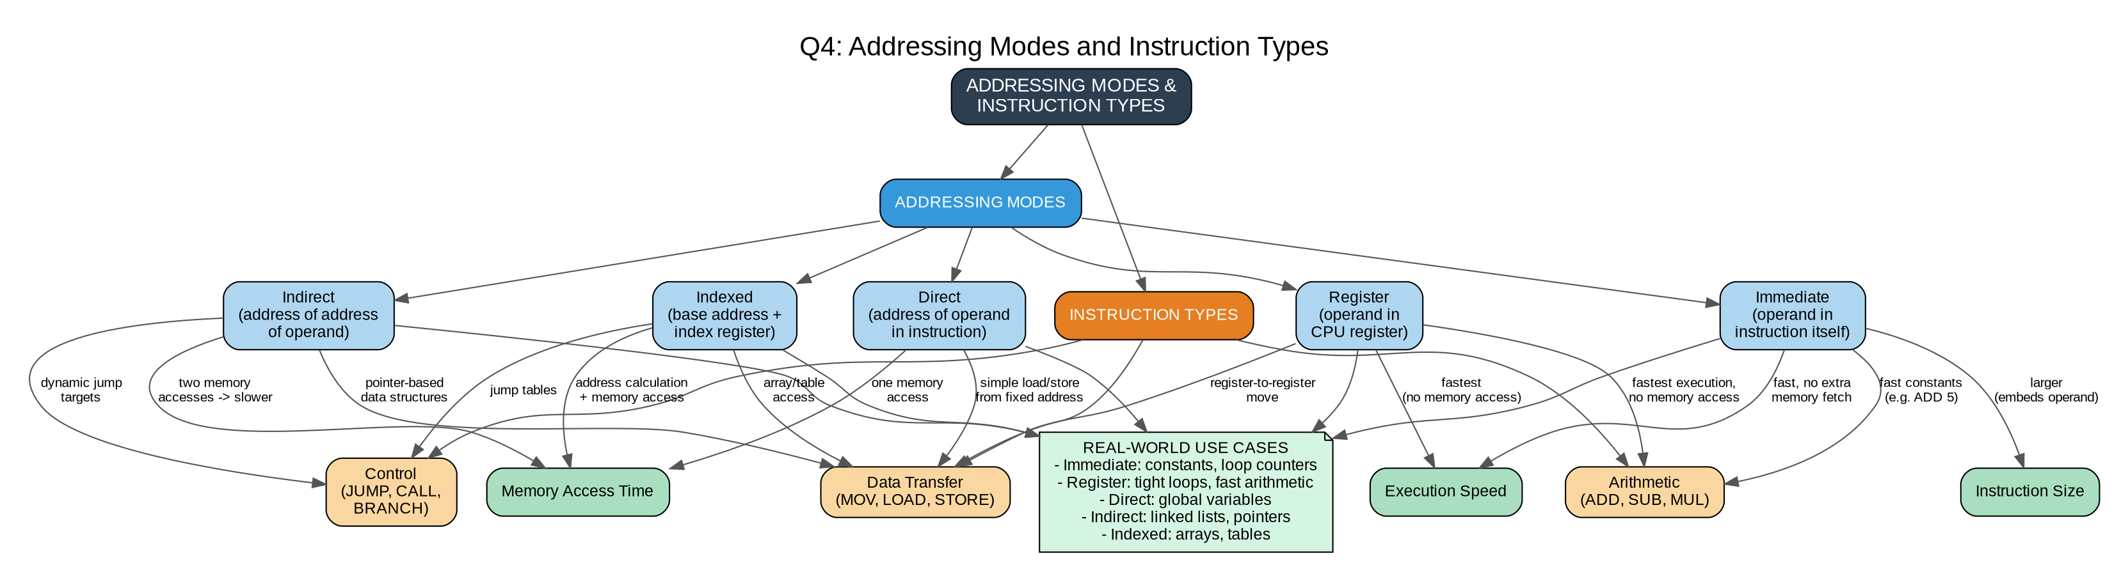
Figure 4: Concept map for Question 4

Addressing Modes & Instruction Types

Register addressing is fastest (no memory access); indirect addressing is slowest (two memory accesses).

Immediate mode increases instruction size but speeds up constant-value operations.

Mode choice trades off instruction size, memory access time, and execution speed depending on use case (arrays, pointers, constants).

Question 5: Number Systems, Instruction Representation and Debugging
Prepare an elaborate concept map integrating number systems (binary and hexadecimal) with instruction representation, memory storage, and debugging processes. Show how data is converted between formats, how instructions are stored and interpreted by the CPU, and why hexadecimal representation is commonly used in low-level programming and system design.
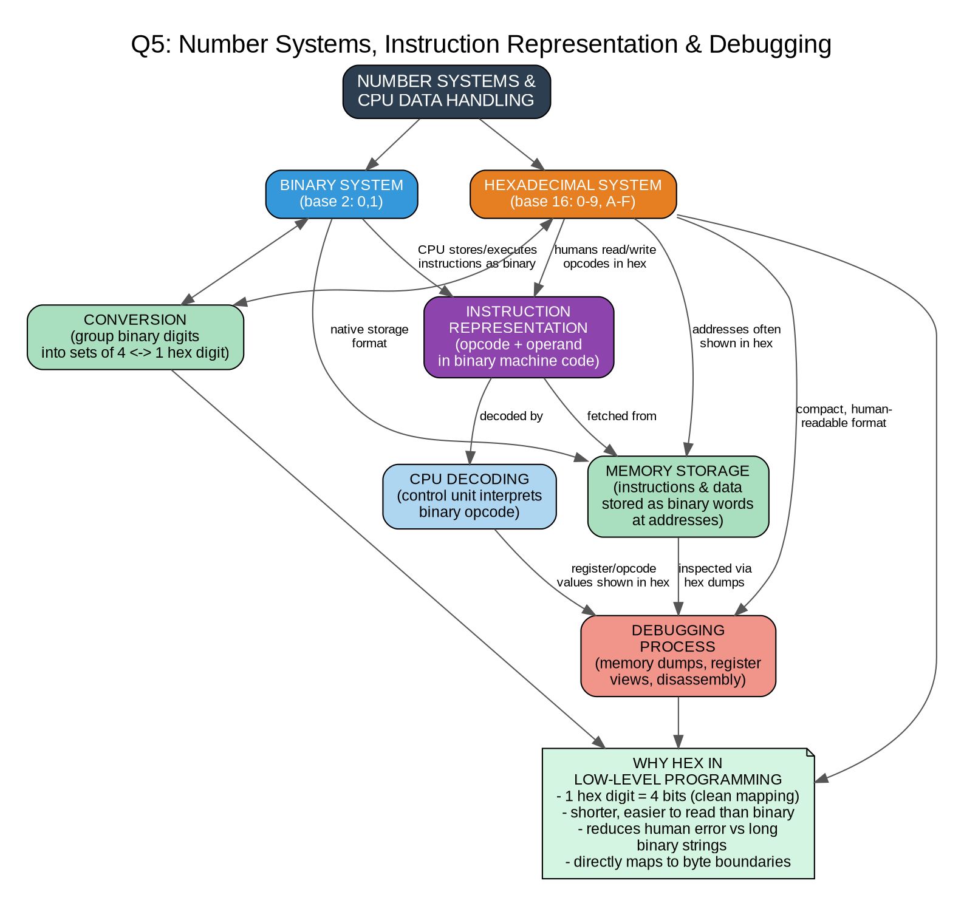
Figure 5: Concept map for Question 5

Number Systems, Instruction Representation & Debugging
- Computers store and execute all instructions/data natively in binary (base 2).
- Hexadecimal (base 16) is used by programmers because each hex digit maps exactly to 4 binary bits, making conversion simple and error-free.
- Instructions are represented as opcode + operand fields in binary machine code, decoded by the Control Unit.
- Memory addresses and stored data are usually displayed in hex during debugging for compactness and readability.
- Debugging tools (memory dumps, register viewers, disassemblers) display values in hex rather than long binary strings to reduce human error.
- Hex is preferred in low-level programming/system design because it aligns with byte boundaries and is far more compact than binary.

