MINOR PROJECT REPORT
Deep Learning-Based Detection and Classification of Brain Tumors Using MRI Images
Submitted in partial fulfilment of the requirements for the degree of Bachelor of Technology in Bioinformatics
Submitted by
[Student name] | [Roll number]
Under the guidance of
[Guide name and designation]
[Department, University or Institute]
[Month and year of submission]
Items in square brackets are placeholders for your own details. The certificate, declaration and acknowledgement pages required by your institute are not included and should be added in front of this page.

Table of Contents

If the page numbers are missing, right-click the table and choose Update field.

Abstract
Brain tumour classification from magnetic resonance images is a standard test problem for convolutional neural networks, but published accuracies are hard to compare because of duplicated images, slice-level data leakage and single-run reporting. This project builds and evaluates a four-class classifier (Glioma, Meningioma, Pituitary tumour, No Tumor) on a public Kaggle dataset of 5249 MRI images with bounding-box annotations. The data were audited before modelling: 1336 exact duplicate files were removed, near-duplicate images were grouped, and a stratified, group-aware split of 2806, 563 and 544 images (train, validation, test) was built and checked for leakage.
A small CNN trained from scratch (test accuracy 0.9283) was compared with ImageNet-pretrained ResNet18 and ResNet50 under three transfer-learning strategies. Full fine-tuning was best for both networks. Over three seeds, ResNet18 reached a test accuracy of 0.9767 (standard deviation 0.0028) and ResNet50 reached 0.9792 (0.0011); the difference is within seed variation. Seven one-factor hyperparameter experiments did not beat the reference setting under a decision rule fixed in advance. ResNet18 with full fine-tuning was selected as the final model for its smaller size (test accuracy 0.9798, macro-F1 0.9797, one checkpoint).
Error analysis showed that errors concentrate on Meningioma, on images from particular filename families (a proxy for source) and on images that are less similar to any training image. Because the dataset has no patient identifiers, same-patient leakage and source differences cannot be separated, so the reported accuracy may be optimistic. Grad-CAM peaks fell inside the annotated tumour box for 38.2% of tumour test images, against 17.3% for a fixed centre baseline, so the heatmaps agree with the boxes only weakly and are not presented as tumour localisation. The model is a research prototype and is not a diagnostic tool.

1. Introduction

1.1 Background and motivation
Magnetic resonance imaging (MRI) is a main imaging method for brain tumours. Reading MRI slices and deciding the tumour type is a task for trained specialists. Convolutional neural networks can learn to separate tumour classes from slice images, and many studies report high accuracy on public datasets. However, accuracy figures are only meaningful if the test images are independent of the training images, if the result does not depend on one lucky training run, and if the evaluation says something about the images the model has not seen from a new source. These conditions are often not checked, which motivates a project that treats the evaluation design as part of the work and not only the network.

1.2 Problem statement
Given a two-dimensional brain MRI slice, assign one of four labels: Glioma, Meningioma, Pituitary tumour or No Tumor. In addition, examine whether the regions that the trained network emphasises coincide with the annotated tumour boxes supplied with the dataset.

1.3 Objectives
- Audit the public dataset for duplicates, label problems and shortcuts, and design a train, validation and test split that avoids leakage.
- Build a baseline CNN and compare it with pretrained ResNet18 and ResNet50 under frozen, partial and full fine-tuning.
- Run controlled one-factor hyperparameter experiments and repeat the main configurations over several random seeds.
- Evaluate the selected model with per-class metrics and confidence intervals, and analyse its errors.
- Compare Grad-CAM heatmaps with the annotated bounding boxes, with baselines and sanity checks.

1.4 Scope of the claims
Each chapter separates what was implemented, what was measured, what is only proposed, what limits the conclusion and what is left for future work. Chapter 9 collects these in one table. In short:
- Implemented and measured: the data audit, the leakage-checked split, 20 training runs, the final evaluation, the error analysis and the Grad-CAM comparison. Every number in this report was computed from saved result files.
- Not claimed: clinical usefulness, diagnosis, tumour localisation by the network, or performance on data from other hospitals or scanners. No external test set was available.
- Reference repository: a public GitHub project on brain tumour detection was read for general methodology only. Its code, figures, results and wording were not used.

2. Literature Review
This review is deliberately narrow. It covers the sources that this work relies on directly and whose bibliographic details were checked against the publisher or index page while the report was prepared. It is not a survey of all brain tumour classification research, and the reader should add further studies that they have read and can cite from the originals.

2.1 Public brain tumour MRI data
Cheng et al. [5] collected 3064 contrast-enhanced T1-weighted slices from 233 patients, covering meningioma, glioma and pituitary tumours, and studied how tumour region augmentation and partition affect classification performance. The paper describes the collection at patient level (233 patients). The dataset used in this project differs: it has four classes including No Tumor, it contains images in many sizes and sources, it carries bounding boxes in YOLO format, and it has no patient identifiers. This project does not claim that the Kaggle dataset is derived from the data of Cheng et al.

2.2 Convolutional networks, residual learning and transfer learning
He et al. [1] introduced residual networks, in which each block adds its input to its output through a shortcut connection. This makes deep networks easier to optimise, and ResNet18 and ResNet50 are widely available with ImageNet weights. Yosinski et al. [9] studied how general or specific the features of different layers are and how well they transfer, which is the basis for freezing early layers and fine-tuning later ones. The Adam optimiser [10] was used for all training here. These sources justify the design of the experiments in Chapter 4 (frozen, last-stage and full fine-tuning). They do not by themselves predict which strategy is best on this dataset, which is why it was measured.

2.3 Evaluation pitfalls: leakage and run-to-run variance
Yagis et al. [6] examined slice-level splitting of three-dimensional brain MRI data for Alzheimer and Parkinson classification with 2D networks. They reported that splitting at slice level instead of subject level inflated test accuracy by 29 to 55 percent depending on the dataset, and that a randomised-label experiment reached about 96 percent accuracy with slice-level splitting against 50 percent with subject-level splitting. Wen et al. [7] reviewed convolutional network studies on Alzheimer classification and stated that more than half of the surveyed papers may have suffered from data leakage. Both studies deal with other diseases, but the mechanism applies to any dataset in which several images come from one subject. The dataset in this project has no subject identifiers, so the same risk exists and is addressed here by duplicate removal, near-duplicate grouping and an explicit leakage analysis (Chapters 3 and 6).
Pham et al. [8] measured the variance of deep learning training and reported that runs with identical data, algorithm and network can produce models with different accuracies. This is relevant to this project because two executions of the same configuration and seed gave different test results (Chapter 5), and because a single run cannot separate small differences between models from noise.

2.4 Explaining image classifiers with heatmaps
Grad-CAM [2] produces a coarse heatmap for a chosen class by weighting the activation maps of a convolutional layer with the average gradient of the class score. The pointing game [4] scores a heatmap by checking whether its maximum lies inside the annotated object. Adebayo et al. [3] showed that some saliency methods give similar maps when the network weights are randomised, and proposed randomisation of weights as a sanity check. These three sources define the Grad-CAM analysis in Chapter 7: heatmaps, pointing game against the annotated boxes, and a randomisation check.

2.5 What this project adds
The project does not propose a new network. Its contribution is a documented evaluation: a leakage-aware split built from a data audit, a controlled comparison with seed repeats and a pre-set decision rule, an error analysis that includes similarity to the training set, and a Grad-CAM comparison with baselines. The limits of this evidence are stated in Chapter 8.

3. Dataset and Data Audit
Implemented and measured. All numbers in this chapter were computed from the downloaded files (Stage 1 and Stage 2 of the project).

3.1 Dataset description
The dataset is the Kaggle dataset "MRI for Brain Tumor with Bounding Boxes" (ahmedsorour1/mri-for-brain-tumor-with-bounding-boxes). It contains 5249 JPEG images, all readable, with one text file per image holding bounding boxes in YOLO format (5873 boxes in total). The files are organised in two folders, Train and Val, with one subfolder per class. The folder counts are Meningioma 1589, Pituitary 1560, Glioma 1289 and No Tumor 811. There are 325 distinct image sizes, and the colour modes are RGB (4247), grayscale (998), RGBA (3) and palette (1). The dataset has no patient identifiers and no information about scanner, plane or sequence.
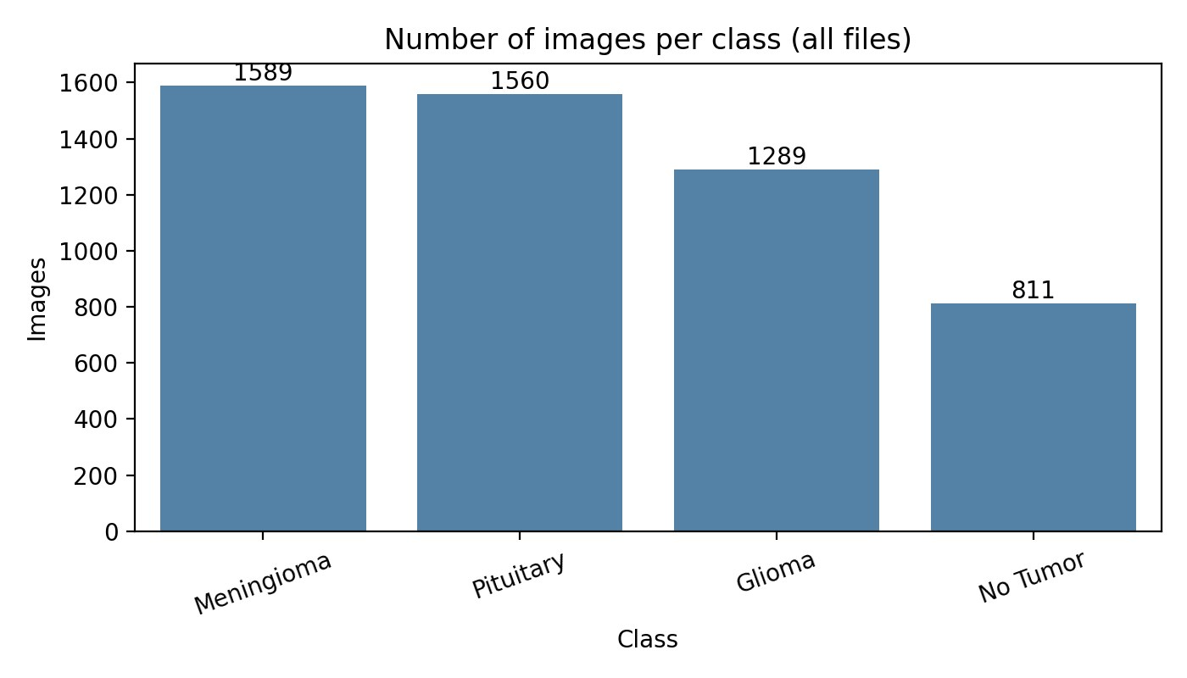
Figure 3.1. Class distribution of the dataset by folder (Stage 1).

3.2 Findings of the audit
- Exact duplicates. 1228 groups of byte-identical images were found. In total 2564 images (48.8 percent) belong to such a group, leaving 3913 unique images; 1336 redundant copies were removed.
- The supplied Val folder leaks. Of the 512 images in the original Val folder, 218 (42.6 percent) are byte-identical to an image in the Train folder. Evaluating on the supplied Val folder would therefore overstate performance, so the original split was not used.
- Near duplicates. Pairs of images with a small perceptual-hash distance and high pixel correlation were treated as the same underlying image or neighbouring slices. 641 pairs satisfied both criteria (hash distance at most 2 and correlation at least 0.95); the images were merged into 3598 groups.
- Annotation oddities. The box class identifier does not always match the folder: 167 of 1667 boxes in the Glioma folder and 111 of 1731 in the Meningioma folder carry a different class identifier, and one of 1664 boxes in the Pituitary folder does. For No Tumor images the boxes are large (659 of 809 cover more than half of the image), so they mark the brain and not a lesion. Three images have no box. In the localisation analysis (Chapter 7) only boxes whose class matches the image class were used and No Tumor images were excluded.
- Shortcuts in the metadata. Image size depends on the class (the share of 512 by 512 images is 100 percent for Glioma, 87.2 percent for Meningioma, 97.1 percent for Pituitary and 2.0 percent for No Tumor). A random forest that sees only image size, colour mode, file size and global intensity statistics, and not the anatomy, predicts the validation class with an accuracy of 0.7123 against 0.3002 for always choosing the majority class (Table 3.1). A network can therefore reach part of its accuracy through such cues.
Table 3.1. Class prediction without looking at anatomy (random forest on metadata, validation split).
Features | Validation accuracy | Validation macro-F1
majority class (reference) | 0.3002 | 0.1154
image size only (width, height, aspect, is_512x512) | 0.4831 | 0.4080
size + colour mode + file size | 0.6075 | 0.6431
size + mode + file size + global intensity (mean, std) | 0.7123 | 0.7363

3.3 Split design
The 3913 unique images were split with a stratified, group-aware procedure (StratifiedGroupKFold with seven folds and random seed 42; one fold for test, one for validation and five for training), so that images of the same near-duplicate group are never separated. This gave 2806 training, 563 validation and 544 test images (about 72, 14 and 14 percent). 157 groups contain more than one image (472 images). Verification after splitting found no MD5 hash shared across splits, no group shared across splits and no linked near-duplicate pair across splits.
Table 3.2. Images per class and split after cleaning.
Class | Train | Validation | Test | Total
Glioma | 852 | 169 | 169 | 1190
Meningioma | 783 | 157 | 155 | 1095
No Tumor | 432 | 95 | 74 | 601
Pituitary | 739 | 142 | 146 | 1027
All | 2806 | 563 | 544 | 3913

Limitation. Grouping uses image content only. Slices of the same patient that look different (for example another plane or sequence) cannot be linked, so same-patient images may still lie on both sides of the split. This is the main threat to the validity of the test results and is analysed further in Chapter 6.

4. Methodology
Implemented. Everything described in this chapter was implemented in PyTorch and run on a free Google Colab GPU (Tesla T4, PyTorch 2.11.0+cu130, Python 3.13.15).

4.1 Preprocessing and augmentation
Images are converted to three-channel RGB, padded with black to a centred square, resized to 224 by 224 pixels and normalised with the ImageNet mean and standard deviation. Padding keeps the proportions of the head, which stretching would distort. Validation and test images use only these deterministic steps. Training images additionally receive mild random augmentation: a random resized crop (scale 0.85 to 1.0, aspect ratio 0.95 to 1.05), a rotation of at most 10 degrees with a shift of at most 5 percent, and a brightness and contrast change of 10 percent. Horizontal flipping was not used in the main experiments, because it can change the anatomical side of a finding; it was tested only as a separate experiment (T7).

4.2 Models
- Baseline CNN. Five convolution blocks (convolution, batch normalisation, ReLU, max pooling) with 32, 64, 128, 256 and 256 filters, global average pooling, dropout 0.5 and a linear layer, 980,260 parameters, trained from random initialisation (B1). A second run used a class-weighted loss (B2).
- ResNet18 and ResNet50. Torchvision networks with ImageNet weights and a new four-way linear output layer. Three strategies: (A) backbone frozen, only the output layer trained; (B) last residual stage and output layer trained; (C) all layers trained (full fine-tuning). The new layer uses a learning rate of 1e-3 and the pretrained layers 1e-4.

4.3 Training protocol
All runs use cross-entropy loss, the Adam optimiser, batch size 32, mixed-precision arithmetic, a learning-rate reduction by half after three epochs without improvement of the validation loss, and early stopping after six epochs without improvement of the validation macro-F1. The best epoch by validation macro-F1 is kept. The maximum number of epochs was 40 for the baseline and 30 for the ResNets. The random seed was 42 unless stated; seeds 43 and 44 were used for repeats. The test set was not used for any decision. The cuDNN deterministic mode was requested, yet repeated runs still differed (Section 5.3).

4.4 Experiment plan and decision rule
The experiments were run in stages: baseline (2 runs), ResNet18 strategies (3 runs), ResNet50 strategies (3 runs), seven one-factor changes of the ResNet18 full fine-tuning setting (T1 to T7: pretrained-layer learning rate 1e-5 and 1e-3, batch size 16, AdamW with weight decay 0.01, dropout 0.3, class-weighted loss, horizontal flip), and seed repeats for both ResNets. Before the one-factor runs the following rule was fixed: a change is adopted only if its validation macro-F1 exceeds the mean of the three reference seeds by more than the larger of the seed range and 0.005. With the measured values the threshold is 0.0050.

4.5 Evaluation
Metrics are accuracy, balanced accuracy, macro and weighted precision, recall and F1, per-class sensitivity (recall) and specificity, and one-vs-rest ROC-AUC. Confidence intervals for accuracy and macro-F1 come from a bootstrap over test images; intervals for recall use the Wilson score method. Exploratory comparisons of error groups use Fisher exact tests and are reported without any claim of confirmation. All metrics were recomputed from the saved class probabilities in Stage 7 and agreed with the values logged during training.

4.6 Grad-CAM and box comparison
Grad-CAM is computed on the last residual stage (a 7 by 7 grid) and, as a sensitivity check, on the stage before it (14 by 14), for the predicted class. The heatmap is resized and mapped back to the original image by undoing the padding and the resize. Four measures are reported for the tumour classes against boxes of the matching class: the pointing game (heatmap maximum inside any box), intersection over union between the region above half of the maximum and the box, and the share of heatmap energy inside the box relative to the box area. Three baselines use no information about the individual image or only a little: a fixed Gaussian at the image centre, the heatmap of another test image of the same class, and the expected score of a random point. A weight randomisation check follows Adebayo et al. [3]. The mapping code was tested with synthetic heatmaps with known answers, and the hooked gradients were compared with the exact formula for this network.

4.7 Code and data availability
All notebooks, source code, saved results (per-run metrics, class probabilities, tables and figures), the model card and this report are available in the project repository: https://github.com/kdivyasrija/brain-tumor-mri-classification. The images are not redistributed; the repository explains how to obtain the dataset. The model checkpoint is not stored in the repository by default. The repository README lists the notebooks in the order in which they were run and the commands used to test the code.

5. Results
Measured. Test numbers are reported for transparency. Selection of the final model used validation results and the rule of Section 4.4.

5.1 Comparison of all configurations
Table 5.1. Validation and test results by configuration (mean ± standard deviation over runs when there are three).
Configuration | Runs | Trainable parameters (M) | Val macro-F1 | Test accuracy | Test macro-F1 | Test ROC-AUC
CNN from scratch | 1 | 0.98 | 0.9358 | 0.9283 | 0.9238 | 0.9902
CNN, weighted loss | 1 | 0.98 | 0.9547 | 0.9301 | 0.9264 | 0.9909
ResNet18, frozen backbone | 1 | 0.002 | 0.8826 | 0.8768 | 0.8846 | 0.9779
ResNet18, layer4 + fc | 1 | 8.4 | 0.9726 | 0.9559 | 0.9569 | 0.9961
ResNet18, full fine-tuning | 3 | 11.18 | 0.9924 ± 0.0007 | 0.9767 ± 0.0028 | 0.9773 ± 0.0022 | 0.9988 ± 0.0006
ResNet50, frozen backbone | 1 | 0.008 | 0.9127 | 0.8879 | 0.8922 | 0.9816
ResNet50, layer4 + fc | 1 | 14.97 | 0.9830 | 0.9761 | 0.9770 | 0.9988
ResNet50, full fine-tuning | 3 | 23.52 | 0.9906 ± 0.0008 | 0.9792 ± 0.0011 | 0.9794 ± 0.0013 | 0.9995 ± 0.0001

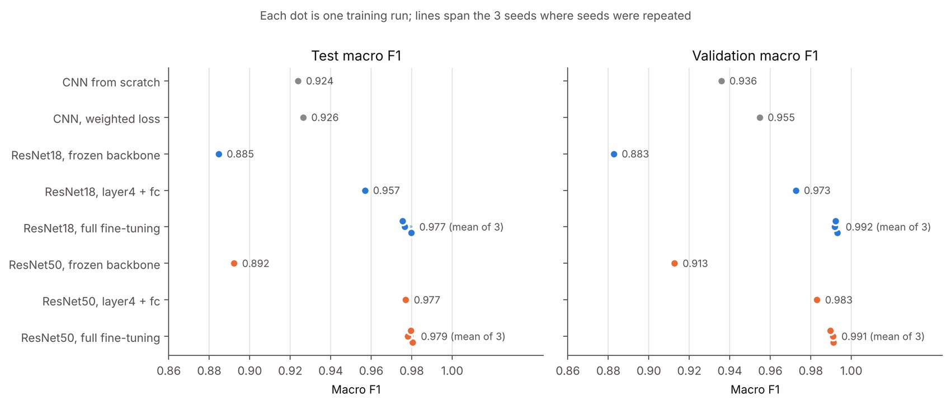
Figure 5.1. Macro-F1 by configuration on the validation and test splits (Stage 7).
The CNN from scratch reached a test accuracy of 0.9283. With a frozen backbone, the pretrained networks were clearly worse (ResNet18 0.8768, ResNet50 0.8879), so features learned on natural images were not sufficient without adaptation. Training the last stage already gave 0.9559 (ResNet18) and 0.9761 (ResNet50), and full fine-tuning gave the best results for both. The class-weighted baseline (B2) differed little from B1 (0.9301 against 0.9283), and it ran into the 40-epoch limit, so it may have been stopped before convergence.

5.2 Repeated runs and nondeterminism
The full fine-tuning configurations were trained with three seeds. ResNet18 reached a test accuracy of 0.9767 (standard deviation 0.0028) and a test macro-F1 of 0.9773 (0.0022). ResNet50 reached 0.9792 (0.0011) and 0.9794 (0.0013). The validation macro-F1 means are 0.9924 and 0.9906. The differences between the two networks are of the same size as the spread between seeds, so these data do not show that either architecture is better.
An earlier execution of the ResNet18 full fine-tuning configuration with seed 42 (run R18-C-orig, test accuracy 0.9706) differed from the later execution with the same seed and settings (R18-C, 0.9798). Both are reported. The cause was not isolated; nondeterministic GPU operations are a plausible reason, in line with the variance reported by Pham et al. [8]. The practical consequence is that differences of about one percentage point between single runs should not be interpreted.

5.3 One-factor hyperparameter experiments
Table 5.2. One-factor changes of the ResNet18 full fine-tuning setting (validation macro-F1; reference mean over three seeds 0.9924).
Run | Change | Val macro-F1 | Difference from reference | Adopted
T1-lr1e-5 | pretrained-layer learning rate 1e-5 | 0.9771 | -0.0153 | no
T2-lr1e-3 | pretrained-layer learning rate 1e-3 | 0.9827 | -0.0097 | no
T3-bs16 | batch size 16 | 0.9750 | -0.0174 | no
T4-adamw | AdamW, weight decay 0.01 | 0.9819 | -0.0105 | no
T5-dropout | dropout 0.3 before output layer | 0.9862 | -0.0062 | no
T6-weighted | class-weighted loss | 0.9853 | -0.0071 | no
T7-hflip | horizontal flip, probability 0.5 | 0.9947 | +0.0023 | no

Six of the seven changes gave a lower validation macro-F1 than the reference. Horizontal flipping gave a higher value (+0.0023), which is below the threshold of 0.0050, so it was not adopted and the original setting was kept. The test set was not consulted for this decision.
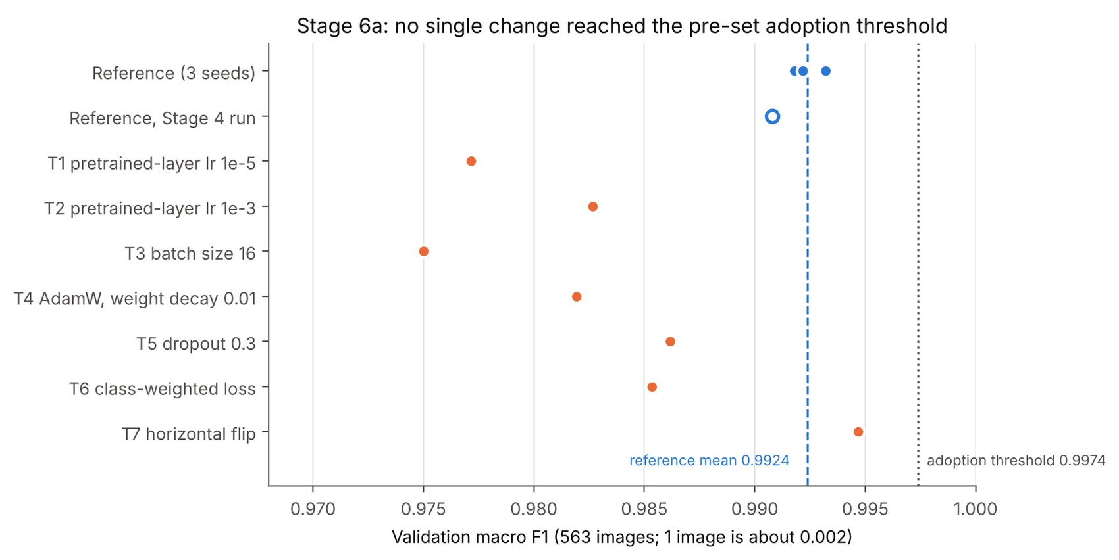
Figure 5.2. Validation macro-F1 of the one-factor experiments against the three reference seeds.

5.4 Final model
The selected model is ResNet18 with full fine-tuning, run R18-C (best validation macro-F1 of the three ResNet18 seeds, 0.9932). On the 544 test images it reached an accuracy of 0.9798, a macro-F1 of 0.9797 and a macro ROC-AUC of 0.9994, with 11 errors. Because it is also the best of its three seeds on the test set, it probably lies at the upper end of what the recipe gives; the three-seed mean of 0.9767 is the fairer expectation for a newly trained model.
Table 5.3. Per-class test results of the final model (recall with 95 percent Wilson interval).
Class | Test images | Precision | Sensitivity (recall) | Specificity | F1 | ROC-AUC
Glioma | 169 | 0.977 | 0.988 (0.958 to 0.997) | 0.989 | 0.982 | 0.9994
Meningioma | 155 | 0.987 | 0.955 (0.910 to 0.978) | 0.995 | 0.971 | 0.9989
No Tumor | 74 | 0.986 | 0.973 (0.907 to 0.993) | 0.998 | 0.980 | 0.9995
Pituitary | 146 | 0.973 | 1.000 (0.974 to 1.000) | 0.990 | 0.987 | 0.9998

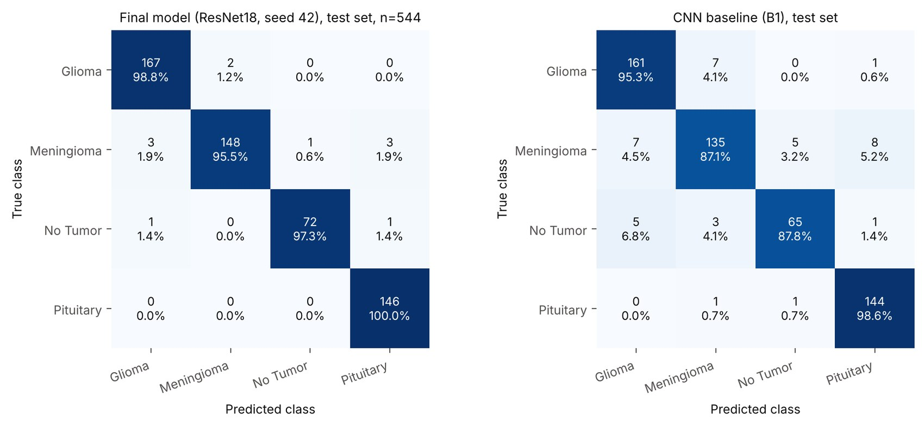
Figure 5.3. Confusion matrices on the test split: final model (right) and the CNN baseline (left).
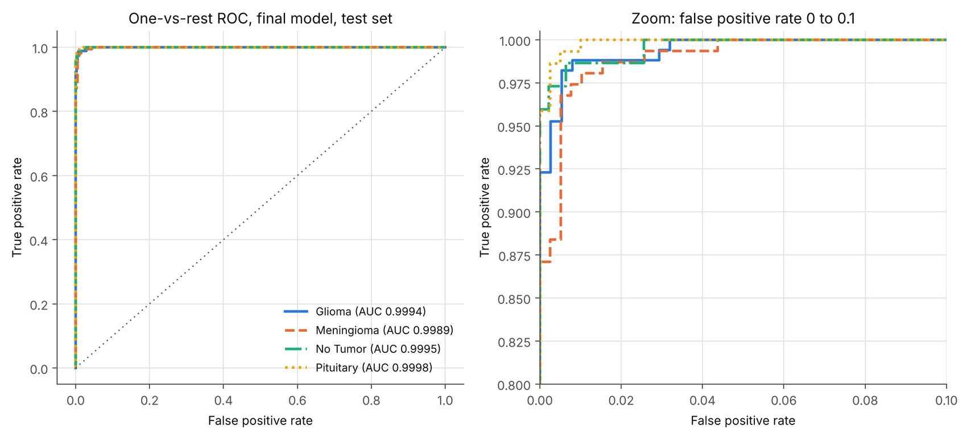
Figure 5.4. One-vs-rest ROC curves of the final model on the test split.
Computational cost. Mean training time per run was about 8.5 minutes for ResNet18 and 8.4 minutes for ResNet50 with full fine-tuning on the shared Colab GPU. The numbers are approximate because the GPU and its load were not controlled. ResNet18 has 11.18 million trainable parameters against 23.52 million for ResNet50.

6. Error Analysis and Validity Checks
Measured, exploratory. The number of errors is small (11 for the final model, 72 over six fine-tuned runs), so the group comparisons below describe the data and do not confirm causes.

6.1 Which images are wrong
The final model made 11 errors: Glioma to Meningioma 2, Meningioma to Glioma 3, Meningioma to No Tumor 1, Meningioma to Pituitary 3, No Tumor to Glioma 1, No Tumor to Pituitary 1. Seven of the 11 are Meningioma images, and Meningioma has the lowest recall (0.955). Over six fine-tuned runs, the most frequent confusion was Meningioma predicted as Pituitary (23 of 72 wrong predictions), followed by Glioma predicted as Meningioma (12) and Meningioma predicted as Glioma (11). Nine of the 11 errors of the final model were also wrong in the baseline CNN. Of the 544 test images, 25 were wrong in at least one of the six runs and 3 in all six, so a small set of difficult images accounts for much of the error.
The wrong predictions are not reliably flagged by low confidence: over six runs the mean top probability was 0.852 for wrong and 0.992 for correct predictions, and 38 of the 72 wrong predictions had a top probability above 0.9.
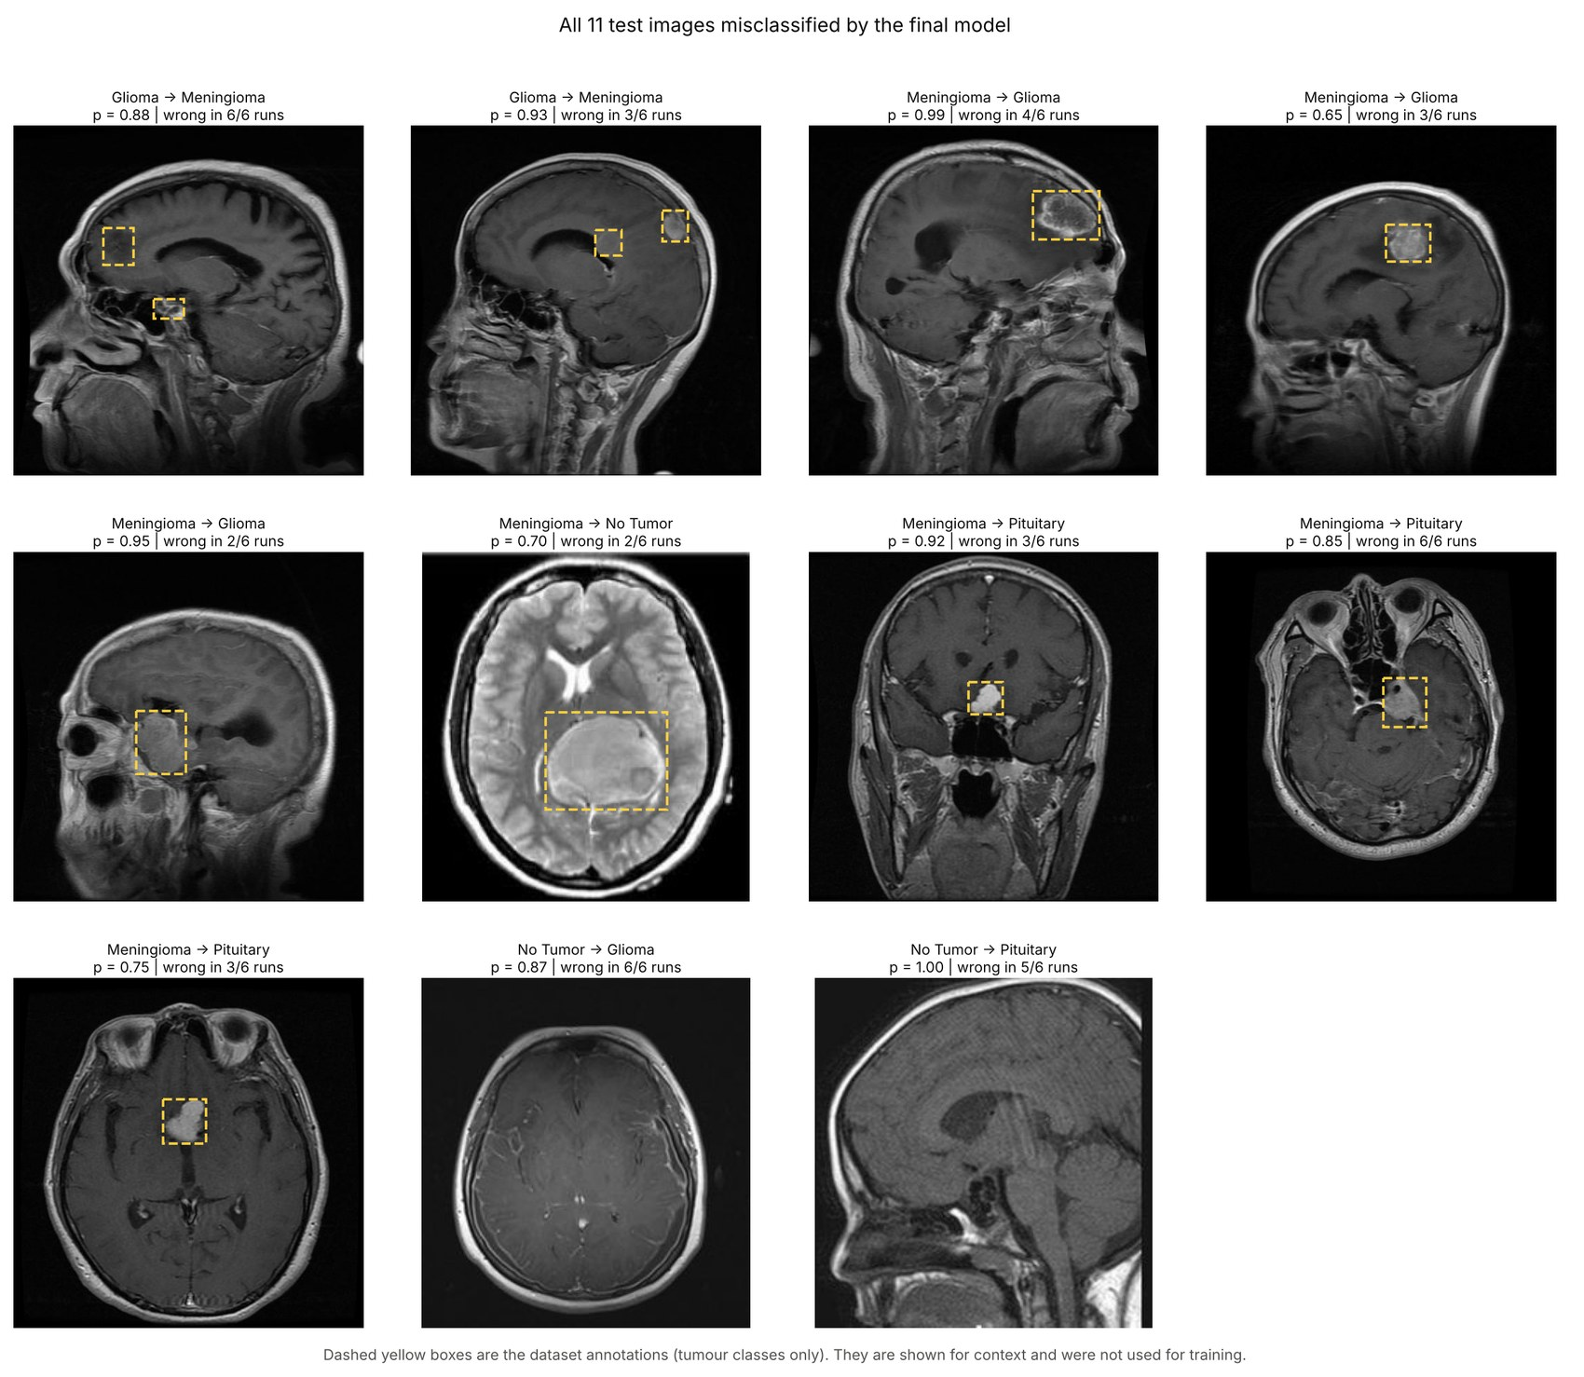
Figure 6.1. Test images misclassified by the final model (Stage 7).

6.2 Dependence on image properties
Table 6.1 lists the error rate pooled over the six fine-tuned runs by several properties. The filename pattern is used as a proxy for image source, because the dataset gives no source information. Images from the "m" family (Meningioma files named m, m1 to m3) and from the "image (n)" family show much higher error rates than images with the Tr- or Te- prefix. Fisher exact tests for image size, box size and group membership gave no sign of a difference (p = 0.27, 1.0 and 0.46); with so few errors these tests have little power.
Table 6.1. Error rate pooled over six fine-tuned runs (three ResNet18 and three ResNet50 seeds), by image property.
Property | Group | Images | Error rate | Images wrong in any run
true class | Glioma | 169 | 1.58% | 6
true class | Meningioma | 155 | 4.09% | 13
true class | No Tumor | 74 | 2.70% | 3
true class | Pituitary | 146 | 0.68% | 3
image size | 512x512 | 455 | 1.94% | 19
image size | other size | 89 | 3.56% | 6
filename pattern (source proxy) | Tr-/Te- prefixed | 335 | 0.55% | 6
filename pattern (source proxy) | gg (n) | 87 | 2.87% | 5
filename pattern (source proxy) | image (n) | 23 | 7.97% | 2
filename pattern (source proxy) | m (n) / m1-3 (n) | 48 | 10.42% | 10
filename pattern (source proxy) | p (n) | 51 | 1.63% | 2
box area (tumour classes) | smallest third | 158 | 2.00% | 6
box area (tumour classes) | middle third | 155 | 3.23% | 10
box area (tumour classes) | largest third | 157 | 1.17% | 6
contrast (pixel std) | lowest third | 182 | 1.47% | 7
contrast (pixel std) | middle third | 181 | 4.24% | 12
contrast (pixel std) | highest third | 181 | 0.92% | 6
near-duplicate group | singleton image | 498 | 2.04% | 22
near-duplicate group | member of a multi-image group | 46 | 3.99% | 3

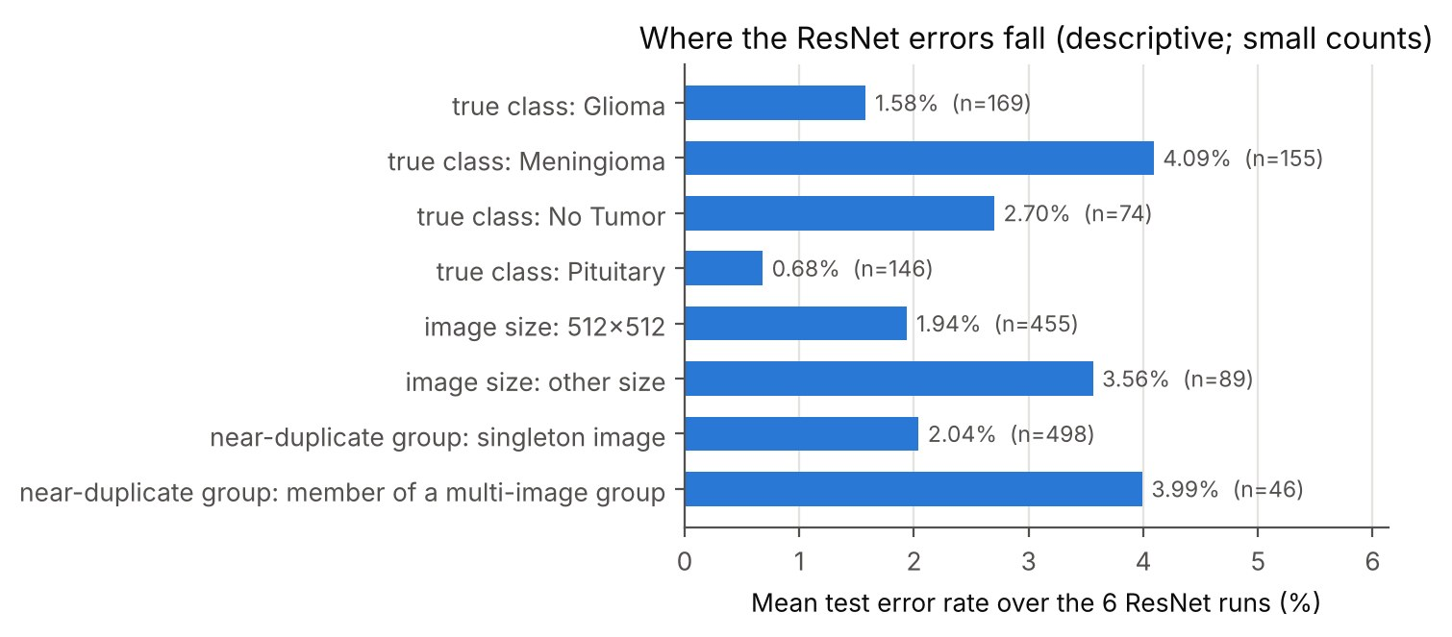
Figure 6.2. Pooled error rate by image property (Stage 7).

6.3 Similarity to the training set
For every validation and test image the highest correlation of a 64 by 64 grayscale thumbnail with any training image was computed. A one-nearest-neighbour classifier based only on this similarity reaches an accuracy of 0.8828 on the validation and 0.8879 on the test split, against about 0.30 for the majority class. The test images therefore have close relatives in the training set. Images with a lower similarity have a higher error rate (Table 6.2).
Table 6.2. Error rate of the six fine-tuned runs by similarity to the closest training image.
Highest correlation with a training image | Test images | Error rate, six runs pooled | Images wrong in any run
<0.80 | 91 | 6.23% | 12
0.80-0.90 | 153 | 3.05% | 9
0.90-0.95 | 212 | 0.55% | 3
>=0.95 | 88 | 0.57% | 1

The family effect remains when similarity is taken into account: among test images whose closest training image has a correlation below 0.90, the error rate is 9.4% for images with another filename pattern (n = 96) and 0.9% for Tr- or Te- images (n = 148). Among images with correlation of 0.90 or more the rates are 1.0% and 0.3%.
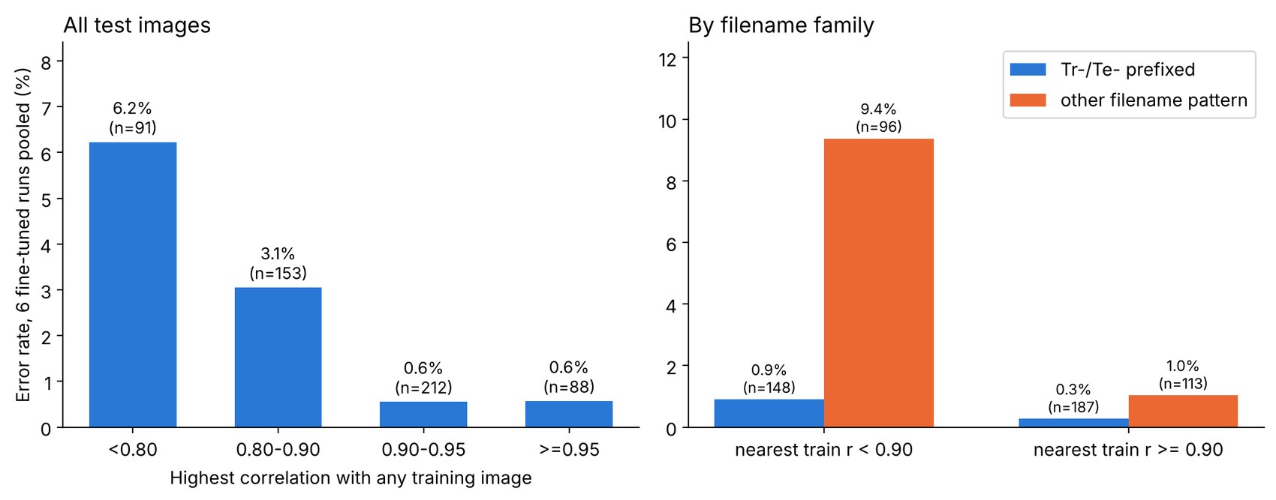
Figure 6.3. Error rate by similarity to the closest training image (left) and by filename family within similarity groups (right).

6.4 Interpretation
- Supported by the data: most test images have a close relative in the training set, and the models make most of their errors on images that are less similar to training images and that come from certain filename families.
- Not separable with these data: whether the low error on close relatives reflects real recognition of the same anatomy or same-patient leakage, and whether the filename effect reflects a different source, a different tumour appearance, or label noise. No patient identifier or source label exists to test this.
- Consequence: the reported test accuracy should be read as accuracy on a held-out part of the same collection and may be optimistic for new patients and new scanners. An external test set from another source is needed to settle this.

7. Grad-CAM Analysis
Implemented and measured. The analysis used the final checkpoint on the test split. Before any result was computed, the checkpoint reproduced the saved test predictions of run R18-C (label agreement 100.0%), and the hooked gradients matched the exact formula for this network (largest difference 2.3e-10 on weights of size 1.6e-3).
468 of 470 tumour test images had at least one box of the matching class and were evaluated. No Tumor images were excluded, because their boxes cover most of the brain.

7.1 Agreement with the annotated boxes
Table 7.1. Pointing game, overlap and energy enrichment for all evaluated tumour images (95 percent intervals in brackets; for permuted heatmaps, the range over five draws).
Method | Pointing game | Mean IoU (threshold 0.5) | Energy enrichment (median)
Grad-CAM, last stage (7 x 7) | 38.2% (34.0% to 42.7%) | 0.120 (0.111 to 0.130) | 3.08
Grad-CAM, previous stage (14 x 14) | 44.0% (39.6% to 48.5%) | 0.141 (0.126 to 0.157) | 2.70
Centre prior (fixed Gaussian) | 17.3% (14.1% to 21.0%) | 0.082 (0.077 to 0.088) | 2.39
Heatmap of another image, same class | 15.6% (14.5% to 16.7%) | 0.084 (0.081 to 0.085) | mean 2.49
Random point (expected) | 2.5% | not defined | not defined

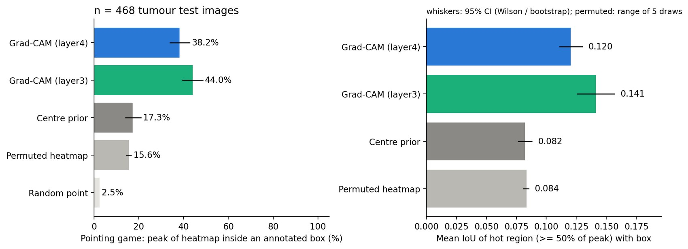
Figure 7.1. Pointing game and overlap with the annotated boxes against the baselines (Stage 8).
The last-stage Grad-CAM peak lies inside an annotated box for 38.2% of the images, which is higher than for the centre prior (17.3%) and for heatmaps of other images of the same class (15.6%). The heatmaps therefore carry information about the individual image beyond a central blob. Still, 61.8% of the peaks fall outside the box. The overlap is low (mean IoU 0.120 against 0.082 for the centre prior). The region above half of the maximum covers on average 21.7% of the image while the boxes cover 2.5%, which limits the overlap that any 7 by 7 map can reach.

7.2 Differences between classes and box sizes
Table 7.2. Pointing game by class.
Class | Images | Last stage | Previous stage | Centre prior | Other image, same class | Random point
Glioma | 169 | 34.3% | 24.3% | 18.3% | 16.7% | 2.6%
Meningioma | 153 | 55.6% | 71.9% | 8.5% | 10.2% | 3.6%
Pituitary | 146 | 24.7% | 37.7% | 25.3% | 20.1% | 1.3%

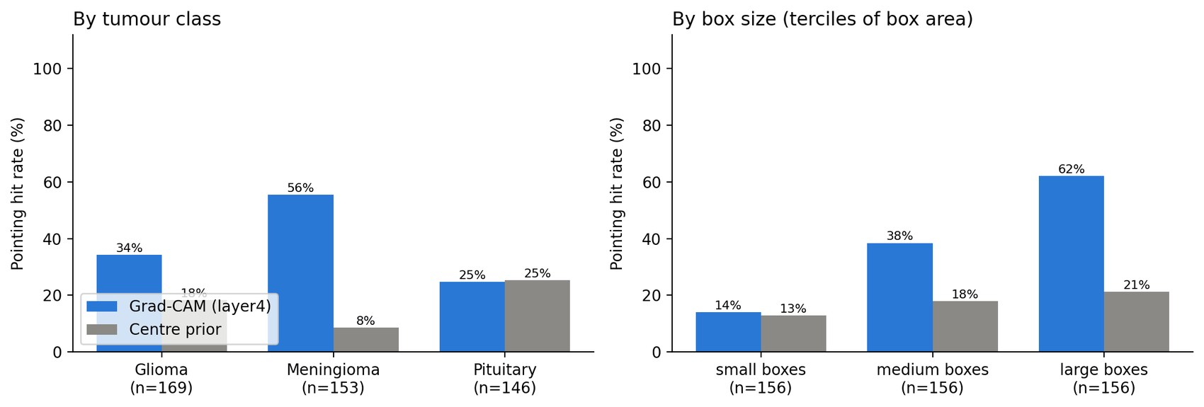
Figure 7.2. Pointing game by class (left) and by tercile of box area (right).
Meningioma has the highest hit rate of the three classes (55.6% for the last stage). For Pituitary the last-stage hit rate (24.7%) is not distinguishable from the centre prior (25.3%), which is expected because pituitary tumours lie near the centre of the image. The two layers disagree on which class benefits, so the ranking of layers is not stable. The hit rate rises with box size: 14.1% for the smallest third of boxes and 62.2% for the largest third, consistent with the coarse resolution of the map.
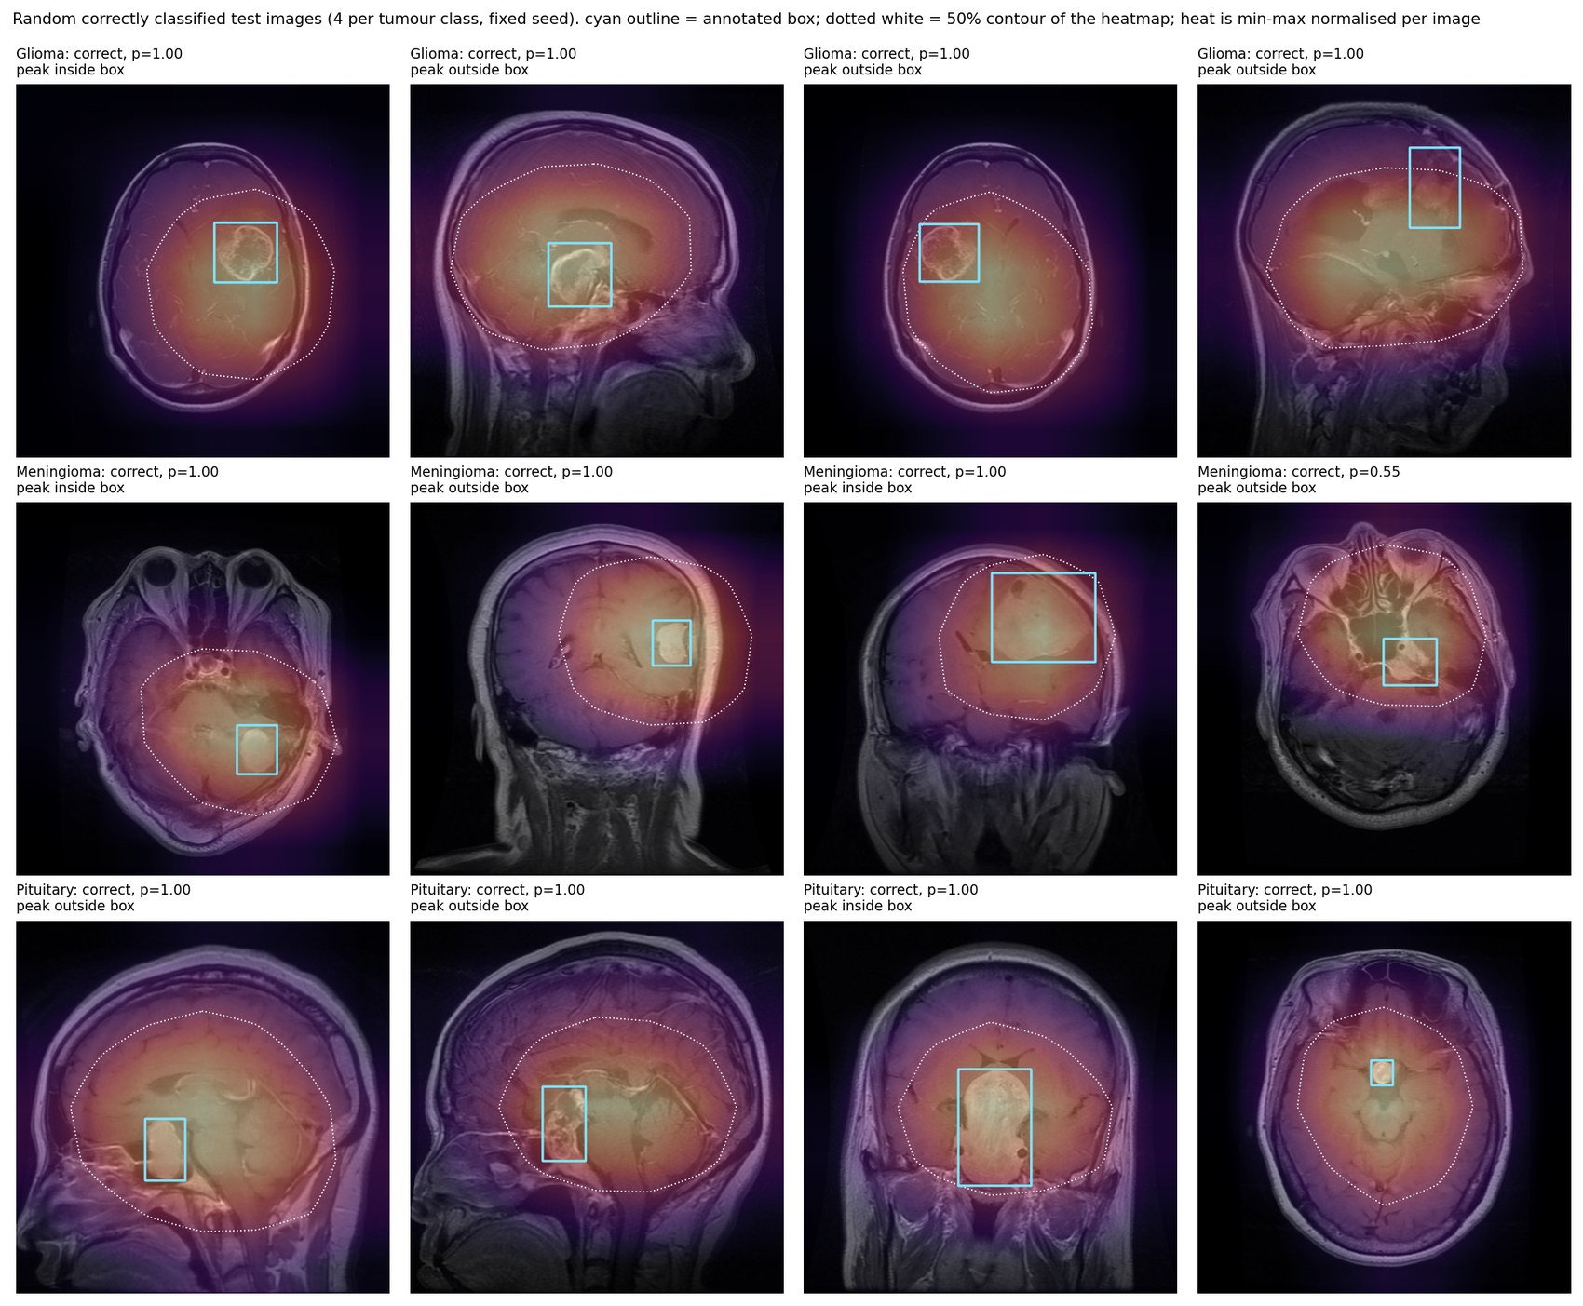
Figure 7.3. Random correctly classified test images, four per tumour class (fixed seed). Cyan: annotated box. Dotted white: 50 percent contour of the heatmap.

7.3 Sanity checks and misclassified images
When the output layer was randomised, the Spearman correlation between the trained and the randomised heatmap was 0.05 on average (median -0.05); when the last stage and output layer were randomised it was -0.01 (median -0.00). When all layers were randomised the correlation was -0.12, but 17 of 60 maps were entirely zero after the ReLU, so that row is not informative. The maps therefore change when the weights change, which is the minimum expected of a saliency method. In the examples, one case with only the output layer randomised still looked similar to the trained map, so the check supports but does not prove that the maps depend on the learned weights.
Among the 8 misclassified tumour images with a box, the last-stage peak was inside the box in 0 (95 percent interval 0.0% to 32.4%). The sample is too small to compare with correctly classified images.
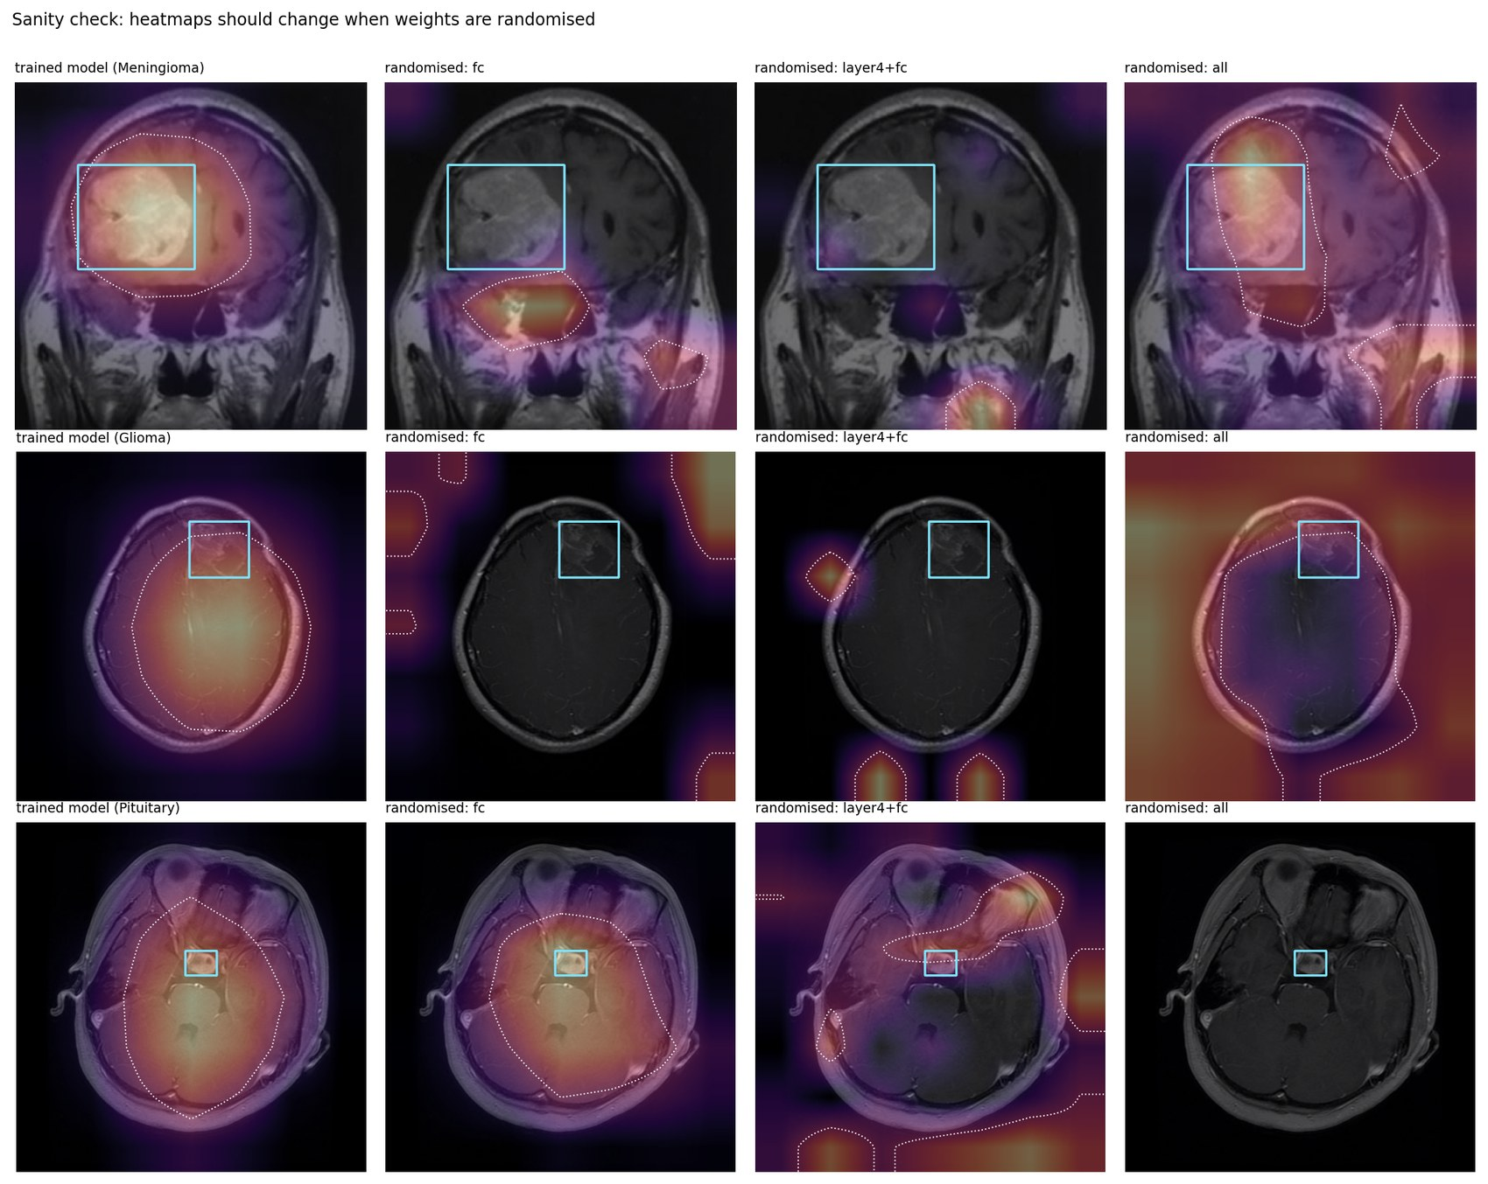
Figure 7.4. Weight randomisation check: trained model and three randomised variants for three test images.

7.4 Interpretation
- Supported: Grad-CAM peaks fall inside the annotated box more often than for the baselines, and the maps depend on the network weights.
- Not supported: that the network localises tumours or bases its decision on the tumour region. Most peaks lie outside the boxes, the maps are broad, and the boxes are an imperfect reference (Section 3.2). No deletion or insertion test was run, so no causal reading of the maps is justified.
- Future work: methods with higher spatial resolution or perturbation-based maps, deletion and insertion tests, and evaluation on a dataset with tumour masks.

8. Discussion and Limitations

8.1 What the evidence supports
- Pretrained networks fine-tuned end to end classify the four classes better than a small CNN trained from scratch (test accuracy about 0.977 to 0.979 against 0.928) on this split.
- ResNet18 and ResNet50 cannot be separated with three seeds each. ResNet18 was chosen for its smaller size, which is a parsimony choice and not a finding of superiority.
- None of the one-factor hyperparameter changes improved on the reference under the pre-set rule.

8.2 Limitations
- Possible leakage and source effects. No patient identifiers exist. Test images have close relatives in the training set (nearest-neighbour accuracy 0.888), and error rates differ by filename family. The test accuracy may be optimistic for new patients and scanners.
- Single dataset and single test split. No external validation was possible. Intervals describe sampling variation within this test set only.
- Few runs. Three seeds per main configuration and one run for most other configurations. Same-seed reruns differed, so small differences are not interpretable.
- Label and annotation quality. Class identifiers in the box files sometimes disagree with the folders, and No Tumor boxes mark the brain.
- Two-dimensional slices. The model sees one slice at a time and has no information on plane, sequence, age or clinical history.
- Explanations. Grad-CAM agreement with the boxes is weak and cannot be read as localisation.
- Tuning budget. Hyperparameters were varied one factor at a time with a limited budget, not searched jointly.

8.3 Ethical and clinical note
The model was trained on public images of unknown origin and has not been validated for clinical use. It must not be used to diagnose or to support treatment decisions. Any real use would require data from the intended setting, patient-level validation, calibration of the output probabilities and review by clinicians.

9. Conclusion and Future Work
A four-class brain MRI classifier was built on a public dataset after a data audit that removed 1336 duplicate files and showed that the supplied validation folder leaks into the training folder. A leakage-checked split, controlled comparisons and repeated runs led to ResNet18 with full fine-tuning as the final model (test accuracy 0.9798 for the selected checkpoint and 0.9767 on average over three seeds). The error analysis and the Grad-CAM comparison show that the result should be interpreted with care: errors concentrate on Meningioma and on images that are less similar to the training images, and heatmaps agree with the annotated boxes only weakly.
Table 9.1. Summary of what was done and what it supports.
Category | Content
Implemented | Data audit; leakage-checked group-aware split; baseline CNN; ResNet18 and ResNet50 with three strategies; seven one-factor experiments; seed repeats; final evaluation; error analysis; Grad-CAM with baselines and sanity checks; inference script and model card.
Measured | Accuracy, macro-F1 and ROC-AUC for 20 runs; per-class sensitivity and specificity with intervals; error rates by image property and by similarity to training images; Grad-CAM pointing game, IoU and enrichment with baselines.
Proposed | ResNet18 with full fine-tuning (run R18-C) as the final model, chosen by validation results and parsimony.
Limitations | No patient identifiers; possible same-patient leakage and source effects; one dataset and one test split; few seeds; weak agreement of heatmaps with boxes; not validated for clinical use.
Future work | External test set from another source; patient-level split with identifiers; more seeds and calibration of probabilities; higher-resolution or perturbation-based explanations with deletion and insertion tests; three-dimensional input.

References
[1] He K, Zhang X, Ren S, Sun J. Deep residual learning for image recognition. In: Proceedings of the IEEE Conference on Computer Vision and Pattern Recognition (CVPR); 2016. p. 770-778.
[2] Selvaraju RR, Cogswell M, Das A, Vedantam R, Parikh D, Batra D. Grad-CAM: visual explanations from deep networks via gradient-based localization. International Journal of Computer Vision. 2020;128(2):336-359. doi:10.1007/s11263-019-01228-7.
[3] Adebayo J, Gilmer J, Muelly M, Goodfellow I, Hardt M, Kim B. Sanity checks for saliency maps. In: Advances in Neural Information Processing Systems 31 (NeurIPS 2018); 2018.
[4] Zhang J, Lin Z, Brandt J, Shen X, Sclaroff S. Top-down neural attention by excitation backprop. In: European Conference on Computer Vision (ECCV); 2016. arXiv:1608.00507.
[5] Cheng J, Huang W, Cao S, Yang R, Yang W, Yun Z, Wang Z, Feng Q. Enhanced performance of brain tumor classification via tumor region augmentation and partition. PLoS ONE. 2015;10(10):e0140381. doi:10.1371/journal.pone.0140381.
[6] Yagis E, Atnafu SW, Garcia Seco de Herrera A, Marzi C, Scheda R, Giannelli M, Tessa C, Citi L, Diciotti S. Effect of data leakage in brain MRI classification using 2D convolutional neural networks. Scientific Reports. 2021;11. doi:10.1038/s41598-021-01681-w.
[7] Wen J, Thibeau-Sutre E, Diaz-Melo M, Samper-Gonzalez J, Routier A, Bottani S, Dormont D, Durrleman S, Burgos N, Colliot O. Convolutional neural networks for classification of Alzheimer's disease: overview and reproducible evaluation. doi:10.1016/j.media.2020.101694. [Add journal volume and article number from the publisher page.]
[8] Pham HV, Qian S, Wang J, Lutellier T, Rosenthal J, Tan L, Yu Y, Nagappan N. Problems and opportunities in training deep learning software systems: an analysis of variance. In: 35th IEEE/ACM International Conference on Automated Software Engineering (ASE); 2020. doi:10.1145/3324884.3416545.
[9] Yosinski J, Clune J, Bengio Y, Lipson H. How transferable are features in deep neural networks? In: Advances in Neural Information Processing Systems 27 (NeurIPS 2014); 2014.
[10] Kingma DP, Ba J. Adam: a method for stochastic optimization. In: International Conference on Learning Representations (ICLR); 2015. arXiv:1412.6980.
Dataset. Sorour A. MRI for Brain Tumor with Bounding Boxes. Kaggle dataset ahmedsorour1/mri-for-brain-tumor-with-bounding-boxes (accessed for this project).

Appendix A. All Training Runs
Validation and test results of all 20 runs (seed 42 unless the identifier shows another seed). R18-C-orig is the first execution of the ResNet18 full fine-tuning setting and R18-C the later one.
Run | Model and strategy | Epochs run | Best epoch | Val accuracy | Val macro-F1 | Test accuracy | Test macro-F1
B1 | BaselineCNN, none (trained from scratch) | 33 | 25 | 0.9343 | 0.9358 | 0.9283 | 0.9238
B2 | BaselineCNN, none (trained from scratch) | 40 | 39 | 0.9538 | 0.9547 | 0.9301 | 0.9264
R18-A | resnet18, frozen backbone, new fc | 28 | 22 | 0.8757 | 0.8826 | 0.8768 | 0.8846
R18-B | resnet18, layer4 + fc | 14 | 8 | 0.9698 | 0.9726 | 0.9559 | 0.9569
R18-C-orig | resnet18, full fine-tuning | 21 | 15 | 0.9893 | 0.9908 | 0.9706 | 0.9723
R18-C | resnet18, full fine-tuning | 20 | 14 | 0.9929 | 0.9932 | 0.9798 | 0.9797
R18-C-s43 | resnet18, full fine-tuning | 22 | 16 | 0.9911 | 0.9918 | 0.9761 | 0.9766
R18-C-s44 | resnet18, full fine-tuning | 20 | 14 | 0.9911 | 0.9922 | 0.9743 | 0.9756
T1-lr1e-5 | resnet18, full fine-tuning | 23 | 17 | 0.9751 | 0.9771 | 0.9632 | 0.9634
T2-lr1e-3 | resnet18, full fine-tuning | 17 | 11 | 0.9822 | 0.9827 | 0.9632 | 0.9631
T3-bs16 | resnet18, full fine-tuning | 10 | 4 | 0.9734 | 0.9750 | 0.9522 | 0.9541
T4-adamw | resnet18, full fine-tuning | 15 | 9 | 0.9822 | 0.9819 | 0.9669 | 0.9675
T5-dropout | resnet18, full fine-tuning, dropout 0.3 | 12 | 6 | 0.9858 | 0.9862 | 0.9669 | 0.9675
T6-weighted | resnet18, full fine-tuning | 12 | 6 | 0.9840 | 0.9853 | 0.9688 | 0.9700
T7-hflip | resnet18, full fine-tuning | 15 | 9 | 0.9947 | 0.9947 | 0.9724 | 0.9732
R50-A | resnet50, frozen backbone, new fc | 29 | 23 | 0.9059 | 0.9127 | 0.8879 | 0.8922
R50-B | resnet50, layer4 + fc | 16 | 10 | 0.9822 | 0.9830 | 0.9761 | 0.9770
R50-C | resnet50, full fine-tuning | 23 | 17 | 0.9911 | 0.9911 | 0.9798 | 0.9805
F-R50-s43 | resnet50, full fine-tuning | 15 | 9 | 0.9911 | 0.9909 | 0.9779 | 0.9779
F-R50-s44 | resnet50, full fine-tuning | 19 | 13 | 0.9893 | 0.9897 | 0.9798 | 0.9796

Appendix B. Reproducibility
- Environment: Google Colab, Tesla T4 GPU, PyTorch 2.11.0+cu130, Python 3.13.15. Seeds 42, 43 and 44.
- Repository: https://github.com/kdivyasrija/brain-tumor-mri-classification. It contains the split table, all predictions with class probabilities, training histories, the experiment table, the notebooks of Stages 1 to 9, the Grad-CAM code, the inference script and the model card.
- Every number in this report was generated from those result files by a script; the Stage 7 evaluation recomputed all metrics from saved probabilities and asserted agreement with the logged values.
- The final checkpoint is verified by a checksum and by reproducing all 544 saved test predictions with the packaged inference script (no label disagreement).

