Groq API — Quick Start Guide
SOP | Internal Reference | Free Tier Setup & Usage

1. Purpose & Intent
This document is intended as an informal, internal quick-start reference for team members who want to set up and experiment with the Groq API during a Proof of Concept (POC). It walks through the account registration, API key creation, a minimal working code example, and the free-tier limitations you should be aware of.
The goal is to lower the barrier to entry — anyone on the team should be able to go from zero to a working chat call in under 15 minutes.

2. What is Groq?
Groq is an AI inference platform built around its custom Language Processing Unit (LPU), designed for very fast, low-latency LLM inference. Unlike GPU-based providers, Groq's hardware is optimized for sequential token generation, which translates to noticeably faster response times for chat and completion tasks.
Groq hosts several popular open-source models (Llama 3, Mixtral, Gemma, etc.) and exposes them through an OpenAI-compatible REST API, making it easy to integrate into existing projects or swap in as an alternative to other providers.

3. Registration & API Key Setup
Registration is free and straightforward. Follow the steps below.

Step 1 — Create an account
Go to console.groq.com. Sign up using your email address or your GitHub account.
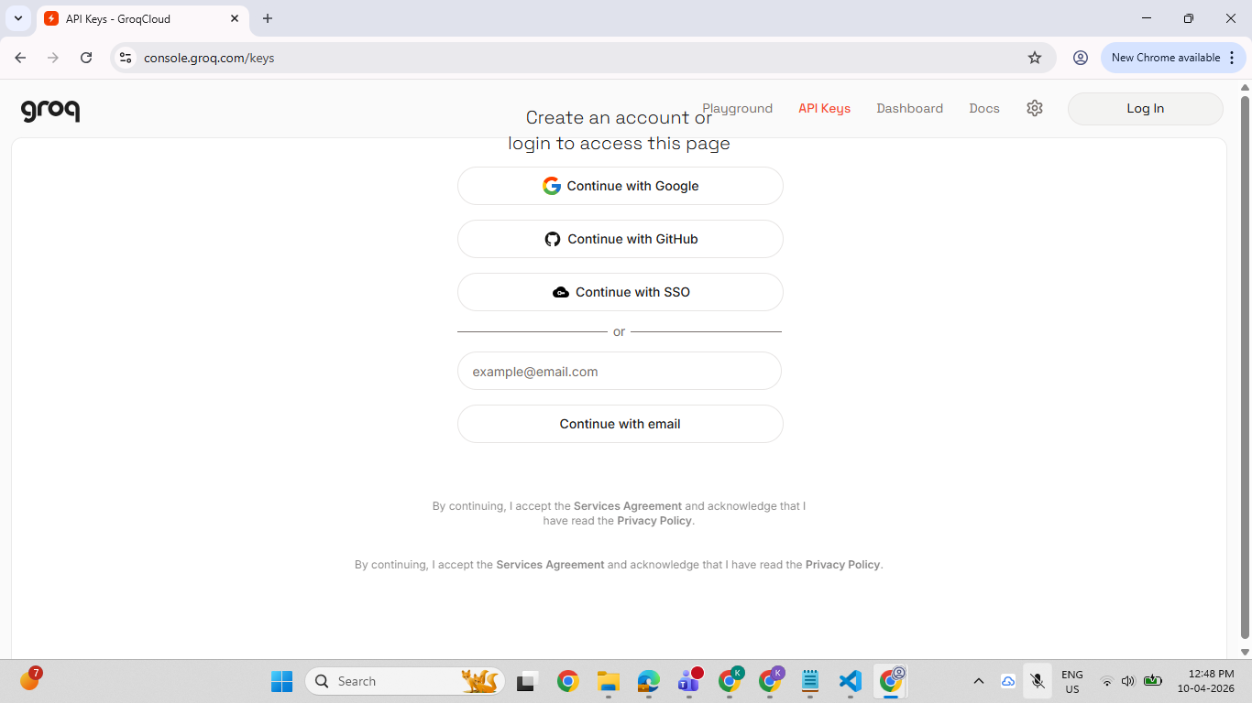

Step 2 — Navigate to API Keys
Once logged in, click on "API Keys" in the left-hand sidebar, then click "Create API Key".
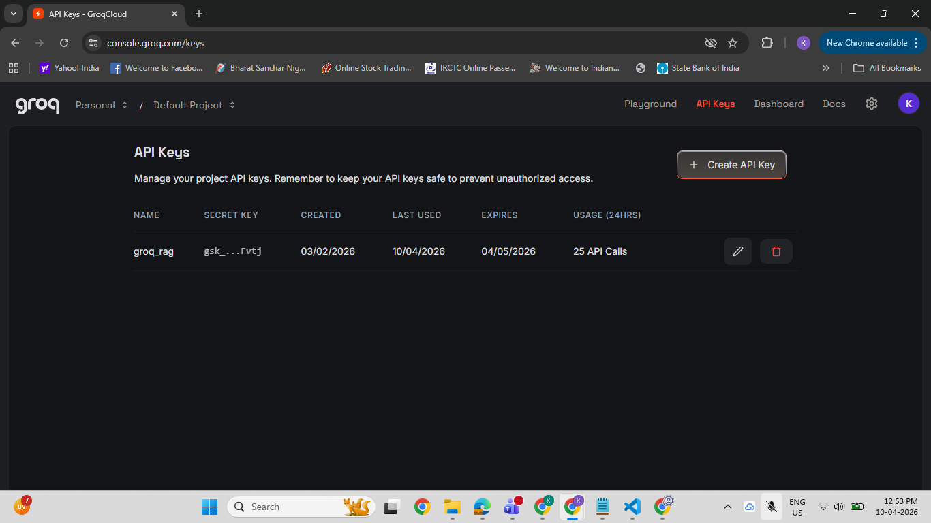

Step 3 — Name & configure the key
Give your key a descriptive name (e.g., poc-test) and optionally set an expiration date. For a short-term POC, leaving the expiration open is fine — just remember to revoke it afterwards.
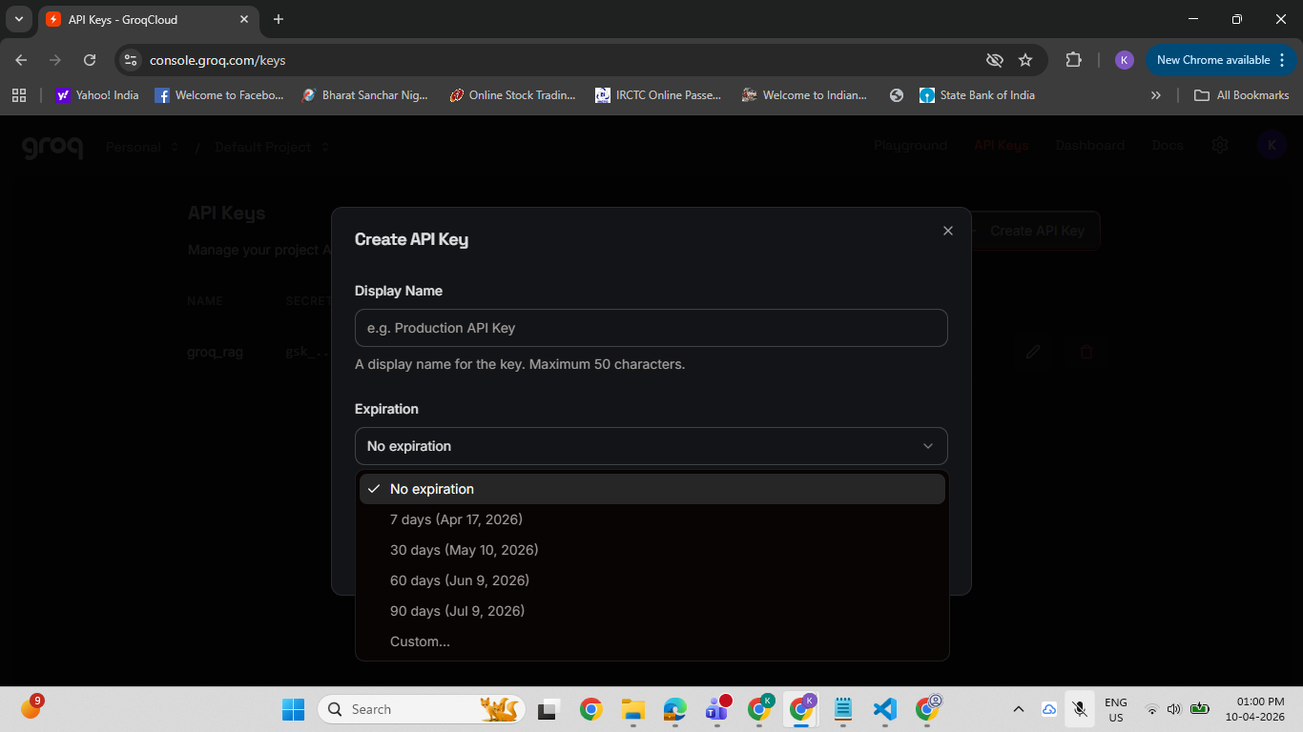
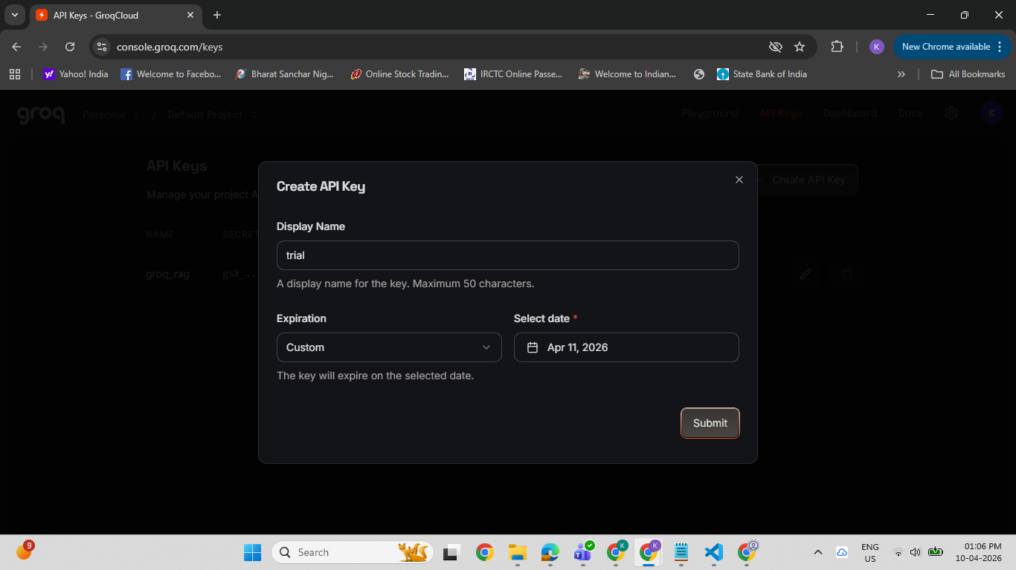

Step 4 — Copy and store the key
Copy the key immediately — it is only shown once. Store it in your project's .env file (see Section 4 for usage). Never commit this value to source control.
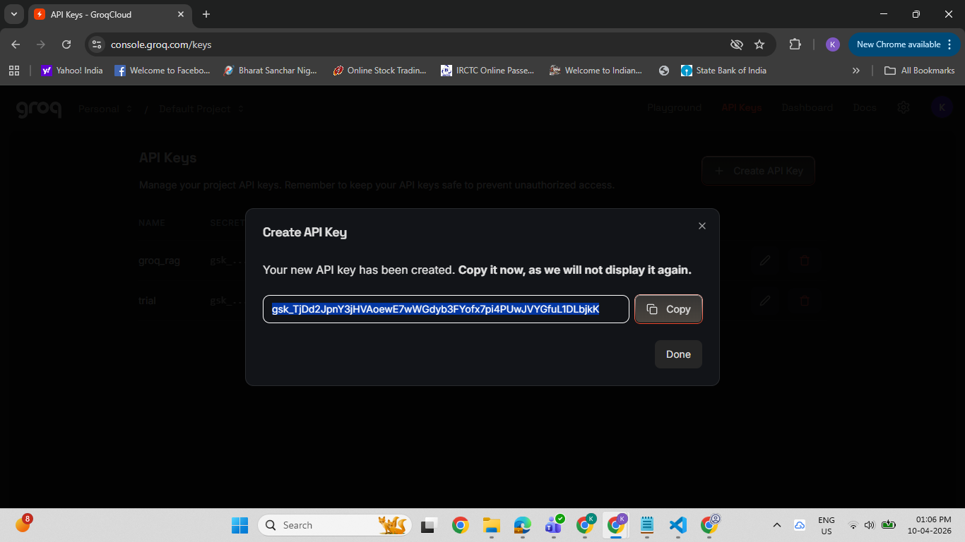

Step 5 — Review available models
On the Models page you can see all models available on the free tier along with their context window sizes and per-token limits. Choose the model that fits your use case.
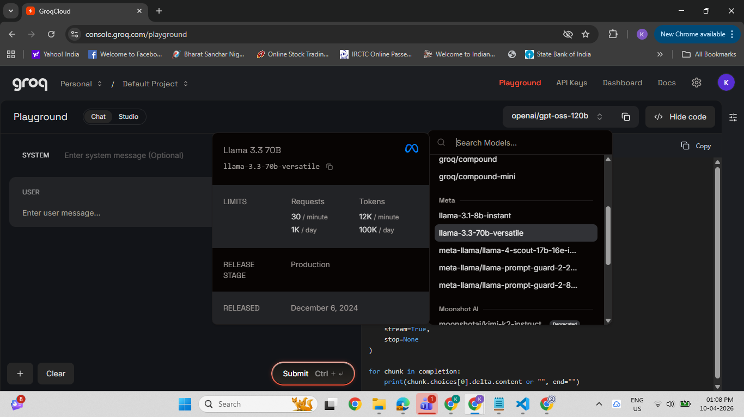

4. Simple Chat Example (Python + .env)
The example below shows the minimal code needed to send a message to the Groq API using Python. The API key is loaded from a .env file so it never appears in your source code.

4.1 Install dependencies
pip install groq python-dotenv

4.2 Create your .env file
Create a file named .env in your project root (same level as your script):
# .env
GROQ_API_KEY=gsk_xxxxxxxxxxxxxxxxxxxxxxxxxxxxxxxxxxxx
Add .env to your .gitignore so the key is never pushed to a repository.
# .gitignore
.env

4.3 Python chat script
# chat_example.py

import os
from dotenv import load_dotenv
from groq import Groq

# Load API key from .env file
load_dotenv()

client = Groq(api_key=os.environ.get("GROQ_API_KEY"))

chat_completion = client.chat.completions.create(
messages=[
{
"role": "user",
"content": "Explain what Groq is in two sentences.",
}
],
model="llama3-8b-8192", # fast, free-tier model
)

print(chat_completion.choices[0].message.content)
Run the script with:
python chat_example.py
The Groq SDK's interface is intentionally identical to the OpenAI Python SDK. If your team already uses OpenAI, the migration to Groq (or switching between the two) requires changing only the client import and the base URL — no other code changes are needed.

5. Free Tier Limitations
The free tier is generous for development and POC work but does have hard caps. These are enforced at the API level; once a limit is hit, requests return a 429 Too Many Requests error until the window resets.

5.1 Rate limits (as of the time of writing)
Limits are applied across three dimensions simultaneously:
- Requests per Minute (RPM) — the number of API calls you can make in any rolling 60-second window.
- Tokens per Minute (TPM) — the total input + output tokens consumed within 60 seconds.
- Tokens per Day (TPD) — a daily cap on total token consumption. This resets every 24 hours (UTC).
Each model has its own specific limits. Larger or more capable models (e.g., Llama 3 70B) have lower limits than smaller ones (e.g., Llama 3 8B). Check the Groq console "Limits" page for the most current values, as these are updated periodically.

5.2 No rate-limit issues observed during POC
During our internal POC, we did not encounter any rate-limiting errors. The free tier was more than sufficient for iterative testing and exploratory development. This is consistent with Groq's positioning — they want developers to evaluate the platform without friction.
That said, if you are planning a load test or batch-processing scenario, you should account for the TPD cap, as high-volume runs can exhaust the daily token budget faster than expected.

5.3 Other constraints
- No SLA guarantee on the free tier — availability is best-effort.
- No fine-tuning support on the free tier.
- Context window is model-dependent; most free-tier models support 8 K to 128 K tokens.
- API keys created on the free tier cannot be scoped to specific models or IPs; all restrictions are account-wide.
- Paid tiers unlock higher limits, dedicated capacity, and priority support.

6. Remarks
This document is shared internally to help team members get up and running quickly without needing to dig through official documentation from scratch. It is not a replacement for the official Groq docs (console.groq.com/docs) — those should be consulted for advanced configuration, streaming, tool use, and production considerations.
Key takeaways:
- Setup is quick — account creation to first API call takes under 15 minutes.
- The free tier is well-suited for POC and exploratory work; no billing information is required to get started.
- The OpenAI-compatible interface makes it easy to evaluate Groq as a drop-in replacement or complement to existing LLM integrations.
- Always store API keys in environment variables, never in source code.

