Chunking Strategies:

Trying out various chunking strategies on the text extracted using a different Lang Chain Loaders approach.

For developing initial understanding referring the>Text Splitters in LangChain | Generative AI using LangChain | Video 11 | CampusX

Visualization of chunking -> https://chunkviz.up.railway.app/

1. Length-based Chunking
Splits text based on fixed character or token length
Simple and fast but may break semantic meaning
2. Text Structure-based Chunking
Splits based on paragraphs, sentences, or separators
Helps preserve natural text boundaries

3. Document Structure-based Chunking
Uses document elements like headings, sections, pages, or slides
Useful for PDFs, DOCX, and structured documents
4. Semantic Meaning-based Chunking (with embedding)
Splits text based on semantic similarity
Preserves contextual meaning but is computationally more expensive
Exploring Complex PDF Again to extract useful information:
Uses PyMuPDF (fast) or pdfplumber (layout-preserving
Uses pdfplumber to detect and extract tables accurately
Uses Docling,Pymupdf and rapidOCR to enhance the result

Exploring multiple document Loader together to enhance the result
Document Loader | Remarks
Used PyMuPDF and pdfplumb together one for text-heavy pdfs and other for complex layouts | Working efficiently with text and also fetching all the contents from the table but still failing to extract in tabular format
Used docling + pymupdf + rapidocr together to enhance the results | Working good with text but  Facing the problem to extract tabular layout (Fetching the tables data in textual format successfully)
Docling To detect the layout | Working better with tables and text both.Also working great with extended tables

PyMuPDF + pdfplumb :
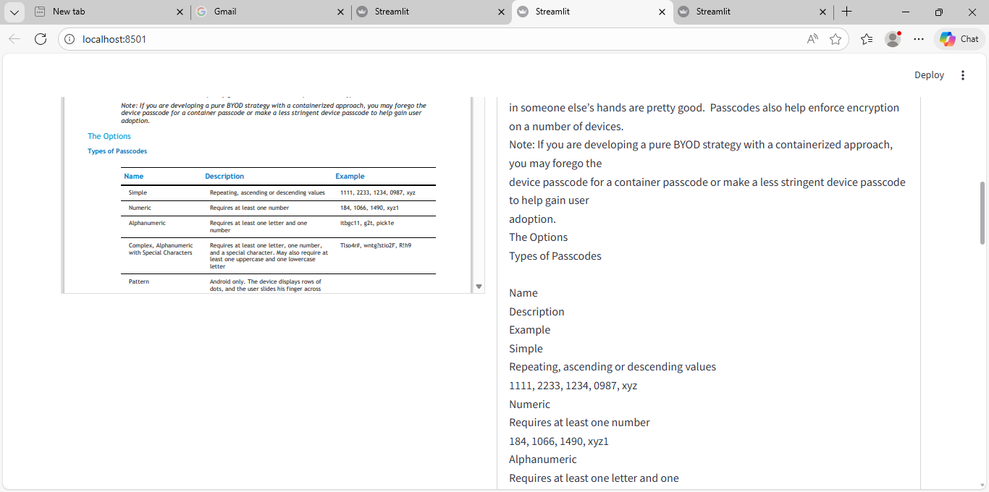

docling + pymupdf + rapidocr :

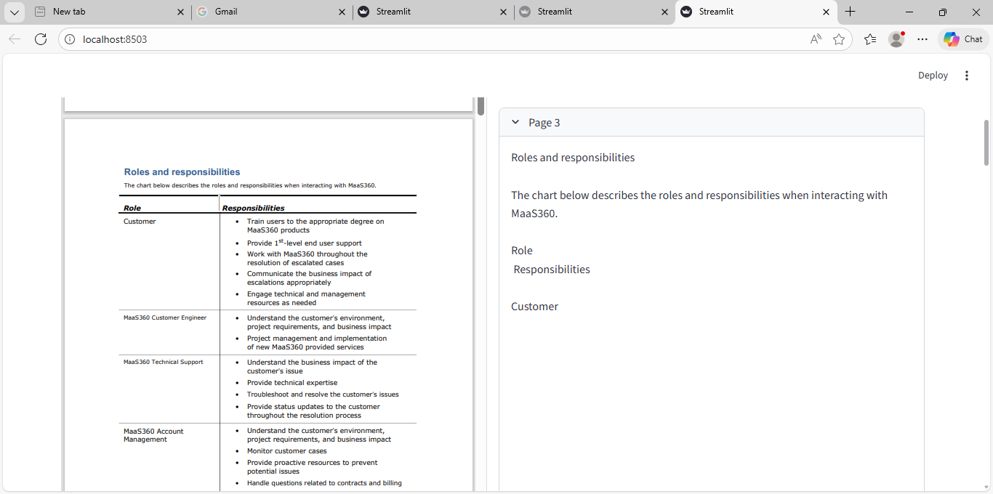
Using Docling:
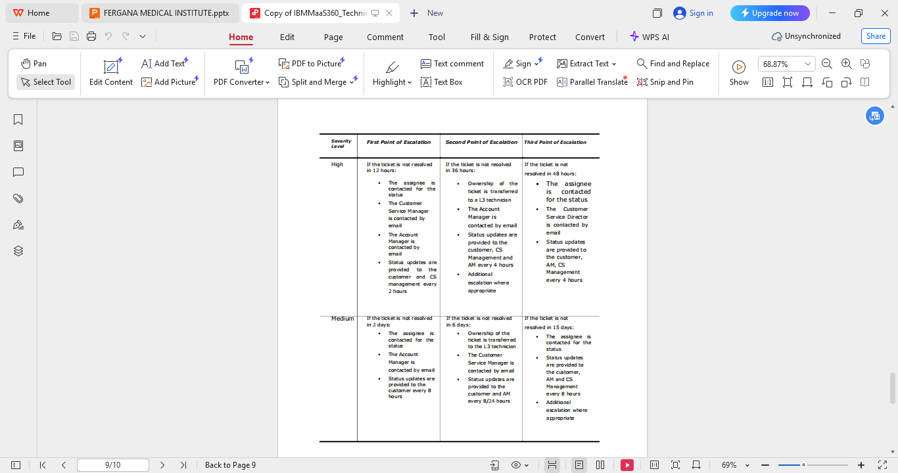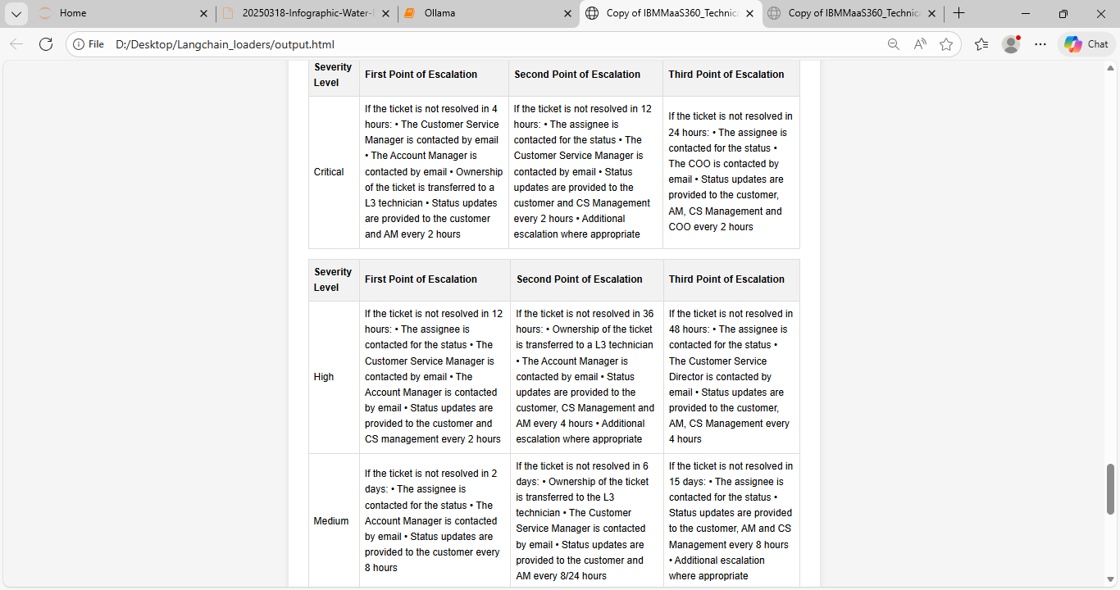

Ollama Vision Model --> llava:latest
Implemented image caption generation using the LLaVA model to enable semantic understanding of visual content within the RAG pipeline.
Image -->
Caption generated by Model:

The image displays a vibrant and colorful diagram that appears to be an infographic or map of various companies, tools, and technologies related to the field of artificial intelligence (AI). The background is a bright, gradient blue that transitions from light at the top to darker as it goes downwards. This gradient creates a sense of depth, adding to the overall visual appeal of the diagram.

At the center of the image, there's an illustration of a sun with its rays extending outward, symbolizing the radiance or influence of AI technologies. This central image is surrounded by several logos and names of companies and tools associated with AI. Each logo is distinct and represents a different entity within this domain.

From left to right, the visible logos include "Python", which is a popular programming language used in many AI applications; "SciPy", a library for scientific computing in Python; "NumPy", a library for numerical computations in Python; "SciPy", again for scientific computing, but with a focus on specific domains; "SciPy", this time for signal and image processing; "Matplotlib", another library for creating static plots and interactive visualizations in Python; "IPy", which is an interactive computing environment that includes several other libraries such as Jupyter Notebook, JupyterLab, and others; "Numpy", the Numeric Python Library; "SciPy", a scientific library for Python again; "SciPy", this time for signal and image processing; "IPy", an interactive computing environment with various extensions like Jupyter Notebooks and JupyterLab; "NumPy", a library for numerical computations in Python.Each logo is accompanied by text that provides further context about the company or tool it represents, although some of this text is partially obscured. For example, "NumPy" is labeled as "Numeric Python Library". The logos are arranged in such a way that they overlap and intersect with each other, creating a complex network that visually represents the interconnectedness of these AI technologies.

The style of the image is informative and appears to be designed for educational or illustrative purposes, providing an overview of important tools and companies within the realm of artificial intelligence. The use of bright colors and clear labels makes it easy for viewers to understand the content at a glance.

Exploring MMR Retrieval :
MMR (Maximal Marginal Relevance) is a retrieval technique used in RAG systems to return results that are both relevant to the query and diverse from each other. It helps avoid retrieving multiple chunks that say the same thing repeatedly.
In simple terms:
MMR = Relevance to query + Diversity among results
Mathematical Idea Behind MMR
MMR selects documents by maximizing:
MMR = λ * Similarity (Query, Document)
- (1-λ) * Similarity (Document, SelectedDocs)
Where:
Term | Meaning
Similarity (Query, Document) | how relevant document is
Similarity (Document, SelectedDocs) | how similar it is to already selected docs
λ (lambda) | balance between relevance and diversity

Interpretation
If λ = 1
➡ only relevance (normal similarity search)
If λ = 0
➡ only diversity (not useful)
Typical values:
λ = 0.5 – 0.7

Different Types of Retrieval Techniques can be used in RAG:

Retrieval Method | LangChain Support | Type
Similarity Search | ✅ | Embedding
MMR | ✅ | Diversity
Similarity Threshold | ✅ | Filtered
BM25 | ✅ | Keyword
MultiQuery Retriever | ✅ | Query Expansion
Contextual Compression | ✅ | Chunk filtering
Self-Query Retriever | ✅ | Metadata search
Parent Document Retriever | ✅ | Hierarchical
Ensemble Retriever | ✅ | Hybrid
Time Weighted Retriever | ✅ | Recency
Hybrid Retrieval | ⚠ Partial | BM25 + Embedding
Cross Encoder Reranking | ❌ Custom | Deep ranking
Graph Retrieval | ❌ Custom | Knowledge graph
Late Interaction | ❌ Custom | Token level

AI Applications with LangChain :

In LangChain, AI Applications are built by moving beyond a single prompt to a structured system that can reason, remember, and use external tools.
1. Prompt Engineering & Management
Prompt engineering in LangChain is the process of optimizing the "input contract" between you and the LLM.
- Prompt Templates: Instead of hardcoding text, you create reusable templates with placeholders (e.g., Translate {text} to {language}). This allows you to dynamically inject user data into a fixed instruction set.
- Output Parsers: These ensure the LLM returns data in a specific format, such as JSON or a clean string, making it easier for your software to use the response.
2. Multi-step Chains
Chains are the "glue" of LangChain, allowing you to link multiple components into a single workflow.
- Sequential Chains: These link steps linearly where the output of Step 1 (e.g., "Summarize this article") becomes the input for Step 2 (e.g., "Translate this summary").
- LCEL (LangChain Expression Language): A modern way to build these chains using the | (pipe) operator, making the code modular and easy to read (e.g., template | llm | parser).
3. Tools & Agents
While chains follow a fixed path, Agents use an LLM to decide which path to take.
- Tools: These are functions that an agent can call, such as a Google Search, a calculator, or a database query.
- Agents: They act as reasoning engines. Given a goal, an agent analyzes the user's input, chooses the right tool, executes it, and repeats until the task is finished.
4. Memory Management
LLMs are naturally "stateless"—they forget everything once a request is finished. Memory allows them to "remember" past interactions.
- ConversationBuffer: Stores the entire raw history of the chat. It is simple but can become expensive and hit token limits as the conversation gets longer.
- EntityMemory: A more advanced type that extracts and stores specific facts about people, places, or objects mentioned (e.g., "The user lives in New York"). This allows the AI to recall specific details without needing the full transcript.
5. Custom Tools
Custom tools allow you to connect an AI to your own proprietary logic or APIs.
- Definition: You can wrap any Python function (like a specific business calculation or a internal database lookup) as a Tool.
- Usage: Once defined, you give this tool to an Agent. The Agent can then "see" it and decide to use it whenever a user's question requires that specific capability.

Sub- Categories in Memory Management:
In LangChain, Memory Management is the system that allows naturally "stateless" Large Language Models (LLMs) to remember context from previous interactions. This section is split into two primary approaches: Buffer-based memory (storing raw history) and Fact-based memory (storing structured knowledge).
1. Conversation Buffer Memory (Raw History)
This type of memory keeps a literal log of every message exchanged. It is best for short, high-precision conversations where the exact wording of past turns matters.
Sub-categories & Variants:
- Conversation Buffer Memory: Stores the entire history. It provides the most context but can quickly exceed the LLM's token limit and become expensive in long sessions.
- Conversation Buffer Window Memory: Uses a "sliding window" to keep only the last
interactions (e.g., the last 5 turns). Older messages are automatically discarded to keep the prompt size manageable.
- Conversation Token Buffer Memory: Similar to the window memory, but instead of counting "turns," it keeps history based on a strict token limit. It prunes the oldest messages once a specific word/token count is hit.
- Conversation Summary Memory: Instead of raw text, it uses an LLM to maintain a running summary of the chat. This is highly efficient for very long conversations where you only need the "gist" of what happened.
- Conversation Summary Buffer Memory: A hybrid that keeps the most recent messages as raw text for precision while summarizing all older history into a single block.
2. Entity Memory (Fact-based)
Instead of remembering a transcript, Entity Memory extracts and remembers specific facts about "entities" (people, places, or things). This allows the AI to recall that "John is 32" even if that specific sentence was buried hundreds of messages ago.
Sub-categories & Components:
- Conversation Entity Memory: The standard version that identifies entities in real-time and builds a "knowledge profile" for each one.
- Conversation Knowledge Graph Memory: A highly advanced variant that stores information as a network of relationships (e.g., "Sam" -> "works with" -> "Alex"). It is ideal for complex reasoning where the AI needs to understand how different facts are connected.
- VectorStore-Retriever Memory: Stores history as vector embeddings in a database (like Pinecone or FAISS). When the user asks a question, the system performs a "similarity search" to pull only the most relevant past facts rather than the whole history.
Which one should you use? Use Buffer Window for simple chatbots to save money, and Entity or Knowledge Graph Memory for complex assistants that need to remember specific user details over many sessions.
Would you like to see a comparison table of these memory types to see which is most cost-effective for your project?
Enhancement can be made In Med POC with respect to Data Bases:
For a medical chatbot specializing in cancer care, your architecture must handle three distinct "data streams": static knowledge (general cancer info), dynamic patient data (uploaded reports), and conversation state (cross-questioning history).
1. The Core Database Architecture
To build this securely and efficiently, you should use a three-tier database approach:
- Knowledge Vector Database (e.g., Milvus, Qdrant):
  - Purpose: Stores "chunks" of general medical knowledge, cancer research papers, and treatment guidelines.
  - Usage: When a patient asks a general query without a report, the system performs a semantic search here to find relevant medical facts to ground its answer.
- Ephemeral/Session Vector Store (e.g., ChromaDB, FAISS):
  - Purpose: Temporarily stores the analyzed "chunks" of a specific patient's uploaded report.
  - Usage: When a patient uploads a report, it is parsed, chunked, and vectorized. These vectors should be tagged with a session_id and often deleted once the session ends to maintain strict privacy.
- Persistent Chat Memory (e.g., Redis, DynamoDB):
  - Purpose: Stores the literal chat history (the "who said what").
  - Usage: This allows the patient to do "cross-questioning" (e.g., "What did you mean by 'malignant' in the previous answer?"). Redis is ideal for high-speed session tracking.
2. Handling the Two User Scenarios
Feature | Data Source | Database Used
Report Analysis | User-uploaded PDF/Image | Ephemeral Vector Store (Report Chunks)
Cross-Questioning | Previous Chat Turns | Redis/DynamoDB (Conversation History)
General Queries | Medical Guidelines/FAQs | Knowledge Vector DB (Global Cancer Data)
3. Critical Medical & Privacy Aspects
- Metadata Filtering: In your Knowledge Vector DB, use metadata tags to separate information by cancer type (e.g., type: lung_cancer). This ensures the bot doesn't pull irrelevant data from breast cancer studies when answering a lung cancer query.
- Data Isolation: Never mix different patients' report chunks in the same global index. Use Namespace partitioning or separate collections in Milvus/Qdrant to ensure User A's report data is physically unreachable by User B's query.
- PII Stripping: Before storing report summaries or chat history in a database like Redis, use a "De-identification" layer to strip names, addresses, and ID numbers to comply with health regulations like HIPAA or GDPR.
4. Recommended Tech Stack
- Orchestration: LangChain or LangGraph to manage the logic between report-based and general-based queries.
- Vector DB: Milvus (Enterprise scale) or Qdrant (High speed) for the main knowledge base.
- Memory: Redis for fast session management.
Would you like to see how to write a LangChain "Router" that automatically detects if a user is asking about their uploaded report or a general question?
When a user asks repetitive questions, how can we handle it:
When a user repeats a question, you have three main strategies to handle it. The "best" one depends on whether you want to save money, ensure accuracy, or provide a better user experience.
1. The "Cache" Strategy (Cost Saving)
Instead of sending the repeated question to the LLM (which costs money and time), you use Semantic Caching (often via Redis VL or GPTCache).
- How it works: Before the request hits the LLM, the system checks the Chat History or a dedicated Cache DB.
- The Logic: If the "Cosine Similarity" between the new question and a previous question is > 0.95 (meaning they are nearly identical), you simply return the previous answer stored in the database.
- Pros: Instant response; $0 LLM cost.
- Cons: If the patient’s report has changed in the last 5 minutes (e.g., they uploaded a new version), a cached answer might be outdated.
2. The "Reframing" Strategy (Better UX)
If the user asks the same thing twice, it usually means they didn't understand the first answer.
- How it works: Your System Prompt should include instructions: "If the user asks a question they have already asked in this session, do not repeat yourself exactly. Instead, try to explain the concept using simpler terms or a different analogy.
- The Logic: You allow the LLM to see the previous interaction in the Conversation Buffer, and it uses its "reasoning" to provide a more helpful, alternative explanation.
- Pros: Feels more human; helps a confused patient.
- Cons: Full LLM cost for every repeat.
3. The "Validation" Strategy (Medical Accuracy)
In a medical context, repeating a question might be a sign of high anxiety or cognitive load.
- How it works: You use a Router or a Small LLM (like Llama-3-8B) to detect the repetition.
- The Logic: The system identifies the repeat and adds a prefix to the answer: "As mentioned earlier, your report indicates... To clarify further, this means..."
- Pros: Maintains professional clinical "presence" and confirms the user was heard.
The Recommended "Medical Architecture" for Repetition:
- Check Redis Cache: If the exact string matches, pull the answer.
- Threshold Check: If the user repeats the same question more than 3 times, have the AI trigger a "Support Flag" (e.g., "I've explained this a few times now—would you like me to highlight the specific page in your report where this is discussed?").
- Contextual Awareness: Always pass the Last_Answer into the prompt so the LLM knows it is repeating itself and can adjust its tone to be more empathetic.
In summary: Don't just "return from history" blindly. If the user repeats themselves, they likely need clarity, not just a copy-paste of the old answer.
Custom Metrices to Evaluate the pipeline:
RAGAS vs TruLens :

Final Thoughts

RAG systems feel intelligent.

But intelligence without evaluation is just guesswork.
RAGAS helps you ask:
“How good is this system right now?”
TruLens helps you ask:
“Is my system still good under real user traffic?”
📘 RAG Evaluation Worklog & Challenges Document (RAGAS Focused)
Writing

RAG Pipeline Evaluation Documentation (RAGAS Focused)

1. Objective of the Evaluation Work
The primary objective of this work was to evaluate the performance, reliability, and groundedness of the existing RAG pipeline using RAGAS (Retrieval Augmented Generation Assessment).
The evaluation was focused on measuring:
- Faithfulness → whether the generated answer is grounded in retrieved context
- Answer Relevance → whether the response answers the user query
- Context Recall / Precision → whether the retriever is fetching correct chunks
- Failure Attribution → whether issues are caused by retrieval, generation, or graph reasoning
RAGAS was selected because it supports reference-free as well as golden-dataset-based evaluation workflows. ()

2. Initial Challenge: Working Without Golden Dataset

Problem Faced
At the initial stage, evaluation was performed without any golden dataset.
This introduced several issues:
- No benchmark answer available
- No standard expected context
- Difficult to compare pipeline versions
- Hard to identify whether low score was due to:
  - retrieval issue
  - hallucination
  - poor prompt design

Impact
This made evaluation highly dependent on reference-free RAGAS metrics only, such as:
- faithfulness
- answer relevance
- context precision
While useful, this approach was insufficient for production-grade benchmarking.

Resolution
To resolve this, a golden dataset creation workflow was introduced.
The dataset included:
- question
- expected answer
- expected context chunks
- graph-specific reasoning samples
This significantly improved evaluation confidence and comparability across versions.

3. Challenge: Designing Golden Dataset

Problem Faced
Creating a good golden dataset was itself challenging.
Major issues included:
- selecting representative queries
- balancing vector vs graph queries
- creating realistic medical / domain-specific questions
- handling paraphrased user questions
- avoiding bias toward easy factual questions

Resolution
The dataset was structured into multiple categories:
- simple factual queries
- multi-hop reasoning queries
- graph relation queries
- retrieval stress-test queries
This improved coverage and made RAGAS scores more meaningful.

4. Challenge with Open Source LLMs (Groq Models)

Problem Faced
All evaluation and pipeline work was performed using open-source LLMs hosted via Groq.
The major challenges observed were:

4.1 Evaluator Inconsistency
Open-source LLMs often produced inconsistent judgments for the same evaluation sample.
Example:
- same answer
- same context
- different faithfulness score across runs
This directly affected RAGAS reliability because many metrics use LLM-as-a-judge. ()

4.2 Weak Reasoning in Multi-hop Queries
For graph and medical reasoning queries, open models struggled with:
- relationship validation
- multi-hop chain reasoning
- contradiction detection
This sometimes reduced the trustworthiness of:
- faithfulness
- graph reasoning scores

4.3 Context Length / Token Constraints
Large retrieved contexts caused:
- truncation
- incomplete evaluation
- context loss
This particularly affected:
- context recall
- faithfulness

Resolution
The following fixes were implemented:
- TOP-K context limitation
- context compression before evaluation
- separate vector vs graph evaluation
- weighted scoring pipeline

5. Challenge: Retrieval Evaluation Complexity

Problem Faced
The pipeline used:
- dense retrieval
- BM25
- RRF fusion
- MMR reranking
- graph enrichment
Because of this hybrid architecture, a single RAGAS score was not enough.
The challenge was:
identifying which retrieval stage caused failure

Resolution
A component-level evaluation strategy was introduced.
Separate metrics were tracked for:
- pre-rerank retrieval
- post-RRF retrieval
- final MMR output
This helped isolate retriever bottlenecks.

6. Challenge: Hallucination Detection

Problem Faced
A major issue was identifying when answers looked semantically correct but were not grounded in retrieved context.
This was particularly common with open-source LLMs.

Resolution
RAGAS faithfulness metric was used as the primary hallucination signal.
Faithfulness checks whether generated claims are supported by the provided context. ()
This became one of the most critical evaluation metrics.

7. Challenge: Failure Attribution

Problem Faced
Low final score alone did not help debugging.
Example:
- Is retrieval failing?
- Is prompt failing?
- Is model hallucinating?

Resolution
A failure bucketing system was implemented.
Examples:
- low context recall → retrieval failure
- low faithfulness → hallucination
- low semantic similarity → generation issue
- low graph score → reasoning failure
This significantly improved root cause analysis.

8. Challenge: Graph-Based Query Evaluation

Problem Faced
Standard RAGAS metrics are strong for text RAG, but limited for graph reasoning.
The pipeline contained:
- Neo4j graph enrichment
- relationship traversal
- node reasoning
Standard metrics alone were insufficient.

Resolution
A custom graph evaluation layer was added on top of RAGAS.
This included:
- entity correctness
- relation correctness
- graph path consistency
This was combined with faithfulness for final scoring.

9. Importance of TruLens in Evaluation Workflow
TruLens plays a critical role from an evaluation and observability point of view.
Its key importance is:

9.1 End-to-End Traceability
Unlike RAGAS, TruLens provides execution-level tracing and instrumentation.
This helps monitor:
- query input
- retrieval spans
- reranker output
- final generation
- latency
- token usage ()

9.2 RAG Triad
TruLens introduces the RAG Triad:
- context relevance
- groundedness
- answer relevance ()
This complements RAGAS extremely well.

9.3 Production Monitoring
While RAGAS is excellent for offline evaluation, TruLens is extremely important for:
- online monitoring
- production debugging
- trace-based failure analysis
- drift detection

9.4 Continuous Evaluation
TruLens enables attaching evaluation feedback directly to traced spans.
This makes it highly suitable for:
- production RAG systems
- agentic workflows
- long-term quality monitoring ()

10. Final Learning Summary
Key learning from the evaluation work:
- RAGAS is excellent for offline metric evaluation
- golden dataset is essential for trustworthy benchmarking
- open-source LLMs introduce evaluator inconsistency
- hybrid retrieval requires component-level metrics
- TruLens is critical for production observability
The combination of:
Golden Dataset + RAGAS + TruLens
provides the most reliable evaluation workflow for enterprise-grade RAG systems.
This is now in a professional documentation format that you can keep as your daily engineering log.
If you want, next I can help convert this into a resume/project documentation style “Challenges faced & resolution” section for reporting to your manager or internship/project review.
Result:

