PDF Loaders
Used different PDF loaders (all except the ones which require API keys or credentials).
Used them to load the two pdfs - Disaster Management and GRE Math Formulas, in order to understand if the loaders can work well with images, tables and math formulas.

Document Loader | Remark
PyPDF | Doesn't work well with table, math formula and image
PDFPlumber | Doesn't work with tables
PyPDFDirectory | It is same as PyPDF but instead needs the directory path, and gives the entire folder pdfs in the output
PyPDFium2 | Cant extract tables,but extracts text from images not that well but it does good with images.
PyMuPDF | Works with table but not that great, is a bit wonky with the disaster pdf
PyMuPDF4LLM (best option so far) | Works better with table than previous, as for images, it works okay with RapidOCR
PDFMiner | Doesn't work that good with tables and okayish with images
Docling | Not working that well.

PPT Loader:

Used OS_Unit_4 ppt for the analysis.

Document Loader | Remark
UnstructuredPowerPointLoader | Works great with text, but not with images.

CSV Loader
Used the warehouse_messy_data.csv

Document Loader | Remark
CSVLoader | Loads the csv data as it is.

URL Loader

Document Loader | Remark | Challenges faced
WebBaseLoader | Loads the url fully, only text but not in a proper format.
RecursiveUrlLoader | It prints the html code of the webpage, using a user defined function, we can make the content LLM friendly.
SiteMapLoader |  | Not able to use the loader properly
Docling | Docling scrapes the content very well, and the format is really good as well.

Loading Complex Tables :
Using IBMMaaS360_Best_Practices_for_Policies.pdf for initial practice.

Document Loader | Remark | Challenges Faced | Notes
PyMuPDF4LLM |  | Table not being extracted in a proper format | Use pandas to show the output in the better format(have to redo the code again)
Unstructured | - Table’s content is being extracted properly, but its not able to detect the table as such, its taking up the text from the table and printing it.  - using it alone gives better performance than when merging with another loader.  - it extracts the text in a way that LLM can read it, and can understand it. |  | - Tried using PyMuPDF4LLM + Unstructured- but that is not working properly  - Unstructured works alone better  - Poppler + Tesseract is supposedly said to work better, but cannot use without  Admin access to make changes in the path.
Docling + Ollama  (Using IBMMaaS360_Best_Practices_for_Policies.pdf - it includes both table and images) | -> extracts the tables in a really great manner | -> not able to extract images or its description,  ->using llava7b-> made it detect the image placement, but still no image text description.
PyMuPDF+ Ollama(llava:7b) | Extracts images and gives great description as well | Takes too much time to process a single page(~ 3-4min), which is not a feasible option

https://www.youtube.com/watch?v=YAgjtZKLVKo&t=2s
Apparently, Docling can be used with diff pdfloader, an entire pipeline can be created just for data ingestion. Another approach to work with.
Docling +PDFium2 in the backend is working very well for this youtuber
Docling+ollama -> disaster management pdf
(is not giving summary for the images)
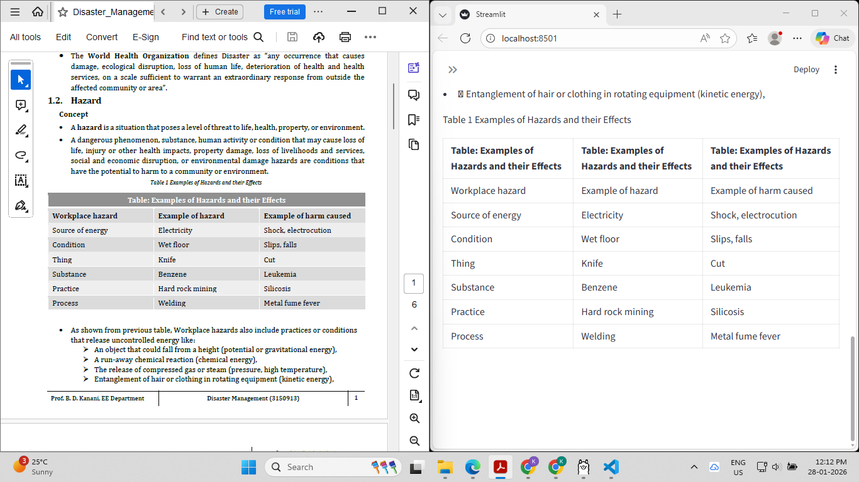

Ibm sam esso practices pdf (this approach has worked the BEST so far for this pdf and table)
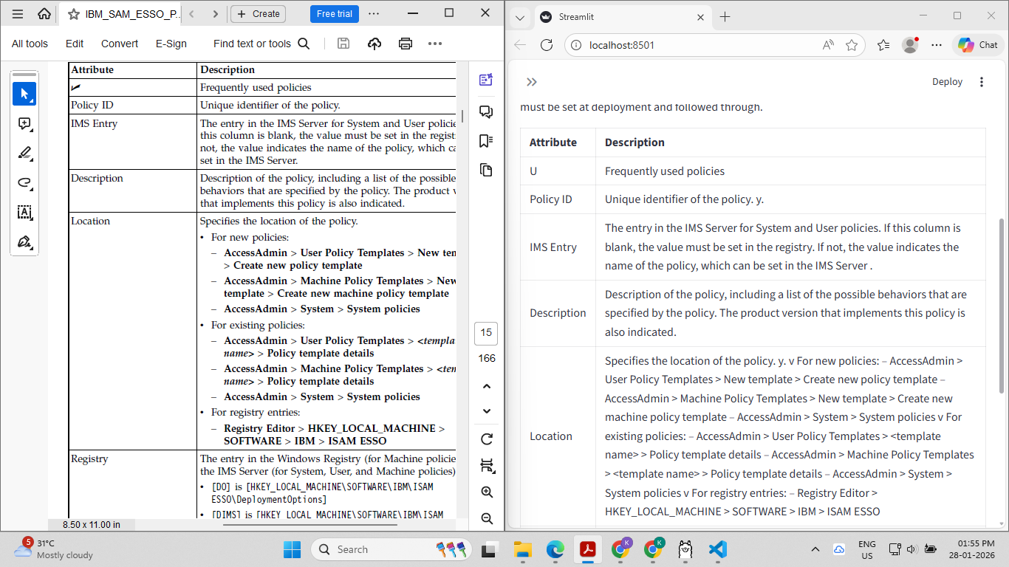

Ibmmaas_best_practices_for_policies

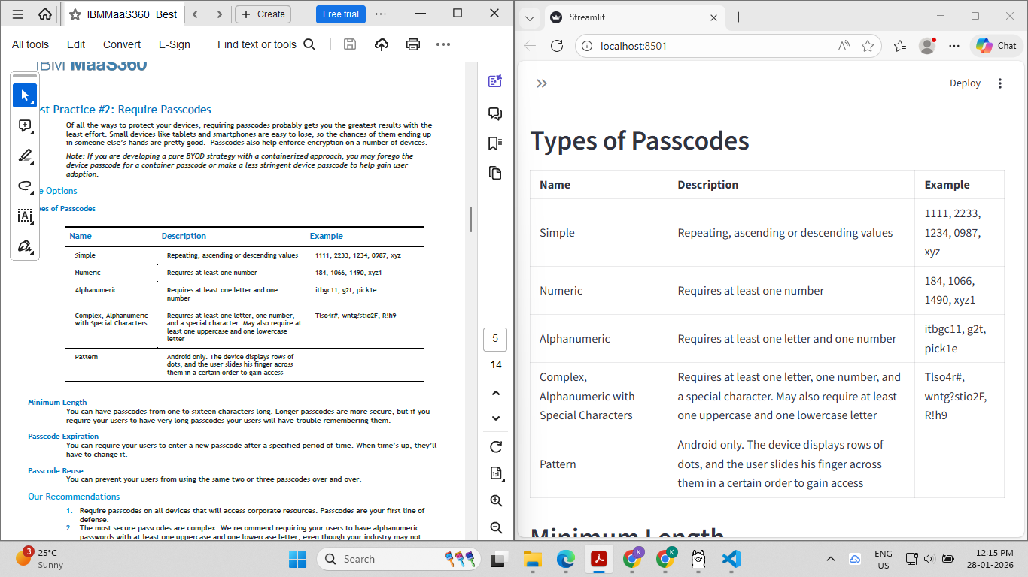
Try1 -> Still failing with images,
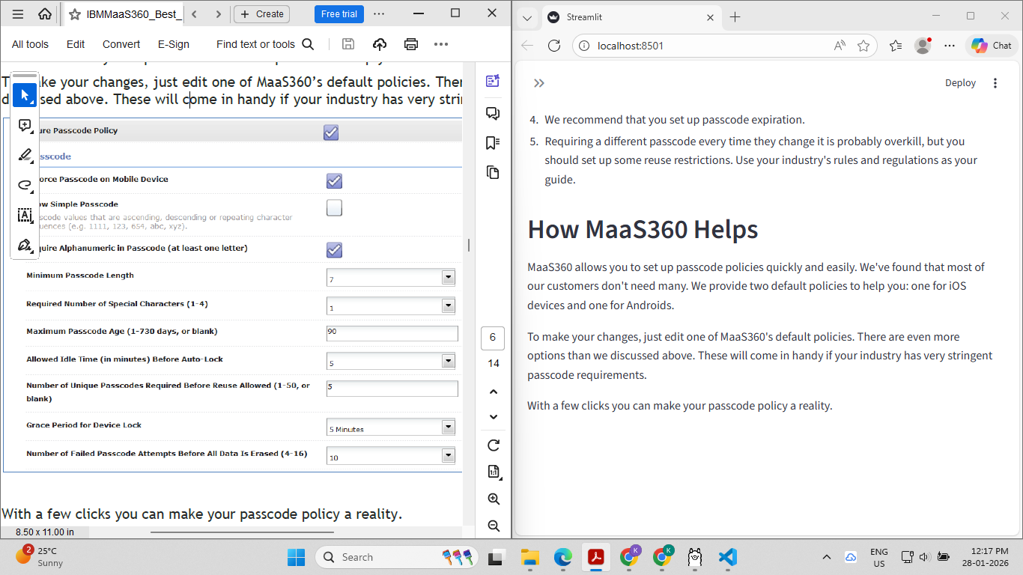

Try2 (for image inclusion) ->
Trial1 (using claude)
Detecting that there are images in that place, no description yet but theres a bit of progress.
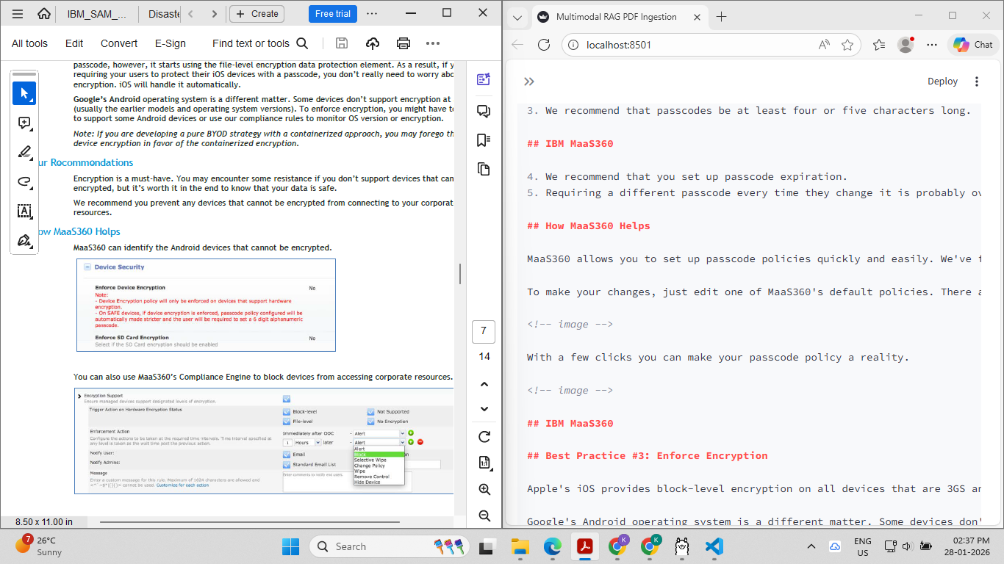
qwen3 -vl:7b fails to give a text description of the image, and only is able to detect where the images are, so instead of that , qwen2-vl:7b,2b or llava:7b is supposed to work.
Using llava:7b (since thats the only one which could get installed onto the pc)
Tried manual vlm description and that too failed epically(ran for over 10-15min)
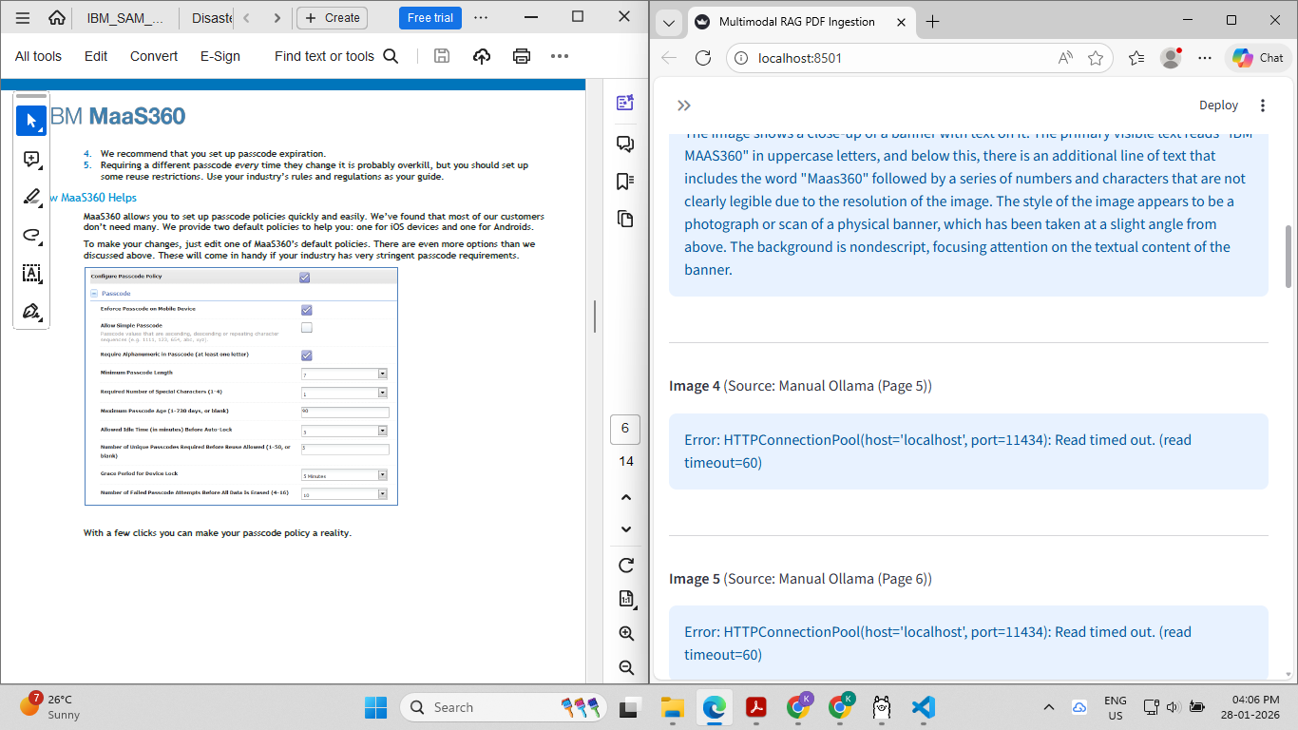
Try2 -> now using pymupdf + llava instead
Takes too much time to load and extract -> technically not a feasible option, but it does WELL with a single page.
Takes at least 2-3 minutes to process a single page, have to search for another feasible option.

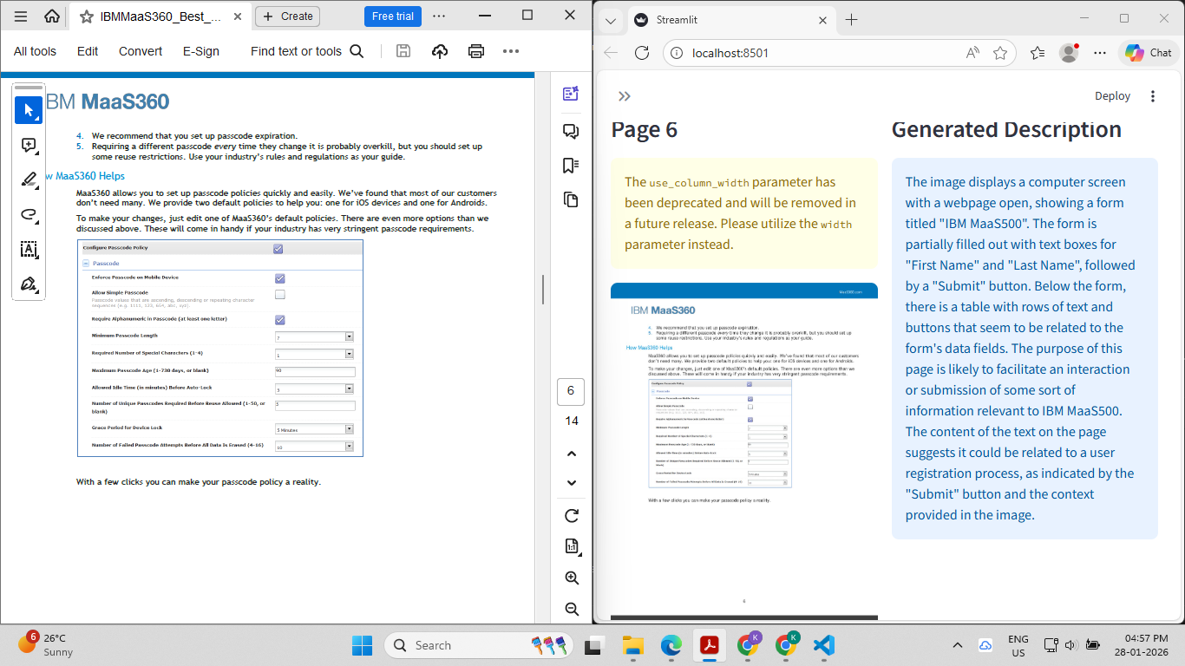

Trying out a different approach -> PaddleOCR + LLM for images, does not work well , even with tesseractocr it doesnt work well.

Last approach : docling + pymupdf + rapidocr if that works then try out chunking strategies.
IT WORKS!!!!! Doclingollama2.py -> doclingpymupdf.py workssss !!!! the images are processed first and then text is shown but its okay!!! Takes atleast 3 minutes to load but it works well.

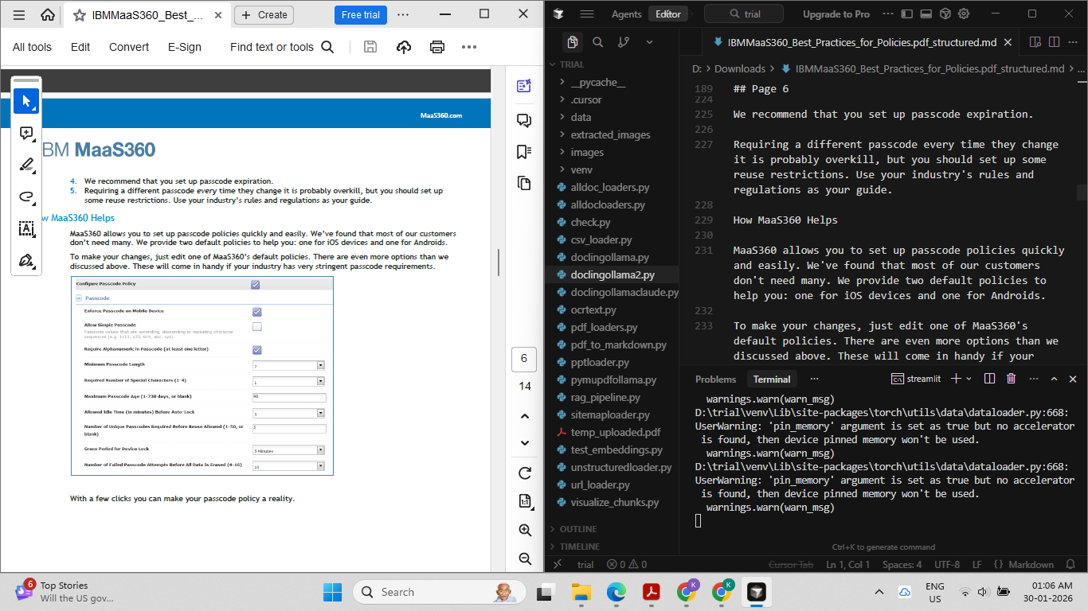

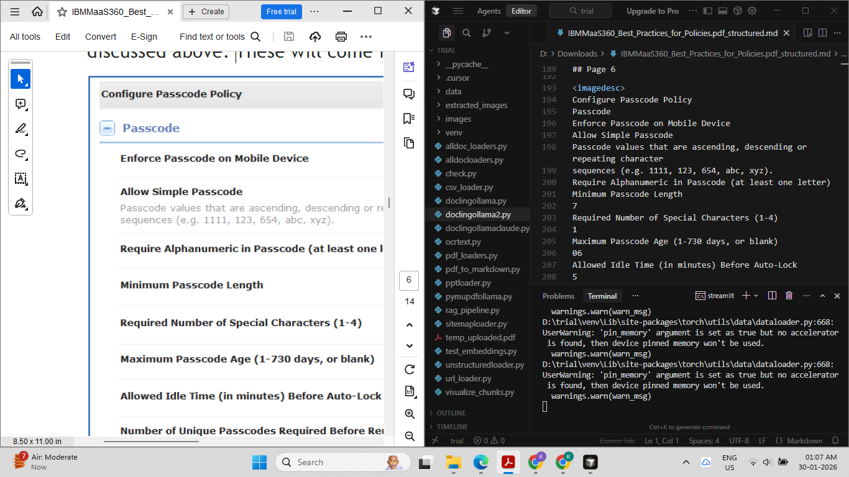
Trying a faster approach -> doesn’t work well , skips the images .
Docling + pymupdf + moondream works but it does not give the description as good as llava model

<imagedesc>
The image shows a configuration page that is open on a computer screen. The page has a header at the top with the words "CONFIGURE PASSWORD" written in white letters. Below this heading are several checkboxes labeled with numbers ranging from 0 to 10, indicating the level of password complexity desired for each checkbox. There is also text below the checkboxes that provides instructions on how to set the password strength. The page has a form at the bottom where users can enter their password and confirm it before data is sent or stored securely.
</imagedesc>.

Chunking Strategies/ Text Splitters

Trying out various chunking strategies on the text extracted using docling+pymupdf+rapidocr approach.
Referring to -> https://www.youtube.com/watch?v=8OJC21T2SL4 for initial understanding.
https://docs.langchain.com/oss/python/integrations/splitters

Visualisation of chunking -> https://chunkviz.up.railway.app/

Have to use langchain_text_splitters -> langchain.text_splitter is old and doesnt work
Chunk overlap means that the amount you would like your sequential chunks to overlap. This is to try to avoid cutting a single piece of context into multiple pieces. This will create duplicate data across chunks.

There’s something called token splitting as well -> chunk size = tokens

Levels of Text Splitting | Notes
Character Splitting | - chunks = no. of characters  - easy to use but does not take the structure of the text into account.  - is not advisable to use, it cuts within the sentences as well.
Recursive Character Splitting | - Recursively tries to split by different characters to fit that works  - Separators = [ “\n\n”, “\n” , “ “ ,”” (character) ]  - A great choice to start with, makes chunks without breaking any sentences.  - The chunk sizes are almost uniform throughout the document.
Document Specific Splitting | It is specific for different types of doc like markdown, python or js , etc . Unstructured is used for splitting the content with table + images, but it cannot be used here since i am using docling approach.
Semantic Splitting (with embedding)
Agentic Splitting

Adaptive chunking->
Main challenge is to retain information from the table ->
How chunks is stored -> first json format fir conversion

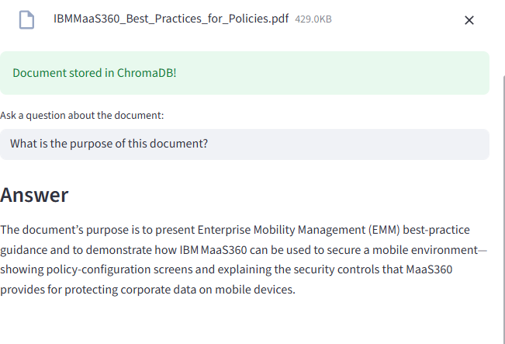

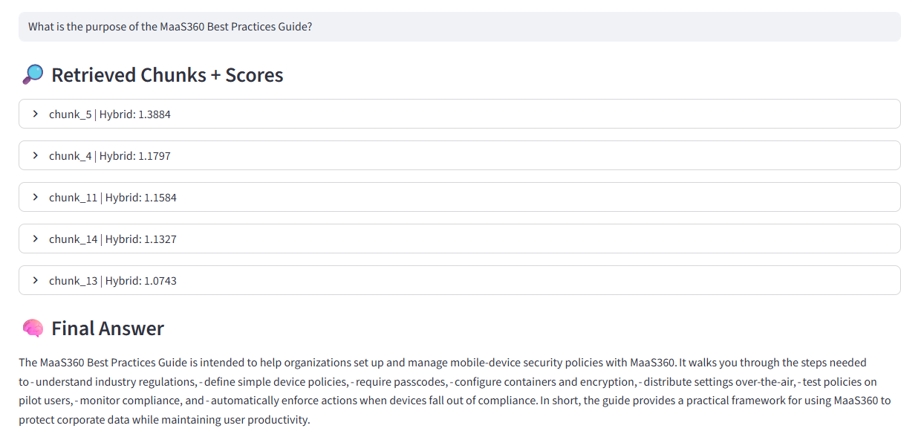

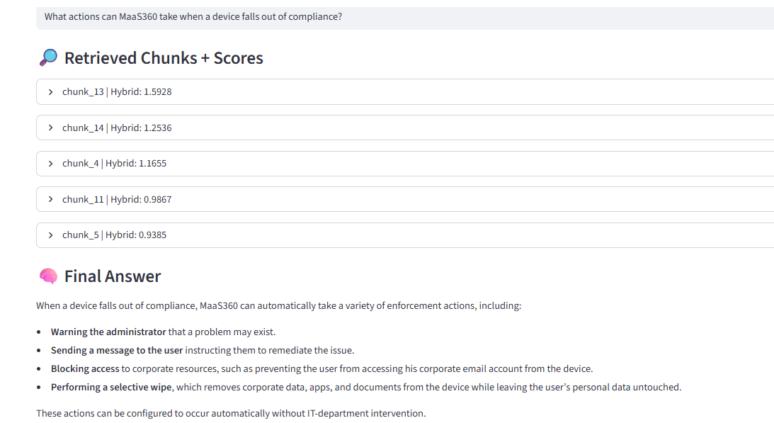
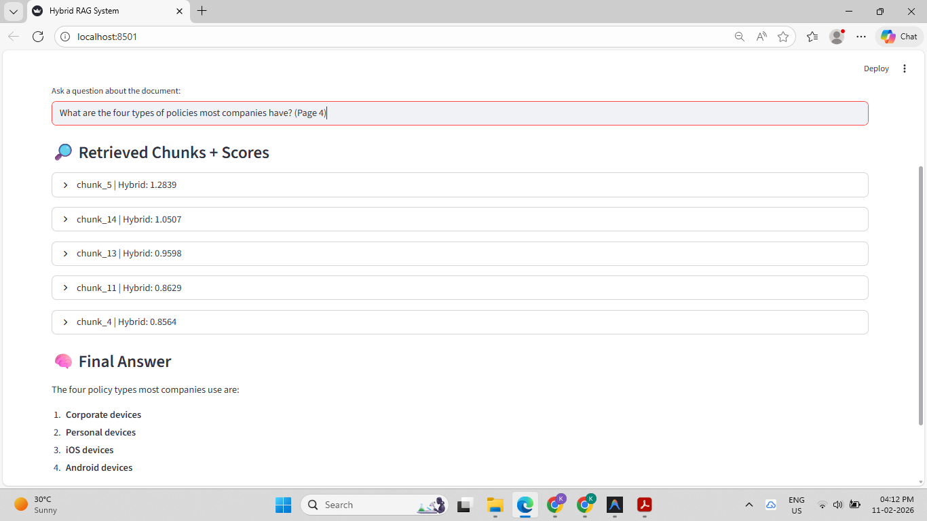
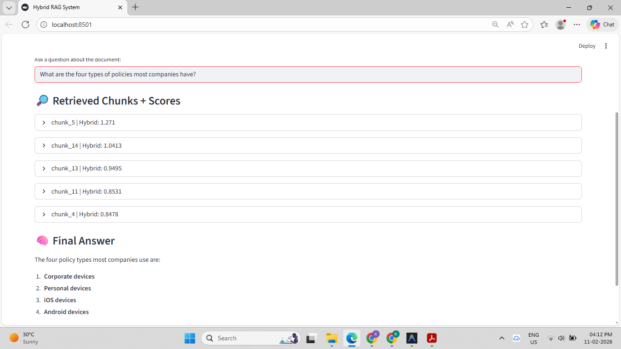

TRIAL 2 - works with images and table

