Document Loaders & Chunking Strategies
Insights, Observations, and Experimental Results

1. PDF Document Loaders
A comprehensive evaluation was conducted across multiple PDF loading libraries (excluding those that require API keys or external credentials). Two test documents were used: a Disaster Management report and a GRE Math Formulas guide. These were selected to assess each loader's ability to handle images, tables, and mathematical formulae accurately.

Document Loader | Observations
PyPDF | - Does not handle tables, mathematical formulae, or embedded images reliably.
PDFPlumber | - Does not extract tables accurately.
PyPDFDirectory | - Functionally equivalent to PyPDF, but accepts a directory path as input rather than a single file.  - Processes and returns all PDF files within the specified folder.
PyPDFium2 | - Unable to extract tables accurately.  - Demonstrates a partial ability to extract text embedded within images, though the output quality is inconsistent.
PyMuPDF | - Provides basic table support, though results can be inconsistent.  - Performance was notably unreliable on the Disaster Management document.
PyMuPDF4LLM (Best option identified at this stage) | - Demonstrates improved table extraction compared to PyMuPDF.  - Handles images adequately when paired with RapidOCR.
PDFMiner | - Table extraction is unreliable.  - Image handling produces mediocre results.
Docling | - Did not perform satisfactorily in initial tests.

2. PowerPoint Document Loader
The following evaluation was carried out using the OS_Unit_4 presentation file.

Document Loader | Observations
UnstructuredPowerPointLoader | - Extracts textual content effectively.  - Does not support image extraction.

3. CSV Document Loader
The following evaluation was carried out using the warehouse_messy_data.csv dataset.

Document Loader | Observations
CSVLoader | - Loads CSV data as-is, preserving the original structure of the file.

4. URL Document Loaders

Document Loader | Observations | Challenges Encountered | Notes
WebBaseLoader | Retrieves the full content of the target URL. Only plain text is captured; output formatting is not structured.
RecursiveUrlLoader | Returns the raw HTML source of the webpage. The output can be made more suitable for LLM consumption by implementing a user-defined parsing function.
SiteMapLoader |  | The loader could not be configured correctly during testing.
Docling | Produces well-structured, LLM-ready output. Web content is scraped accurately with good formatting fidelity.

5. Loading Complex Tables
Initial experimentation was carried out using the IBMMaaS360_Best_Practices_for_Policies.pdf document. This file was specifically chosen because it contains both complex tables and embedded images.

Document Loader | Observations | Challenges Encountered | Notes
PyMuPDF4LLM |  | Tables are not extracted in a well-structured format. | Using pandas to post-process the output may improve formatting; however, the extraction code requires revision.
Unstructured | - Table content is extracted accurately, but the loader does not identify it as a table structure — it treats table text as ordinary flowing text.  - When used independently, it delivers better results than when combined with another loader.  - Output is structured in a format that an LLM can read and interpret effectively. |  | - Attempted combining PyMuPDF4LLM with Unstructured — this did not yield satisfactory results.  - Unstructured performs better when used as a standalone loader.  - Poppler combined with Tesseract is reported to produce superior results; however, this combination could not be tested due to the absence of administrator-level access required to modify system paths.
Docling + Ollama  (Tested using IBMMaaS360_Best_Practices_for_Policies.pdf, which contains both tables and images) | - Table extraction is highly accurate and well-structured. | - Unable to extract images or generate image descriptions.  - Substituting llava:7b enabled detection of image placement within the document, but textual descriptions of image content were still not produced.
PyMuPDF + Ollama (llava:7b) | - Successfully extracts images and generates descriptive captions. | - Processing time is prohibitively high — approximately 3 to 4 minutes per page — making this approach impractical for multi-page documents.

5.1 Reference and Additional Approaches
A useful reference for multi-loader pipeline design was identified:
YouTube: Docling Pipeline Walkthrough

According to this source, Docling is capable of being integrated into a comprehensive data ingestion pipeline in combination with various PDF loaders. In particular, the combination of Docling with PDFium2 as the backend is reported to produce high-quality results.

Key Finding: The combination of Docling + Ollama was tested using the Disaster Management PDF. While table extraction performed well, image summaries were not generated. Switching to PyMuPDF as the image extractor resolved this limitation.

5.2 Experimental Results — Image Extraction Attempts
The following screenshots document the progression of experiments aimed at achieving reliable image extraction.

Docling + Ollama — Initial Test (IBM SAM ESSO Practices PDF):
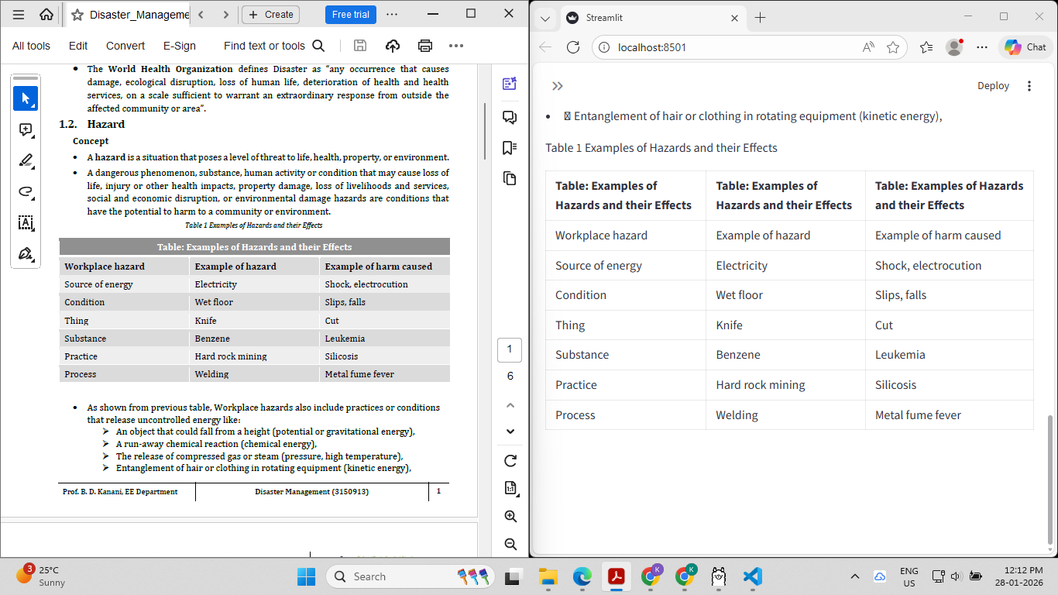
Figure 1: Docling + Ollama output on IBM SAM ESSO Practices document.
IBM MaaS360 Best Practices for Policies — Docling + Ollama:
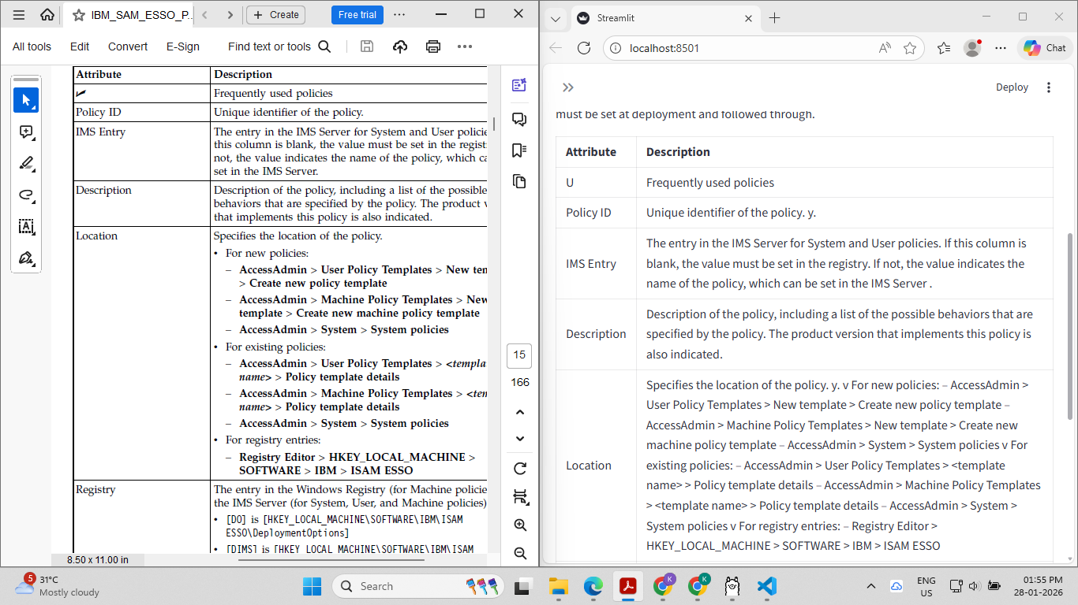
Figure 2: Docling + Ollama output on IBMMaaS360_Best_Practices_for_Policies.pdf.
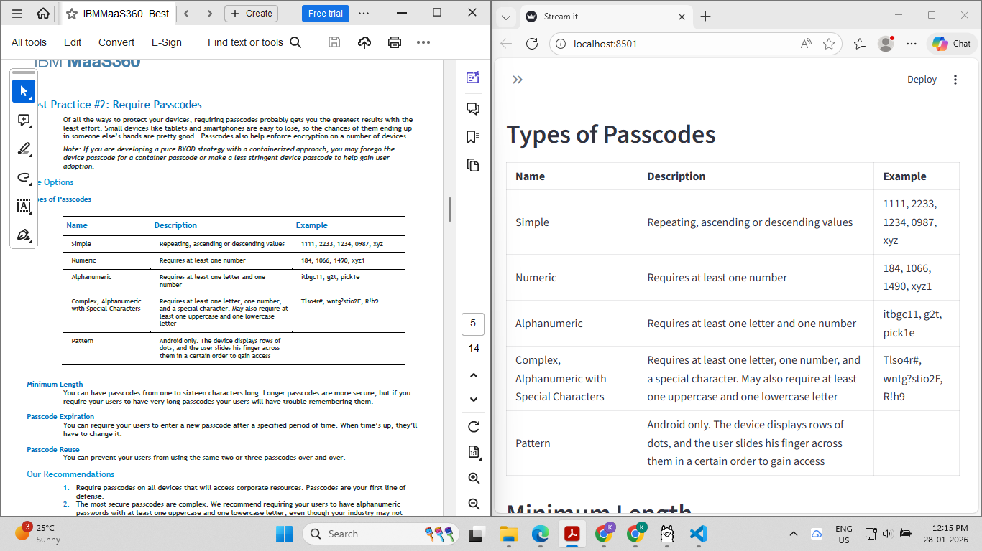
Figure 3: Further output from IBMMaaS360_Best_Practices_for_Policies.pdf.
Trial 1 — Image extraction still not working:
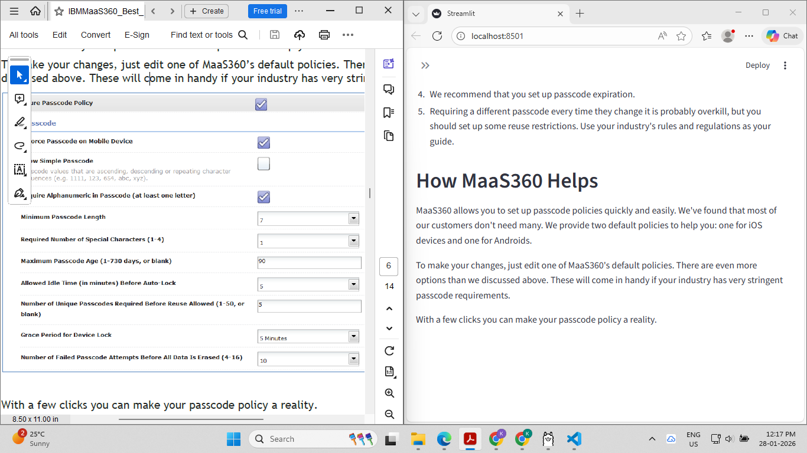
Figure 4: First attempt at image extraction — unsuccessful.
Trial 2 — Using Claude for image detection:
Progress was observed: the system successfully detected the presence of images within the document. However, descriptive captions were not yet being generated at this stage.
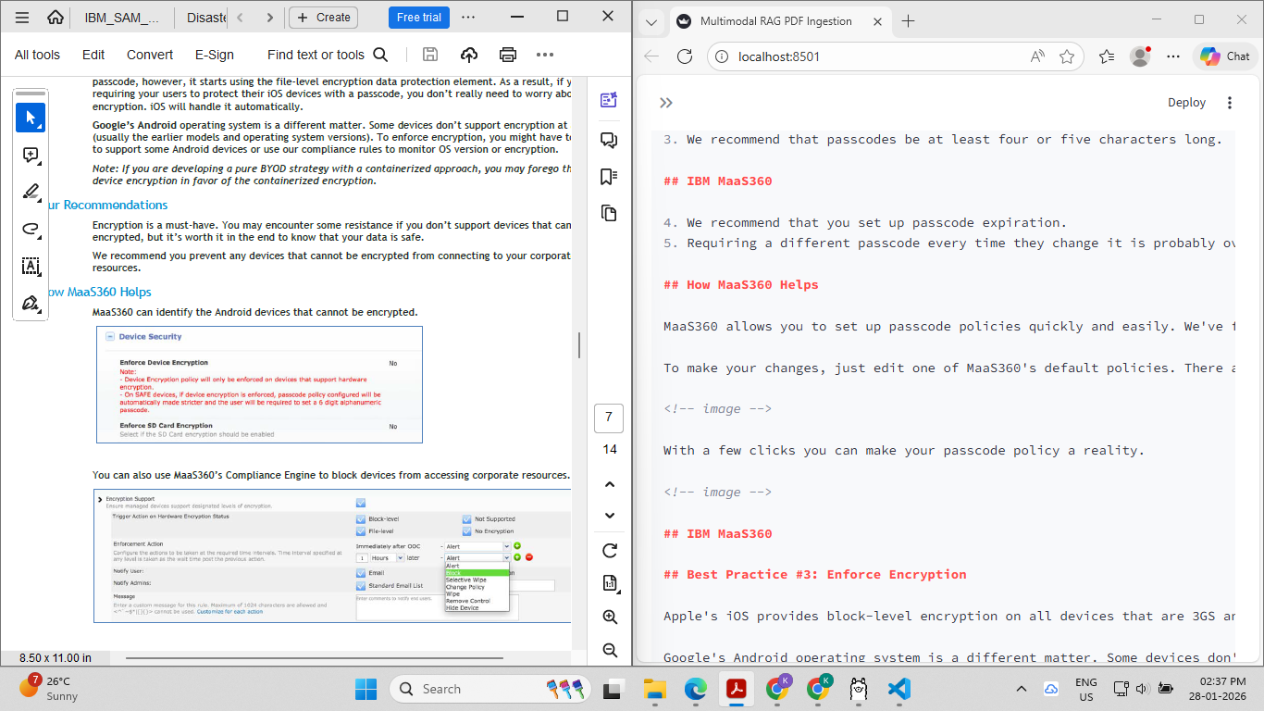
Figure 5: Image placement detected; description not yet available.
The qwen3-vl:7b model was found to be capable only of detecting image locations, not describing their content. As an alternative, qwen2-vl:7b, qwen2-vl:2b, or llava:7b are recommended for this task. The llava:7b model was selected, as it was the only compatible model that could be successfully installed on the available hardware.

Attempting manual VLM (Vision Language Model) description — unsuccessful:
The manual VLM pipeline was run but failed — execution time exceeded 10 to 15 minutes without producing output.
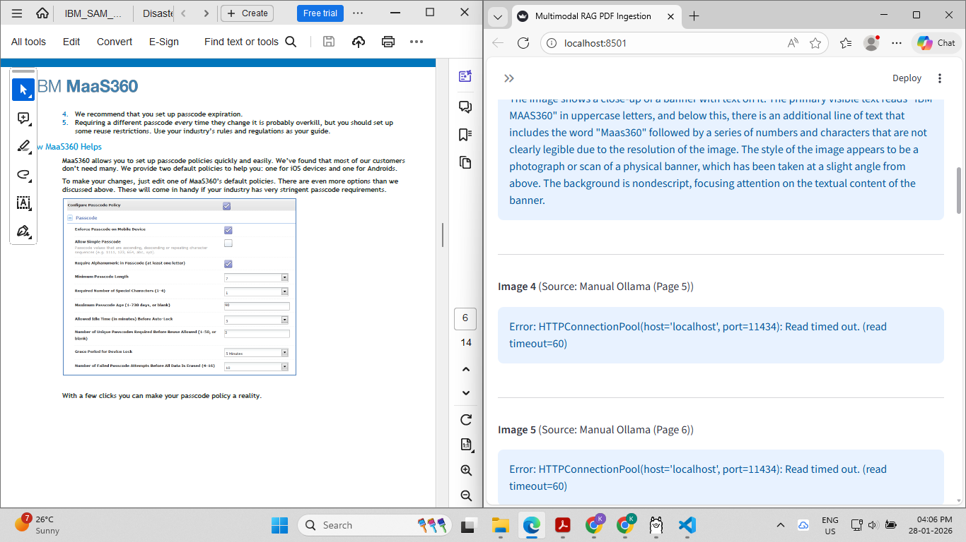
Figure 6: Manual VLM description attempt — timed out.
Trial 2 — Switching to PyMuPDF + llava:7b:
This approach succeeded in generating image descriptions, but at a processing cost of approximately 2 to 3 minutes per page — rendering it unsuitable for documents with a large number of pages. An alternative approach with better performance characteristics is required.
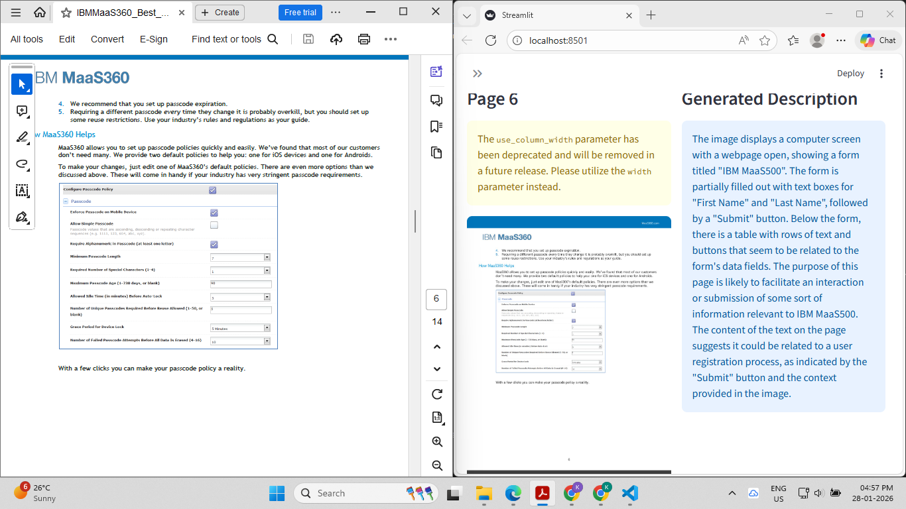
Figure 7: PyMuPDF + llava:7b output — accurate but slow.
PaddleOCR + LLM and TesseractOCR — Additional Approaches Tested:
Both PaddleOCR combined with an LLM, and TesseractOCR as a standalone tool, were evaluated. Neither approach yielded satisfactory results for image extraction.

Final Resolution: The pipeline combining Docling + PyMuPDF + RapidOCR was identified as the most effective approach. This combination successfully processes both images and text. Images are processed first, followed by text extraction. Total initialisation time is approximately 3 minutes, which is considered acceptable given the quality of results. Refer to the implementation files Doclingollama2.py and doclingpymupdf.py for the working implementation.

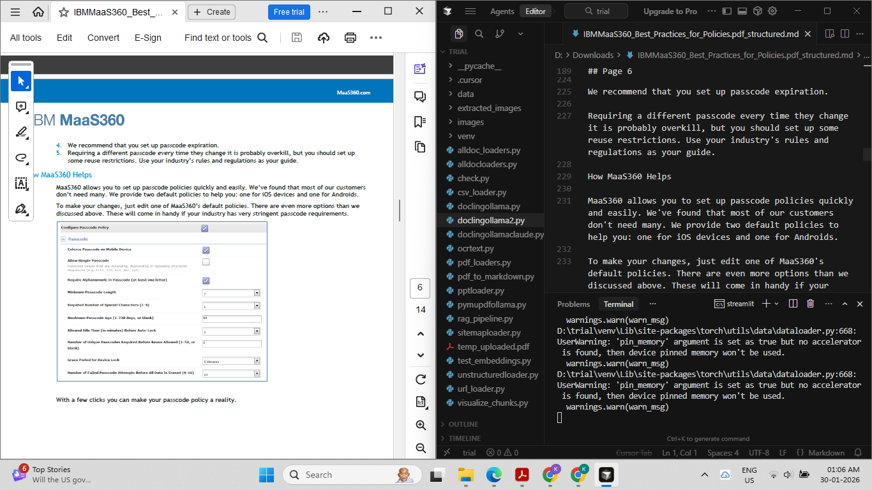
Figure 8: Successful output — Docling + PyMuPDF + RapidOCR pipeline.
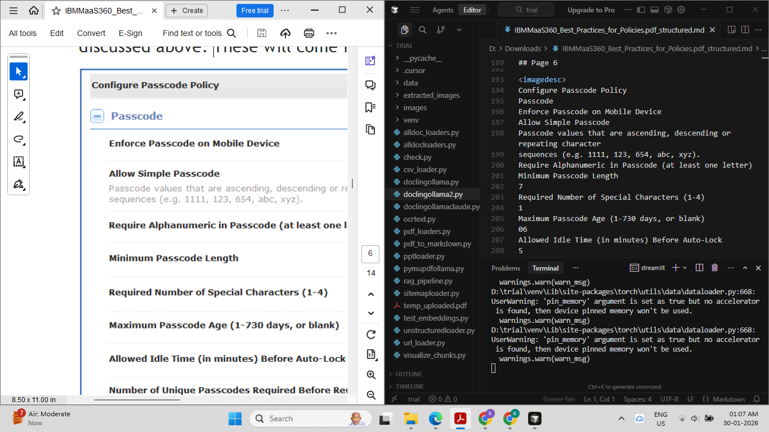
Figure 9: Further successful output from the finalised pipeline.
Faster Alternative — Docling + PyMuPDF + Moondream:
A faster variant was tested using the Moondream model in place of llava:7b. While this configuration runs more quickly, the descriptive quality of image captions is notably lower than that produced by the llava model.

Sample Image Description Generated by Moondream:
"The image shows a configuration page that is open on a computer screen. The page has a header at the top with the words CONFIGURE PASSWORD written in white letters. Below this heading are several checkboxes labelled with numbers ranging from 0 to 10, indicating the level of password complexity desired for each checkbox. There is also text below the checkboxes that provides instructions on how to set the password strength. The page has a form at the bottom where users can enter their password and confirm it before data is sent or stored securely."

6. Chunking Strategies and Text Splitters
Following the successful implementation of the Docling + PyMuPDF + RapidOCR extraction pipeline, various text chunking strategies were evaluated. Chunking refers to the process of dividing a large document into smaller, manageable pieces of text (called "chunks") that can be stored in a vector database and retrieved efficiently by an AI system.

Reference materials consulted:
YouTube: Chunking Strategies Overview
LangChain Text Splitters Documentation
Interactive Chunking Visualisation Tool

Important — Correct Module to Use:
Use langchain_text_splitters (the updated module). The older langchain.text_splitter module is deprecated and no longer functions correctly.

What is Chunk Overlap?
Chunk overlap refers to the number of characters or tokens that are intentionally repeated across consecutive chunks. This overlap ensures that contextual information is not lost at the boundary between two chunks. The trade-off is that overlapping chunks introduce some degree of data duplication across the stored segments.

Note: Token-based splitting is also available, where the chunk size is defined in terms of tokens rather than characters.

Level of Text Splitting | Notes
Character Splitting | - Chunk size is defined by the number of characters.  - Simple to implement, but does not account for the semantic or structural organisation of the text.  - Not recommended for most use cases, as it frequently splits mid-sentence, disrupting the flow of meaning.
Recursive Character Splitting | - Attempts to split the text using a hierarchy of separators, progressively narrowing down to find appropriate boundaries.  - Default separator hierarchy: ["\n\n", "\n", " ", ""] (double newline, single newline, space, then individual character).  - A strong starting point for most documents — preserves sentence integrity and produces consistently sized chunks.  - Chunk sizes are relatively uniform throughout the document.
Document-Specific Splitting | - Tailored for specific document types such as Markdown, Python code, JavaScript, and similar structured formats.  - The Unstructured library is typically used for documents containing tables and images; however, it is incompatible with the Docling-based extraction approach used in this project.
Semantic Splitting (requires embeddings) | Splits text based on semantic similarity, using embedding models to identify natural topic boundaries within the content.
Agentic Splitting | An advanced strategy in which an AI agent determines the most appropriate chunk boundaries dynamically, based on the content and context of the document.

6.1 Adaptive Chunking
Adaptive chunking explores strategies that adjust chunk boundaries dynamically, based on the structure and content of the document. A key challenge with complex documents is retaining the structured information contained within tables when converting them into chunks.

The following screenshots illustrate how chunks are stored, including the intermediate JSON conversion format used during the process.

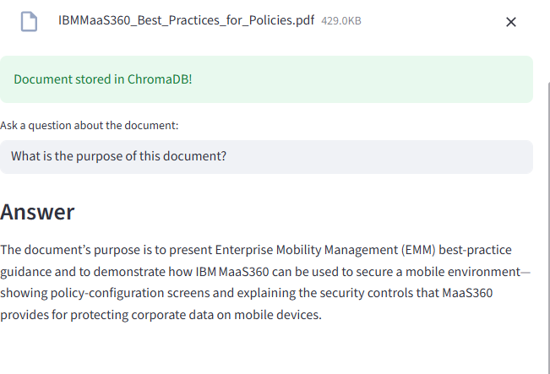
Figure 10: JSON representation of extracted chunks.
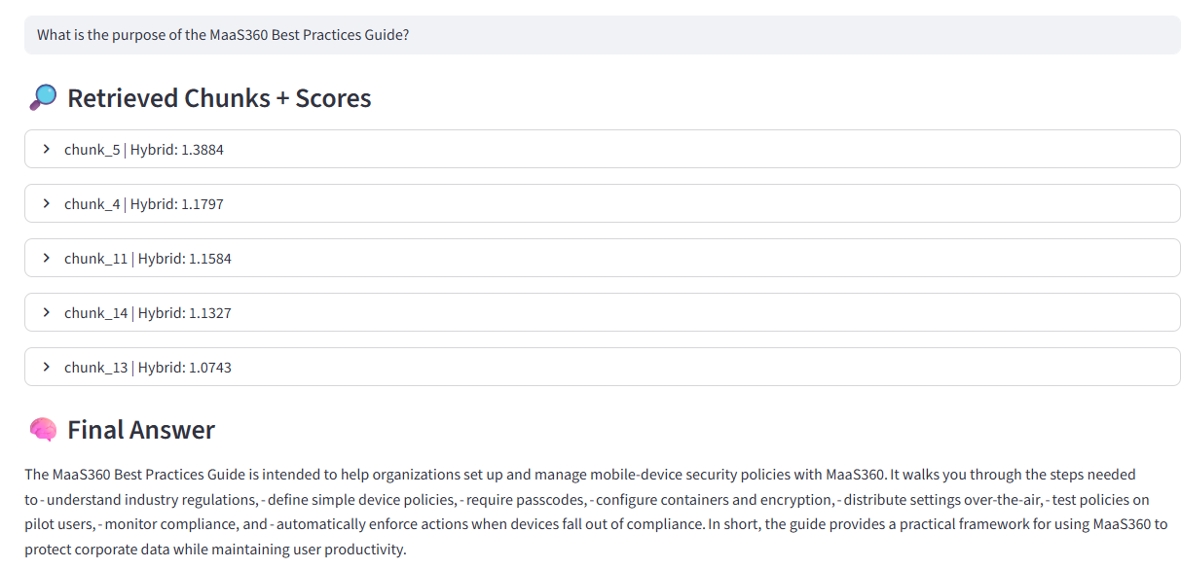
Figure 11: Chunk storage structure.
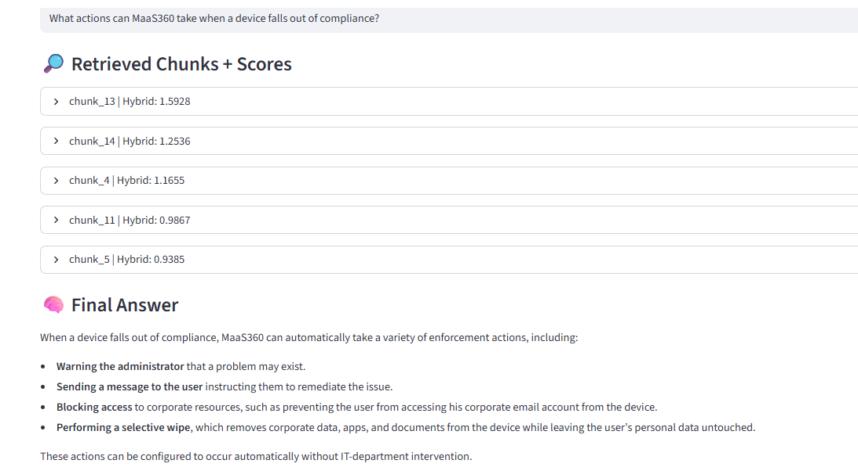
Figure 12: Chunking output — initial trial.
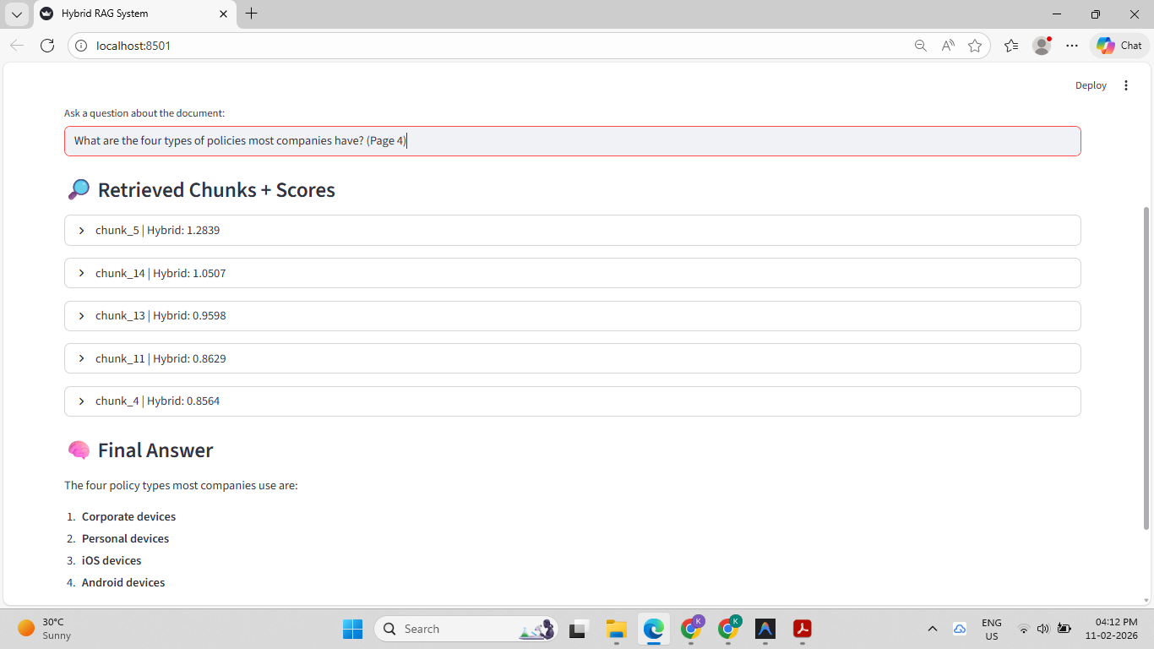
Figure 13: Chunking output — further analysis.
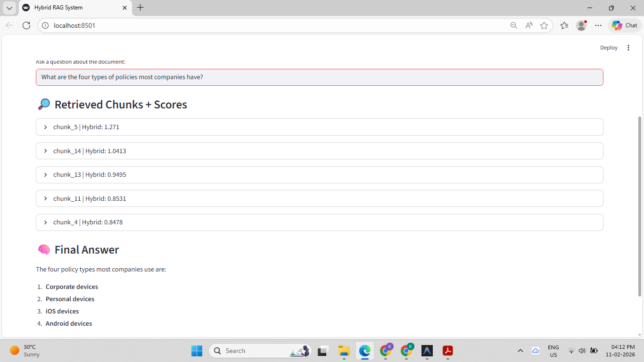
Figure 14: Additional chunking result.

6.2 Final Trial — Images and Tables Handled Successfully
Following several iterative refinements, a configuration was reached that successfully handles both image descriptions and structured table content within the same chunking pipeline.

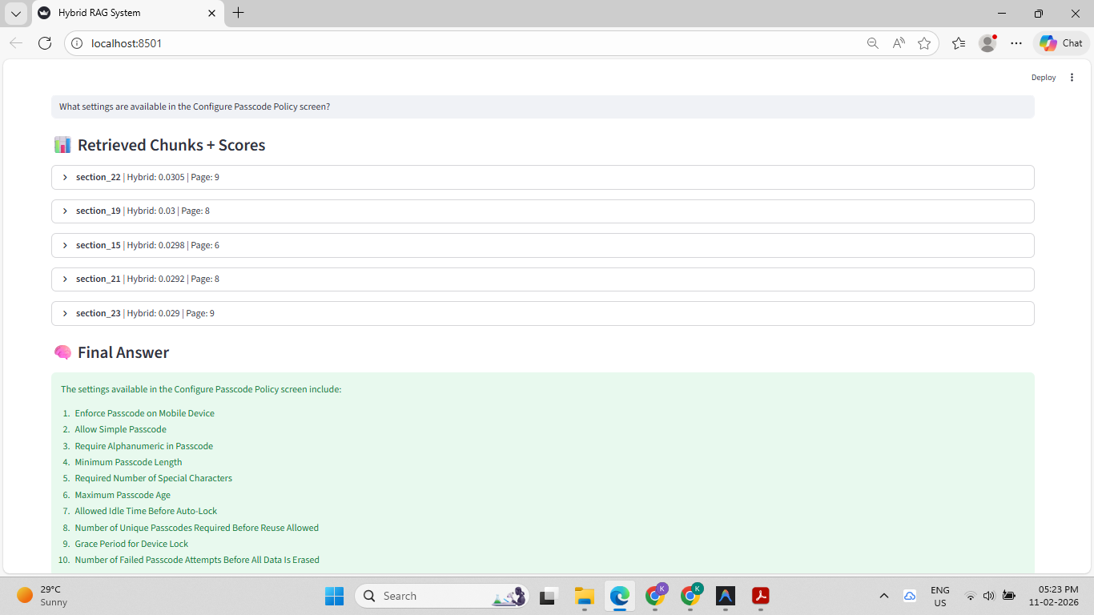
Figure 15: Trial 2 — Successful output with images and tables.
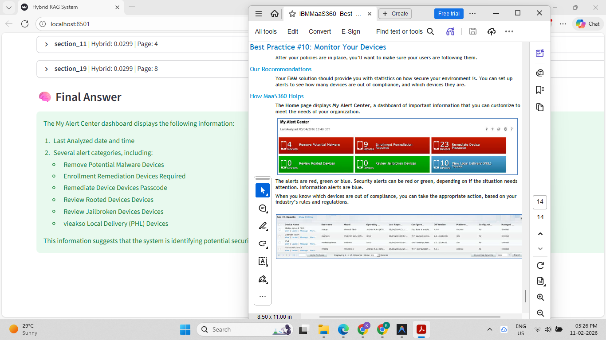
Figure 16: Further successful output from the finalised chunking pipeline.

End of Document

