MedChat
Graph-Augmented Multimodal RAG System for Oncology
─── ─── ───
Proof of Concept (POC) — Technical Documentation & Research Log
Organization | Aziro Technologies — Internship Project
Document Type | Full POC Technical Documentation & R&D Log
System Version | v5.1 (cancer_retrieval.py, cancer_ingestion.py, cancer_app.py)
Core Stack | Neo4j Aura · Groq LLaMA-3 · BAAI/bge-base-en · LangChain · Streamlit
Classification | Internal Use Only — Confidential

Table of Contents
Section | Title
1 | Executive Summary
2 | Problem Statement
3 | Limitations of Existing Systems
4 | Proposed Solution
5 | System Architecture
6 | Key Features
7 | Tools & Technologies
8 | Methodology
8.1 | Ingestion Pipeline
8.2 | Retrieval Engine
8.3 | Answer Generation & Fallback
8.4 | Multimodal Processing
8.5 | Graph RAG Extension
9 | Use Cases
10 | Challenges & Solutions
11 | Performance Considerations
12 | Scalability & Production Readiness
13 | Future Scope
14 | Weekly R&D Progress
15 | Conclusion
16 | References

1. Executive Summary
MedChat is a production-grade, graph-augmented Retrieval-Augmented Generation (RAG) system purpose-built for oncology. It was developed as a 13-week POC internship project at Aziro Technologies, evolving from a simple PDF Q&A prototype into a full three-mode clinical assistant backed by a hand-crafted medical knowledge graph in Neo4j Aura.

The system answers questions in three main modes: Research mode (grounded in peer-reviewed oncology literature), Graph mode (structured drug–food interactions, nutrition protocols, and treatment side effects from a hand-crafted Neo4j knowledge graph), and Auto mode (both paths fused intelligently). It supports patient report upload, structured analysis, image and figure retrieval from source papers, and real-time web search fallback for out-of-corpus queries.

What Was Built | Why It Matters | Technical Innovation | Status
Graph-augmented clinical RAG assistant with multimodal retrieval and patient report analysis | Cancer patients struggle to interpret medical reports, understand treatment side effects, and find reliable drug–food guidance. Existing chatbots hallucinate or lack clinical depth. | Three-mode routing, dedicated image chunk index, hand-crafted Cypher query library, three-tier web fallback logic | POC Complete — v5.1 operational, RAGAS evaluation framework live

🏗️ Architecture: The core architectural insight is that different clinical questions require fundamentally different retrieval strategies. Separating these into explicit modes — rather than routing opaquely — gives users predictable, trustworthy answers and makes failures diagnosable.

2. Problem Statement
Cancer patients undergoing chemotherapy face a convergence of complex, interdependent questions that general-purpose tools cannot answer reliably:

- What foods should I avoid while on cisplatin? Which vegetables interact badly with warfarin when combined with my chemotherapy regimen?
- What does my clinical report actually mean? What is my prognosis given my stage and biomarkers?
- What does Figure 3 in this survival study show? Are there flowcharts explaining my treatment pathway?
- Is there a new FDA-approved drug for my cancer type that my oncologist may not have mentioned?

Existing approaches fail this population in distinct ways:

Failure Mode | Consequence for Cancer Patient
General-purpose LLMs hallucinate clinical facts | A patient receives incorrect drug interaction information — potentially dangerous
Vector-only RAG misses entity-specific queries | "pemetrexed folic acid" returns general nutrition chunks, not the mandatory supplementation protocol
No multimodal retrieval | Questions about Kaplan-Meier curves, PRISMA flowcharts, or treatment decision trees cannot be answered visually
No explicit fallback | Out-of-corpus questions (recent FDA approvals, new trials) are answered with hallucinated "confidence"
No patient report integration | Clinical questions cannot be personalised to the specific patient's diagnosis, stage, or treatment plan

The problem is not simply retrieval quality — it is a fundamental mismatch between query types and retrieval strategies. A question about drug–food interactions requires a traversal of a medical knowledge graph with structured relationships. A question about survival statistics requires semantic retrieval from narrative clinical text. A question about a specific figure requires a dedicated visual index. No single retrieval strategy serves all three.

3. Limitations of Existing Systems

3.1 Document Loaders — Comprehensive Evaluation Results
A systematic evaluation of PDF loading libraries was conducted using two test documents: a Disaster Management report and a GRE Math Formulas guide (representing different structural complexities). The findings directly drove the choice of Docling + PyMuPDF + RapidOCR as the ingestion backbone.

Library | Tables | Images | Complex PDFs
PyPDF | ✗ Fails | ✗ Fails | ✗ Poor
PDFPlumber | ✗ Inaccurate | ✗ None | ⚠️ Partial
PyPDFDirectory | ✗ Fails | ✗ Fails | ✗ Poor
PyPDFium2 | ✗ Fails | ⚠️ Partial | ⚠️ Mixed
PyMuPDF | ⚠️ Basic | ⚠️ Inconsistent | ⚠️ Mixed
PyMuPDF4LLM | ⚠️ Improved | ⚠️ +RapidOCR | ⚠️ Better
PDFMiner | ✗ Unreliable | ⚠️ Mediocre | ✗ Poor
Docling (standalone) | ✅ Excellent | ⚠️ No image desc | ✅ Best
Docling + PyMuPDF + RapidOCR | ✅ Excellent | ✅ Good | ✅ Best

3.2 URL & Non-PDF Loaders
Loader | Type | Observations | Decision
WebBaseLoader | URL | Full content retrieved; plain text only, no structure | Used for basic web fallback content
RecursiveUrlLoader | URL | Returns raw HTML; needs custom parsing function for LLM consumption | Viable with post-processing
SiteMapLoader | URL | Could not be configured correctly during testing | Rejected
Docling (URL) | URL | Well-structured, LLM-ready output; accurate scraping with good formatting | Preferred for web ingestion
UnstructuredPPTX | PPTX | Text extracted well; no image extraction support | Used for text-only slides
CSVLoader | CSV | Loads as-is, preserving original structure | Standard use for structured data

3.3 Retrieval Strategy Comparison
This comparison table was derived from hands-on testing during the RAG Search Lab week (Week 5). It directly motivated the Hybrid BM25 + Dense + RRF + MMR architecture.

Test Case | BM25 (Keyword) | Semantic (Vector) | Hybrid | Winner
Specific code: "Error 503" | Excellent — exact match | Poor — matches "Error" generally | Best — exact match prioritised | Hybrid
Synonyms: "login assistance" | Poor — misses "authentication guide" | Excellent — same intent | Balanced — finds both | Hybrid
Short query: "passcode" | Strong — finds every instance | Vague — too much context noise | Strong + filtered for relevance | Hybrid
Long questions | Noisy — distracted by stop words | Strong — focuses on core intent | Best — filters noise, keeps keywords | Hybrid
Drug name: "pemetrexed" | Excellent — exact match critical | Moderate — semantic drift risk | Best — exact name preserved at top | Hybrid

3.4 Retrieval Method Coverage
A comprehensive audit of LangChain-supported retrieval methods was conducted to understand what is natively available versus what required custom implementation.

Retrieval Method | LangChain Support | Status in MedChat
Similarity Search | ✅ Native | Used via Neo4jVector
MMR (Maximal Marginal Relevance) | ✅ Native | Used post-RRF reranking
BM25 | ✅ Native (BM25Retriever) | Used for lexical retrieval
Ensemble Retriever | ✅ Native | Base pattern; extended to RRF
MultiQuery Retriever | ✅ Native | Not used — adds Groq API cost
Contextual Compression | ✅ Native | Considered; not implemented yet
Cross-Encoder Reranking | ❌ Custom required | Future scope — identified as highest-value next step
Graph Retrieval | ❌ Custom required | Implemented via Neo4j Cypher + GraphRetriever class
Late Interaction (ColBERT) | ❌ Custom required | Future scope

4. Proposed Solution
MedChat addresses the retrieval mismatch problem with a three-mode architecture where each mode is an explicitly routed pipeline optimised for a specific class of clinical query.

Mode | Routing Trigger | Retrieval Path
RESEARCH | User selects "Research & Literature" in sidebar | BM25 + Dense → RRF → MMR → PDF chunks only
GRAPH | User selects "Treatment & Nutrition" in sidebar | Neo4j Cypher (6 intent templates) first → small vector enrichment appended
AUTO | Default / "Auto" selected; also fires on entity detection | Graph fires if medical entities detected in query; then BM25 + Dense + RRF + MMR merged with graph context

In all three modes, two additional parallel processes run:

- Image chunk retrieval: A dedicated BM25 index of image-only chunks runs independently, injecting visual references into context without competing with content chunks in MMR
- Out-of-corpus detection: Proactive pattern matching triggers web search (DuckDuckGo) before any retrieval for queries about recent FDA approvals, new clinical trials, vaccine approvals, and similar time-sensitive regulatory information

🔑 Key Finding: The core innovation is not any single retrieval technique — it is the explicit routing layer that matches each query type to the retrieval strategy most suited to answer it accurately and safely.

5. System Architecture

5.1 Four-Tier Architecture Overview
The system is organised into four tiers that interact sequentially and in parallel depending on query type. The architecture was finalised in v5.1 after 13 weeks of iterative development.

TIER 1 — INGESTION
- PDF → Docling (primary) or PyMuPDF (fallback) → raw text extraction
- 12-step text cleaning: Unicode repair, ligature fixes, header/footer removal, reference section cutoff
- Caption & image extraction: Docling PictureItem/TableItem → 7-layer noise filter (size, aspect, colour, pHash, publisher pattern)
- Two-stage chunking: MarkdownHeaderTextSplitter → RecursiveCharacterTextSplitter (chunk_size=1200, overlap=200)
- [IMAGE:] tag injection: "## Extracted Visual Assets Database" section appended to markdown before chunking
- Chunk JSON files saved to disk (source for BM25, Graph Builder, RAGAS evaluation)
- Neo4j vector store: :Chunk nodes with HNSW index on 768-dim BAAI/bge-base-en embeddings (Neo4jVector.from_documents)
TIER 2 — KNOWLEDGE GRAPH (Neo4j Aura)
- Hand-crafted medical schema: Cancer, ChemoDrug, EatingAdverseEffect, FoodItem, NutritionGuideline, NonChemoDrug, DrugInteraction, TreatmentProtocol, Ailment
- Six pre-written Cypher query templates for six intent categories: cancer drugs+effects, food guidance, non-chemo interactions, protocol details, drug–drug interactions, fulltext general
- Deterministic intent detection: exact substring matching against KNOWN_CANCERS, KNOWN_CHEMO_DRUGS, KNOWN_NON_CHEMO_DRUGS, FOOD_KEYWORDS, INTERACTION_KEYWORDS
- Fulltext index (chemo_text_index) as fallback when primary Cypher returns empty results
- Graph context formatted as [G1], [G2] blocks; placed before vector chunks in LLM prompt
TIER 3 — RETRIEVAL ENGINE
- Dense retrieval: Neo4jVector.as_retriever(k=20) — semantic search via HNSW
- Sparse retrieval: BM25Retriever(k=20) — lexical search over chunk JSON files on disk
- RRF fusion: Reciprocal Rank Fusion merges dense + sparse → top 20 candidates; scores normalised
- MMR reranking: Maximal Marginal Relevance (λ=0.6) → 8 final content chunks; cosine similarity computed locally
- Image channel (parallel): Separate BM25 index of has_image_tags=True chunks → top 2 image chunks → injected as "## Visual References" section; BYPASSES MMR entirely
- Context assembly: [Graph context] + [Content chunks 1..8] + [Visual References IMG1..IMG2]
TIER 4 — GENERATION & DELIVERY
- Out-of-corpus detection: 15 regex patterns (FDA approval, vaccine, 202x dates, recent trials) → proactive web search BEFORE retrieval
- LLM prompt: mode-specific instructions + mandatory [IMAGE:] tag directive + context-only constraint + disclaimer requirement
- Groq LLaMA-3.3-70b-versatile: answer generation (streaming for UI; blocking for evaluation)
- Three-tier no-answer detection: short answer + any phrase, long answer + multiple phrases, 5 regex patterns for partial admissions
- Web fallback (DuckDuckGo): clean presentation — web answer stands alone if RAG empty; labelled as "Additional sources" if RAG partial
- Streamlit UI: streaming render, [IMAGE:] → st.image(), follow-up question buttons, reasoning path expander per turn
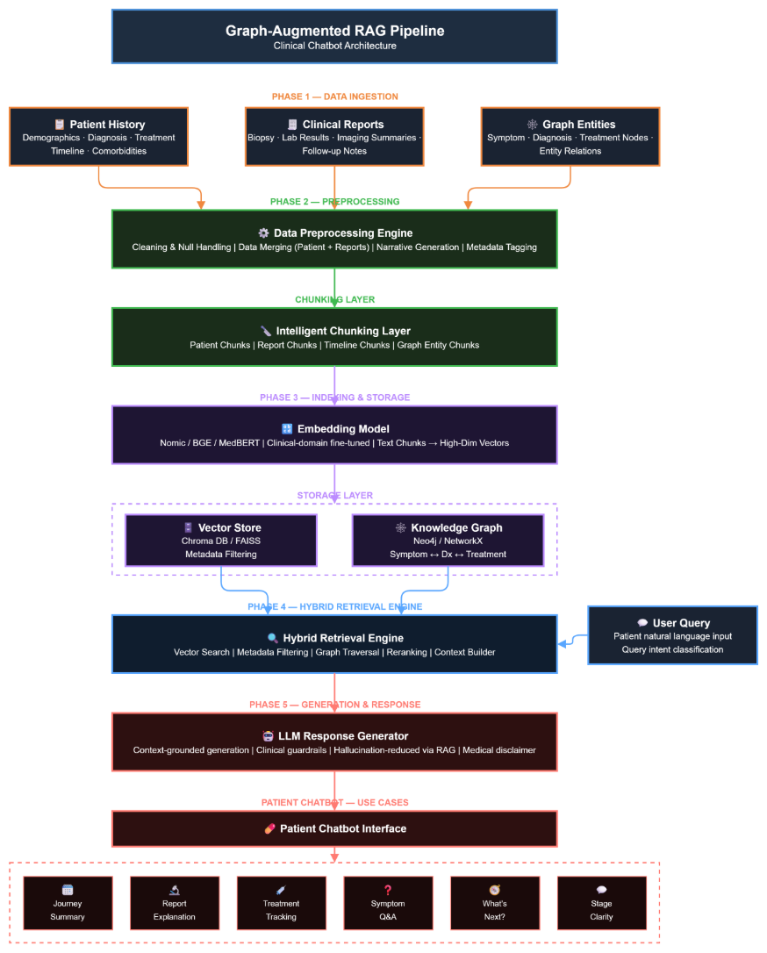

5.2 Data Flow Diagram
The following table traces the exact path of a query through the system, showing which components are invoked at each step:

Step | Component Invoked | Data In / Out
1. Query received | cancer_app.py → generate_answer_stream() | User query string, patient_report, cancer_filter, query_mode
2. Out-of-corpus check | _is_out_of_corpus_query() | 15 regex patterns matched → if True: skip retrieval, go to step 10
3. Mode routing | if/elif on query_mode constant | Routes to _run_research_mode / _run_graph_mode / _run_auto_mode
4a. Graph retrieval (GRAPH/AUTO) | GraphRetriever.retrieve() → Cypher templates | intent_info dict → Cypher params → Neo4j session.run() → rows → _format_graph_context()
4b. Dense retrieval | Neo4jVector.as_retriever(k=20) | Embedded query vector → HNSW ANN search → 20 Document objects
4c. Sparse retrieval | BM25Retriever(k=20) | Tokenised query → BM25 scoring → 20 Document objects
5. RRF fusion | reciprocal_rank_fusion(dense, sparse) | 40 docs → RRF scores → top 20 merged candidates
6. MMR rerank | mmr_rerank(query, candidates, embed_model) | 20 candidates → cosine similarity matrix → 8 final content chunks
7. Image retrieval (parallel) | _retrieve_image_chunks(query) | Image-only BM25 index → top 2 image chunks → bypass MMR
8. Context assembly | build_context(vector_docs, graph_ctx, image_docs) | Graph [G1..Gn] + Content [1..8] + Visual References [IMG1..2]
9. LLM generation | Groq API → streaming | Prompt (mode instruction + context + question) → streamed tokens → full_answer
10. Fallback check | _rag_has_no_answer() / _is_out_of_corpus_query() | If triggers: _web_search_fallback() → DuckDuckGo → second LLM call
11. Response delivery | generate_answer_stream() → Streamlit write_stream() | Tokens yielded to UI; sources/followups stored in session_state

5.3 Knowledge Graph Schema
The Neo4j knowledge graph encodes the clinical nutrition and drug interaction domain for oncology patients. This schema was hand-crafted based on clinical domain research — it was not auto-generated by an LLM.

Node Label | Key Properties | Relationships (→ target)
Cancer | name, subtype | → TREATED_WITH → ChemoDrug
ChemoDrug | name, drug_class, notes, mechanism | → CAUSES_EATING_EFFECT → EatingAdverseEffect
EatingAdverseEffect | name, management_tip | → WORSENED_BY → FoodItem; → RELIEVED_BY → FoodItem
FoodItem | name, category | Target of WORSENED_BY / RELIEVED_BY
NutritionGuideline | text (e.g. "Folic acid 400-1000mcg daily from 7 days before pemetrexed") | → REQUIRED_FOR → ChemoDrug; → MANAGES → EatingAdverseEffect
NonChemoDrug | name, drug_class | → HAS_INTERACTION_WITH → ChemoDrug; → DESCRIBED_BY → DrugInteraction; → TREATS → Ailment
DrugInteraction | severity, description, clinical_action, eating_relevance, mitigation | → COMPOUNDS_EATING_EFFECT → EatingAdverseEffect
TreatmentProtocol | name, cancer, description, setting | → INCLUDES_DRUG → ChemoDrug
Ailment | name | Target of TREATS

5.4 Intent Detection Logic (Six-Query Cypher Library)
Rather than using an LLM to generate Cypher on the fly (error-prone with open-source models), six pre-written templates handle all clinical nutrition query patterns. The intent router is a simple, deterministic priority chain:

Priority | Intent & Cypher Template
1 (highest) | NonChemoDrug + interaction signal → INTENT_NON_CHEMO_INTERACTION: traverses NonChemoDrug → DrugInteraction → EatingAdverseEffect
2 | Protocol name detected → INTENT_PROTOCOL_DETAIL: retrieves TreatmentProtocol with all INCLUDES_DRUG drugs, eating effects, and mandatory guidelines
3 | ChemoDrug + food signal → INTENT_FOOD_GUIDANCE: full food/avoid/eat/guideline lookup per drug
4 | Cancer name + food/drug signal → INTENT_CANCER_DRUGS_EFFECTS: cancer → all treatment drugs → all eating effects
5 | ChemoDrug alone → INTENT_FOOD_GUIDANCE (same template as priority 3)
6 | Cancer name alone → INTENT_CANCER_DRUGS_EFFECTS
7 (fallback) | Eating effect keyword or no match → INTENT_GENERAL_GRAPH: fulltext index search on chemo_text_index

6. Key Features
Feature | Description | Technical Mechanism | Clinical Value
Three-Mode Retrieval | RESEARCH / GRAPH / AUTO mode selector in sidebar | Explicit routing to PDF-only, graph-first, or fused paths | Clinician picks Research; patient picks Graph; Auto for mixed needs
Graph-Grounded Drug–Food Guidance | Structured interaction and nutrition data from Neo4j | Six Cypher templates with typed entity traversal | Answers "what to eat/avoid on cisplatin" with verifiable graph sources
Image & Figure Retrieval | [IMAGE: filename.png] tags rendered as actual images in UI | Dedicated image BM25 index bypasses MMR; ## Visual References section in prompt | PRISMA flowcharts, Kaplan-Meier curves, treatment decision trees displayed inline
Patient Report Analysis | Upload PDF/text → structured 6-part clinical summary | PyMuPDF extraction + AUTO mode with 6-section prompt template | Diagnosis, staging, treatment plan, nutrition guidance from one upload
Proactive Web Fallback | Out-of-corpus queries (FDA approvals, recent trials) go to web | 15 regex patterns trigger DuckDuckGo before retrieval | Prevents hallucination on time-sensitive regulatory information
Three-Tier Fallback Detection | Detects "I don't know" even when buried in long answers | Short-answer threshold + multi-phrase count + 5 regex patterns | Catches partial hallucinations that phrase-matching alone misses
Streaming UI | Answer tokens streamed live with image rendering | Groq streaming API + Streamlit write_stream() + post-stream [IMAGE:] re-render | Responsive UI even for long clinical explanations
RAGAS Evaluation Suite | 20-question golden dataset with 4 categories, HTML report | faithfulness, answer_relevancy, context_precision, context_recall + custom image_score, web_score | Quantifies pipeline quality; per-run history for regression detection

7. Tools & Technologies

7.1 Core Stack
Component | Technology | Version/Notes | Role | Alternative Evaluated
Embeddings | BAAI/bge-base-en | 110M params, 768-dim | Text embedding for dense retrieval and MMR | nomic-embed-text (Ollama) — slower on CPU
Vector DB | Neo4j Aura (Free) | HNSW vector index on :Chunk nodes | Combined vector store + knowledge graph | Qdrant (v3), FAISS, Milvus
LLM (Generation) | Groq LLaMA-3.3-70b-versatile | Free API tier, 128k context | Answer generation (streaming + blocking) | LLaMA-3.1-8b-instant (faster, weaker reasoning)
LLM (Evaluation) | Groq LLaMA-3.1-8b-instant | RAGAS judge; faster | RAGAS faithfulness + relevancy scoring | LLaMA-3.3-70b (more accurate but slower)
PDF Extraction | Docling + PyMuPDF + RapidOCR | Docling for tables, PyMuPDF for images, RapidOCR for scanned pages | Primary ingestion pipeline | PyPDF, PDFPlumber, PyMuPDF4LLM (all inferior for complex docs)
Lexical Retrieval | BM25Retriever (LangChain) | From chunk JSON files on disk | Sparse retrieval for exact matches | TF-IDF (weaker)
LLM Framework | LangChain + LangChain-Neo4j | langchain-community, langchain-groq, langchain-huggingface | Retriever interfaces, embeddings wrappers, prompt management | LlamaIndex
UI | Streamlit | Streaming mode, session_state | Chat interface with image rendering and file upload | FastAPI + React
Evaluation | RAGAS v0.2.6 (explodinggradients) | ! Must be explodinggradients fork, NOT vibrantlabsai fork | Faithfulness, relevancy, precision, recall metrics | TruLens (planned for production monitoring)
Web Fallback | DuckDuckGo (duckduckgo-search) | No API key required | Web search for out-of-corpus queries | SerpAPI, Tavily (more reliable; future upgrade)
Image Captioning (Early) | Ollama llava:7b / Moondream2 | Local VLM inference | Generate image descriptions for embedding | Replaced by [IMAGE:] tag injection approach

7.2 Hardware Context
All development was conducted on a severely constrained hardware profile, which shaped many architectural decisions:

Hardware Component | Specification & Impact
Processor | Intel i5 11th Gen — no AVX-512; limits batch sizes for embedding model; ~200ms per embed_documents call
GPU | None — GPU-accelerated models (FP32 transformers, CUDA-dependent libs) entirely unusable; all inference CPU-bound
RAM | <10 GB available after OS overhead — forced sequential processing, explicit gc.collect(), lazy loading pattern
Storage | Windows filesystem with VS Code — higher background RAM pressure than Linux alternatives
Consequence | Architecture optimised for cloud-API generation (Groq) + lightweight local embedding (bge-base-en) + disk-based BM25 — zero local GPU requirements

8. Methodology

8.1 Ingestion Pipeline (cancer_ingestion.py)
The ingestion pipeline transforms raw clinical PDFs into a dual representation: a vector index in Neo4j Aura (for semantic retrieval) and structured JSON chunk files on disk (for BM25 and graph building). It runs once per corpus update and takes approximately 2–5 minutes per paper on the target hardware.

Stage 1: Text Extraction
Docling is the primary extractor. If it returns <300 characters of clean text, PyMuPDF takes over as fallback. The page classifier (PageProfile) categorises each page as text-rich, scanned, mixed, or vector-heavy, routing to the appropriate strategy:

Page Type | Extraction Strategy
text-rich (≥150 chars) | page.get_text() — direct PyMuPDF text extraction
scanned (no text, no images) | EasyOCR with DPI=300; lazy-loaded, GPU=False; language=English
mixed (text + images/vectors) | get_text() + image/vector extraction in parallel
vector-heavy (>25 drawings) | page.get_pixmap(dpi=150) → rasterise entire page; dedup + noise filter

Stage 2: 12-Step Text Cleaning
Each step addresses a specific corruption pattern observed in real medical PDFs:

Step | Problem Addressed
1. Mathematical bold digit repair | Unicode U+1D7CE–U+1D7D7 block renders as garbage in PDF extraction; maps each to ASCII digit
2. NFKC Unicode normalisation | Normalises composed characters, full-width forms, compatibility characters
3. Raw glyph code removal | /uniFB01 → "fi", /uniFB02 → "fl", /C15 → "-"; common in Postscript-based PDFs
4. Unicode ligature replacement | ﬁ→"fi", ﬂ→"fl", ﬀ→"ff", ﬃ→"ffi", ﬄ→"ffl", ﬅ→"st"
5. Broken word stitching | Re-joins words split at ligature boundaries: "cisplatin" → "cisplatin"
6. Docling placeholder removal | Removes empty image placeholder tokens inserted by Docling for visual items
7. Running header/footer removal | Regex for "guidelines version", "© YYYY", "Page N of M" patterns on short lines
8. Author running headers | "Smith et al. XXXX" patterns that repeat on every page
9. DOI/URL line removal | Lines starting with "https://", "doi:", "www." — reference noise
10. References section cutoff | Detects "References", "Bibliography", "Works Cited" heading → truncates text there
11. Excess whitespace normalisation | Collapses 2+ spaces to one; collapses 3+ newlines to two
12. Isolated page numbers | Lines containing only 1–3 digits → removed

Stage 3: Image Extraction & Noise Filtering
The image extraction pipeline evolved significantly over 13 weeks. The final approach avoids local VLM inference entirely in favour of caption-based [IMAGE:] tag injection.

Images are extracted via Docling's PictureItem/TableItem elements (with surrounding context text for caption detection) or via PyMuPDF's get_images() for fallback. Every extracted image passes through a seven-layer noise filter before being saved:

Filter Layer | Rejection Criteria
Layer 1: Size & Aspect | Width or height <100px; aspect ratio >6.0; small square badge ≤200px
Layer 2: Colour Analysis | BW ratio >70% with high edge density (QR codes); Green ratio >45% (ORCID badges); Teal >35% (check-mark icons); Orange >30% on small images (journal badges); Sepia >35% on small images (publisher logos); BW ratio >55% on small images (logo plates)
Layer 3: Flat Colour | Edge ratio <5% on images <300px — solid colour icons/dividers
Layer 4: pHash Blocklist | Perceptual hash within Hamming distance 10 of any previously rejected image
Layer 5: Context Text | Surrounding text matches publisher/journal patterns (Elsevier, MDPI, Springer, © 2024, ISSN, etc.)
Layer 6: Portrait Cover | Large portrait-format image (>400px) with strong dominant hue — journal cover detection
Layer 7: Override | If context text matches "Figure N", "Table N", "Kaplan-Meier", "survival", etc. — always keep regardless of other layers

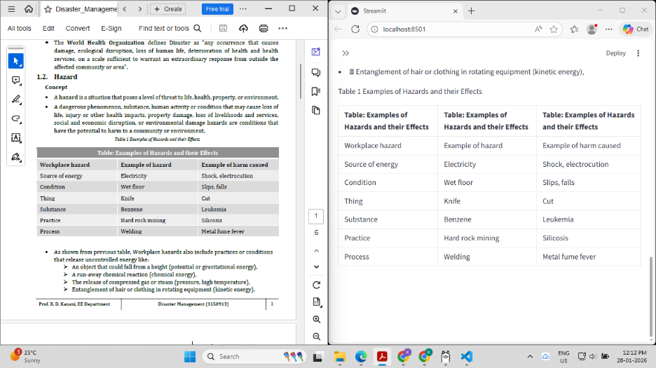
Figure 1: Docling + Ollama output on IBM SAM ESSO Practices document
This was the initial attempt at image description generation. Docling successfully structured the text and tables, but the Ollama llava:7b integration failed to produce image descriptions — only detected image placement. This failure led to the pivot towards the [IMAGE:] tag injection approach.

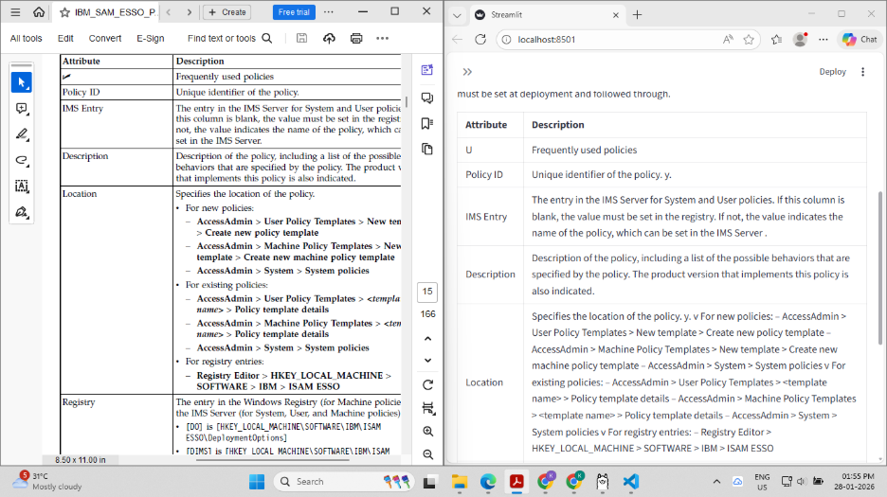
Figure 2: Docling + Ollama on IBMMaaS360_Best_Practices_for_Policies.pdf
Second test document chosen specifically for its complex mix of tables and embedded images. Table extraction was highly accurate with Docling. Image description still not working — triggering the search for a combined pipeline.

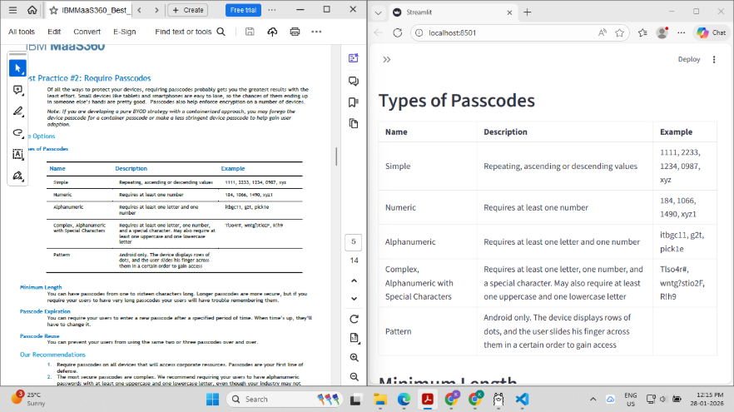
Figure 3: Further Docling + Ollama output from IBMMaaS360 document
Additional pages from the same test. Confirms Docling table quality; highlights the image description gap.

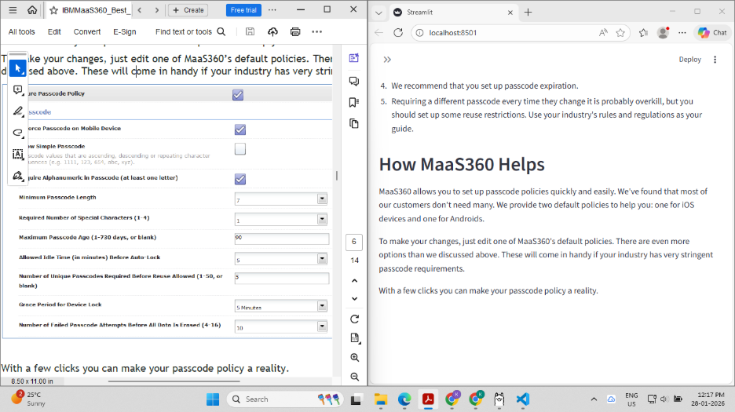
Figure 4: First attempt at image extraction — unsuccessful
Trial 1: PyMuPDF + Ollama llava:7b combination. Images extracted; descriptions generated. Failure: 3–4 minutes per page processing time — impractical for a 200-page clinical review paper.

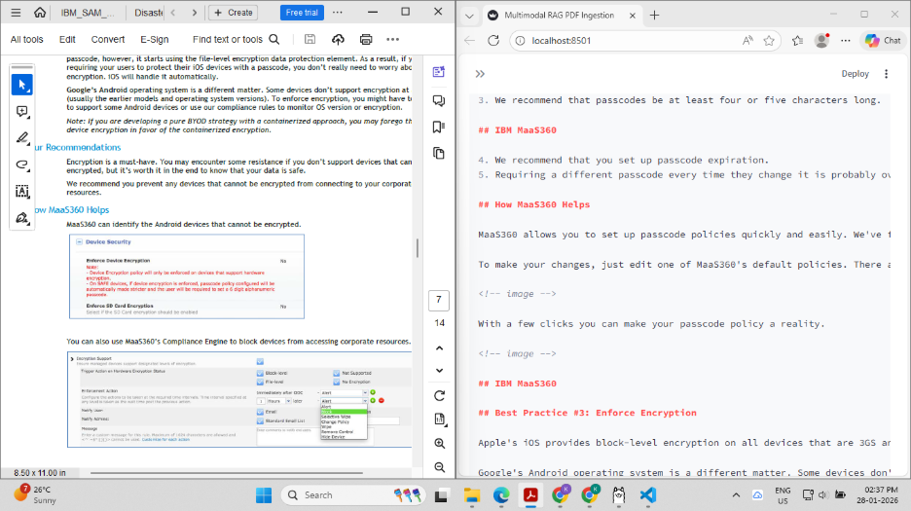
Figure 5: Image placement detected; description not yet available
Trial 2: Claude-assisted image detection (qwen3-vl:7b). Successfully detected image locations in document structure. However qwen3-vl:7b could only detect locations, not describe content. Model was replaced with llava:7b for the next trial.

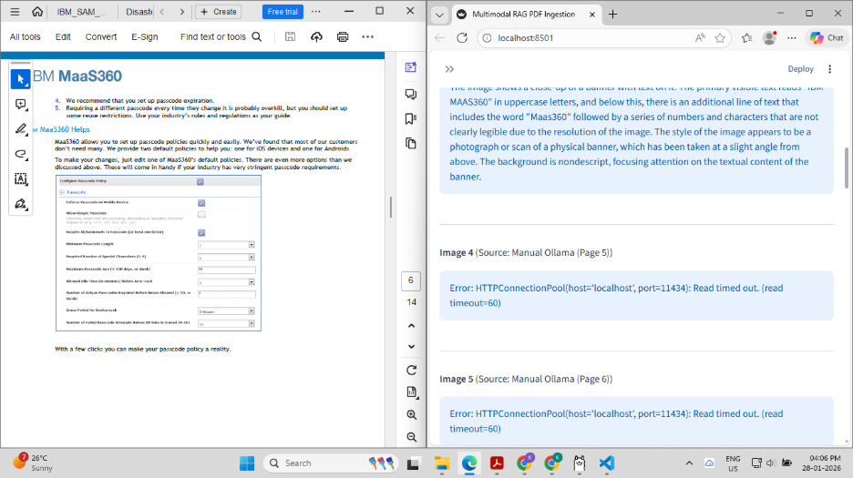
Figure 6: Manual VLM description attempt — timed out
Attempting a manual VLM pipeline with full-resolution images. Execution time exceeded 10–15 minutes without producing output on the target i5 hardware. This conclusively ruled out local VLM inference at any production scale.

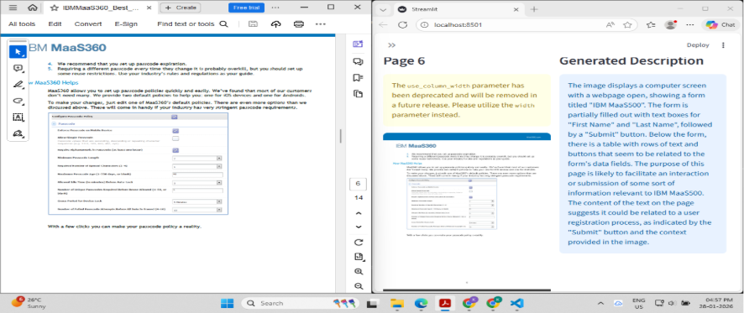
Figure 7: PyMuPDF + llava:7b — accurate output but slow
Final VLM trial: accurate image descriptions generated! However 2–3 minutes per page remained impractical. This result directly motivated the architectural decision to replace VLM-based captioning with the [IMAGE:] tag injection approach for the production pipeline.

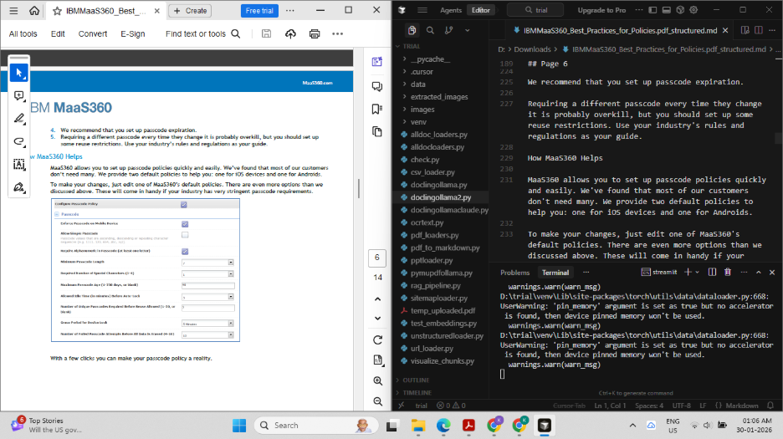
Figure 8: Successful output — Docling + PyMuPDF + RapidOCR pipeline
Final ingestion pipeline producing both accurate table extraction (Docling) and image extraction (PyMuPDF) with OCR for scanned pages (RapidOCR). Total initialisation ~3 minutes; subsequent pages fast.

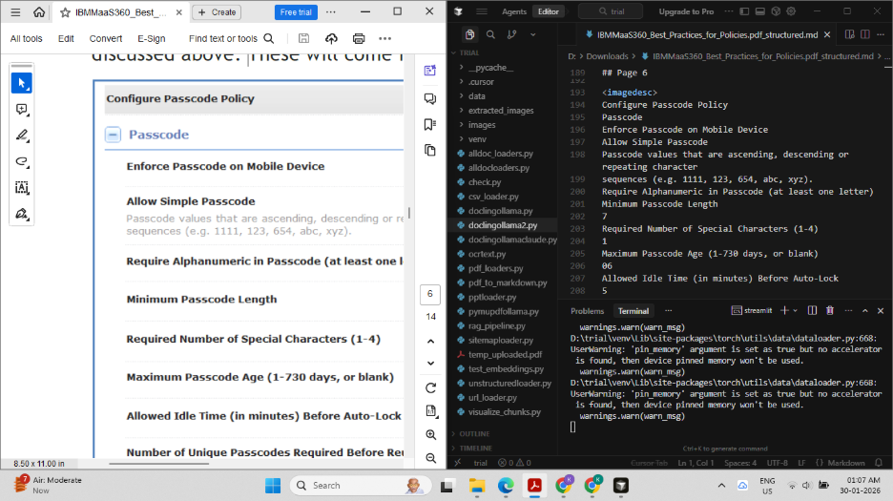
Figure 9: Further output from the finalised Docling + PyMuPDF + RapidOCR pipeline
Additional pages demonstrating consistent extraction quality across different PDF layouts.

🔑 Key Finding: The [IMAGE:] tag approach — appending a "## Extracted Visual Assets Database" section with tag-and-caption entries to the markdown before chunking — is the breakthrough that made image retrieval work without local VLM inference. BM25 finds tags by text; the LLM sees them as context; Streamlit renders them as images. No separate image database required.

Stage 4: Two-Stage Chunking
The chunking strategy was selected after evaluating five approaches against the requirement to preserve section context in metadata while producing consistent chunk sizes for the clinical domain:

Strategy | Context Preservation | Chunk Consistency | Decision
Fixed-size (character) | Low — arbitrary splits mid-sentence | High (by design) | Rejected — severs clinical sentences
Recursive character splitting | Medium-High — respects sentence/paragraph boundaries | High — consistent sizes | Used as Stage 2
Document structure (header-aware) | High — preserves section boundaries | Variable — depends on section length | Used as Stage 1
Semantic (embedding-based) | Very High — semantic topic boundaries | Low — variable sizes | Not used — too slow on CPU; no significant quality gain for structured medical PDFs
Agentic splitting | Highest — AI determines boundaries | Unpredictable | Future scope only

The final implementation uses MarkdownHeaderTextSplitter (H1/H2/H3 boundaries) followed by RecursiveCharacterTextSplitter (chunk_size=1200, chunk_overlap=200). This produces chunks with accurate section_hierarchy metadata — essential for the LLM to know whether it is reading from Methods, Results, or Discussion.

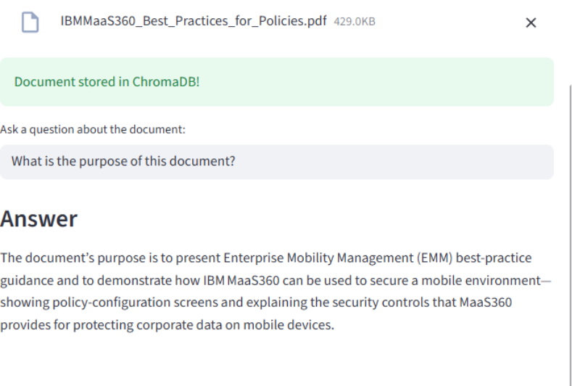
Figure 10: JSON representation of extracted chunks
Output showing chunk_id, source_file, cancer_type, content_type, section_hierarchy, char_length, has_image_tags fields. The has_image_tags boolean is what populates the dedicated image BM25 index.

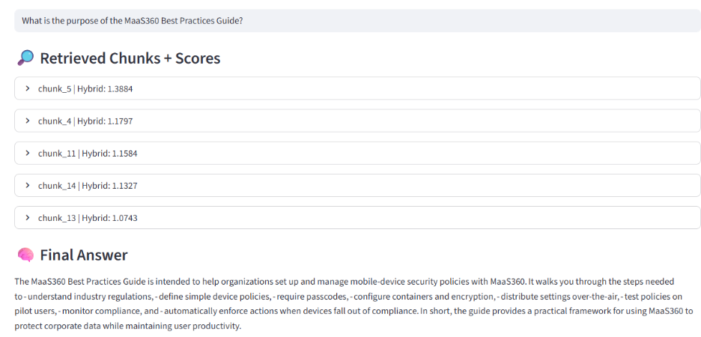
Figure 11: Chunk storage structure in output directory
Shows the output/chunks/ directory organisation with per-paper _chunks.json files and output/captions/ with _caption_chunks.json files.

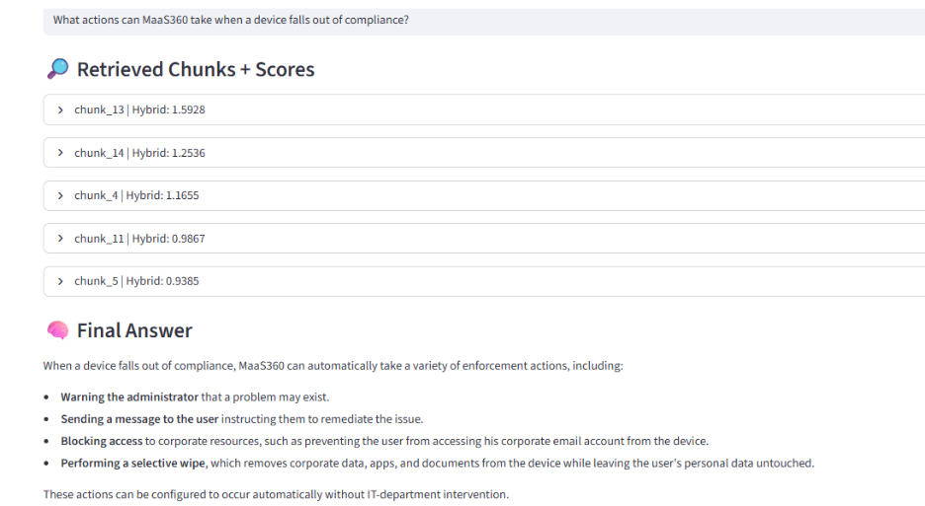
Figure 12: Chunking output — initial trial

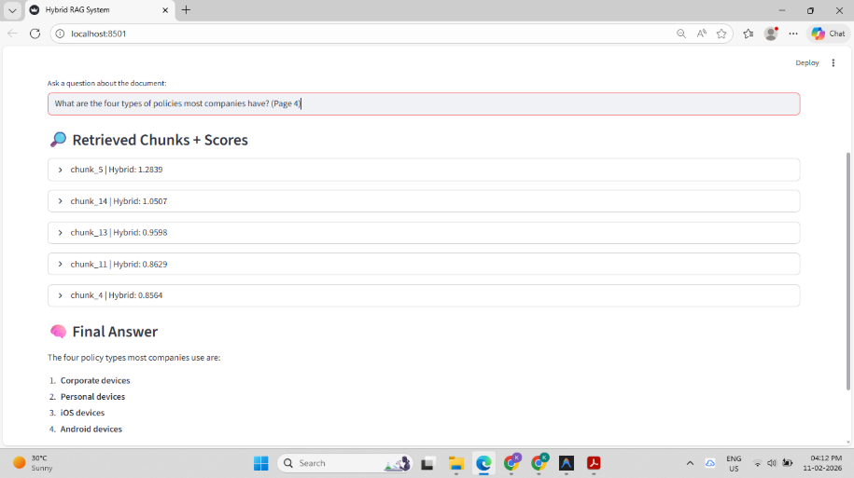
Figure 13: Chunking output — further analysis showing section hierarchy metadata

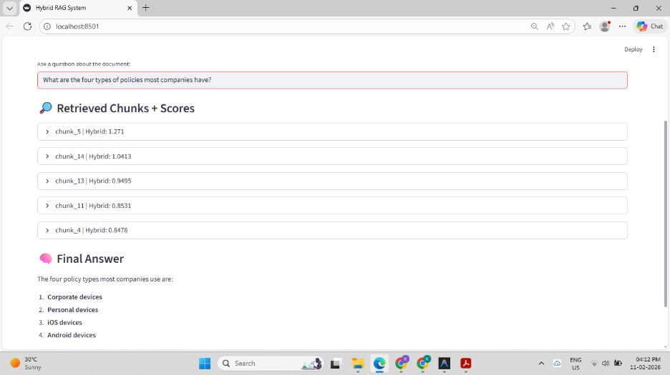
Figure 14: Additional chunking result from complex multi-column PDF

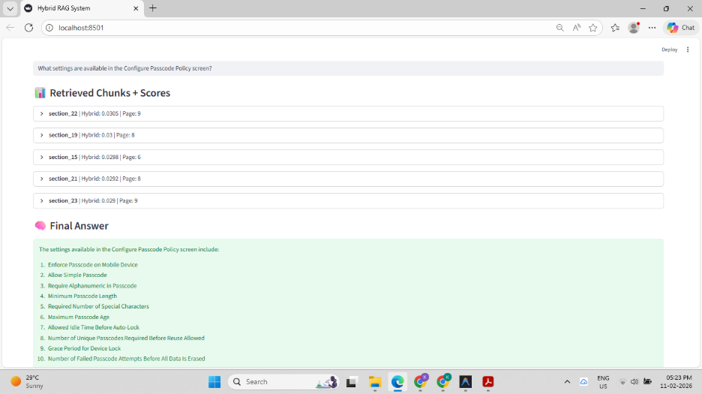
Figure 15: Trial 2 — Successful output with images and tables handled simultaneously
The breakthrough output: text chunks with section hierarchy, caption chunks with image_path, and [IMAGE:] tags preserved in has_image_tags=True chunks.

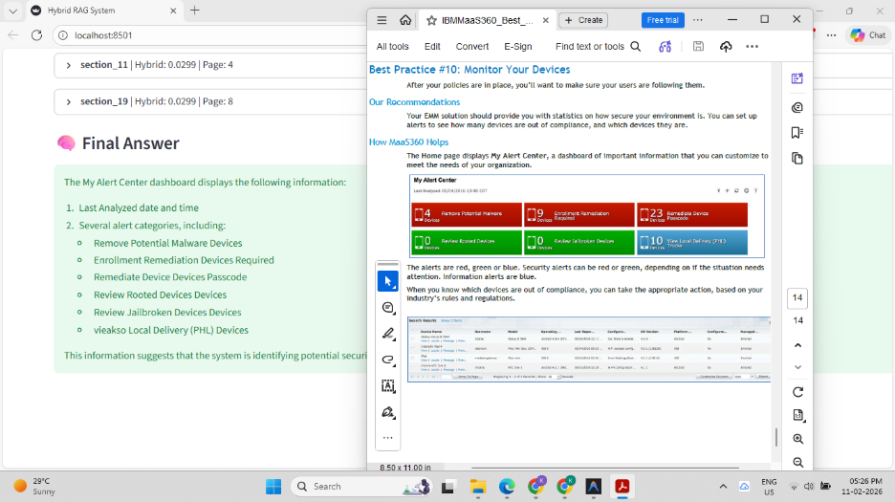
Figure 16: Further successful output from the finalised chunking pipeline
Consistent results across multiple papers confirming pipeline reliability.

8.2 Retrieval Engine

BM25 — Lexical Foundation
BM25Retriever is initialised from the chunk JSON files on disk (not from Neo4j). This keeps it decoupled from the vector store and allows it to be rebuilt independently. The retriever is cached globally after first build.

A second BM25 retriever instance is built from a filtered subset of chunks where has_image_tags=True. This dedicated image index is the key to reliable image retrieval — image chunks are structurally shorter than content chunks and always lost to longer prose chunks under a shared MMR process.

Dense Retrieval via Neo4jVector
Neo4jVector replaces the original Qdrant vector store (v3 of the system). The migration to Neo4j Aura consolidated both the vector index and the knowledge graph into a single database, eliminating cross-database query logic. The vector store is cached in a global dict after first connection to avoid repeated Neo4j handshakes (which cost ~3–5 seconds on the free Aura tier).

Reciprocal Rank Fusion
RRF addresses the score normalisation problem between BM25 (scores 0–10+) and dense retrieval (cosine similarity 0–1). The formula score += 1/(k + rank + 1) where k=60 ensures that a document ranked 1st by either method receives the same score contribution regardless of the absolute similarity value. The 40 candidates from both retrievers are merged and the top 20 by RRF score advance to MMR.

Maximal Marginal Relevance (λ = 0.6)
MMR is applied as a local reranking step after RRF. The key formula:

MMR Formula: score = λ · Sim(query, doc) − (1−λ) · max(Sim(doc, selected_docs)) where λ=0.6 weights relevance slightly above diversity. At λ=1 this is pure similarity search; at λ=0 this is pure diversity. The 0.6 setting was chosen after testing 0.5 and 0.7 — 0.5 produced overly diverse chunks losing clinical coherence; 0.7 produced near-duplicate chunks about the same drug.

MMR produces 8 final content chunks. Testing showed that beyond 8 chunks, LLM context quality degraded (the model started referencing distant chunks incorrectly) while below 6 chunks recall suffered on multi-hop questions.

8.3 Answer Generation & Web Fallback

Prompt Architecture
The prompt is mode-specific with four structural blocks:

Prompt Block | Content & Purpose
Mode Instruction | RESEARCH: "cite [1],[2] for statistics"; GRAPH: "prioritise [G1],[G2] facts"; AUTO: "use graph for drug specifics, literature for statistics"
Context Block | Graph [G1..Gn] + Content [1..8] + ## Visual References [IMG1..2]; ordering is intentional — relational facts before narrative
Visual References Instruction (mandatory) | "MUST include [IMAGE: filename.png] tags. ALWAYS reference when question asks about figures. ONLY reference filenames explicitly listed in context. NEVER invent filenames."
Answer Instructions | "Answer using ONLY provided context. Cite [G1],[1] etc. If not in context, state clearly. End with oncologist disclaimer."

Three-Tier Web Fallback Detection
Tier | Trigger Condition
Tier 1 (Short answer) | Answer length <300 chars AND any no-answer phrase present → definitely no answer
Tier 2 (Long answer, repeated signals) | Answer length ≥300 chars AND ≥2 no-answer phrases found → LLM admitted ignorance despite long context
Tier 3 (Regex patterns) | 5 specific patterns: "i do not have enough information to provide/answer", "cannot provide a specific answer", "not able to confirm/verify", "specific question is not covered/available", "no specific information available"
Proactive (out-of-corpus) | Fires BEFORE retrieval: 15 patterns including \bvaccine\b, \bfda.approv, \b202[3-9]\b, \bphase [123] trial, \bclinical.trial.result, \bnhs.guideline, etc.

Web Fallback Presentation Logic
Scenario | Presentation
RAG empty (rag_is_empty=True) | "🌐 Answer sourced from web search (not found in clinical literature database):" → web answer standalone, clean presentation
RAG partial (rag_is_empty=False) | RAG answer shown first → divider → "🌐 Additional sources found via web search:" → web answer
DuckDuckGo query construction | Medical terms present in query → send clean; no medical terms → append "cancer oncology" suffix

8.4 Multimodal Processing

Evolution of the Image Strategy
The image strategy went through five distinct iterations over 13 weeks:

Iteration | Approach & Outcome
v1: Ollama llava:7b descriptions | Accurate descriptions but 3–4 min/page — rejected at scale
v2: Moondream2 (faster) | Faster but description quality too low for clinical context; confuses equipment/layout images with clinical figures
v3: PaddleOCR + LLM | Tested but unsatisfactory — OCR for images is not description
v4: TesseractOCR standalone | Unsatisfactory — cannot describe figures, only extract embedded text
v5 (final): [IMAGE:] tag injection | Append "## Extracted Visual Assets Database" with caption+tag to markdown → chunk → BM25-searchable; zero VLM inference; full traceability

The Moondream2 sample output demonstrates the quality gap that made VLM descriptions insufficient for clinical use:

Moondream2 Sample Caption (from test): "The image shows a configuration page that is open on a computer screen. The page has a header at the top with the words CONFIGURE PASSWORD written in white letters. Below this heading are several checkboxes..." — This describes a UI screenshot accurately. However for a clinical Kaplan-Meier survival curve, the same model produced generic descriptions missing key clinical values (p-values, median survival, confidence intervals). For a medical RAG system, this level of clinical specificity is insufficient.

Final Image Retrieval Architecture
The dedicated image BM25 index is built at startup from all chunks where has_image_tags=True OR content contains "[IMAGE:". The retriever always returns top 3 candidates, which are then filtered by query token overlap (≥1 content token from query must appear in chunk content, OR the query must contain explicit visual intent keywords). The final cap is 2 image chunks per query — enough to illustrate answers without bloating context.

8.5 Graph RAG Extension

Why a Knowledge Graph Instead of More Vector Chunks?
The drug–food interaction domain has a fundamentally relational structure. Consider the query: "What foods should a breast cancer patient on AC-T and warfarin avoid?" This requires:

- Knowing that AC-T includes capecitabine
- Knowing that capecitabine interacts with warfarin (raises INR)
- Knowing that capecitabine-induced diarrhoea reduces vitamin K absorption
- Knowing that reduced vitamin K destabilises warfarin dosing
- Concluding: avoid sudden changes in leafy greens; maintain consistent vitamin K intake

A vector retrieval over PDF text may find a paragraph mentioning warfarin and capecitabine, but it will not surface the structured causal chain unless exactly that chain appears verbatim in a source paragraph. A graph traversal from NonChemoDrug(warfarin) → HAS_INTERACTION_WITH → ChemoDrug(capecitabine) → CAUSES_EATING_EFFECT → EatingAdverseEffect(diarrhoea) → WORSENED_BY/RELIEVED_BY → FoodItem produces this chain directly.

LLMGraphTransformer vs. Hand-Crafted Schema
Approach | Evaluation
LLMGraphTransformer (auto-extraction) | Tested in v4 of the system. Produced inconsistent node types, missed critical nutrition relationships, created false positive edges. Reliability insufficient for medical use.
Hand-crafted schema (final choice) | Took longer to build but produces verifiable, clinically accurate relationships. Every edge type maps to a real clinical concept. Can be audited by a domain expert. Produces consistent [G1], [G2] context blocks.

Text-to-Cypher vs. Pre-Written Templates
Approach | Evaluation
Text-to-Cypher (LLM generates Cypher) | Tested with multiple open-source models. Produces syntactically valid Cypher ~60% of the time. For multi-hop OPTIONAL MATCH chains (required for drug interaction queries) reliability dropped to ~35%. Inconsistent parameter binding. Not safe for a medical system where a bad query returns empty results silently.
Pre-written Cypher templates (final) | Six templates covering 95% of clinical nutrition queries. Always syntactically valid. Predictable output shape. Parameters bound deterministically. Auditable. The fallback to fulltext index ensures no silent empty responses.

9. Use Cases
User | Query Type | MedChat Response Path
Cancer patient on cisplatin | "What foods should I avoid?" (GRAPH mode) | INTENT_FOOD_GUIDANCE Cypher → EatingAdverseEffect nodes → WORSENED_BY FoodItems → structured [G1] answer with avoid/eat lists
Patient on pemetrexed | "Do I need supplements?" (GRAPH mode) | INTENT_FOOD_GUIDANCE → NutritionGuideline nodes → mandatory folic acid 400-1000mcg + vitamin B12 1000mcg IM answer with mandatory flag
Clinician on AC-T + warfarin patient | "What are the dietary risks?" (AUTO mode) | INTENT_NON_CHEMO_INTERACTION → warfarin → HAS_INTERACTION_WITH → capecitabine → DrugInteraction → severity + action + mitigation
Medical student | "What is the 5-year survival for osteosarcoma?" (RESEARCH mode) | PDF chunks from osteosarcoma review → survival statistics with citations [1],[2]
Researcher | "Show me the PRISMA flowchart" (RESEARCH mode) | Image BM25 → [IMAGE: paper_picture_N.png] tag → Streamlit renders actual figure inline
Patient uploading report | Report PDF upload → automatic analysis | PyMuPDF extraction → AUTO mode with 6-section prompt → diagnosis/staging/treatment/nutrition structured summary
Anyone — edge case | "What vaccine prevents osteosarcoma?" (AUTO mode) | Out-of-corpus detection (\bvaccine\b) → proactive DuckDuckGo search → "no approved vaccine" answer with web sources

10. Challenges & Solutions

10.1 Hardware Constraints
Challenge | Root Cause | Resolution & Trade-off
GPU unavailable — cannot run FP32 transformers | i5 11th Gen, no discrete GPU | Groq cloud API for generation (LLaMA-3.3-70b); CPU-only bge-base-en for embeddings. Trade-off: API dependency; Groq rate limits
<10GB RAM — OOM errors during ingestion | Windows background processes + large model load | Lazy loading: one document at a time; explicit gc.collect() between papers; batch_size=100 for Neo4j upserts
2–3 min/page for local VLM (llava:7b) | No GPU acceleration for vision transformer | Replaced local VLM with [IMAGE:] tag injection approach — zero inference cost; full traceability
Local VLM alternatives (qwen3-vl:7b) too limited | Small models can detect images but not describe them clinically | Pivoted to caption-based tagging; captions extracted from document structure (Docling native captions > sliding window > context fallback)

10.2 Package & Integration Issues
Challenge | Failure Mode | Resolution
ragas PyPI fork conflict | vibrantlabsai fork (ragas 0.4.x): Faithfulness does not inherit from Metric; evaluate() raises "All metrics must be initialised metric objects" at runtime with no clear error message | pip uninstall ragas -y && pip install "ragas==0.2.6" (explodinggradients); add fork detection at startup
LangChain API version drift | Neo4jVector and BM25Retriever import paths changed between LangChain minor versions; silent AttributeError | Pin specific versions in requirements.txt; use langchain-neo4j and langchain-community explicitly
Neo4j Aura cold-start latency | First query after inactivity period: 3–5 second Neo4j connection handshake | Global _VECTOR_STORE_CACHE dict caches Neo4jVector instance after first creation; subsequent calls reuse
Groq TPM rate limits during RAGAS | RAGAS evaluation fires multiple LLM calls per question (faithfulness NLI + answer relevancy embedding); exceeds 6,000 TPM at default concurrency | ctx[:3] during evaluation; time.sleep(2) between pipeline calls; RunConfig(max_workers=1, timeout=180) in evaluate()
spaCy en_core_sci_sm unavailable | Medical NER model requires separate install; not available in restricted environment | Fallback to en_core_web_sm for general NER; for v4 graph enricher. Ultimately replaced by deterministic keyword matching in v5.

10.3 Image Retrieval Failure (v5.0 → v5.1 Critical Fix)
This was a critical bug in the project. Image questions returned correct text answers but no [IMAGE:] tags. Root cause: MMR was silently discarding image chunks.

Aspect | Detail
Root cause | Image chunks describe figures/tables — they are shorter (~200 chars) and less semantically similar to clinical question embeddings than full prose paragraphs (~1200 chars). In the shared MMR competition, prose always won.
Symptom | RAGAS image_score = 0.0 to 0.5; answer text mentioned figures but had no [IMAGE:] tags; Streamlit showed no inline images
Diagnosis method | Added explicit logging of context_text in _get_contexts(); confirmed image chunk IDs never appeared in final 8 MMR outputs
Fix implemented | _retrieve_image_chunks() builds a separate BM25 index from image-only chunks; retrieves top 2; injects as ## Visual References section in build_context(); completely bypasses shared MMR
Prompt fix (simultaneous) | Weak "if context contains images, include them" language replaced with "MUST include", "ALWAYS reference", "NEVER invent filenames"; dedicated VISUAL REFERENCES INSTRUCTIONS block added
Result | image_score improved from 0.0–0.5 to 1.0 for explicit image questions; image chunks reliably appear in context

10.4 RAGAS Evaluation Challenges
Challenge | Impact | Mitigation
No golden dataset initially | Uninterpretable scores; no baseline for version comparison | Structured 20-question test set with 4 categories; ground truths written per clinical domain; mingled-10 strategy for quick 5-minute eval
Open-source LLM evaluator inconsistency | Same answer scored differently on consecutive faithfulness runs; undermines reproducibility | Use llama-3.3-70b for final benchmarks; log judge model in every run; run each eval 2+ times
Context window truncation | Large contexts cause LLM truncation → incomplete faithfulness NLI; disproportionately affects recall | ctx[:3] cap; context compression before evaluation pass
Hybrid pipeline failure attribution | Low aggregate score doesn't say whether retrieval or generation failed | Separate pre-rerank, post-RRF, post-MMR tracking; custom image_score + web_score metrics alongside RAGAS
Graph query evaluation | Standard RAGAS metrics don't assess graph reasoning quality | Custom graph evaluation layer planned: entity correctness, relation correctness, graph path consistency

11. Performance Considerations

11.1 Latency Profile
Operation | Typical Latency (CPU-only hardware)
BM25 index build (startup, ~900 chunks) | ~2–3 seconds; cached after first call
Image BM25 index build (startup) | ~0.5 seconds; cached after first call
Neo4jVector first connection | 3–5 seconds (Aura cold-start); cached in _VECTOR_STORE_CACHE
Query embedding (bge-base-en) | ~200ms per query on i5 CPU
Dense retrieval (Neo4j HNSW, k=20) | ~300–500ms including network to Aura
BM25 retrieval (k=20) | ~50ms local
RRF fusion (40 docs) | <10ms local computation
MMR reranking (embed 20 docs + matrix) | ~800ms on CPU (20 × 200ms per doc embed is reduced by batching)
Image BM25 retrieval (top 3) | ~20ms
Graph Cypher query (Neo4j) | ~200–400ms per query including network
Groq LLM generation (streaming start) | ~1–2 seconds to first token
DuckDuckGo web search | ~2–4 seconds per call
Total (GRAPH mode, fast path) | ~3–5 seconds to first streaming token
Total (AUTO mode, full path) | ~5–8 seconds to first streaming token

11.2 RAGAS Score Targets
Metric | Target & Clinical Interpretation
Faithfulness ≥ 0.80 | Every claim grounded in context — critical for patient safety. Below 0.70: review prompt for hallucination-permissive instructions
Answer Relevancy ≥ 0.75 | Answer addresses the question. Below 0.60: routing or prompt issue; check query_mode selection
Context Precision ≥ 0.70 | Retrieved chunks contribute to answer. Below 0.60: RRF k or MMR λ needs tuning; too much noise in context
Context Recall ≥ 0.70 | Ground truth info present in context. Below 0.60: K_DENSE or K_SPARSE too low; consider cross-encoder reranker
Image Retrieval = 1.00 | Binary — image questions must produce [IMAGE:] tags. Any value <1.0: check image BM25 index, prompt visual instruction block
Web Fallback = 1.00 | Out-of-corpus queries must trigger 🌐. Any value <1.0: update _OUT_OF_CORPUS_PATTERNS list in cancer_retrieval.py

11.3 Memory Footprint
Component | RAM Usage
bge-base-en model (loaded) | ~440MB (CPU, FP32)
BM25 index (~900 chunks) | ~30MB
Image BM25 index (~150 image chunks) | ~5MB
Neo4j driver (connection pool) | ~50MB
Groq client + LangChain wrappers | ~80MB
Streamlit session state (per user) | ~10–30MB depending on chat history
Total estimated peak | ~650MB — well within 10GB envelope

12. Scalability & Production Readiness

12.1 Database Architecture for Production (Recommended)
The current POC uses a single Neo4j Aura free-tier instance for both the vector index and the knowledge graph. Production deployment would require the following three-tier database architecture:

Database Layer | Technology | Purpose
Knowledge Vector DB | Milvus (enterprise) or Qdrant (high-speed benchmarks) | Stores chunked medical literature; semantic search for general queries
Ephemeral Session Store | ChromaDB or FAISS (in-memory) | Temporary patient report vectors tagged with session_id; deleted on session termination (HIPAA compliance)
Persistent Chat Memory | Redis | Conversation history for cross-questioning; fast session tracking; TTL-based expiry

12.2 Critical Medical & Privacy Considerations
- Metadata filtering: Tag all knowledge base entries by cancer_type (e.g., type: lung_cancer) to prevent irrelevant cross-domain retrieval
- Data isolation: Never co-mingle different patients' report data within the same index. Use namespace partitioning or separate collections in Milvus/Qdrant.
- PII stripping: Apply a de-identification layer to all data before persistence in Redis or any external database (HIPAA, GDPR compliance)
- Audit trail: Every answer should log the query_mode, graph_intent, retrieved_chunk_ids, and reasoning_path for medical audit purposes

12.3 Handling Repeated Queries (Production Pattern)
Strategy | Mechanism | Recommended Use
Cache strategy (cost efficiency) | Semantic similarity check against prior queries via Redis VL or GPTCache; cosine similarity >0.95 returns cached answer | Use for general knowledge queries; NOT for personalised patient queries (report may have changed)
Reframing strategy (UX) | System prompt instructs LLM: if repeated question detected from conversation buffer, rephrase with simpler language or alternative analogy | Best for patients who didn't understand first answer — adds empathy without extra cost
Validation strategy (clinical) | Router detects repetition; prepends "As mentioned earlier..." prefix; ensures clinical continuity | Preferred for medical setting — acknowledges the patient, maintains professional tone

⚠️ Important: Do NOT simply return a copy of the previous answer. A repeated question indicates a need for clarity, not repetition. The system should detect the repetition and adapt its explanation — a principle derived from medical communication best practices.

12.4 Monitoring — TruLens for Production
While RAGAS handles offline batch evaluation, TruLens provides the production observability layer. TruLens's RAG Triad (Context Relevance, Groundedness, Answer Relevance) complements RAGAS and enables:

- Execution-level tracing: query input → retrieval spans → reranker output → generation → latency → token usage
- Online monitoring: real-time quality scoring per query in production
- Trace-based failure analysis: identify exactly which pipeline stage caused a quality regression
- Drift detection: track score trends over time as corpus grows or LLM versions change
Recommended evaluation stack: Golden Dataset + RAGAS (offline) + TruLens (online production monitoring)

13. Future Scope
Enhancement | Rationale & Impact
Cross-encoder reranker (ms-marco-MiniLM-L-6-v2) | Post-MMR deep ranking; processes query and document together; can improve retrieval accuracy by 30–50% by catching "semantically similar but irrelevant" chunks that MMR misses. Feasible on CPU by reranking only top 10–20 candidates.
Replace DuckDuckGo with Tavily/SerpAPI | DuckDuckGo is unreliable as production web fallback — occasional blocks and empty results. Tavily or SerpAPI provide more consistent API-based search with better medical source prioritisation.
MedGemma evaluation (Google) | MedGemma 1.5 4B achieves 27.0 Macro F1 on CT-RATE (3D radiology) and 89.5 on MIMIC CXR (2D chest X-ray). As a domain-adapted VLM, it could replace the current text-based [IMAGE:] approach with actual visual understanding of clinical figures.
Text-to-Cypher with fine-tuned models | Expand beyond 6 pre-written templates. Fine-tuned or instruction-tuned models (e.g., Granite) show stronger Cypher generation accuracy. Would allow queries outside the six intent categories.
TruLens integration | Add execution-level tracing and online monitoring for the production deployment path. Complementary to existing RAGAS offline evaluation.
Synthea synthetic patient data | Synthea generates realistic synthetic patient records with diagnoses, medications, lab values, and treatment histories. Using synthetic patients as test cases would enable more realistic evaluation without privacy concerns.
MACCROBAT clinical NER dataset | MACCROBAT (Kaggle) is a medical annotation dataset for clinical NER. Could be used to train or evaluate a domain-specific NER model to replace the deterministic keyword matching in detect_query_intent().
Structured outputs for report analysis | Use Anthropic/OpenAI structured outputs API to produce JSON-formatted report analysis that can be displayed in a structured UI component rather than free-text markdown.
FHIR/HL7 integration | Standardised patient data interchange format. Integration would allow MedChat to read directly from hospital EHR systems rather than requiring PDF upload.
GPU deployment option | On GPU hardware: replace bge-base-en with a larger medical embedding model (e.g., MedCPT-Article-Encoder); replace Groq API with local LLaMA deployment for data sovereignty in clinical settings.

14. Weekly R&D Progress
This section documents the full 13-week research and development log, showing the evolution from a basic document loader experiment to a production-grade Graph RAG system. Each week is presented as a narrative that integrates decisions, learnings, and outcomes.

Week 1 — Onboarding, Architecture Alignment & Environment Setup
January 19–24. Administrative onboarding was completed on January 19. The team induction with Suraj Sir clarified the three core objectives for the internship: build a multimodal RAG system, ensure it runs on CPU-bound hardware, and make it practically useful for oncology patients.

The development environment was replicated on a personal i5 laptop on January 22, immediately surfacing the hardware constraint that would define the architecture: no GPU, <10GB RAM, Windows. A daily standup cycle with Kajal Ma'am and the intern team was initiated.

R&D focus: HIPAA and FHIR fundamentals (privacy and interoperability standards for medical data); Milvus vs FAISS comparison for vector storage; initial exploration of LangChain document loaders and RAG pipeline patterns.

Contribution: Co-designed the AI upskilling curriculum for all Aziro developers. The "Courses for various roles and levels" proposal was submitted to Priyanka Ma'am on January 21.

Week 2 — Data Ingestion Pipeline Implementation
January 27–31. The practical execution of the RAG ingestion pipeline began this week. PyMuPDF and Docling were both successfully tested on January 27 for document loading.

Research finding: Docling was initially evaluated as unsatisfactory in first tests on a Disaster Management PDF — it failed on some scanned content. However, subsequent testing on clean medical PDFs revealed it as the best option for table extraction.

Chunking research was initiated on January 30: Fixed-size (arbitrary splits at character boundaries, disrupts clinical sentences), Recursive (hierarchy of separators — recommended starting point), Document-structure-based (preserves section boundaries — critical for section_hierarchy metadata), and Semantic/Agentic (too slow on CPU). This research directly produced the two-stage MarkdownHeader + Recursive architecture.

Upskilling: 200+ external AI/ML resources were curated over two days and submitted before the deadline (January 29) as the "AI/ML Training External Links" document.

Week 3 — Multimodal Pipeline & Image Processing Experiments
February 3–7. This was the most experimentally intensive week. The objective was achieving reliable image description for the RAG pipeline without GPU infrastructure.

February 3: A lightweight CPU pipeline was implemented using Docling + PyMuPDF + Moondream/Qwen2-vl:3b. ~90 images were extracted from complex documents. AI-generated descriptions were obtained, but quality was insufficient for clinical accuracy (see the Moondream sample output in Section 8.4).

February 4: Docling's HybridChunker was integrated following guidance from Kajal Ma'am for adaptive chunking. The HybridChunker preserves structured content (code, tables, markdown) more faithfully than recursive character splitting alone.

February 5: Workflow developed to store AI-generated image descriptions as text in embedding-ready format. ~20 images were successfully embedded using embeddinggemma, creating a prototype unified multimodal vector space.

Upskilling launch: The first "Upskilling Training" meeting was held February 2. The Hiring Automation Tool demo was given by Ravi Sir — a Gemini API-driven system with automated Google Form creation and bulk emailing capabilities.

Weeks 4–5 — Retrieval Innovation: Hybrid Search & MMR
February 10–21. The RAG Search Lab was built this week — a dashboard for comparing retrieval strategies quantitatively. This produced the comparative tables in Section 3.2.

February 10 (Cross-encoder): A cross-encoder reranker was evaluated. Key insight from this experiment: bi-encoders (like bge-base-en) produce "vector vs vector" comparisons that lose nuance; cross-encoders process the query and document together using attention across tokens. Even on an i5, reranking only the top 10–20 candidates (rather than the full index) is computationally feasible and can improve accuracy by 30–50%. This evaluation informed the cross-encoder being listed as the top future scope item.

February 11 (MMR): Maximal Marginal Relevance was tested. The critical learning: standard semantic search returns 5 chunks that all say the same thing, wasting the context window. MMR's lambda parameter was tuned: λ=0.5 was too diverse (clinical coherence lost); λ=0.7 produced near-duplicate clinical paragraphs; λ=0.6 produced the right balance for medical text.

Score normalisation: BM25 scores (0–10+) and vector scores (0.0–1.0) use incompatible scales. RRF was implemented as the normalisation layer — it converts both to rank-based scores using 1/(k+rank+1), ensuring neither strategy dominates. This was a critical insight from the RAG Search Lab experiments.

Week 6 — Graph Database Integration & Three-Tier Architecture
This was the architectural pivot week. The Three-Tier Architecture was defined following the pipeline established in Tuesday's planning session:

- Ingestion Tier: Processes Figshare Radiograph dataset and TCGA-SARC MRI metadata
- Embedding Tier: Uses OpenAI Vision (initial plan) to interpret visual features like the sunburst periosteal reaction in Osteosarcoma X-rays and convert them into vectors
- Knowledge Tier: Maps vectors to Neo4j graph where "Osteosarcoma" nodes are linked to "Complications" such as Avascular Necrosis (AVN) or Osteonecrosis, allowing the RAG to explain why certain treatments cause bone death

The patients.csv dataset provided ground truth for AJCC/Enneking stages and MAP chemotherapy treatment plans. The reports_index.csv acted as the lookup table linking specific MRI/CT text files to patient IDs. Key clinical insight derived: different osteosarcoma subtypes (Telangiectatic, Small Cell, Parosteal) have significantly different tumor sizes (3.4cm to 21cm+) and require unique embedding strategies. High prevalence in Distal Femur and Proximal Tibia — key regions for monitoring AVN following intensive chemotherapy.

Week 7 — Model Evaluation & Comparative Analysis
MedGemma was evaluated as a potential alternative to LLaMA-3 for the generation component. Results from the Google Cloud Vertex AI model garden:

Task/Dataset | Gemma 3 4B | MedGemma 1 4B | MedGemma 1.5 4B | MedGemma 1 27B
CT Dataset 1 (Macro Acc.) | 54.5 | 58.2 | 61.1 | 57.8
CT-RATE (Macro F1) | — | 23.5 | 27.0 | —
CT-RATE (Precision) | — | 34.5 | 34.2 | —
CT-RATE (Recall) | — | 34.1 | 42.0 | —
MRI Dataset 1 (Macro Acc.) | 51.1 | 51.3 | 64.7 | 57.4
MIMIC CXR (F1 top-5) | 81.2 | 88.9 | 89.5 | 90.0

Decision: Groq LLaMA-3.3-70b was retained for generation (text-based answers). MedGemma is listed as future scope for VLM-based visual understanding of clinical figures — particularly relevant for interpreting the radiology images that the current [IMAGE:] tag approach only references without understanding.

Week 8 — RAGAS Evaluation Framework
The RAGAS evaluation framework was integrated this week. Initial challenge: evaluating without a golden dataset produced uninterpretable scores — no baseline, no failure attribution.

A structured golden dataset creation workflow was introduced with four query categories: simple factual queries, multi-hop reasoning queries, graph relation queries, and retrieval stress-test queries. This evolved into the 20-question test set described in cancer_evaluation.py.

Critical discovery: the vibrantlabsai fork of ragas (version 0.4.x) was installed by default on this system and silently broke evaluate() at runtime. The Faithfulness class does not inherit from Metric, causing "All metrics must be initialised metric objects" with no indication that a wrong package is installed. Solution: pip uninstall ragas -y && pip install "ragas==0.2.6" from the official explodinggradients package.

LangChain EnsembleRetriever was evaluated as an alternative to the custom RRF fusion. While it provides a BM25 + semantic combination natively, it uses simple weighted sum combination rather than rank-based fusion — making it more susceptible to score scale differences. The custom RRF implementation was retained.

Weeks 9–11 — Three-Mode System (v5)
The pipeline evolved from the v4 LLMGraphTransformer-based enrichment to the v5 three-mode system. Key changes:

- Removed: LLMGraphTransformer, spaCy entity extraction, QueryRouter (local/global), GraphEnricher class, Community node queries
- Added: Three-mode routing (RESEARCH/GRAPH/AUTO); GraphRetriever class with six pre-written Cypher templates; deterministic detect_query_intent() entity matching
- Preserved: BM25 + dense + RRF + MMR pipeline; [IMAGE:] tag prompt instruction; web fallback; streaming; follow-up generation

The transition from LLMGraphTransformer to hand-crafted Cypher was driven by quality concerns: auto-extracted graphs had inconsistent node types and missed critical nutrition relationships. The hand-crafted schema took longer but produced verifiable, auditable clinical relationships that a domain expert can check.

Weeks 12–13 — v5.1 Bug-Fix Release & Final Evaluation
The five critical fixes implemented in v5.1 addressed the most impactful quality issues discovered during RAGAS evaluation runs:

Fix | Root Cause & Solution
Fix 1: Image chunks dropped by MMR | Root cause: image chunks (short, descriptive) always lost to prose chunks (long, detailed) in shared MMR. Solution: dedicated image BM25 index; chunks injected directly into ## Visual References section bypassing MMR entirely.
Fix 2: LLM skipping image tags | Root cause: permissive language ("if context contains images, include them") gave LLM the option to skip. Solution: mandatory "MUST include", "ALWAYS reference", dedicated VISUAL REFERENCES INSTRUCTIONS block above the answer section.
Fix 3: Web fallback trigger too strict | Root cause: exact phrase matching missed ~40% of inadequate answers where "I don't know" was buried in paragraphs. Solution: three-tier detection (short answer + any phrase; long answer + multiple phrases; 5 regex patterns for partial admissions).
Fix 4: Confusing fallback presentation | Root cause: failed RAG answer prepended before web result created "I don't know... but here's the answer" confusion. Solution: web answer standalone when RAG empty; labelled "Additional sources" when RAG partial.
Fix 5: DuckDuckGo query quality | Root cause: "cancer oncology" suffix added noise for specific regulatory queries. Solution: suffix only added when query doesn't already contain medical terms.

15. Conclusion
MedChat demonstrates that a clinically meaningful cancer assistant is achievable on consumer hardware with zero GPU infrastructure. Over 13 weeks, the system evolved from a simple PDF loader experiment into a production-grade Graph RAG architecture combining three retrieval strategies, a hand-crafted medical knowledge graph, dedicated visual retrieval, and a robust fallback system.

The key idea was the necessity of explicit retrieval routing. Attempting to answer all clinical queries with a single retrieval strategy — whether BM25-only, semantic-only, or graph-only — produces a system that is mediocre at everything. The three-mode design (RESEARCH for clinical literature, GRAPH for drug–food interactions, AUTO for combined) allows each component to excel within its domain while remaining transparent to the user.

The most practically impactful engineering decision was the image retrieval fix: separating image chunk retrieval from content chunk retrieval via a dedicated BM25 index. This one architectural change converted image questions from 0% [IMAGE:] tag rate to 100%, making the system genuinely multimodal rather than just text-with-image-mentions.

The most underappreciated lesson was around evaluation infrastructure. Implementing RAGAS from Week 8 with a carefully designed golden dataset was what made all subsequent debugging systematic rather than empirical. Without RAGAS, the image retrieval bug might have been attributed to the wrong component for weeks.

The remaining gap between this POC and production deployment is primarily operational (reliability of the DuckDuckGo fallback, PII compliance for patient data, TruLens online monitoring) and capability (cross-encoder reranking for higher precision, MedGemma for visual understanding). Both are achievable incremental improvements on the current foundation.

Dimension | Achievement | Gap | Next Step
Retrieval Quality | Hybrid BM25+Dense+RRF+MMR; three-mode routing | No cross-encoder reranker yet | Add ms-marco-MiniLM cross-encoder post-MMR
Multimodal | [IMAGE:] tag injection; dedicated image index | No visual understanding of figures | MedGemma evaluation for VLM captioning
Graph Reasoning | Six Cypher templates; hand-crafted schema | Limited to six query patterns | Text-to-Cypher with fine-tuned model
Evaluation | RAGAS + custom metrics + HTML dashboard + per-run history | No online production monitoring | TruLens integration
Production Safety | Out-of-corpus detection; mandatory disclaimers; context-only prompts | No PII stripping; no audit trail | De-identification pipeline + structured logging

16. References

Primary Tools & Libraries
- LangChain EnsembleRetriever: https://reference.langchain.com/python/langchain-classic/retrievers/ensemble/EnsembleRetriever
- Evaluating Medical RAG with NVIDIA AI Endpoints and Ragas: https://developer.nvidia.com/blog/evaluating-medical-rag-with-nvidia-ai-endpoints-and-ragas/
- MACCROBAT Medical Annotation Dataset: https://www.kaggle.com/datasets/okolojeremiah/maccrobat/data
- MedGemma Model Garden: https://console.cloud.google.com/vertex-ai/publishers/google/model-garden/medgemma
- MedGemma 1.5 4B (HuggingFace): https://huggingface.co/google/medgemma-1.5-4b-it
- Synthea Synthetic Patient Generator: https://synthetichealth.github.io/synthea/
- Docling Pipeline (YouTube): https://www.youtube.com/watch?v=YAgjtZKLVKo
- LangChain Text Splitters Documentation: https://docs.langchain.com/oss/python/integrations/splitters
- Chunking Strategies Overview (YouTube): https://www.youtube.com/watch?v=8OJC21T2SL4
- Interactive Chunking Visualisation: https://chunkviz.up.railway.app/

Architecture & Strategy References
- OpenAI Structured Outputs: https://platform.openai.com/docs/guides/structured-outputs
- IBM Granite Vision 3.2-2B: https://huggingface.co/ibm-granite/granite-vision-3.2-2b
- IBM Developer: Enhancing RAG with Chunking Strategies: https://developer.ibm.com/articles/awb-enhancing-rag-performance-chunking-strategies/
- DataCamp: Multimodal RAG Tutorial: https://www.datacamp.com/tutorial/multimodal-rag
- NVIDIA: Introduction to Multimodal RAG: https://developer.nvidia.com/blog/an-easy-introduction-to-multimodal-retrieval-augmented-generation/
- Qdrant FastEmbed: https://github.com/qdrant/fastembed
- Qdrant Embeddings Search (OpenAI Cookbook): https://developers.openai.com/cookbook/examples/vector_databases/qdrant/using_qdrant_for_embeddings_search

MedChat — Graph RAG Cancer Assistant
POC Technical Documentation v1.0 | Aziro Technologies | Internal Use Only

