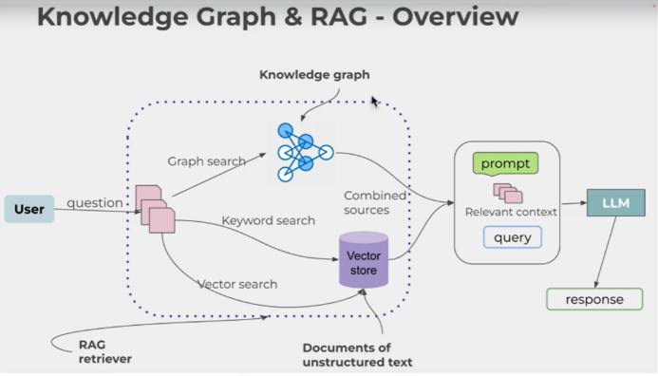
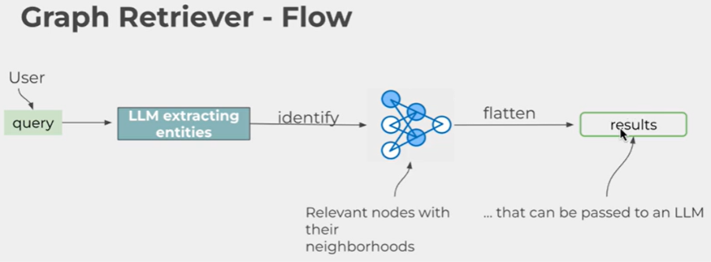
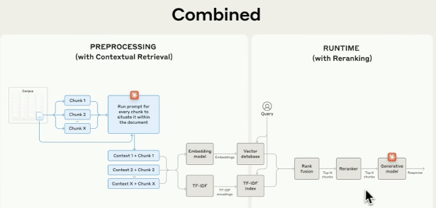

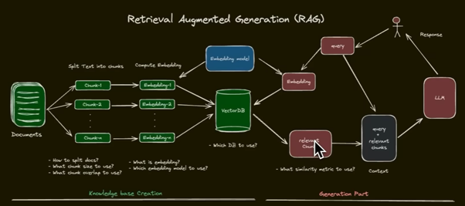
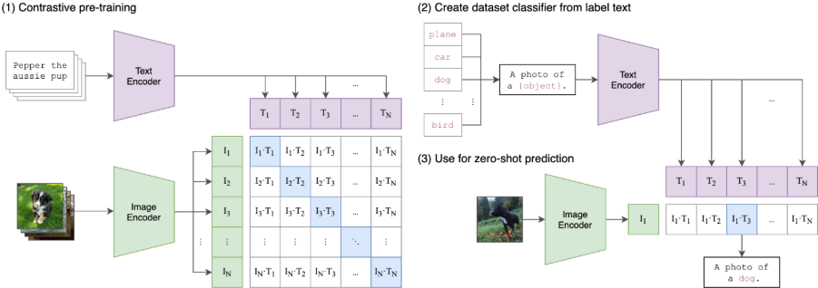
Strategy | Best Performance On... | CPU Impact | Overall Verdict
BM25 | Exact codes, acronyms, and technical IDs. | Negligible | Essential safety net.
Semantic | Broad questions, "How-to" intent. | Medium | Good, but needs reranking.
Hybrid | Multi-topic PDFs and complex queries. | Medium | Winner for enterprise docs.
MMR | Long PDFs with repetitive info. | Low | Best for summarization tasks.
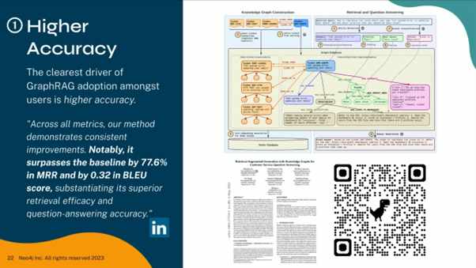
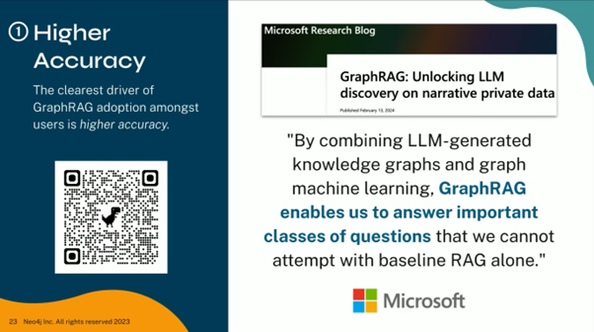
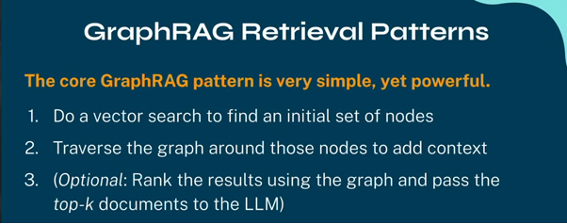
Test Case | BM25 (Keyword) | Semantic (Vector) | Hybrid (Combined)
Specific Code (e.g., "Error 503") | Excellent. Finds exact matches. | Poor. Might match "Error" in general. | Best. Keeps the exact match at the top.
Synonyms (e.g., "login assistance") | Poor. Won't find "authentication guide." | Excellent. Understands they mean the same. | Balanced. Finds the synonym and the exact word.
Short Queries (e.g., "passcode") | Strong. Finds every instance. | Vague. Might find too much context. | Strong. Filters for relevance.
Long Questions | Noisy. Gets distracted by words like 'the'. | Strong. Focuses on the core "intent." | Best. Filters noise while keeping keywords.

https://platform.openai.com/docs/guides/structured-outputs
https://huggingface.co/ibm-granite/granite-vision-3.2-2b
https://developer.ibm.com/articles/awb-enhancing-rag-performance-chunking-strategies/
https://www.datacamp.com/tutorial/multimodal-rag
https://developer.nvidia.com/blog/an-easy-introduction-to-multimodal-retrieval-augmented-generation/
https://console.cloud.google.com/vertex-ai/publishers/google/model-garden/medgemma
https://huggingface.co/google/medgemma-1.5-4b-it
https://synthetichealth.github.io/synthea/

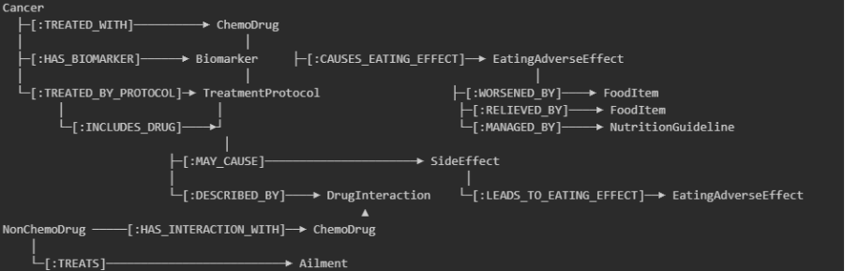
EnsembleRetriever | langchain_classic | LangChain Reference
Evaluating Medical RAG with NVIDIA AI Endpoints and Ragas | NVIDIA Technical Blog
MACCROBAT

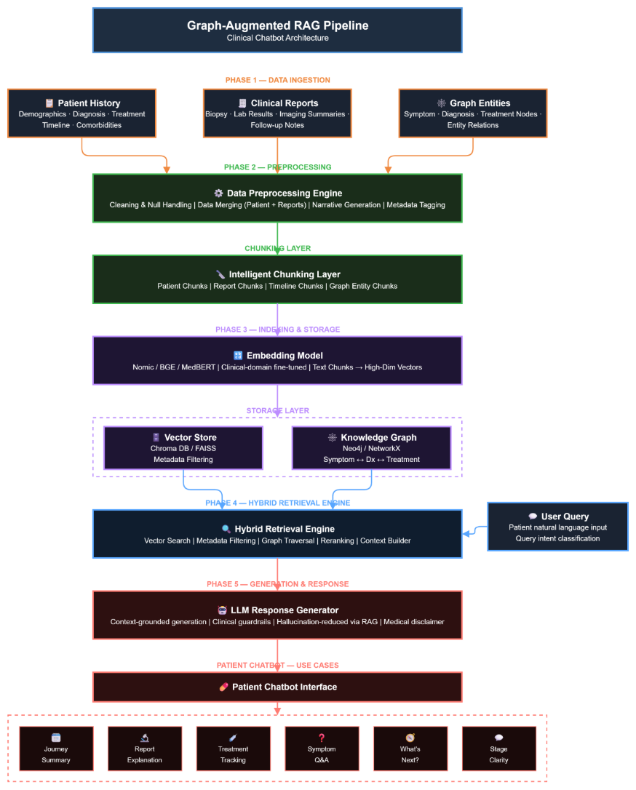

Current Status of Local Assets
Your uploaded files are now being used to define the graph schema:
- patients.csv: Providing the ground truth for stages and treatment plans (MAP chemotherapy).
- Insilco - reports_index.csv: Acting as the lookup table to link specific
MRI/CT/X-ray text files to session caching (browser + user compliances)
- 
Based on the pipeline established on Tuesday, the system follows a Three-Tier Architecture:
- Ingestion Tier: Processes the Figshare Radiograph dataset and TCGA-SARC MRI metadata.
- Embedding Tier: Uses LLM - OpenAI Vision to interpret visual features
(like the sunburst periosteal reaction in Osteosarcoma)
and converts them into vectors.
- Knowledge Tier: Maps these vectors to the Neo4j graph, where "Osteosarcoma" nodes are linked to "Complications" such as Avascular Necrosis (AVN) or Osteonecrosis, allowing the RAG to explain why a certain treatment leads to bone death.

Week 1
Overview This week focused on completing administrative onboarding, understanding the core project architecture ("Multi-modal Agentic RAG"), and setting up the local development environment. Additionally, I contributed to the company-wide AI upskilling initiative.
1. Administrative & Onboarding
- Onboarding: Completed all documentation and form submissions (Jan 19).
- Induction: Attended team induction with Suraj Sir; received clarity on the three core objectives for the internship.
2. Project: Multi-modal Agentic RAG for Enterprise Relations
- POC Alignment: Initiated daily standup cycle with the intern team and Kajal Ma'am.
- Environment Setup: Successfully replicated the required development environment on my personal laptop (Jan 22).
- R&D & Learning:
  - Reviewed provided resource materials.
    - Milvus vs FAISS
    - HIPAA (Privacy) and FHIR (Interoperability)
  - Explored Python libraries specific to our stack as well as brushing up on fundamentals.
  - Started exploring Document Loaders and RAG pipelines to understand data ingestion flows.
3. Strategic Initiative: Company-wide AI Upskilling
- Course Design: Collaborated on the curriculum design to equip all existing Aziro developers at all levels with AI capabilities.
- Submission: Submitted the "Courses for various roles and levels" proposal to Priyanka Ma'am (Jan 21).
Plan for Next Week
- Deepen understanding of the RAG pipeline architecture.
- Extract data using document loader from these:
  - .xlsx
  - .csv
  - .pptx
  - .docx
  - .url
  - A complex .pdf
- Can use custom scripts for logic if wanted (example summary using LLMs)

Week 2

Overview
This week focused on the practical execution of the RAG data ingestion pipeline and deep-diving into educational resources for the company-wide upskilling initiative. Key achievements included successful document parsing and curated resource selection from over 200 sources.

1. Administrative & Onboarding
- Security Training: Continued progress on the assigned Security Compliance training.

2. Project: Multi-modal Agentic RAG for Enterprise Relations
- Data Extraction: Successfully implemented and tested document loading using PyMuPDF and Docling (Jan 27) .
- R&D & Learning:
  - Initiated research into various Chunking Strategies (Fixed-size, Recursive, Semantic) to optimize data retrieval for the RAG pipeline (Jan 30).
  - Explored the nuances of handling complex PDFs via Docling to ensure high-fidelity data extraction.

3. Strategic Initiative: Company-wide AI Upskilling
- Resource Curation: Browsed through 200+ external resources over a two-day sprint to identify world-class, free, and industry-relevant AI/ML training materials.
- Submission: Successfully compiled and submitted the "AI/ML Training External Links" document to Priyanka Ma'am before the deadline (Jan 29).

Adaptive document chunking
Adaptive chunking ensures that structured content, like code snippets, tables, or markdown documents, is preserved in a meaningful way. This prevents breaking important relationships within the data and improves retrieval efficiency.
Timestamp-based chunking
When dealing with conversational data from sources like Slack messages, system logs, or chat transcripts, traditional chunking methods often fail to capture the natural flow of interactions. Conversations are context-dependent, meaning the relevance of a message is often tied to previous messages and their timestamps.
Timestamp-based chunking groups messages based on specific time intervals (e.g., every 5 minutes, per session, or within an hour). This ensures that chunks retain contextual continuity, making them more effective for retrieval and analysis. ￼

Week 3

Overview
Week 3 focused on the practical implementation of multimodal RAG capabilities and the launch of the internal upskilling initiative. Significant progress was made in image processing, adaptive chunking, and developing an automated HR recruitment tool using the Gemini API.

1. Administrative & Onboarding
- Advanced Coursework: Commenced the "Ramp up: Interns" coursework assigned by Ravi Sir to align technical skills with organizational standards (Feb 4).

2. Project: Multi-modal Agentic RAG for Enterprise Relations
- Pipeline Optimization:
  - Implemented a lightweight pipeline using Docling, PyMuPDF, and Moondream/Qwen2-vl:3b to ensure efficient performance on CPU-based environments (Feb 3).
  - Experiment with a lightweight embedding stack using Ollama (sentence-transformer/nomic-embed-text) to optimize the pipeline for resource-constrained devices (Feb 3).
- Image Processing: Successfully extracted ~90 images from complex documents, generating brief AI descriptions for each (Feb 3).
- Adaptive Chunking: Integrated the HybridChunker library from Docling for adaptive chunking, following guidance from Kajal Ma'am to improve retrieval precision (Feb 4).
- Embedding Strategy: Developed a workflow to store AI-generated image descriptions in lists for text-based chunking and embedding. Successfully embedded ~20 images using embeddinggemma (Feb 5).

3. Strategic Initiative: Company-wide AI Upskilling
- Program Launch: Initiated the first "Upskilling Training" meeting (Feb 2).
- Hiring automation Tool Demo: given by Ravi sir and overlooked by Sagar sir.
  - Features: Gemini API-driven question generation based on domain/role, Streamlit frontend, automated Google Form creation, and bulk emailing capabilities for HR admins (Feb 2).

Plan for Next Week
- Started exploring OpenAI's CLIP model for advanced image processing and retrieval within the multimodal RAG framework (Feb 6).
- Refine the image-to-text-to-embedding pipeline to reduce processing time (currently 2+ hours for 20 images).
- Continue the "Ramp up: Interns" coursework.

Week 4
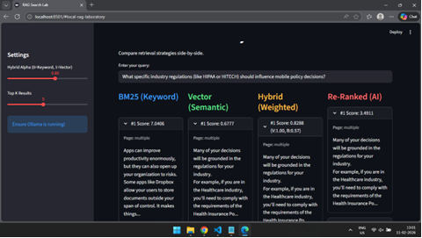
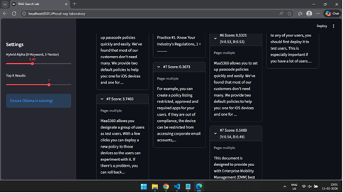

qdrant/fastembed: Fast, Accurate, Lightweight Python library to make State of the Art Embedding
Using Qdrant for embeddings search

