-> continuous tables - grouped columns - 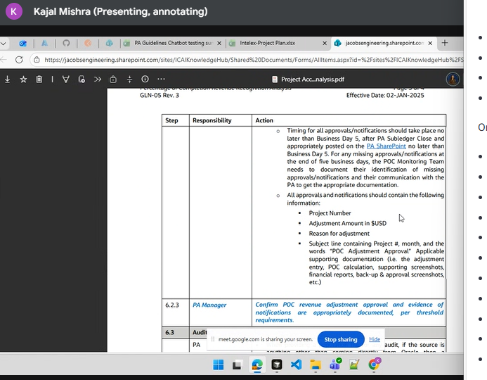

->Extract images, how we can use images for chunking -> images index , understand that
->extract tables properly -> grouped columns -> possibility of losing data

Note down all the challenges faced during the tasks in the entire process.
-> Load images using pymupdf4llm - in same format - store in one index and then feed into llm

Using only lines keyword-
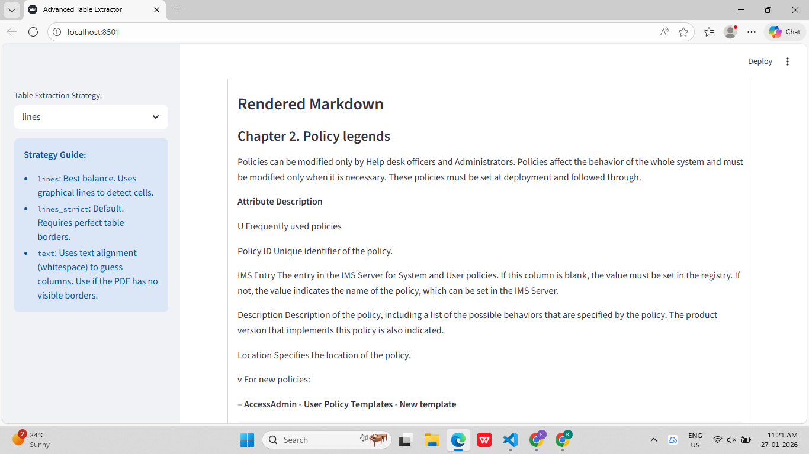

Lines_strict

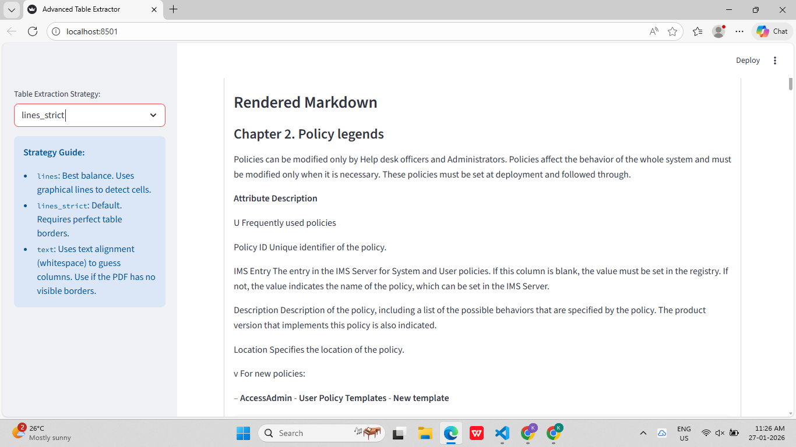

Use pandas to convert to dataframes

Tasks for the week 3->
1.Whatever docs-> extract docs -> experiment chunking strategies as well ,
2. Understand chunking strategies , what is there, etc.

28/01/2026 - gemini 3.5 use karenge cuz woh free hai-> it will not work with FAISS so work with ChromaDB
For images - we can use gemini

Gemini - > free?!!!??!?!??!?!

qwen thought for 24secs for a hello T_T
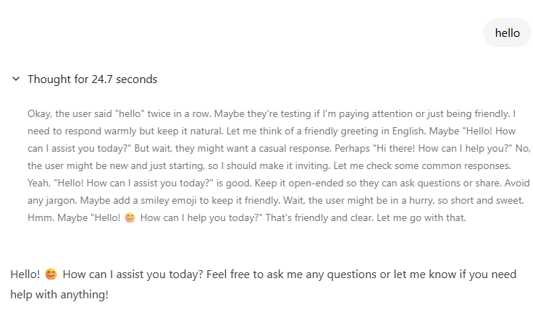
29/01/26 - > extract and try out chunking strategies
Try using yolo???? Or gemini 3.5
If gemini -> use chromadb cuz it doesnt work with faiss
Groq is free
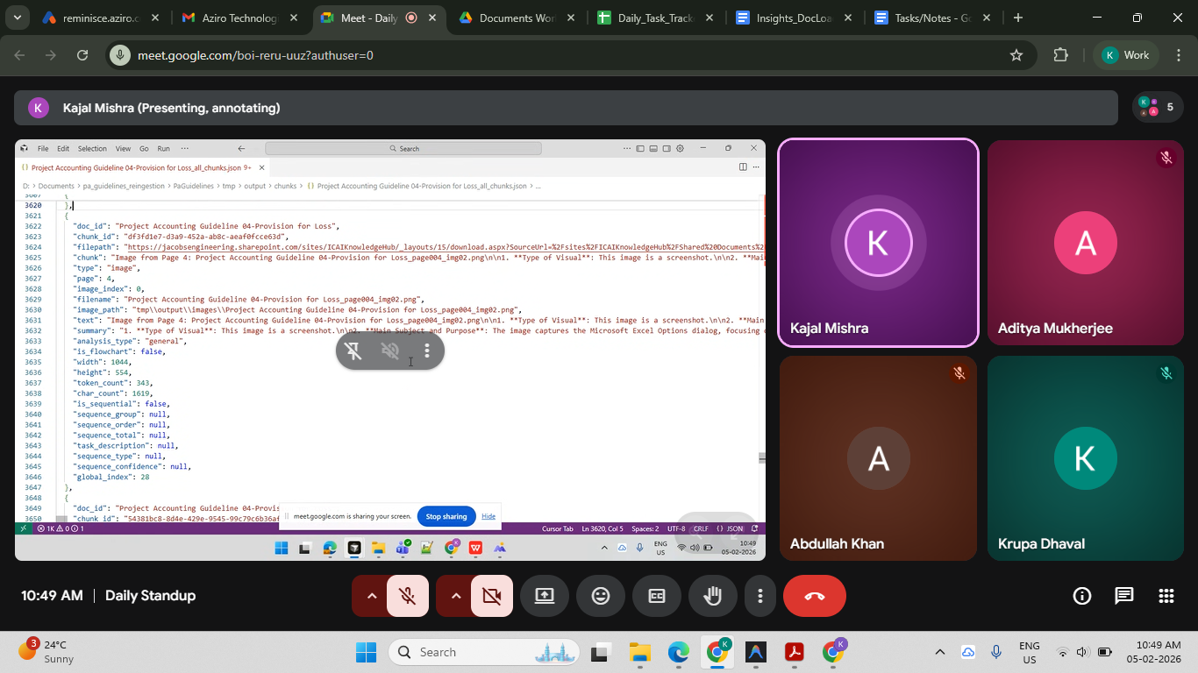

RETRIEVAL ->

Core Retrieval Approaches
- Dense Retrieval: Uses semantic vector search with embedding models to find conceptually similar chunks, excellent for natural language but can miss exact terms.
- Sparse Retrieval: Keyword-based (like BM25), fast and precise for exact matches, but lacks semantic understanding.
- Hybrid Search: Combines dense and sparse methods (often with Reciprocal Rank Fusion) to get the best of both worlds, now a standard for robust RAG.

Questions to ask :
1. Basic Retrieval Questions (Check Simple RAG Accuracy)
- What is the purpose of the MaaS360 Best Practices Guide?
- What actions can MaaS360 take when a device falls out of compliance?
- What are the four types of policies most companies have? (Page 4)
- Why are passcodes considered the first line of defense?
- What are the recommended passcode requirements?
- What is the recommended minimum passcode length?
- What is the difference between iOS and Android encryption handling?
- What are the recommendations under Best Practice #4?
- What does Best Practice #7 suggest regarding OTA distribution?
- What does Best Practice #10 recommend for monitoring devices?
🔹 2. Table-Specific Questions (Test Table Extraction)
From Types of Passcodes Table (Page 5):
- What are the different types of passcodes listed?
- What is the difference between Numeric and Alphanumeric passcodes?
- What additional requirement does “Complex, Alphanumeric with Special Characters” include?
- Which passcode type is Android-only?
- Give examples of complex passcodes from the table.
- Compare Simple vs Pattern passcodes.
🔹 3. Reasoning / Analytical Questions (Multi-Chunk Retrieval)
- Why might an organization restrict device features differently for company-owned vs personal devices?
- Why is encryption considered a must-have even if it causes user resistance?
- Why is testing policies before deployment important?
- How does MaaS360 reduce IT department workload?
- How does MaaS360 balance security with employee productivity?
🔹 4. Image / Screenshot Based Questions (Critical for Multimodal RAG)
From screenshots on Pages 6–14:
- What settings are available in the Configure Passcode Policy screen?
- What options appear under Enforcement Actions in the Compliance Engine screenshot?
- What information is displayed in the My Alert Center dashboard?
- What does the Wi-Fi / WPA2 profile configuration screen show?
- What are the different alert colors and what do they represent?
👉 These test whether OCR text from screenshots is retrievable.

🔹 5. Advanced Multi-Modal + Cross-Section Questions (RAG Stress Test)
- How do passcode policies support encryption enforcement?
- Compare Best Practice #2 and Best Practice #3 in terms of security layering.
- How does MaaS360 help enforce compliance automatically?
- Explain how app management policies help reduce corporate data leakage.
- What is the relationship between containerization and encryption?

🔹 6. Enterprise-Level Scenario Questions (Great for Demo)
These are very strong for your internship presentation:
- If an Android device does not support encryption, what should be done?
- How can MaaS360 handle repeated policy violations?
- How can OTA configuration reduce IT overhead?
- If an employee leaves the company, how does MaaS360 handle corporate data?
- How can MaaS360 prevent data leakage via third-party apps?

🔹 7. Multi-Modal Agent Evaluation Questions
These are useful to test your Multi-Modal RAG Agent:
- Summarize the passcode configuration interface shown in the screenshot.
- Extract all enforcement options visible in the Compliance Engine image.
- Convert the passcode types table into structured JSON.
- Summarize the My Alert Center dashboard.
- What visual elements indicate device compliance status?

Answer
Main contents of the document
- Copyright and Legal Notice – IBM MaaS360 (Fiberlink) copyright statement, licensing disclaimer, trademark notice, and company address (May 2016).
- Best Practice #6 – Use a FIPS‑Compliant Container for Email and Content
  - Explanation of why a secure container is needed (encryption, preventing unauthorized backups, copy‑paste, attachment blocking, consistent user experience).
  - Our Recommendations – four actions:
    - Block native email capabilities on the device
    - Block Gmail
    - Encrypt emails
    - Encrypt attachments
- How MaaS360 Helps – Description of the MaaS360 Secure Productivity Suite, including:
  - Secure container for email, contacts, calendars, documents, intranet, SharePoint, Fileshare, OneDrive.
  - Policy controls for data movement, sharing, forwarding, copying/pasting.
  - Selective wipe of lost or stolen devices.
  - App Catalog that separates personal and corporate apps and allows push of market/enterprise apps.
- Policy‑Configuration Interface – Overview of the “Configure Device Security Policies” / “Configure Data Protection Policies” screen, listing the toggle options that can be set:
  - Restrict Jailbreak / Rooted Device
  - Prevent Access
  - Enable Timebomb (days)
  - Restrict File Export
  - Restrict Clipboard Export
  - Restrict Screenshot
  - Restrict Print
  - Restrict Import Files
  - Allowance settings for calendar, documents, etc.
  - Purpose: block compromised/rooted devices, limit data export, enforce time‑based deletion of corporate data.
- Search Results Screen – Description of a device‑management console view that lists enrolled devices with columns such as:
  - Device Name, Username, OS Version, Platform, Managed/Enrolled status, Last Report, Wi‑Fi configuration.
  - Controls for Configure, Customize Columns, Export CSV, and pagination (“Jump To Page”, “Display 1‑4 of … Records”).
- Home Page – My Alert Center – Explanation of the dashboard that shows alerts (red, green, blue) which can be customized; red/green for security alerts, blue for informational
