YaPPI – A Particle Property Database

Patrick Hellwig¹

¹ CERN, CH-1211 Geneva 23, Switzerland

Abstract

YaPPI is a database of particle properties in XML. An API, written in Java, provides easy access to the data. To provide portability across many platforms the data are stored in the XML format. YaPPI uses the Apache Xerces XML Parser for the Java language to load data files.
The data is imported from the Review of Particle Physics (RPP) of the Particle Data Group (PDG).
A Interface was build to provide the Java Analysis Studio (JAS), a High Energy Physics analysis software package, with the particle properties in XML. A Java servlet allows browsing through the particle properties online on the Web. To get a printed form the servlet can create LaTeX files.

Keywords: Particle Properties; PDG ; Java; XML; database

1 Introduction

This project was intended to create a database containing particle properties. The standard source for particle properties is the Particle Data Group [PDG]. For an experiment or analysis you normally take the data out of the Review of Particle Physics [RPP] book and make your application.
Most physicists want to provide this information once to the analysis software and afterwards easily access the data. Unfortunately no official published database exists that the physicist can access avoiding typing in around 1000 different particles by hand, all with their properties and decay modes.
The result is, that each analysis software package has its own database either “hardcoded”, that means the data is implemented directly into the source code, or provided by any other database system specific for the software package. The problem begins here: Each software has its own database. In case of new data, each administrator of the software packages has to type in the data by hand. This situation is not really convenient.

For this reason we started the YaPPI project, wanting to build up a database with particle properties. Primarily it should be implemented for the Java Analysis Studio JAS[JAS] and as a second task a more common API (application program interface) should be implemented. To avoid the problem with data updates a conversion tool was implemented to import the PDG data [PDG-MC].
As computer language for this task the Java programming language was chosen because of its platform independency. For the same reason XML[XML] was chosen as database format.

2 XML

The “eXtensible Markup Language” XML is the universal format for structured documents and data on the Web. It developed out of SGML, which was implemented in the early 1980’s (ISO standard since 1986). Basically XML is defined by the base specifications of the W3C, the world wide web consortium, in the XML 1.0 W3C Recommendation of February 1998 [XML98]. It is a method for putting structured data in a text file. The advantage you get from a text file is the platform independency. One can just copy the file and use it somewhere else. Making use of tags (words bracketed by ‘<’ and ‘>’) and attributes (of the form name=”value”) all data is stored in a similar way like HTML, but in contrast to HTML the function of a tag or a attribute is in XML not predefined. XML uses the tags only to delimit pieces of data, and leaves the interpretation of the data completely to the application that reads it.
XML itself is a family of technologies combining a lot of different tasks to one notion, like Hyperlinks (Xlink), Pointers (XPointer & XFragments), stylesheets (CSS), etc.
XML is license free, but nevertheless well supported.

3 Architecture

The primary task was providing Java Analysis Studio (JAS) with particle properties. Especially for this task the XML database format is a good choice, because the whole analysis package should be platform independent. And with XML it is.
Another reason is the wide range of software tools for XML. There exist professional XML Parsers which allow you to analyze and read XML. For this project we took the Apache Xerces XML Parser for Java[XERCES].
The special thing about this project is to build a data model fitting the requirements, but to be capable about storing new particles, properties and other information in the database. To achieve this our approach was very general. We started with some assumptions:

- A particle has always a unique name
- The particle name can always be expressed in LaTeX
- All Properties exist independently, thus the data entries can be stored separately without cross references in between them
- There is no order in the particle sequence, thus there is no hierarchy in the particles itself (there is one, namely the family structure itself, but this comes later)
- The particle family structure can be stored independent of the particle properties

We took the following approach:

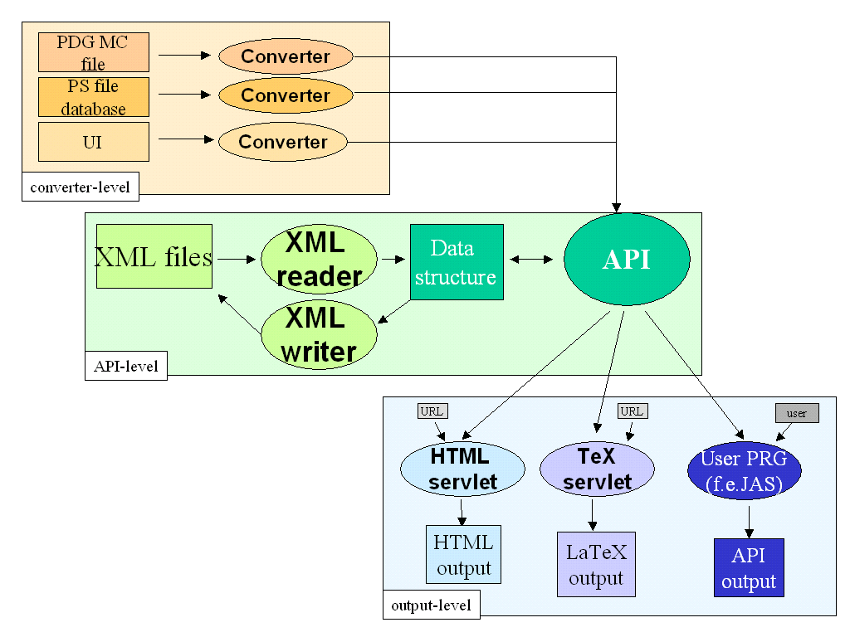
Figure 1: Data flow diagram

The whole process consists of three layers. The first layer is the “Converter-level”: the data coming from different sources (for example the PDG computer readable file, or the PDG internal database) is translated to the common data structure of the API. There the information can be written to a XML file, or vice versa. This information can then be provided to different applications through the API. These are currently:

- A Java-Servlet [Servlet], which allows you to browse through the data and create printable LaTeX2e files (see Figure 5).
- A common Java API, which allows Java Applications to use the data
- The Java Analysis Studio (JAS) Interface which is a subset of the common Java API

4 Implementation

The first task was to implement a class structure and a XML-Schema describing the data model. After this was done we used the Apache Xerces Java Parser to create a program for reading the XML files. Every time the parser finds an XML-tag it gives the application a call. Then you are able to define how to handle the data, which the parser found. Step for step each XML-tag is read and interpreted.

Applying this to our project we defined two main tags:

ParticleType
- FamilyStructure

The “ParticleType” defines a particle (see Figure 2). It has attributes describing the name of the particle and its anti-particle. For typesetting reasons we added a LaTeX2e encoded name field.
Figure 2: A Particle entry in the XML file
<Particle name="pi+-"
texname="\pi^{\pm}">
<Comment>
This is a example.
Data taken from PDG98.
No positive or negative errors included.
</Comment>
<Data name=”Mass”
value=”139.57”
unit=”MeV”/>
<Data name=”Meanlife”
value=”2.6e-8”
unit=”s”/>
<Decay fraction=”99.9877”>
<DecayParticle particle=”MU+”/>
<DecayParticle particle=”NU(MU)”/>
</Decay>
</Particle>

The data of a particle is stored with “<Data>” tags. Each data entry (f.e. mass, width, etc.) has one tag. A data tag consists of name, value, errors, unit, and more specific information.

The decay channels are stored with “<Decay>” tags. Each decay channel gets one decay tag. A decay channel consists of specific values like fraction, confidence level and errors and the products resulting out of the decay. A particle decays into set of particles, or, if only a subset of the decay is known, only the family or even less information is available. You can find some examples in Figure 3.

For comments about this particle a “<Comment>” field was added.
Figure 3: Examples for different decay channels
All Particles known:D± → μ^{+ ν}_{μ}
Particle+unknown:D± → e⁺ anything
family:W⁺ → hadrons
The particle family order is stored in a recursive way. Each family tag has as many sub-family entries and particle entries as needed. The API looks the particles up in the XML file and makes a link to the proper particle. After reading the whole XML file a tree of the whole family can be accessed. This allows to browse through the particles in a very instructive way. A example of a family tree is shown in Figure 4.

The possibility to read multiple XML files allows user defined data. You could first read a common PDG data file, then overwrite some of the data with your own experimental data.

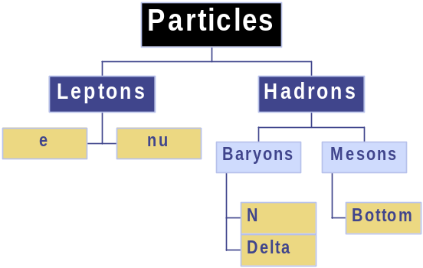5 Data Access
Figure 4: Example family tree (left side: XML file, right side: resulting tree structure)
<Family name=“Particles">
<Family name=“Leptons">
<Particle name=“e"/>
<Particle name=“nu"/>
</Family>
<Family name=“Hadrons">
<Family name=“Baryons">
<Particle name=“N"/>
<Particle name=“Delta"/>
</Family>
<Family name=“Mesons">
<Family name=“Bottom"/>
</Family>
</Family>
</Family>
</Family>

Currently there are several sources of information:

- A computer readable file from the PDG [PDG-MC] containing only a subset of information:
  - Particle ID Number
  - Particle Name
  - Mass + Errors
  - Width + Errors
  - Charge
- PDG Review [RPP] book in printed form
- Database to create the PDG Review [RPP]
- Postscript files from the PDG server containing the printed book in electronically form
- XML files created by any source

Primarily we implemented a Java Application that read the computer readable file and created an XML file containing this limited set of information. We worked on a Postscript import utility and the results are convincing: Until now the Postscript import utility can get the LaTeX name, the masses, width, etc. The work will be continued to read also the decay channels.
A future task could be a administration utility, where you can search, import, export, etc. through the whole XML database.

6 Conclusions

YaPPI provides particle properties to a wide range of applications. For Java applications it provides an API. Programs in other languages have to read the XML file itself, but there exist XML Parsers for nearly every programming language. It is platform independent and portable to many systems. The Servlet gives users a easy to use particle property lookup program. The import routines provide a interface to the PDG and therefore the guaranty, that one can use the newest data.
Another advantage is the XML technology itself: It allows for extension by just adding a new tag to your file. This gives the possibility to add for example typesetting properties for printing the data.

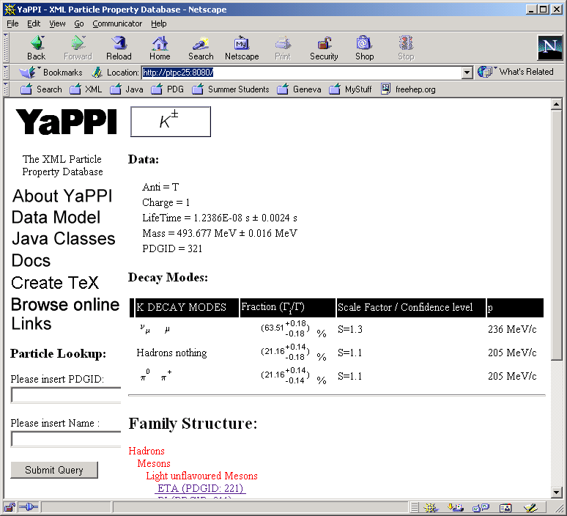
References
Figure 5: The Java Servlet provides online information about particle properties. On the bottom left you can see the search field (name or ID-Number). You can also browse through the family tree (bottom).

YaPPI = Yet another Particle Property Interface
URI: http://pdg.lbl.gov
URI: http://jas.freehep.org
YaPPI = Yet another Particle Property Implementation
See also “XML in 10 points” from Bert Bos, http://www.w3.org/XML/1999/XML-in-10-points
[PDG] Particle Data Group (PDG), http://pdg.lbl.gov
[RPP] Review of Particle Physics, Eur. Phys. J. C 15, 1-878 (2000)
[JAS] Java Analysis Studio (JAS), http://jas.freehep.org
[PDG-MC] Particle Data Group, computer readable file, http://pdg.lbl.gov/rpp/mcdata/garren_98.mc
[XML] Extensible Markup Language (XML) 1.0 (Second Edition), W3C Working Draft 14 August 2000 http://www.w3.org/TR/2000/WD-xml-2e-20000814
[XML98] Extensible Markup Language (XML) 1.0, W3C Recommendation 10-February-1998 http://www.w3.org/TR/1998/REC-xml-19980210
[XERCES] Apache Xerces XML Parser for Java, http://xml.apache.org/xerces-j/index.html
[Servlet] http://yappi.freehep.org or http://www.yappi.de

