# Lab: Django REST Framework Basics

# Books API

Create a simple **Books API** using the **Django REST framework**.

## Create the Project

* **Create** your **project** and your **API app**

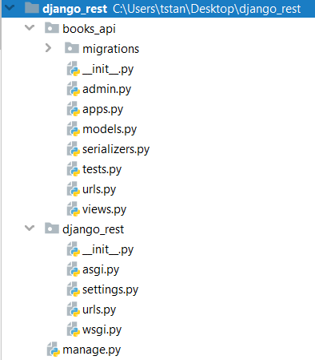

## Setup

* Make sure that you have **djangorestframework** installed (if not, install it using pip)
* Add **'rest_framework'** to the **INSTALLED_APPS**
* Add **'books_api'** to the **INSTALLED_APPS**

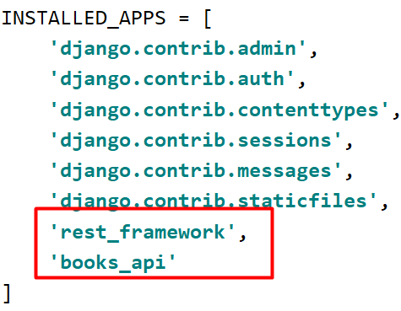

* **Configure** and **create** your **database**

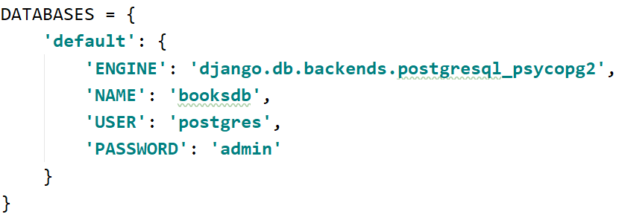

## Create your Model

Create the **Book model** as shown below

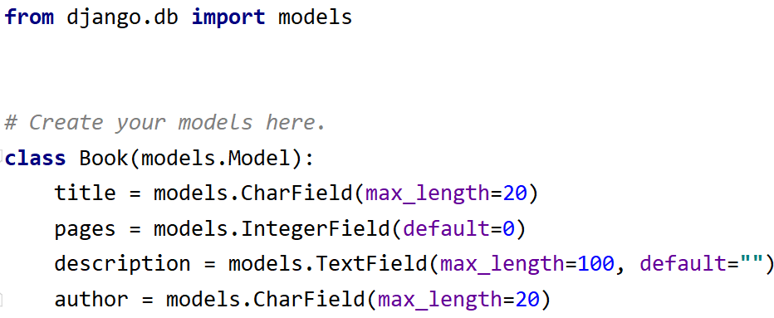

Make **migrations** and **register the model** in the **admin.py** file

## Create the Serializer

Create a new file called **'serializers.py'** and create the **BookSerializer**

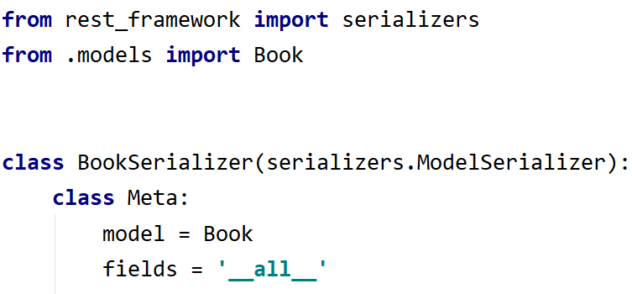

## Creating the Views

First, create the **ListBooksView**

And then, the **DetailBookView**

## Configure the urls.py Files

Create **urls.py** file in the **app**, and add the **urls**

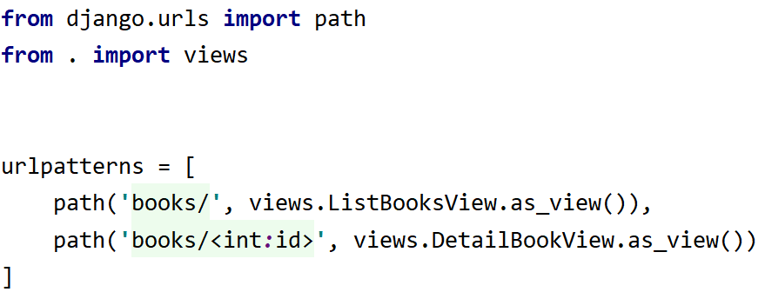

And the **urls.py** file in the **project**

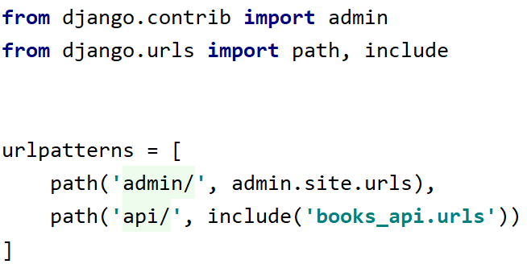

## Create a superuser

Create a **superuser** and **create some books**

## Test The API

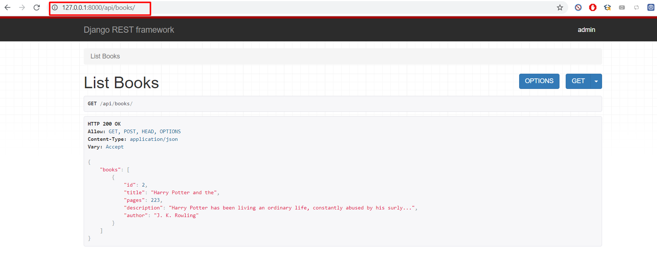

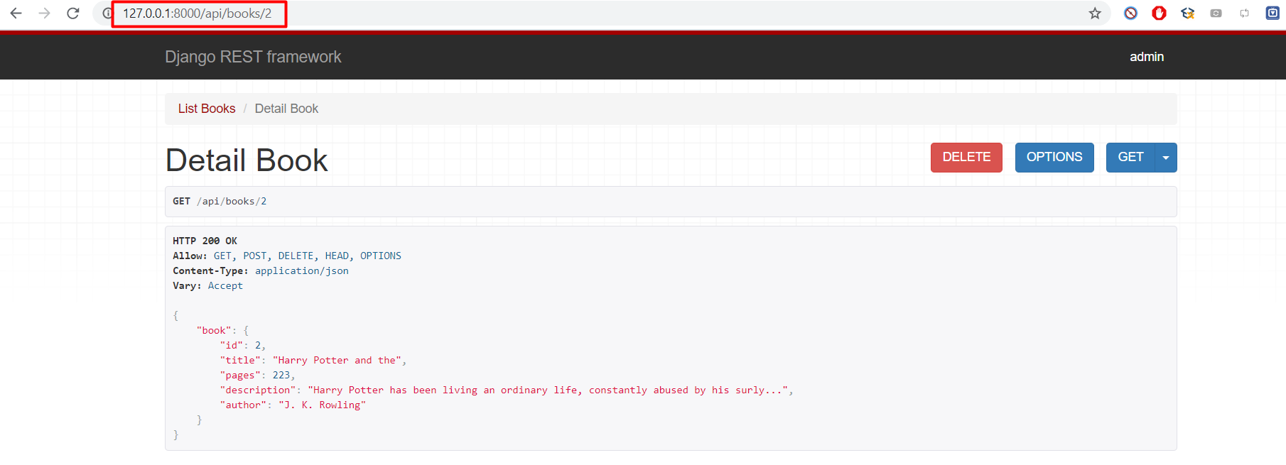

## HTTP Requests via Postman

Download, install, and run the **Postman Desktop Agent** from[*https://www.postman.com/downloads/*](https://www.postman.com/downloads/)

Create a **GET Request**:

**The Response**:

Create a **POST Request**:

**The Response**:

Create and test the **PUT** and **DELETE** Requests for a **specific book** and **check** the **Response**.