Workshop: Petstagram
This document comprises the fourth segment of the Petstagram Workshop, focusing on integrating a user into our project. Our agenda for today includes expanding the user model initially. Subsequently, we'll proceed to incorporate functionalities such as registration, login, and logout. Additionally, we'll address the profile templates and undertake code refactoring across all applications to seamlessly integrate the user object where necessary.
The full project description can be found in the Workshop Description Document.

Workshop - Part 4.1

Extending the Abstract Base User Model
There are several ways that we can choose from to implement our user model. The way Django handles authorization is a perfect fit for our project but still. So, we are going to create a custom user model inheriting from the AbstractBaseUser Django class. The model consists of the following fields:
- email - email field, required and unique.
- is_active - boolean field with default value True.
- is_staff - boolean field with default value False.
USERNAME_FIELD - specifies the field to be used as the unique identifier for authentication, which is email.
REQUIRED_FIELDS - an empty list, implying that no additional fields are required when creating a user.
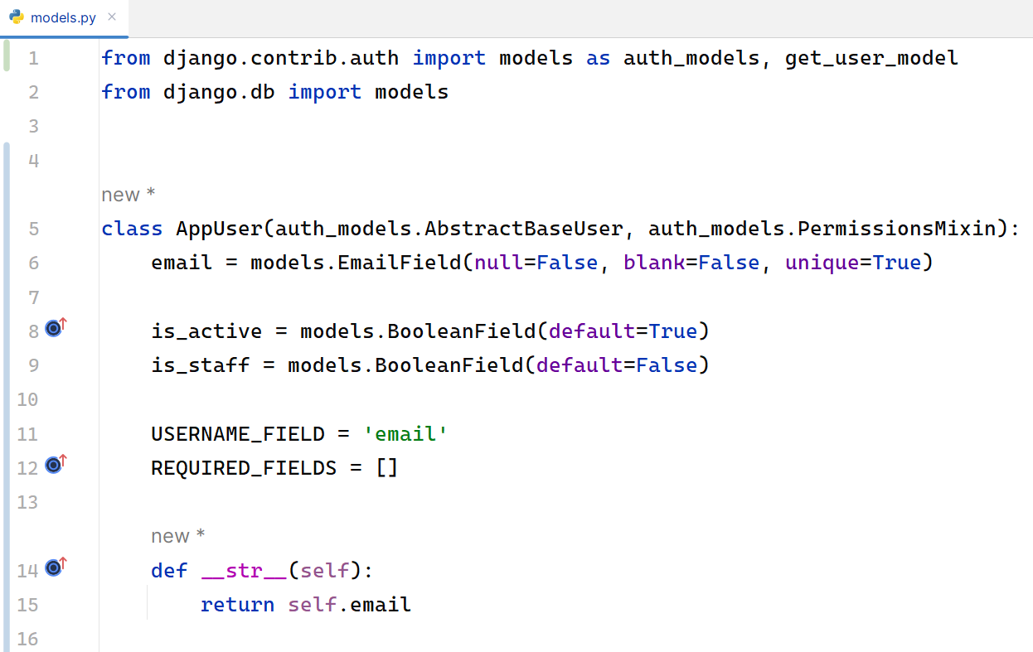
Then, we will need to update the settings.py defining the AUTH_USER_MODEL property to our custom user model:
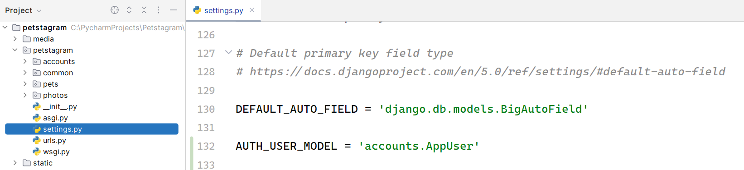
Now we are going to link our AppUser with a custom Petstagram profile. Create a new model called Profile:
- user - one-to-one field, primary key, with CASCADE delete option.
- first_name - character field, with maximum of 30 characters, optional.
- last_name - character field, with maximum of 30 characters, optional.
- date_of_birth - date field, optional.
- profile_picture - URL field, optional.
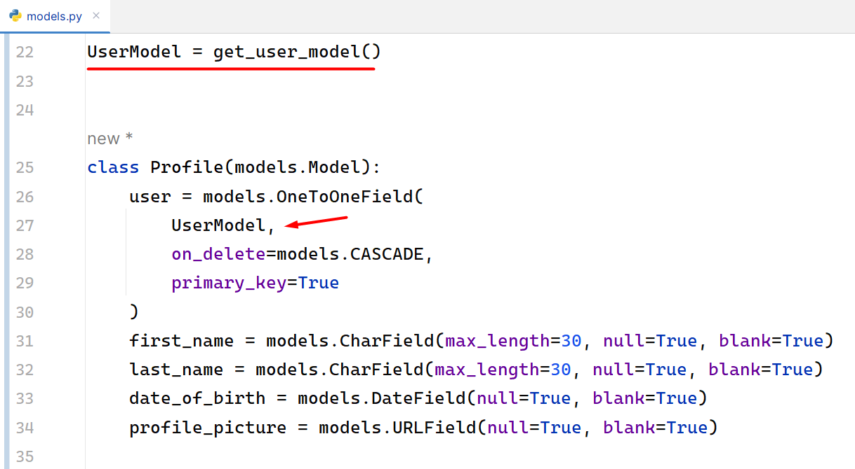

User Manager
We are now creating a custom manager that creates users and superusers for our Django application:
- create_user(self, email, password=None, **extra_fields) - this method is responsible for creating a standard user instance.
- create_superuser(self, email, password=None, **extra_fields) - This method is responsible for creating a superuser instance with staff and superuser privileges.
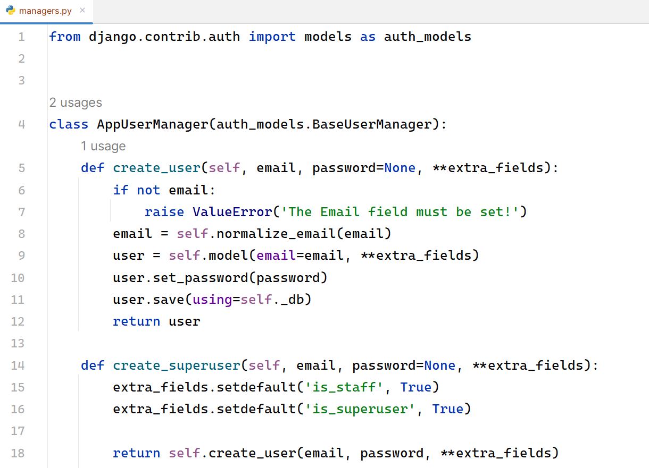
We need to import our manager in the AppUser model:
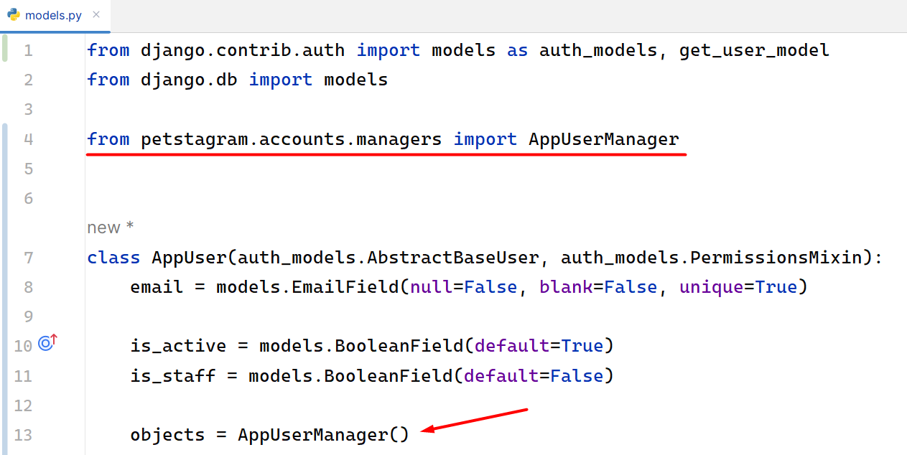
Note: if you are building an app with user authentication, you should consider creating a custom user model at the beginning of the work process.
As this is a workshop project, for the needs of this course, we will need to drop the database and create it all over again. Then, we can delete all migration files, and make the migration for all apps once again.

User Admin
To adjust a better-looking admin site, we can implement some of the Django Admin Site techniques that we have already mastered in the previous Python ORM course. First, we need to create a user change form that will inherit the UserChangeFrom in our forms.py file:
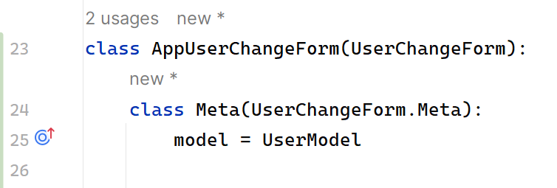
There is the full code structure in the admin.py file:
from django.contrib import admin
from django.contrib.auth.admin import UserAdmin
from django.contrib.auth import get_user_model
from petstagram.accounts.forms import AppUserCreationForm, AppUserChangeForm
UserModel = get_user_model()
@admin.register(UserModel)
class AppUserAdmin(UserAdmin):
model = UserModel
add_form = AppUserCreationForm
form = AppUserChangeForm
list_display = ('pk', 'email', 'is_staff', 'is_superuser')
search_fields = ('email',)
ordering = ('pk',)
fieldsets = (
(None, {'fields': ('email', 'password')}),
('Personal info', {'fields': ()}),
('Permissions', {'fields': ('is_active', 'is_staff', 'groups', 'user_permissions')}),
('Important dates', {'fields': ('last_login',)}),
)
add_fieldsets = (
(
None,
{
"classes": ("wide",),
"fields": ("email", "password1", "password2"),
},
),
)

User Registration
To create a user registration form, we can extend the Django built-in UserCreationForm. Let us add a forms.py file in our accounts app and inherit from the built-in Django form:
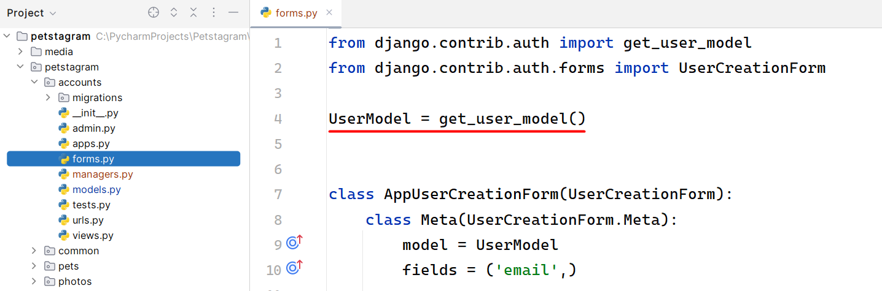
Let us now add the form functionality in the register view (when the user is successfully registered, they should be redirected to the login page). As we know more about the CBVs in Django we will try to implement the register functionality using CreateView. There we should add the model, the form, the template, and the success URL:
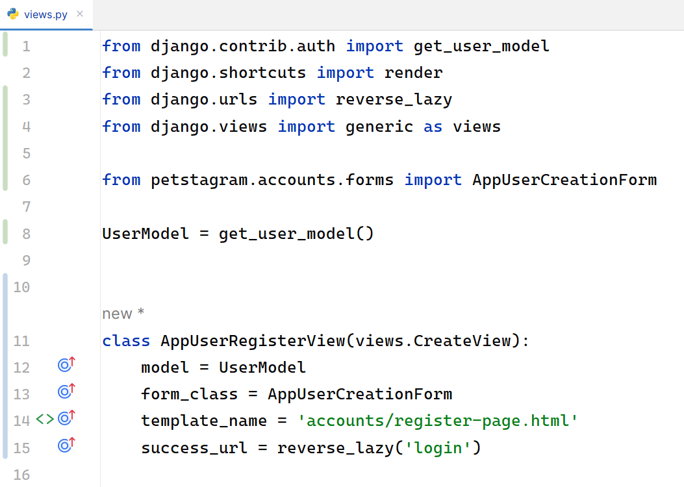

We should change the view in the path function on accounts/urls.py file:
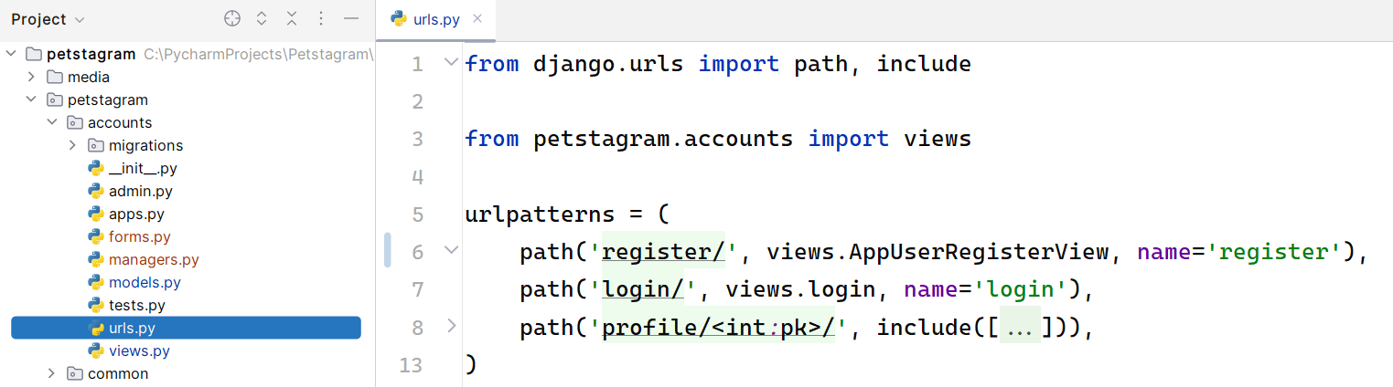
Next, we will add the form to the register-page.html template. We can escape showing the help texts on the web page, by simply adding the concrete fields we want our users to fill. Note: Do not forget to add a "href" on the Login link:
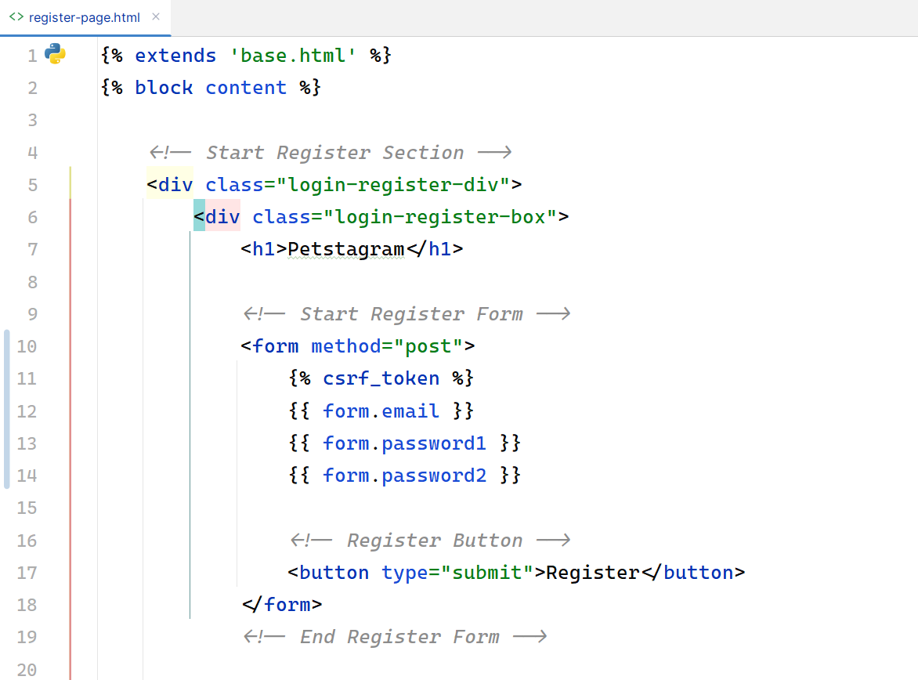

However, it is not enough - it is missing the placeholders:
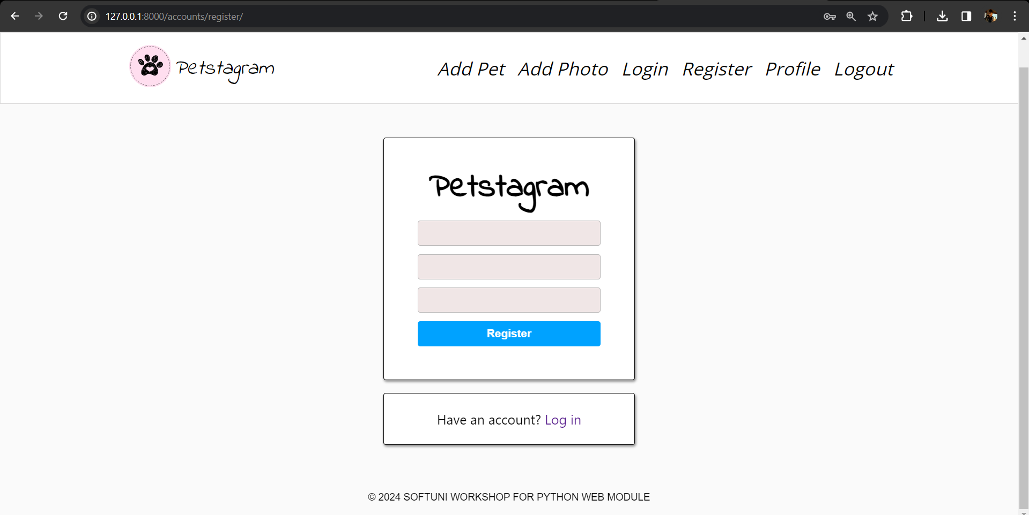
To add them, we can easily create a template filter. Add a templatetags package in the accounts app and create a custom_filters.py file. Then, add the implementation of the placeholder and register it:
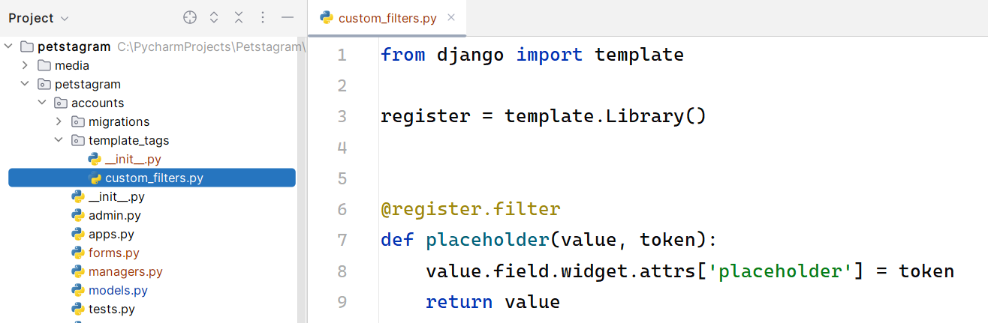
Now, we can add the template filter with the value we want to show on the page:
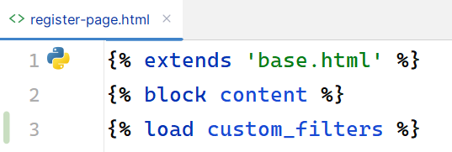

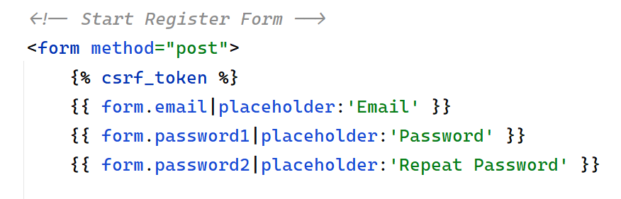
Also, we want to show errors when they occur. We can decide if they are going to stay above or below the field:
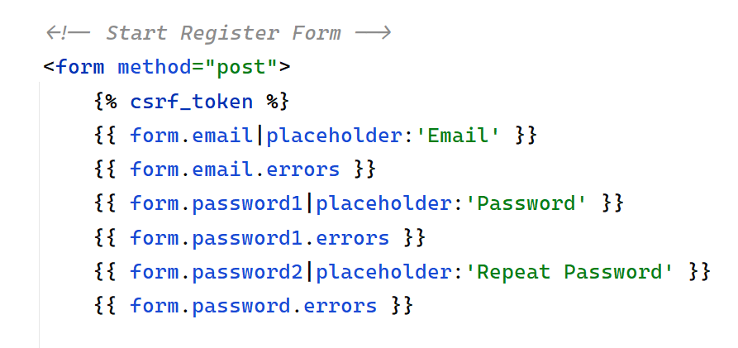
Restart the development server and check if the implementation works correctly:
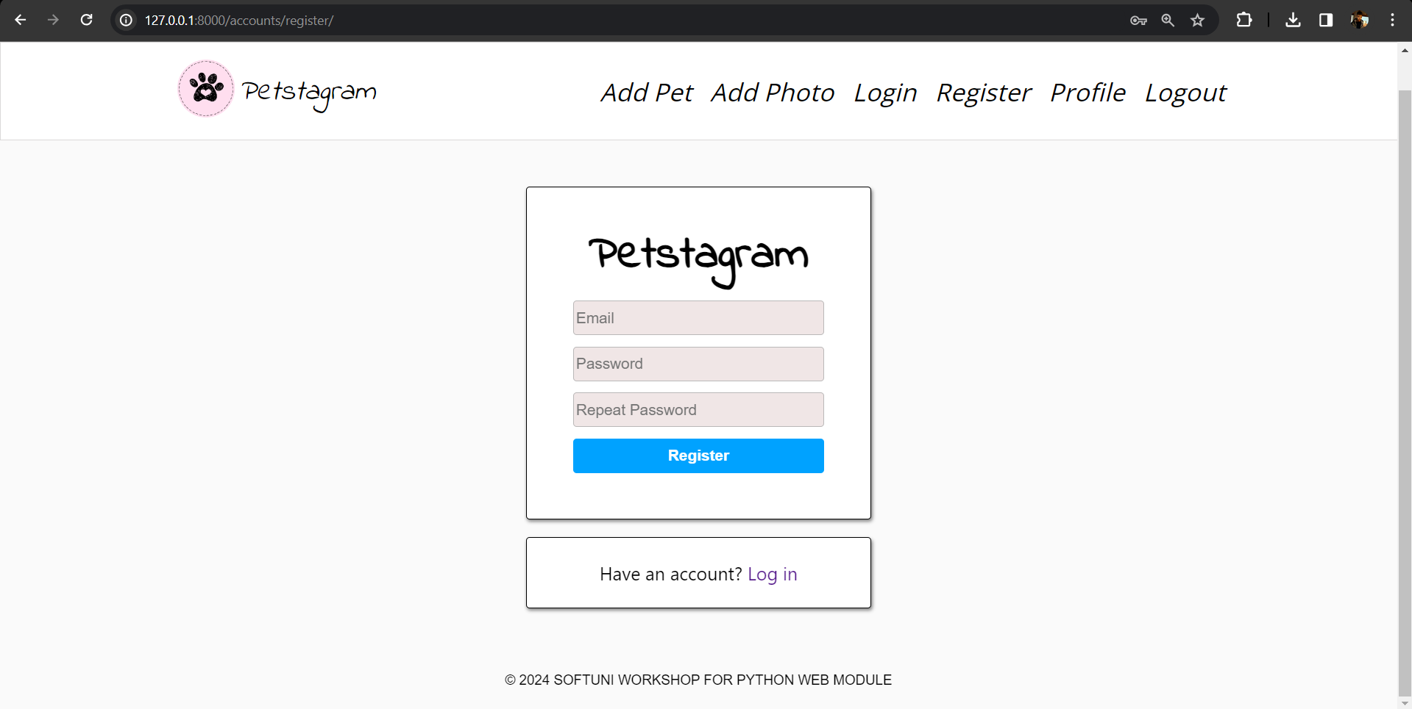

User Login
Now, it is time to add a user login functionality. First, we will override the AuthenticationForm so that we can add placeholders in the fields - "email" and "password":
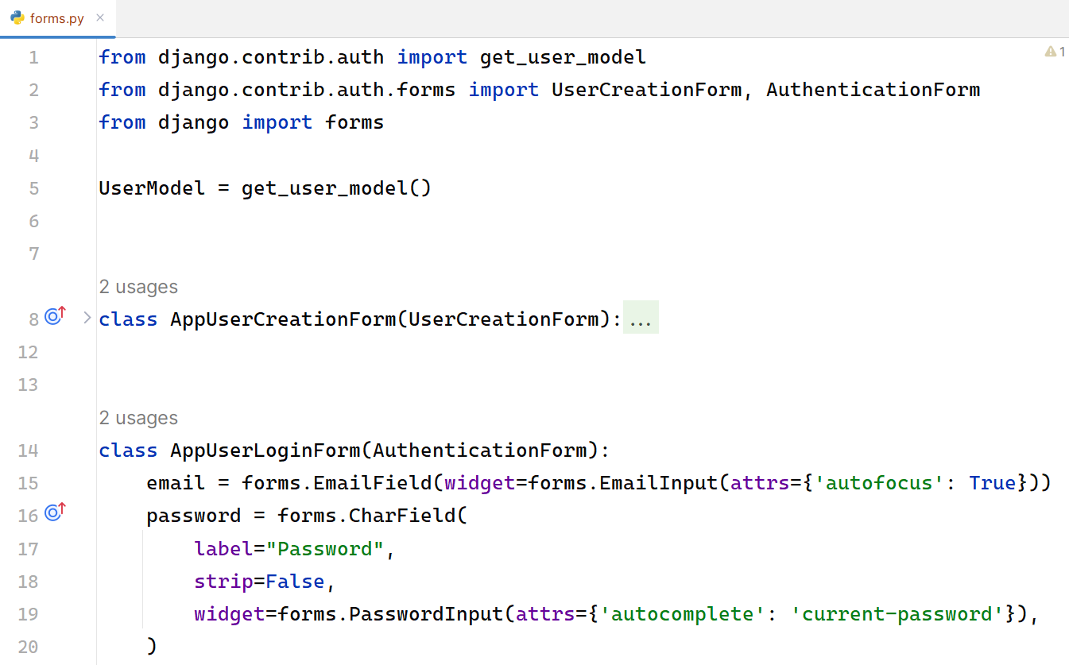
We can use the built-in view LoginView from the contrib.auth.views module. It is important to create a default profile. Next, we will add the overridden form, the template we want to use, and the URL where requests are redirected after login:
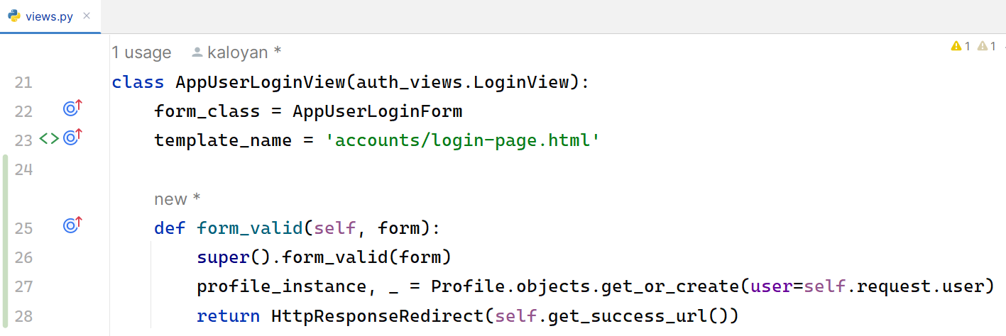
Also, in the settings.py we need to setup our login redirect url:
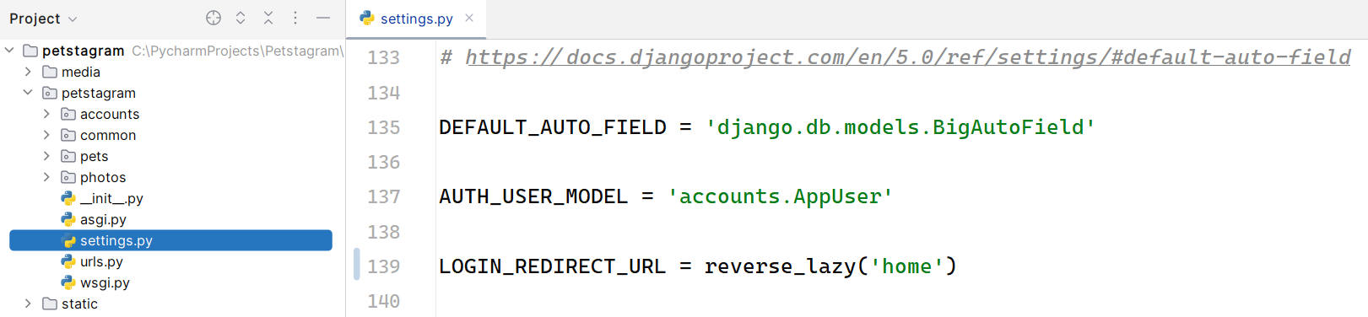
The form that we need to override is the AuthenticationForm. Look that we are overriding also both authentication fields and modifying the username field as an email:
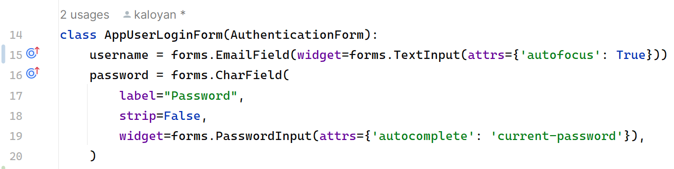
Let us refactor the login-page.html template by adding the "form" attribute. Note: Do not forget to add the "href" on the Register link. Then, start the development server and check if the form is created correctly.
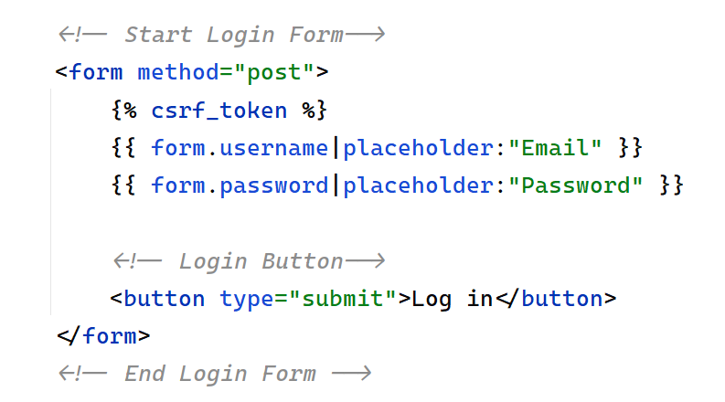

User Logout
Let us create the user logout functionality. First, we will add the path in the account/urls.py file:
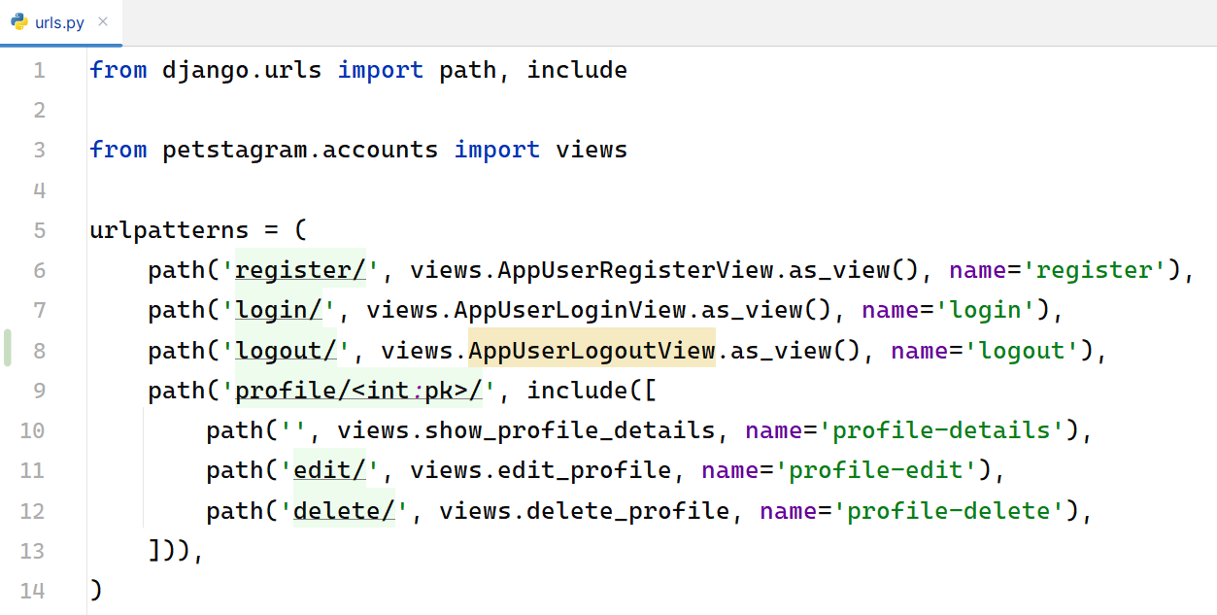
Next, we will use the Django built-in LogoutView to reuse the logout functionality and will leave it for later custom implementation if needed:
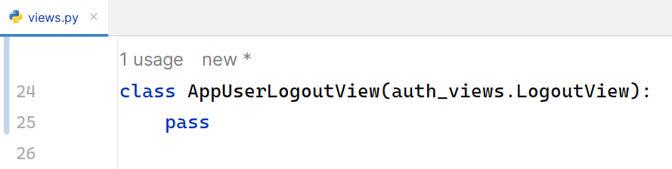
In the settings.py this time we setup our logout redirect url:
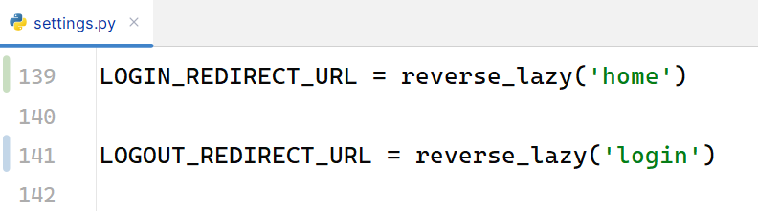
Last, we will add a button that the users will use to log out from the app. Let us open the base.html file and use a HTML code to implement a new navigation bar hyperlink:
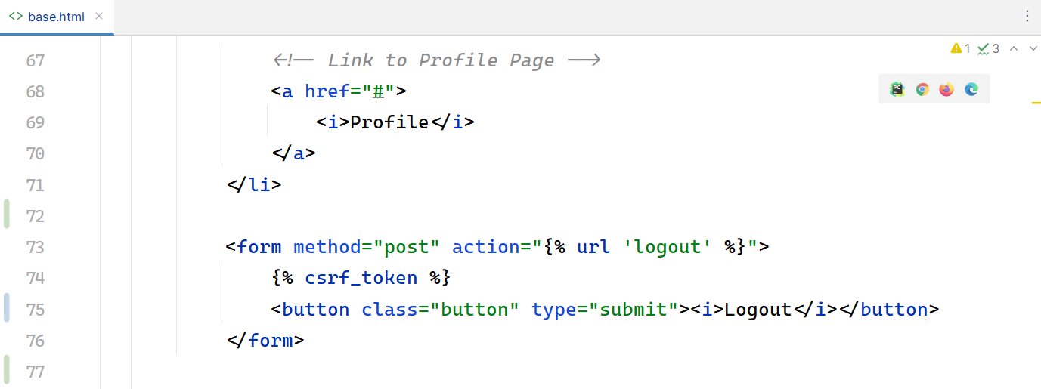
Note: Since Django 5.0, we need to do this through a POST request, since it has side-effects. The fact that it worked with a GET request was (likely) a violation of the HTTP protocol: it made it possible for certain scripts to log out users, without the user wanting to.
Add the following CSS styles in the css/home.css file:
.button {
background-color: white;
border: none;
font-size: 22px;
margin: 2.5px 0px 0px 8px;
padding: 0;
cursor: pointer;
}

Workshop - Part 4.2

Refactor Navigation Bar
Now, as we have a user, we need to make some changes to the app. Let us start by refactoring the navigation bar. We want to show the links "Profile" and "Logout" to authenticated users only, and the links "Register" and "Login" to unauthenticated users only. Open the base.html template and add the condition:
...

{% if not request.user.is_authenticated %}
<li class="nav-item">
<!-- Link to Login Page -->
<a href="{% url 'login' %}">
<i>Login</i>
</a>
</li>
<li class="nav-item">
<!-- Link to Register Page -->
<a href="{% url 'register' %}">
<i>Register</i>
</a>
</li>
{% else %}
<li class="nav-item">
<!-- Link to Profile Page -->
<a href="#">
<i>Profile</i>
</a>
</li>
<form method="post" action="{% url 'logout' %}">
{% csrf_token %}
<button class="button" type="submit"><i>Logout</i></button>
</form>
{% endif %}

...
Next, we can implement the Profile Page URL:
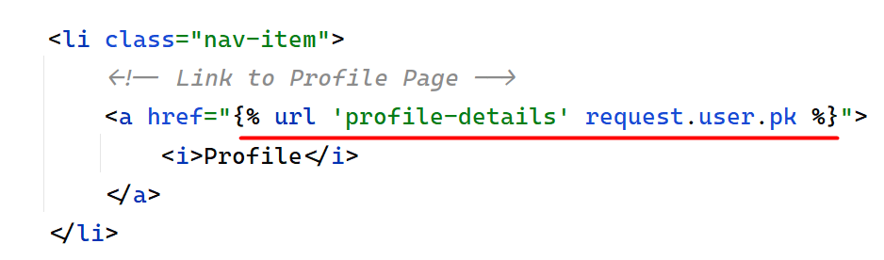

User Editing
We will continue to implement the user functionality by adding a user edit form. We want the form to contain the first name, last name, date of birth and profile picture:
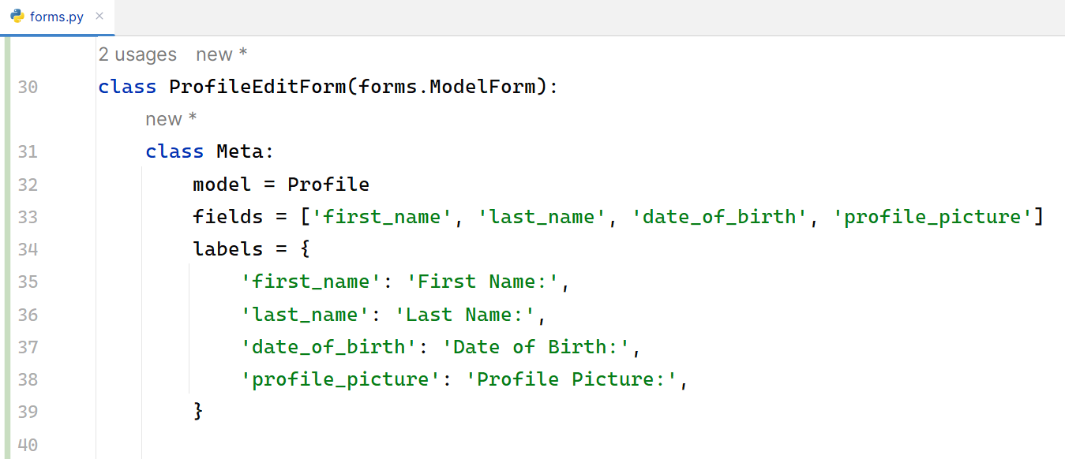
Then, we will implement the profile edit view that will inherit from the UpdateView class:
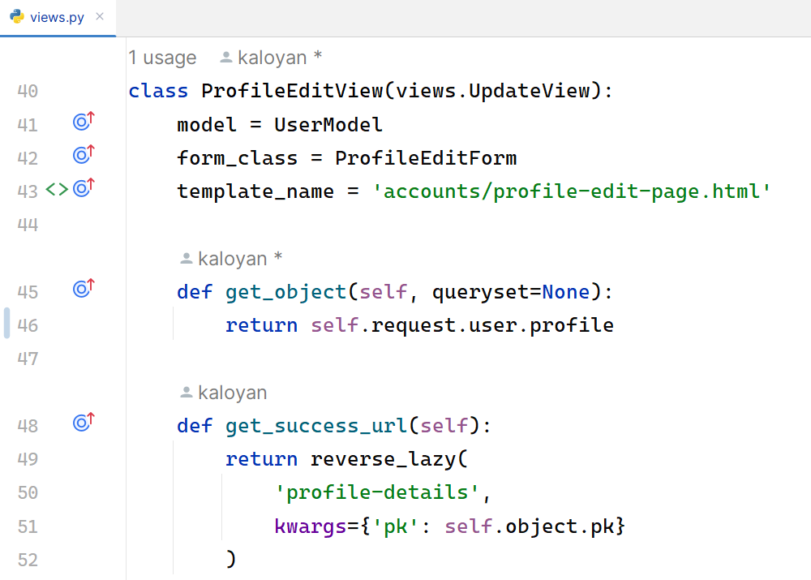
Next, we will refactor the code in the profile-edit-page.html template to implement the user form using the Django template language:
{% extends 'base.html' %}
{% block content %}
<!-- Start Edit Profile Section -->
<div class="edit-delete">
<h2>Edit Profile</h2>
<!-- Start Edit Profile From -->
<form method="post">
{% csrf_token %}
{% for field in form %}
<p class="error"> {{ field.errors }} </p>
<div class="label-input">
<label>{{ field.label }}</label>
{{ field }}
</div>
<br>
{% endfor %}
<!-- Edit Profile Button -->
<button class="edit-btn" type="submit">Edit</button>
</form>
<!-- End Edit Profile Form -->
</div>
<!-- End Edit Profile Section -->
{% endblock %}

The edit profile form should be like this:
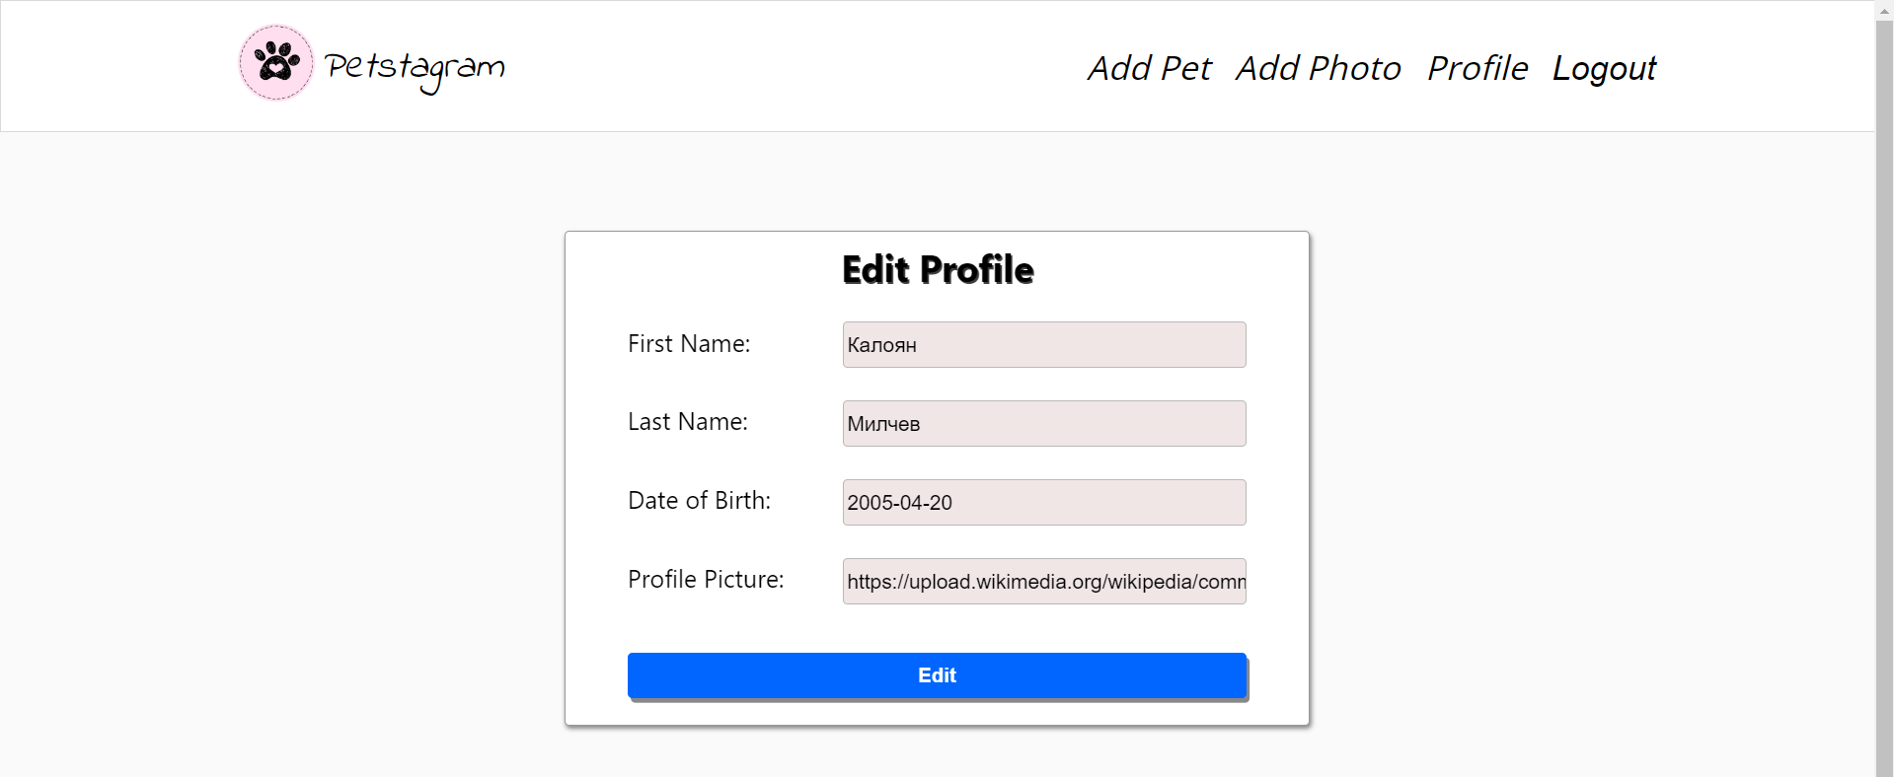

Workshop - Part 4.3

Refactor Models
We should connect the project models to the user. Let us start by adding the user to the pet's model:
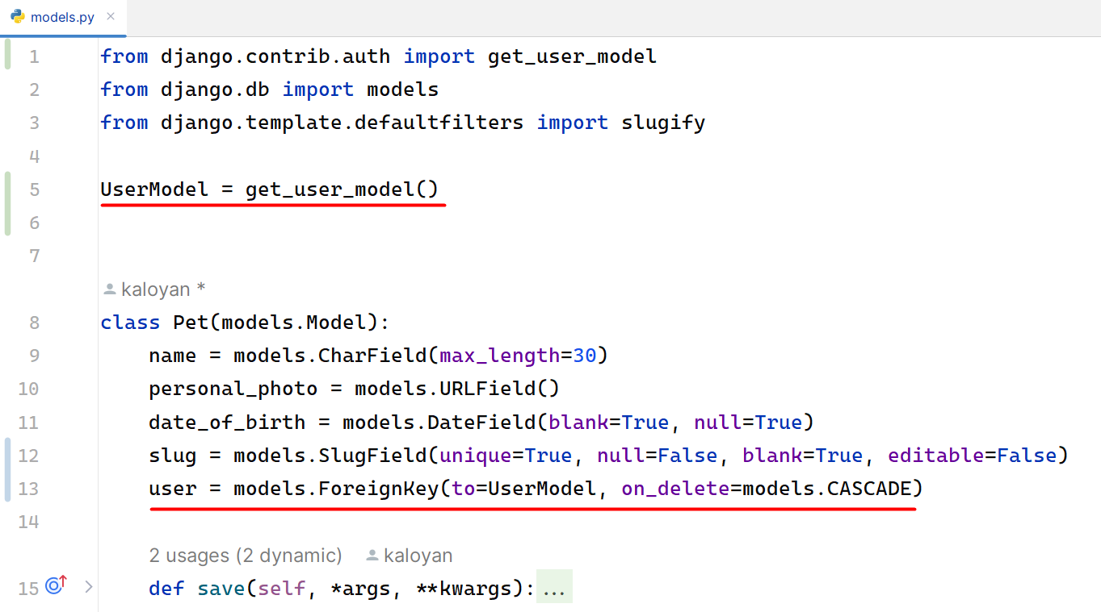
Next, we can connect the user to the photos, the comments, and the likes. Make the migration files and migrate the changes to the database.
When a user creates a pet or a photo they should be automatically added to the model. Let us implement it:
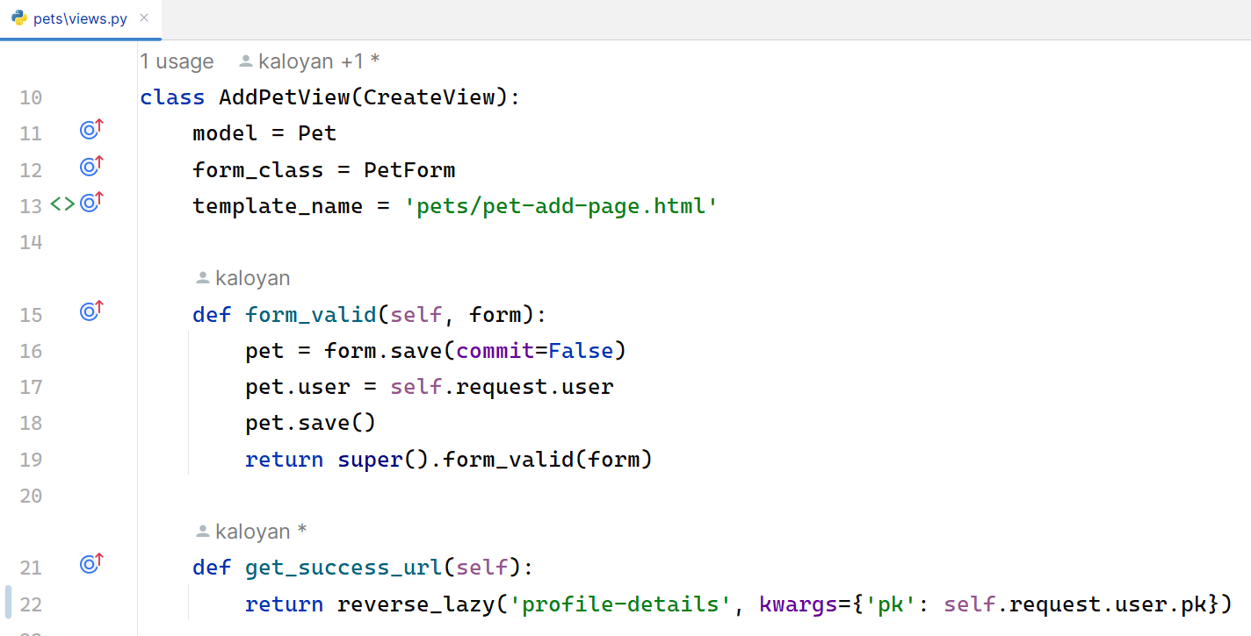
Implement the functionality to the add_photo view, too. Note: when our form includes many-to-many fields, we should also call form.save_m2m() after saving the model instance. Make changes to the forms if needed.
We should also add the user to the like and comment views. Let us start by refactoring the code in the like_functionality view:
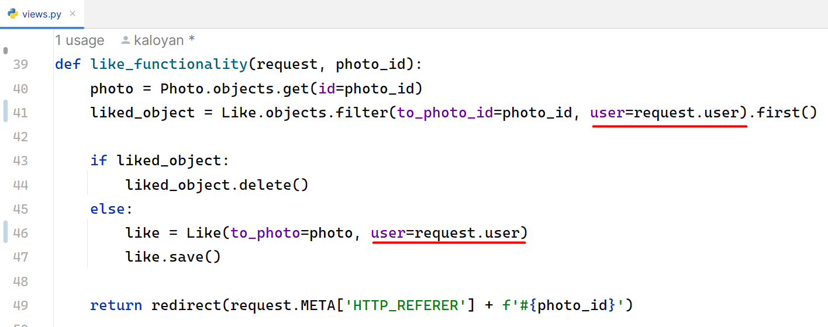
Next, add the user to the comment they post:
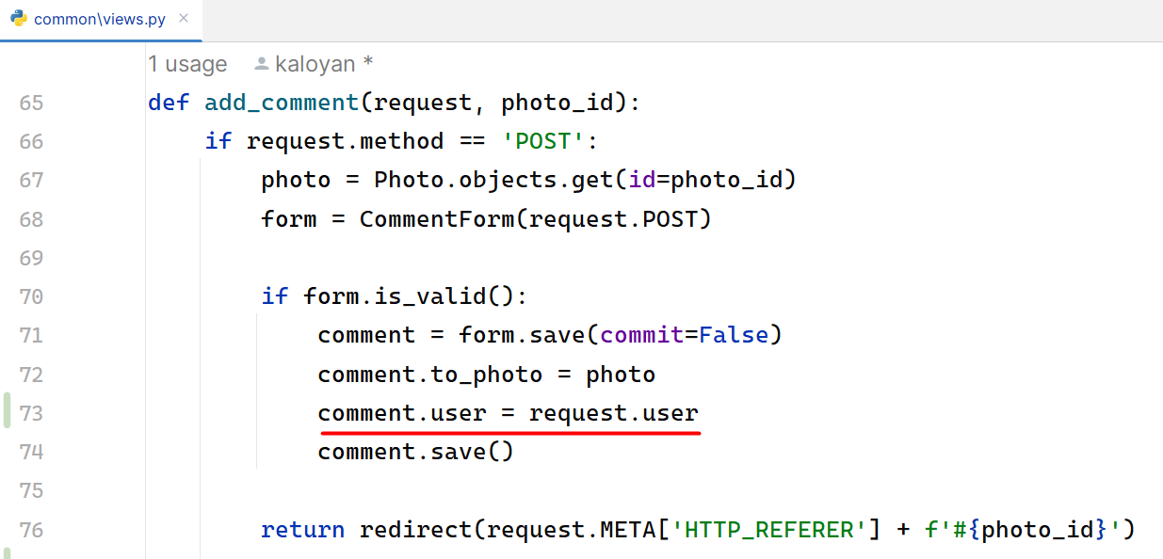

Refactor Pet Photo Posts
Let us refactor the pet-posts.html template. We want for each picture to show to the user who uploaded it. Let us open the file and start implementing the user information:
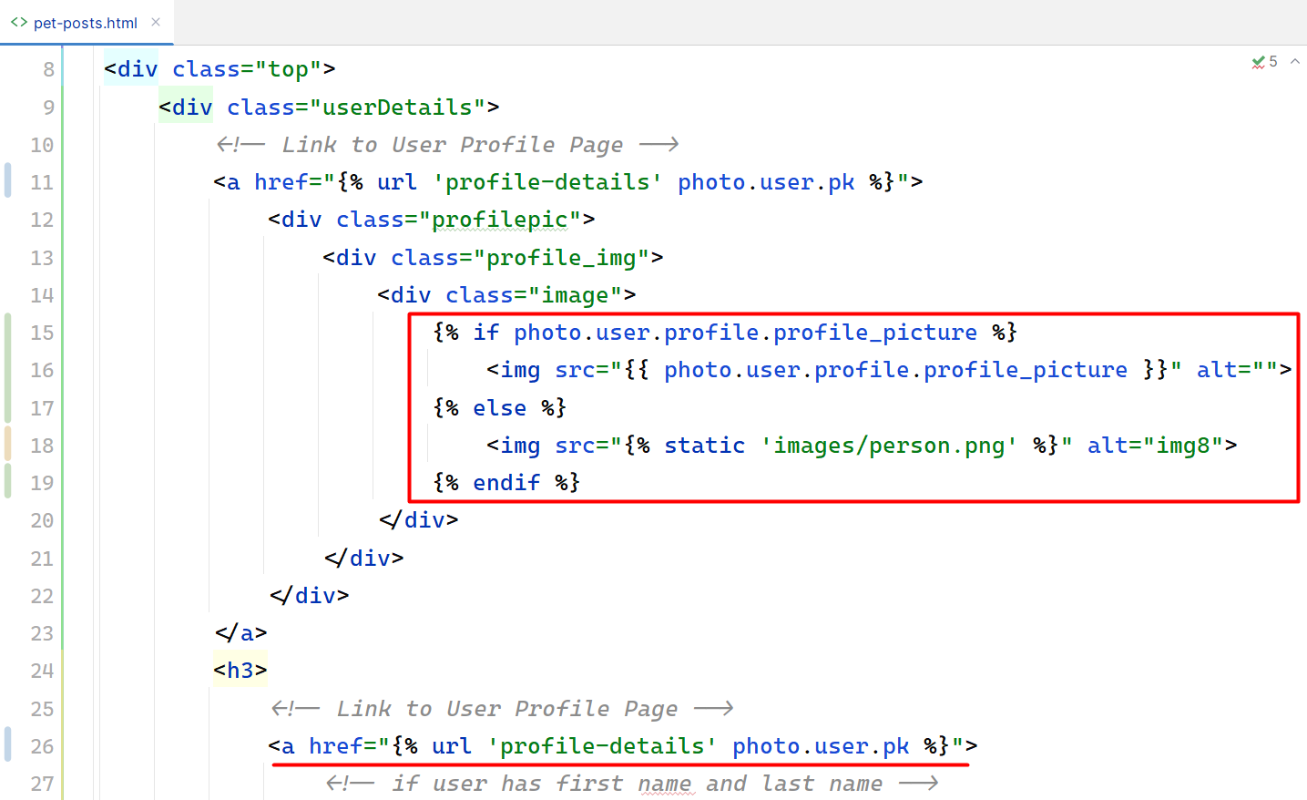
On the next rows we can see that we should show the first and/or the last name of the user if they exist. Otherwise, we should show Anonymous User. To do that, we can escape writing code in the template by adding an additional method to the user model:
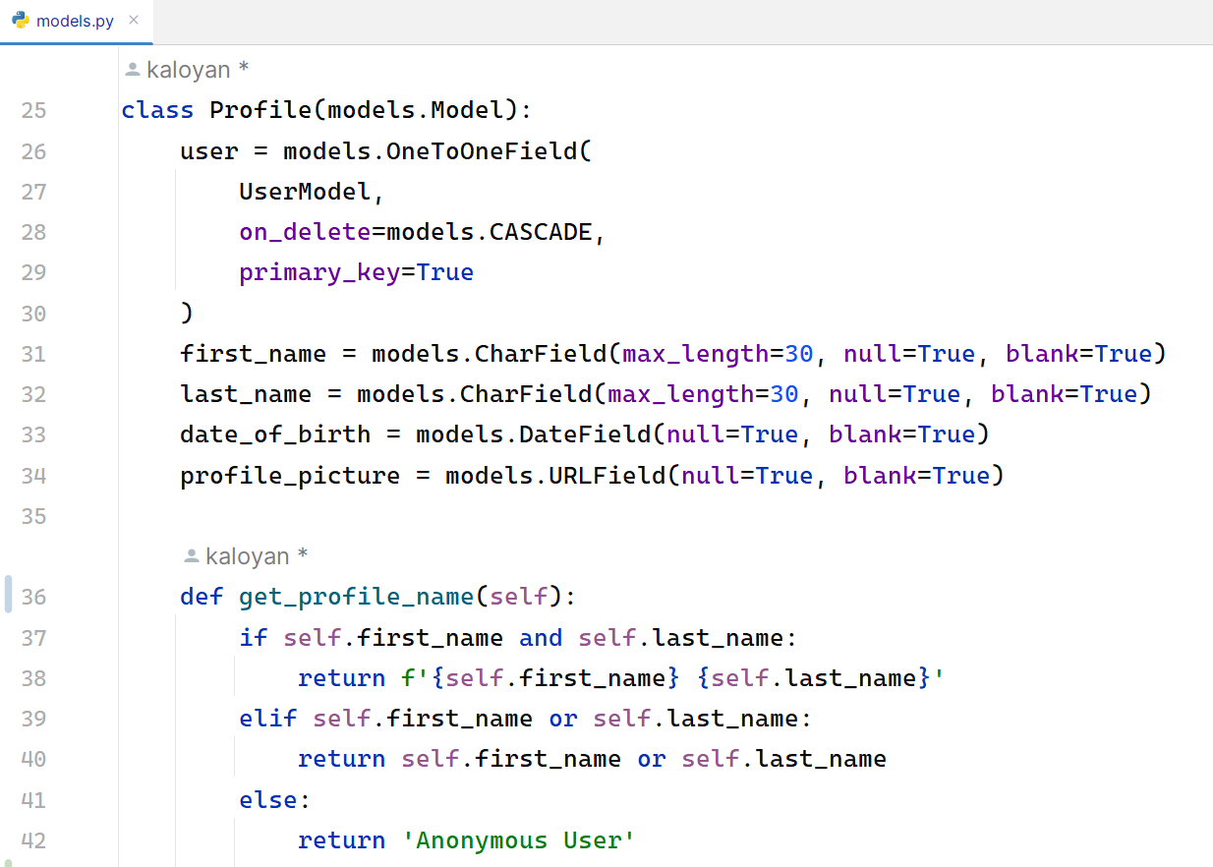
Then, we can use the method in the template:
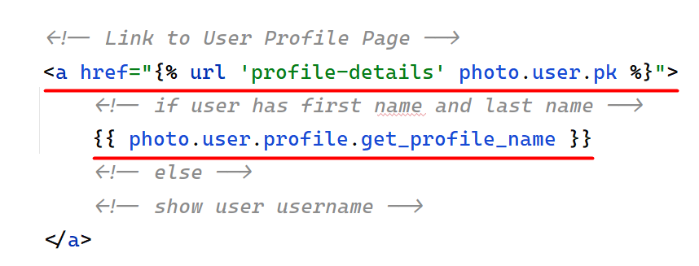
We should refactor the pet details URL, too:
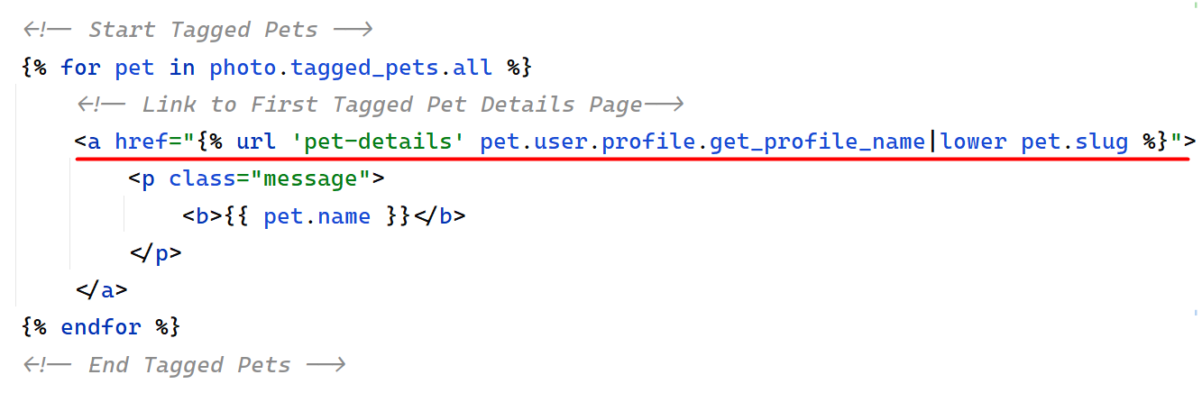
Start the development server and check the visualization.

Refactor Photo Details Page
Add the photo owner's data, and the comment user data and implement the like button visualization, so the current user sees if they liked the photo or not. The buttons edit and delete should be only visible to the owner of the photo.
Hint: you can do that by checking if the photo and its creator id is related to the id of the logged user.
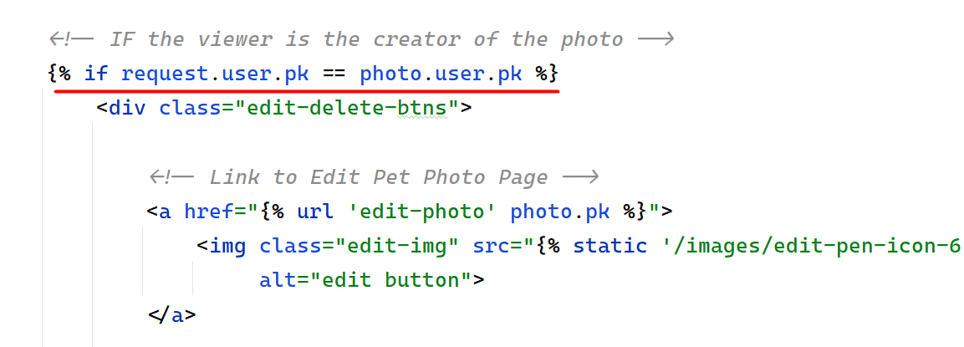

Refactor Profile Details Page
It is time to add the user data to the profile. We will use a CBV to incorporate both the user model and the template, and we will additionally add the total count of likes in the context:
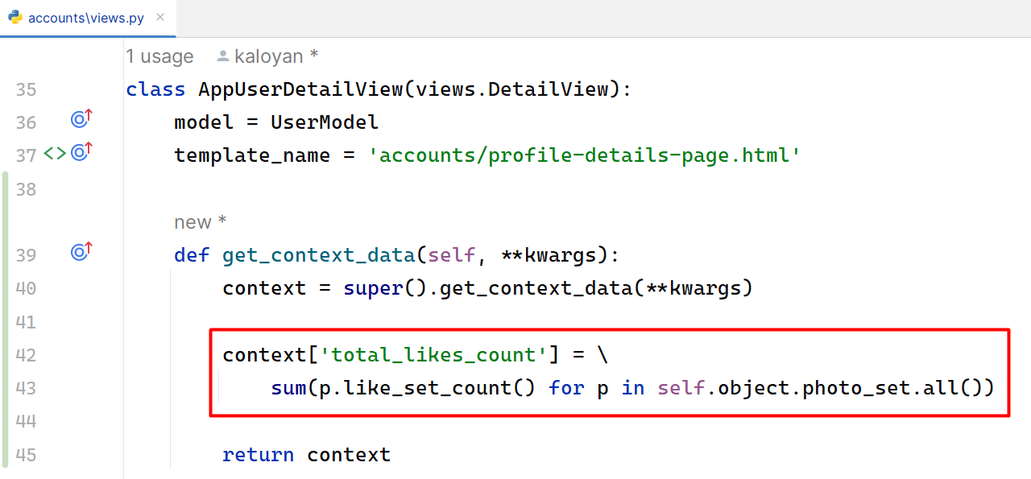
In the profile-details-page.html template we will add the user data, the count of all user photos, the count of all user pets, and the count of all likes that the user has collected, all user pets, and all user photos.

Check for Additional Changes
Do not forget to check all functionality on the app to see if everything works correctly:
- Check if the user object is needed elsewhere.
- Check all links and buttons.
- Login is required for all pages and buttons, except for the home page, and share post button.
Example: in the pet app, the show_pet_details view should find the owner of the pet and use it to visualize the edit/delete button to the owner of the pet only:
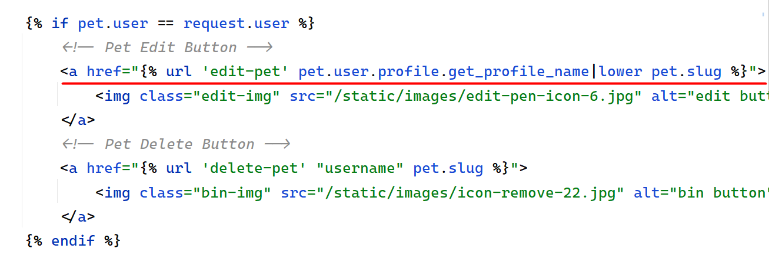

Workshop - Part 4.4

Add user delete functionality
We will add the final user functionality for this workshop. When a user is deleted, all their photos, pets, likes, and comments should be deleted too. Then, the app redirects to the home page with no authentication:
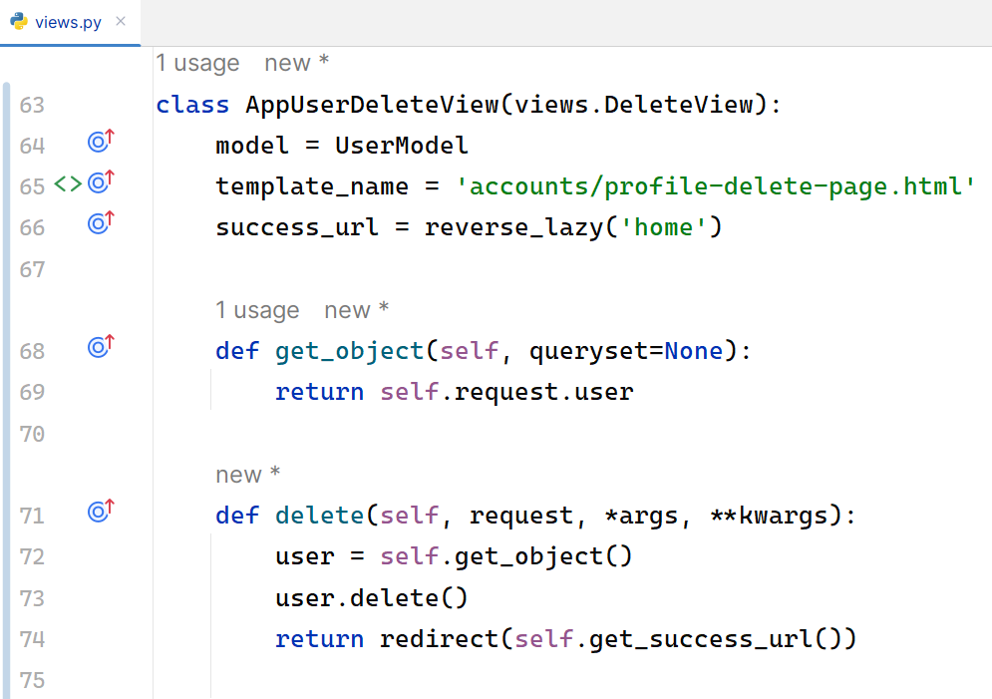
We should refactor the profile-delete-page.html template:
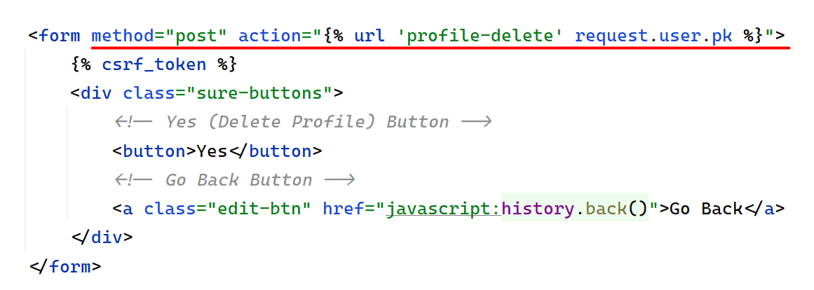

Django Signals
Creating relationship between AppUser and Profile through the login view is not the most accurate way. We can do this with Django signals. Feel free to delete the form_valid method from the login view.
In the accounts create a new file called signals.py and create a create_profile signal:
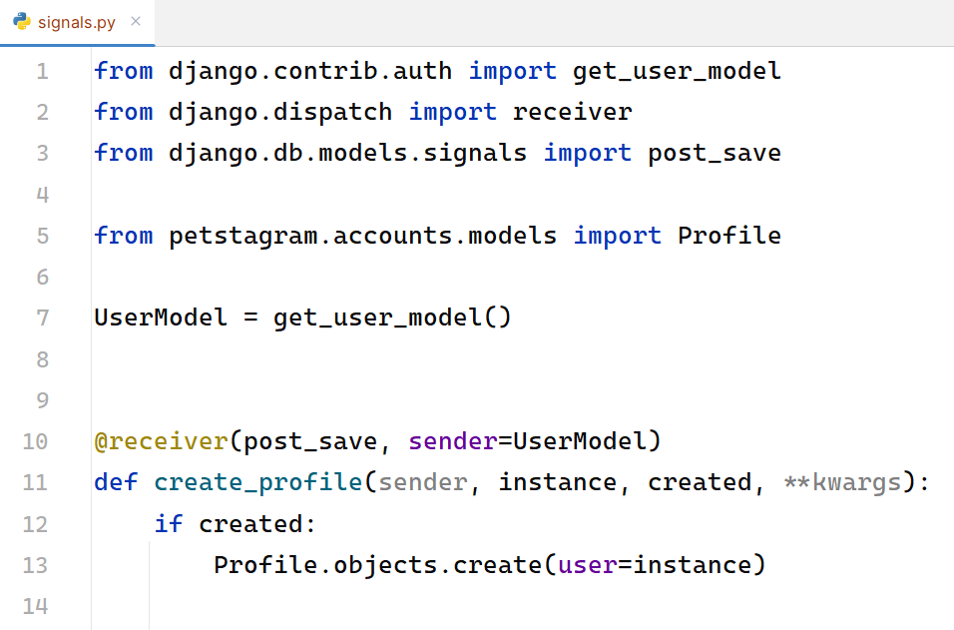
Note: it is important to import our signals from the accounts/apps.py file:
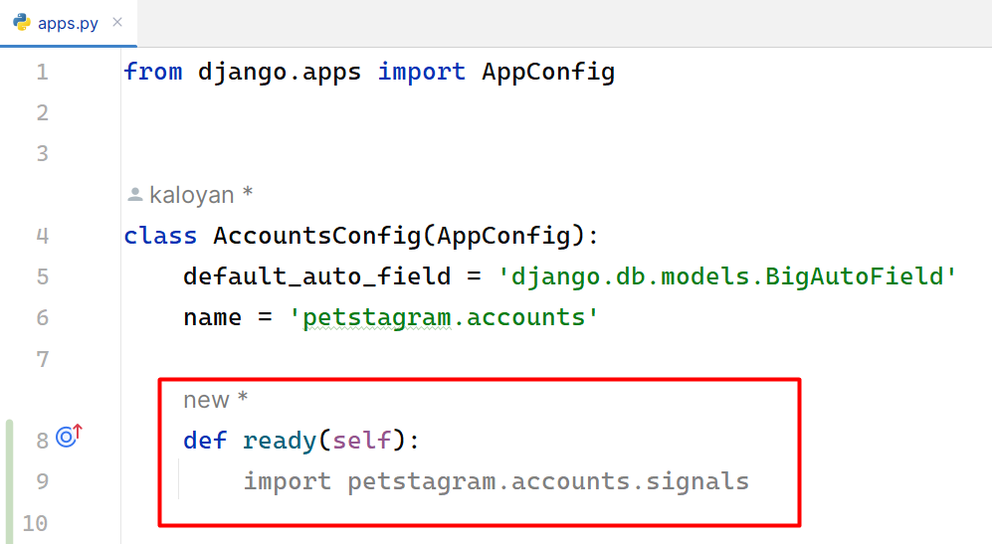

Workshop - Part 4.5 - Homework

Extend Profile Details Page
We can finalize our application functionality by extending the profile page. We must do two things:
- Link Pet Details Page.
- Link Uploaded Pet Photos (descending).
In the profile-details-page.html we are going to link our pets by defining the URL of the pet, its photo and name:
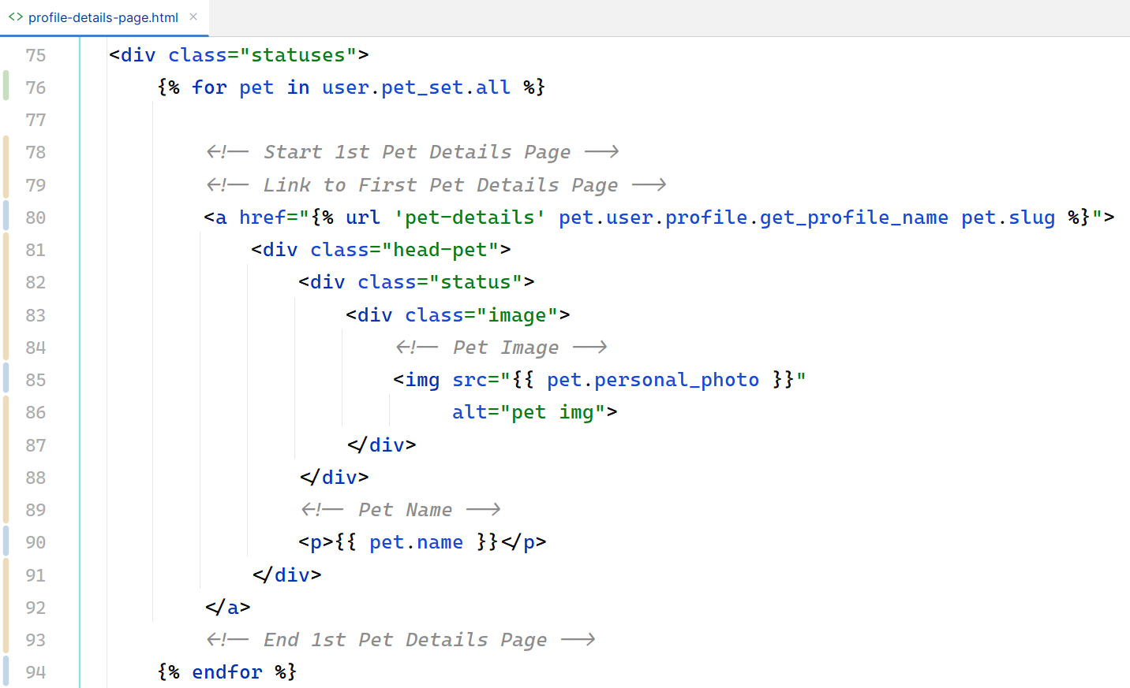
Next, we are going to link our photos, starting from the last uploaded one.
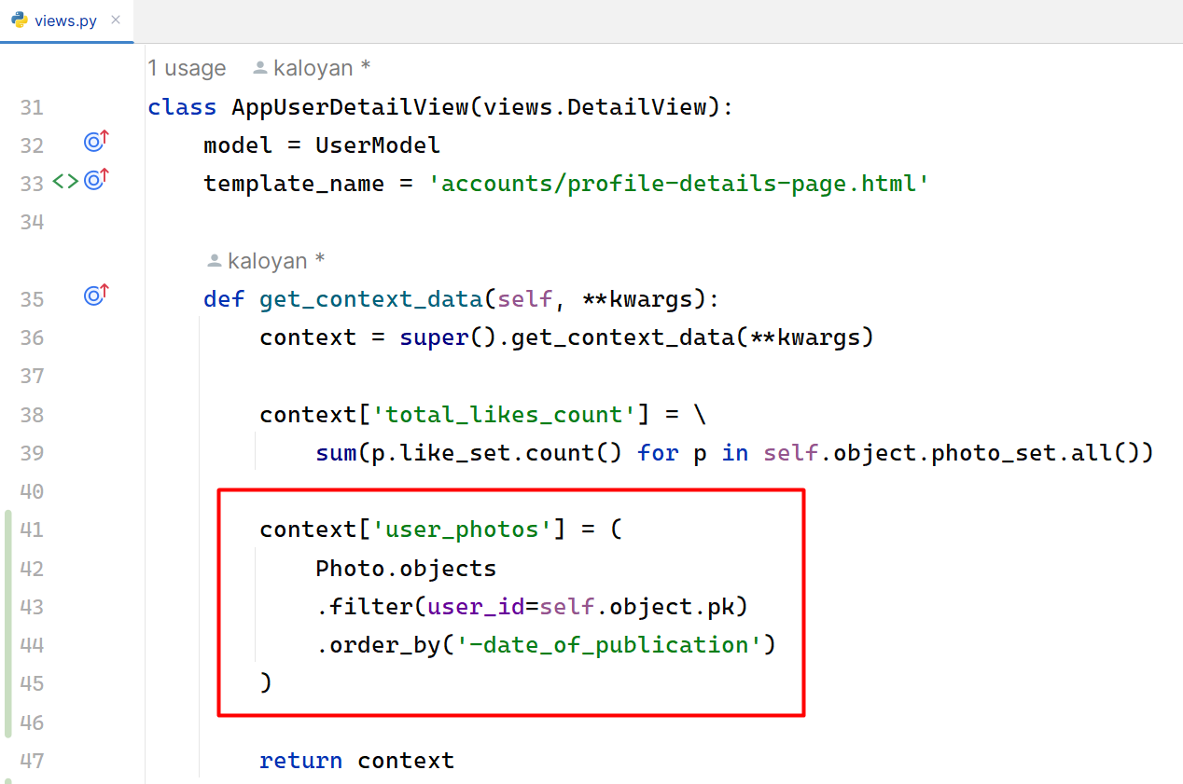
Update the profile-details-page.html:
