Workshop: Petstagram
This document marks the third segment of the Petstagram Workshop. In today's session, we will transform our existing Function-Based Views into Class-Based Views. Furthermore, in today's session, we will delve into the integration of Django's pagination feature. This powerful tool will enable us to efficiently manage and present large datasets, ensuring a smoother and more user-friendly experience for our Petstagram application.
The full project description of the project can be found in the Workshop Description Document.

Workshop - Part 3.1

Recreating the Add Pet View
Let us recreate the Pet Model Views with Class-Based Views. Class-Based Views (CBV) in Django are an alternative to Function-Based Views (FBV) for handling HTTP requests and generating responses. Instead of using functions to define views, CBVs use classes.
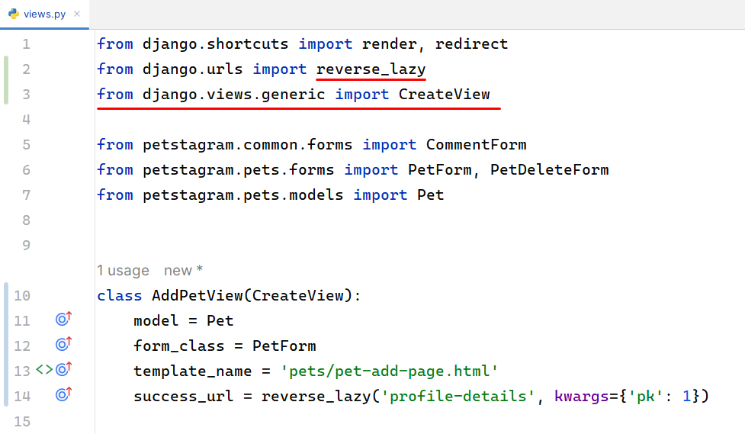
Let us easily explain the code:
- model = Pet: Specifies the model that the view is associated with, in this case, the Pet model.
- form_class = PetForm: Specifies the form class to be used for handling input data. In this context, it's set to PetForm, the form class associated with the Pet model.
- template_name = 'pets/pet-add-page.html': Specifies the template file that will be used to render the HTML content for this view. The template is located at 'pets/pet-add-page.html'.
- success_url = reverse_lazy('profile-details', kwargs={'pk': 1}): Specifies the URL to redirect to after a successful form submission. In this case, it uses reverse_lazy to dynamically generate the URL for the 'profile-details' view with a specific primary key (pk=1). The use of reverse_lazy allows for resolving the URL at runtime.

Recreating the Add Pet URLs
We need to replace the FBV with the new CBV.
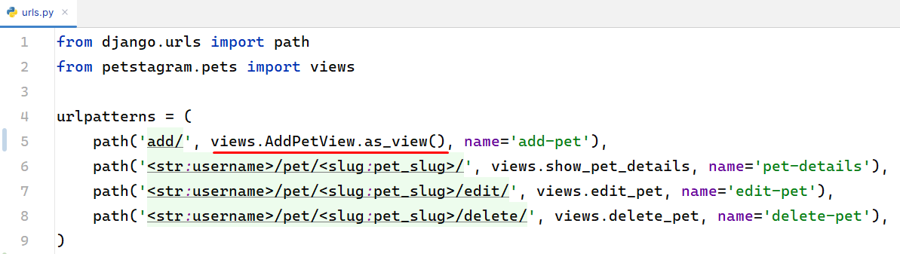
In the provided code as_view() is a method provided by class-based views that converts a class-based view into a function-based view. It's a convention used to make the class-based views compatible with Django's URL routing system, which typically expects function-based views.

Recreating the Show Pet Details View
Let's give a better name for our view. We can name it PetDetailsView. It should inherit the generic DetailView.
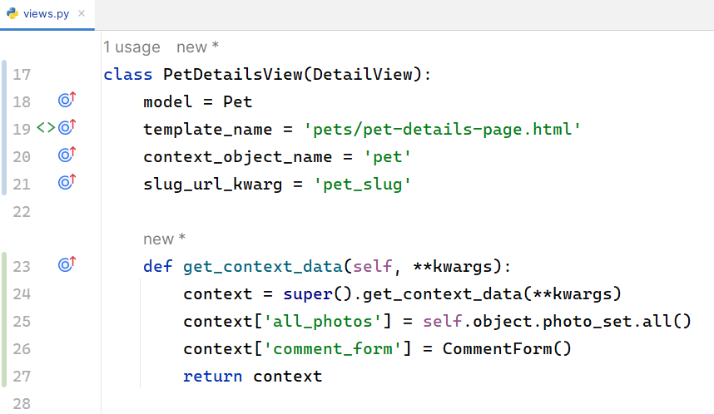
Here we added some new features. Let us break down them step by step:
- context_object_name = 'pet': Assigns the name 'pet' to the object retrieved from the database, making it accessible in the template.
- slug_url_kwarg = 'pet_slug': Captures the pet's slug from the URL and passes it as a keyword argument to the view.
The get_context_data method is overridden to enhance the context with additional data:
- context['all_photos']: Retrieves all photos related to the pet using the reverse relation photo_set.
- context['comment_form']: Includes a new instance of the CommentForm to handle comments.

Recreating the Pet Details URLs
The only thing we have to change is to include the new Class-Based View with the function as_view().
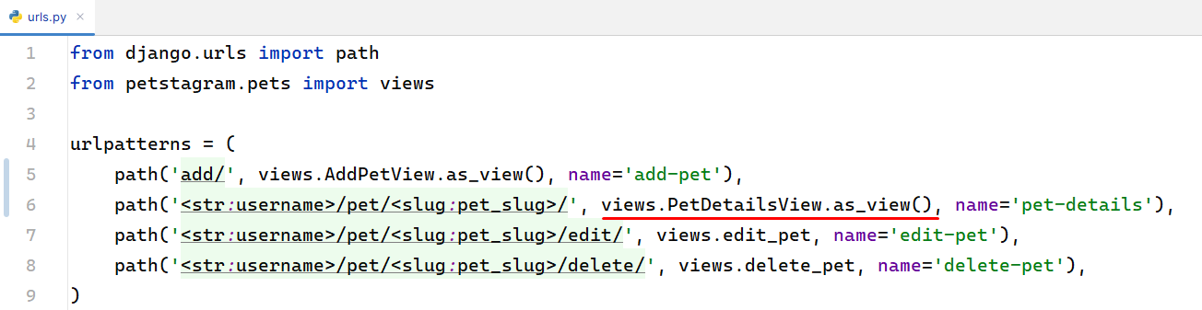

Recreating the Edit Pet View
Now we are going to recreate the EditPetView. It should inherit the generic UpdateView:
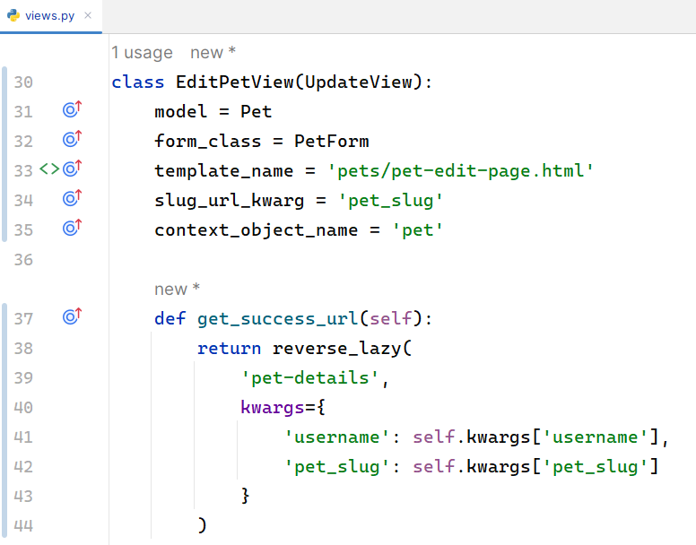
Customizing the Redirect URL:
- In the example code provided, the get_success_url method is overridden to customize the redirect URL.
- The reverse_lazy function is used to dynamically generate the URL based on the pet-details URL pattern. The kwargs parameter allows you to pass dynamic values to the URL pattern.
- In this case, it constructs the URL using the username and pet_slug from the current instance's kwargs.

Recreating the Edit Pet URLs
The only thing we have to change is to include the new Class-Based View with the function as_view().
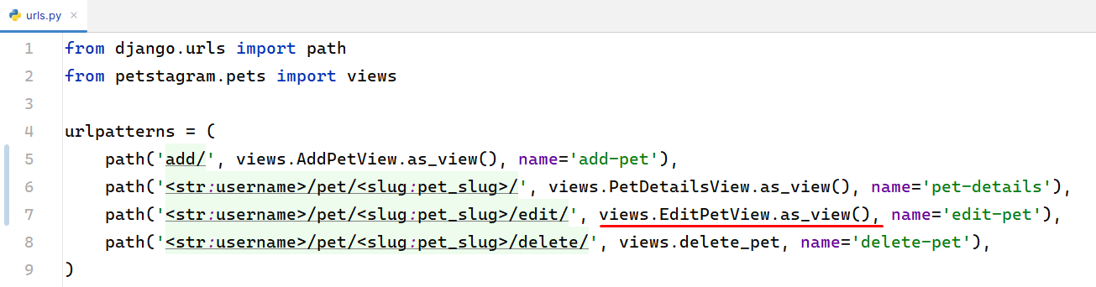

Recreating the Delete Pet View
The last view we are going to recreate is the DeletePetView. It should inherit the generic DeleteView:
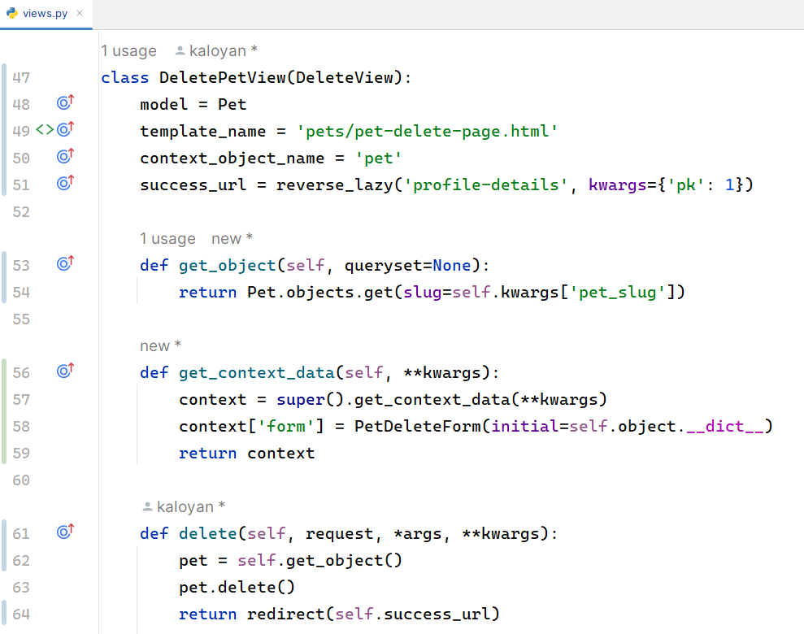
In the DeletePetView class-based view, several methods are overridden to customize the behavior of the view. Here's an explanation of each method:
- get_queryset(self):
  - This method is used to return the queryset of objects that the DeleteView operates on.
  - In the DeletePetView, it is overridden to filter the queryset based on the pet_slug from the URL parameters.
  - This method helps define which set of objects can be deleted. In this case, it ensures that only the specific Pet object with the given slug can be deleted.
- delete(self, request, *args, **kwargs):
  - In the DeletePetView, it uses the get_object method to retrieve the specific Pet object to be deleted.
  - After retrieving the object, it calls the delete method on the object to remove it from the database.
  - Finally, it redirects the user to the specified success_url, which, in this case, is the 'profile-details' page.

Recreating the Delete Pet URLs
The only thing we have to change is to include the new Class-Based View with the function as_view().
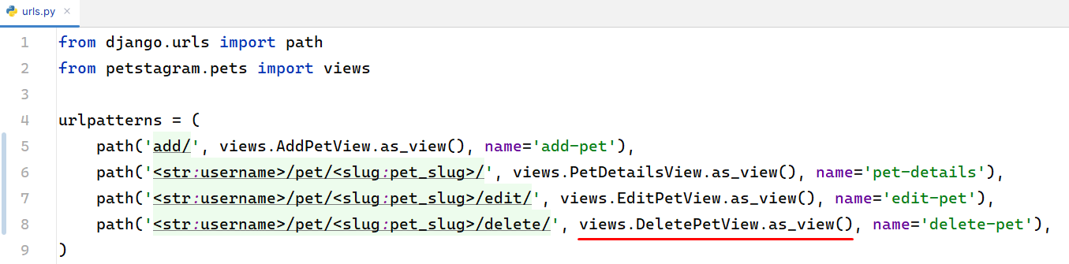

Workshop - Part 3.2

Pagination Functionality
Finally, it is time to add Django pagination. Django pagination is a technique used to divide a large set of data into smaller, more manageable chunks or pages. Open the common/views.py file and let us implement the pagination functionality. The import statements should come from the django.core.paginator module:
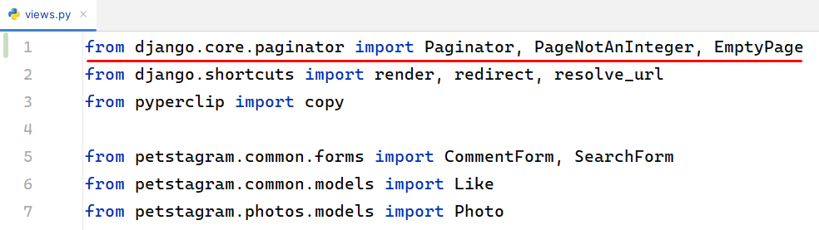
In the show_home_page view we are going to setup our paginator:
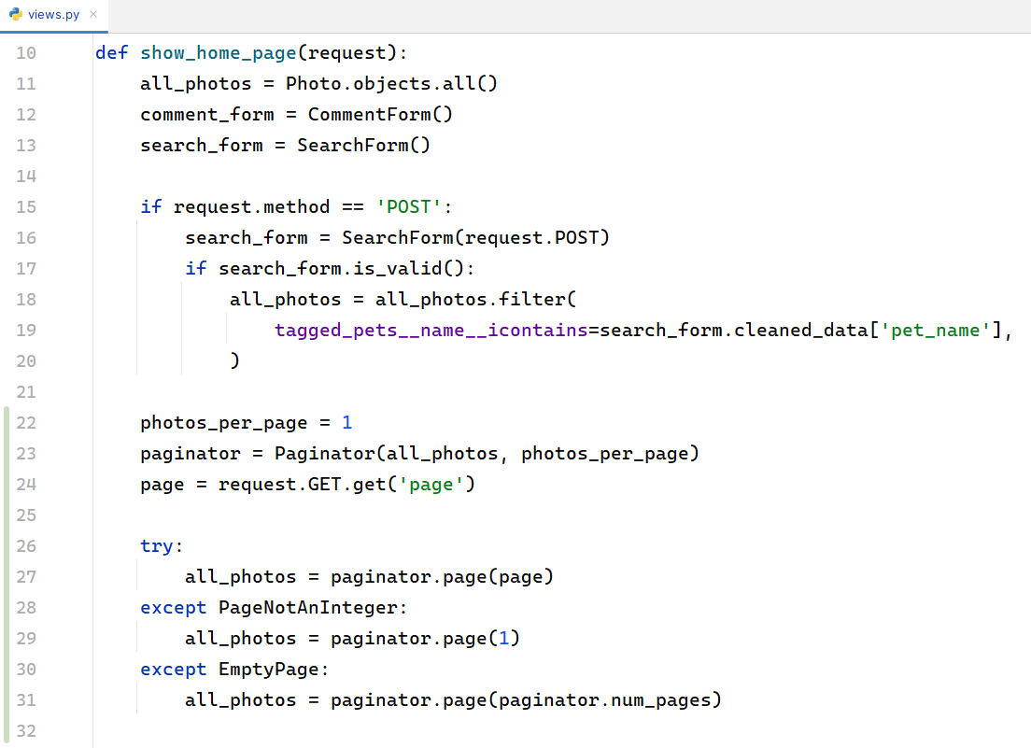
In the code above:
- We set the number of photos per page using photos_per_page.
- We created a Paginator object with all_photos and the specified photos_per_page.
- We attempted to get the requested page number from the request's GET parameters: request.GET.get('page').
- We handled cases where the page number is NOT an integer or when the page is empty by defaulting to the first or last page, respectively.

Pagination Template Setup
Lastly, we are now modifying the common/home-page.html template. We want to add the following HTML that will display the paginator:

{% extends 'base.html' %}
{% block content %}
{% load static %}
<div class="container">
<div class="col-9">
<!-- Start Searchbar Form -->
<form class="searchbar" method="get">
{% csrf_token %}
{{ search_form }}
<button>
<img src="{% static 'images/search.png' %}" height="18" alt="img2">
</button>
</form>
<!-- End Searchbar Form -->
{% include 'common/pet-posts.html' %}
<!-- Start Pagination -->
<div class="pagination">
<span class="current">
Page {{ all_photos.number }} of {{ all_photos.paginator.num_pages }}
</span>
<span class="step-links-buttons">
<!-- If there are previous and next photos -->
{% if all_photos.has_previous and all_photos.has_next %}
<a href="?page={{ all_photos.previous_page_number }}">
<i class="fa-solid fa-arrow-left"></i>
</a>
<a href="?page={{ all_photos.next_page_number }}">
<i class="fa-solid fa-arrow-right"></i>
</a>
<!-- If there are only previous photos -->
{% elif all_photos.has_previous %}
<a href="?page={{ all_photos.previous_page_number }}">
<i class="fa-solid fa-arrow-left"></i>
</a>
<!-- If there are only next photos -->
{% elif all_photos.has_next %}
<a href="?page={{ all_photos.next_page_number }}">
<i class="fa-solid fa-arrow-right"></i>
</a>
{% endif %}
</span>
</div>
<!-- End Pagination -->
</div>
</div>
{% endblock %}

The configuration should look like this:
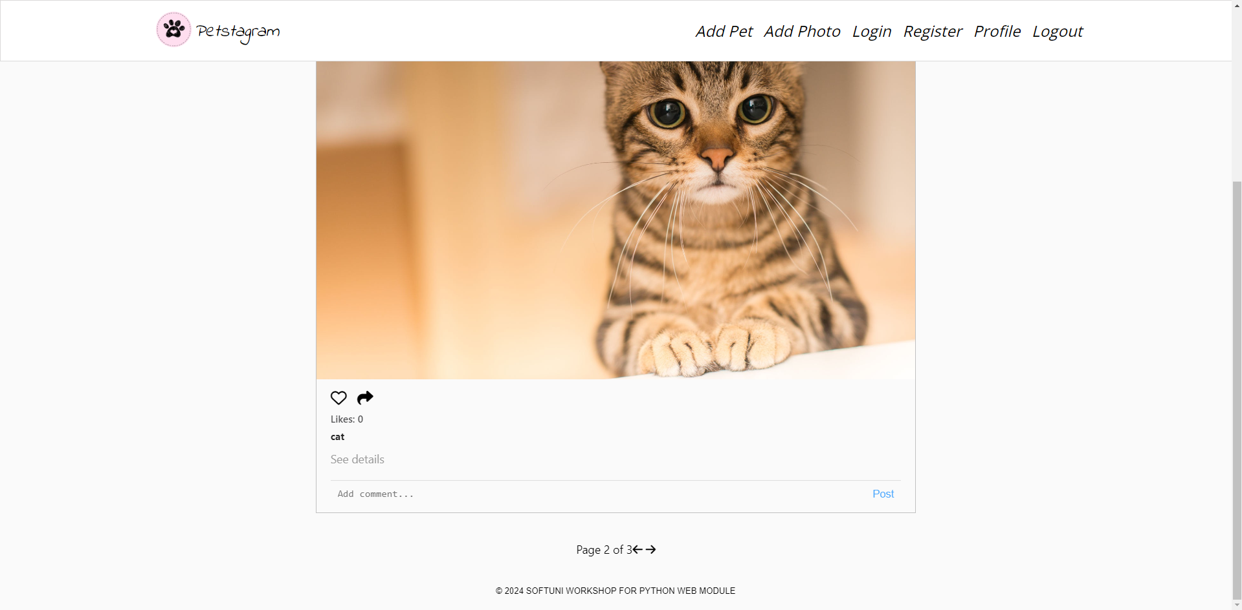

Pagination with Class-Based View
The more elegant way to display our pets is through the Django generic ListView:
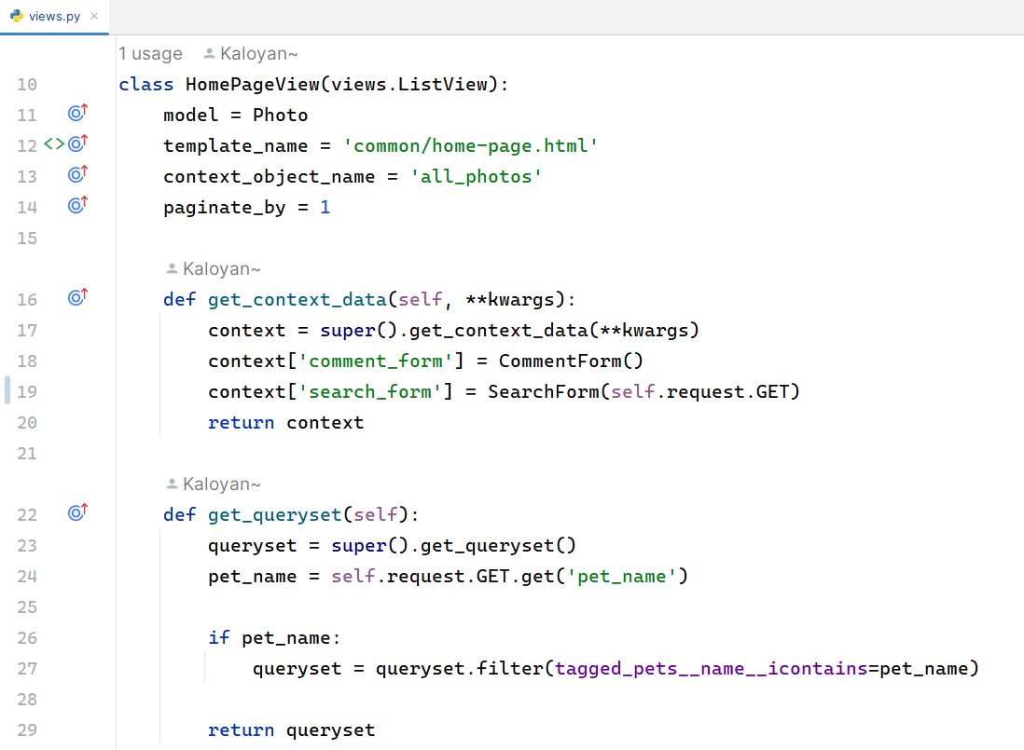
Do not forget to modify the path() function in the common/url.py patterns!
Lastly, there is a small change that we need to apply in our common/home-page.html template. The variable all_photos must change to page_obj:
...
<div class="container">
<div class="col-9">
<!-- Start Searchbar Form -->
<form class="searchbar" method="get">
{% csrf_token %}
{{ search_form }}
<button>
<img src="{% static 'images/search.png' %}" height="18" alt="img2">
</button>
</form>
<!-- End Searchbar Form -->
{% include 'common/pet-posts.html' %}
<!-- Start Pagination -->
<div class="pagination">
<span class="current">
Page {{ page_obj.number }} of {{ page_obj.paginator.num_pages }}
</span>
<span class="step-links-buttons">
<!-- If there are previous and next photos -->
{% if page_obj.has_previous and page_obj.has_next %}
<a href="?page={{ page_obj.previous_page_number }}">
<i class="fa-solid fa-arrow-left"></i>
</a>
<a href="?page={{ page_obj.next_page_number }}">
<i class="fa-solid fa-arrow-right"></i>
</a>
<!-- If there are only previous photos -->
{% elif page_obj.has_previous %}
<a href="?page={{ page_obj.previous_page_number }}">
<i class="fa-solid fa-arrow-left"></i>
</a>
<!-- If there are only next photos -->
{% elif page_obj.has_next %}
<a href="?page={{ page_obj.next_page_number }}">
<i class="fa-solid fa-arrow-right"></i>
</a>
{% endif %}
</span>
</div>
<!-- End Pagination -->
</div>
</div>
...

If you are encountering this type of error, you can modify the search form properties:
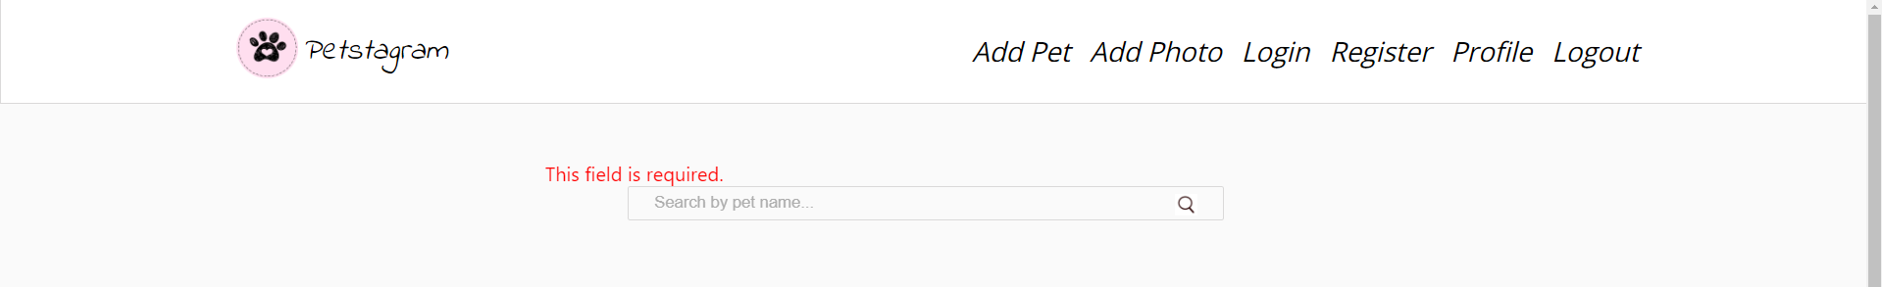
In the common/forms.py set required=False:
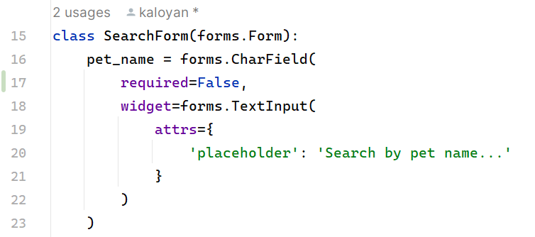

Bonus Task - Pagination Design
As we can see the User Interface is not eye-catching. In the css/home.css we can add custom styling to our HTML:
/* Pagination styles */
.pagination {
display: flex;
flex-direction: column;
justify-content: center;
align-items: center;
margin-top: 20px;
gap: 10px;
}
.step-links-buttons a,
.step-links-buttons span.current {
font-size: 20px;
color: white;
padding: 10px 15px;
margin: 0 5px;
text-decoration: none;
background-color: white;
transition: background-color 0.3s, color 0.3s;
}
.step-links-buttons a:hover {
background-color: #3498db;
}
.step-links-buttons span.current {
cursor: default;
text-shadow: none;
}

.step-links-buttons a:first-child,
.step-links-buttons a:last-child {
margin: 0;
}
.step-links-buttons {
display: flex;
text-shadow: none;
}
.step-links-buttons a.disabled {
pointer-events: none;
opacity: 0.5;
cursor: not-allowed;
}

Refresh the browser and open the Petstagram tab. Now the project has much better visual appeal:
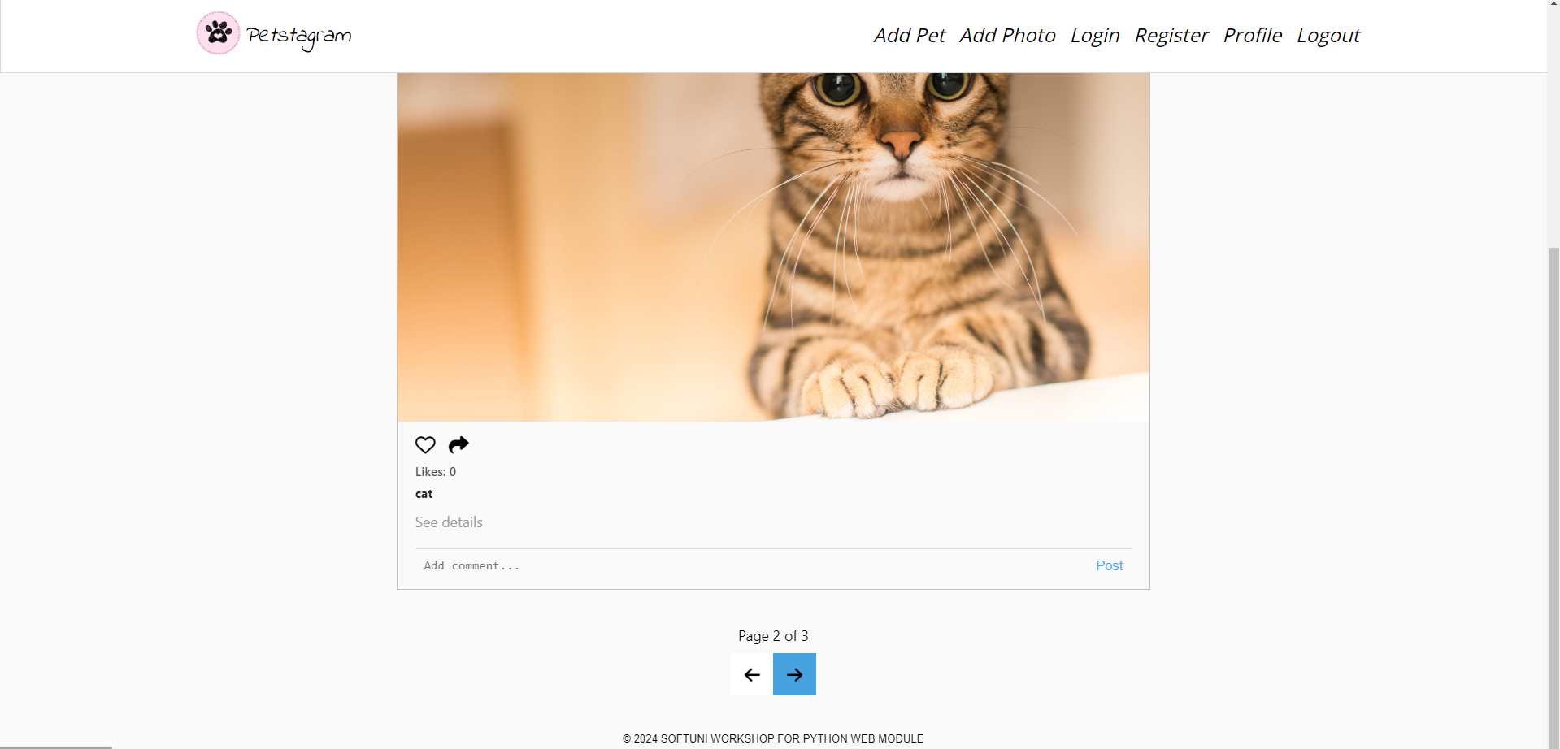

Refactoring Search Bar Functionality
After implementing Django Pagination, the search functionality in our application is not functioning as expected. To resolve this issue, we'll integrate Django Sessions to maintain the search query across pagination.
Please be informed that we will delve deeper into Django sessions during the upcoming Django Advanced Module.
Here's the plan:
- Handle Search Query: When a user performs a search, store the search query in the Django session.
- Retrieve Search Query: Retrieve the search query from the session when generating the queryset.
- Apply Search Query: Modify the queryset to filter objects based on the search query if it exists.
- Clear Search Query: Clear the search query from the session when the user presses Petstagram.

In the common/views.py - HomePageView - we will update the method get_queryset():
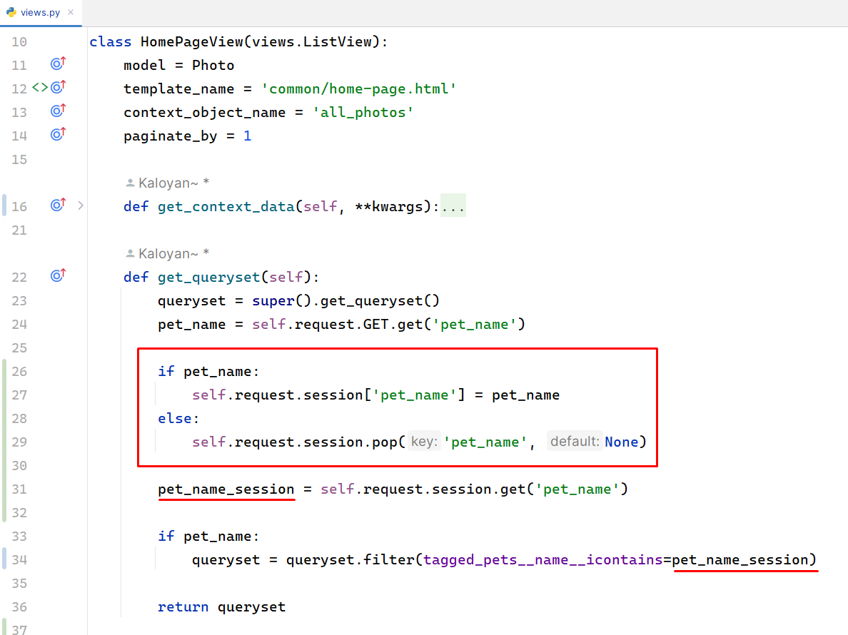
Now let us open the common/home-page.html and update our HTML template tags:
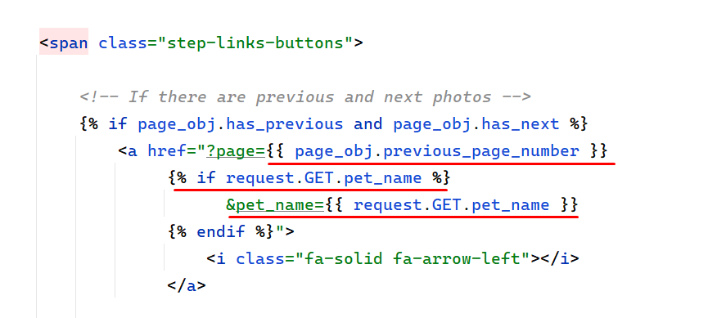

Here's a breakdown of the changes:
- We added logic to include the search_query parameter in the pagination links if it exists in the URL. This ensures that the search query persists across pagination. The {% if request.GET.search_query %} condition checks if the search query parameter is present in the URL, and if so, it appends it to the pagination links using the {{ request.GET.search_query }} template variable.
...

<!-- Start Pagination -->
<div class="pagination">
<span class="current">
Page {{ page_obj.number }} of {{ page_obj.paginator.num_pages }}
</span>
<span class="step-links-buttons">
<!-- If there are previous and next photos -->
{% if page_obj.has_previous and page_obj.has_next %}
<a href="?page={{ page_obj.previous_page_number }}
{% if request.GET.pet_name %}
&pet_name={{ request.GET.pet_name }}
{% endif %}">
<i class="fa-solid fa-arrow-left"></i>
</a>
<a href="?page={{ page_obj.next_page_number }}
{% if request.GET.pet_name %}
&pet_name={{ request.GET.pet_name }}
{% endif %}">
<i class="fa-solid fa-arrow-right"></i>
</a>
<!-- If there are only previous photos -->
{% elif page_obj.has_previous %}
<a href="?page={{ page_obj.previous_page_number }}
{% if request.GET.pet_name %}
&pet_name={{ request.GET.pet_name }}
{% endif %}">
<i class="fa-solid fa-arrow-left"></i>
</a>
<!-- If there are only next photos -->
{% elif page_obj.has_next %}
<a href="?page={{ page_obj.next_page_number }}
{% if request.GET.pet_name %}
&pet_name={{ request.GET.pet_name }}
{% endif %}">
<i class="fa-solid fa-arrow-right"></i>
</a>
{% endif %}
</span>
</div>
<!-- End Pagination -->

...

