USER MANUAL

The project was developed on Eclipse (Version:Oxygen 4.7) using Java version 1.8.

To run the file, follow the below instructions:

1. Extract the compressed folder DataBase_Engine(Downloaded from eLearning).

2. Import the project folder into the Eclipse IDE.

3. Run the DavisBase.java file to start Davisbase.

(or)

1. Extract the compressed folder DataBase_Engine(Downloaded from eLearning).

2. Open Command Prompt.

3. Navigate to the path where the folder has been extracted.

4. Navigate to the src\database folder and compile and run the DavisBase.java file

**FEATURES**

1. **CREATE TABLE**: Creates a table of the given name. The PRIMARY KEY must be

(a) a single column,

(b) the first column listed in the CREATE statement, and

(c) an INT data type.

Syntax:

CREATE TABLE table_name ( row_id INT PRIMARY KEY, column_name2 data_type2 [NOT NULL], column_name3 data_type3 [NOT NULL], ... );

Example:

CREATE TABLE Students (row_id INT, name TEXT, gpa FLOAT);

2. **INSERT** : Inserts a row into the table.  
  
Syntax: INSERT INTO <TABLE_NAME> (<VALUES>);

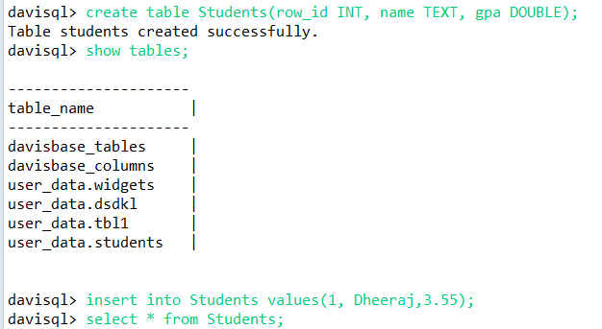

3. **SELECT :**

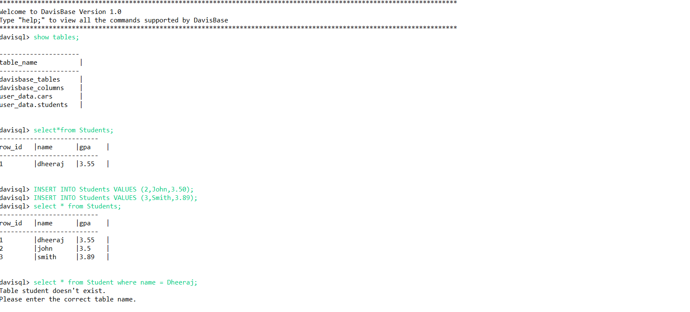

4. **DELETE (BONUS FEATURE)**

5. **UPDATE**

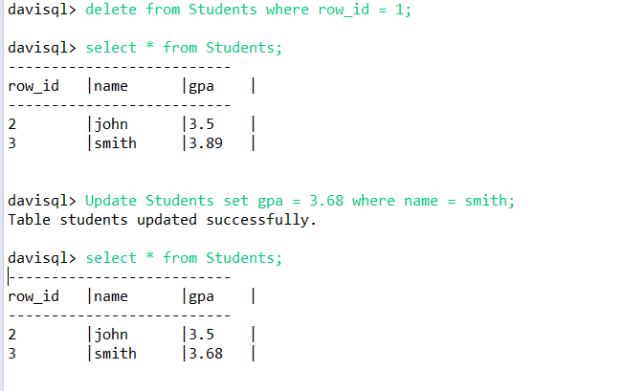

**7. DATABASE OPERATIONS:**

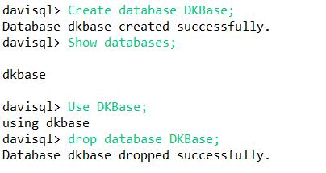

**8. META-DATA**

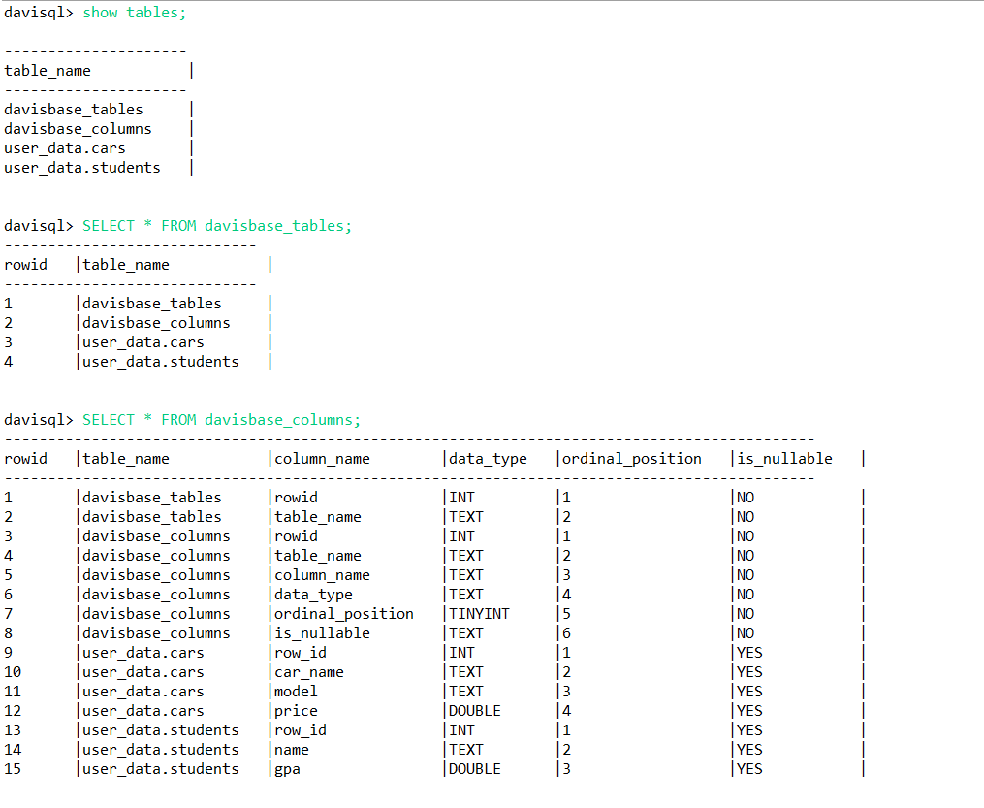

After Insert into the table, creation of index happens.

**File Structure:**

