PROJECT REPORT
ON
“MBM-TALKIES – AN ANDROID APPLICATION”
(AN ONLINE NOTICEBOARD AND FORUM PROVIDING A SIMPLE INTUITIVE COMMUNICATION PLATFORM FOR OUR COLLEGE)
SUBMITTED FOR THE PARTIAL FULFILMENT OF THE DEGREE
OF
BACHELOR OF ENGINEERING IN
ELECTRONICS AND COMPUTER ENGINEERING
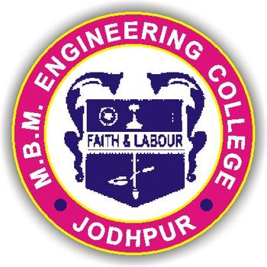

Submitted by: Guided By:
Poorva Sinha, 13/12965, 14ECC76030 Rajendra Bhansali
Poojan Jangid 13/13069, 14ECC73028
Kirti Desai, 13/19025, 14ECC76022
Sanjay Rajpurohit, 13/,14ECC760

Department of Electronics and communication engineering
MBM Engineering College, Faculty of Engineering,
Jai Narayan Vyas University,
Jodhpur (Rajasthan)
Session 2016-17
CONTENTS :

S.no | Topic
1. | Declaration
2. | Abbreviations
3. | Introduction
3.1 | Android at a glance
3.2 | Features of Android
3.3 | Categories of Android Application
3.4 | History of Android
3.5 | API Level
3.6 | Android Architecture
3.6(a) | Linux Kernel
3.6(b) | Libraries
3.6(c) | Android Libraries
3.6(d) | Android Runtime
3.6(e) | Android Framework
3.6(f) | Android Applications
3.7 | Sensors Overview
3.7(a) | Introduction to Sensors
3.7(b) | Sensor types supported by Android
4. | Google Cloud Messaging (GCM)
4.1 | GCM
4.2 | Push Notification
4.3 | User registration key
4.4 | Php code to send the push notification
5. | Android Json Parser
5.1 | Json –Elements
5.2 | Json-Prasing
6. | Android Php/MYSQL
6.1 | PHP/Mysql
6.2 | PHP-get and Post method
6.3 | Android Connecting MySql
6.4 | Connecting via POST method
7. | Android Application in Detail

DECLARATION

We, Poorva sinha, Poojan jangid, Kirti desai and Sanjay Rajpurohit hereby declare that this project titled “MBM Talkies” is a record of original work done by us under the supervision and guidance of Dr. Rajendra Bhansali. We further certify that this project work has not formed the basis for the award of the Degree/ Diploma/ Associateship/ Fellowship or similar work to any candidate of any university and no part of this report is reproduced as it is from any other source without seeking permission.

Signature of the students
Poorva Sinha :
Poojan Jangid :
Kirti Desai :
Sanjay Rajpurohit :

2. Abbreviations :-

API:
Application Programming Interface

AOSP:
Android Open Source Project

SDK:
Software Development Kit

AVD:
Android Virtual Device

UI:
User Interface

JSON:
JavaScript Object Notation

PHP:
Hypertext Preprocessor

3. Abstract
MBM talkies is a combined Application of android and Php. It provides an interface to connect the campus to all the alumnus, professors and students through an android app. There are three different users for the application -Alumnus, professors and students.
In this application, the user can get and provide all information like - contacts, books name, their idea for project and class regarding news from specific subject teachers. Apart from this alumnus can also provide information like walk-in interviews in companies where they are currently serving.

3.1 ANDROID

Android is an open source and Linux-based operating system for mobile devices such as smartphones and tablet computers. Android was developed by the Open Handset Alliance, led by Google, and other companies.
Android offers a unified approach to application development for mobile devices which means developers need only develop for Android, and their applications should be able to run on different devices powered by Android.
The first beta version of the Android Software Development Kit (SDK) was released by Google in 2007 where as the first commercial version, Android 1.0, was released in September 2008.

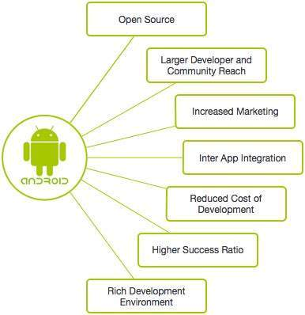

3.2 Features of Android

Android is a powerful operating system competing with Apple 4GS and supports great features. Few of them are listed below:
Feature | Description
Beautiful UI | Android OS basic screen provides a beautiful and intuitive user interface.
Connectivity | GSM/EDGE, IDEN, CDMA, EV-DO, UMTS, Bluetooth, Wi-Fi, LTE, NFC and WiMAX.
Storage | SQLite, a lightweight relational database, is used for data storage purposes.
Media support | H.263, H.264, MPEG-4 SP, AMR, AMR-WB, AAC, HE-AAC, AAC 5.1, MP3, MIDI, Ogg Vorbis, WAV, JPEG, PNG, GIF, and BMP
Messaging | SMS and MMS
Web browser | Based on the open-source WebKit layout engine, coupled with Chrome's V8 JavaScript engine supporting HTML5 and CSS3.
Multi-touch | Android has native support for multi-touch which was initially made available in handsets such as the HTC Hero.
Multi-tasking | User can jump from one task to another and same time various application can run simultaneously.
Resizable widgets | Widgets are resizable, so users can expand them to show more content or shrink them to save space
Multi-Language | Supports single direction and bi-directional text.
GCM | Google Cloud Messaging (GCM) is a service that lets developers send short message data to their users on Android devices, without needing a proprietary sync solution.
Wi-Fi Direct | A technology that lets apps discover and pair directly, over a high-bandwidth peer-to-peer connection.
Android Beam | A popular NFC-based technology that lets users instantly share, just by touching two NFC-enabled phones together.

3.3 Categories of Android applications
There are many android applications in the market. The top categories are:

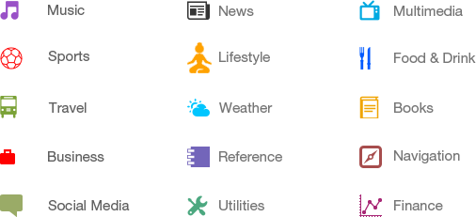

3.4 History of Android

The code names of android ranges from A to L currently, such as Aestro, Blender, Cupcake, Donut, Eclair, Froyo, Gingerbread, Honeycomb, Ice Cream Sandwitch, Jelly Bean, KitKat , Lollipop and Marshmallow. Let's understand the android history in a sequence.
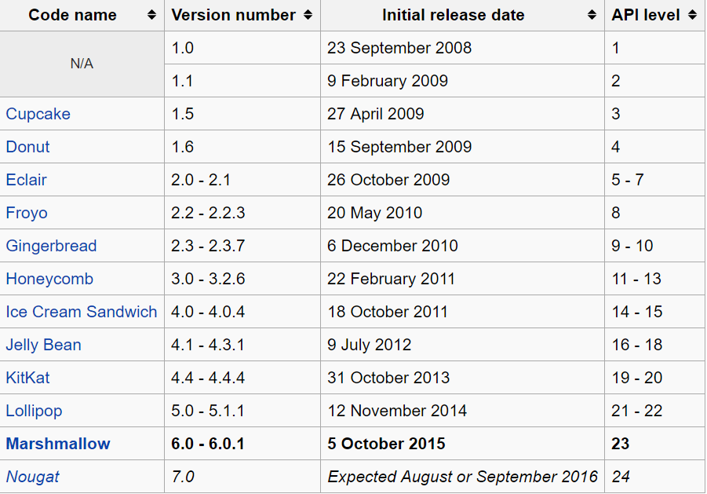

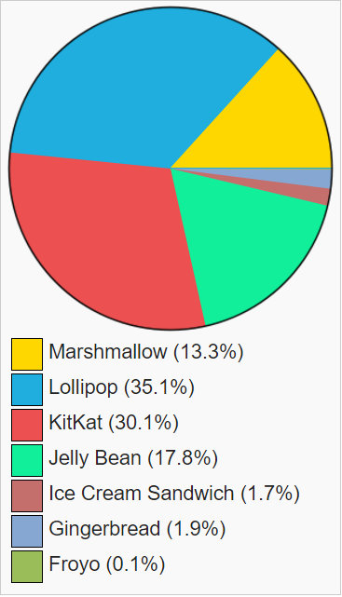

#Above Chart provide breakdowns of Android versions, based on the devices accessing the Play Store

Courtesy: https://en.wikipedia.org/wiki/Android_(operating_system)#Platform_usage

3.5 What is API level?

API Level is an integer value that uniquely identifies the framework API revision offered by a version of the Android platform.
Platform Version | API Level | VERSION_CODE
Android 6.0 | 23 | Marshmallow
Android 5.1 | 22 | LOLLIPOP_MR1
Android 5.0 | 21 | LOLLIPOP
Android 4.4W | 20 | KITKAT_WATCH | KitKat for Wearables Only
Android 4.4 | 19 | KITKAT
Android 4.3 | 18 | JELLY_BEAN_MR2
Android 4.2, 4.2.2 | 17 | JELLY_BEAN_MR1
Android 4.1, 4.1.1 | 16 | JELLY_BEAN
Android 4.0.3, 4.0.4 | 15 | ICE_CREAM_SANDWICH_MR1
Android 4.0, 4.0.1, 4.0.2 | 14 | ICE_CREAM_SANDWICH
Android 3.2 | 13 | HONEYCOMB_MR2
Android 3.1.x | 12 | HONEYCOMB_MR1
Android 3.0.x | 11 | HONEYCOMB
Android 2.3.4  Android 2.3.3 | 10 | GINGERBREAD_MR1
Android 2.3.2  Android 2.3.1  Android 2.3 | 9 | GINGERBREAD
Android 2.2.x | 8 | FROYO
Android 2.1.x | 7 | ECLAIR_MR1
Android 2.0.1 | 6 | ECLAIR_0_1
Android 2.0 | 5 | ÉCLAIR
Android 1.6 | 4 | DONUT
Android 1.5 | 3 | CUPCAKE
Android 1.1 | 2 | BASE_1_1
Android 1.0 | 1 | BASE

Android – Architecture
Android operating system is a stack of software components which is roughly divided into five sections and four main layers as shown below in the architecture diagram.
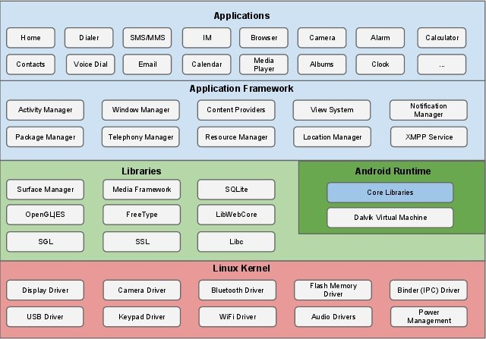

3.6(a) Linux kernel
At the bottom of the layers is Linux - Linux 3.6 with approximately 115 patches. This provides a level of abstraction between the device hardware and it contains all the essential hardware drivers like camera, keypad, display etc. Also, the kernel handles all the things that Linux is really good at such as networking and a vast array of device drivers, which take the pain out of interfacing to peripheral hardware.

3.6(b) Libraries
On top of Linux kernel there is a set of libraries including open-source Web browser engine WebKit, well known library libc, SQLite database which is a useful repository for storage and sharing of application data, libraries to play and record audio and video, SSL libraries responsible for Internet security etc.

3.6(c) Android Libraries
This category encompasses those Java-based libraries that are specific to Android development. Examples of libraries in this category include the application framework libraries in addition to those that facilitate user interface building, graphics drawing and database access. A summary of some key core Android libraries available to the Android developer is as follows −
- android.app − Provides access to the application model and is the cornerstone of all Android applications.
- android.content − Facilitates content access, publishing and messaging between applications and application components.
- android.database − Used to access data published by content providers and includes SQLite database management classes.
- android.opengl − A Java interface to the OpenGL ES 3D graphics rendering API.
- android.os − Provides applications with access to standard operating system services including messages, system services and inter-process communication.
- android.text − Used to render and manipulate text on a device display.
- android.view − The fundamental building blocks of application user interfaces.
- android.widget − A rich collection of pre-built user interface components such as buttons, labels, list views, layout managers, radio buttons etc.
- android.webkit − A set of classes intended to allow web-browsing capabilities to be built into applications.
Having covered the Java-based core libraries in the Android runtime, it is now time to turn our attention to the C/C++ based libraries contained in this layer of the Android software stack.

3.6(d) Android Runtime
This is the third section of the architecture and available on the second layer from the bottom. This section provides a key component called Dalvik Virtual Machine which is a kind of Java Virtual Machine specially designed and optimized for Android.
The Dalvik VM makes use of Linux core features like memory management and multi-threading, which is intrinsic in the Java language. The Dalvik VM enables every Android application to run in its own process, with its own instance of the Dalvik virtual machine.
The Android runtime also provides a set of core libraries which enable Android application developers to write Android applications using standard Java programming language.
3.6(e) Android Framework
The Application Framework layer provides many higher-level services to applications in the form of Java classes. Application developers are allowed to make use of these services in their applications.
The Android framework includes the following key services −
- Activity Manager − Controls all aspects of the application lifecycle and activity stack.
- Content Providers − Allows applications to publish and share data with other applications.
- Resource Manager − Provides access to non-code embedded resources such as strings, color settings and user interface layouts.
- Notifications Manager − Allows applications to display alerts and notifications to the user.
- View System − An extensible set of views used to create application user interfaces.

3.6(f) Applications
All the Android application are at the top layer. The application to be installed is written on this layer only. Examples of such applications are Contacts Books, Browser, Games etc.
Courtesy: http://www.tutorialspoint.com/android

4. Google Cloud Messaging (GCM):
Google provides a service called Google Cloud Messaging (GCM) using which we can send data to our users’ Android devices from our servers and even receive messages from the devices to our servers over the same connection. It handles queueing of messages and delivers to the target Android app on the device based on something called a registration ID. So using GCM, we can keep on sending data to our application on our user’s devices instead of making frequent requests to our servers at regular intervals that could be complicated to implement and even drain the battery big time if not properly executed. On receiving the data, your application can build notifications and how up in the status bar using the Notification Builder class.
4.1) GCM
The GCM is given for the total weight a truck can carry and tow. This is the maximum weight of a loaded articulated vehicle or combination vehicle such as a prime mover with semi-trailer and / or trailers (also referred to as GCW Gross Combination Weight).
4.2) Push notifications
Push notifications let your application notify a user of new messages or events even when the user is not actively using your application. On Android devices, when a device receives a push notification, your application's icon and a message appear in the status bar.

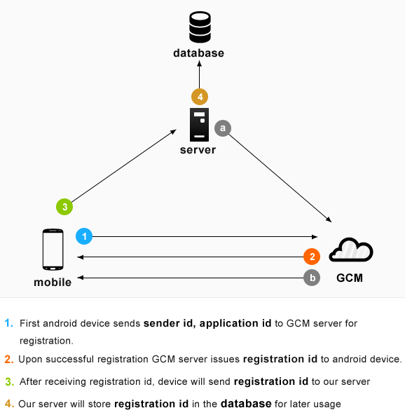

4.3) User Notification Keys:-
A single user might have the same app installed on multiple devices. So in order to solve the problem of sending a single message to all those multiple instances of an app running on multiple devices owned by the same user, we can map all the registration IDs (represents a particular Android app running on a particular device) to a single notification key that’ll be generated by GCM.

4.4) Php code to send the push notification:
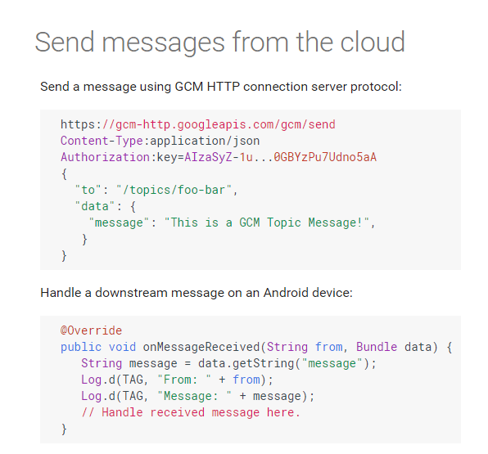

5. Android Json Parser:
JSON stands for JavaScript Object Notation. It is an independent data exchange format and is the best alternative for XML. Android provides four different classes to manipulate JSON data. These classes are JSONArray, JSONObject, JSONStringer and JSONTokenizer. The first step is to identify the fields in the JSON data in which you are interested in. For example. In the JSON given below we interested in getting temperature only.
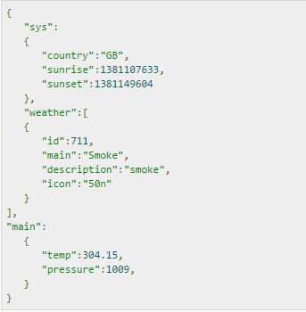

5.1) JSON - Elements
An JSON file consist of many components. Here is the table defining the components of an JSON file and their description –
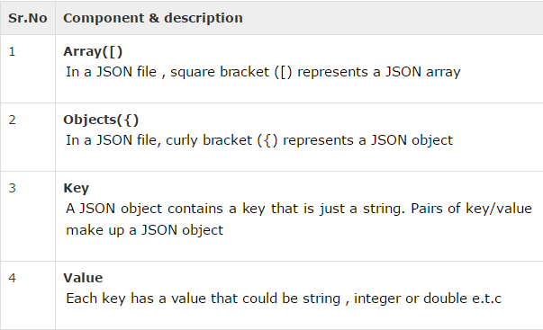

5.2) JSON – Parsing
For parsing a JSON object, we will create an object of class JSONObject and specify a string containing JSON data to it. Its syntax is:

The last step is to parse the JSON. An JSON file consist of different object with different key/value pair e.t.c. So JSONObject has a separate function for parsing each of the component of JSON file. Its syntax is given below:

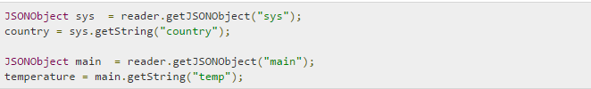

The method getJSONObject returns the JSON object. The method getString returns the string value of the specified key.Apart from the these methods , there are other methods provided by this class for better parsing JSON files. These methods are listed below –

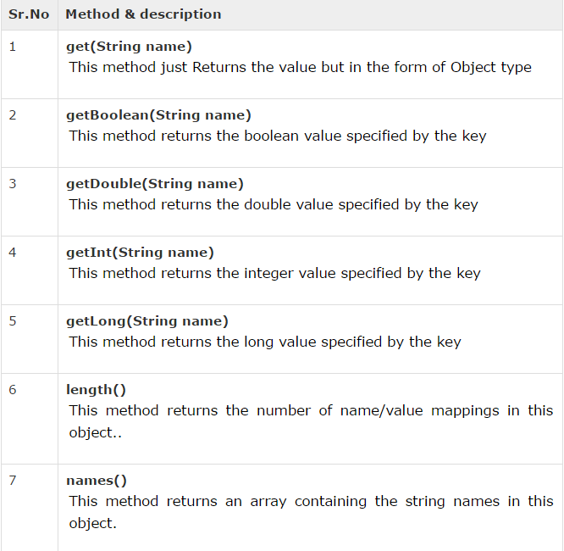

6. Android - PHP/MYSQL:
We are going to explain, how you can integrate PHP and MYSQL with your android application. This is very useful in case you have a webserver, and you want to access its data on your android application.
MYSQL is used as a database at the webserver and PHP is used to fetch data from the database. Our application will communicate with the PHP page with necessary parameters and PHP will contact MYSQL database and will fetch the result and return the results to us.

6.1) PHP – MYSQL:

a. Creating Database
MYSQL database can be created easily using this simple script. The CREATE DATABASE statement creates the database.

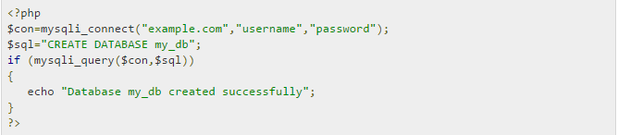

b. Creating Tables
Once database is created, its time to create some tables in the database. The CREATE TABLE statement creates the database.

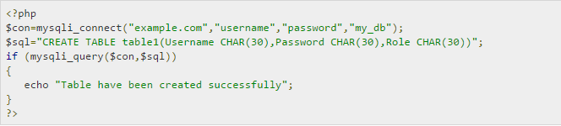

c. Inserting Values in tables
When the database and tables are created. Now its time to insert some data into the tables. The Insert Into statement creates the database.

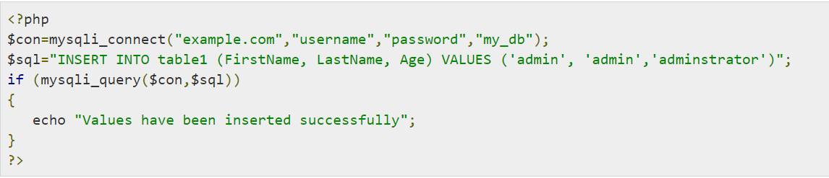

6.2) PHP - GET and POST methods
PHP is also used to fetch the record from the mysql database once it is created. In order to fetch record some information must be passed to PHP page regarding what record to be fetched.
The first method to pass information is through GET method in which $_GETcommand is used. The variables are passed in the url and the record is fetched. Its syntax is given below –
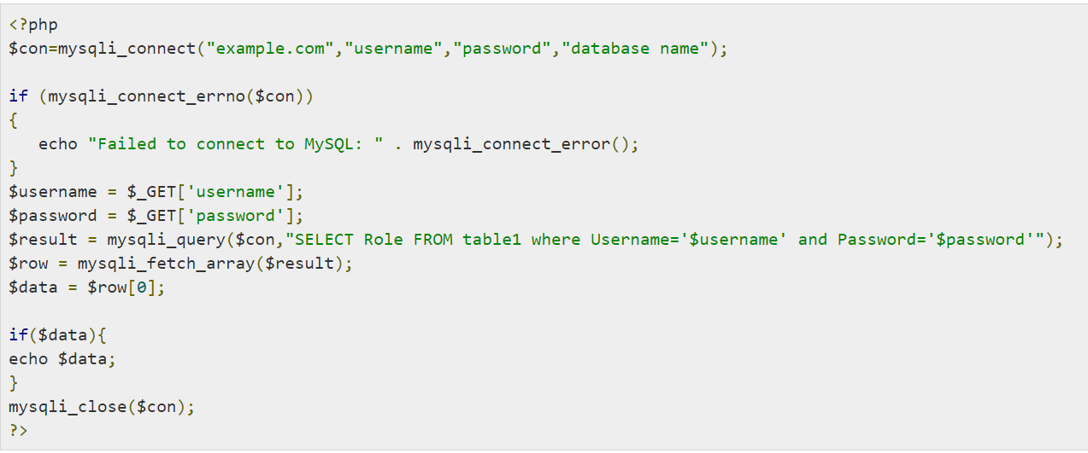

The second method is to use POST method. The only change in the above script is to replace $_GET with $_POST. In Post method , the variables are not passed through URL.

6.3) Android - Connecting MYSQL:

- Connecting Via Get Method
There are two ways to connect to MYSQL via PHP page. The first one is calledGet method. We will use HttpGet and HttpClient class to connect. Their syntax is given below –

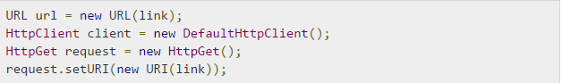

After that you need to call execute method of HttpClient class and receive it in a HttpResponse object. After that you need to open streams to receive the data.

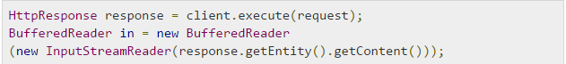

6.4) Connecting Via Post Method
In the Post method , the URLEncoder,URLConnection class will be used. The urlencoder will encode the information of the passing variables. It's syntax is given below –

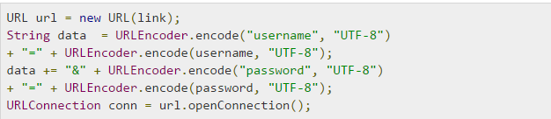

The last thing you need to do is to write this data to the link. After writing, you need to open stream to receive the responded data.

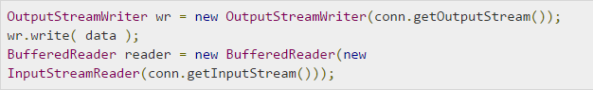

7. MBM TALKIES Screenshots:-

