Spin up Ganache from the local host.

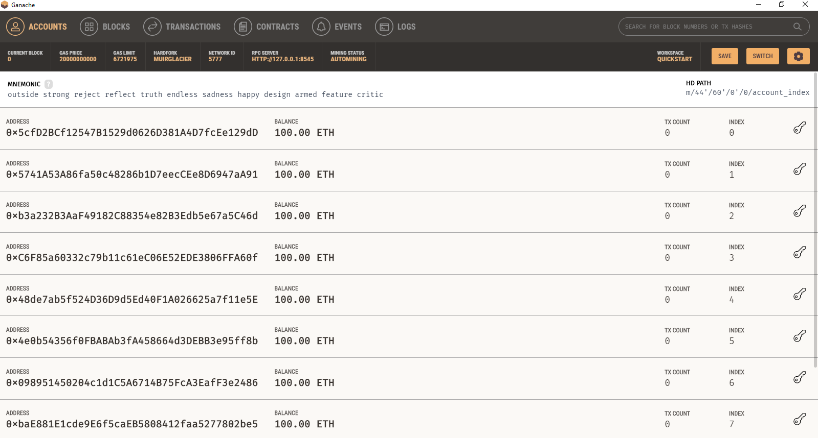

Updated Settings.py to have a correct settings for Ganache. In this case my public key and private came from the first account from Ganache’s 10 accounts start up.

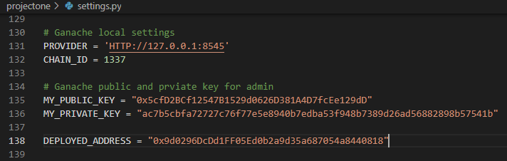

From the command terminal, start Django App Server at the localhost.

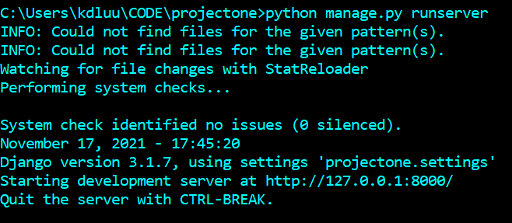

Run the ProjectOne Dapp from your browser.

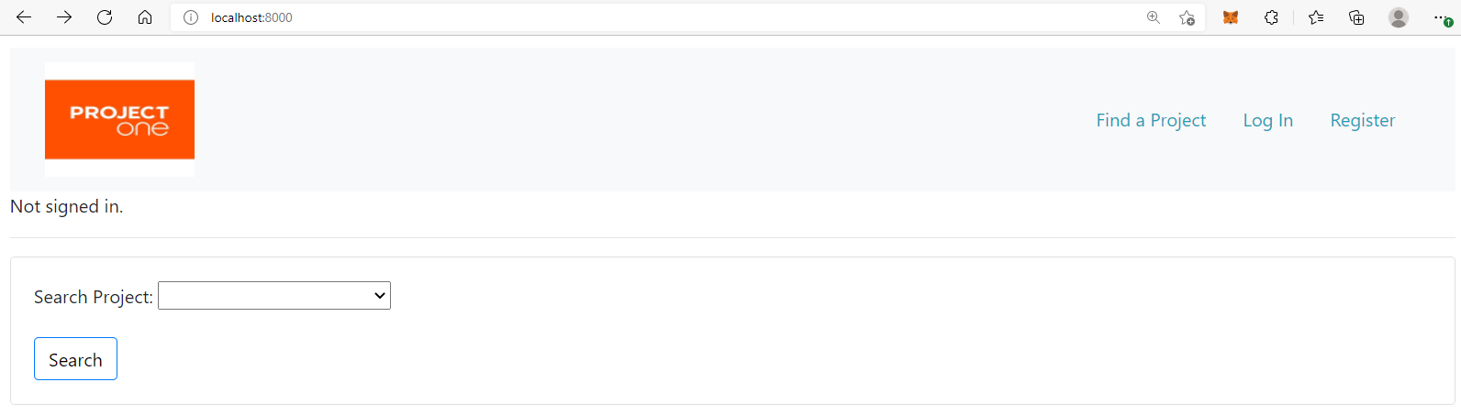

Now we are going thru the application workflow.

Step 1: Login as an admin user (in my case my super user account is system) and create a new fundraising project for the homeless folks in Boston with a goal amount of 3 ETH.

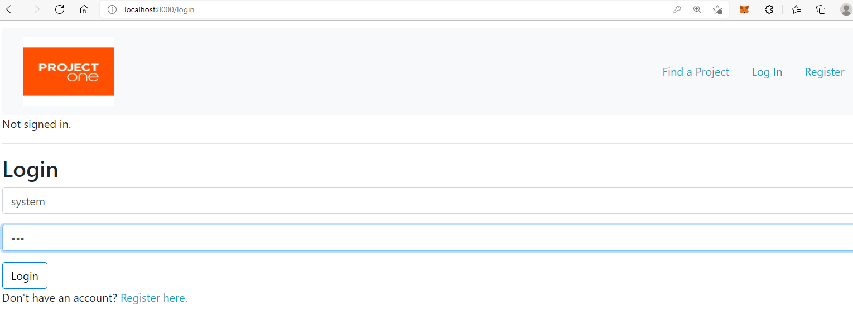

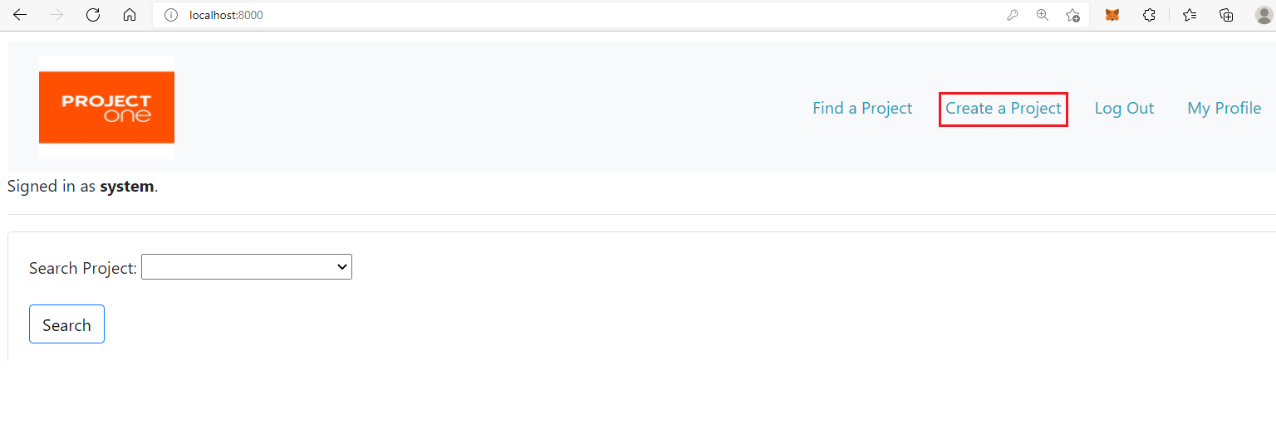

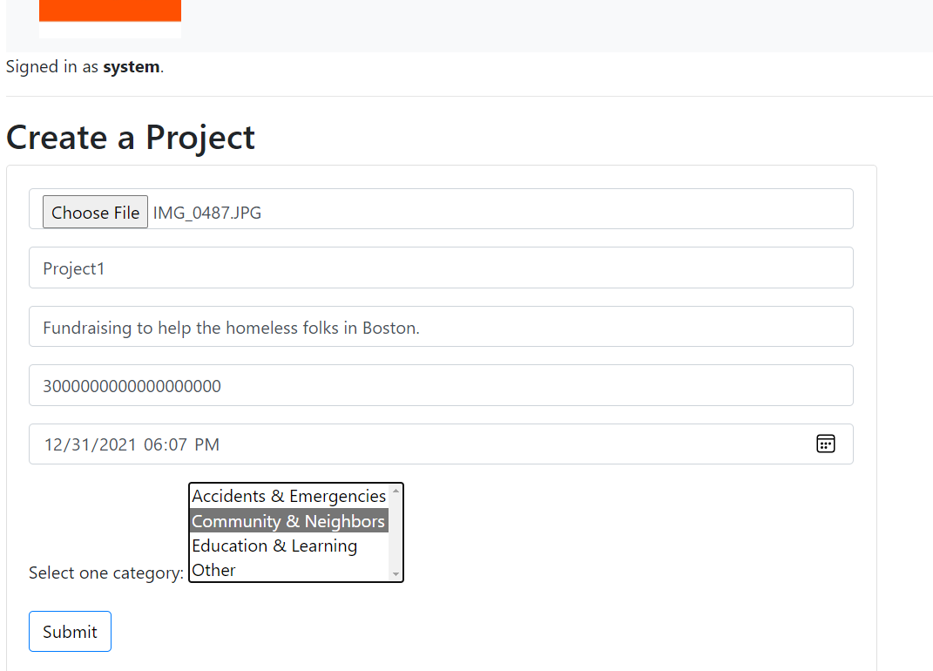

We now can see the new project created from Find a Project form. Click on the project title Project1 to go to the Project Detail page to create a funding distribution request.

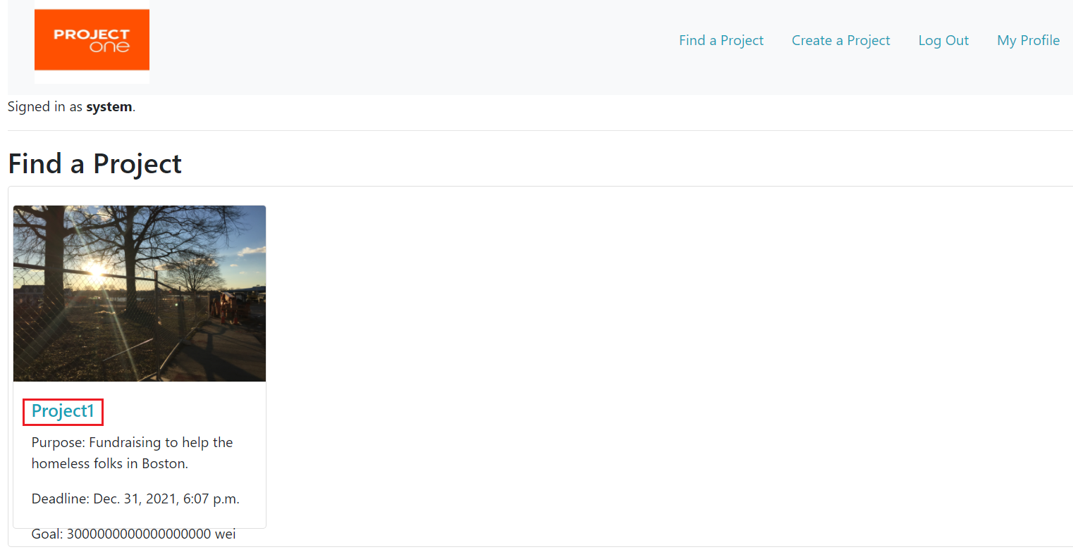

Step 2: For a given project, we can create one or many funding distribution requests. Click on the Request button to create a request.

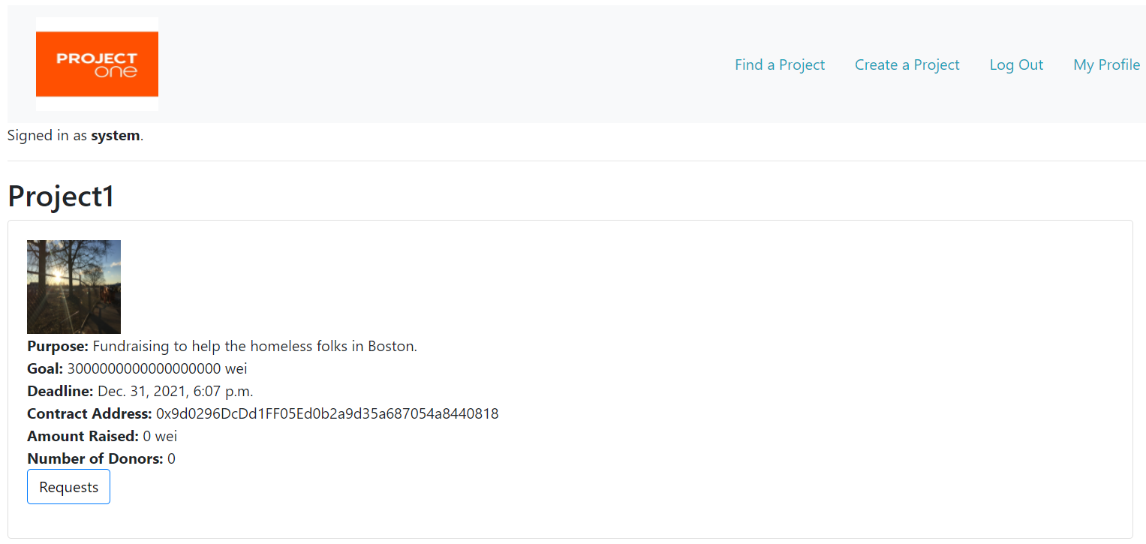

Click on Create Request button.

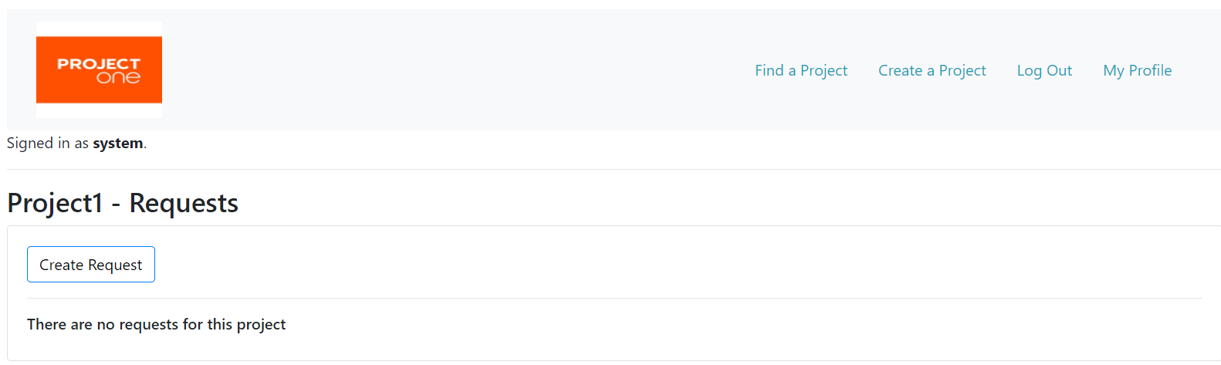

Fill in the request form with Description, Address_To and Request Amount and Submit the form. NOTE: The second address from Ganache spin up was selected for this case.

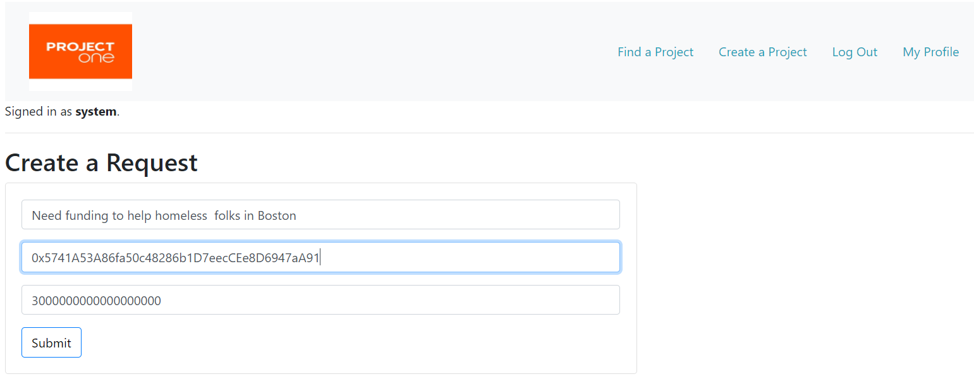

New request is successfully created:

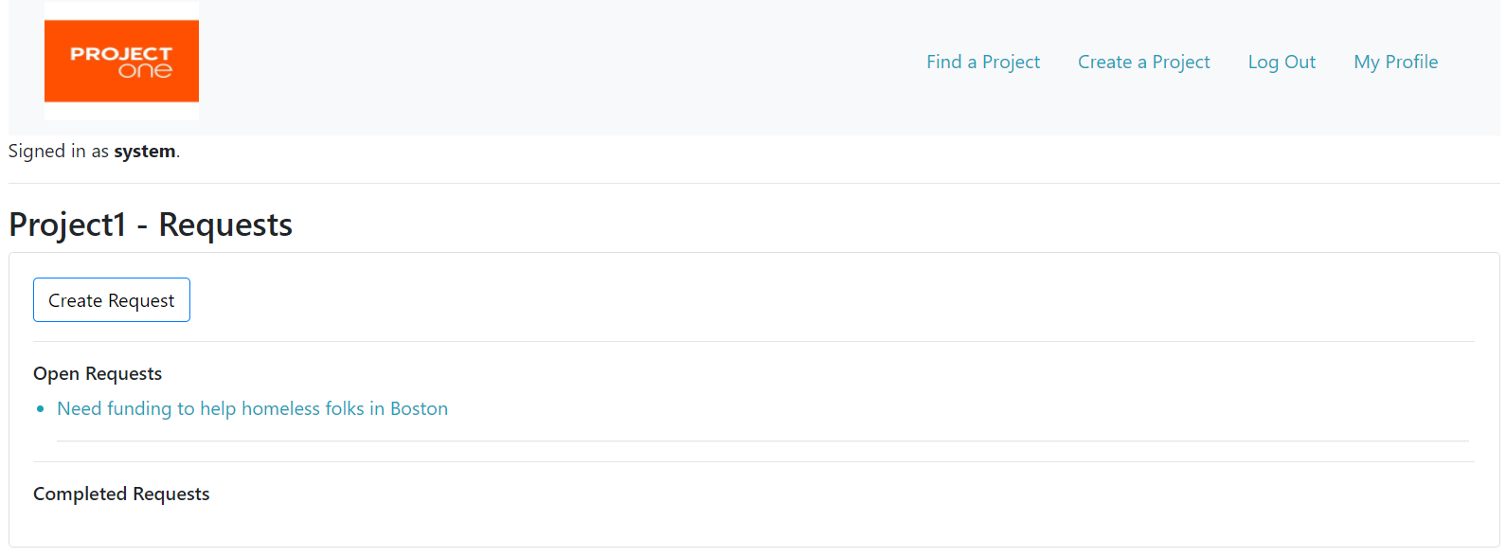

Step 3. Make a donation. Logout and Login as a donor and go to the Project Detail page and click on Donate button.

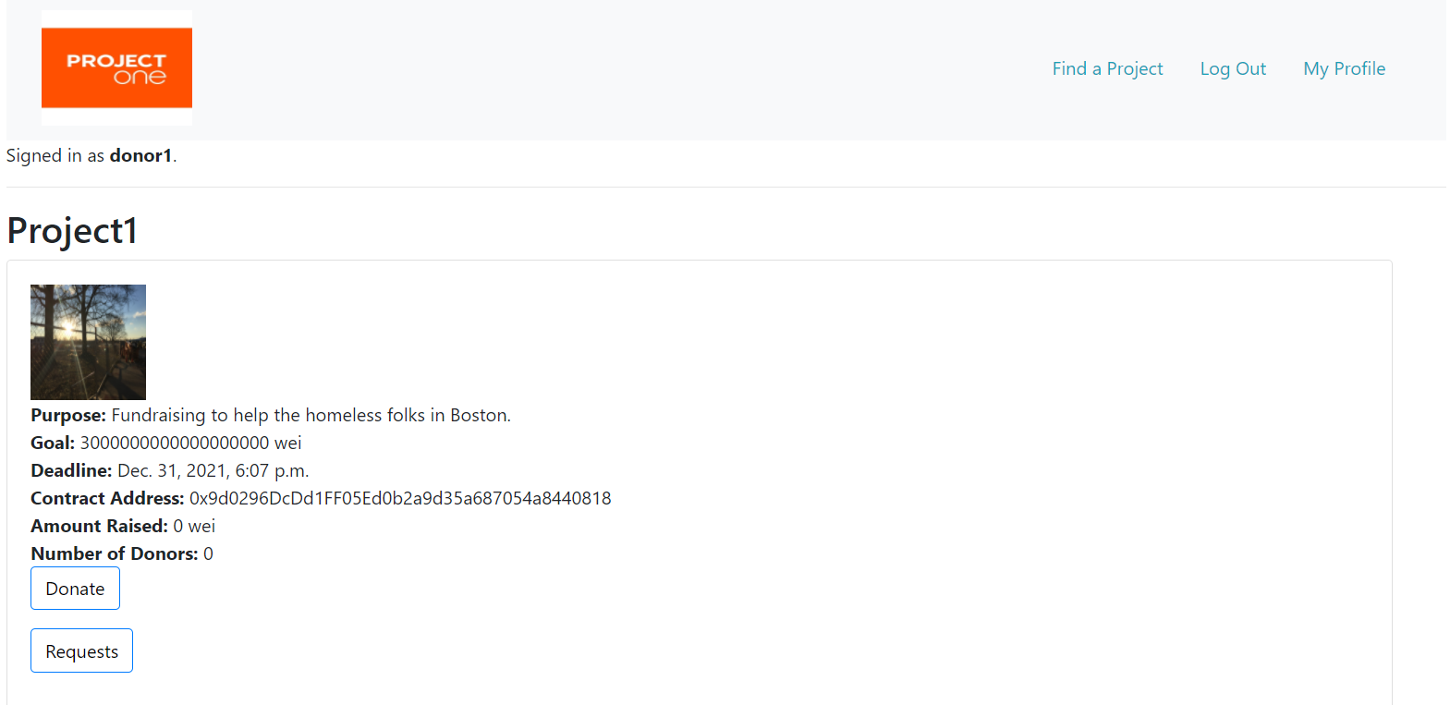

Click Connect to MetaMask buton and select the third Ganache account and donate 1 ETH. 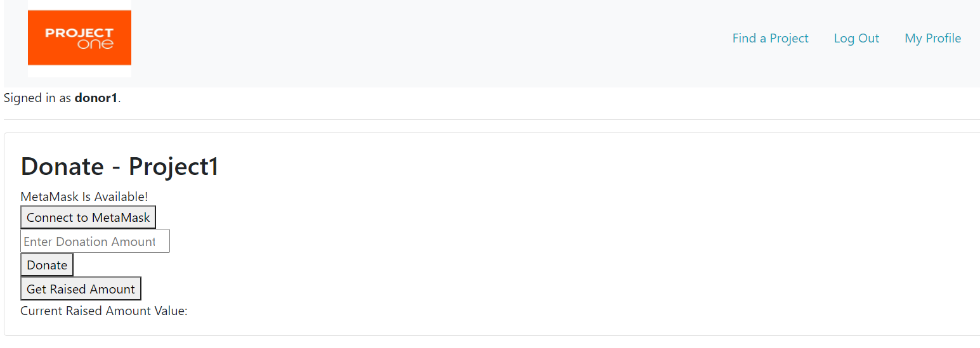

Once we click on the Donate button, MetaMask will prompt for your confirmation. Click confirm.

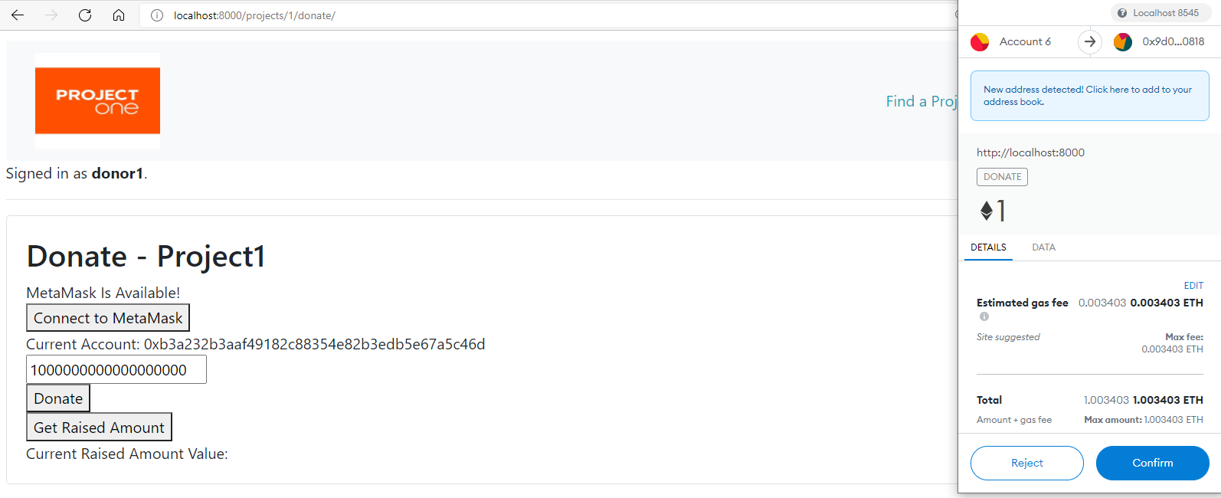

donate.js will print out the acknowledgement message to indicate that the transaction is completed.

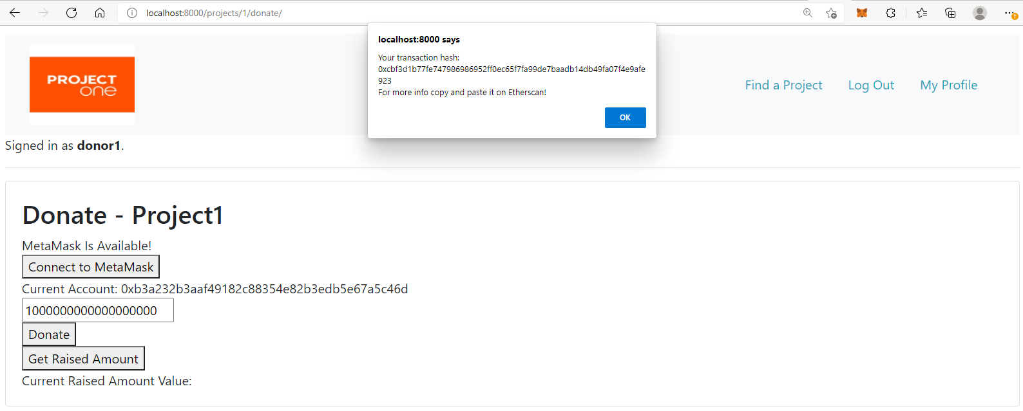

Click on Get Raised Amount button to retrieve the value from block chain.

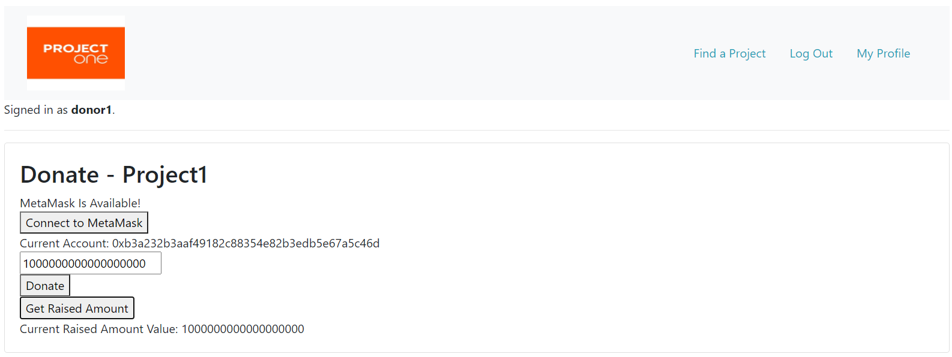

Repeat the Make a Donation step for donor2 (Ganache’s 4th account) and donor3 (Ganache’s 5th account) account with a same amount of 1 ETH contribution.

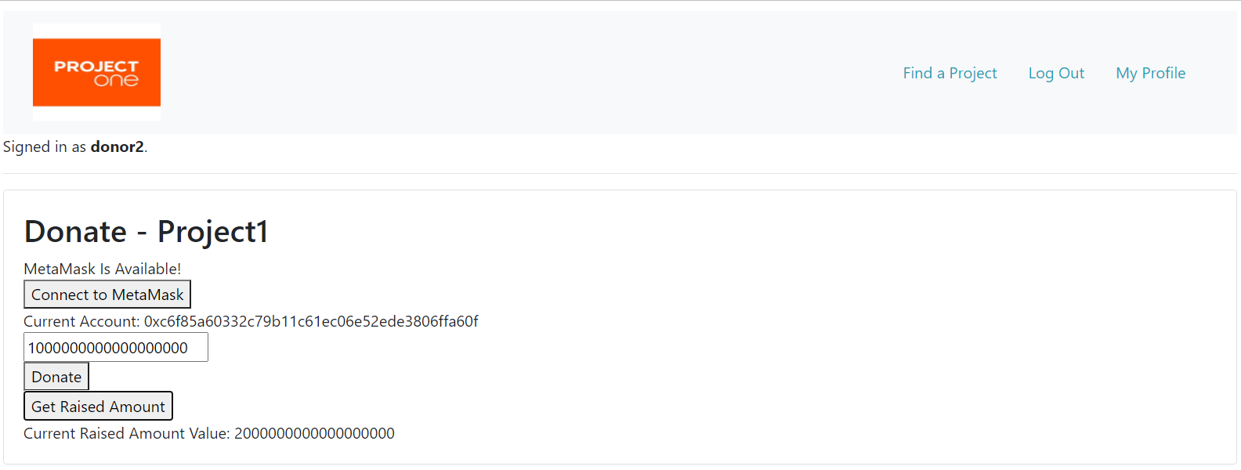

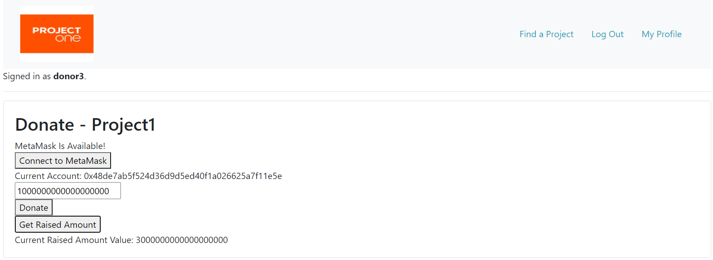

Step 4: Make a Vote from donor1 (Ganache’s 3rd account) and donor2 (Ganache’s 4th account) accounts.

Go to the project request detail page and click on the Vote button. Make sure your MetaMask is connect to a correct Ganache address.

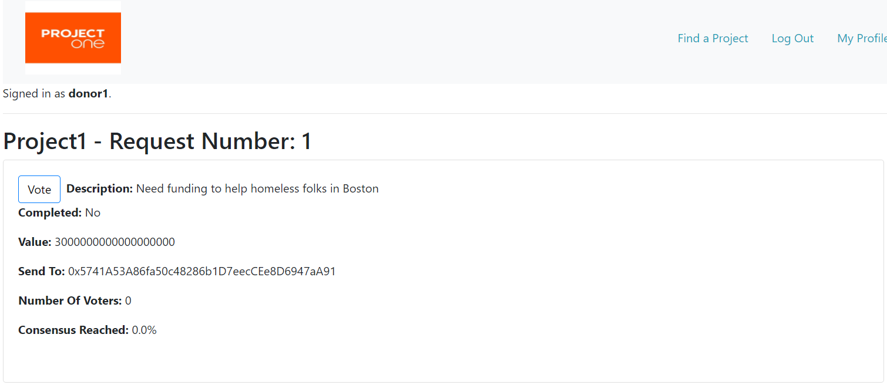

Click Connect to MetaMask button to enable the Yes vote.

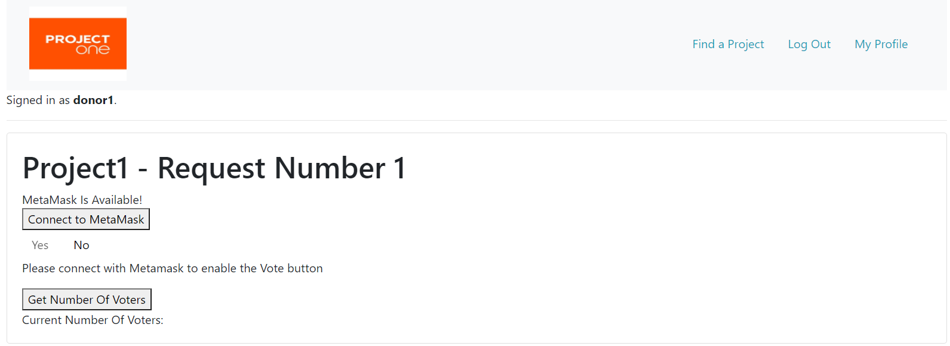

Verify your correct address and click on Yes.

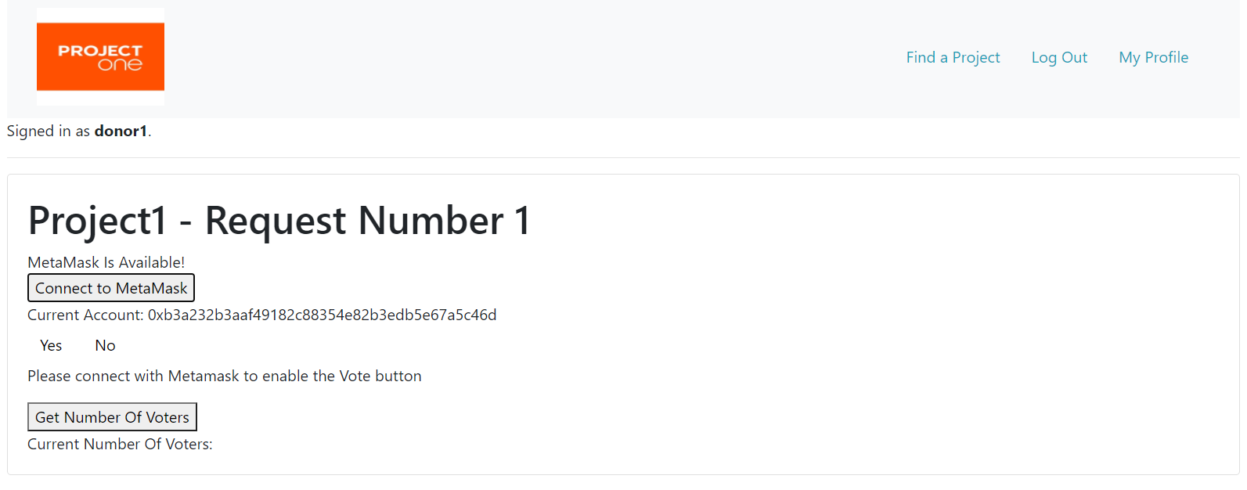

Select Confirm.

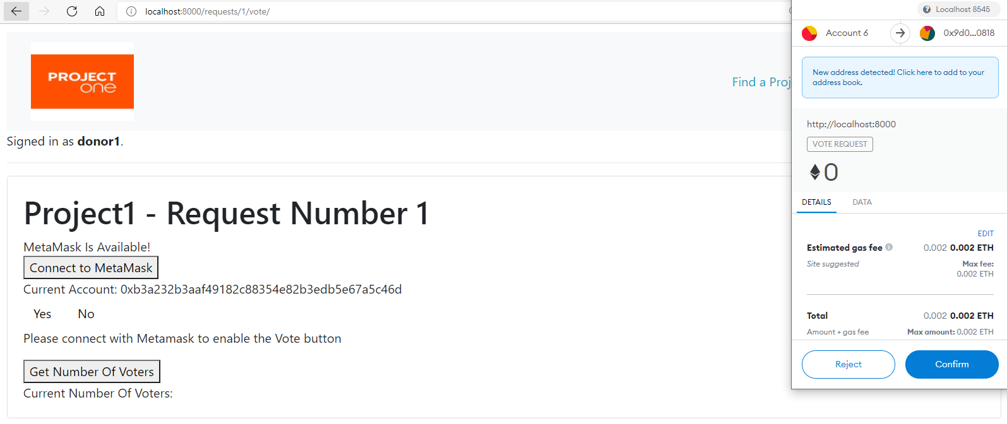

vote.js will print out the acknowledgment message that the vote transaction is completed.

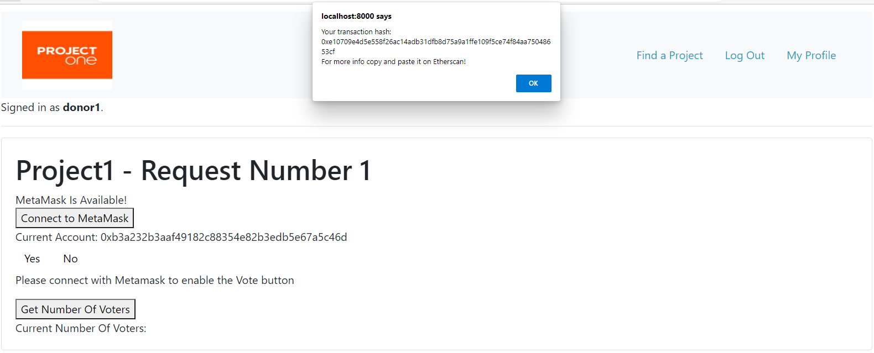

Click on Get Number Of Voters button to receive the current number of voters from block chain.

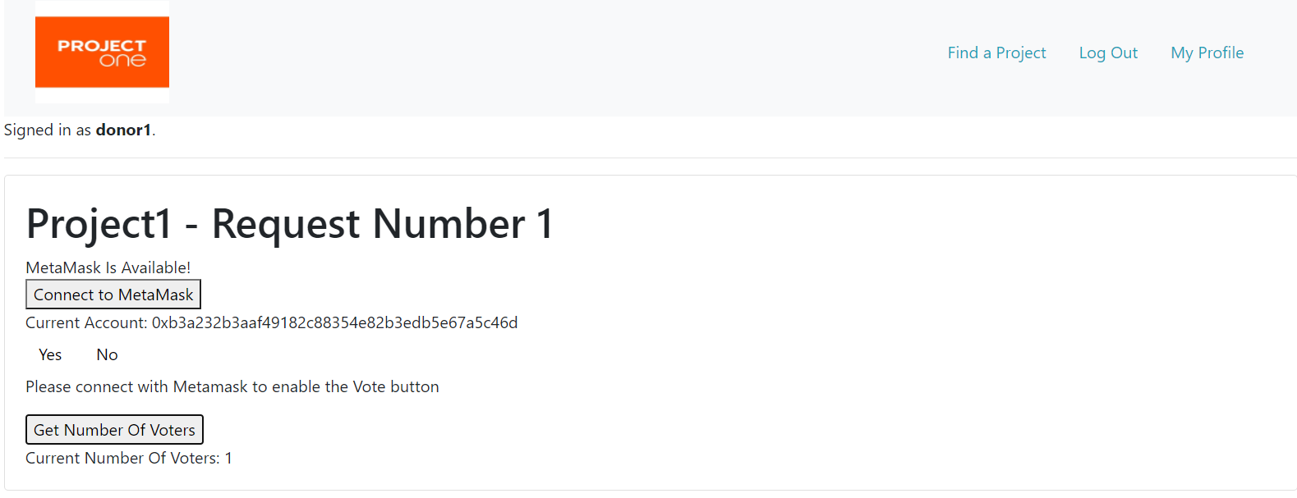

Repeat Make a Vote step from donor2 account.

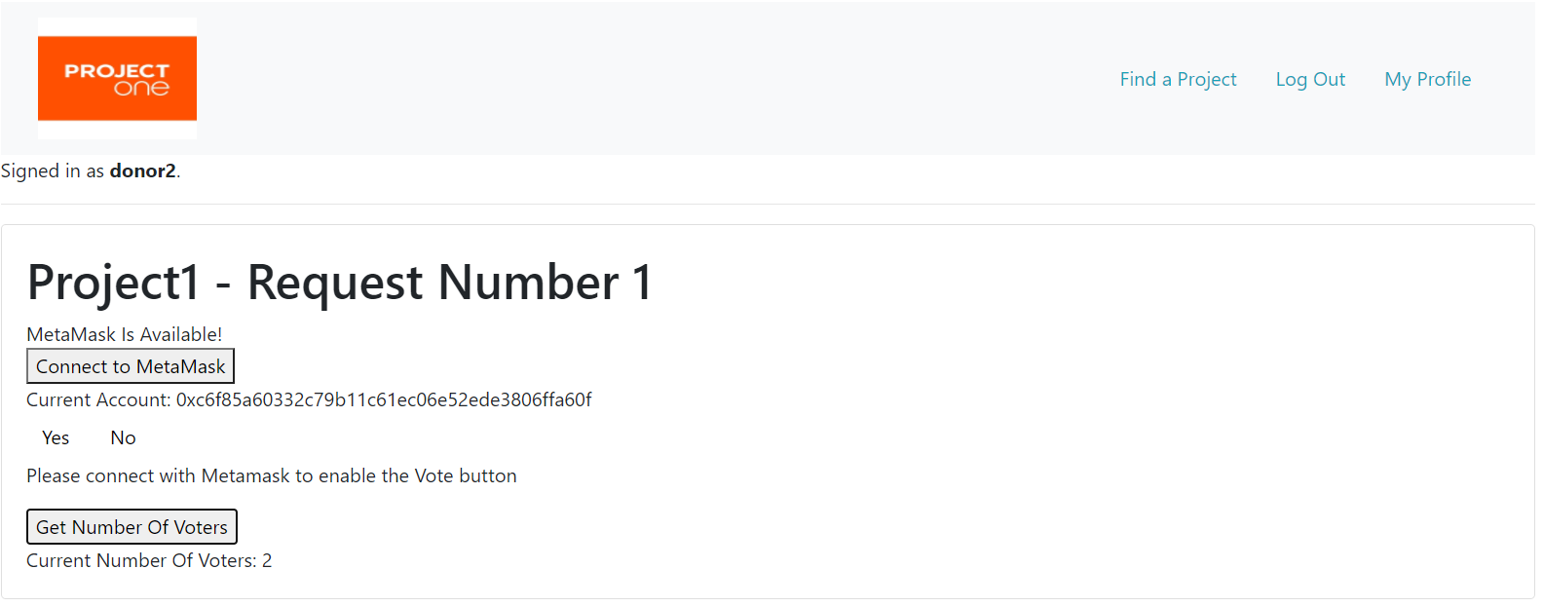

Step 5: Make a Payment to complete the funding request under the system superuser account (Ganache’s first account) since the vote consensus is reached (over 66.66% in this case).

Click the Make Payment button from the Request Detail page.

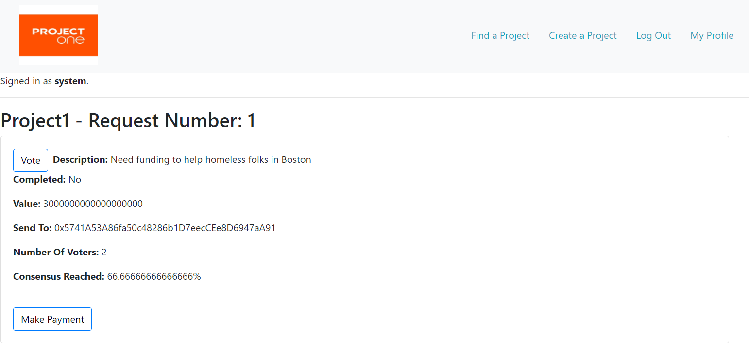

Yah, we just completed the request by moving 3 ETH from the contract address to Ganache’s 2nd recipient account. Balance of donors accounts also have been updated correctly. This is the conclusion of our ProjectOne workflow walk-through.

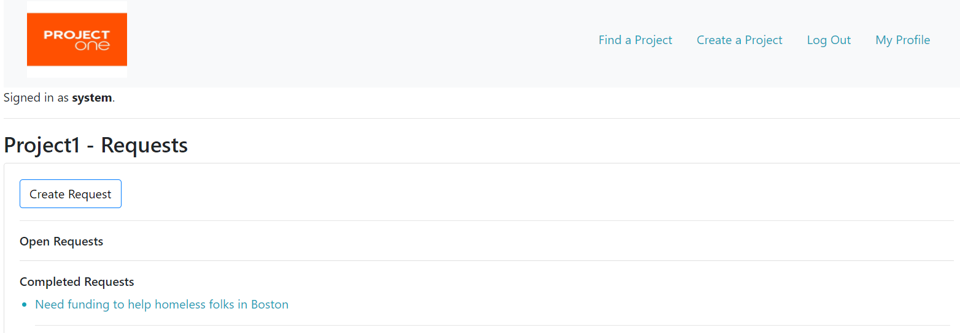

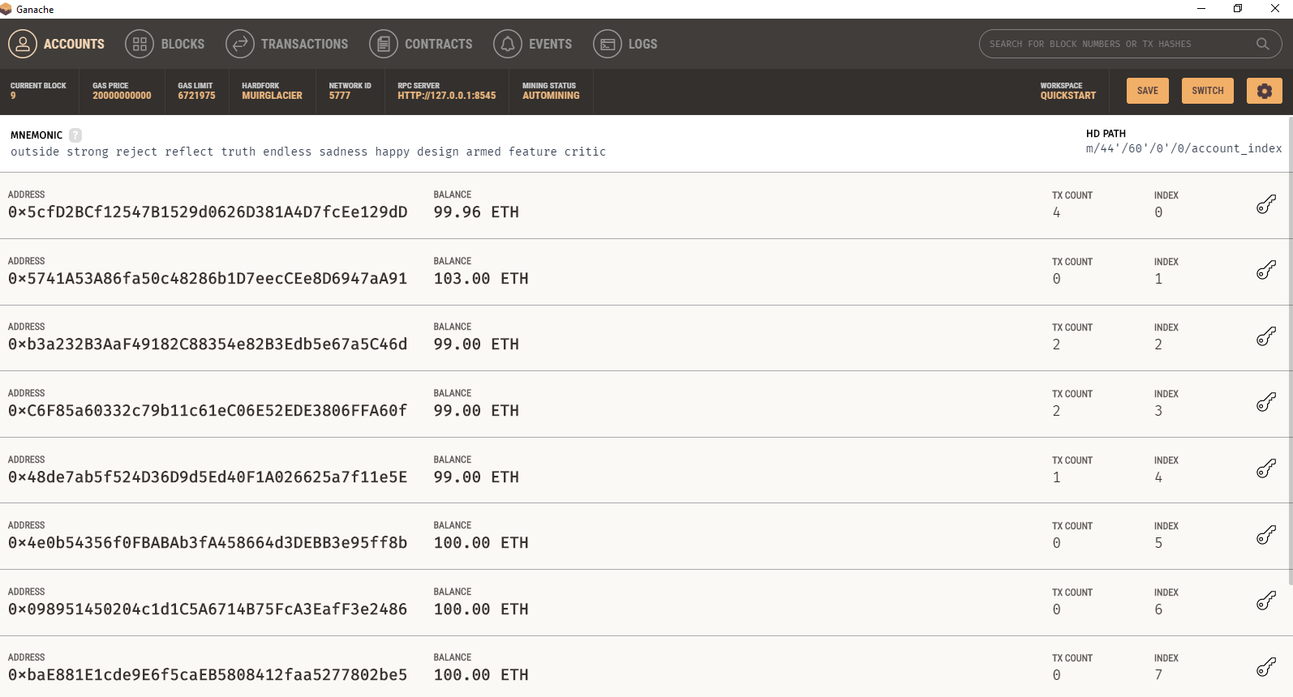

Following is the Brownie test results screen shot to indicate all six tests have been passed:

