**KDM**

**LAB -1**

N.AYYAPPA KUMAR.

ID:16157522.

**E/R Diagram:**

Above diagram represents the E/R diagram for in class exercise on Jan-21.

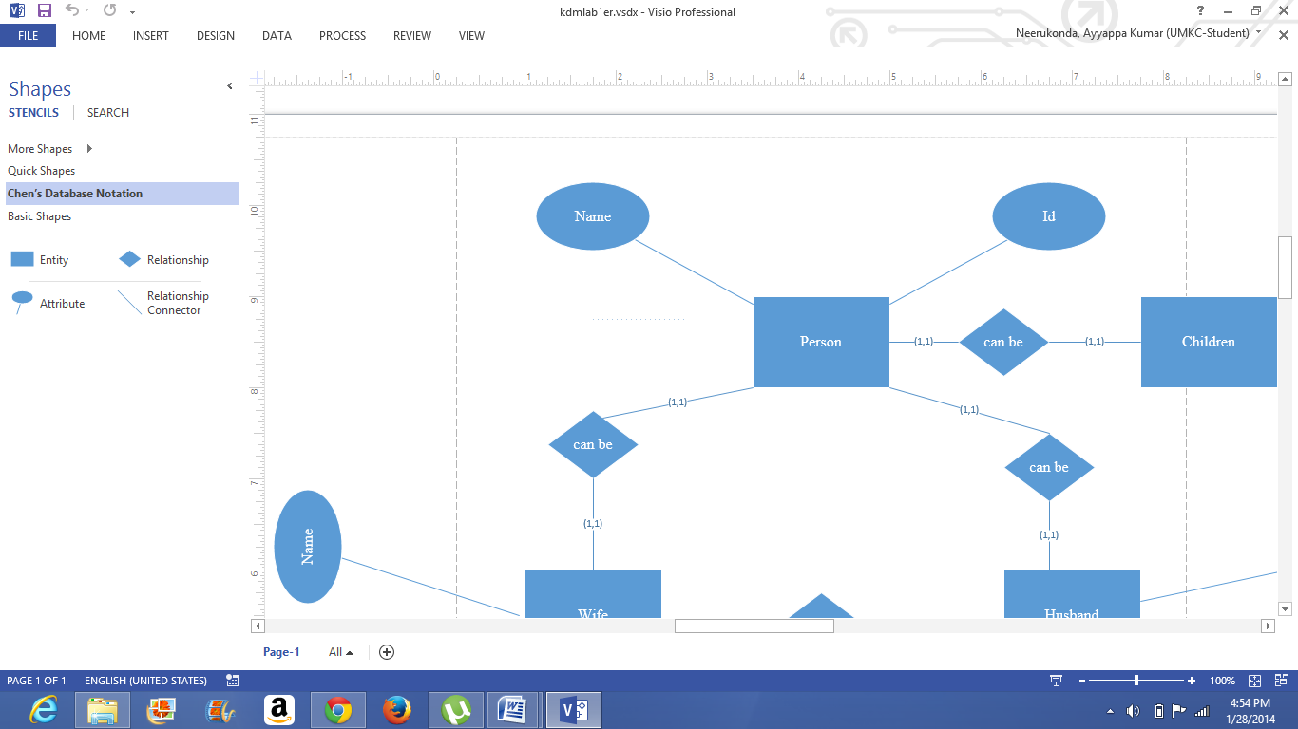

Above figure represents the construction of E/R diagram for in class exercise on Jan-21 in Microsoft Visio.

**Class Diagram :**



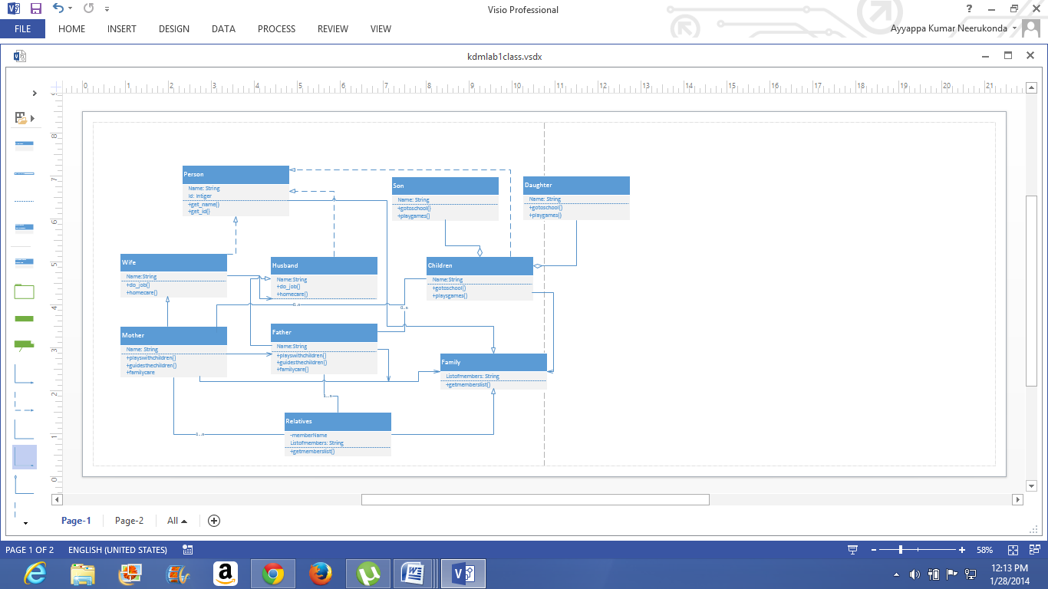

Above diagram and screenshots represent the class diagram for in class exercise on Jan-21.

**NOTE:** Hererelations betweensome classes are not completely copied so for better understanding please be refer to the class diagram (.vsdx file) attached to Github.

**GITHUB screen shots**

In order to open Github account refer to: http://github.com/join

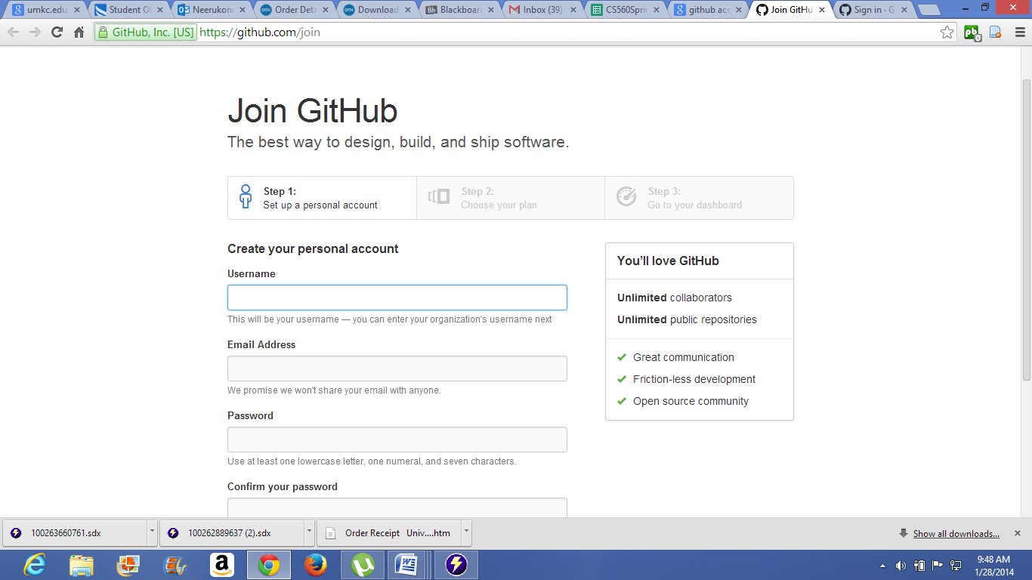

Here we have to provide the necessary data, then click on create an account.

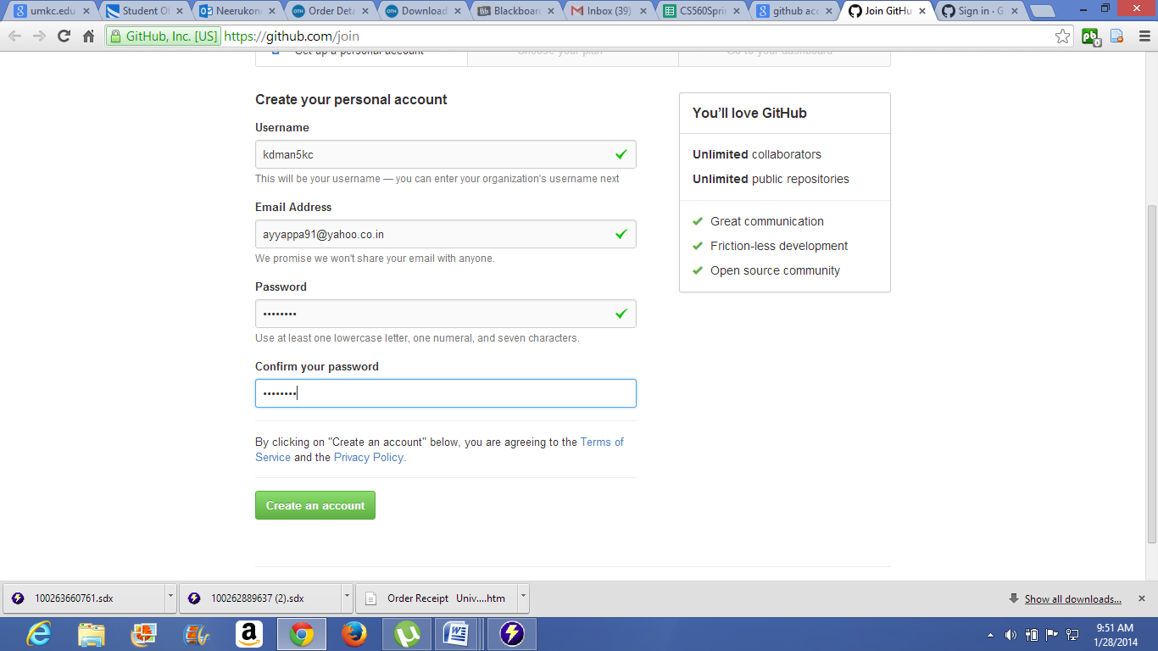

Choose the plan as of your requirement.

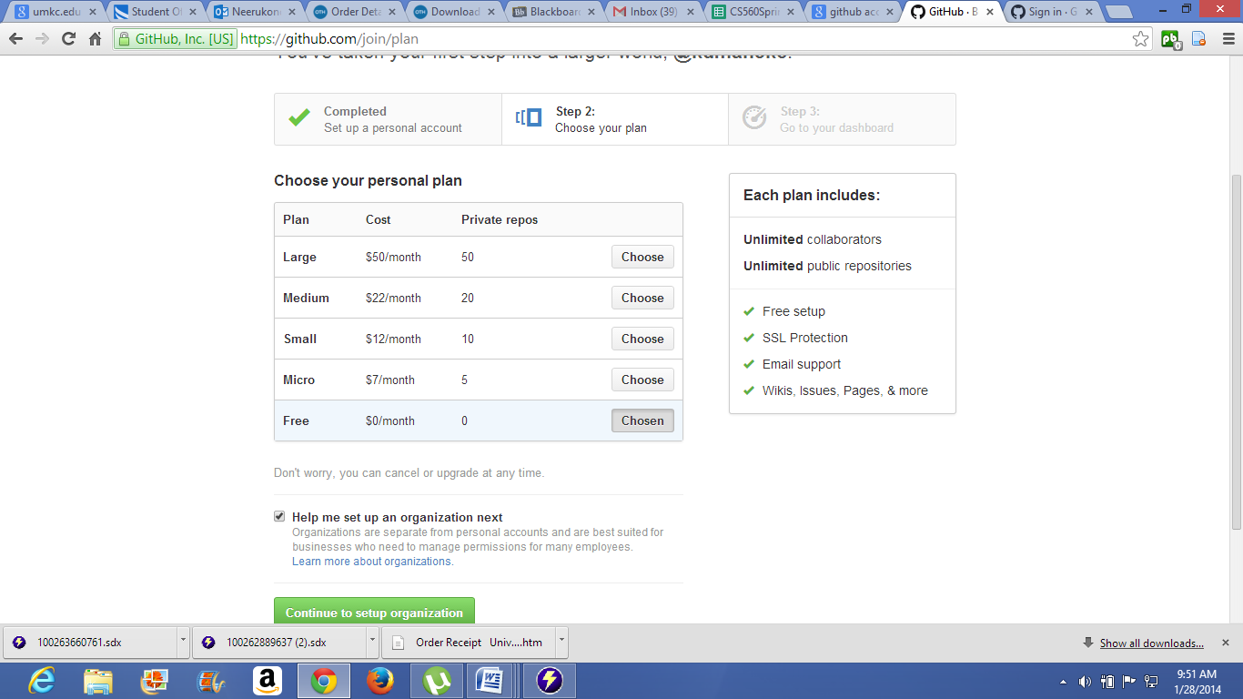

Assign the owner of your Github Account.

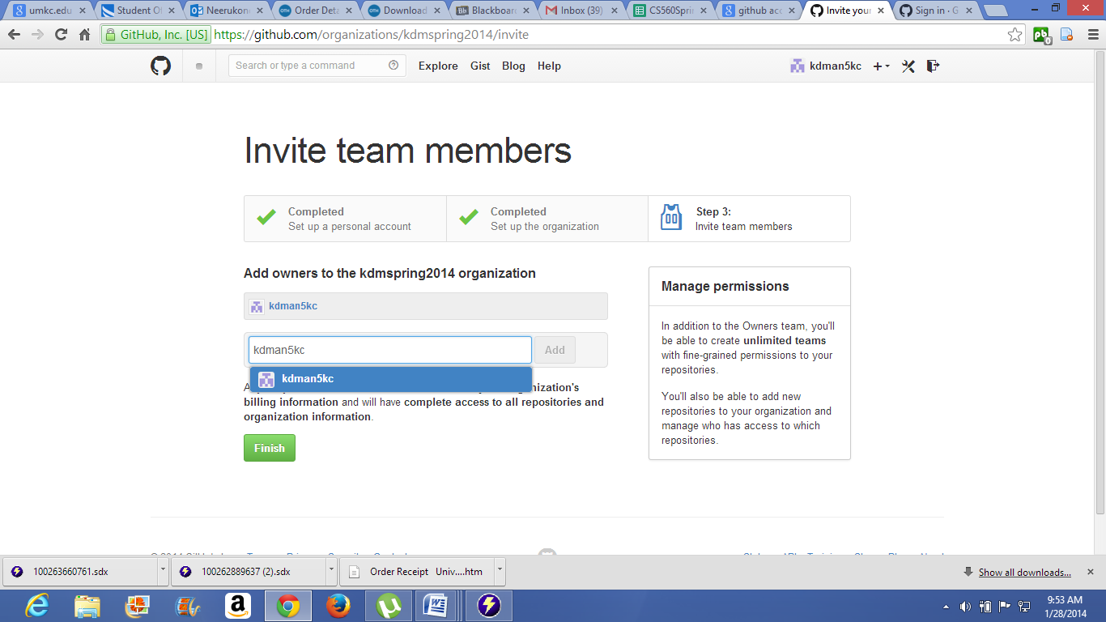

After login in to your Github account, In order to create new repository click on new repository option.

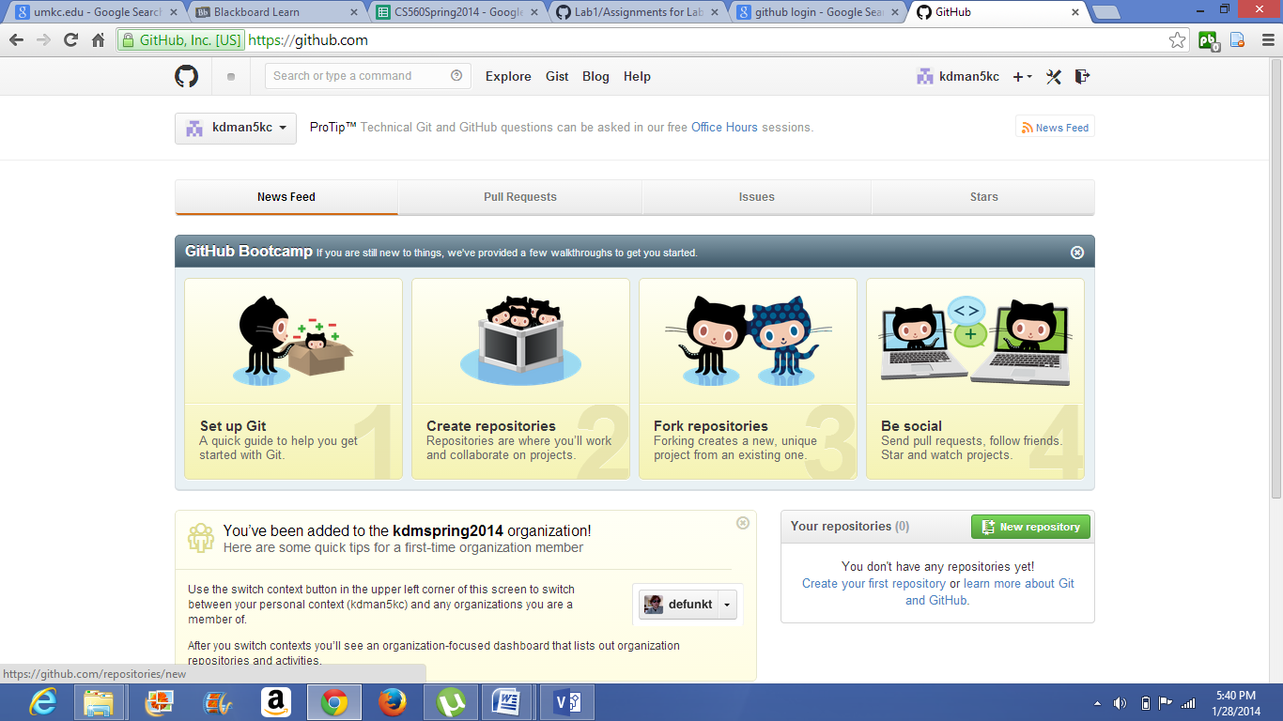

Assign the name to the repository.

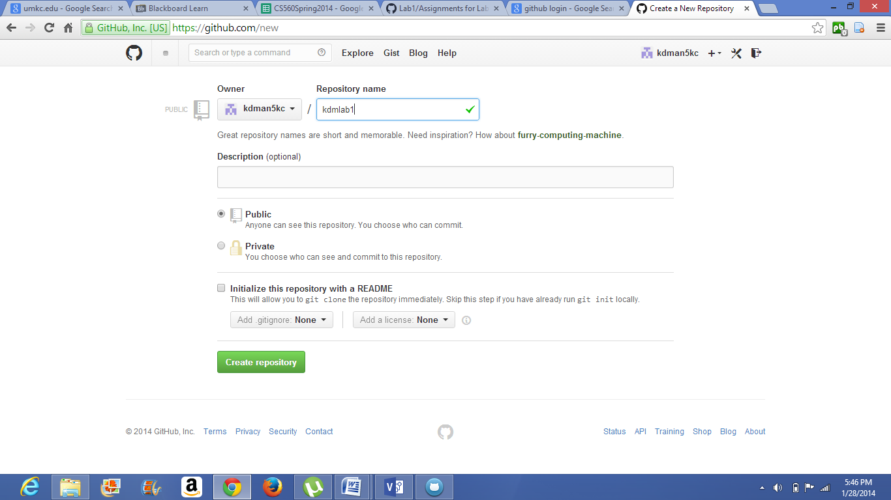

Login into Github account in your local machine.

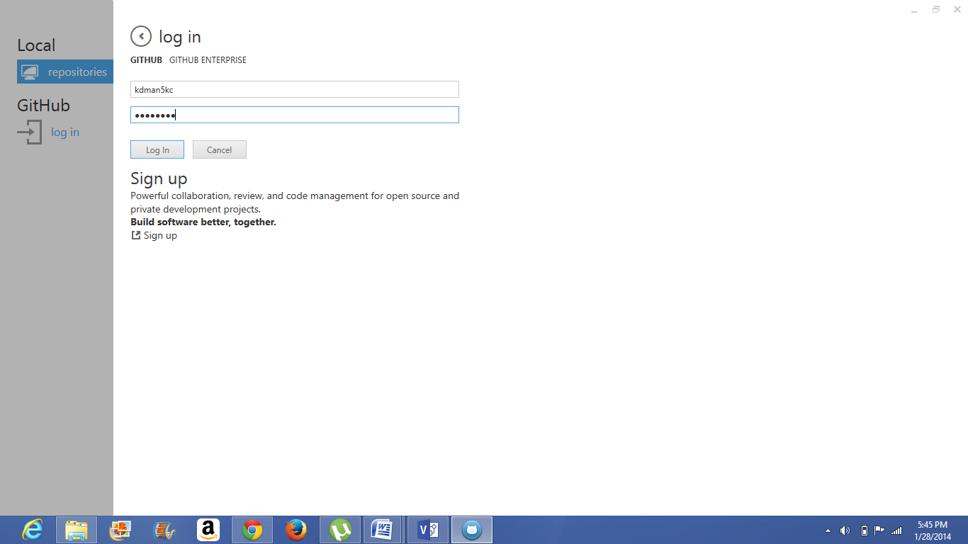

Here you can see the repository created in online. Then click on clone option then folder with that repository name is formed in documents.

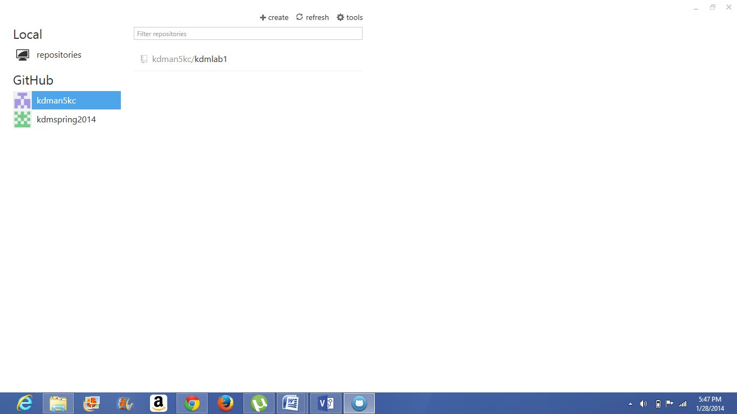

Paste all the documents into that folder, which you want to publish to that repository. then publish those material.

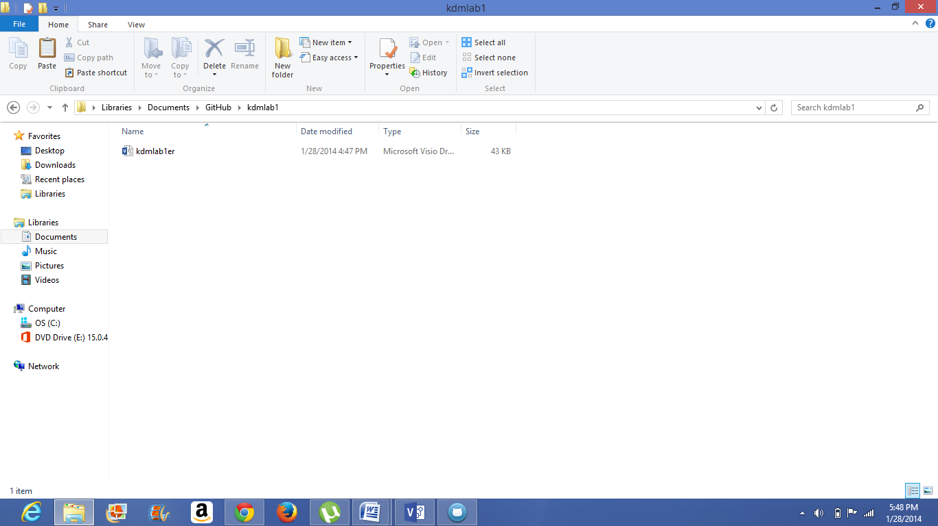

**SCRUMDO Screen shots:**

In order to create Scrumdo account go to: www.scrumdo.com/account/login.

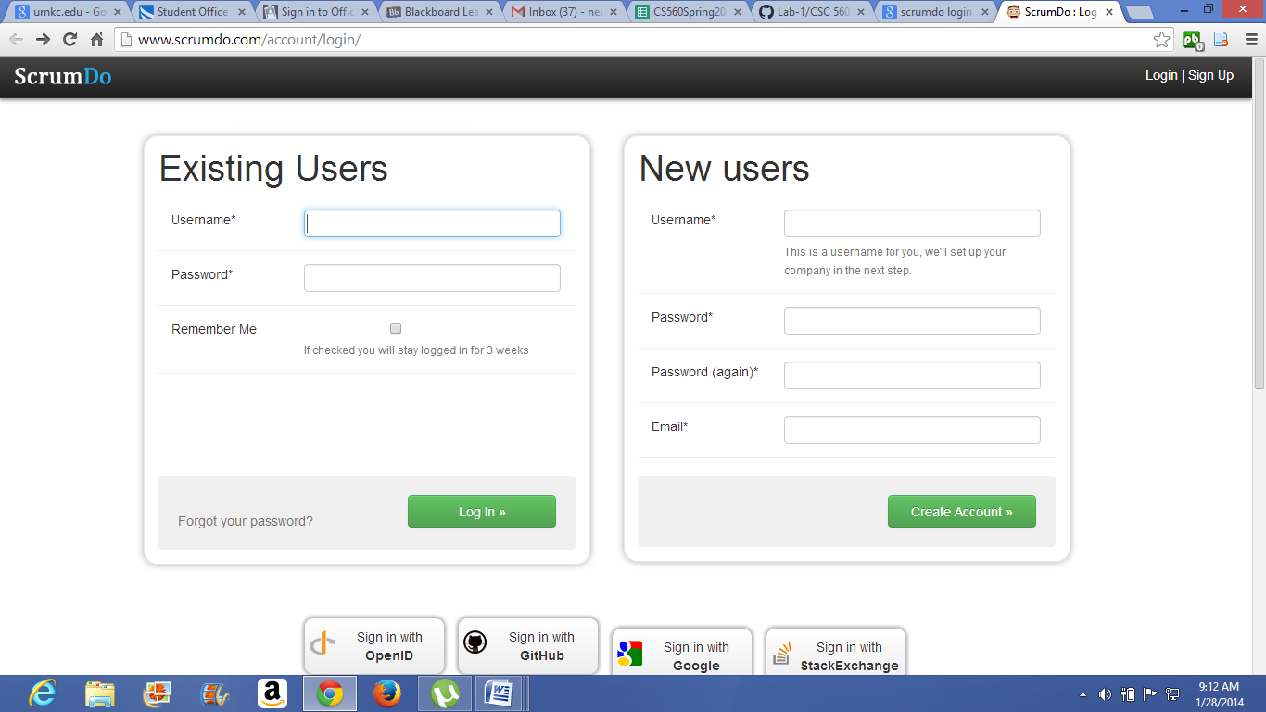

provide the necessary details.

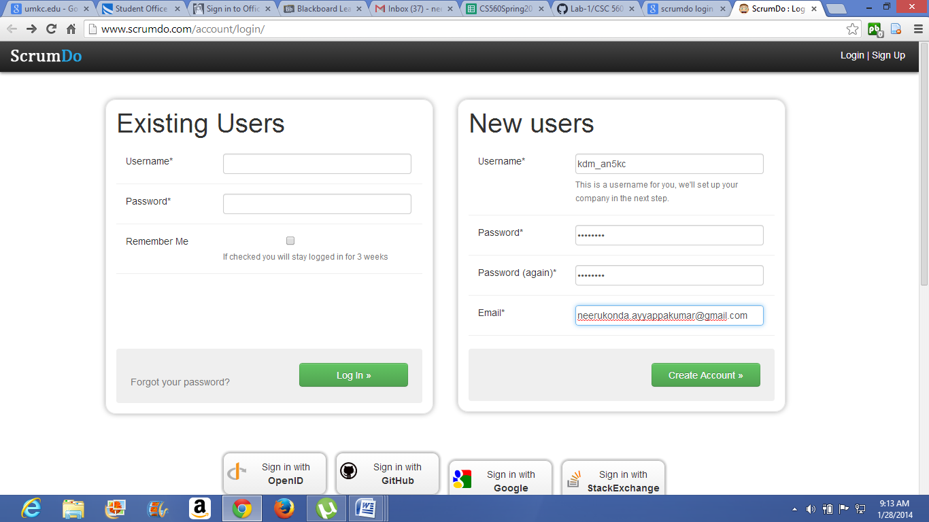

In order to view the progress of the task create project and name that project.

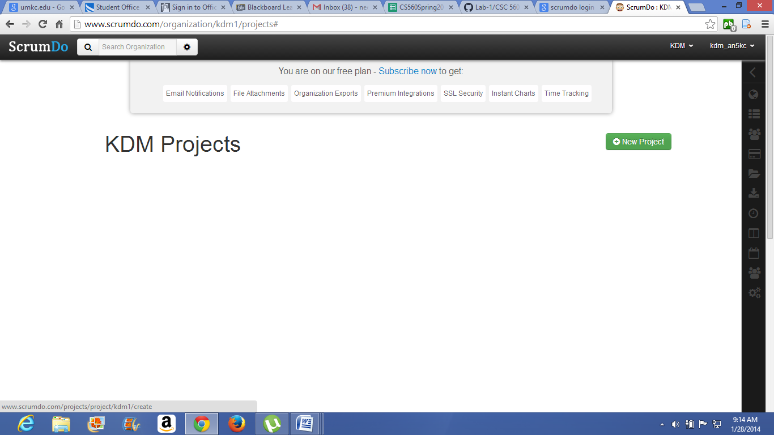

Then create iterations for the project. For this click on the project then click on new iteration.

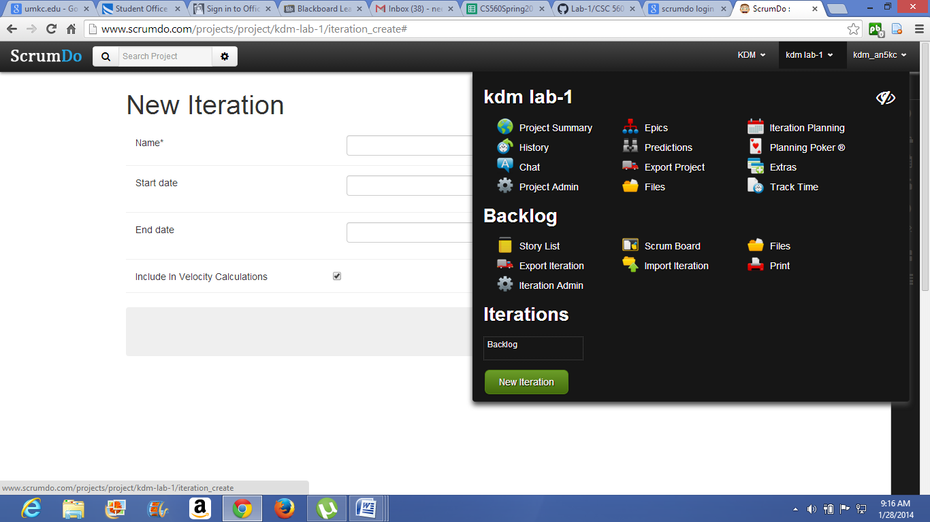

Then in creating the iteration provide the name of the iteration, starting and ending dates of the iteration.

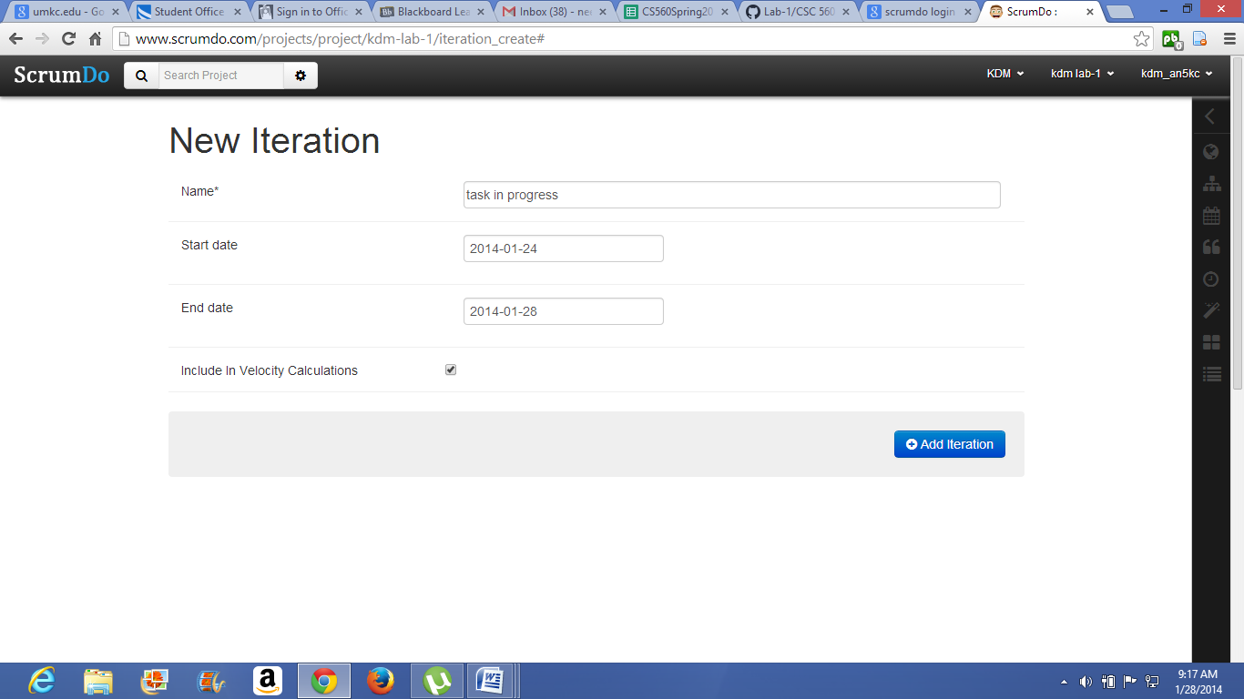

Then create the story for the iteration. story describes the work which has to be done in that specific iteration.

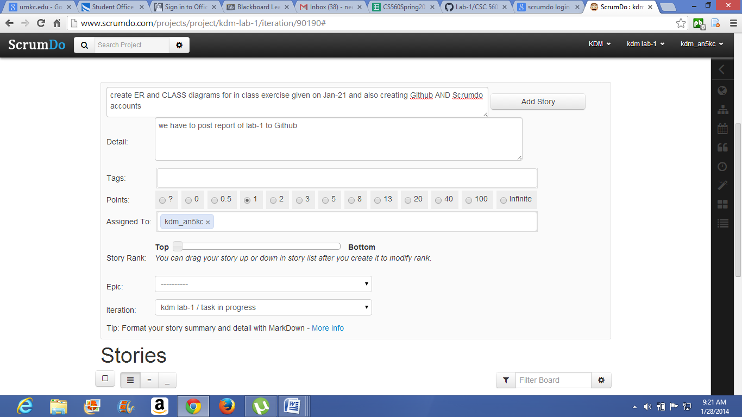

Here I created total three iterations. first iteration is regarding studying and understanding of lab-1 assignment. and second iteration is planning of, how to complete the assignment and doing that assignment.

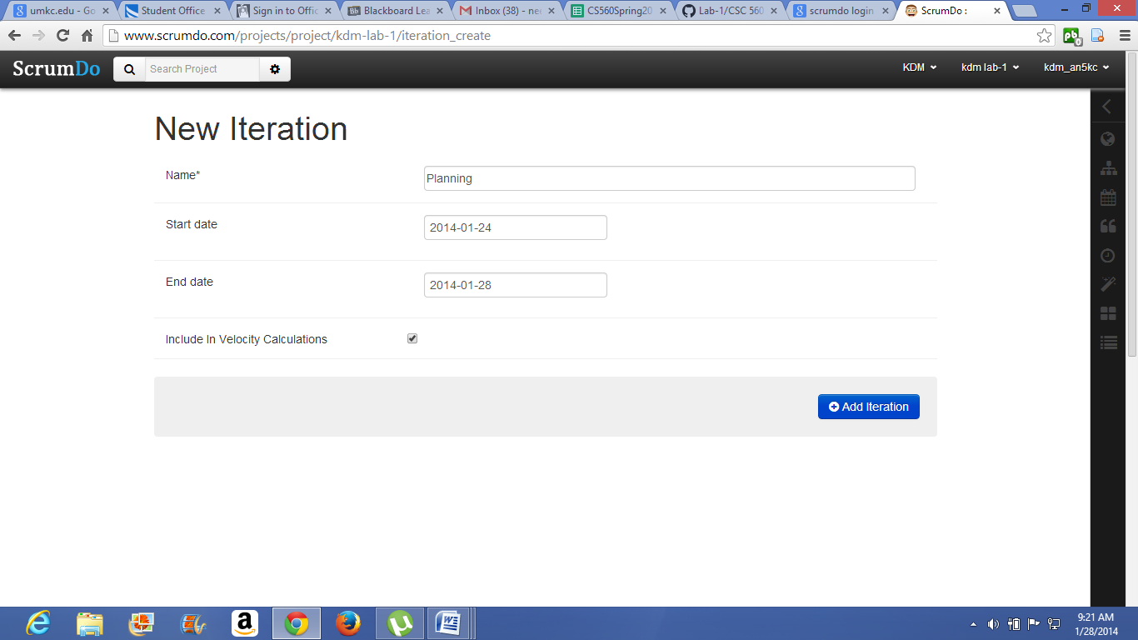

Create the story for that assignment.

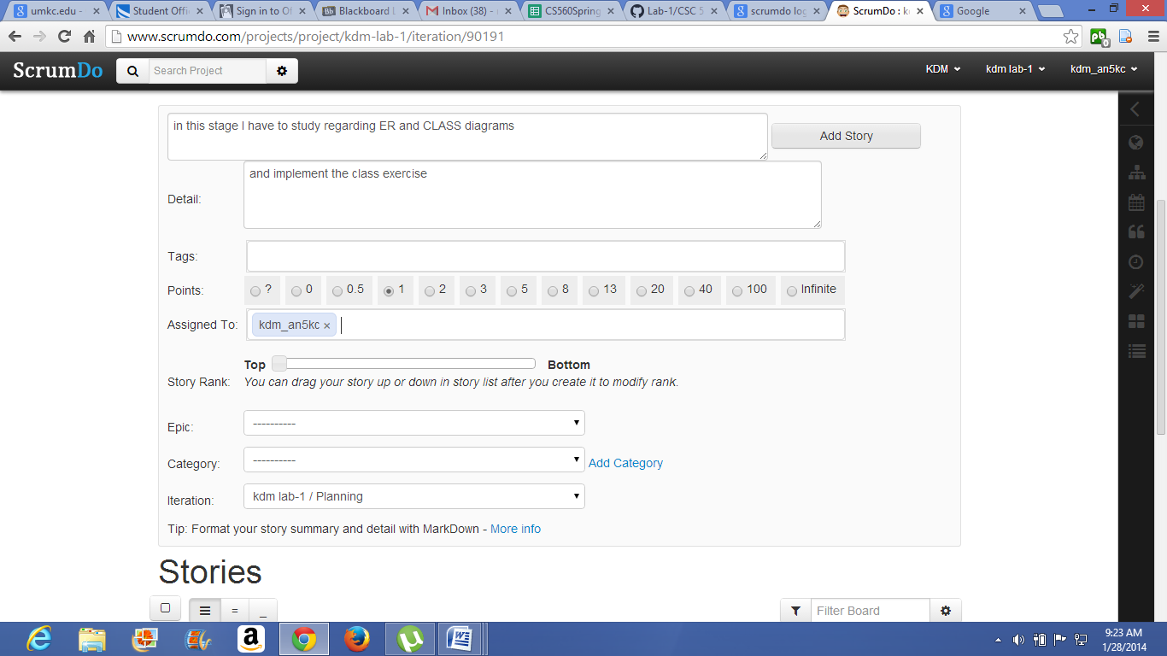

Create the third iteration which named as delivery. In this iteration we have to prepare the report for the lab-1 assignment.

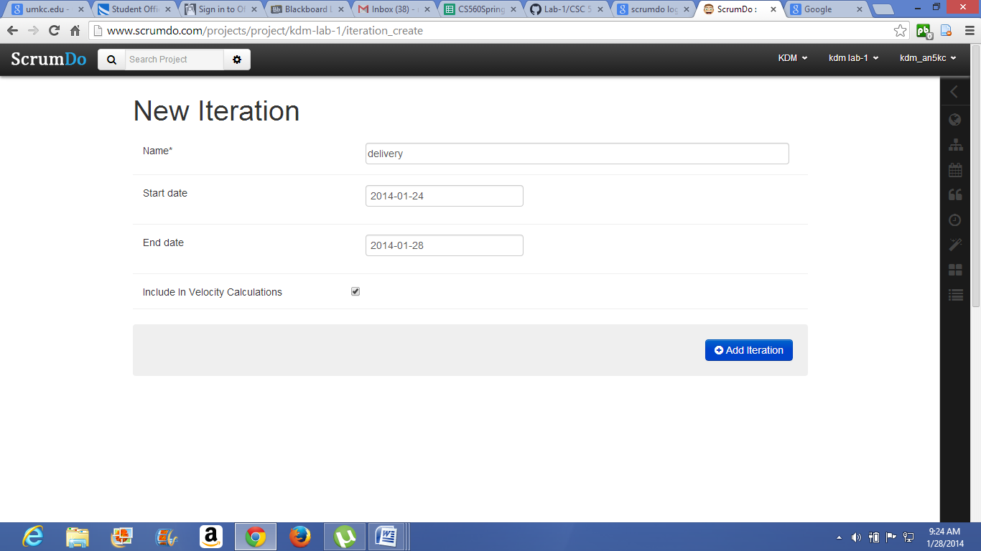

create the story for iteration.

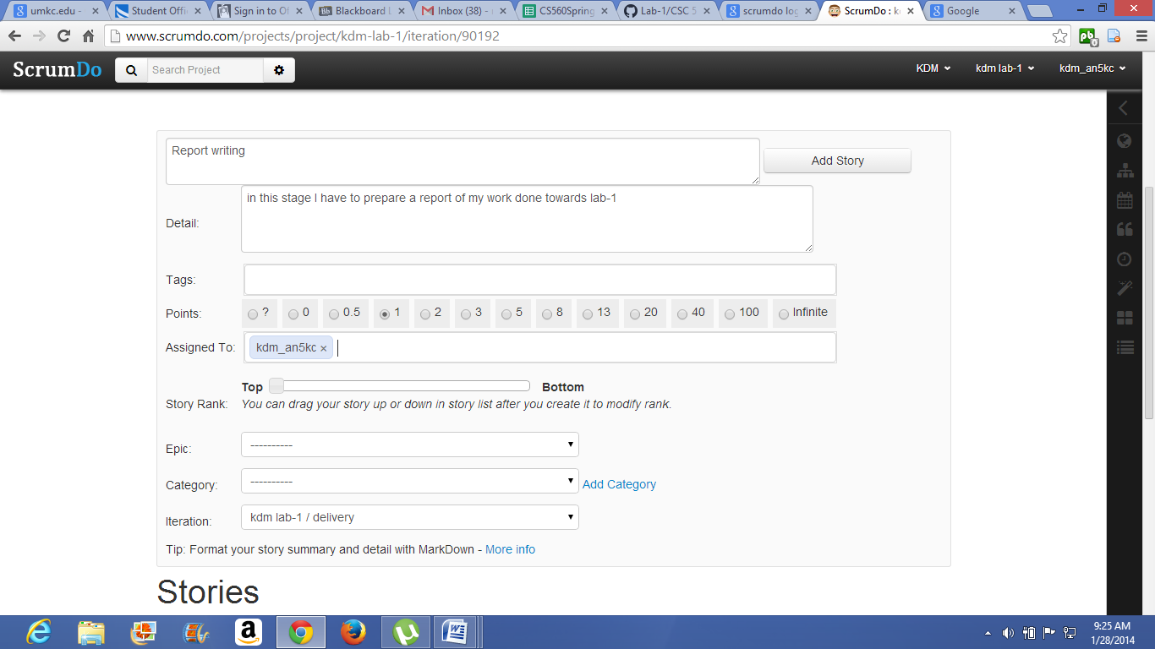

In order to see the summary of project click on project then click on project summary option.

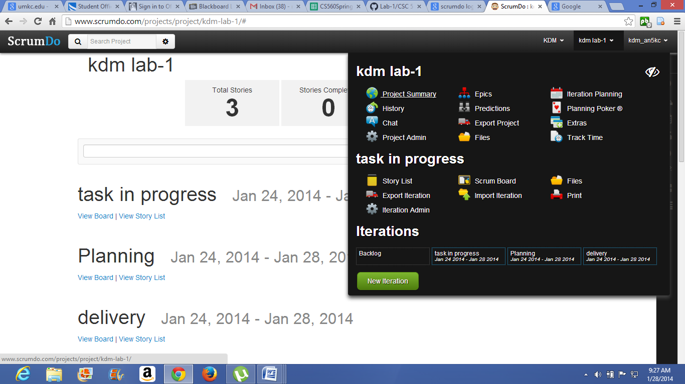

Then summary of project is displayed as below.

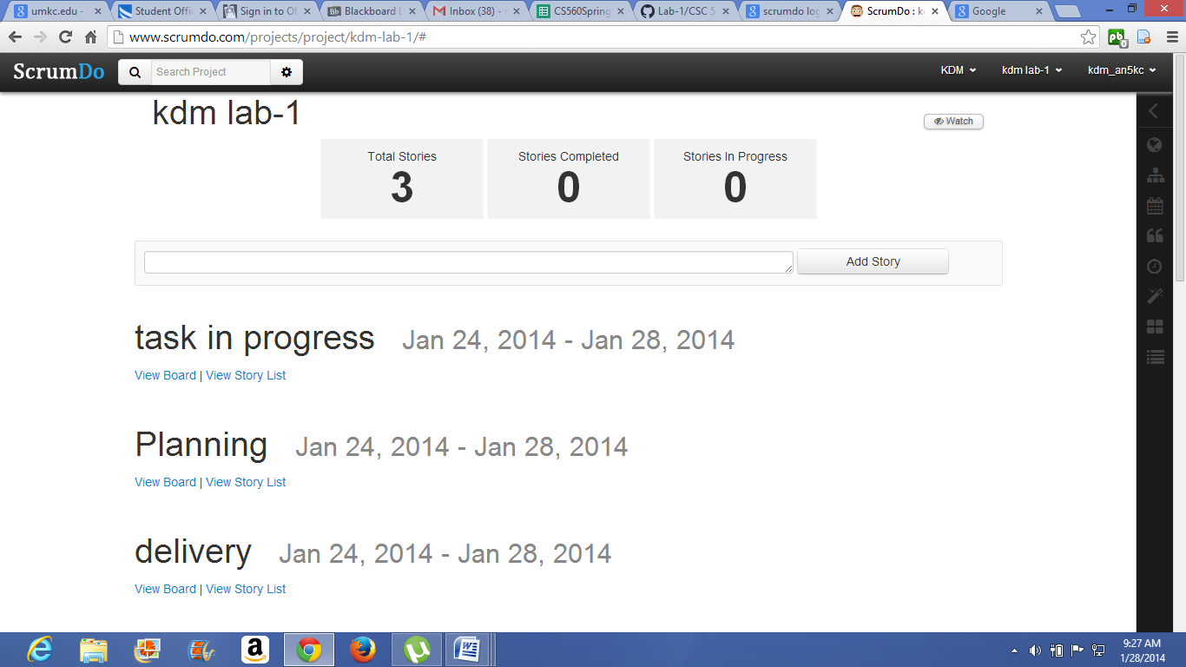

In order to observe the progress of iterations click on project then click on dashboard. So when the iterations are created at that time the status of story is ToDo.

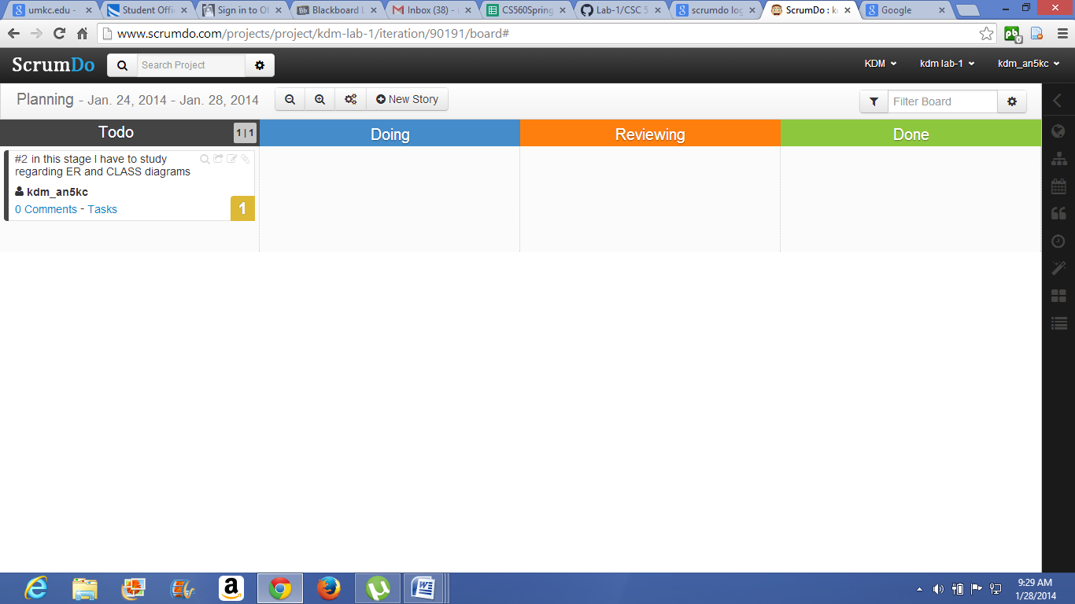

When the iteration is in progress then the status of story is to be doing.

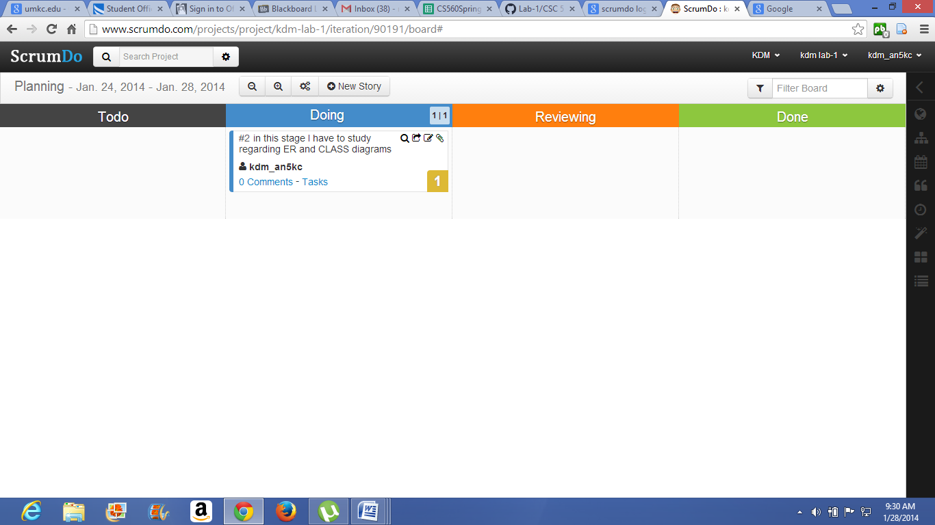

Once the iteration is done the status will change to done. Same scenario is applicable to all the iterations and stories.

