Circle of Viewpoints
Social Media Ban for Under 16s
Student Responses, Boneo Primary School, Year 6 | 24 June 2026

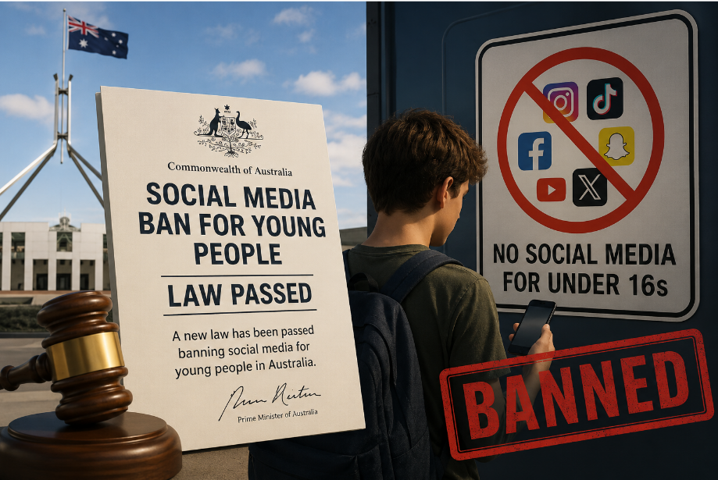
Australia's Social Media Ban for Young People, the law that framed the session.

Overview
This document presents the collated and lightly edited student responses collected during a Circle of Viewpoints (COV) thinking routine session at Boneo Primary School on 24 June 2026. The session was facilitated by STEM Wizard Kieran Nolan and classroom teacher Katie Gunn, and was part of a larger school-wide project exploring Visible Thinking Routines developed by Project Zero at Harvard Graduate School of Education.

The topic explored was Australia's social media ban for young people under the age of 16, a Commonwealth law that took effect in December 2025. Students were asked to adopt a nominated stakeholder viewpoint and respond using the Circle of Viewpoints sentence starters.

Session Details
Date: 24 June 2026
Year Level: Year 6
School: Boneo Primary School
Facilitators: Kieran Nolan (STEM Wizard) & Katie Gunn (Classroom Teacher)
Thinking Routine: Circle of Viewpoints, Project Zero, Harvard Graduate School of Education
Topic: Australia's Social Media Ban for children under 16
Total Responses: 35

Viewpoint Distribution
The following table shows how students were distributed across the six stakeholder viewpoints.

Viewpoint | Responses | Percentage
Parent | 18 | 51.4%
Content creator / influencer | 10 | 28.6%
Mental health professional | 4 | 11.4%
Politician | 1 | 2.9%
Teacher | 1 | 2.9%
Social media company | 1 | 2.9%

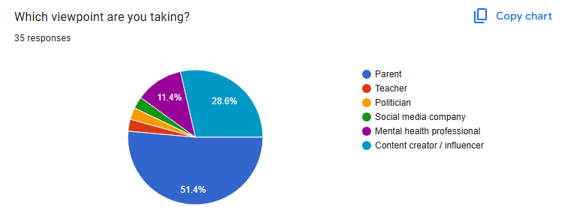
Viewpoint distribution, 35 student responses (Google Forms, 24 June 2026).

About the Circle of Viewpoints Routine
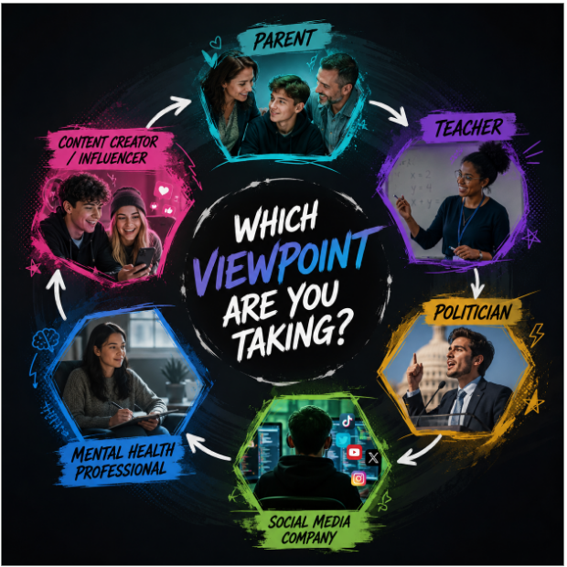
The six stakeholder viewpoints students chose from.
Circle of Viewpoints is a thinking routine that helps students see and explore multiple perspectives on an issue. It helps them understand that different people can have different connections to the same topic, and that these differences influence what people see and think. The routine works especially well for complex, controversial topics where students may initially only see two sides.

Students were guided to respond using the following sentence starters:
- I am thinking of [the topic] from the viewpoint of [chosen viewpoint]...
- I think... [describe the topic from your viewpoint, be an actor and take on the character]
- A question I have from this viewpoint is...
- After considering this viewpoint, has your thinking changed?

Student Responses by Viewpoint
The responses below have been lightly edited for clarity and to remove comments that were off-topic or not constructive. Spelling has been preserved where it reflects authentic student voice but corrected where it obscured meaning. All substantive perspectives have been retained. Of the 35 responses collected, a representative selection is reproduced below; some brief, duplicate, or off-topic responses (including the single Social Media Company response) have been omitted, though every viewpoint remains reflected in the distribution above.

Parent Viewpoint
Responses from students adopting the Parent viewpoint (18 students, 51.4%):

Thinks about ban | Main benefits/concerns | Question raised | Thinking changed?
I think it is good so my kids aren't on a screen all day. | It will let me spend more time with them. | Why they did this I don't know, but I do know I will get a lot more time with my kids. | I think it is good because it will let me spend time with my family and they will go outside more.
I'm so glad my child isn't addicted to their screen. Now my child can have a professional job and earn money and have their own life outside of a screen. | This will teach my children the ways of the real world and realising how things are really done. Maybe I can even get them to do their homework. | Is this ban really full proof or can people find ways out of it? | No, it really hasn't, because I originally thought it was a great idea, we need to have a life outside of our screens.
That you are safe and that kids don't see things online that could be inappropriate or untrue. | Stuff online can be bad for kids to see. | Should kids have access to social media? | No, because the internet isn't always safe for kids.
Annoying because my kid keeps asking to get into my account. | My kids are safer on the internet. | What is the point of the social media ban? | Still unsure.
Good so kids don't get addicted, like my daughter who was on her phone all the time instead of reading books. | So kids don't get addicted and waste all their time on devices. | We should consider banning social media, it's bad for kids' eyes. | My thinking will never change because it has always been bad for kids.
I think it's good for kids because sometimes online they can see things they are not meant to see. When they are older they can manage it better. | This will make children have a better childhood and grow up not always on their devices. My concern is them just asking parents to do face ID or claiming they are over 16. | It should be more child-proof, as lots of kids might make an account when they are too young. | At first I thought it wasn't the best idea, but after writing this I believe it's a good idea.
I think it's a great way of getting kids off social media so they won't experience fake content. | Kids can get off social media and spend more time outside or with family. | What if kids under 16 got onto social media by lying about their age? | It hasn't changed because I already knew why social media was banned and why parents care.
As a parent, I believe the social media ban is a great opportunity for kids to become more helpful around the house, spend time with family and friends, and be more active. | The ban has benefitted my whole family, we spend more time together watching a movie, playing a board game, or doing chores. | What if we made a phone ban at school throughout the day, and kids could have their devices back after school? | My thinking has not changed. I still believe the ban age might be slightly too high, perhaps 14 or 15 instead of 16.
It is bad and kids should get to keep going on social media. | Kids should get to keep the permission to go online. | Why do they have to quit? | No change.
It helps get kids off the internet and stops them going onto things they shouldn't. Blue light from screens also ruins young children's eyes. | The concern is that kids these days aren't experiencing full days of life and burning energy as they should. | Should kids experience more of the outside world? | No, my thinking has stayed the same.
Being a parent is hard enough and social media being taken away means children can't learn some life skills. On the other hand, it is a benefit because they can be creative, spend time outside, and avoid inappropriate content. | My main concern is kids seeing inappropriate content or content that might make them feel uncomfortable or unsafe. | What if social media started doing age-appropriate programs for different age groups? | It has stayed the same.
It glues kids to their phone, makes their eyes suffer, and is destroying our future. | Kids will not be smart enough to apply for a job because they're glued to their phone. | With this law, it is making kids go outside and be creative. | Yes.
Kids' eyes can suffer from too much screen time. If they are not on a screen they are outside. | Kids get smarter. | What are the consequences for underage access? | I've always thought that.
Kids under 16 are still able to live life, and it's not too late to keep it that way. Social media can also teach life lessons so I think it's either/or. | Probably social media bullying, and you can talk to anyone in the world. But it is a fun way to talk to friends. | What will be done if a kid creates an underage account, what are the punishments? | I just don't know if it's bad or good.
It is good for my kids to talk to other people and learn their own lessons in the real world. | There is less bullying on social media for people 16 and older. | How would you make sure kids under age don't access it any way? | No.
I think social media shouldn't be banned because if there's something you need to look up on YouTube and it's banned, you don't know what to do. | If social media wasn't banned, you can talk to people online and see what people on Facebook Marketplace have. | No specific question raised. | No, I have no change to my answer.
I think having social media is like not making you do anything, like going to play outside. | The benefits are that you're not getting stressed and you see your friends. | No specific question raised. | No, I think my answer is not changing.

Content Creator / Influencer Viewpoint
Responses from students adopting the Content Creator / Influencer viewpoint (10 students, 28.6%):

Thinks about ban | Main benefits/concerns | Question raised | Thinking changed?
Bad, because there is nothing wrong with it. | Content creators make money from videos. If there's no young audience, no one will earn money. | Why did you ban it in the first place? | No, because what's the point of banning it.
This is so horrible! Now kids won't see my videos. | I will lose followers, subscribers, and views. | What if kids under 16 need to learn something and they can't use videos because YouTube is blocked? | It has not. Why do kids get banned for what other people post? Why not make a kids' version with a clean version of the platform?
Absolutely terrible for me because now I have a lot fewer viewers and subscribers. | Concern, my channel might not make enough money now because all my videos were directed to kids. | Why did they decide to do that? I am very cross because I'm going to be broke. | No.
Horrible that I can't do my favourite thing and show people new content I find. | People can forget about me, my viewers or online friends. | What if you made it more protective instead of making it 16+, so everyone can have fun? Even lowering the age would be better than 16+. Maybe try to focus more on what people want as well as what they need, include safety updates, but include both 50/50. | A little bit, since I thought about it.
I think it's bad because now content creators can't reach as wide an audience and earn money. | Concerns: not getting enough views or money. What if YouTube, TikTok and other platforms go out of business because of this ban? Should content creators give up? | Why did they do this to kids under 16? In my opinion it should be kids under 12. | No, because I dislike the ban. It has made kids upset because now they have nothing to watch on road trips, long flights, or when they're bored.
I think it was a little bit random and I have a lot of concerns, in particular, companies like Apple abusing face recognition for many apps. | Roblox has ads showing a parent and child playing together, but the child in the ad looks about 6 and the allowed age for Roblox is 10+. | What if someone used an older sibling for face recognition to bypass the age check? | A little bit, since I thought about it more.

Mental Health Professional Viewpoint
Responses from students adopting the Mental Health Professional viewpoint (4 students, 11.4%):

Thinks about ban | Main benefits/concerns | Question raised | Thinking changed?
Good for young kids and early teens. | It is good that it has finally happened because kids were just scrolling for hours. | Why had this not been a law earlier? | No, because I already have no interest in social media myself.
Good, I can play games outside with my brothers. | Benefits: they play games with friends outside now. | I like this new ban because I can go on bike rides. | Yes, because I can do other things with my friends.

Politician Viewpoint
Responses from students adopting the Politician viewpoint (1 student, 2.9%):

Thinks about ban | Main benefits/concerns | Question raised | Thinking changed?
I don't agree but don't disagree. I think they should just stop being able to comment on videos, Shorts, TikTok, Instagram, and Snapchat. | Predators, inappropriate content, and short-form content that drives endless doom-scrolling. | What if kids find ways to get around the age verification? | No.

Teacher Viewpoint
Responses from students adopting the Teacher viewpoint (1 student, 2.9%):

Thinks about ban | Main benefits/concerns | Question raised | Thinking changed?
It's good. | No specific benefits noted. | How would it help me? | Unclear.

Key Themes and Observations

Themes in favour of the ban
- Screen time reduction: Many students (especially in the Parent viewpoint) saw the ban as a welcome reduction in excessive device use, citing benefits such as more outdoor activity, more family time, and improved focus.
- Child safety: Students frequently raised concerns about inappropriate content, online predators, and misinformation accessible through social media platforms.
- Mental health benefits: Several students noted that reducing social media access could reduce anxiety, doom-scrolling, and dopamine-driven compulsive behaviour.
- Cyberbullying: Students identified social media as a vector for bullying and noted the potential for a reduction with the ban in place.

Themes against the ban
- Economic impact on creators: Students in the Content Creator viewpoint consistently highlighted the financial consequences of losing a young audience base.
- Educational value: Multiple students noted that platforms like YouTube serve legitimate educational purposes and that a full ban may restrict access to learning.
- Enforcement concerns: Several students raised practical questions about age verification, platform compliance, and whether determined young people could simply bypass restrictions.

Nuanced positions
- Several students suggested alternatives to a blanket ban, including age-restricted but moderated 'kids' versions of platforms, comment restrictions rather than full bans, or a lower age threshold (e.g., 12 or 14).
- The Politician viewpoint student showed sophisticated understanding, acknowledging both sides while proposing a targeted feature restriction rather than a full ban.

Thinking Changed?
A notable number of students reported that their thinking shifted, or deepened, during the exercise, even when they ultimately maintained their original position. This is consistent with the intent of the Circle of Viewpoints routine: not to change minds, but to develop more considered, multi-perspective understanding of complex issues.

Acknowledgements
This session was conducted as part of a research-connected collaboration with educator and Visible Thinking Routines consultant Karin Morrison, and in connection with work supported by Dr Ron Ritchhart of Project Zero at Harvard Graduate School of Education. The session builds on prior Think-Puzzle-Explore work conducted by Boneo Primary SPARK Centre students on the topic of Artificial Intelligence.

Facilitators: Kieran Nolan (STEM Wizard, Boneo Primary School SPARK Centre) and Katie Gunn (Year 6 Classroom Teacher). Principal: Marija Pandza.

Boneo Primary School SPARK Centre | Digital Playhouse Foundation Ltd | June 2026

