**RPE TRACKER**

**By: Kristopher Doria**

**TABLE OF CONTENTS**

**Problem Statement:**

The mind is a very powerful tool however, it can also be the cause of failure. As a powerlifter, how can I create a device that will be able to let lifters know how many more reps they have in them?

**Aim:**

To create a device using hardware, and Arduino firmware that can track the RPE (Rate of Perceived Exertion) of a person squat, bench, and deadlift.

**Ideas:**

**String attachment: - Using this design**

* String attaches to device
* Something within device spins when string is pulled.
* Velocity of pull is calculated
* RPE calculation
* **PROS:**
  + Accuracy is good
  + Cheap
* **CONS:**
  + IDK

**Motion Sensor:**

* Motion sensor senses velocity of barbell
* RPE calculation
* **PROS:**
  + Cheap
  + Accuracy is okay
* **CONS:**
  + Must attach whole device on bar which adds weight

**Ultrasonic Sensor:**

* Ultrasonic sensor placed on the floor
* Tracks velocity of barbell through soundwaves
* **PROS:**
  + Cheap
  + Easy to implement
* **CONS:**
  + Accuracy is very hard to nail

**Research:**

**Arduino modules:**

**Speed sensor module:**

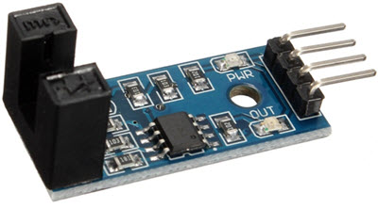

You can place the rotating object like a motor or a wheel in the slot and the sensor will determine the speed in RPM.

<https://whadda.com/product/ir-speed-sensor-module-wpse347/>

**DC Geared Motor with Rubber Wheel:**

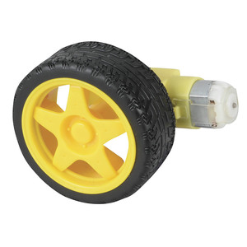

DC Geared Motor with Rubber Wheel perfect for DIY RC cars, robotics projects and more.

**Hardware Implementation:**

|  |  |
| --- | --- |
| Input Voltage |  |
| Output Voltage |  |
| Microcontroller |  |
| Battery |  |
| Speed Sensor |  |
| DC Motor |  |
|  |  |
|  |  |