MINDMATE AI
User Research Analysis Report
HCI Assignment 01 – New Product Experience Design
Survey sample: 31 respondents | Data recorded: 2–3 November 2026

1. Executive Summary
This report analyses 31 responses to the MindMate AI user research questionnaire. The survey explores study-planning habits, study challenges, current study tools, interest in personalised recommendations, comfort with voluntary mood selection, preferred learning activities and desired study-assistant features.
The strongest signals in this sample are the need for support with motivation and time management, low current use of study-planning applications, interest in personalised recommendations, and demand for AI learning assistance. Mood input should remain optional because a substantial share of respondents were unsure or uncomfortable selecting a mood.
Key result | Survey evidence
Leading challenges | Lack of motivation: 13/31 (41.9%); time management: 10/31 (32.3%). Combined: 74.2%.
Study-planning app use | 22/31 (71.0%) do not currently use a study-planning application.
Personalised recommendations | 29/31 (93.5%) answered Yes or Maybe.
Most selected feature | AI learning assistance: 22/31 (71.0%) selected it.
Mood input | 16/31 (51.6%) are comfortable selecting a mood; 15/31 (48.4%) are unsure or not comfortable.

This is a descriptive analysis of the supplied responses. It does not establish that the results represent all university students.

2. Research Method and Data Preparation
The source was the uploaded Google Forms response workbook, “MindMate AI – User Research Questionnaire (Responses).xlsx”. The workbook contains one response sheet and 31 records. Timestamps show that responses were recorded from 2 to 3 November 2026.
- The questionnaire contains nine closed questions and one optional open-ended question.
- All 31 respondents answered Questions 1–9. Question 10 contains 14 comments and 17 blank responses.
- Questions 5 and 8 allow multiple selections. Their percentages use 31 respondents as the denominator, so percentages can add to more than 100%.
- The analysis workbook assigns respondent IDs R01–R31 and omits form timestamps from the shared response table. Surrounding whitespace was trimmed for readability.
- Open-ended comments were grouped into non-exclusive themes. Original comment text is retained in the analysis workbook for checking.

3. Respondent Profile
Education level | Responses | Percentage
Undergraduate | 28 | 90.3%
Employee | 1 | 3.2%
NVQ | 1 | 3.2%
Diploma | 1 | 3.2%

Most respondents were undergraduates (28/31, 90.3%). The remaining responses were one Employee, one NVQ respondent and one Diploma respondent (each 3.2%). The sample is therefore mainly undergraduate, but it is not made up exclusively of undergraduates.

4. Study Planning Habits
Study plan frequency | Responses | Percentage
Sometimes | 12 | 38.7%
Weekly | 11 | 35.5%
Daily | 6 | 19.4%
Never | 2 | 6.5%

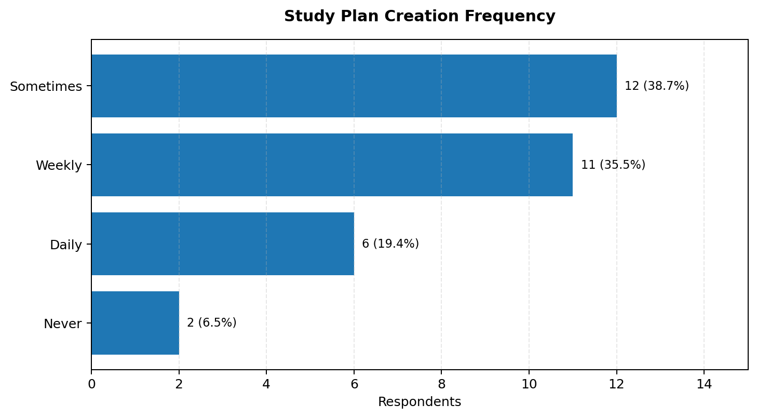
Twelve respondents (38.7%) create a study plan sometimes, while 11 (35.5%) do so weekly. Six (19.4%) plan daily and two (6.5%) never plan. This suggests that regular planning is not consistent for many respondents. MindMate AI should make it easy to create and adjust a realistic plan.

5. Main Study-Related Challenges
Challenge | Responses | Percentage
Lack of motivation | 13 | 41.9%
Time management | 10 | 32.3%
Organizing study materials | 3 | 9.7%
Concentration | 3 | 9.7%
Understanding difficult subjects | 2 | 6.5%

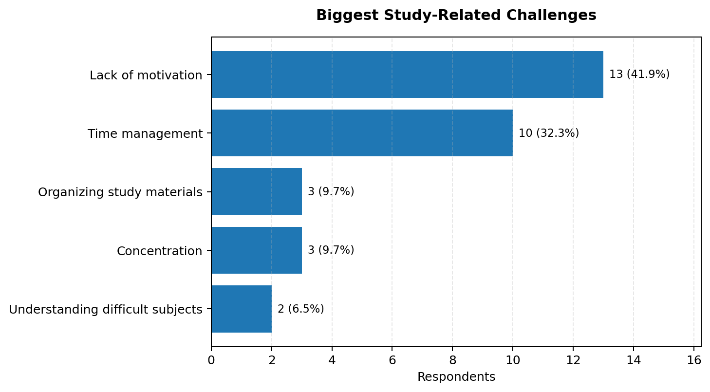
Lack of motivation was the most common selected challenge (13/31, 41.9%), followed by time management (10/31, 32.3%). Together these account for 23 of 31 responses (74.2%). Organising study materials and concentration were each selected by three respondents (9.7%); understanding difficult subjects was selected by two (6.5%).

6. Current Use of Study-Planning Applications and Tools
Currently uses a study-planning app? | Responses | Percentage
No | 22 | 71.0%
Yes | 9 | 29.0%

Twenty-two respondents (71.0%) do not currently use a study-planning application, while nine (29.0%) do. This indicates a potential opportunity for a simple and approachable study-planning experience.
Study tool (multiple selection) | Respondents selecting | Percentage of respondents
Mobile applications | 16 | 51.6%
Websites | 17 | 54.8%
Digital notes | 15 | 48.4%
Videos | 18 | 58.1%
Printed notes or books | 13 | 41.9%
AI short notes | 1 | 3.2%

Videos (18/31, 58.1%), websites (17/31, 54.8%), mobile applications (16/31, 51.6%) and digital notes (15/31, 48.4%) were commonly selected. Respondents therefore use a mixture of digital and traditional study resources.

7. Interest in Personalised Study Recommendations
Response | Responses | Percentage
Yes | 18 | 58.1%
Maybe | 11 | 35.5%
No | 2 | 6.5%

Eighteen respondents (58.1%) answered Yes and 11 (35.5%) answered Maybe. Together, 29 respondents (93.5%) were at least open to personalised recommendations. Only two (6.5%) answered No. The product should let users review and adjust suggestions instead of treating personalisation as a fixed or automatic decision.

8. Most Useful Features
Feature (multiple selection) | Respondents selecting | Percentage of respondents
Personalized study plans | 16 | 51.6%
Interactive quizzes | 15 | 48.4%
AI learning assistance | 22 | 71.0%
Progress tracking | 8 | 25.8%
Study reminders | 10 | 32.3%
Mood-based study suggestions | 11 | 35.5%

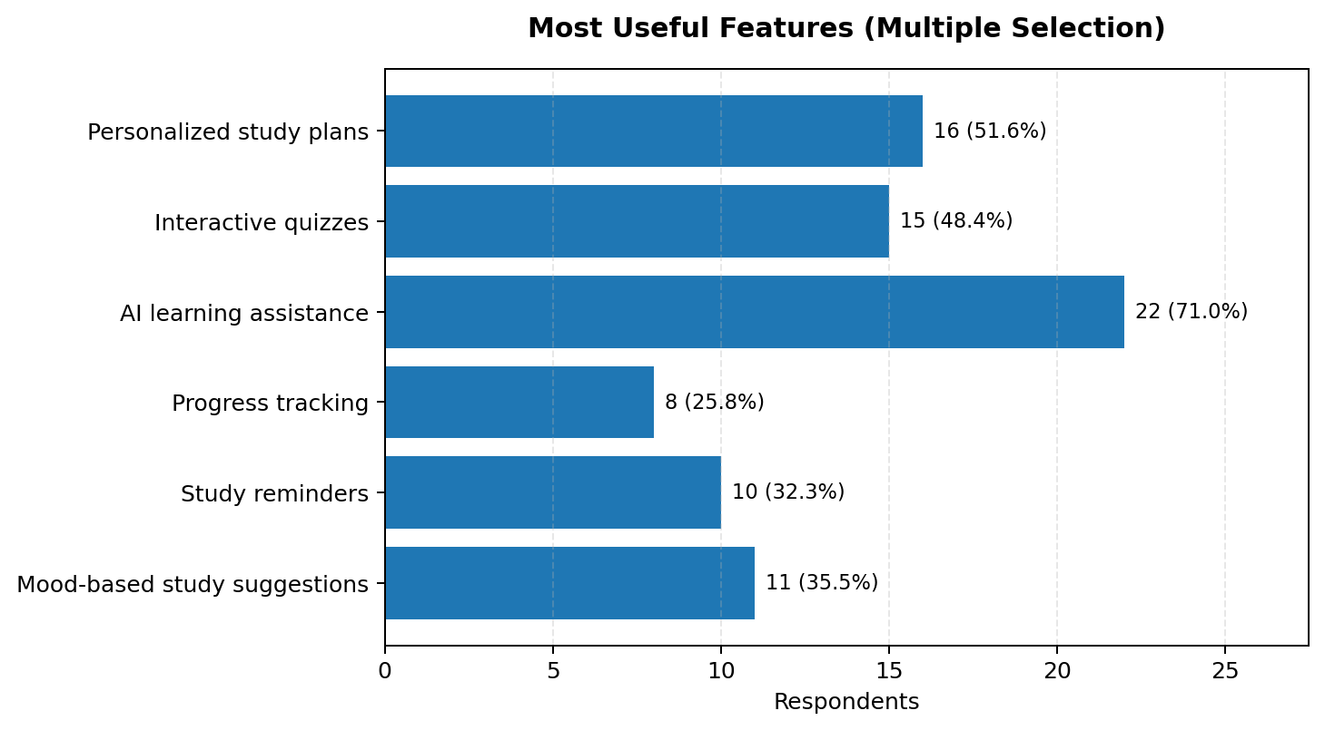
AI learning assistance was the most selected feature (22/31, 71.0%). Personalised study plans (16/31, 51.6%) and interactive quizzes (15/31, 48.4%) followed. Mood-based suggestions (11/31, 35.5%), study reminders (10/31, 32.3%) and progress tracking (8/31, 25.8%) were also selected. These results support prototyping AI assistance, planning and practice as prominent features.

9. Comfort with Voluntary Mood Selection
Response | Responses | Percentage
Yes | 16 | 51.6%
Not sure | 9 | 29.0%
No | 6 | 19.4%

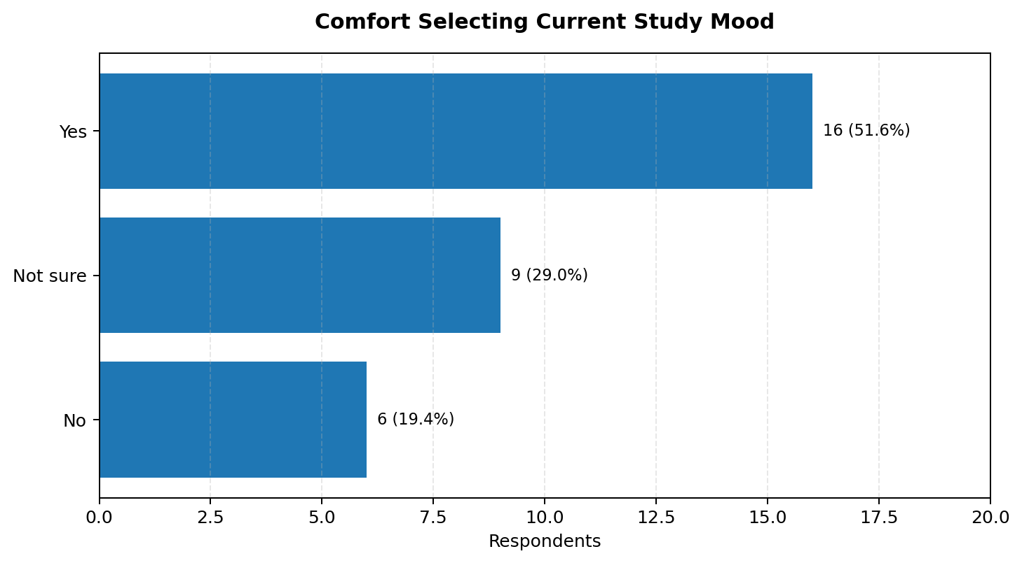
Sixteen respondents (51.6%) said they would be comfortable voluntarily selecting their current study mood. Nine (29.0%) were not sure and six (19.4%) said No. Therefore, 15 respondents (48.4%) were unsure or uncomfortable. Mood selection should be optional, skippable and clearly explained. It should not be presented as a psychological or medical assessment.

10. Preferred Learning Activities
Preferred activity | Responses | Percentage
A combination of different activities | 14 | 45.2%
Educational videos | 7 | 22.6%
Quizzes | 4 | 12.9%
Practical activities | 4 | 12.9%
Reading | 2 | 6.5%

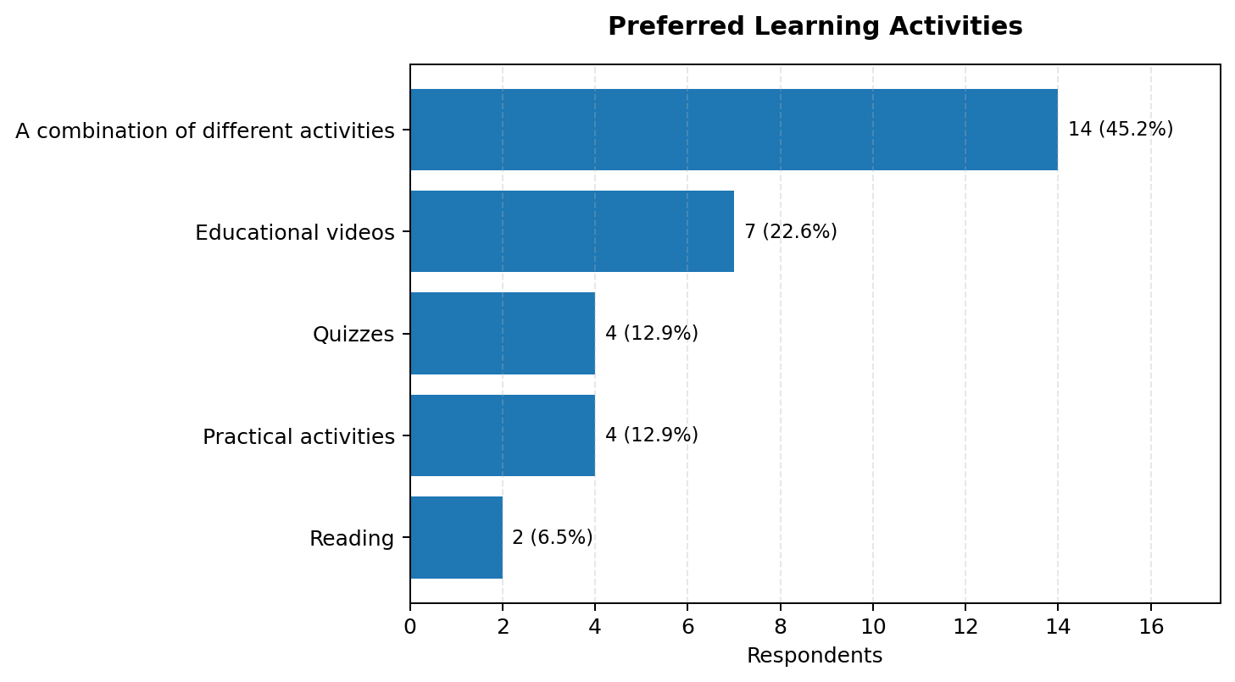
The most common preference was a combination of different activities (14/31, 45.2%). Educational videos were selected by seven respondents (22.6%), quizzes by four (12.9%), practical activities by four (12.9%) and reading by two (6.5%). A flexible experience that supports several formats is therefore more suitable than a single-format learning tool.

11. Open-Ended Suggestions
Fourteen respondents entered a comment in Question 10 and 17 left it blank. Eight comments contained an actionable improvement idea; six non-blank entries were generic acknowledgements, negative/no-suggestion responses or a dash. The thematic coding below is non-exclusive: a single comment can contribute to more than one theme.
Theme | Mentions | Examples of requested improvements
Adaptive scheduling / time management | 3 | Adjust timelines based on progress and difficulty; make study planning easier; support time management.
Quizzes / practice materials | 3 | Quizzes, past papers and model questions.
Personalization / summaries | 2 | More personalized support and summarisation.
Progress tracking / reminders | 1 | Included in a detailed request for several combined features.
Study tools / citation quality / export | 1 | Better tools, accurate citations and easy note export.

Theme counts are counts of coded mentions, not mutually exclusive respondent groups. The raw comment text and respondent IDs are included in the accompanying Excel workbook.

12. Key UX Design Implications
- Core planning experience: Provide a fast way to create a study plan, break work into manageable tasks and adapt schedules when progress or difficulty changes.
- Motivation support: Use achievable goals, visible progress and supportive reminders. Avoid guilt-based language or excessive notifications.
- AI learning assistance: Offer help with explanations and summaries. Make sources and citations visible when the system provides factual learning content.
- Practice and varied learning: Include quizzes and practice resources, while supporting videos, notes and practical activities in a flexible sequence.
- User-controlled mood input: Make mood selection optional and skippable, explain how it influences suggestions, and let the student change or clear it.
- Personalised but adjustable suggestions: Allow students to review, edit or reject recommendations so that the system supports user control.

13. Limitations
- The sample contains 31 responses and is mainly undergraduate (90.3%). It should not be treated as representative of all university students.
- The sampling method and recruitment coverage are not established by the spreadsheet; results should be described as findings from this respondent group.
- Questions 5 and 8 are multi-select questions, so their percentages do not add to 100%.
- Question 10 is optional and has 17 blank responses. Qualitative themes are indicative and based on a small number of comments.
- The results describe stated preferences and self-reported challenges; they do not prove how students behave in a real study session.

14. Conclusion
The survey provides an initial evidence base for MindMate AI. In this sample, motivation and time management are the leading study challenges; current use of study-planning apps is limited; respondents show interest in personalised recommendations and AI learning assistance; and many prefer a mix of learning activities. The design should prioritise an easy-to-use, adjustable study planner, AI-supported learning help and interactive practice. Mood-related features should remain optional and transparent. These insights should guide personas, empathy maps, the user journey and feature prioritisation, and should later be checked through prototype usability testing.

Appendix A. Source and Accompanying Analysis File
Source: MindMate AI survey response workbook (31 entries; timestamps omitted). The analysis workbook includes raw responses, frequencies, multi-select summaries, open-ended coding and a dashboard.

