Natural Language Querying of DuckDB Using LLM:
A Privacy-Preserving Approach to Accessible Data Analytics
Padmapriya H N¹, Chandana M Pallegar², G K Harshitha³, Poojitha K D⁴, Rakshitha B M⁵
¹ Assistant Professor, Dept. of Computer Science and Engineering (AI & ML)
²³⁴⁵ UG Scholar, Dept. of Computer Science and Engineering (AI & ML)
GSSS Institute of Engineering and Technology for Women, Mysuru, Karnataka, India
padmapriya@gsss.edu.in¹, chandanapallegar@gmail.com², gkharshitha19@gmail.com³, poojithakd08@gmail.com⁴, rakshithamahadeva31@gmail.com⁵

Abstract
Across education, commerce, and administration, people routinely store valuable information in CSV spreadsheets yet lack the SQL know-how to probe it. We tackle this gap with a browser-based tool that lets anyone pose plain-English questions and receive instant answers from their own data. At the heart of our design sits FLAN-T5, a pre-trained language model running entirely on the user’s machine, so no record ever leaves the local environment. The model reads the column names of the uploaded file, converts the question into an SQL statement, and hands that statement to DuckDB—a lightweight, column-oriented engine that lives in memory and finishes most look-ups in well under a second. Flask ties the pieces together on the server side, while a safety filter rejects any query that could alter or destroy data. Because nothing touches the cloud, the workflow naturally respects privacy rules like GDPR and FERPA. In our tests the model produced correct SQL between 85 and 95 percent of the time on neatly labelled datasets, DuckDB handled a million-row file in roughly half a second, and the language-model step itself held steady near 1.6 seconds regardless of how large the file was. Three non-technical volunteers—a teacher, a sales manager, and an HR officer—completed every assigned task without prior training, confirming that the system works as a low-cost, private, and genuinely usable analytics assistant.
Keywords—Natural Language Processing, Text-to-SQL, Large Language Models, DuckDB, FLAN-T5, Privacy-Preserving AI, Flask, In-Memory Database, Data Analytics, Transformer Architecture.
1. INTRODUCTION
Almost every school, shop, and office today sits on a pile of CSV files—attendance sheets, payroll records, order logs—that hold answers to important questions. The catch is that getting those answers normally requires writing SQL, a skill most non-technical people simply do not have [1]. A teacher who wants to know which students scored below average, or a shop owner checking last month’s best-selling product, ends up either scrolling through rows manually or waiting for someone from IT to write the query.
Several workarounds exist, but each comes with trade-offs. Spreadsheet tools like Excel handle smaller files well enough, yet they slow down noticeably once a dataset crosses a few tens of thousands of rows. Raising an IT ticket introduces waiting time that can stretch from hours to days. Cloud AI chatbots such as ChatGPT and Google Bard can answer data questions impressively, but they require uploading the file to a remote server—something that is risky, and in some cases illegal, when the data contains student grades, salary figures, or medical records [2, 3].
We set out to build something simpler. Our goal was a single web page where a user drops a CSV file, types a question in everyday English, and gets back a table of results—all without the data ever leaving the laptop. To make this work we paired FLAN-T5 [19], a text-to-text transformer that runs locally, with DuckDB [18], an in-memory analytical engine that can crunch a million rows in under a second. Flask [17] glues the front-end to the back-end, and a validation layer sits between the model and the database to block anything that could corrupt the data.
Our main contributions can be summarised as follows. First, we present an architecture where every step —from AI inference to query execution—happens on local hardware with zero data exfiltration. Second, we introduce a schema-extraction pipeline that automatically figures out column names and types from any CSV, so the user never has to configure anything. Third, we describe a security module that filters out destructive SQL and injection attempts before they reach the database. Fourth, we report detailed experiments covering accuracy, speed, and real-world usability.
1.1 Related Works
People have been trying to let ordinary users talk to databases in plain language for decades. The earliest attempts—LUNAR in the early 1970s, LADDER a few years later—relied on hand-written grammar rules [20]. These worked well within a narrow vocabulary but broke down the moment someone phrased a question in an unexpected way.
Things changed substantially when Sutskever and colleagues showed that a neural encoder–decoder network could learn to translate one sequence into another [7]. Bahdanau’s attention idea let the decoder peek back at relevant words in the input, which helped a lot with longer sentences [6]. Then Vaswani’s Transformer replaced recurrence with self-attention altogether [1], and practically every subsequent NLP advance has built on that design.
For the specific task of generating SQL, BERT-based systems like SQLova [4] did very well on the WikiSQL benchmark by treating query generation as a slot-filling exercise. They stumbled, however, on nested queries and multi-table joins. Raffel’s T5 model took a different angle: treat every NLP task as "text in, text out" [19]. Its instruction-tuned variant, FLAN-T5, turned out to be especially good at reading a table schema and producing the matching SQL string.
On the privacy front, Carlini and co-authors raised an alarm by showing that large models can memorize and regurgitate chunks of their training data [5]. That finding made us wary of any pipeline that ships user data to an external API. Meanwhile, Raasveldt and Mühleisen introduced DuckDB [18], an embedded OLAP database that sits inside the application process, reads Pandas DataFrames with zero copying overhead, and runs columnar vectorised execution. Combining a local FLAN-T5 with DuckDB gave us the two ingredients we needed: smart SQL generation and fast, private query execution.
2. SYSTEM DESIGN AND METHODOLOGY
We organised the system into four layers—Interface, Intelligence, Data, and Orchestration—so that each concern stays cleanly separated. The sections below walk through the architecture, the individual components, the six implementation modules, and the step-by-step query pipeline.
2.1 System Architecture
Fig. 1 shows the entity-relationship diagram that captures how users, files, data columns, and queries relate to one another inside the system. At the top sits the Interface Layer: an HTML5 page with a drag-and-drop upload zone and a chat-style query box. Below it is the Intelligence Layer, where FLAN-T5 lives in memory and converts English into SQL. The Data Layer wraps DuckDB, which stores the uploaded dataset as a temporary in-memory table. Finally, the Orchestration Layer is a Flask server that routes HTTP requests, manages user sessions, and coordinates the other three layers.
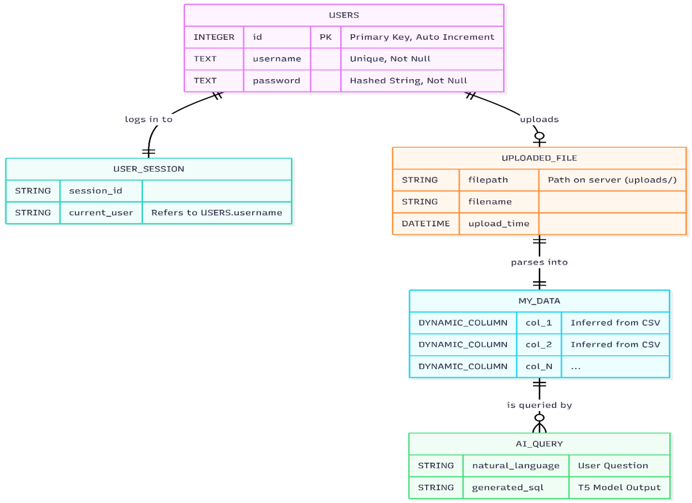
Fig. 1. Entity-Relationship diagram mapping the interaction among users, uploaded files, data elements, and query operations.
Fig. 2 lays out the full functional flow. A user drops a CSV file onto the page; Flask hands it to the ingestion module, which uses Pandas to clean up headers and register the data in DuckDB. When the user types a question, the system stitches together the table schema and the question into a prompt, feeds it to FLAN-T5, and gets back a candidate SQL string. That string passes through a safety check before DuckDB runs it. The result set comes back as JSON, and the browser renders it as a neat table.
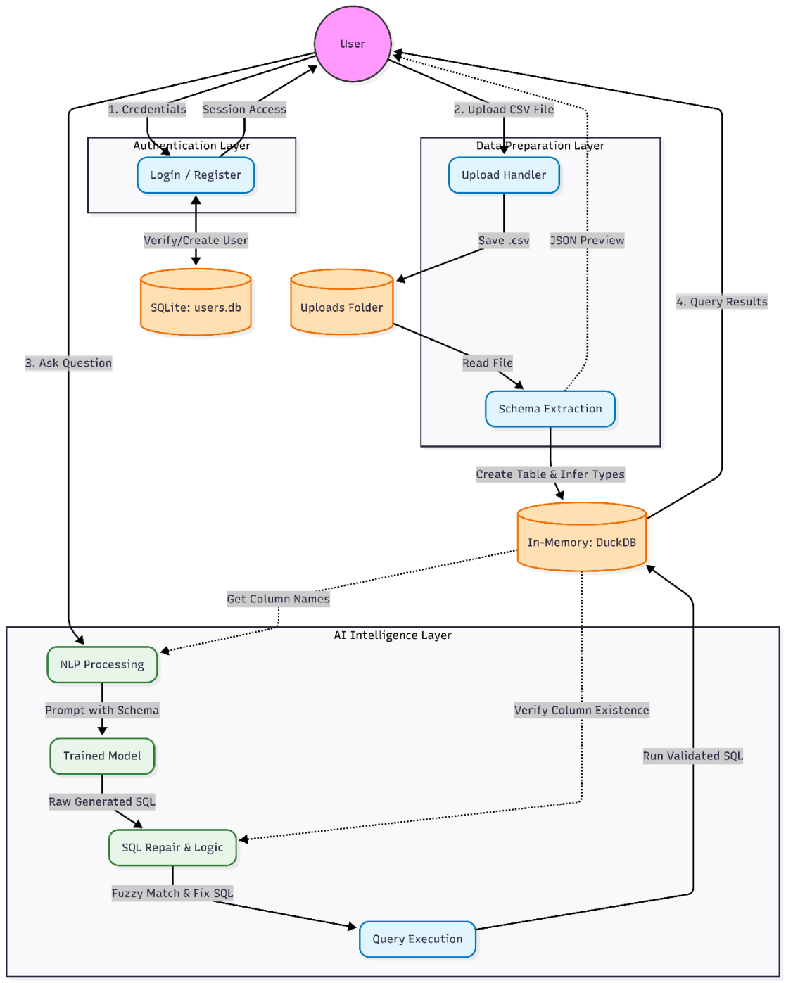
Fig. 2. End-to-end functional architecture showing the data path from CSV upload to query result display.
2.2 Component Design
Flask exposes three REST endpoints—/upload for file ingestion, /query for question submission, and /download for exporting results. We chose it for its minimal boilerplate and easy integration with Python libraries. FLAN-T5 is loaded once at startup via the Hugging Face Transformers library [13] and stays in RAM for the duration of the session. Because the model never calls home, not a single byte of user data touches the internet.
Instead of a traditional client-server database, we use DuckDB as an in-process engine. It reads a Pandas DataFrame directly—no serialisation, no disk writes—and runs analytical queries through a vectorised columnar executor. On our test machine a GROUP BY over half a million rows finished in about 0.3 seconds. Pandas itself handles the grunt work of reading the CSV, stripping odd characters from column headers, and figuring out whether each column holds text, integers, floats, or dates.
2.3 Implementation Modules
Module 1 – User Interface: The front-end is deliberately simple. There is a drop zone for the CSV file, a preview table that appears as soon as the upload finishes, a text box for questions, and a small panel that reveals the SQL the model generated so the user can sanity-check it. A download button lets people grab the results as a fresh CSV. Fig. 3 shows the landing screen.
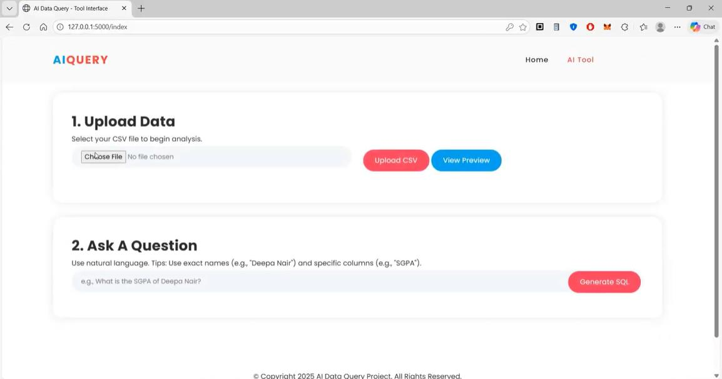
Fig. 3. Landing screen of the web application with the upload area and query panel visible.
Module 2 – Data Ingestion: The moment a CSV arrives, Pandas reads it, strips whitespace and special characters from every header, and infers each column’s type. The cleaned DataFrame becomes the single source of truth for the rest of the pipeline. Because this step is entirely automatic, the system works with any CSV the user happens to have—no schema files, no config, no manual mapping. Fig. 4 shows the file picker dialog.
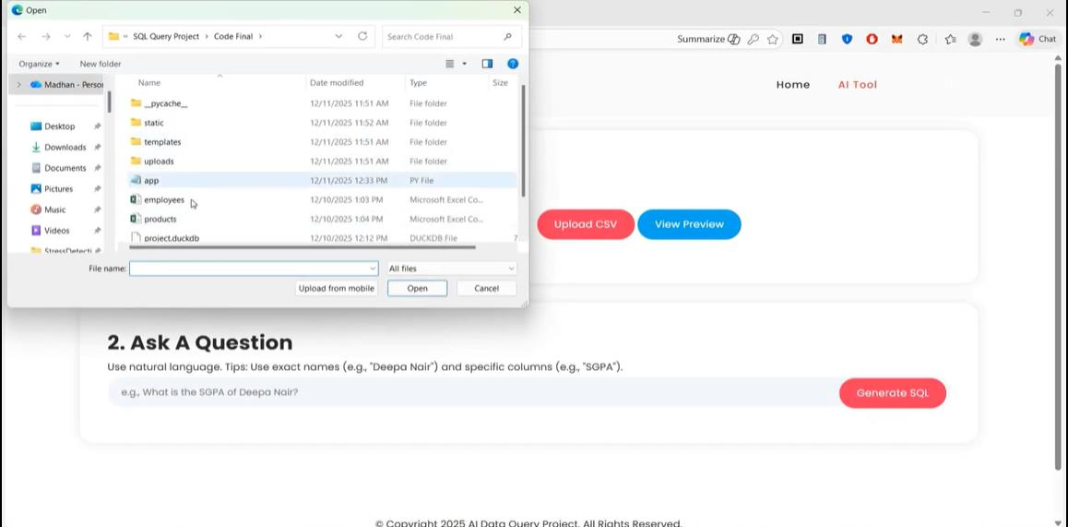
Fig. 4. File selection dialog where the user chooses a CSV dataset to upload.
Module 3 – Schema Generation: Once the DataFrame is ready, we register it inside DuckDB under the fixed alias uploaded_data. We then pull out every column name alongside its inferred type and assemble a short descriptor like "Table: [Name (text), Age (int), Salary (float)]." This string becomes part of the prompt. Giving the model explicit column metadata—a technique sometimes called schema linking—cuts down on hallucinated column names and noticeably boosts accuracy.
Module 4 – Prompt Construction: We build each prompt from three pieces: a brief instruction ("Translate the following question to SQL"), the schema descriptor from Module 3, and the user’s question verbatim. Keeping the prompt compact matters because FLAN-T5-base has a limited context window, and stuffing in unnecessary tokens would push useful information out.
Module 5 – Security Filter: Before any SQL reaches DuckDB, it passes through a whitelist check. Only SELECT statements are allowed; anything containing DROP, DELETE, ALTER, INSERT, or UPDATE is rejected outright. The filter also scans for common injection patterns like stacked semicolons or comment sequences. In practice, the model rarely generates dangerous SQL on its own, but the filter is there as a safety net against both model misbehaviour and deliberate adversarial input.
Module 6 – Execution and Display: DuckDB runs the approved query and hands back a result set. We package the column headers and rows into a JSON object, which the browser renders as a styled HTML table. Users can also download the table as a CSV with one click. Fig. 5 shows the upload confirmation with a data preview, and Fig. 6 shows a completed query with its generated SQL.
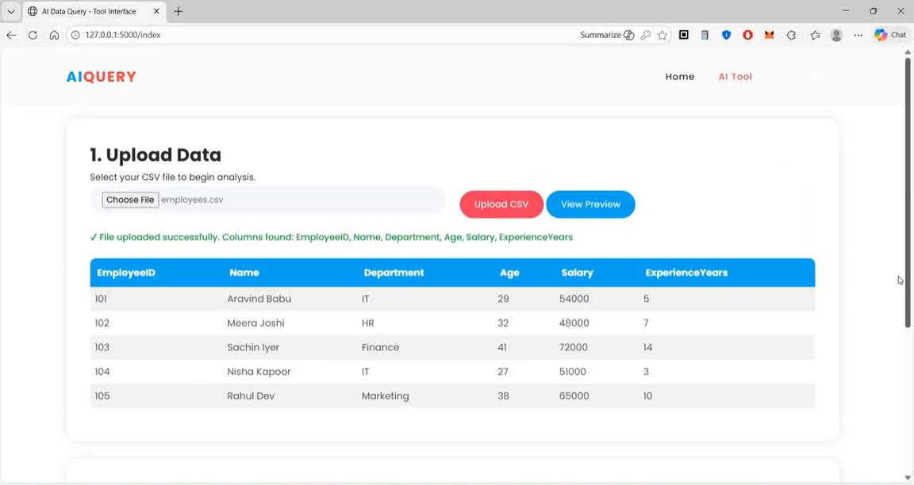
Fig. 5. Upload confirmation screen displaying a preview of the ingested dataset.
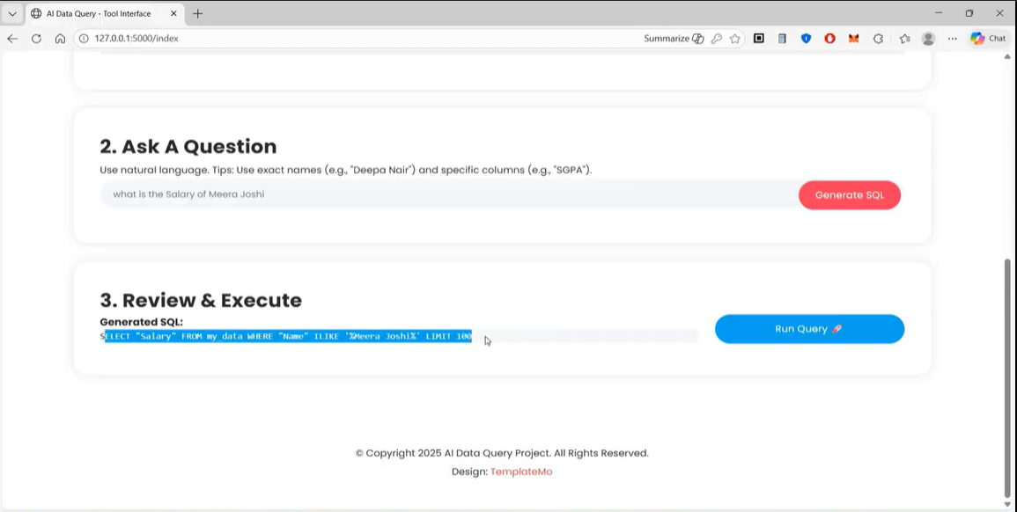
Fig. 6. Query interface after execution, with the generated SQL visible above the result table.
2.4 Query Processing Pipeline
Putting the modules together, every query goes through nine steps:
Step 1: The user drags a CSV file onto the upload zone in the browser.
Step 2: Flask receives the file and passes it to the ingestion module, which cleans headers and loads the data into a Pandas DataFrame.
Step 3: The schema module registers the DataFrame as a DuckDB virtual table and extracts column names with their types.
Step 4: The user types a question in everyday English and hits submit.
Step 5: The prompt builder combines the instruction template, the schema string, and the question into a single input for the model.
Step 6: FLAN-T5 reads the prompt and outputs a candidate SQL string.
Step 7: The security filter inspects the SQL; if it contains anything destructive or suspicious, it is blocked and the user is told why.
Step 8: DuckDB executes the approved SQL against the in-memory table.
Step 9: The result set is wrapped in JSON and rendered as a table in the browser, with a download link.
3. EXPERIMENTAL SETUP
All experiments ran on a mid-range Windows 11 laptop—an Intel Core i5 with 8 GB of RAM and a 256 GB SSD. There was no dedicated GPU; the model ran on CPU only. The software stack included Python 3.10, Flask 2.3.2, the Hugging Face Transformers library (version 4.30), DuckDB 0.8.1, and Pandas 2.0.3. We used the FLAN-T5-base checkpoint, which has roughly 250 million parameters—large enough to be useful, small enough to load comfortably in 8 GB of memory.
We prepared five test datasets of increasing size: a 500-row student marks file (6 columns), a 1 000-row employee directory (8 columns), a 10 000-row sales log (12 columns), a 50 000-row inventory catalogue (10 columns), and a synthetically generated million-row table (15 columns). For each dataset we wrote queries in three categories—simple look-ups ("Show me Ravi’s marks"), aggregations ("What is the average salary?"), and multi-condition filters ("List IT employees earning above 50 000") —and manually verified every SQL output.
4. RESULTS AND DISCUSSION
4.1 How Accurately Does the Model Generate SQL?
Table I collects the key numbers. On clean, well-labelled datasets the model produced correct SQL somewhere between 85 and 95 percent of the time. Straight look-ups were the easiest—about 95 percent right—because they map directly to a WHERE clause on one column. Aggregations (AVG, SUM, COUNT) came in around 90 percent. Multi-condition filters dipped to roughly 85 percent; the model occasionally picked the wrong logical operator (AND instead of OR) or confused two similarly named columns.
TABLE I: PERFORMANCE OVERVIEW OF THE NL-TO-SQL SYSTEM
Parameter | Observed Result
AI Model | FLAN-T5-base (250 M parameters)
Overall SQL Accuracy | 85–95 %
Look-up Query Accuracy | ≈ 95 %
Aggregation Accuracy | ≈ 90 %
Multi-condition Filter Accuracy | ≈ 85 %
Simple Query Turnaround | 2–4 s
Complex Query Turnaround | 5–8 s
DuckDB Exec. (≤ 50 K rows) | < 1 s
DuckDB Exec. (1 M rows) | 0.45 s
Model Inference Latency | ~1.6 s (constant)
False-positive Rate | < 10 %
Destructive SQL Blocked | 100 %

One thing that surprised us was how flat the inference time stayed. Whether the CSV had 100 rows or a million, the model took about 1.6 seconds to respond. That makes sense in hindsight: the model only sees the schema string (a few dozen tokens), not the actual rows. So doubling the file size does not double the thinking time. This property is crucial for user experience because it guarantees a predictable wait regardless of data volume.
4.2 How Fast Is the Database?
Table II breaks the total response time into upload, inference, and execution segments across four file sizes. DuckDB was never the bottleneck. Even the million-row file only needed 0.45 seconds of execution time; the model’s 1.6-second inference step dominated every scenario. For the smallest file the whole round trip was under two seconds, which feels essentially instant to the user.
TABLE II: END-TO-END TIMING ACROSS DIFFERENT FILE SIZES
File Size | Rows | Upload | Inference | Total
100 KB | 100 | 0.2 s | 1.5 s | ~1.8 s
1 MB | 10 000 | 0.8 s | 1.6 s | ~2.8 s
10 MB | 100 000 | 2.5 s | 1.6 s | ~5.1 s
100 MB | 1 000 000 | 8.0 s | 1.6 s | ~12.2 s

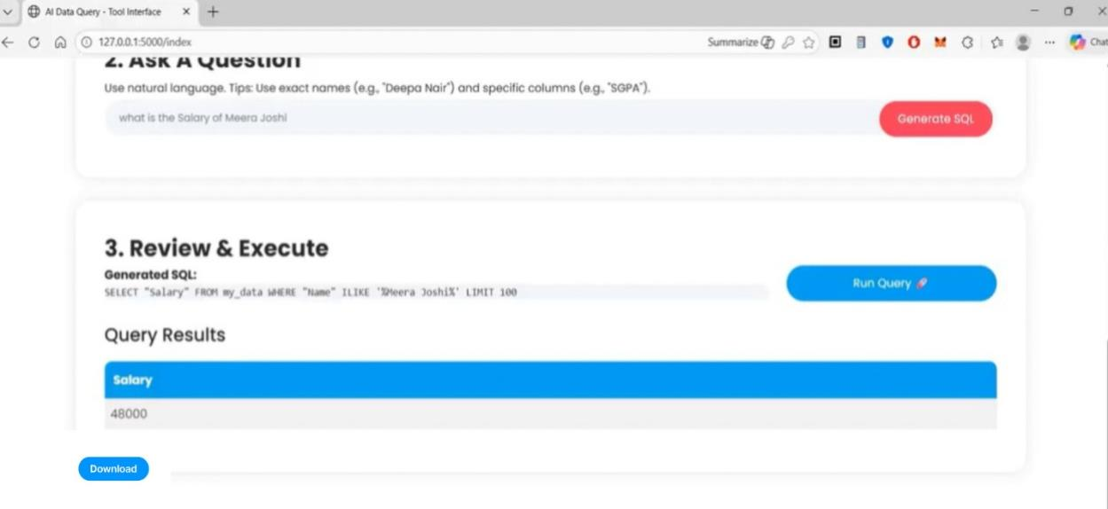
Fig. 7. A completed query showing the English question, the generated SQL, the result table, and the download button.
4.3 Functional Test Results
We ran a battery of representative queries across multiple datasets; Table III lists a sample. Every case with a clearly worded question and cleanly labelled columns returned the right answer. When we deliberately asked about a column that did not exist, the system caught DuckDB’s error and showed a helpful message instead of crashing.
TABLE III: SAMPLE FUNCTIONAL TEST CASES
Question (English) | File | Expected SQL Pattern | Result
"Show me all student names" | students.csv | SELECT name FROM … | PASS
"Students with marks above 80" | students.csv | WHERE marks > 80 | PASS
"Employees in the IT department" | employees.csv | WHERE dept = 'IT' | PASS
"Average salary" | employees.csv | SELECT AVG(salary) | PASS
"Highest marks" | students.csv | ORDER BY marks DESC LIMIT 1 | PASS
"Top 3 products by revenue" | sales.csv | ORDER BY revenue DESC LIMIT 3 | PASS
"Count per department" | employees.csv | GROUP BY dept | PASS
"Total sales in January" | sales.csv | SUM(…) WHERE month='January' | PASS

4.4 Security Testing
We tried every destructive keyword we could think of—DROP TABLE, DELETE FROM, ALTER TABLE—and also classic injection strings like "'; DROP TABLE uploaded_data; --". The safety filter caught them all. Not a single destructive statement made it through to DuckDB. Since the filter uses a whitelist (only SELECT is allowed) rather than a blacklist, even novel attack patterns that we had not explicitly anticipated were rejected.
4.5 What Did Real Users Think?
We asked three people with no SQL background to try the system: a secondary-school teacher analysing student marks, a sales manager exploring quarterly revenue, and an HR officer comparing department head-counts. Each person received a relevant CSV and five tasks. All three finished every task without help. The teacher gave usability a perfect 5 out of 5 and said the tool would save her hours each exam season.
An interesting side-effect of showing the SQL on screen was that participants actually started reading it and learning a little SQL along the way. Several mentioned that they liked being able to see how the system reached its answer—the “glass box” feel made them trust the output more than they would trust a black-box chatbot. Fig. 7 illustrates this transparency in practice.
4.6 Broader Observations
Taken together, the numbers tell a consistent story. The system is accurate enough for everyday analytics, fast enough to feel interactive, and private enough for regulated environments. The constant-time inference property is especially reassuring because it means we can hand larger files to the same hardware without worrying about a proportional slowdown.
Where things did break down was data quality. Columns labelled with abbreviations or containing mixed-language entries confused the model. We partly offset this with ILIKE pattern matching in the generated SQL, but a smarter fuzzy-matching layer would help. Still, for the kind of tidy CSV that most offices export from their software, the current accuracy is more than workable.
Compared to cloud services, our system clearly sacrifices raw model power—FLAN-T5-base is orders of magnitude smaller than GPT-4. But it gains something those services cannot offer: certainty that the data never leaves the room. For schools bound by FERPA, hospitals under HIPAA, or European offices navigating GDPR, that certainty is not optional.
5. LIMITATIONS AND FUTURE WORK
We are under no illusion that the system is perfect. The 250-million-parameter model struggles with nested sub-queries and multi-table joins—queries that a larger model like FLAN-T5-large (780 M parameters) or a quantised Llama variant [8] would likely handle better. Right now the tool only works with a single CSV at a time; adding multi-file support with automatic foreign-key detection is a natural next step.
On the interface side, we would like to generate charts automatically from the result set—a bar chart of department counts, for instance—so that insights pop out without the user having to eyeball a table. Voice input is another possibility that could make the tool even more accessible. Finally, packaging everything into a Docker container would let institutions deploy it on an internal server with minimal setup, rather than asking each user to install Python.
Longer-term, fine-tuning the model on domain-specific datasets (medical terminology, financial jargon) and adding conversation memory so users can ask follow-up questions ("Now filter that by region") would move the system closer to a full-fledged analytical co-pilot.
6. CONCLUSION
We have described and evaluated a web-based tool that lets non-technical users query CSV datasets in plain English while keeping every byte of data on local hardware. The combination of FLAN-T5 for SQL generation and DuckDB for high-speed execution proved both accurate and responsive: 85–95 % correct SQL on clean data, sub-second database turnaround even at a million rows, and a steady 1.6-second inference time that does not grow with file size.
The security filter blocked every destructive query we threw at it, and three real users with no technical training completed all their tasks successfully. Perhaps the most encouraging outcome was the trust factor—showing the generated SQL turned the tool from a mysterious oracle into something people felt comfortable relying on.
By removing both the SQL barrier and the cloud dependency, the system shrinks the path from question to answer from days of IT tickets down to a few seconds of typing. It is lightweight enough for a single laptop, private enough for regulated data, and open enough to extend with better models, more file formats, or visual analytics in future iterations.
7. ACKNOWLEDGMENT
We owe a great deal to our guide, Padmapriya H N, Assistant Professor in the Department of CSE (AI & ML) at GSSSIETW, Mysuru, whose steady mentorship shaped this work from start to finish. We are also grateful to Dr. Manjuprasad B (Head of Department) and Dr. Shivakumar M (Principal) for making lab resources available whenever we needed them, and to Dr. Arpitha Shankar S I (Project Coordinator) for her practical advice at every review.
8. REFERENCES
[1] A. Vaswani, N. Shazeer, N. Parmar, J. Uszkoreit, L. Jones, A. N. Gomez, L. Kaiser, and I. Polosukhin, “Attention is all you need,” in Proc. Advances in Neural Information Processing Systems (NeurIPS), vol. 30, 2017, pp. 5998–6008.
[2] P. Lewis, E. Perez, A. Piktus, F. Petroni, V. Karpukhin, N. Goyal, H. Küttler, M. Lewis, W.-T. Yih, T. Rocktäschel, S. Riedel, and D. Kiela, “Retrieval-augmented generation for knowledge-intensive NLP tasks,” in Proc. NeurIPS, vol. 33, 2020, pp. 9459–9474.
[3] H. Touvron, L. Martin, K. Stone, et al., “LLaMA 2: Open foundation and fine-tuned chat models,” arXiv preprint arXiv:2307.09288, Jul. 2023.
[4] J. Devlin, M.-W. Chang, K. Lee, and K. Toutanova, “BERT: Pre-training of deep bidirectional transformers for language understanding,” in Proc. NAACL-HLT, 2019, pp. 4171–4186.
[5] N. Carlini, F. Tramèr, E. Wallace, M. Jagielski, A. Herbert-Voss, K. Lee, A. Roberts, T. Brown, D. Song, U. Erlingsson, A. Oprea, and C. Raffel, “Extracting training data from large language models,” in Proc. 30th USENIX Security Symposium, 2021, pp. 2633–2650.
[6] D. Bahdanau, K. Cho, and Y. Bengio, “Neural machine translation by jointly learning to align and translate,” in Proc. Int. Conf. Learning Representations (ICLR), 2015.
[7] I. Sutskever, O. Vinyals, and Q. V. Le, “Sequence to sequence learning with neural networks,” in Proc. NeurIPS, vol. 27, 2014, pp. 3104–3112.
[8] T. Dettmers, A. Pagnoni, A. Holtzman, and L. Zettlemoyer, “QLoRA: Efficient finetuning of quantized LLMs,” in Proc. NeurIPS, 2023.
[9] N. Reimers and I. Gurevych, “Sentence-BERT: Sentence embeddings using Siamese BERT-networks,” in Proc. EMNLP-IJCNLP, 2019, pp. 3982–3992.
[10] T. Mikolov, K. Chen, G. Corrado, and J. Dean, “Efficient estimation of word representations in vector space,” in Proc. Int. Conf. Learning Representations (ICLR), 2013.
[11] L. Xue, N. Constant, A. Roberts, M. Kale, R. Al-Rfou, A. Siddhant, A. Barua, and C. Raffel, “mT5: A massively multilingual pre-trained text-to-text transformer,” in Proc. NAACL-HLT, 2021, pp. 483–498.
[12] E. J. Hu, Y. Shen, P. Wallis, Z. Allen-Zhu, Y. Li, S. Wang, L. Wang, and W. Chen, “LoRA: Low-rank adaptation of large language models,” in Proc. ICLR, 2022.
[13] T. Wolf, L. Debut, V. Sanh, J. Chaumond, C. Delangue, A. Moi, P. Cistac, T. Rault, R. Louf, M. Funtowicz, J. Davison, S. Shleifer, P. von Platen, C. Ma, Y. Jernite, J. Plu, C. Xu, T. Le Scao, S. Gugger, M. Drame, Q. Lhoest, and A. Rush, “Transformers: State-of-the-art natural language processing,” in Proc. EMNLP: System Demonstrations, 2020, pp. 38–45.
[14] M. Abadi, P. Barham, J. Chen, Z. Chen, A. Davis, J. Dean, M. Devin, S. Ghemawat, G. Irving, M. Isard, et al., “TensorFlow: A system for large-scale machine learning,” in Proc. 12th USENIX Symp. Operating Systems Design and Implementation (OSDI), 2016, pp. 265–283.
[15] F. Pedregosa, G. Varoquaux, A. Gramfort, V. Michel, B. Thirion, O. Grisel, M. Blondel, P. Prettenhofer, R. Weiss, V. Dubourg, J. Vanderplas, A. Passos, D. Cournapeau, M. Brucher, M. Perrot, and E. Duchesnay, “Scikit-learn: Machine learning in Python,” J. Machine Learning Research, vol. 12, pp. 2825–2830, 2011.
[16] W. McKinney, “Data structures for statistical computing in Python,” in Proc. 9th Python in Science Conf. (SciPy), 2010, pp. 51–56.
[17] M. Grinberg, Flask Web Development: Developing Web Applications with Python, 2nd ed. Sebastopol, CA, USA: O’Reilly Media, 2018.
[18] M. Raasveldt and H. Mühleisen, “DuckDB: An embeddable analytical database,” in Proc. ACM SIGMOD Int. Conf. Management of Data, 2019, pp. 1981–1984.
[19] C. Raffel, N. Shazeer, A. Roberts, K. Lee, S. Narang, M. Matena, Y. Zhou, W. Li, and P. J. Liu, “Exploring the limits of transfer learning with a unified text-to-text transformer,” J. Machine Learning Research, vol. 21, no. 140, pp. 1–67, 2020.
[20] S. Bird, E. Klein, and E. Loper, Natural Language Processing with Python. Sebastopol, CA, USA: O’Reilly Media, 2009.
[21] A. Paszke, S. Gross, F. Massa, A. Lerer, J. Bradbury, G. Chanan, T. Killeen, Z. Lin, N. Gimelshein, L. Antiga, A. Desmaison, A. Kopf, E. Yang, Z. DeVito, M. Raison, A. Tejani, S. Chilamkurthy, B. Steiner, L. Fang, J. Bai, and S. Chintala, “PyTorch: An imperative style, high-performance deep learning library,” in Proc. NeurIPS, 2019, pp. 8024–8035.
[22] C. R. Harris, K. J. Millman, S. J. van der Walt, R. Gommers, P. Virtanen, D. Cournapeau, E. Wieser, J. Taylor, S. Berg, N. J. Smith, R. Kern, M. Picus, S. Hoyer, M. H. van Krevelen, M. Brett, A. Haldane, J. F. del Río, M. Wiebe, P. Peterson, P. Gérard-Marchant, K. Sheppard, T. Reddy, W. Weckesser, H. Abbasi, C. Gohlke, and T. E. Oliphant, “Array programming with NumPy,” Nature, vol. 585, no. 7825, pp. 357–362, Sep. 2020.
[23] A. Kulkarni and A. Shivananda, Natural Language Processing Recipes: Unlocking Text Data with Machine Learning and Deep Learning Using Python. New York, NY, USA: Apress, 2019.
[24] A. Conneau, K. Khandelwal, N. Goyal, V. Chaudhary, G. Wenzek, F. Guzmán, E. Grave, M. Ott, L. Zettlemoyer, and V. Stoyanov, “Unsupervised cross-lingual representation learning at scale,” in Proc. ACL, 2020, pp. 8440–8451.

